# ICP – 4

**Nithin Thota**

**700764916**

**GitHub: https://github.com/NithinThota9/Neural_ICP3**

**Video Link:** https://drive.google.com/file/d/1q22k3E4TTMQ0GVbZMXvfWvmSzPjnXEAY/view?usp=sharing

# Q1:

**Code:**

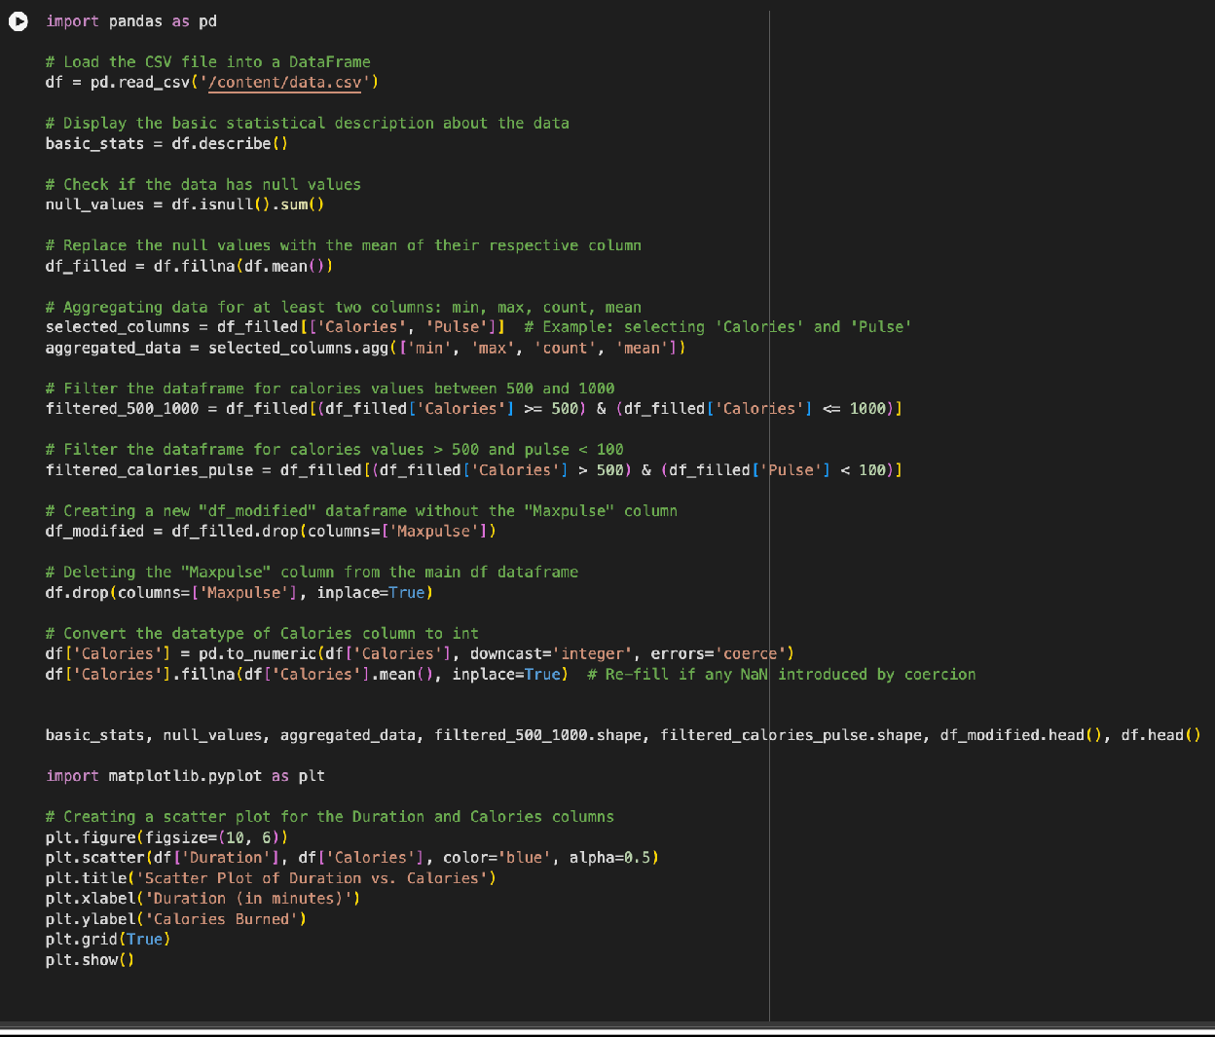

**Explanation:**

1. **Load Data:** Reads a CSV file into a pandas DataFrame**.**
2. **Basic Stats:** Generates summary statistics for numeric columns.
3. **Check Nulls:** Identifies any missing values in the dataset.
4. **Handle Nulls:** Replaces missing values with the column mean.
5. **Aggregate Data:** Computes min, max, count, and mean for selected columns (Calories, Pulse).
6. **Filter Data:** Filters rows where Calories are between 500-1000 or Calories > 500 and Pulse < 100.
7. **Drop Column:** Removes Maxpulse column from the DataFrame.

**Output:**

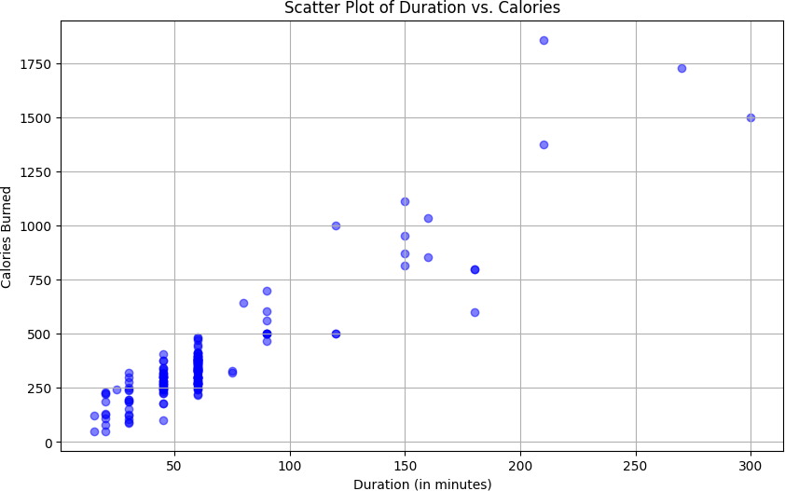

# Q2:

**Code:**

**Explanation:**

**Purpose**: Visualizing the results helps you understand how well your model is performing on both the training and test data.

**Training Set Visualization**: Displays how the model fits the data it was trained on. Red dots represent the actual data points, while the blue line represents the model’s predictions for that data.

**Test Set Visualization**: Shows how well the model generalizes to unseen data. The red dots are the actual test data points, and the blue line represents the model's predictions based on the training data.

**Scatter Plot**: A scatter plot is used to visualize the actual data points. This makes it easy to compare the predicted values (blue line) against the actual values (red dots).

**Model Evaluation**: These visualizations allow you to assess the accuracy and performance of the regression model in a straightforward, intuitive way.

**Layout**: The visualizations are shown side by side (two subplots), making it easy to compare how the model performs on both the training and test sets.

**Output:**

