#11
import matplotlib.pyplot as plt
months = [1, 2, 3, 4, 5, 6]
sales = [1200, 1500, 1700, 1600, 1800, 2000]
plt.plot(months, sales)
plt.xlabel("Month")
plt.ylabel("Sales")
plt.title("Monthly Sales Line Plot")
plt.show()
plt.scatter(months, sales)
plt.xlabel("Month")
plt.ylabel("Sales")
plt.title("Monthly Sales Scatter Plot")
plt.show()
plt.bar(months, sales)
plt.xlabel("Month")
plt.ylabel("Sales")
plt.title("Monthly Sales Bar Plot")
plt.show()

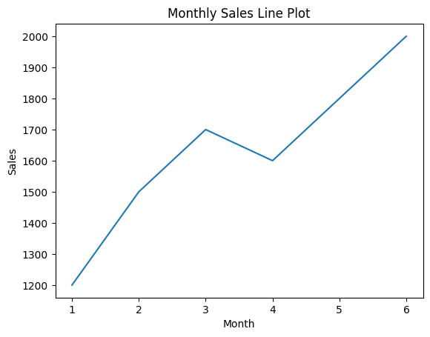
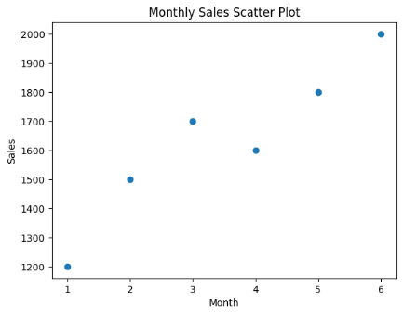
#12
import matplotlib.pyplot as plt
months = ["Jan", "Feb", "Mar", "Apr", "May", "Jun",
"Jul", "Aug", "Sep", "Oct", "Nov", "Dec"]
temperature = [22, 24, 27, 30, 34, 36, 35, 34, 32, 29, 25, 23]
rainfall = [30, 25, 40, 60, 120, 150, 180, 160, 140, 90, 50, 35]
plt.plot(months, temperature)
plt.xlabel("Month")
plt.ylabel("Temperature (°C)")
plt.title("Monthly Temperature Line Plot")
plt.show()
plt.scatter(months, rainfall)
plt.xlabel("Month")
plt.ylabel("Rainfall (mm)")
plt.title("Monthly Rainfall Scatter Plot")
plt.show()
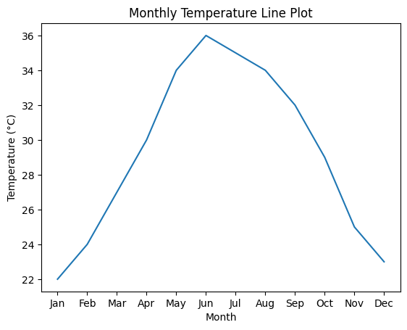
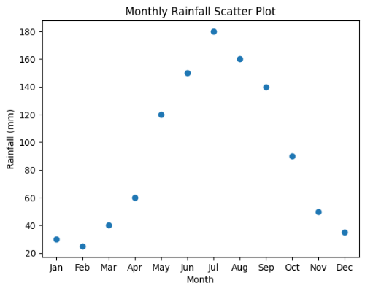
#13
sample_text = """Data science is an interdisciplinary field that uses scientific methods.
Data science involves statistics, machine learning, and data analysis.
Machine learning is a key part of data science."""

with open("sample_text.txt", "w") as file:
file.write(sample_text)
with open("sample_text.txt", "r") as file:
text = file.read()
text = text.lower()
for ch in ",.!?;:\"()[]{}":
text = text.replace(ch, "")
words = text.split()
word_freq = {}
for word in words:
if word in word_freq:
word_freq[word] += 1
else:
word_freq[word] = 1
for word, freq in word_freq.items():
print(word, ":", freq)
outpu:
data : 4
science : 3
is : 2
an : 1
interdisciplinary : 1
field : 1
that : 1
uses : 1
scientific : 1
methods : 1
involves : 1
statistics : 1
machine : 2
learning : 2
and : 1
analysis : 1
a : 1
key : 1
part : 1
of : 1
#14
import pandas as pd
data = {
"Customer_ID": [101, 102, 103, 104, 105, 106],
"Age": [22, 25, 22, 30, 25, 22],
"Purchase_Amount": [500, 800, 450, 900, 700, 650]
}
df = pd.DataFrame(data)
age_frequency = df["Age"].value_counts()
print(age_frequency)
#15
import pandas as pd
data = {
"Post_ID": [1, 2, 3, 4, 5, 6],
"Likes": [10, 20, 10, 30, 20, 10]
}

df = pd.DataFrame(data)
likes_frequency = df["Likes"].value_counts()
print(likes_frequency)
output:
Likes
10 3
20 2
30 1
Name: count, dtype: int64

