**PESTICIDES MANAGEMENT SYSTEM**

**SOFTWARE ENGINEERING PROJECT**

**TEAM:**

D NITHIN DATTA AP20110010362

G CHANDRA SHEKAR. AP20110010410

CH SAI AP20110010402

**ABSTRACT**

Pesticide management system is a software application that helps crop farmers select and use pesticides safely and effectively. The system has functions like crop and pest identification, a database of pesticides, pesticide recommendations, tracking of pesticide consumption, safety precautions, and alerts and reminders.

To implement this, we have used several programming tools HTML, CSS, JavaScript, Node.js, React and MongoDB

Pesticide management system is designed to help farmers use pesticides safely and responsibly, while ensuring that they choose the appropriate pesticide for their crop and follow recommended usage limits. It is expected that the system will contribute to the reduction of environmental damage and health risks associated with the misuse of pesticides.

**INTRODUCTION**

The purpose of pesticides is to destroy pests using chemicals. The best invention for saving farmers' labour and hard-won productivity is pesticide technology. Also, they support agricultural and land protection against invasive plants or organisms that would otherwise leech every nutrient from crops. Incorrect application of pesticides can have negative effects on both the environment and human health. Pesticides are used to control pests and illnesses and boost agricultural productivity. Hence, it is crucial to choose pesticides carefully and use them in a responsible manner.

In order to cultivate more crops on their land, farmers have started using pesticides, which has resulted in a 20–50% productivity gain.

Pesticide management system is a software application that helps crop farmers select and use pesticides safely and effectively. The system has functions like crop and pest identification, a database of pesticides, pesticide recommendations, tracking of pesticide consumption, safety precautions, and alerts and reminders.

Pesticide management system Software Program is anticipated to offer a complete solution to aid farmers in the safe and responsible selection and application of pesticides, improving crop production efficiency and fostering sustainable agriculture.

**1.1 Purpose**

This software will help the Farmers to be more efficient and gain knowledge in pesticides and crops . The main purpose of this software is to simplify the tedious task of Gaining and Knowing Types of pesticides used for different Crops

This project is supported by a well-designed DBMS that integrates Pesticide data. A user-friendly interface is also provided so that the user's searches return accurate results by accessing the database information.

* 1. **Additional Information**

SQL -> Structured query Language   
DFD -> Data Flow Diagram  
CFD -> Context Flow Diagram  
SRS -> Software Requirement Specification

**SOFTWARE REQUIREMENTS**

User Interfaces

The software provides a good graphical user interface to the user.

Hardware Interfaces

1. Mouse

2. Keyboard  
3. Hard Disk  
4. Ram with memory 256MB or more

4.System Features  
4.1 Response to Abnormal Situations

If any of the process does not go on or if any process stops for some reason in any situation the error messages and logs will be sent to admin. So that they can resolve as well as they can.

5 Other Non-Functional Requirements

5.1 Performance Requirements

5.1.1 Capacity  
The software is designed to run in the given timings of the library

5.1.2 Dynamic Requirements

5.1.3 Quality  
The overall software is fast, error free and reliable.

5.2 Software System Attributes

5.2.1 Reliability

To ensure reliability, this software is designed in such a way that it is stable and reliable to use.

5.2.2 Availability  
The software can be operated anytime and anywhere.

5.2.3 Security

The access to the complete software is given only to administrators . administrator have their respective username and password so that only authenticated personnel can access the software and no other users can access the software.

5.2.4 Maintainability None.

**2.0 ER Diagram**

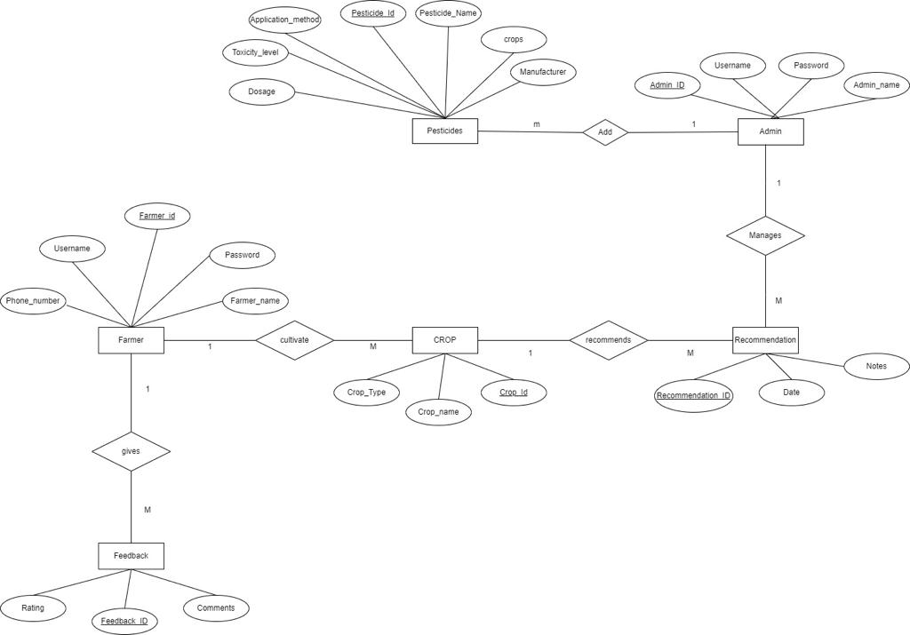

**3.0 USE CASE**

**3.1 General Use Case**

In the Unified Modelling Language (UML), a use case diagram can summarize the details of your system's users (also known as actors) and their interactions with the system.

We have Two actors For this management system Farmer and Admin. Admin Access to pesticides details and recommendations

**Actors :** Farmer , Admin

**Use Cases :**

From Sender side

CROP

RECOMMENDAION

FEEDBACK

From Receiver side

PESTICIDES

RECOMMENDATION

**Data Flow Diagram**

**5.1 Zero Level DFD**

**5.2 FIRST LEVEL DFD**

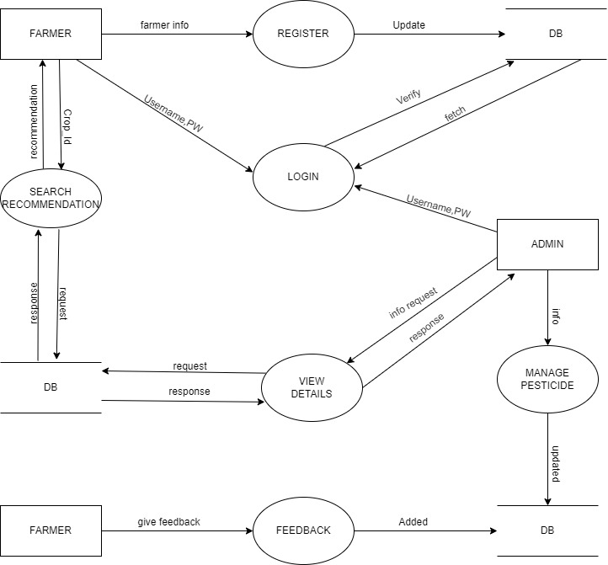

**5.3 SECOND LEVEL DFD**

**REGISTER**

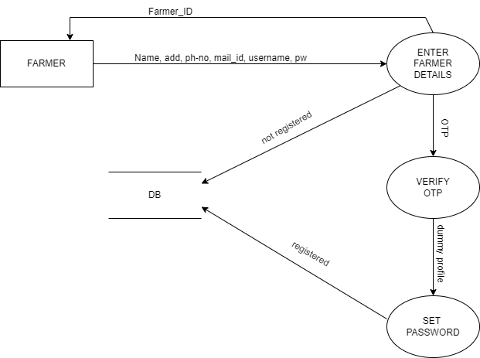

**5.3.2**

**SEARCH RECOMMENDATION**

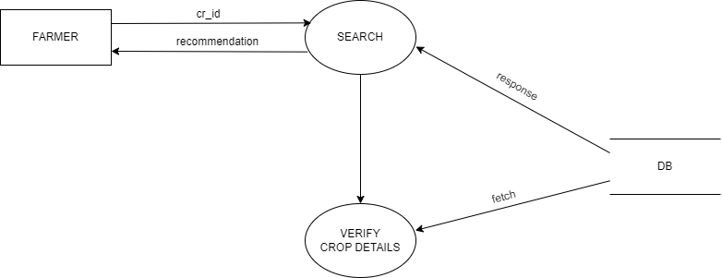

**5.3.3**

**LOGIN**

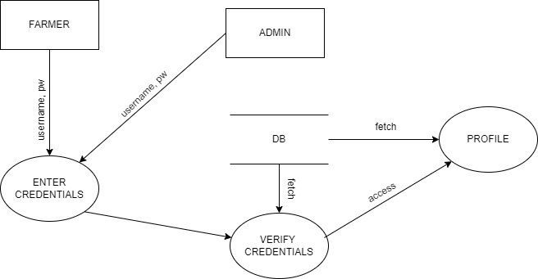

**5.3.4**

**VIEW DETAILS**

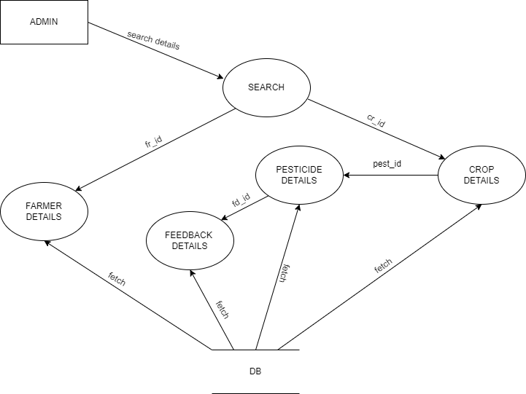

**5.3.5**

**MANAGE PESTICIDE**

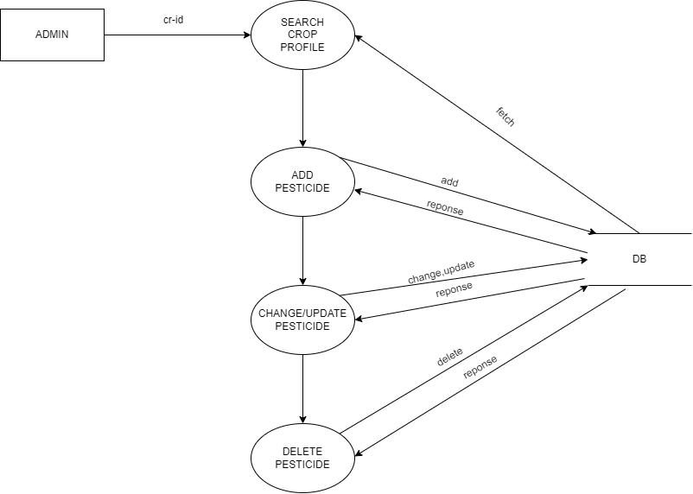

**6.0 SEQUENTIAL DIAGRAM**

**6.1 USER**

**6.2**

**ADMIN**

**7 COLLABORATION DIAGRAM**

**7.1 USER COLLABORATION DIAGRAM**

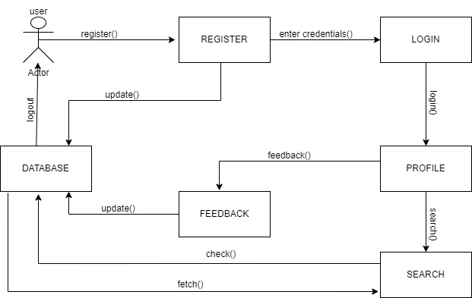

**7.2 ADMIN COLLABORATION DIAGRAM**

