REPORT

ON

**FOUR WEEKS OF INTERNSHIP**

Carried out at

**ELECTROMOTIVE CLUB**

*Submitted to*

**NMAM INSTITUTE OF TECHNOLOGY, NITTE**

(An Autonomous Institution under VTU, Belagavi)

*In partial fulfillment of the requirements for the award of the*

Degree of Bachelor of Engineering

in

#### Computer Science & Engineering

#### *by*

**Parthasarathy H M**

**4NM19CS128**

Under the guidance of

MR SINCHAN MS

Managing director

Electromotive club





Certificate

*This is to certify that the “Internship report” submitted by* **Mr. Parthasarathy H M** bearing USN **4NM19CS128** *of 8th semester B.E., a bonafide student of NMAM Institute of Technology, Nitte, has undergone four weeks of internship at Electromotive club during July 2022 fulfilling the partial requirements for the award of the degree of Bachelor of Engineering in* ***Computer Science & Engineering*** *at NMAM Institute of Technology, Nitte****.***



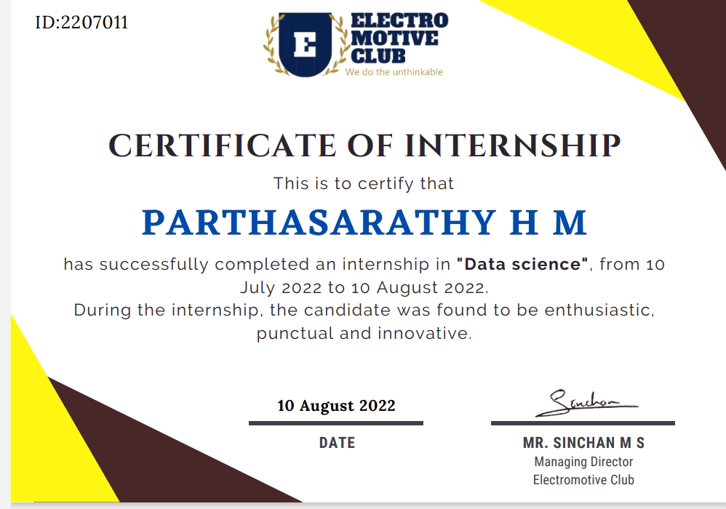

**ACKNOWLEDGMENT**

I take this opportunity to express my heartfelt gratitude and appreciation to all those who provided me the support and encouragement to complete these projects. Without their contributions, input, and suggestions, I would not have succeeded in developing the idea and completing the project. I record my indebtedness to ELECTROMOTIVE CLUB for giving me a platform to learn during my internship.

My heartfelt thanks to my esteemed guide and mentor**, Mr. SINCHAN MS** from ELECTROMOTIVE CLUB, for his valuable advice, endless support, and motivation, constantly throughout.

I would like to thank **Dr. Niranjan Chiplunkar**, Principal, NMAMIT, and the Department of Computer Science and Engineering for their consistent support and for providing me with this opportunity to do the internship.

I would like to thank **Dr. Jyothi Shetty,** Head of Department, Computer Science and Engineering for their constant support and for providing me with this opportunity to do the internship.

I would like to thank my Guide **Dr. Jyothi Shetty**, Head of Department, Department of CSE for all the support and guidance.

I would like to thank ELECTROMOTIVE CLUB for providing me with the necessary facilities for carrying out the work.

I would also like to thank all the technical and non-technical staﬀ of ELECTROMOTIVE CLUB whose support motivated me to complete the internship

My un inching gratitude to everyone who has directly or indirectly contributed to the internship

**TABLE OF CONTENTS**

**CONTENT PAGE NUMBER**

TITLE PAGE…………………………………………………………………………………..I

INSTITUTION CERTIFICATE………………………………………………………………II

INDUSTRY CERTIFICATE…………………………………………………………………III

ACKNOWLEDGMENT……………………………………………………………………. IV

TABLE OF CONTENTS……………………………………………………………………. V

LIST OF FIGURES………………………………………………………………………….VI

ABSTRACT 1

INTRODUCTION TO THE INDUSTRY 2

DETAILS OF THE TRAINING UNDERGONE 3

CONCLUSION 6

REFERENCES 7

**LIST OF FIGURES**

Figure 1 Home View…………………………………………………………………………3

Figure 2 Home View…………………………………………………………………………4

Figure 3 Description…………………………………………………………………………5

1. **ABSTRACT**

Every year, the Electromotive Club launches the College Internship Drive to allow NMAMIT students to see industry standards firsthand. These internship drives at the NMAM Institute of Technology in Nitte are supported by the college and accepted as partial prerequisites for the award of the degree of Bachelor of Engineering in Computer Science & Engineering.

A stock market is a public market where you can buy and sell shares for publicly listed companies. The stocks, also known as equities, represent ownership in the company. The stock exchange is the mediator that allows the buying and selling of shares.

The goal of the internship was to independently create an stock price predictor to have a solid understanding of the process of creating stock price predictor and to predict the stock price.

Due to the high profit of the stock market, it is one of the most popular investments. People investigated for methods and tools that would increase their gains while minimizing the risk, as the level of trading and investing grew. Two stock exchanges namely- the National Stock Exchange (NSE) and the Bombay Stock Exchange (BSE), which are the most of the trading in Indian Stock Market takes place. Sensex and Nifty are the two prominent Indian Market Indexes. Since the prices in the stock market are dynamic, the stock market prediction is complicated.

From gradually the very past years some forecasting models are developed for this kind of purpose and they had been applied to money market prediction.

**2. INTRODUCTION TO THE INDUSTRY**

ElectroMotive Club is a start-up that specializes in Artificial Intelligence, Machine Learning, and VLSI technologies. According to their statement, the company's Research and Development department is working on IoT and AI/ML applications, as well as tech solutions for smart cities. They also provide consultancy and software services to various clients, including software companies, educational institutions, small-scale industries, and entrepreneurs.

The company's culture is described as inclusive and pleasant, with a strong emphasis on quality and scheduling. According to their statement, they aim to create a community that offers skill, knowledge, practical experience in futuristic technologies, and a platform for transforming ideas into reality.

The company's vision is to establish a renowned community that equips members with the necessary tools to develop their skills and knowledge in futuristic technologies. They believe that this will enable them to make a positive impact on society and improve the quality of life for individuals and communities.

The company's mission, according to its statement, is to provide businesses with technological solutions that leverage their expertise and skills to address challenges and turn them into opportunities. They are committed to assisting their clients in achieving their objectives and establishing successful businesses in the ever-changing technological landscape.

Overall, ElectroMotive Club appears to be a company with a clear sense of purpose and direction. They are committed to developing a community of skilled and knowledgeable individuals who can contribute to the field of AI/ML and related technologies while providing expert consultancy and software services to assist businesses in thriving.

**3**. **DETAILS OF THE TRAINING UNDERGONE**

The CSV dataset is given by the elcetromitve, using this dataset we have to predict the stock price.

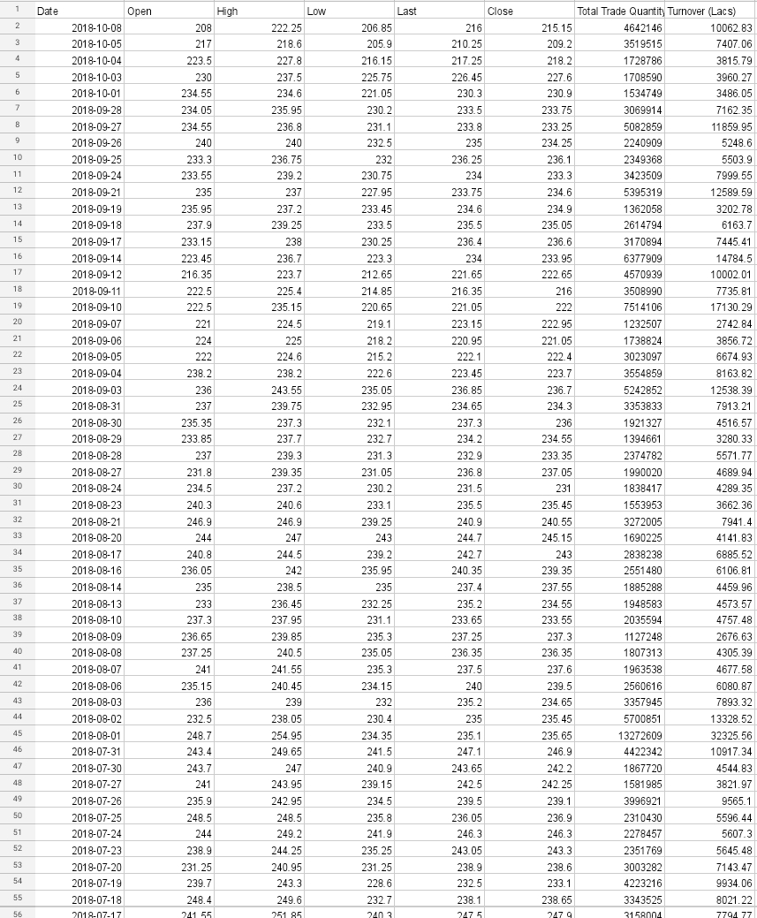

Output:-

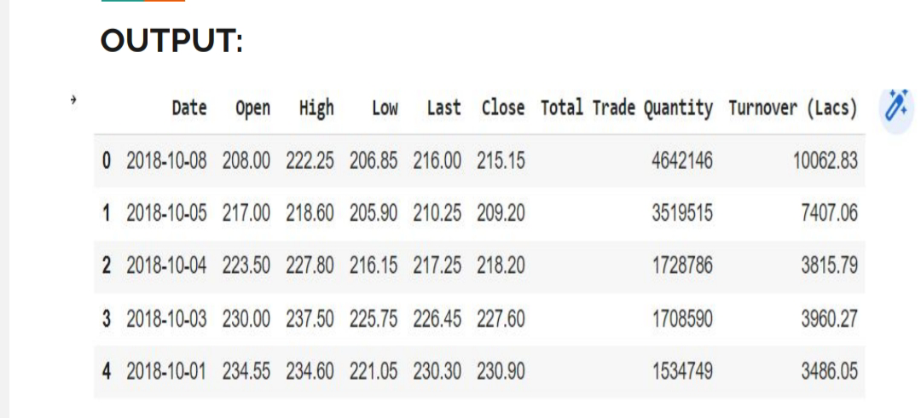

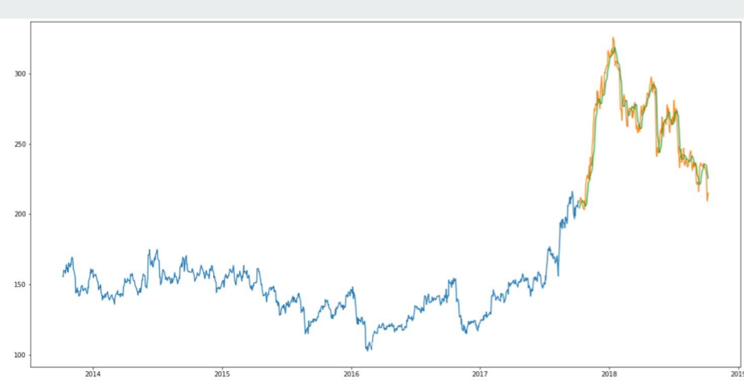

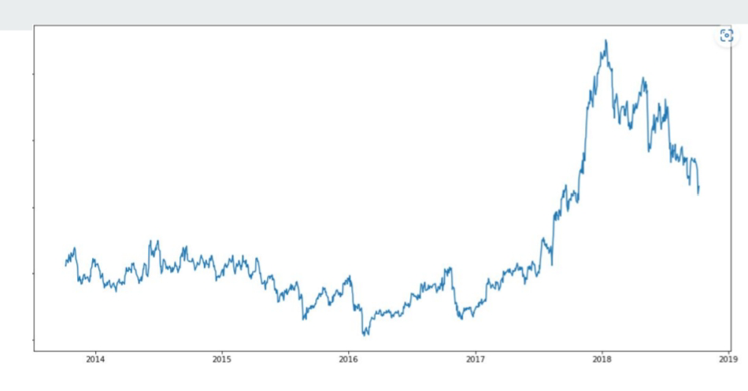

**4**. **CONCLUSION**

The LSTM model can be tuned for various parameters such as changing the

number of LSTM layers, adding dropout value or increasing the number of epochs.

But are the predictions from LSTM enough to identify whether the stock price will

increase or decrease? It's a probability.

**5**. **REFERENCES**

1. <https://github.com/>
2. <http://https//stackoverflow.com/>
3. <https://www.javatpoint.com>
4. <https://www.youtube.com/>