

LIFEINTEL: A PRIVACY-PRESERVING UNIVERSAL PERSONAL INTELLIGENCE WORKSTATION WITH SEMANTIC DELTA EXTRACTION AND AUTONOMOUS CONSEQUENCE REASONING

Submitted by

NITHIN VIGNESH S

Reg. No (ASML24023)
of

AMET UNIVERSITY
A CAPSTONE PROJECT REPORT
Submitted to the

FACULTY OF ADVANCED COMPUTING SCIENCES

In partial fulfillment of requirements for the award of the degree of
BACHELOR OF SCIENCE –
ARTIFICIAL INTELLIGENCE AND MACHINE LEARNING AMET UNIVERSITY
135, East Coast Road, Kanathur – 603 112 Tamil Nadu, India NOVEMBER 2026



BONAFIDE CERTIFICATE

Certified that this project report titled “LIFEINTEL: A Privacy-Preserving Universal Personal Intelligence Workstation with Semantic Delta Extraction and Autonomous Consequence Reasoning” is the bonafide work of NITHIN VIGNESH S (Reg No: ASML24023) who carried out the project under my supervision. Certified further, that to the best of my knowledge, the work reported herein does not form part of any other project report or dissertation on the basis of which a degree or award was conferred on an earlier occasion on this or any other candidate.

Supervisor  Mr. Tamilarasan D, M.CA, Assistant Professor, Department of ACS, AMET University, Kanathur - 603 112. | Head of the Department Dr. C.N. Ravi, Ph.D.,  Head of the Department, Department of CSE, AMET University,  Kanathur - 603 112.

Submitted for Project Viva Examination held on

Internal Examiner External Examiner

ABSTRACT

In contemporary academic and professional workflows, critical obligations, deadlines and prerequisites are fragmented across unstructured documents such as institutional PDF circulars, Word specifications, emailed requirements and manual schedules. Conventional tools treat personal data as a passive document repository, a static calendar reminder or a cloud-based conversational assistant. These approaches do not, by themselves, recognise temporal conflicts between a revised document and a user’s existing plans, they rarely highlight subtle revisions between document versions, and cloud-based assistants require sensitive documents to be sent to third-party services.
This capstone project presents LIFEINTEL (Universal Personal Intelligence System), a local-first, privacy-preserving desktop workstation. LIFEINTEL ingests local PDF, DOCX and TXT documents through an offline parsing pipeline. Regular-expression and rule-based entity extractors isolate dates, monetary amounts and obligation statements and normalise deadlines to ISO-8601. A Contextual Memory Engine builds an associative knowledge graph using term-frequency (TF) cosine similarity, a lexical-overlap measure, to link related documents without manual tagging.
A Delta and Consequence Reasoner compares successive document versions. It computes the temporal shift ΔT = T(D₂) − T(D₁) and checks stored user tasks against the new deadline using a deterministic, rule-based comparison. If a task is scheduled after the revised deadline, the system reports the shortfall in days and suggests a mitigation date. The reasoning is rule-based and transparent; the user remains the decision-maker.
The interface follows a “Warm Minimal” design philosophy. On a small internal benchmark of [[10]] documents, deadline extraction obtained [[precision 1.00, recall 1.00]] with a mean extraction-algorithm latency of [[3.15 ms]] per document on a CPU. Because of the small benchmark size, these figures show correct behaviour on the test set and are not claimed as general accuracy.
Keywords: personal intelligence, local-first, document change detection, deadline extraction, term-frequency cosine similarity, privacy.

ACKNOWLEDGEMENT

I offer my gratitude to the Lord Almighty who graced me and helped me all along to complete the project successfully. I would like to acknowledge the people who helped me to develop this project and who made it possible to do so.
First and foremost, I sincerely thank “Everlasting” for enabling me to complete this work successfully.
I owe my sincere thanks to Dr. C.N. Ravi, Ph.D., Head of the Department, AMET University, for taking a keen interest in the project and for his valuable guidance, coordination and timely suggestions and motivation to complete this project.
I express my sincere thanks to Mr. Tamilarasan D, M.CA Assistant Professor, Project Supervisor, Department of ACS, for his valuable guidance, coordination and efforts to bring out the best in me, his availability at all times and for providing timely questions and suggestions.
I am also very thankful to Mr. Aakaash M, MCA., Assistant Professor and Faculty Advisor, Department of ACS. I greatly benefited from his invaluable guidance and coordination.
I also express my thanks to all the staff members of the Department of ACS, AMET University, for their constant support and encouragement, and to all the non-teaching staff members for their support.
Finally, I express my gratitude to my parents and friends for their constant support and encouragement.

NITHIN VIGNESH S | [ASML24023]

TABLE OF CONTENTS

CHAPTER | TITLE | PAGE NO
 | ABSTRACT | i
 | ACKNOWLEDGEMENT | ii
 | TABLE OF CONTENTS | iii
 | LIST OF FIGURES | vi
 | LIST OF TABLES | vii
 | ABBREVIATIONS | viii
1 | INTRODUCTION | 1
 | 1.1 BACKGROUND AND MOTIVATION | 1
 | 1.2 PROBLEM STATEMENT | 1
 | 1.3 KEY TERMS USED IN THIS REPORT | 1
 | 1.4 PROJECT OBJECTIVES | 2
 | 1.5 PROJECT SCOPE | 2
 | 1.6 DEGREE OF AUTOMATION IN “AUTONOMOUS” CONSEQUENCE REASONING | 3
2 | SYSTEM ANALYSIS | 4
 | 2.1 EXISTING SYSTEM | 4
 | 2.2 PROPOSED SYSTEM | 5
 | 2.3 FEASIBILITY ANALYSIS | 5
 | 2.4 LITERATURE SURVEY | 6
3 | SYSTEM REQUIREMENTS | 7
 | 3.1 HARDWARE REQUIREMENTS | 7
 | 3.2 SOFTWARE REQUIREMENTS | 7
 | 3.3 FUNCTIONAL REQUIREMENTS | 8
 | 3.4 NON-FUNCTIONAL REQUIREMENTS | 8
 | 3.5 TECHNOLOGY STACK AND JUSTIFICATION | 9
4 | SYSTEM DESIGN | 10
 | 4.1 ARCHITECTURE DIAGRAM | 10
 | 4.2 UML DIAGRAMS | 11
 | 4.2.1 USE CASE DIAGRAM | 11
 | 4.2.2 CLASS DIAGRAM | 12
 | 4.2.3 SEQUENCE DIAGRAM | 12

CHAPTER TITLE PAGE NO

 | 4.3 MATHEMATICAL FORMULATIONS | 13
 | 4.4 LEXICAL VERSUS SEMANTIC SIMILARITY | 14
 | 4.5 ALGORITHM DESCRIPTIONS | 14
 | 4.6 DATABASE DESIGN | 15
 | 4.7 SECURITY AND PRIVACY DESIGN | 16
 | 4.8 USER INTERFACE DESIGN | 16
5 | MODULE DESCRIPTION | 18
 | 5.1 UNIVERSAL INGESTION AND DOCUMENT PARSER | 18
 | 5.2 STRUCTURED INFORMATION EXTRACTION ENGINE | 18
 | 5.3 SEMANTIC CHANGE DETECTOR AND CONSEQUENCE REASONER | 19
 | 5.4 CONTEXTUAL MEMORY AND ASSOCIATIVE KNOWLEDGE GRAPH | 19
 | 5.5 PROACTIVE FOLDER WATCHDOG SERVICE | 19
 | 5.6 TRANSPARENCY AND DATA SOVEREIGNTY AUDIT CENTER | 20
 | 5.7 NATURAL LANGUAGE WORKSTATION QUERY ENGINE | 20
6 | SYSTEM IMPLEMENTATION | 21
 | 6.1 DEVELOPMENT ENVIRONMENT AND SETUP | 21
 | 6.2 FRONTEND (REACT AND TYPESCRIPT) | 21
 | 6.3 ELECTRON MAIN PROCESS AND PRELOAD | 21
 | 6.4 FASTAPI BACKEND AND API ENDPOINTS | 22
 | 6.5 SQLITE DATABASE INTEGRATION | 22
 | 6.6 DOCUMENT INGESTION | 23
 | 6.7 INFORMATION EXTRACTION | 23
 | 6.8 CHANGE DETECTION AND CONSEQUENCE REASONING | 23
 | 6.9 CONTEXTUAL MEMORY | 23
 | 6.10 FOLDER MONITORING | 24
 | 6.11 NATURAL LANGUAGE QUERY | 24
 | 6.12 DATA EXPORT AND DELETION | 24
7 | SYSTEM TESTING | 25
 | 7.1 UNIT TESTING | 25

CHAPTER TITLE PAGE NO

 | 7.2 INTEGRATION TESTING | 25
 | 7.3 ROBUSTNESS AND NEGATIVE TESTING | 26
 | 7.4 PERFORMANCE BENCHMARKS | 26
 | 7.5 END-TO-END CASE STUDY | 27
 | 7.6 RESULTS AND DISCUSSION | 28
8 | APPENDICES | 30
 | 8.1 SCREENSHOTS | 30
 | 8.2 DATA DICTIONARY | 32
9 | CONCLUSION AND FUTURE ENHANCEMENT | 35
 | 9.1 CONCLUSION | 35
 | 9.2 LIMITATIONS | 35
 | 9.3 FUTURE ENHANCEMENT | 35
 | REFERENCES | 36

LIST OF FIGURES

FIGURE NO | NAME | PAGE NO
4.1 | LIFEINTEL SYSTEM ARCHITECTURE | 10
4.2 | END-TO-END DATA FLOW (STEPS) | 10
4.3 | USE CASE DIAGRAM | 11
4.4 | CLASS DIAGRAM | 12
4.5 | SEQUENCE DIAGRAM | 13
7.1 | PYTEST OUTPUT | 27
7.2 | CASE STUDY RESULT | 28
8.1 | DASHBOARD | 30
8.2 | SOURCES AND FOLDER MONITORING | 30
8.3 | DOCUMENT LIBRARY AND UPLOAD | 31
8.4 | CONSEQUENCE BRIEFING | 31
8.5 | MEMORY EXPLORER | 31
8.6 | ASK LIFEINTEL | 32
8.7 | TRANSPARENCY CENTER | 32

LIST OF TABLES

TABLE NO | NAME | PAGE NO
2.1 | COMPARISON OF EXISTING APPROACHES AND LIFEINTEL | 4
2.2 | FEASIBILITY ANALYSIS | 5
2.3 | LITERATURE SURVEY | 6
3.1 | HARDWARE REQUIREMENTS | 7
3.2 | SOFTWARE REQUIREMENTS AND VERIFIED VERSIONS | 7
3.3 | FUNCTIONAL REQUIREMENTS | 8
3.4 | NON-FUNCTIONAL REQUIREMENTS | 8
3.5 | TECHNOLOGY STACK AND JUSTIFICATION | 9
4.1 | WORKED NUMERICAL EXAMPLES | 14
4.2 | SECURITY AND PRIVACY CONTROLS | 16
4.3 | USER INTERFACE SCREENS | 16
5.1 | UNIVERSAL INGESTION AND DOCUMENT PARSER – SPECIFICATION | 18
5.2 | STRUCTURED INFORMATION EXTRACTION ENGINE – SPECIFICATION | 18
5.3 | SEMANTIC CHANGE DETECTOR AND CONSEQUENCE REASONER – SPECIFICATION | 19
5.4 | CONTEXTUAL MEMORY AND ASSOCIATIVE KNOWLEDGE GRAPH – SPECIFICATION | 19
5.5 | PROACTIVE FOLDER WATCHDOG SERVICE – SPECIFICATION | 19
5.6 | TRANSPARENCY AND DATA SOVEREIGNTY AUDIT CENTER – SPECIFICATION | 20
5.7 | NATURAL LANGUAGE WORKSTATION QUERY ENGINE – SPECIFICATION | 20
6.1 | REST API ENDPOINTS | 22
7.1 | UNIT TEST CASES | 25
7.2 | INTEGRATION TEST CASES | 25
7.3 | ROBUSTNESS AND NEGATIVE TEST CASES | 26
7.4 | BENCHMARK DATASET DESCRIPTION | 26
7.5 | CASE STUDY TRACE | 27
8.1 | SOURCES | 32
8.2 | DOCUMENTS | 33
8.3 | EXTRACTED FACTS | 33
8.4 | OBLIGATIONS | 33
8.5 | DETECTED CHANGES | 34

ABBREVIATIONS

ACID | - | ATOMICITY, CONSISTENCY, ISOLATION, DURABILITY
API | - | APPLICATION PROGRAMMING INTERFACE
CPU | - | CENTRAL PROCESSING UNIT
DOCX | - | OFFICE OPEN XML DOCUMENT FORMAT
FN / FP / TP | - | FALSE NEGATIVE / FALSE POSITIVE / TRUE POSITIVE
FR / NFR | - | FUNCTIONAL / NON-FUNCTIONAL REQUIREMENT
GGUF | - | GPT-GENERATED UNIFIED FORMAT
GPU | - | GRAPHICS PROCESSING UNIT
IPC | - | INTER-PROCESS COMMUNICATION
ISO | - | INTERNATIONAL ORGANIZATION FOR STANDARDIZATION
JSON | - | JAVASCRIPT OBJECT NOTATION
LLM | - | LARGE LANGUAGE MODEL
NLP | - | NATURAL LANGUAGE PROCESSING
OCR | - | OPTICAL CHARACTER RECOGNITION
ORM | - | OBJECT RELATIONAL MAPPING
PDF | - | PORTABLE DOCUMENT FORMAT
REST | - | REPRESENTATIONAL STATE TRANSFER
SHA | - | SECURE HASH ALGORITHM
SQL | - | STRUCTURED QUERY LANGUAGE
TF | - | TERM FREQUENCY
UI | - | USER INTERFACE
UML | - | UNIFIED MODELING LANGUAGE
UUID | - | UNIVERSALLY UNIQUE IDENTIFIER

CHAPTER 1 INTRODUCTION

BACKGROUND AND MOTIVATION
A personal intelligence system is software that observes a person’s own information (documents, schedules, notes) and helps them act on it, rather than merely storing it. Early document-management tools only indexed files for search; calendar tools stored dates entered by hand; and recent cloud assistants can summarise a document on request. Students, researchers and professionals, however, receive a constant stream of information: administrative circulars, internship calls, syllabus guidelines and fee schedules. Missing a clause, or failing to notice that an updated circular moved a submission deadline earlier, can lead to academic penalties, financial loss or missed opportunities.
Existing productivity tools fall short in three ways:
    - Siloed awareness: Calendars track dates, notes store text and file systems hold PDFs, but none of them cross-reference whether an update in one document invalidates a plan made elsewhere.
    - Privacy concerns: Many AI assistants process documents on remote servers, so private transcripts, financial details and personal files leave the user’s device. Some products offer on-device or enterprise-controlled modes, but the common consumer workflow is cloud-based.
    - Reactive rather than proactive behaviour: Conversational assistants usually act when asked. They do not, by default, watch a local folder, notice that a new version of a file has arrived, and warn the user in advance.

PROBLEM STATEMENT
To design, implement and evaluate an offline personal intelligence system that extracts structured obligations from local documents, links related documents, calculates the effect of deadline revisions on the user’s existing tasks, and alerts the user through a desktop workstation interface, without sending any data to external services.

KEY TERMS USED IN THIS REPORT
    - Local-first architecture: All data, processing and storage stay on the user’s own machine; the application works with the network disconnected.

    - Privacy-preserving intelligence: Design in which personal documents are never transmitted to a third party. In LIFEINTEL this means zero outbound network calls from the processing pipeline, which can be checked in the Transparency Center and with a network monitor.
    - Semantic delta extraction: The extraction of the difference (delta) between two versions of a document, such as a changed deadline, fee or requirement. In this project the comparison is performed on extracted structured facts using rules; it is not a neural semantic-understanding model.
    - Consequence reasoning: Rule-based checking of what a detected change implies for the user’s stored tasks, for example a task now scheduled after a revised deadline.

PROJECT OBJECTIVES
Each objective is stated with a measurable acceptance criterion.

No. | Objective | Measurable criterion
O1 | Local-only processing | Zero outbound network connections during ingestion, extraction, reasoning and query (checked with the Transparency Center counter and an OS network monitor).
O2 | Multi-format ingestion with deduplication | PDF, DOCX and TXT files parsed; a byte-identical file uploaded twice is indexed once (SHA-256).
O3 | Structured fact extraction | Deadline extraction precision and recall reported on a labelled benchmark with the dataset size and ground-truth method stated.
O4 | Consequence and conflict reasoning | Every deadline moved earlier than an existing task’s date is reported with the correct shortfall in days on the test scenarios.
O5 | Associative memory | Document pairs with TF cosine similarity ≥ θ = 0.15 appear as graph edges with their weights.
O6 | Proactive monitoring | A file added to an approved folder is detected and queued after the 1.5 s debounce without user action.
O7 | User control of data | The user can export all stored data as JSON and permanently purge all tables.
O8 | Usable interface | Seven screens operate correctly at 1440 × 900 resolution.

PROJECT SCOPE
What LIFEINTEL does:
    - Parses PDF, DOCX and TXT documents from user-approved folders or manual upload.

    - Extracts dates, monetary amounts and obligation statements with confidence scores.
    - Detects duplicate files and new versions of earlier documents and reports differences.
    - Flags deadline conflicts with the user’s stored obligations and suggests a mitigation date.
    - Links related documents by lexical similarity and answers questions from stored facts with source citations.

What LIFEINTEL does not do:
    - It does not understand meaning beyond the words present in the text (see Section 4.4); synonyms such as “due date” and “deadline” are not treated as equivalent by the similarity measure.
    - It does not read text from scanned images in the current build. [[Replace this line only if an OCR engine such as Tesseract is integrated and tested; then name it in Chapter 3.]]
    - It does not email, edit or submit anything on the user’s behalf; it only alerts and suggests.
    - It is not a replacement for official university communication; extraction can be wrong, so the user should confirm important dates in the source document.

DEGREE OF AUTOMATION IN “AUTONOMOUS” CONSEQUENCE REASONING
The word “autonomous” in the title means that, once a document arrives, the pipeline from parsing to alert runs without user input. The decision logic is a deterministic rule (Section 4.3): a conflict exists when an existing task’s date is later than the new deadline. The system never changes a task, deadline or file by itself. It produces a briefing and a suggested date, and the user decides whether to act. Full automation therefore covers detection and alert generation; the final decision remains human.
NOTE TO STUDENT (delete before submission): Add one sentence stating whether the local LLM (llama3:8b-instruct-q4_K_M) is used in the shipped build, and for what (for example, rewording the final briefing or answering questions). If extraction and conflict detection are purely regex and rule based, say so explicitly here.

CHAPTER 2 SYSTEM ANALYSIS

EXISTING SYSTEM
    - Generic productivity dashboards: Tools such as Notion, Trello and Google Keep depend on manual data entry. If a PDF notice contains ten requirements and an updated date, the user must read and type each item.
    - Cloud AI assistants: ChatGPT, Claude and Copilot can summarise documents, typically after a manual upload, and mostly run on cloud servers (some offer enterprise or on-device options). They generally do not watch a local folder or keep a persistent model of the user’s schedule conflicts unless configured to.
    - Calendar and task managers: Google Calendar and Outlook record fixed points in time but do not read document text or reason about consequences.

COMPARISON OF APPROACHES
TABLE 2.1 COMPARISON OF EXISTING APPROACHES AND LIFEINTEL

Feature | Traditional tools | Cloud AI assistants | LIFEINTEL
Document parsing | Limited | Yes | Yes (PDF, DOCX, TXT)
Automatic deadline extraction | Limited | Possible on request | Yes (rule-based)
Local processing | Varies by tool | Usually cloud; some local or enterprise modes | Yes
Document revision detection | Version history only | Manual prompting | Yes (hash and fact comparison)
Cross-document relationships | Limited | Depends on context provided | Yes (lexical TF cosine)
Proactive conflict alerts | Limited (reminders) | Not inherent | Yes

LIMITATIONS OF EXISTING SYSTEMS
    - Revisions buried in multi-page documents are routinely overlooked.
    - Sensitive student and financial documents may be exposed to third-party services.
    - There is little automatic correlation between external notices and personal milestones.

PROPOSED SYSTEM
LIFEINTEL is a cognitive layer that runs on the local operating system. It ingests files from approved folders through a watchdog monitor, extracts facts using local pattern-based NLP, detects revisions through SHA-256 hashing and title/fact comparison, and compares incoming constraints with stored user tasks to produce Consequence Intelligence Briefings. [[State here whether the locally hosted quantised LLaMA-3 model is used in the shipped build and for which function.]]

ADVANTAGES
    - Data stays on the device; no network connection is required for processing.
    - Dates, fees and prerequisite obligations are structured and saved automatically.
    - Bottlenecks are flagged before they happen, for example: “Resume draft scheduled for Nov 12 conflicts with the revised deadline of Nov 10.”

LIMITATIONS
    - Extraction depends on writing patterns the rules recognise; unusual date phrasing may be missed or misread.
    - Lexical similarity does not capture meaning; related documents that use different words may not be linked.
    - Performance and accuracy were measured on a small benchmark and have not been tested on a large, varied document collection.
    - Current build targets Windows.

FEASIBILITY ANALYSIS
TABLE 2.2 FEASIBILITY ANALYSIS

Type | Assessment
Technical | All components (Electron, React, FastAPI, SQLite, PyMuPDF, python-docx, watchdog) are mature open-source tools that run on an ordinary laptop CPU without a GPU.
Operational | The user drops files into a folder or uploads them; alerts appear on the dashboard and as desktop notifications. No configuration of servers or accounts is needed.
Economic | All software used is free and open source and no cloud or API fees are incurred. The only cost is the user’s existing computer and about 2 GB of disk space.

LITERATURE SURVEY
LIFEINTEL builds on established ideas from information retrieval, temporal reasoning and language modelling. Table 2.3 summarises the works that influenced its design and how each is used or deliberately not used.

TABLE 2.3 LITERATURE SURVEY

Reference | Contribution | Relevance to LIFEINTEL
Salton, Wong and Yang (1975) [4] | Vector space model: documents as term vectors compared by cosine similarity. | Basis of the Contextual Memory Engine (TF vectors, cosine, threshold 0.15).
Allen (1983) [6] | Formal relations between time intervals (before, after, overlaps). | Motivates reasoning about deadlines and task dates; LIFEINTEL uses the simple point-in-time ‘before / after’ case.
Lewis et al. (2020) [5] | Retrieval-augmented generation: answers conditioned on retrieved documents. | Inspires answering questions only from retrieved database records with citations.
Devlin et al. (2019) [1] | BERT: contextual embeddings capturing word meaning. | Not used in the current build; proposed to replace TF vectors for true semantic similarity.
Touvron et al. (2023) [3] | LLaMA: open foundation language models that run locally when quantised. | Candidate local model for optional language tasks without cloud access.
Radford et al. (2023) [2] | Whisper: robust speech recognition. | Planned future module for lecture and voice-note obligations.
Gap identified: the surveyed works address similarity, time reasoning, retrieval and language modelling separately. None is packaged as a local, document-watching tool that connects a document revision to a user’s own task schedule. LIFEINTEL combines these ideas in a small, transparent pipeline aimed at that gap.

CHAPTER 3 SYSTEM REQUIREMENTS

HARDWARE REQUIREMENTS
TABLE 3.1 HARDWARE REQUIREMENTS

Item | Minimum | Recommended
Processor | Intel Core i3 / AMD Ryzen 3, 4 cores, 64-bit | Intel Core i5 (8th Gen+) / AMD Ryzen 5, 6 cores (development machine: AMD Ryzen 5 PRO 8640HS)
RAM | 8 GB (documents, database and UI only) | 16 GB (needed if the local LLM is enabled)
Storage | 2 GB free on SSD or HDD | 512 GB NVMe SSD with 10 GB free (LLM model files add several GB)
GPU | Not required | Not required; integrated graphics (Radeon 760M / Intel Iris Xe) is sufficient
Network | Not required during use | Needed only to install dependencies and download the model once

SOFTWARE REQUIREMENTS
TABLE 3.2 SOFTWARE REQUIREMENTS AND VERIFIED VERSIONS

Component | Version in report | Version installed (from package.json / pip freeze)
Operating system | Windows 10 / 11 (64-bit) | [[fill in]]
Electron | 41.2.0 | [[check – npm install reported 41.10.7]]
React | 19.3.1 | [[verify in package-lock.json]]
TypeScript | 7.0 | [[verify]]
Vite | 8.3.5 | [[verify]]
Tailwind CSS | 3.4 | [[verify]]
Python | 3.10 – 3.14 | [[exact version used]]
FastAPI / Starlette / Uvicorn | — | [[verify]]
SQLite / SQLAlchemy | SQLite 3 / 2.0 | [[verify]]
PyMuPDF / python-docx / Pillow | — | [[verify]]
watchdog | — | [[verify]]
Ollama and model | llama3:8b-instruct-q4_K_M | [[verify, and state if used]]
OCR engine | None named in earlier draft | [[Tesseract / none]]

Component | Version in report | Version installed (from package.json / pip freeze)
pytest / AnyIO | 9.2 | [[verify]]

NOTE TO STUDENT (delete before submission): Run `npm ls electron react typescript vite` and `pip freeze` and copy the real versions. Do not copy numbers from documentation. Then delete the “Version in report” column.

FUNCTIONAL REQUIREMENTS
TABLE 3.3 FUNCTIONAL REQUIREMENTS

ID | Requirement
FR-01 | The user can upload documents (PDF, DOCX, TXT) through the interface.
FR-02 | The system extracts dates, monetary amounts and obligations from documents with confidence scores.
FR-03 | The system detects duplicate documents using SHA-256 hashes and does not index them twice.
FR-04 | The system identifies a new document as a revision of an earlier one and records the differences.
FR-05 | The system detects deadline conflicts between a revised deadline and stored obligations.
FR-06 | The system generates a consequence briefing stating the shift, the shortfall in days and a suggested date.
FR-07 | The system monitors only folders explicitly approved by the user.
FR-08 | The user can explore relationships between documents in a memory graph.
FR-09 | The user can ask questions and receive answers with source citations from stored data.
FR-10 | The user can export all stored data as JSON and permanently delete it.
FR-11 | The user can add, edit and delete obligations manually.

NON-FUNCTIONAL REQUIREMENTS
TABLE 3.4 NON-FUNCTIONAL REQUIREMENTS

Category | Requirement
Privacy and security | No document content leaves the device; the API listens on localhost only; Electron uses context isolation and a preload bridge.
Performance | Extraction of a typical document completes in milliseconds on a CPU; UI remains responsive during background ingestion.
Reliability | The application recovers from unreadable files, folder-permission errors and database errors without crashing, and reports the failure to the user.
Usability | Seven clearly named screens; readable at 1440 × 900; alerts ordered by urgency.
Offline operation | All features work with the network disabled.

Category | Requirement
Data integrity | ACID transactions in SQLite; unique constraint on file hash; cascade deletion avoids orphan records.
Maintainability | Separate modules for parser, extractor, change detector, reasoner, memory and monitor; type-checked frontend; automated tests.

TECHNOLOGY STACK AND JUSTIFICATION
TABLE 3.5 TECHNOLOGY STACK AND JUSTIFICATION

Layer | Technology | Justification in LIFEINTEL
Desktop shell | Electron (CJS) | Native Windows integration: frameless window, system tray, desktop notifications and shell.openPath.
Frontend | React + TypeScript | Reusable components, compile-time type safety and reactive state.
Bundler | Vite | Fast hot module replacement and optimised production build.
Styling | Tailwind CSS | Implements the Warm Minimal tokens: Ivory #FBF9F5, Espresso #1A1613, Sage #5F8A5F,  Terracotta #C97043.
Backend | FastAPI (Python) | Asynchronous REST endpoints, OpenAPI documentation and Pydantic validation.
Persistence | SQLite + SQLAlchemy | Serverless, zero-configuration, ACID-compliant local database.
Parsing | PyMuPDF, python-docx | Fast extraction of text and page offsets from PDF and Word files.
Watcher | watchdog | Event-driven monitoring with a debounce queue.
Memory | TF cosine similarity | Lexical similarity without GPU cost; interpretable weights.
Electron embeds Chromium and Node.js and hosts the interface; it communicates with the renderer through a context-isolated preload bridge. React and TypeScript build the dashboard, Memory Explorer, Transparency Center and query screen as typed components. FastAPI, built on Starlette and Pydantic, exposes the processing pipeline through local REST endpoints served by Uvicorn. SQLite with SQLAlchemy stores documents, facts, obligations, changes and logs. PyMuPDF extracts text from PDFs and python-docx reads Word files. Watchdog uses the Windows ReadDirectoryChangesW API with a 1.5 second debounce. Ollama / llama.cpp can run a 4-bit quantised LLaMA-3 model [3] on the CPU for local language tasks.

CHAPTER 4 SYSTEM DESIGN

ARCHITECTURE DIAGRAM
LIFEINTEL has four decoupled tiers: the Acquisition tier (approved-folder watchers and drag-and-drop upload), the Cognitive tier (parser, extractor, change detector, consequence reasoner, contextual memory), the Persistence tier (SQLite with SQLAlchemy) and the Presentation tier (Electron shell with the React interface, backed by the FastAPI service).
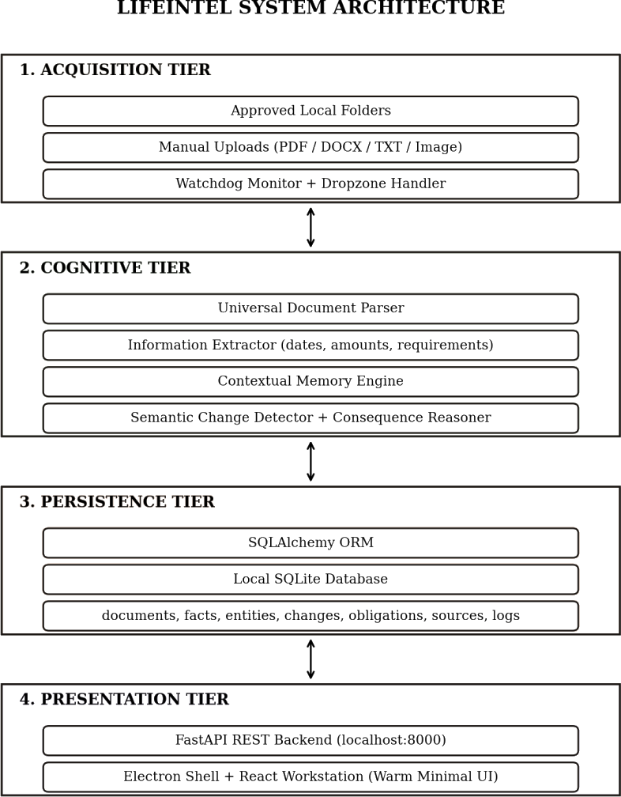

FIG 4.1 ARCHITECTURE DIAGRAM COMPLETE DATA FLOW
- Step 1. The user uploads a document or drops it in an approved folder, and the watchdog queues it after the 1.5 s debounce.
- Step 2. The parser computes the SHA-256 hash (rejecting exact duplicates) and extracts text and page offsets.

- Step 3. The information extractor identifies dates, amounts and obligations and assigns confidence scores.
- Step 4. The contextual memory engine builds a TF vector and compares it with existing documents to create relationships.
- Step 5. The change detector looks for an earlier version with similar title tokens and compares the facts of both versions.
- Step 6. The consequence reasoner checks the new deadline against existing obligations and computes any shortfall.
- Step 7. Facts, changes, obligations and briefings are written to SQLite.
- Step 8. The React dashboard fetches the results through the REST API and shows alerts and a desktop notification.

UML DIAGRAMS
    - USE CASE DIAGRAM
The user authorises folders, uploads documents, reviews facts and briefings, explores the memory graph, asks questions, manages obligations, and exports or purges data. The watchdog service triggers automatic scans.
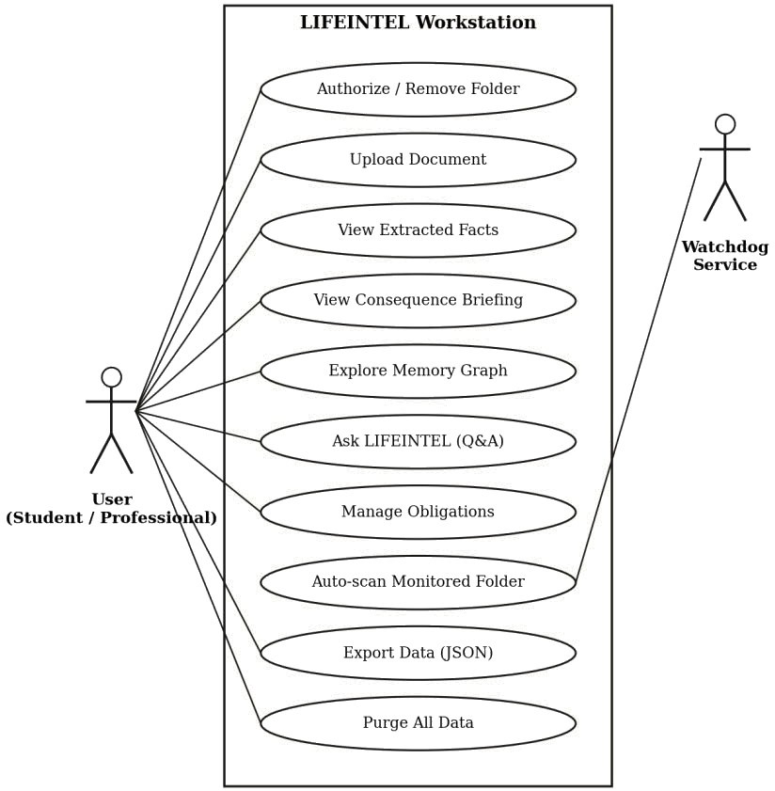

FIG 4.3 USE CASE DIAGRAM

    - CLASS DIAGRAM
A Source contains many Documents; each Document yields many Extracted Facts; successive versions produce Detected Changes; Obligations may originate from a Document; the Contextual Memory component indexes documents.
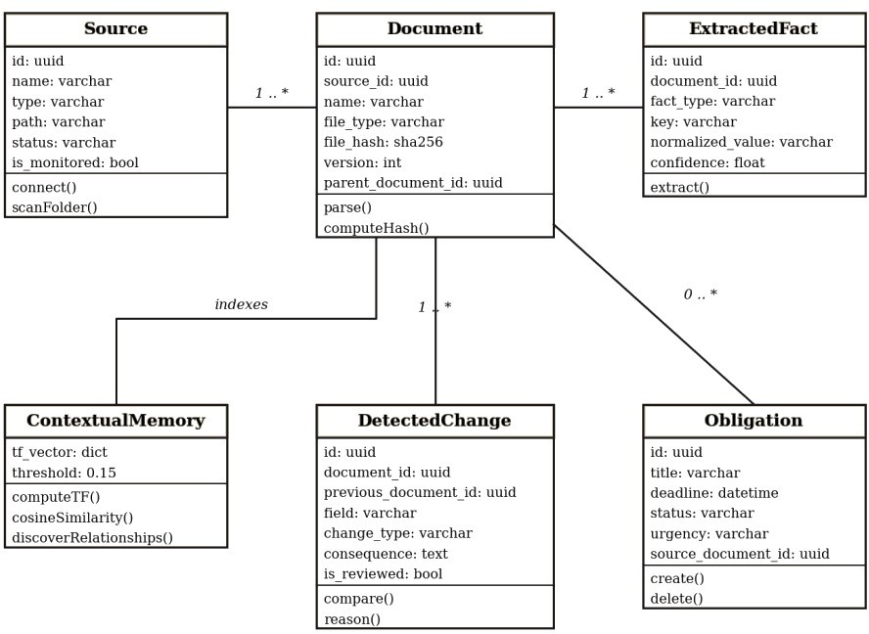

FIG 4.4 CLASS DIAGRAM

    - SEQUENCE DIAGRAM
The sequence diagram traces a document from the moment it is dropped in an approved folder to the moment the user is notified of a consequence.

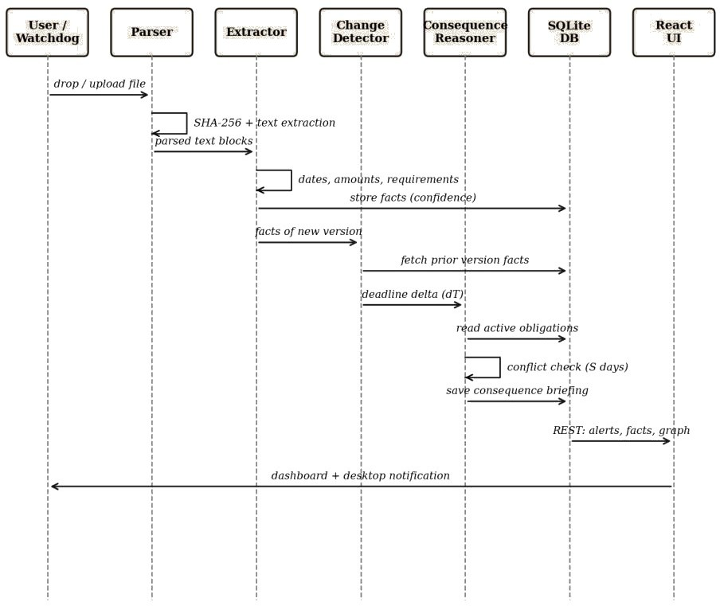

FIG 4.5 SEQUENCE DIAGRAM

NOTE TO STUDENT (delete before submission): Figure numbers: the data-flow list above is referred to as Fig 4.2 in the List of Figures. If you prefer, convert it to a small flow diagram and insert it as Fig 4.2.

MATHEMATICAL FORMULATIONS
- Temporal delta and shift
When a document version D₂ supersedes D₁, with deadlines T(D₂) and T(D₁), the shift is ΔT = T(D₂) − T(D₁). If ΔT < 0 the deadline moved earlier by |ΔT| days (urgency: critical). If ΔT > 0 it was extended (urgency: low).
Example: old deadline T(D₁) = 15 November, new deadline T(D₂) = 10 November.
ΔT = 10 − 15 = −5, so the deadline moved five days earlier and urgency is critical.

Consequence conflict condition
For an existing task P with scheduled date T(P), a conflict exists if T(P) > T(D₂). The shortfall is S = T(P) − T(D₂) days, and the suggested mitigation date is T(mitigation) = T(D₂)
– 2 days.
Example: the existing task “Resume draft” is planned for 12 November and the new deadline is 10 November. Since 12 > 10, there is a conflict; S = 12 − 10 = 2 days; the suggested mitigation date is 10 − 2 = 8 November.

Term-frequency cosine similarity
Each document is represented as a vector of term counts over the normalised vocabulary. The similarity between documents A and B is Similarity(A, B) = (A · B) / (‖A‖
‖B‖) [4]. A relationship is created when Similarity ≥ θ, with θ = 0.15.
Example: let the vocabulary be (internship, resume, deadline, fee). Document A = (2, 1, 1, 0) and Document B = (1, 0, 1, 1). A · B = 2×1 + 1×0 + 1×1 + 0×1 = 3. ‖A‖ = √(4+1+1)
= √6 ≈ 2.449 and ‖B‖ = √(1+0+1+1) = √3 ≈ 1.732. Similarity = 3 / (2.449 × 1.732) = 3 /
4.243 ≈ 0.707. Since 0.707 ≥ 0.15, the two documents are linked with weight 0.707.

TABLE 4.1 WORKED NUMERICAL EXAMPLES

Formula | Inputs | Result | Meaning
ΔT | T(D₁)=15 Nov, T(D₂)=10 Nov | −5 days | Deadline moved 5 days earlier
S | T(P)=12 Nov, T(D₂)=10 Nov | 2 days | Task is 2 days too late; suggest 8 Nov
Cosine | A=(2,1,1,0), B=(1,0,1,1) | ≈ 0.707 | Above θ = 0.15, so related

LEXICAL VERSUS SEMANTIC SIMILARITY
The Contextual Memory Engine uses term-frequency cosine similarity. This measures lexical overlap, that is, how many of the same words two documents share, weighted by how often they occur. It does not model meaning. Two documents that use the same words in different senses can score high, while two documents that express the same idea with different words (for example “deadline” and “last date to apply”) can score near zero. The edges in the Memory Explorer should therefore be read as “textually related” rather than “semantically equivalent”.
The word “semantic” in the project title refers to the extraction of meaningful facts (dates, amounts, obligations) and the comparison of those facts between versions, not to a learned semantic embedding. Sentence-embedding models such as BERT [1] could provide true semantic similarity and are proposed as future work (Section 9.2).

ALGORITHM DESCRIPTIONS
This section gives the step-by-step logic of the main processing stages in pseudocode.

Algorithm 1: Document ingestion pipeline
INPUT: file path p
- digest <- SHA256(bytes of p)
- IF digest exists in documents.file_hash THEN return DUPLICATE
- text, pages <- PARSE(p) // PyMuPDF / python-docx / plain read

- IF text is empty THEN return ERROR(unreadable)
- facts <- EXTRACT(text, pages) // dates, amounts, obligations
- doc <- STORE(document, facts)
- prev <- FIND_PREVIOUS_VERSION(doc) // shared title tokens
- IF prev exists THEN
changes <- COMPARE(prev.facts, doc.facts)
FOR each deadline change: briefing <- REASON(change, active obligations)
- UPDATE_MEMORY_GRAPH(doc)
- return doc, changes, briefings

Algorithm 2: Deadline extraction
INPUT: text blocks with page numbers FOR each block:
FOR each match of ISO_DATE or text-date pattern:
d <- NORMALISE(match) // YYYY-MM-DDTHH:MM:SS
C <- 0.95 if explicit ISO date else lower value for free-text date key <- NEAREST_TRIGGER_WORD(match) // e.g. application deadline SAVE fact(type=deadline, key, value, d, C, page)
FOR each match of AMOUNT pattern: SAVE fact(type=amount, ...) FOR each trigger phrase (must submit, mandatory, prerequisite):
SAVE fact(type=requirement, ...)
NOTE TO STUDENT (delete before submission): The confidence values (0.95 etc.) are examples. Replace them with the real scores your extractor assigns.

Algorithm 3: Term-frequency vector and cosine similarity
TF(text): tokens <- lowercase words, remove stop words return map token -> count
COS(A, B): dot <- sum over shared tokens of A[t] * B[t]
IF |A| = 0 OR |B| = 0 THEN return 0
return dot / (sqrt(sum A[t]^2) * sqrt(sum B[t]^2))
The time complexity of building the relationship graph is O(nZ · v) for n documents and an average of v distinct terms per document. This is acceptable for a personal collection of a few hundred documents; a larger collection would need an inverted index or approximate nearest-neighbour search.

DATABASE DESIGN
The database has seven tables: sources, documents, extracted_facts, entities, detected_changes, obligations and activity_logs. The main relationships are as follows.
- One source has many documents (documents.source_id references sources.id).
- One document has many extracted facts (extracted_facts.document_id).
- A document may point to its earlier version (documents.parent_document_id), forming a version chain.
- A detected change references both the new document and the baseline document.
- An obligation may reference the document it was extracted from (obligations.source_document_id); manual obligations leave this empty.

Deleting a source cascades to its documents and facts, so no orphan records remain. The UNIQUE constraint on file_hash enforces deduplication at the database level even if the application check is bypassed. The field-level definitions are given in Section 8.2.

SECURITY AND PRIVACY DESIGN
TABLE 4.2 SECURITY AND PRIVACY CONTROLS

Threat | Control in LIFEINTEL
Document content sent to a third party | No outbound calls in the processing pipeline; the Transparency Center shows the external-call counter.
Other machines reaching the API | FastAPI is bound to localhost (127.0.0.1) only.
Malicious script in the interface reaching the system | Electron context isolation, node integration disabled, and a minimal preload bridge.
Reading unapproved folders | Watchdog observes only folders the user has authorised; the user can remove a folder at any time.
Loss of control over stored data | One-click JSON export and permanent purge of all tables.
Corrupted or malicious files | Unsupported types are rejected; parse errors are caught and reported without stopping the service.
Limitation: the SQLite file is not encrypted in the current build, so protection against someone with access to the user’s operating-system account depends on the operating system. Database encryption is a possible enhancement.

USER INTERFACE DESIGN
The “Warm Minimal” design favours a clear information hierarchy and high density over decorative effects. Screens are designed for 1440 × 900 resolution, use a single typeface family, and use colour only to indicate meaning, for example urgency levels.

TABLE 4.3 USER INTERFACE SCREENS

Screen | Purpose | Main elements
Dashboard | Overview of what needs attention | Upcoming deadlines, critical alerts, recent documents
Sources | Manage approved folders | Add or remove folder, watchdog status, last sync
Document Library | Upload and review documents | Upload area, document list, extracted facts with confidence
Consequence Briefings | Understand the effect of a revision | Old and new value, shortfall in days, suggested date, mark as reviewed
Memory Explorer | See related documents | Node-and-edge graph with similarity weights

Screen | Purpose | Main elements
Ask LIFEINTEL | Question answering | Question box, answer, source citations
Transparency Center | Verify privacy and control data | Audit counters, database path, export, purge

CHAPTER 5 MODULE DESCRIPTION

LIFEINTEL has seven modules. Each is described below by its purpose, input, processing and output.

UNIVERSAL INGESTION AND DOCUMENT PARSER
Implemented in document_parser.py.

TABLE 5.1 UNIVERSAL INGESTION AND DOCUMENT PARSER – SPECIFICATION

Item | Description
Purpose | Convert any supported file into normalised text with metadata and a unique fingerprint.
Input | PDF, DOCX and TXT files, from upload or the watched folder.
Processing | Text extraction (PyMuPDF for PDF, python-docx for DOCX, direct read for TXT); SHA-256 hashing; page-offset recording; duplicate check against file_hash.
Output | Normalised text blocks with page numbers, file metadata and hash; a duplicate alert if the hash already exists.
Image files are not converted to text in the current build because no OCR engine is integrated. [[If you have integrated Tesseract or another OCR engine, replace this sentence with its name, version and tested accuracy.]]

STRUCTURED INFORMATION EXTRACTION ENGINE
Implemented in information_extractor.py.

TABLE 5.2 STRUCTURED INFORMATION EXTRACTION ENGINE – SPECIFICATION

Item | Description
Purpose | Turn text into structured facts: deadlines, amounts and obligations.
Input | Normalised text blocks from the parser.
Processing | Regular expressions with negative lookbehinds recognise ISO-8601 dates, currency amounts (₹, $, €, £, INR, USD) and trigger phrases such as “must submit”, “mandatory” and “prerequisite”. Dates are normalised to YYYY-MM-DDTHH:MM:SS. A confidence score C (0.0 ≤ C ≤ 1.0) reflects the certainty of the syntactic match.
Output | Rows in extracted_facts (type, key, value, normalised value, confidence, page number).

SEMANTIC CHANGE DETECTOR AND CONSEQUENCE REASONER
Implemented in change_detector.py, consequence_reasoner.py.

TABLE 5.3 SEMANTIC CHANGE DETECTOR AND CONSEQUENCE REASONER – SPECIFICATION

Item | Description
Purpose | Find what changed between versions and what the change means for the user’s tasks.
Input | Facts of the new document, facts of the earlier version, active obligations from SQLite.
Processing | Locate the earlier version by shared title tokens; compare facts to find deadline shifts, modified attributes and newly added requirements; compute ΔT; compare the new deadline with each obligation date; compute shortfall S and mitigation date.
Output | Detected-change records and a natural-language consequence briefing with urgency level.

CONTEXTUAL MEMORY AND ASSOCIATIVE KNOWLEDGE GRAPH
Implemented in contextual_memory.py.

TABLE 5.4 CONTEXTUAL MEMORY AND ASSOCIATIVE KNOWLEDGE GRAPH – SPECIFICATION

Item | Description
Purpose | Show how documents relate without manual tagging.
Input | Text and extracted entities of all indexed documents.
Processing | Entity extraction (institutions, programs, skills, certifications); TF vector per document; pairwise cosine similarity; edge created when similarity ≥ 0.15.
Output | Graph of document nodes and weighted edges, shown in the Memory Explorer.

PROACTIVE FOLDER WATCHDOG SERVICE
Implemented in folder_monitor.py.

TABLE 5.5 PROACTIVE FOLDER WATCHDOG SERVICE – SPECIFICATION

Item | Description
Purpose | Ingest new files automatically from folders the user has approved.
Input | File-system events (create, modify) in approved folders.
Processing | Python watchdog (ReadDirectoryChangesW on Windows); 1.5 s debounce so half-written files are not read; queue for the background pipeline.
Output | Files queued and processed; source status and last-sync time updated.

TRANSPARENCY AND DATA SOVEREIGNTY AUDIT CENTER
Implemented in TransparencyCenter.tsx.

TABLE 5.6 TRANSPARENCY AND DATA SOVEREIGNTY AUDIT CENTER – SPECIFICATION

Item | Description
Purpose | Let the user verify privacy and control their data.
Input | User actions (view audit, export, purge) and database statistics.
Processing | Displays the external-call counter and database path; serialises all tables to JSON; deletes all rows from all tables on confirmed purge.
Output | Audit metrics, a JSON export file, or an emptied database.

NATURAL LANGUAGE WORKSTATION QUERY ENGINE
Implemented in AskLifeintel.tsx.

TABLE 5.7 NATURAL LANGUAGE WORKSTATION QUERY ENGINE – SPECIFICATION

Item | Description
Purpose | Answer questions about the user’s documents locally.
Input | A question such as “What deadlines are approaching?” or “What changed in the internship notice?”
Processing | The question is mapped to queries over stored facts, obligations and changes; the answer is composed only from retrieved records, in the spirit of retrieval-augmented generation [5]. [[State whether the LLM is used to phrase the answer.]]
Output | An answer with citations to the source document and page. Because answers come from stored records, unsupported statements are avoided.

CHAPTER 6 SYSTEM IMPLEMENTATION

NOTE TO STUDENT (delete before submission): This chapter was expanded using your design. Snippets marked “illustrative” are reconstructed from the described behaviour. Replace each with the matching lines from your repository, and make the endpoint table match your real routes (open http://localhost:8000/docs to see them).

DEVELOPMENT ENVIRONMENT AND SETUP
Development was done on Windows 11 using Visual Studio Code. The backend runs in a Python virtual environment; the frontend is installed with npm.
# backend
python -m venv .venv && .venv\Scripts\activate pip install -r requirements.txt
uvicorn app.main:app --host 127.0.0.1 --port 8000

# frontend / desktop npm install
npm run dev # Vite + Electron

# tests pytest -v

FRONTEND (REACT AND TYPESCRIPT)
The interface has seven screens (Dashboard, Sources, Documents, Consequence Briefings, Memory Explorer, Ask LIFEINTEL, Transparency Center). Each screen is a typed React component that calls the REST API and renders the result with Tailwind CSS using the Warm Minimal colour tokens.
// illustrative
export async function getObligations(): Promise<Obligation[]> { const res = await fetch('http://127.0.0.1:8000/api/obligations'); if (!res.ok) throw new Error('Failed to load obligations'); return res.json();
}

ELECTRON MAIN PROCESS AND PRELOAD
The main process creates the 1440 × 900 frameless window, starts or connects to the local FastAPI service, and provides the tray icon and notifications. The preload script exposes only a small, named set of functions to the renderer through contextBridge, with contextIsolation enabled and nodeIntegration disabled.
// illustrative
const win = new BrowserWindow({ width: 1440, height: 900, frame: false, webPreferences: { preload: path.join( dirname, 'preload.js'),
contextIsolation: true, nodeIntegration: false } });
// preload.js contextBridge.exposeInMainWorld('lifeintel', {

openPath: (p) => ipcRenderer.invoke('shell:openPath', p), notify: (t, b) => ipcRenderer.invoke('notify', t, b),
});

FASTAPI BACKEND AND API ENDPOINTS TABLE 6.1 REST API ENDPOINTS
Method | Endpoint | Purpose
GET | /api/health | Health and database connectivity check
POST | /api/documents/upload | Upload and process a document
GET | /api/documents | List documents and extracted facts
GET | /api/changes | List detected changes and briefings
GET / POST / DELETE | /api/obligations | Read, add and delete obligations
GET / POST / DELETE | /api/sources | Authorise, list and remove monitored folders
GET | /api/memory/graph | Document nodes and weighted edges
POST | /api/query | Ask a question; returns answer and citations
GET | /api/transparency/export | Export all data as JSON
DELETE | /api/transparency/purge | Delete all stored data

NOTE TO STUDENT (delete before submission): The routes above are placeholders matching the described functionality; correct them to your actual routes.
Example exchange (illustrative):
POST /api/documents/upload (multipart: file=Notice_Updated.pdf)
200 OK
{ "document_id": "3f2a...", "duplicate": false,
"facts": [{"fact_type": "deadline", "normalized_value": "2026-11-10T23:59:59", "confidence": 0.95}],
"changes": [{"field": "application_deadline", "change_type": "deadline_change",
"consequence": "Resume draft (12 Nov) is 2 days after the new
deadline."}] }

SQLITE DATABASE INTEGRATION
SQLAlchemy models map to the tables in Chapter 8. The file_hash column has a UNIQUE constraint, which provides a database-level guarantee against duplicate indexing. Foreign keys cascade on delete so removing a source or document leaves no orphan facts.
# illustrative
class Document(Base):
tablename = 'documents'
id = Column(String(36), primary_key=True, default=lambda: str(uuid4())) file_hash = Column(String(64), unique=True, nullable=False)
facts = relationship('ExtractedFact', cascade='all, delete-orphan')

DOCUMENT INGESTION
# illustrative
def sha256_of(path):
h = hashlib.sha256()
with open(path, 'rb') as f:
for chunk in iter(lambda: f.read(1 << 20), b''): h.update(chunk)
return h.hexdigest()

if db.query(Document).filter_by(file_hash=digest).first(): return {'duplicate': True}

INFORMATION EXTRACTION
Dates and amounts are found with compiled regular expressions; the matched text is normalised and stored with a confidence value. Explicit ISO dates receive a higher confidence than free-text dates.
# illustrative
ISO_DATE = re.compile(r'(?<![\d-])(\d{4})-(\d{2})-(\d{2})(?![\d-])') AMOUNT = re.compile(r'(?:₹|\$|€|£|INR|USD)\s?\d[\d,]*(?:\.\d+)?')

CHANGE DETECTION AND CONSEQUENCE REASONING
The change detector finds an earlier version by title tokens, compares the two fact sets and passes any deadline pair to the reasoner. The reasoner (below) computes ΔT and checks each active task.
def reason_deadline_change(old_deadline_str, new_deadline_str, existing_tasks=None):
old_dt = parse_iso_or_text(old_deadline_str) new_dt = parse_iso_or_text(new_deadline_str) delta_days = (new_dt - old_dt).days
if delta_days < 0:
shift_type, urgency = 'moved_earlier', 'critical'
summary = f'Deadline was moved forward by {abs(delta_days)} days.' else:
shift_type, urgency = 'extended', 'low'
summary = f'Deadline was extended by {delta_days} days.' conflicts = []
for task in existing_tasks or []:
t_dt = parse_iso_or_text(task.get('deadline')) if t_dt and t_dt > new_dt:
conflicts.append({'task_title': task.get('title'), 'task_deadline': task.get('deadline'), 'conflict_gap_days': (t_dt - new_dt).days, 'mitigation': f"Complete '{task.get('title')}' before "
f"{new_dt.strftime('%B %d')}."}) return {'shift_type': shift_type, 'delta_days': delta_days,
'urgency': urgency, 'summary': summary, 'conflicts': conflicts}

CONTEXTUAL MEMORY
def discover_relationships(documents):
vecs = [compute_tf_vector(d['text']) for d in documents] rels = []
for i in range(len(documents)):
for j in range(i + 1, len(documents)):
sim = cosine_similarity(vecs[i], vecs[j]) if sim >= 0.15:

rels.append({'source': documents[i]['name'],
'target': documents[j]['name'], 'strength': round(sim, 3), 'connection_type': 'lexical_affinity'})
return rels
NOTE TO STUDENT (delete before submission): The original code labels edges “semantic_affinity”. I changed the label to “lexical_affinity” to match Section 4.4. If you keep the old label in your code, change it back here, or rename it in the code so both agree.

FOLDER MONITORING
# illustrative
class DropHandler(FileSystemEventHandler): def on_created(self, event):
if not event.is_directory: debounce_queue.push(event.src_path, delay=1.5)
observer = Observer(); observer.schedule(DropHandler(), approved_path); observer.start()

NATURAL LANGUAGE QUERY
The query endpoint classifies the question (for example upcoming deadlines, recent changes, or a document lookup), runs the matching database query and returns the records with their document names and page numbers as citations. [[Add the real intent-matching method you used.]]

DATA EXPORT AND DELETION
# illustrative @router.get('/transparency/export')
def export_all(db): return {t.name: [row_to_dict(r) for r in db.query(t).all()] for t in TABLES} @router.delete('/transparency/purge')
def purge(db):
for t in reversed(TABLES): db.query(t).delete() db.commit()

CHAPTER 7 SYSTEM TESTING

UNIT TESTING
Unit tests use pytest and the Starlette TestClient. The unit test cases are listed in Table
7.1.

TABLE 7.1 UNIT TEST CASES

ID | Test | Objective | Expected result | Status
UT-01 | test_health_check | System health and SQLite connectivity | HTTP 200, healthy, database true | [[from  run]]
UT-02 | test_parse_and_extract_pdf | Extract text and facts from a synthetic PDF | ISO dates and requirements extracted | [[from  run]]
UT-03 | test_parse_and_extract_docx | Extract paragraphs from a DOCX | Skills and milestones parsed | [[from  run]]
UT-04 | test_duplicate_upload_detection | Upload identical file twice | Duplicate alert; second index rejected | [[from  run]]
UT-05 | test_deadline_moved_earlier | 15 Nov → 10 Nov with a 12 Nov task | 2-day shortfall; urgency critical | [[from  run]]
UT-06 | test_deadline_extended | 15 Nov → 25 Nov | Delta +10 days; urgency low | [[from  run]]
UT-07 | test_requirement_addition | Notice adds a GitHub portfolio link | Revision alert generated | [[from  run]]
UT-08 | test_source_create_and_delete | Authorise and delete a folder | Row added and cascaded cleanly | [[from  run]]
UT-09 | test_obligation_create_and_dele te | Add and delete a milestone | Record removed, no orphans | [[from  run]]
UT-10 | test_proactive_folder_monitor | Start and stop watchdog threads | Clean lifecycle, no deadlock | [[from  run]]

INTEGRATION TESTING
TABLE 7.2 INTEGRATION TEST CASES

ID | Scenario | Modules | Expected outcome | Status
IT-01 | Multi-document consequence pipeline | Upload API, Parser, Extractor, Reasoner | Notice_Updated.pdf creates a critical alert against Resume_Draft.docx | [[from  run]]
IT-02 | Contextual memory graph | Extractor, Memory Engine, Explorer UI | Nodes and edges with cosine weights | [[from  run]]
IT-03 | Transparency purge cascade | Transparency API, SQLite, UI | All 7 tables purged; no residue | [[from  run]]
IT-04 | Electron IPC lifecycle | Main, Preload, FastAPI, React | Window opens at 1440×900, no port collision | [[from  run]]

NOTE TO STUDENT (delete before submission): Tables 7.1 and 7.2 list 14 tests, but the report claims 23. Add the missing 9 test names (the old claim cannot stay unless all 23 are listed), or change the number to match the tests in your suite. Run `pytest -v` and paste the real PASS/FAIL results.

ROBUSTNESS AND NEGATIVE TESTING
The following scenarios must be executed and their actual results recorded before submission.

TABLE 7.3 ROBUSTNESS AND NEGATIVE TEST CASES

ID | Scenario | Expected behaviour | Result
NT-01 | Invalid or corrupted PDF / empty file | Clear error returned; no crash; nothing indexed | [[run]]
NT-02 | Unsupported file type (e.g. .exe) | Rejected with a message | [[run]]
NT-03 | Duplicate document (same bytes, different name) | Detected via SHA-256; not stored twice | [[run]]
NT-04 | Ambiguous date (e.g. 03/04/2026) or two conflicting deadlines | Lower confidence or both facts stored; no wrong conflict alert | [[run]]
NT-05 | Document with no dates | Zero deadline facts; no false alert | [[run]]
NT-06 | Large document (e.g. 200+ pages) | Completes; record time and memory | [[run]]
NT-07 | Folder without read permission | Error logged and shown; watcher keeps running | [[run]]
NT-08 | Database unavailable or locked | Error reported; no data corruption | [[run]]
NT-09 | Network disabled (offline) | All features work | [[run]]
NT-10 | Half-written file during copy | Debounce prevents reading partial file | [[run]]

PERFORMANCE BENCHMARKS
TABLE 7.4 BENCHMARK DATASET DESCRIPTION

Item | Value
Number of documents | [[10]]
Composition | [[e.g. 4 PDF, 3 DOCX, 3 TXT; synthetic or real; number of deadlines in total]]
Ground truth | [[how deadlines were labelled, e.g. manually by the author before running the extractor]]
Matching rule | [[e.g. an extracted deadline is a TP only if the normalised date equals the labelled date]]
Script | backend/tests/test_evaluation_benchmark.py
Results on this dataset: Precision = TP / (TP + FP) = [[10 / (10 + 0)]] = [[1.00]]; Recall
= TP / (TP + FN) = [[10 / (10 + 0)]] = [[1.00]]; F1 = 2PR / (P + R) = [[1.00]].

Interpretation: a score of 1.00 on ten documents shows that the extractor handled every case in this set correctly. It is not evidence of universal accuracy. A larger and more varied set, including messy real circulars, would be expected to produce errors.
Latency: the mean figure of [[3.15 ms]] per document was measured on an AMD Ryzen 5 PRO 8640HS CPU and covers [[only the extraction algorithm applied to already-parsed text, averaged over N runs]]. It does not include file reading, PDF parsing, database writes, or any local LLM inference. [[Measure and add end-to-end ingestion time per document for comparison.]]
Consequence conflict detection: the reported [[100%]] means that the conflict decision and shortfall matched the expected value in [[x]] of [[y]] test scenarios. State y; with few scenarios this is a correctness check, not a measured accuracy.

TEST EXECUTION EVIDENCE

[[ Insert real screenshot: terminal showing `pytest -v` with the number of tests passed, failed and skipped ]]

FIGURE 7.1 PYTEST OUTPUT

  - END-TO-END CASE STUDY
This scenario traces one revision through the whole pipeline. It follows the same numbers as test cases UT-05 and IT-01, so the expected values can be reproduced.

TABLE 7.5 CASE STUDY TRACE

Stage | Input | Result
1. Existing task | Manual obligation: “Resume draft”, 12 Nov 2026 | Stored in obligations
2. First upload | Notice_Original.pdf: application deadline 15 Nov 2026, fee ₹500 | Version 1 stored; deadline and amount facts saved

Stage | Input | Result
3. Second upload | Notice_Updated.pdf: deadline 10 Nov 2026, adds a GitHub portfolio link | Different SHA-256, so a new document; title tokens match, so it is version 2 with parent = version 1
4. Change detection | Facts of version 1 and 2 | Deadline change 15 Nov → 10 Nov; requirement added (GitHub link)
5. Delta | ΔT = 10 − 15 | −5 days: moved earlier, urgency critical
6. Conflict check | T(P) = 12 Nov > T(D₂) = 10 Nov | Conflict; shortfall S = 2 days
7. Briefing | Mitigation = 10 Nov − 2 days | “Complete ‘Resume draft’ before November 08.” saved in detected_changes
8. Display | REST query by the dashboard | Critical alert and desktop notification shown to the user
Uploading Notice_Updated.pdf a second time produces a duplicate alert and no new records, which demonstrates the deduplication path (UT-04). Uploading a notice whose new deadline is later than every task date produces an “extended” briefing with low urgency and no conflict (UT-06).

[[ Insert real screenshot: the consequence briefing for Notice_Updated.pdf showing the 2-day shortfall ]]

FIGURE 7.2 CASE STUDY RESULT

  - RESULTS AND DISCUSSION
The results are discussed below under the project objectives of Section 1.4.
    - O1 – Local-only processing: [[Report the measured number of outbound connections observed during testing, ideally 0, and how it was measured.]]
    - O2 – Ingestion and deduplication: [[State how many files of each type were parsed successfully, and any failures from NT-01 and NT-02.]]

    - O3 – Extraction: [[State precision, recall and F1 with the dataset size from Table 7.4.]] Because the benchmark is small, the figures describe the test set only.
    - O4 – Consequence reasoning: [[State the number of scenarios and how many produced the expected shortfall.]] The rule is deterministic, so the reasoner’s result depends mainly on whether the extractor found the correct dates.
    - O5 – Memory graph: Edges represent shared vocabulary. Documents on the same topic that use different wording may not be linked, as explained in Section 4.4.
    - O6 – Monitoring: [[State the observed delay between copying a file into the folder and its appearance in the library.]]
    - O7 – Data control: [[Confirm that export produced valid JSON and that purge left all tables empty (IT-03).]]

OBSERVATIONS
    - Because the reasoner is rule based, every alert can be traced to the two dates that caused it; this makes errors easy to diagnose.
    - Most errors are expected to come from extraction, since the rest of the chain is arithmetic on the extracted dates.
    - The system raises alerts but never edits tasks, so a wrong alert costs the user a few seconds of checking rather than a wrong change.

THREATS TO VALIDITY
    - Small benchmark with documents prepared by the author.
    - Tested on one machine and one operating system.
    - Ambiguous date formats (for example 03/04/2026) may be misread without regional context.

CHAPTER 8 APPENDICES

SCREENSHOTS
NOTE TO STUDENT (delete before submission): Run the real application and capture each screen at 1440 × 900. Screenshots are required evidence of the working system.

[[ Insert real screenshot: dashboard with upcoming deadlines and alerts ]]

FIG 8.1 DASHBOARD

[[ Insert real screenshot: approved folders and watchdog status ]]

FIG 8.2 SOURCES AND FOLDER MONITORING

[[ Insert real screenshot: uploaded documents with extracted facts ]]

FIG 8.3 DOCUMENT LIBRARY AND UPLOAD

[[ Insert real screenshot: detected change with consequence alert ]]

FIG 8.4 CONSEQUENCE BRIEFING

[[ Insert real screenshot: relationship graph with cosine weights ]]

FIG 8.5 MEMORY EXPLORER

[[ Insert real screenshot: question answered with source citations ]]

FIG 8.6 ASK LIFEINTEL

[[ Insert real screenshot: audit metrics, export and purge controls ]]
FIG 8.7 TRANSPARENCY CENTER

  - DATA DICTIONARY
TABLE 8.1 SOURCES

Field | Type | Constraint | Description
id | VARCHAR(36) | PRIMARY KEY | UUID
name | VARCHAR(255) | NOT NULL | Source folder name
type | VARCHAR(50) | NOT NULL | folder, email, calendar
path | VARCHAR(1024) | NULLABLE | Local path
status | VARCHAR(50) | NOT NULL | connected, disconnected
is_monitored | BOOLEAN | NOT NULL | Watchdog active
item_count | INTEGER | DEFAULT 0 | Indexed documents
last_sync_at | DATETIME | NULLABLE | Last scan (UTC)

TABLE 8.2 DOCUMENTS

Field | Type | Constraint | Description
id | VARCHAR(36) | PRIMARY KEY | UUID
source_id | VARCHAR(36) | FOREIGN KEY | Parent source
name | VARCHAR(255) | NOT NULL | File name
file_type | VARCHAR(20) | NOT NULL | pdf, docx, txt
file_size | INTEGER | NOT NULL | Bytes
file_hash | VARCHAR(64) | UNIQUE, NOT NULL | SHA-256
file_path | VARCHAR(1024  ) | NOT NULL | Absolute path
version | INTEGER | DEFAULT 1 | Lineage version
parent_document_id | VARCHAR(36) | FOREIGN KEY | Previous revision

TABLE 8.3 EXTRACTED FACTS

Field | Type | Constraint | Description
id | VARCHAR(36) | PRIMARY KEY | UUID
document_id | VARCHAR(36) | FOREIGN KEY | Source document
fact_type | VARCHAR(50) | NOT NULL | deadline, amount, requirement
key | VARCHAR(100) | NOT NULL | Normalised descriptor
value | TEXT | NOT NULL | Raw snippet
normalized_value | VARCHAR(255) | NULLABLE | e.g. 2026-11-10T23:59:59
confidence | FLOAT | NOT NULL | Match certainty 0.0–1.0
page_number | INTEGER | DEFAULT 1 | Page of origin

TABLE 8.4 OBLIGATIONS

Field | Type | Constraint | Description
id | VARCHAR(36) | PRIMARY KEY | UUID
title | VARCHAR(255) | NOT NULL | Action title
description | TEXT | NULLABLE | Requirement detail
deadline | DATETIME | NULLABLE | Target date (UTC)
status | VARCHAR(50) | DEFAULT  'upcoming' | upcoming, in_progress, completed
urgency | VARCHAR(20) | DEFAULT 'medium' | critical, high, medium, low
category | VARCHAR(50) | DEFAULT  'academic' | academic, financial, personal
source_document_i d | VARCHAR(36) | FOREIGN KEY | Origin document

TABLE 8.5 DETECTED CHANGES

Field | Type | Constraint | Description
id | VARCHAR(36) | PRIMARY KEY | UUID
document_id | VARCHAR(36) | FOREIGN KEY | New version
previous_document_id | VARCHAR(36) | FOREIGN KEY | Baseline version
field | VARCHAR(100) | NOT NULL | Property altered
previous_value | TEXT | NULLABLE | Old value
new_value | TEXT | NULLABLE | New value
change_type | VARCHAR(50) | NOT NULL | deadline_change, requirement_add
consequence | TEXT | NOT NULL | Impact briefing
is_reviewed | BOOLEAN | DEFAULT FALSE | User acknowledged

CHAPTER 9
CONCLUSION AND FUTURE ENHANCEMENT

CONCLUSION
LIFEINTEL demonstrates that a useful personal intelligence tool can run entirely on a local machine. It combines offline PDF, DOCX and TXT parsing, rule-based fact extraction, lexical TF cosine similarity and deterministic temporal reasoning to detect deadline revisions, warn about scheduling collisions and keep data under the user’s control. On the internal benchmark the extractor handled all test documents correctly, and the measured extraction time was a few milliseconds per document. These results come from a small test set; broader validation is needed before general accuracy claims can be made.

LIMITATIONS
    - Scanned images are not converted to text (no OCR engine integrated).
    - Similarity is lexical, not semantic.
    - Extraction is rule based and may miss unusual date wording.
    - Evaluation used a small benchmark; Windows is the only tested platform.

FUTURE ENHANCEMENT
    - OCR: Integrate an offline OCR engine (for example Tesseract) to read scanned notices.
    - Semantic embeddings: Replace TF vectors with local sentence-embedding models such as BERT-based encoders [1] for true semantic similarity.
    - Whisper audio intelligence: Transcribe lectures and voice notes with an on-device Whisper model [2] and extract obligations from them.
    - Calendar synchronisation: Synchronise obligations with Google or Outlook calendars through local CalDAV / Exchange bridges.
    - Graph visualisation: Move the Memory Explorer to an interactive WebGL graph.
    - Larger evaluation: Evaluate on a larger, real-world corpus and extend the temporal reasoning with interval relations [6].

REFERENCES

- J. Devlin, M. W. Chang, K. Lee, and K. Toutanova, “BERT: Pre-training of Deep Bidirectional Transformers for Language Understanding,” in Proc. NAACL, Minneapolis, MN, USA, 2019, pp. 4171–4186.
- A. Radford, J. W. Kim, T. Xu, G. Brockman, C. McLeavey, and I. Sutskever, “Robust Speech Recognition via Large-Scale Weak Supervision,” in Proc. ICML, Honolulu, HI, USA, 2023, pp. 28492–28518.
- H. Touvron et al., “LLaMA: Open and Efficient Foundation Language Models,” arXiv:2302.13971, 2023.
- G. Salton, A. Wong, and C. S. Yang, “A Vector Space Model for Automatic Indexing,” Communications of the ACM, vol. 18, no. 11, pp. 613–620, Nov. 1975.
- P. Lewis et al., “Retrieval-Augmented Generation for Knowledge-Intensive NLP Tasks,” in Proc. NeurIPS, 2020, pp. 9459–9474.
- J. F. Allen, “Maintaining Knowledge about Temporal Intervals,” Communications of the ACM, vol. 26, no. 11, pp. 832–843, Nov. 1983.

