HIGH-LEVEL DESIGN / SYSTEM ARCHITECTURE
SENTINEL GUJARAT
Vehicle Intelligence & License Plate Review System
Document Status: PROTOTYPE ARCHITECTURE — Version 2.2
Classification: Engineering Design Reference
Audience: Technical hackathon jury · AI/ML engineers · Systems architects · Technical reviewers
Central Engineering Statement
Sentinel converts authorised camera observations into vehicle and plate-reading candidates by processing video at the edge, tracking vehicles and combining OCR evidence across frames. A rule-based gate controls whether masked candidate metadata enters central event processing. Gate acceptance is not ground-truth verification; operators review any resulting alert.

Contents
- Part I — System Purpose: 1 Executive Summary · 2 Problem Definition · 3 Design Goals and Non-Goals
- Part II — System Architecture: 4 System Context · 5 High-Level Architecture · 6 End-to-End Data Flow · 7 Trust Boundaries and Data Lifecycle
- Part III — Edge Intelligence: 8 Edge Pipeline · 9 Detection and Tracking · 10 Plate Localisation and OCR · 11 Multi-Frame Fusion · 12 Acceptance Gate
- Part IV — Central Intelligence: 13 Secure Event Delivery · 14 Central Processing · 15 Watchlist Matching · 16 Operator Workflow
- Part V — Reliability, Security and Privacy: 17 Failure Handling · 18 Security · 19 Privacy · 20 Observability
- Part VI — Validation: 21 Strategy · 22 Current Evidence · 23 Current vs Experimental · 24 Known Limitations
- Part VII — Scale and Roadmap: 25 Edge Capacity · 26 Regional Architecture · 27 Validation Roadmap · 28 Final System Position

PART I — SYSTEM PURPOSE

1. Executive Summary
This document describes an edge-to-central vehicle-intelligence prototype for authorised camera feeds. It analyses video near the camera, tracks vehicles and assembles plate-reading candidates across frames. A rule-based acceptance gate controls which masked candidate metadata can enter central alert processing. Passing the gate is not proof that a plate identity is correct. Operators review alerts; the prototype does not make enforcement decisions.
Production edge path: Video is decoded and sampled using video timestamps. YOLOv8n detects vehicles; ByteTrack maintains per-vehicle tracks; YOLOv9-Tiny-512 localises plate regions; FastALPR CCT-S v2 generates OCR candidates. Rule-based multi-frame evidence fusion ranks candidates for an acceptance gate. PASS means only that configured rules accepted a candidate, not that ground truth confirms the plate. The cited live tests produced zero accepted plate IDs.
Central and operator path: The production worker masks a gate-passing candidate, creates a keyed identifier and stores a durable event in the SQLite outbox before sending minimised metadata to FastAPI. Central services deduplicate events, store metadata in PostgreSQL (with the PostGIS extension enabled), compare keyed identifiers with a synthetic demonstration watchlist and push any match as a clearly labelled demo alert over WebSocket. Synthetic alerts use the same dashboard queue. An authorised on-demand live preview follows a separate MediaMTX video path; it is not included in the event payload and is not recorded.
Human: Operators review, investigate, acknowledge and resolve events. An audit trail records operator actions.
Current status: The production worker, central workflow and both user interfaces have been exercised. The cited short opt-in live-camera windows produced zero accepted plate IDs; they do not establish recognition accuracy. Capacity beyond the two selected AI feeds is unmeasured.
Next step: Build a rights-cleared, ground-truthed Indian plate dataset; measure candidate coverage and recognition performance; calibrate the acceptance gate; benchmark edge capacity; and validate authorised operation.

1.1 System at a Glance
AUTHORISED CAMERA
↓ RTSP / HLS
EDGE PROCESSING Decode → Sample → Detect → Track
↓
PLATE INTELLIGENCE Localise → OCR → Multi-frame Fusion
↓
ACCEPTANCE GATE ── ABSTAIN ──▶ Diagnostic Console
│ PASS
↓
Mask + Key → SQLite Outbox → FastAPI → Deduplication
↓
PostgreSQL/PostGIS → Watchlist Match → WebSocket → Operator

Core principle: Process video at the edge, transmit only gate-accepted masked candidate metadata through event ingestion, and never describe a model-accepted candidate as a verified plate identity.

2. Problem Definition
Control-room challenge | Engineering consequence
Multiple continuous camera feeds | Video volume exceeds manual review capacity
Vehicle identification in stream | Frame-by-frame manual inspection is not scalable
Plate localisation on moving targets | Single-frame crops are frequently noisy, blurred or occluded
Uncertain or partial OCR readings | Single-frame confidence is insufficient for reliable identification
Network interruptions between edge and centre | Events may be lost without durable delivery
Duplicate events from slow-moving vehicles | Database and alert quality degrade without deduplication
Watchlist investigation | Unstructured video cannot be directly searched
Operator cognitive overload | Unfiltered alerts reduce investigative effectiveness
Audit and oversight requirement | Automated actions without human review are operationally unacceptable

Design response: Process video at the source. Build per-vehicle track identities and accumulate OCR evidence across frames before a production acceptance decision. Deliver only gate-accepted, masked and keyed event metadata through event ingestion. Keep operators in the decision loop, and keep any authorised live preview separate from event ingestion and recording.

3. Design Goals and Non-Goals

3.1 Design Goals
# | Goal | Rationale
G1 | Edge-first video processing | Prevents raw video from saturating the central network
G2 | Track-level evidence accumulation | Treats vehicles as persistent objects across time, not isolated frames
G3 | Multi-frame OCR fusion | Combines repeated observations to improve candidate ranking
G4 | Fail-closed acceptance gate | Abstention rather than forced identification when evidence is insufficient
G5 | Durable event delivery | SQLite outbox tolerates temporary connectivity loss
G6 | Deduplication at ingestion | Prevents duplicate alerts from slow-moving vehicles
G7 | Data minimisation | Central platform operates on metadata, not raw video
G8 | Human-in-the-loop review | Consequential operational actions remain subject to operator review
G9 | Auditability | Operator actions and system events are recorded
G10 | Strict current/experimental separation | No unvalidated model enters the live pipeline

3.2 Non-Goals
The current prototype does not claim:
- Verified live plate-recognition accuracy
- Universal Indian plate recognition under all conditions
- Autonomous law-enforcement or operational decisions
- Continuous raw-video recording or centralised storage
- Validated capacity for large-scale deployment
- Calibrated confidence scores on plate candidates
- Regional-scale production deployment readiness
- Benchmark-class precision, recall or F-score on live data
These are explicitly deferred to the validation roadmap (§27).

PART II — SYSTEM ARCHITECTURE

4. System Context
How Sentinel sits between authorised camera infrastructure and human operators.
Boundary principle: The event-ingestion path transmits only gate-accepted, masked and keyed metadata; it does not carry raw video. Separately, an authorised on-demand preview can relay live video to an operator, but it is not stored or included in event records.

5. High-Level Architecture
The system is structured across four trust zones.
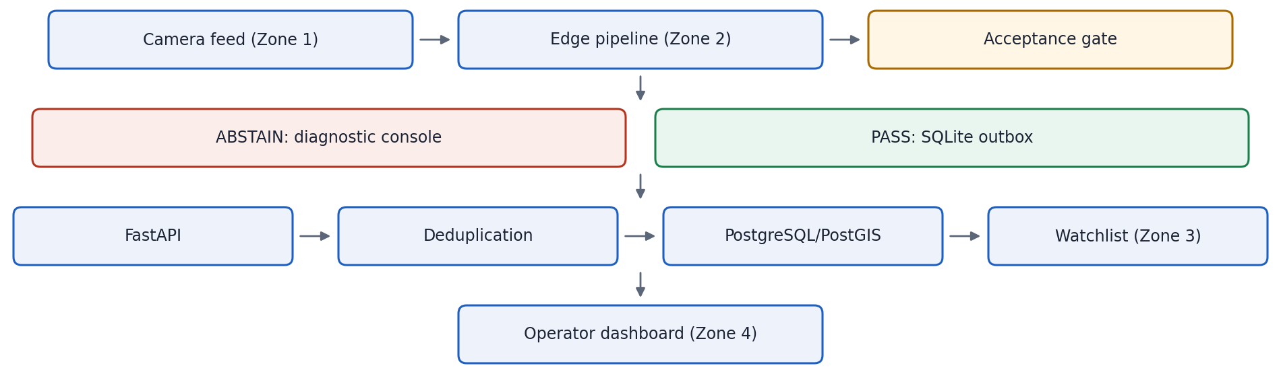

6. End-to-End Data Flow
The complete data path from camera input to operator action. Each stage is listed once; see Parts III and IV for detail.
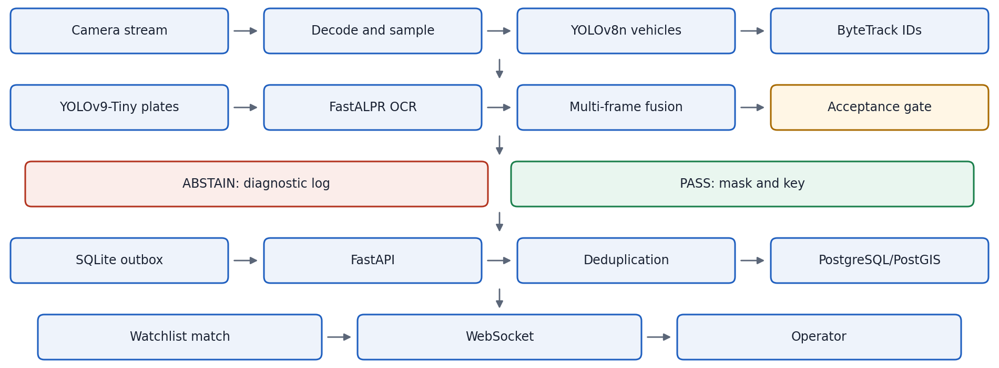
Production worker and diagnostic console are separate paths. Production uses YOLOv8n, ByteTrack, YOLOv9-Tiny-512, FastALPR CCT-S v2, rule-based multi-frame fusion and a gate. The opt-in engineering console uses YOLO26s, ByteTrack, the parent YOLOv9-Tiny plate detector and adapted Awiros CTC OCR. When sufficient distinct crops are available, the diagnostic path applies checked ECC alignment and native-grid reconstruction; this is geometric alignment, not learned super-resolution, and does not add independent OCR evidence. The diagnostic path does not replace production models.

7. Trust Boundaries and Data Lifecycle

7.1 Trust Zone Summary
Zone | Boundary | Contents | Exits as
1 — Camera | Physical camera infrastructure | Raw video stream | RTSP / HLS stream
2 — Edge | Edge compute node | Decoded frames, AI inference, tracking state, OCR evidence, fusion state | Gate-accepted masked/keyed metadata via event API; separate authorised preview relay only when requested
3 — Central | Central server | Event metadata, synthetic demo watchlist and operator state; no stored video or genuine crops | WebSocket alerts; separate preview is available only through the authorised media relay
4 — Operator | Dashboard client | Alert queue, masked candidate context, operator actions and optional live preview | Acknowledge / resolve action; preview is not retained as evidence

7.2 Data Lifecycle
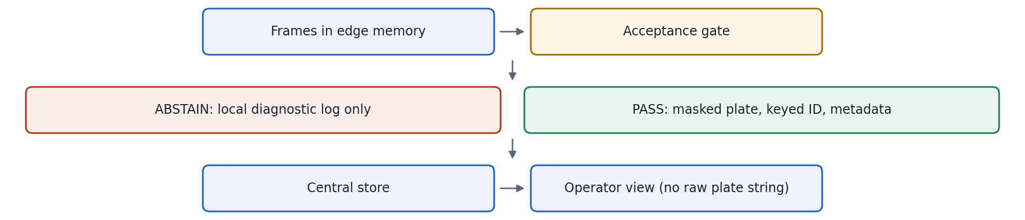
Checkpoint | Retained | Discarded
After frame decode | Sampled frames in memory | Raw video stream
After acceptance ABSTAIN | Engineering console log | No central record created
After acceptance PASS | Masked plate, keyed ID, event metadata | Raw plate image
At central ingestion | Masked candidate context; live preview only when requested | No raw plate string in standard view; no stored genuine crop or footage
At operator view | Alert context | No raw plate string in standard view
On-demand live preview | Live video only while an authorised preview is active | No recording or stored genuine crop

Production-analysis frames are held in edge memory only during active processing. Recording and centralised download are disabled. A separately authorised on-demand MediaMTX preview may relay live video to a viewer, but it is not recorded or stored as event evidence.

PART III — EDGE INTELLIGENCE

8. Edge Processing Pipeline
The edge pipeline executes per sampled frame. Each stage has a defined input, output and failure behaviour.
Stage | Component | Output | Failure behaviour
1 Video ingestion | FFmpeg / PyAV | Video packets | HLS fallback; health flag
2 Frame sampling | PTS-based sampler | Sampled frames | Drop frame; continue
3 Vehicle detection | YOLOv8n | Vehicle bounding boxes | No detections; next frame
4 Vehicle tracking | ByteTrack | Track ID per vehicle | Lost track; re-initialise
5 Plate localisation | YOLOv9-Tiny-512 | Plate region | No plate; skip to next frame
6 OCR | FastALPR CCT-S v2 | OCR candidates | No candidate; skip
7 Evidence fusion | Multi-frame fusion | Ranked candidate | Insufficient evidence → abstain
8 Acceptance gate | Rule-based gate | PASS / ABSTAIN | ABSTAIN → diagnostic

9. Vehicle Detection and Tracking
9.1 Vehicle detection — YOLOv8n. A lightweight single-stage detector that locates vehicles in each sampled frame and outputs bounding boxes with class and confidence. It is the current configured model and runs on the edge node without a high-power GPU cluster.
9.2 Vehicle tracking — ByteTrack. A multi-object tracker that associates detections frame to frame using IoU and motion matching, holding a persistent track ID until the vehicle leaves the scene. Without tracking, every frame would be an independent detection; tracking is the prerequisite for multi-frame fusion.

10. Plate Localisation and OCR
10.1 Plate localisation — YOLOv9-Tiny-512. Detects the plate region within the tracked vehicle crop rather than the full frame, reducing false positives from other rectangular objects.
10.2 OCR — FastALPR CCT-S v2. Generates one or more OCR string candidates with confidence scores from a plate crop. A single-frame output is a candidate, not an accepted reading; all candidates feed the fusion stage.

11. Multi-Frame Evidence Fusion

11.1 What fusion does
For each tracked vehicle, fusion collects all OCR candidates generated across every frame in which the vehicle had a plate crop extracted, ranks them, and selects the most consistent, best-evidenced candidate.
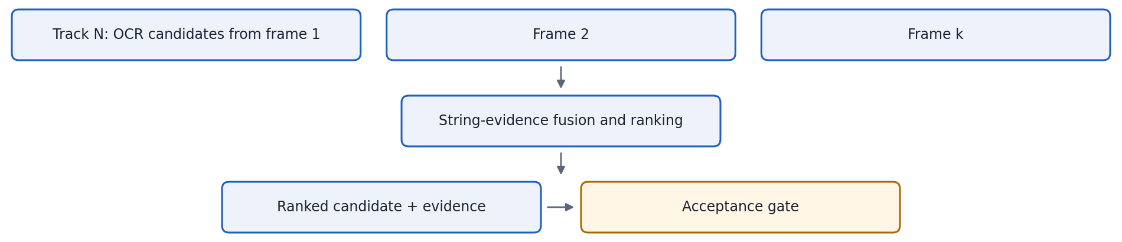

11.2 What fusion does not do
Multi-frame fusion is not a trained temporal neural network. It combines OCR string evidence from multiple observations of the same tracked vehicle.
Fusion cannot recover visual information the camera never captured. If all frames contain motion blur, severe occlusion or extreme distance, fusion aggregates uncertain candidates and the gate abstains.

11.3 Why this matters
A single crop may be affected by blur, glare, angle or occlusion. Multiple observations of the same track give additional evidence for ranking and acceptance. Fusion does not guarantee a correct reading; it provides the most evidenced candidate for the gate to evaluate.

12. Acceptance / Abstention Gate
Abstention is a valid system output. The gate prevents unsupported recognition results from becoming central operational alerts. The system does not force an identifier when evidence is insufficient.

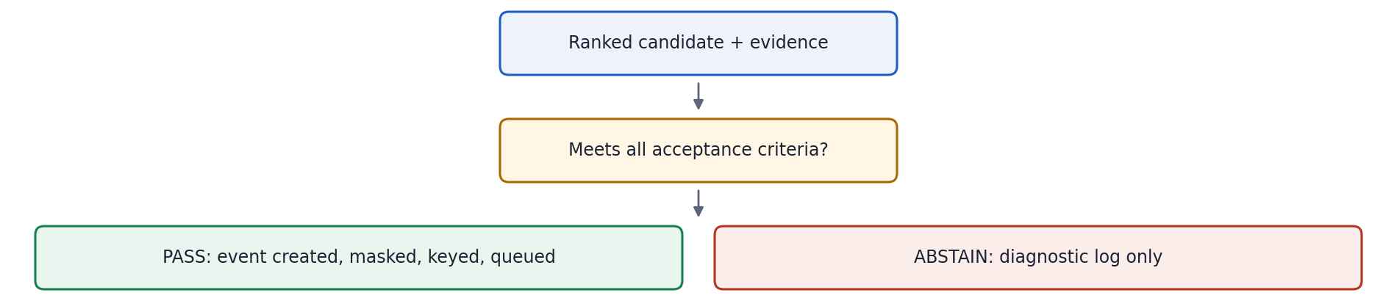
Outcome | Meaning | Central effect
PASS | Candidate meets configured rules; not independently verified | Event created, masked, keyed, queued for delivery
ABSTAIN | Evidence insufficient or inconsistent | No event created; diagnostic log in engineering console

Production alert path is fail-closed: the gate creates an event only when configured evidence rules pass. PASS is not an accuracy guarantee or identity verification. Insufficient or inconsistent evidence is ABSTAIN for the production alert path; diagnostic hypotheses remain available in the separate engineering console. Current live recognition accuracy and gate calibration are unproven.

PART IV — CENTRAL INTELLIGENCE

13. Secure Event Delivery
Property | Mechanism | Effect
Privacy | Plate masking before transmission | Raw plate string is not transmitted to the central platform
Identity / deduplication | Deterministic keyed identifier per event | Enables duplicate detection and event correlation; the identifier is not a reversal of the plate
Reliability | SQLite durable outbox with retry | Accepted events are preserved during temporary connectivity failures and retried when connectivity returns
Minimisation | Metadata-only central payload | Camera ID, track ID, keyed ID, timestamp and location — no raw video or raw plate strings

The keyed identifier is not encryption and is not claimed as a message-integrity mechanism. It provides deterministic identity for deduplication and correlation without transmitting a raw recognisable string to the central store.

14. Central Event Processing
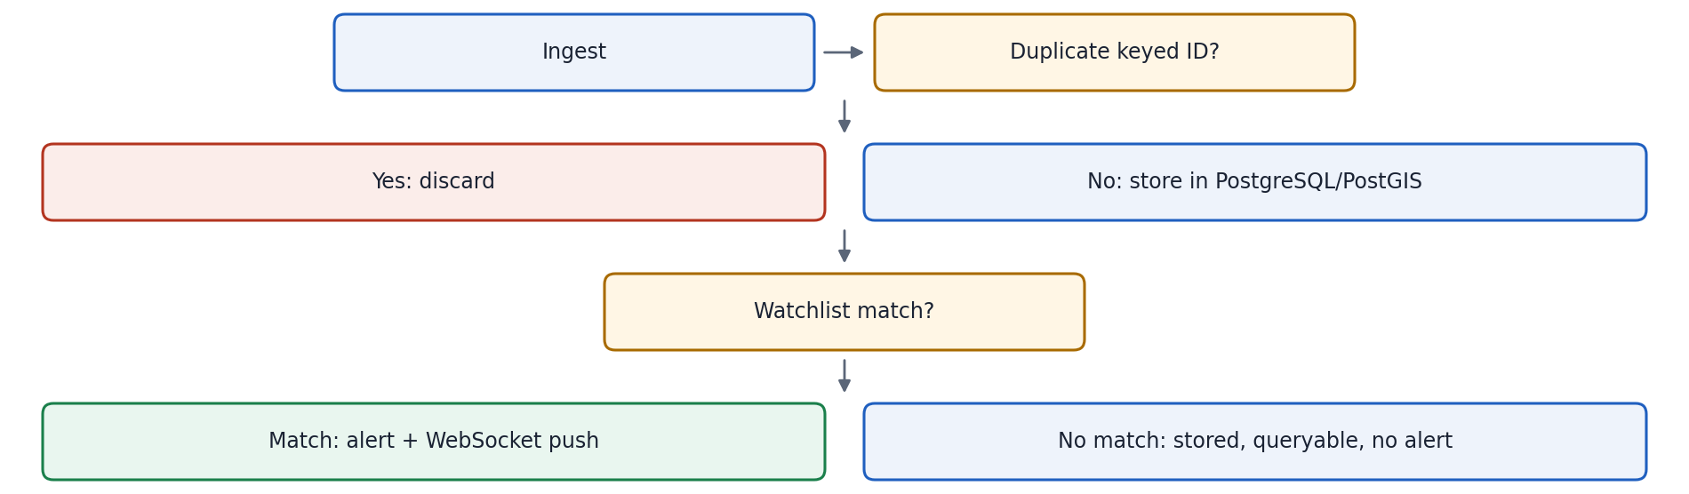
14.1 Deduplication. Slow or stationary vehicles may generate multiple accepted events from overlapping sampling windows. Central deduplication checks the incoming keyed identifier against recently processed events and discards duplicates before database insertion.
14.2 PostGIS. PostgreSQL has the PostGIS extension enabled. In the current prototype, map locations use stored latitude/longitude fields; spatial-index operations and zone queries have not been demonstrated.

15. Watchlist Matching
- Input: accepted event with keyed identifier.
- Process: In the current demo, the keyed identifier is compared with a locally seeded synthetic watchlist entry. No official state vehicle-registration registry is connected.
- Match: A match creates a visibly labelled synthetic/demo alert and pushes it over WebSocket into the same dashboard alert queue used for the demonstration workflow. It is not an independently verified vehicle identity.
- No match: The masked/keyed event metadata is stored in PostgreSQL without generating a watchlist alert; it remains queryable.
The demonstration watchlist and accepted candidate use deterministic keyed representations, so central matching does not require a plaintext plate. This synthetic matching workflow does not establish vehicle identity or connect to a government registry.

16. Operator Workflow
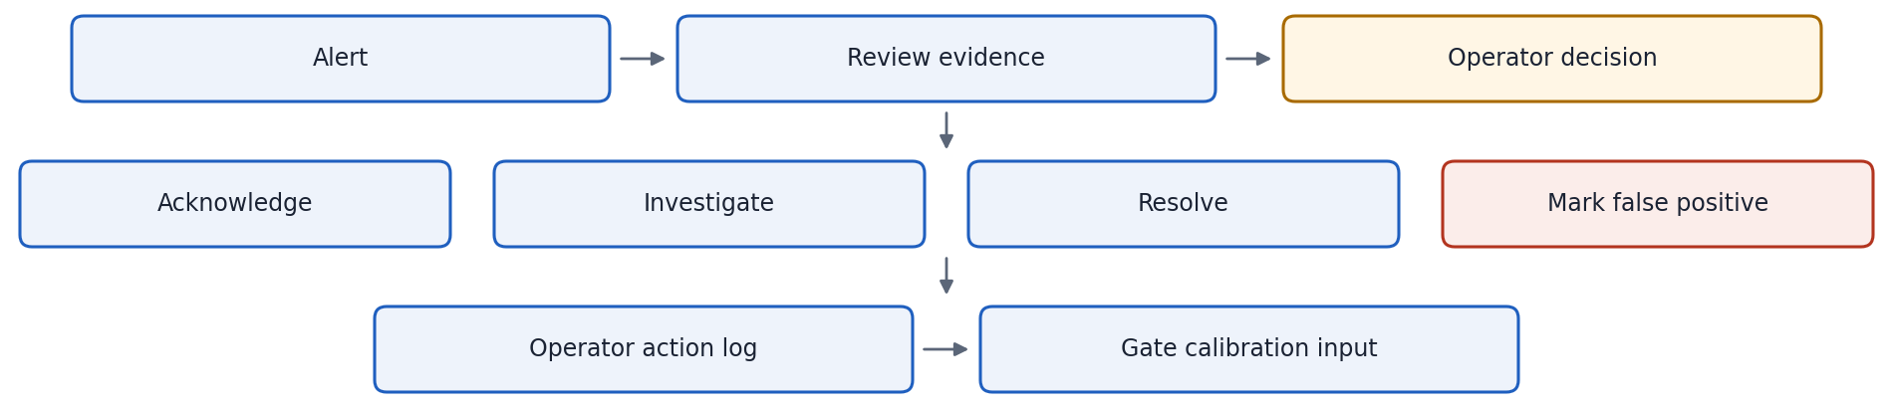

16.1 Human-in-the-loop design
Consequential operational actions remain subject to operator review; the AI pipeline does not perform autonomous enforcement actions. The system:
- Surfaces masked candidate metadata and context to operators, with an authorised on-demand live preview available through a separate, non-recording media path. Genuine crops and footage are not retained as incident evidence in the current prototype; the system issues no autonomous enforcement actions.
- Requires explicit operator acknowledgement of alerts.
- Maintains an audit trail recording operator actions.
- Allows false-positive marking, used to diagnose acceptance-gate calibration.

16.2 Engineering console
The opt-in engineering console is a separate diagnostic session, not the production alert worker. It exposes frame-level vehicle boxes, native-pixel plate crops, OCR candidates and CTC alternatives, track history, video timestamps and gate reasons. Its selected path uses YOLO26s with ByteTrack, the parent YOLOv9-Tiny plate detector, and adapted Awiros CTC OCR. When at least three suitable distinct crops are retained, it uses checked ECC alignment and native-grid multi-frame reconstruction before derived OCR. This is geometric alignment and fusion—not learned super-resolution—and it adds no independent OCR votes. Scores remain uncalibrated hypotheses, not probabilities or verified readings. Diagnostic images and hypotheses stay in bounded local memory and are cleared with the session; no genuine diagnostic image is sent to central.

PART V — RELIABILITY, SECURITY AND PRIVACY

17. Failure Handling and Recovery
Failure condition | System response | Operational impact
Camera unavailable | Feed marked unavailable; operator notified | Operator awareness; no edge processing for that feed
RTSP stream failure | Automatic fallback to HLS | Processing continues on alternate stream
Network unavailable (edge → central) | Accepted events persist in SQLite outbox; retry when connectivity resumes | Accepted events remain queued for retry during temporary connectivity failures
Central API unavailable | Retry via SQLite outbox | Delayed processing; events remain queued
Duplicate event at central | Keyed ID match; discarded before insertion | No duplicate alert or record
Low OCR confidence | ABSTAIN; diagnostic log | No central alert; no operator fatigue
Evidence inconsistent across frames | ABSTAIN; diagnostic log | Conservative outcome; no forced identifier
Operator false positive | Alert marked; audit record written | Input to gate calibration

All listed responses are supported by the current implemented architecture. No theoretical or unimplemented recovery mechanisms are included.

18. Security Architecture
Control | Mechanism | Location
Authorised camera feeds only | Camera catalogue registration | Zone 1 boundary
No raw video centralisation | Event-payload video excluded; authorised on-demand preview is separate | Zone 1 → 2 boundary
Event identity / deduplication key | Keyed identifier | Edge, prior to transmission
Duplicate prevention | Keyed-ID deduplication | Central ingestion
Protected operator functions | Authentication controls | Zone 4
Synthetic events labelled | Demo source labels on injected and synthetic events | Central event record and dashboard queue
Audit trail | Operator action log | Central database

19. Privacy and Data Minimisation
Principle | Implementation
Raw video stays at edge | Analysis frames remain in edge memory. A separate authorised live preview may stream on request; no recording or stored event video.
Recording disabled | Centralised raw-video recording and download are not enabled
Plate masking before transmission | Raw plate string is masked at the edge before any central transmission
Metadata-only central store | Camera ID, track ID, keyed identifier, timestamp, location
Diagnostic evidence stays local | Uncertain crops and OCR hypotheses stay in bounded local memory; optional test delivery is masked/keyed metadata only and labelled unverified.
Synthetic events labelled | Synthetic demo events are visibly labelled but enter the same demonstration alert queue; there is no official registry.

Through event ingestion, the central platform receives no raw frames, no unmasked plate strings, no OCR hypotheses that did not pass the production gate, and no stored genuine crops or footage. Separately, an authorised on-demand MediaMTX preview can relay live video to a viewer; it is not part of the event payload and is not recorded. The opt-in engineering console keeps sensitive diagnostic evidence in bounded local memory; any optional test delivery is limited to masked/keyed candidate metadata explicitly labelled unverified.
No legal compliance certification (GDPR, DPDP, etc.) is claimed. The privacy architecture reflects engineering design intent; compliance assessment is outside the scope of this document.

20. Observability and Auditability
Metrics marked INTENDED are instrumentation goals. No performance figure (frames/s, throughput, latency) has been measured.
Layer | Metric | Status
Camera | Connectivity status; stream health per feed | IMPLEMENTED
Edge pipeline | Frames sampled/s; vehicles/frame; active tracks; crops/track | INTENDED / TO BE MEASURED
Recognition | OCR candidates/track; fusion outcomes; PASS / ABSTAIN counts | INTENDED / TO BE MEASURED
Delivery | Outbox depth; events sent / retry count | INTENDED / TO BE MEASURED
Central | Events received / duplicates rejected | INTENDED / TO BE MEASURED
Central | Watchlist matches | IMPLEMENTED
Operator | Alerts delivered; acknowledgements, resolutions, false positives | IMPLEMENTED

PART VI — VALIDATION

21. Validation Strategy
Validation is divided into two independent categories that must not be conflated.
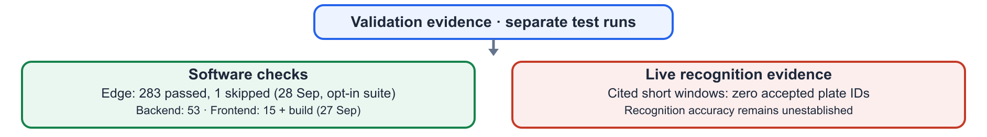
Software test success does not equal recognition accuracy. The recorded software checks came from different suites and dates: Edge 283 passed / 1 skipped (28 Sep opt-in recovery suite); Backend 53 passed; Frontend 15 passed plus production build (27 Sep dual-interface regression). They are not one combined end-to-end test run. The cited live windows produced zero accepted IDs and had no labelled per-vehicle ground truth, so they do not measure recognition accuracy.

21.1 Design decisions that affect validation
Decision | Rationale | Consequence for validation
Edge-first processing | Reduces central video burden | Edge capacity must be measured separately
Track-level fusion | Combines repeated observations | Fusion quality depends on track quality; evaluate both
Fail-closed acceptance | Prevents unsupported alerts | Calibration needs ground-truth data to set thresholds
Durable SQLite outbox | Tolerates connectivity loss | Retry and dedup correctness need integration testing
Masked / keyed central data | Reduces unnecessary data transfer | End-to-end keying correctness needs validation
Measure before scale | Avoids unsupported deployment | Capacity validation precedes any deployment claim

22. Current Evidence

22.1 Software Validation
283 EDGE PASSED / 1 SKIPPED (28 SEP, OPT-IN) | 53 BACKEND PASSED (27 SEP) | 15 FRONTEND PASSED + BUILD (27 SEP) | SEPARATE RUNS — NOT A COMBINED TOTAL

Suite scope and provenance: Edge = pipeline unit and integration; Backend = API, deduplication, database and watchlist; Frontend = dashboard and operator workflow. Edge results below are from 28 September 2026; the recorded backend and frontend suite results are from 27 September 2026. These are separate runs, not one combined end-to-end test.

22.2 Live Pipeline Evidence
CAM17 · opt-in engineering viewer · 30 s (28 Sep, before 29 Sep changes)  183 decoded · 15 analysed · 6 vehicle-box instances  0 native plate crops · 1 full-image call · 0 recovered crops  0 accepted identifiers | CAM01 · opt-in engineering viewer · 30 s (28 Sep, before 29 Sep changes)  403 decoded · 77 analysed · 188 vehicle-box instances  8 native plate crops · 18 full-image calls · 0 recovered crops  0 accepted identifiers

These are short engineering-viewer windows, not production accuracy benchmarks. Both feeds produced live frames, but neither yielded an accepted identifier in the cited run. Without independently transcribed per-vehicle ground truth and representative sampling, these counts do not estimate accuracy. A model-accepted candidate would still not be an independently verified registration.

22.3 Degradation Evaluations
84  DEGRADATION EVALUATIONS | 0  ACCEPTED

The 84 evaluations are repeated evaluations of a limited set of source crops under artificial degradation conditions.
Not 84 vehicles. Not an accuracy benchmark. Not a representative sample of live Indian plate diversity.

22.4 A/B Candidate Comparison
A limited controlled comparison of two OCR configurations on 21 selected candidate windows, not 21 vehicles.
Metric | Hybrid model | FastALPR CCT-S v2
Candidate sets evaluated | 21 | 21
Correct candidate appeared in output | 16 / 21 | 9 / 21
Correct candidate ranked first | 1 / 21 | 4 / 21

On the small 21-window set, the hybrid OCR output contained the ground-truth candidate in 16/21 cases versus 9/21 for FastALPR; FastALPR ranked the correct candidate first in 4/21 cases versus 1/21 for the hybrid. This selected-crop comparison is not representative of live Indian traffic and does not establish universal superiority or camera-level accuracy.
These numbers must not be converted into an overall accuracy percentage. The evaluated set is not a statistically representative sample of operational conditions.

22.5 Proven vs Not Yet Proven
SOFTWARE / INTEGRATION EXERCISED  Edge-to-central workflow · vehicle detection/tracking path · plate localisation/OCR path · multi-frame evidence processing · production acceptance gate · SQLite outbox · API/database/watchlist workflow · operator dashboard and separate engineering console · separate test-suite records in §22.1 | NOT YET PROVEN  Live plate-reading accuracy · calibrated recognition scores or gate · representative Indian plate performance · maximum cameras per edge node · regional-scale capacity · production deployment readiness

23. Current vs Experimental Components
PRODUCTION ALERT WORKER — configured path  YOLOv8n · ByteTrack · YOLOv9-Tiny-512 plate detector · FastALPR CCT-S v2 OCR · rule-based multi-frame fusion and acceptance gate · SQLite outbox · FastAPI · PostgreSQL/PostGIS extension · WebSocket · operator dashboard | OPT-IN ENGINEERING CONSOLE — separate diagnostic path  YOLO26s + ByteTrack · parent YOLOv9-Tiny plate detector · adapted Awiros CTC OCR · checked ECC alignment/native-grid reconstruction when enough distinct crops are available · frame-level candidates and uncalibrated scores  Not the production worker; reconstruction is geometric, not learned super-resolution, and adds no independent OCR votes. Other research candidates (YOLO11-P2, PARSeq, NAFNet, RAFT) are not claimed as production models.

The opt-in engineering path is separate from production; it does not replace or silently alter the production worker. Its OCR candidates and ECC reconstructions are diagnostic hypotheses, not verified readings. Other research models are not configured as the live production path. A model should enter production only after controlled A/B evaluation against rights-cleared, ground-truthed data and a documented safety review.

24. Known Limitations
Limitation | Current status | Mitigation path
Live recognition accuracy unverified | 0 accepted IDs from pilot runs | Labelled dataset evaluation (§27 Phases 2–3)
Acceptance gate uncalibrated | Thresholds not tuned to ground truth | Calibration with precision/coverage analysis (Phase 4)
Limited plate diversity evaluated | Small set of source crops in degradation evaluation | Indian plate diversity dataset required
Edge capacity unmeasured | No stream-count benchmarking | Edge load testing (Phase 5)
A/B comparison limited | 21 candidate windows only | Expanded controlled test set
Large-scale capacity undemonstrated | Not benchmarked | Regional-scale validation (Phase 6)
No legal compliance certification | Engineering design only | Outside prototype scope

PART VII — SCALE AND ROADMAP

25. Edge Capacity and Scaling Strategy
The current prototype processes two selected feeds, CAM17 and CAM01. Video analysis runs at the edge and production event ingestion sends only gate-accepted masked/keyed metadata. An authorised on-demand MediaMTX preview is a separate live-video path, is not recorded, and does not add a camera to the AI workload. Regional edge nodes could partition a future deployment, but no capacity beyond these two selected feeds—and no 80,000-camera capacity—has been validated.

Benchmark dimensions to measure
Dimension | What to measure
Stream count | Maximum concurrent camera feeds per edge node
Decode utilisation | GPU / NVDEC decode load
Detection throughput | Frames per second through YOLOv8n
Tracking overhead | ByteTrack CPU/memory per active track
OCR throughput | FastALPR candidates per second
Queue depth | SQLite outbox backlog during connectivity interruption
End-to-end latency | Camera event → operator alert round trip
Recovery time | Reconnection latency after network interruption

None of these benchmarks has been measured in the current prototype. Capacity must be measured before any deployment claim is made.

26. Future Regional Architecture
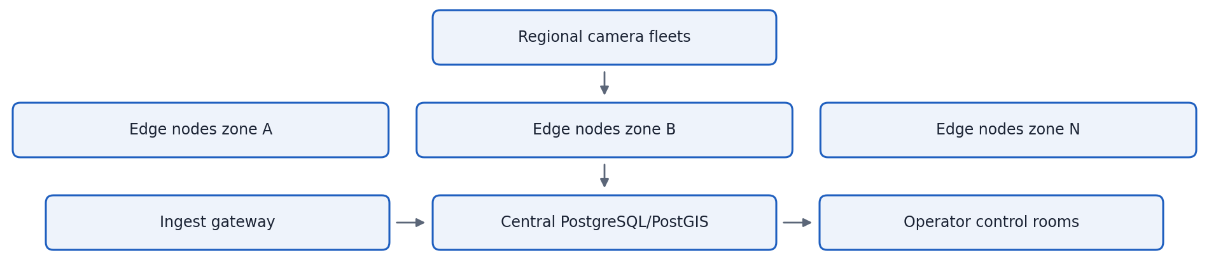
The regional architecture is a future deployment target, not demonstrated capacity. The 80,000-camera figure is an architectural ambition, not tested throughput. This prototype has two selected AI feeds (CAM17 and CAM01); any wider deployment claim requires measured per-node capacity and operational validation.

27. Validation Roadmap
Phase | Prerequisites | Key output
1 — Current prototype | Complete | Production/diagnostic workflows exercised; separate software suite records; 0 accepted IDs in the cited 30-second live viewer windows; accuracy and scale unproven
2 — Recognition dataset | Authorised labelled Indian plate data | Ground-truth transcripts with track grouping
3 — A/B evaluation | Phase 2 dataset | Objective model comparison; best candidate pipeline identified
4 — Calibration | Phase 3 results | Calibrated acceptance thresholds; precision/coverage balance
5 — Edge load testing | Phase 4 acceptance configuration | Measured stream capacity, latency and resource utilisation
6 — Operational validation | Phases 4 and 5 complete | Validated recognition performance; deployment-readiness evidence

28. Final System Position
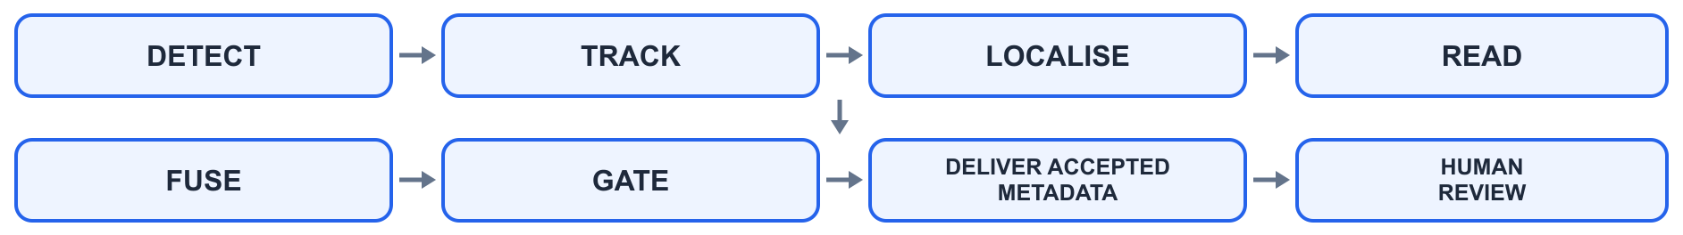
What we built  An implemented edge-to-central vehicle intelligence prototype. | Separate software suites passed on different dates; production and diagnostic integration exercised. Cited short live windows produced zero accepted IDs; no recognition accuracy claim.

What remains unproven  Live recognition accuracy · candidate coverage · gate calibration · edge capacity · regional-scale deployment | What comes next  Rights-cleared, ground-truthed Indian plate data → controlled A/B evaluation → gate calibration → edge capacity/load testing → authorised operational validation

DETECT. TRACK. ASSESS. REVIEW.
“Show OCR candidates for diagnosis. Gate operational delivery. Keep people in control.”
Sentinel Gujarat Vehicle Intelligence · HLD v2.2 · Prototype Architecture · Engineering Design Reference

