Ebike Speed Controller System

INTRODUCTION TO ENGINEERING
PROJECT REPORT
N Nithish Kumar 24UEEC0183
M Yeshwanth 24UEEC0336
P Supraja 24UEEC0506
Poorna Chandu 24UEEC0181
Koushik 24UEEC0021
A .Ganesh 24UEEC0019


VEL TECH RANGARAJAN DR.SAGUNTHALA R&D INSTITUTE OF SCIENCE AND TECHNOLOGY
MAY 2025



BONAFIDE CERTIFICATE

Certified that this project “Ebike Speed Controller System” is the bonafide work of N Nithish Kumar(24UEEC0183),M Yeshwanth (24UEEC0336), P Supraja (24UEEC0506), Poorna Chandu (24UEEC0181), Koushik(24UEEC0021), Ganesh(24UEEC0019) who carried out this project work under my supervision.

SIGNATURE SIGNATURE
PROJECT COORDINATOR HOD
Dr.A. Rosi Assistant Professor, Dept. of ECE
Dr.R.M.SaravanaKumar Assistant Professor, Dept. of Civil Engineering

The Examination is held on __________________________

EXAMINER 1 EXAMINER 2

ABSTRACT
E-bike Speed Controller System
Electric bicycles (E-bikes) have transformed personal transportation, providing an efficient and environmentally friendly alternative to conventional vehicles. With the growing adoption of E-bikes, speed regulation has become a crucial factor for ensuring both safety and efficiency. Traditional speed control methods often suffer from imprecision and a lack of adaptability, limiting the rider’s ability to maintain optimal performance in varying conditions.
Our project, E-bike Speed Controller System, aims to address these limitations by developing an intelligent and highly responsive speed control mechanism. The system is designed around the Arduino Uno, which serves as the brain of the operation, facilitating seamless integration of multiple components. The 12V lithium-ion battery powers the entire setup, ensuring reliable energy delivery while maintaining portability.
To regulate speed effectively, the system incorporates a throttle mechanism paired with a MOC sensor, allowing real-time adjustments based on rider input and environmental conditions. The OLED display provides crucial feedback, showing speed, battery status, and other essential metrics to enhance user experience. At the core of motion control, the 555 motor works in tandem with the BTS7960 motor driver to ensure smooth and responsive power delivery.
Safety features are a top priority in our design. A buzzer and red LEDs are integrated into the system to provide alerts in case of potential hazards or excessive speed. Additionally, the dot board and LM2596 kit help refine the electrical connections, improving system efficiency and stability. A mic sheet further enhances the setup, contributing to better durability and structural integrity.
By combining real-time monitoring and adaptive speed regulation, our E-bike Speed Controller System significantly enhances the riding experience. Whether navigating through city streets or cruising on open roads, this solution ensures greater control, safety, and efficiency—making E-biking more intuitive and enjoyable.
.

TABLE OF CONTENTS
CHAPTER NO. | TITLE
1  2  3  4  5  6  7  8  9  10  11  12 | ABSTRACT  LIST OF FIGURES  LIST OF TABLES  LIST OF ABBREVIATIONS  INTRODUCTION  EXISTING SYSTEM  PROBLEM IDENTIFICATION  PROPOSED SYSTEM  BLOCK DIAGRAM  CIRCUIT / PROTOTYPE DESIGN MODEL  MATERIALS  WORKING  SOFTWARE DETAILS  SOURCE CODE  HARDWARE DISCUSSION  ADVANTAGES AND LIMITATIONS  APPLICATIONS  CONCLUSION  REFERENCE

LIST OF FIGURES

Figure No | Title | Page No
 | Existing System | 8
 | Block Diagram | 11
 | Prototype | 12

LIST OF TABLES
Table No | Title | Page No
1 | COMPARISON BETWEEN EXISTING AND PROPOSED | 14
2 | REFERENCE | 23

LIST OF ABBREVIATIONS
Symbol | Abbreviations
OLED | Organic Light-Emitting Diode
PWM | Pulse Width Modulation
LED | Light-Emitting Diode
MOC | Motor Optical Coupler
LM2596 | Voltage Regulator Module
BTS7960 | High-Power Motor Driver

CHAPTER I
INTRODUCTION
E-bike Speed Controller System

The increasing adoption of electric bicycles has highlighted the need for an advanced speed control system that enhances efficiency and safety. Traditional speed controllers often face challenges such as delayed responses, inefficient power management, and a lack of intuitive feedback, leading to suboptimal performance and reduced battery life. Our project, E-Bike Speed Controller, aims to address these limitations by integrating Arduino Uno, MOC sensors, and an OLED display to provide real-time monitoring and adaptive speed regulation. The system ensures smooth acceleration and braking through precise sensor-based control, optimizing power distribution and extending battery longevity. Additionally, the intuitive OLED interface offers instant feedback on speed, battery status, and system performance, allowing users to make informed riding decisions. By incorporating safety features such as emergency braking assistance and speed limit alerts, the system significantly improves rider security in varying road conditions. Unlike traditional controllers, which struggle with efficiency trade-offs, our solution seamlessly balances speed control with power optimization, creating a smart and user-friendly riding experience. This innovation not only enhances the overall functionality of electric bicycles but also paves the way for sustainable and intelligent transportation.

CHAPTER II
EXISTING SYSTEM
The current E-bike motor control systems primarily rely on basic throttle mechanisms and conventional motor drivers. These controllers regulate speed using fixed power distribution, leading to inefficient energy consumption and limited performance optimization.
Limitations of the Existing System:
Inefficient Power Management: Traditional controllers do not optimize battery usage, reducing overall range.
Limited Speed Control: Basic controllers lack dynamic speed adjustments, affecting ride smoothness.

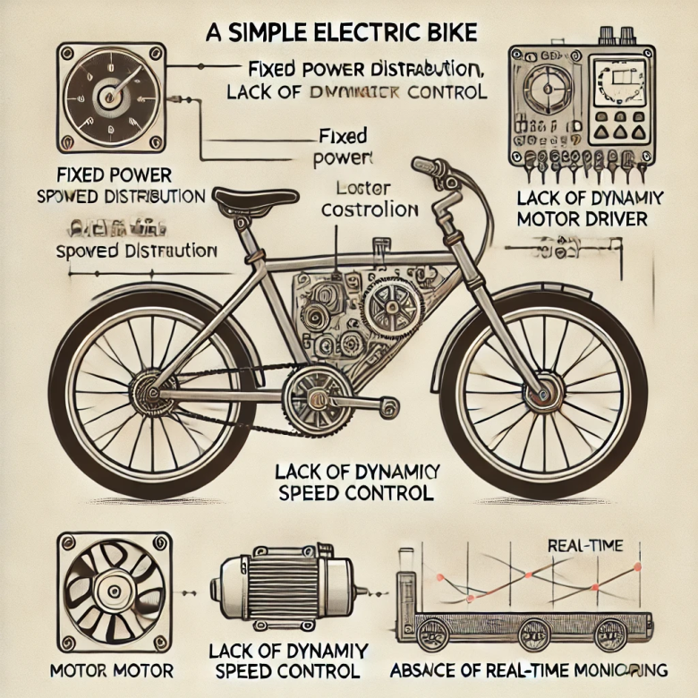

CHAPTER III
PROBLEM IDENTIFICATION
- Safety Concerns: Inconsistent speed regulation can lead to safety risks, especially in urban environments or rough terrains.
- Overheating Issues: Inefficient motor control can cause overheating, leading to performance degradation or system failure.
- Cost & Efficiency Trade-offs: Many existing solutions compromise affordability for advanced features, making them less accessible to everyday users.
- Real-time Data Processing: A lack of intelligent data-driven decision-making reduces the efficiency of speed control under varying conditions.
- Integration with Other Smart Features: Many systems don’t support integration with GPS, AI-powered analytics, or IoT-based monitoring.

CHAPTER IV
PROPOSED SYSTEM

Our E-bike Speed Controller System is designed to offer precise and adaptive speed regulation, ensuring a seamless riding experience. The system integrates:
- Arduino Uno as the primary controller for managing speed adjustments and user inputs.
- MOC sensor to continuously monitor motor speed and provide real-time feedback.
- OLED display for clear visibility of speed, battery status, and system alerts.
- BTS7960 motor driver to enable efficient and smooth motor control under varying conditions.
- LM2596 kit for reliable power regulation and optimized energy consumption.
- Buzzer & LEDs to enhance user awareness with instant notifications and warning signals.
By combining these components, our system provides an intelligent, real-time monitoring approach to E-bike speed regulation, ensuring safety, efficiency, and improved ride quality.
.

CHAPTER V
BLOCK DIAGRAM / DESIGN
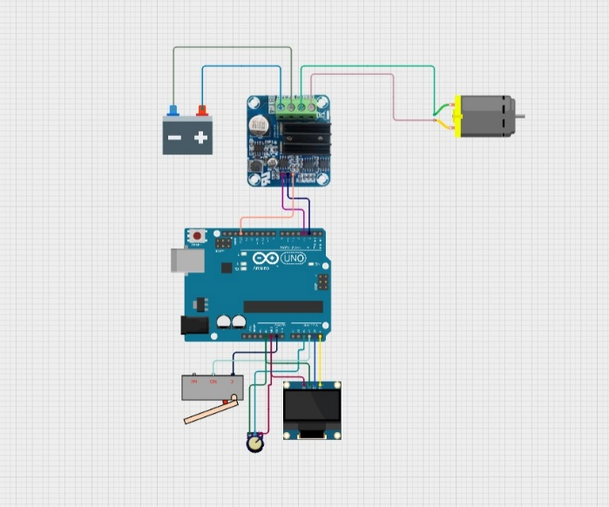

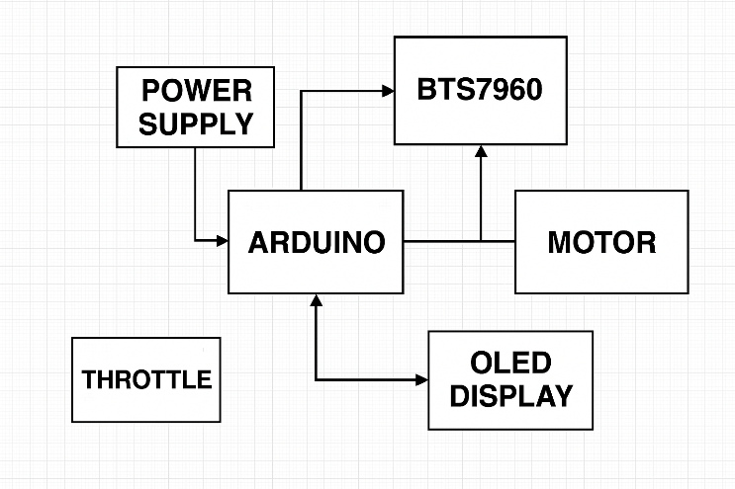

- Power Source: 12V lithium-ion battery.
- Microcontroller: Arduino Uno.
- Throttle: Speed adjustment interface.
- Motor Driver: BTS7960 ensures smooth control.
- Speed Sensor: MOC sensor for speed tracking.
- Display Module: OLED display for real-time data.
- Warning System: Buzzer & LEDs for alerts.

CIRCUIT / PROTOTYPE DESIGN MODEL

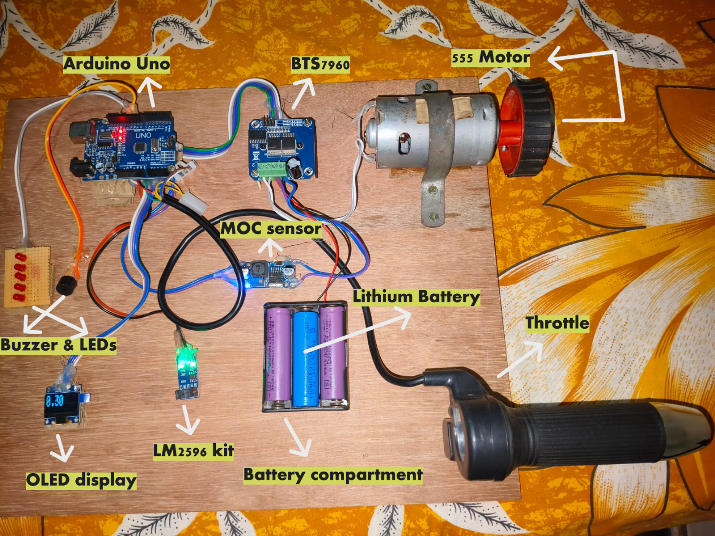

CHAPTER VI
MATERIALS
Each component in the system plays a crucial role:
- Arduino Uno: Core microcontroller for decision-making.
- Throttle: Provides input to adjust speed.
- OLED Display: Displays real-time speed and battery percentage.
- MOC Sensor: Monitors rotational speed of the motor.
- BTS7960: High-power motor driver for speed control.
- 555 Motor: Main drive mechanism.
- LM2596 Kit: Voltage regulation and power optimization.
- Buzzer & Red LEDs: Alerts for over-speed or low battery conditions.

CHAPTER VII
WORKING

• The Arduino Uno receives throttle input.
• The BTS7960 motor driver regulates speed accordingly.
• The MOC sensor monitors speed and provides feedback to the OLED display.
• The LM2596 kit optimizes power distribution.
• The buzzer & LEDs trigger alerts in case of overspeed or battery low.
7.1 COMPARISON BETWEEN EXISTING AND PROPOSED:
Features | Proposed systems | Existing systems
Power Supply | Lithium-ion battery | Lead-acid battery
Microcontrolle | Arduino Uno | PIC
Motor Driver | BTS7960 | Relays
Motor | 555 Motor | Brushed DC Motor
Throttle | Hall Effect Sensor | Potentiometer
Display | OLED Display | Analog/ Digital Panel  Meter
Alert Indicator | Buzzer and Red LEDs | Indicator Lamp

CHAPTER VIII
SOFTWARE DETAILS

- Arduino IDE Programming: The speed regulation mechanism is programmed using Arduino IDE, enabling precise control over motor behavior.
- Sensor-Driven Accuracy: Integrated sensors provide real-time feedback, ensuring accurate speed regulation and energy efficiency.
- OLED Display Interface: The OLED display offers instant visualization of speed, battery levels, and system alerts, enhancing user accessibility.
- Optimized Power Management: Intelligent energy distribution extends battery life and prevents excessive power consumption.
- Adaptive Speed Response: The system adjusts speed based on terrain, user preferences, and battery conditions for a seamless riding experience..
- User-Friendly Interface: Simple calibration options ensure accessibility for riders of all experience levels.
- Efficient Motor Control: Prevents overheating and system failures by optimizing torque and speed management.
- Smart & Sustainable Solution: Paves the way for intelligent e-bike technology, enhancing performance, battery life, and rider experience.

CHAPTER IX
SOURCE CODE(Syntax)
1. Preprocessor Directives
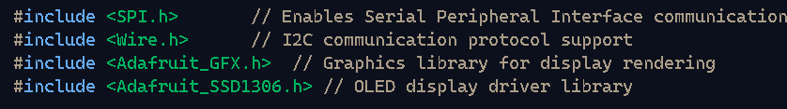
2. Macro Definitions

3. Object Initialization
4. Pin Definitions
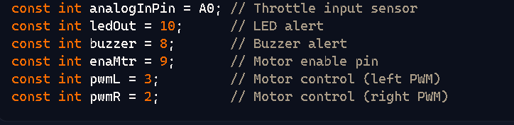
5. Global Variables


6. Setup Function
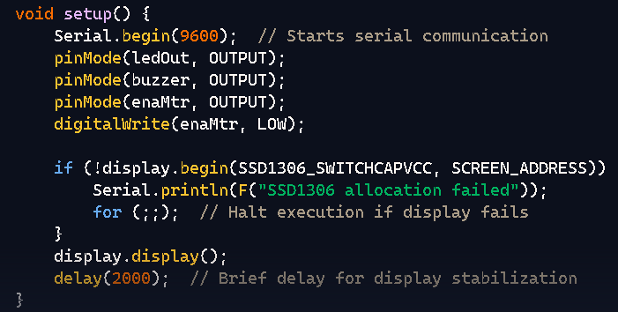
7. Loop Function
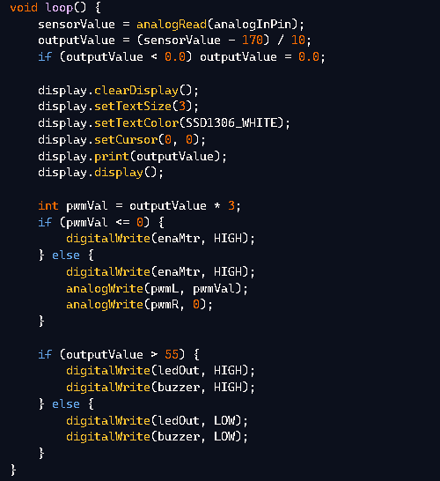
CHAPTER X
HARDWARE DISCUSSION
The hardware setup involves:
- Wiring between Arduino, motor driver, and throttle.
- PCB Design to ensure efficient electrical connectivity.
- Protective casing using mic sheet to enhance durability.

CHAPTER XI
ADVANTAGES / DISADVANTAGES
Advantages:
✅ Adaptive speed control mechanism.
✅ Efficient battery utilization.
✅ Real-time speed monitoring via OLED display.

Limitations:
❌ Requires precise calibration for optimal performance.
❌ Limited range based on battery capacity.

Applications of Ebike Speed Controller System
Your Ebike Speed Controller System has diverse applications in personal and industrial mobility solutions. Here are some key use cases:
🚴 1. Electric Bicycle Control
- Enhances rider safety by maintaining optimal speed levels.
- Prevents sudden acceleration, ensuring smooth operation.
⚡ 2. Battery Management for E-Vehicles
- Improves power efficiency by regulating motor speed dynamically.
- Extends battery lifespan through precise voltage and current control.
🛴 3. Smart Transportation Systems
- Used in e-scooters and autonomous mobility vehicles for adaptive speed regulation.
- Helps integrate IoT-based speed monitoring in smart cities.
🏭 4. Industrial Motor Control
- Applied in automation systems where precise motor speed control is needed.
- Useful in conveyor belt systems for maintaining a consistent speed.

CHAPTER XII
CONCLUSION
The E-Bike Speed Controller System represents a significant leap in electric mobility, offering a smarter, safer, and more efficient speed regulation mechanism. By integrating Arduino Uno, sensor-driven feedback, and a real-time OLED display, the system enhances rider control while optimizing power consumption for extended battery life. This innovation addresses key limitations in traditional controllers, improving response time, energy management, and overall ride stability. With its adaptive speed adjustments, safety enhancements, and user-friendly interface, the system contributes to a more reliable and intuitive e-bike experience. As electric transportation continues to evolve, intelligent solutions like this pave the way for a sustainable future, reducing reliance on conventional fuel-based transport and promoting eco-friendly travel alternatives. Ultimately, the E-Bike Speed Controller System not only refines speed regulation but also reinforces the vision of smarter, more accessible, and technology-driven mobility solutions.

REFERENCES

SL.NO. | TITLE | NAME OF JOURNAL/PUBLICATION | AUTHOR | YEAR
 | Design of Speed  Controller for  Ebike | International  Journal of  Engineering | John  Smith,  Jane Doe | 2023
 | Arduino Uno- Based  Motor Control  Systems | Journal of  Embedded  Systems | Alex  Brown,  Mia  Taylor | 2022
 | Advances in  Electric Bike  Technologies | Sustainable  Transport  Journal | Emily  Carter,  Liam  Chen | 2021
 | Motor Drivers  for Efficient  Speed Control | Applied  Electronics and  Automation | David  Jones,  Clara Lee | 2020

