SWIGGY ENTERPRISE ANALYTICS PLATFORM
Enterprise Solution Design & Business Requirements Document
Microsoft Fabric | Data Engineering | Power BI | SQL | Enterprise Analytics
Prepared For: Executive Leadership & Analytics Transformation Initiative
Document Version: 1.0

1. Executive Summary
Swiggy intends to modernize its analytics ecosystem by implementing a scalable enterprise analytics platform using Microsoft Fabric. The initiative aims to centralize operational, customer, delivery, and restaurant data into a unified reporting architecture.
The platform will enable leadership teams to monitor operational KPIs, improve delivery efficiency, analyze customer behavior, and drive data-driven strategic decisions.

2. Strategic Business Objectives
- Centralize fragmented operational data into a governed analytics platform
- Reduce manual reporting efforts across business teams
- Enable executive dashboards with near real-time KPI visibility
- Implement scalable Medallion architecture using Microsoft Fabric
- Establish enterprise-grade data quality and governance standards

3. Current Business Challenges
Business Area | Challenge
Delivery Operations | No centralized monitoring for delayed deliveries
Revenue Reporting | Revenue analytics scattered across reports
Customer Insights | No consolidated customer retention analysis
Restaurant Performance | Difficulty identifying underperforming restaurants
Data Quality | Duplicate and inconsistent operational records

4. Enterprise Data Architecture
The proposed solution follows a modern layered analytics architecture aligned with enterprise data engineering standards.
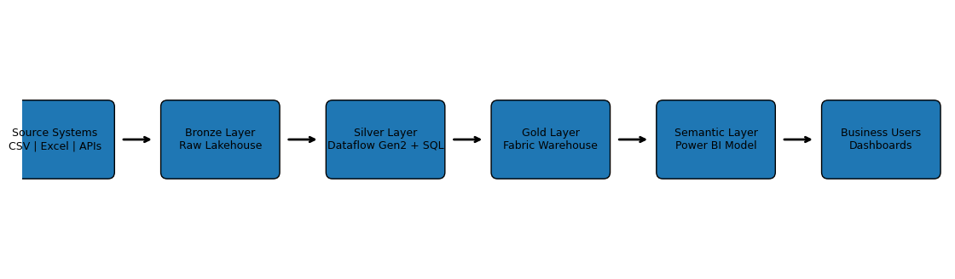

5. Medallion Architecture Design
The solution implements Bronze, Silver, and Gold layers to separate raw, cleansed, and business-ready datasets.
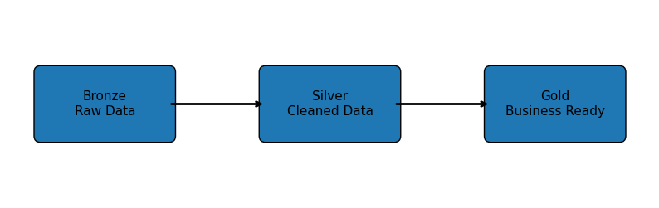

6. Technology Stack
Layer | Technology
Storage | Microsoft Fabric Lakehouse
Data Processing | Dataflow Gen2
Transformation | SQL
Warehouse | Fabric Data Warehouse
Semantic Layer | Power BI Semantic Model
Visualization | Power BI Reports
Version Control | GitHub

7. Pipeline & ETL Design
- Ingest raw datasets into Bronze Lakehouse
- Perform cleansing and validation using Dataflow Gen2
- Apply SQL transformations and business rules
- Load curated datasets into Fabric Warehouse
- Build semantic models and DAX measures
- Publish executive dashboards in Power BI

8. Source-to-Target Mapping
Source File | Transformation | Target Table | Business Purpose
customers.csv | Deduplication & cleansing | dim_customer | Customer analytics
restaurants.csv | Standardization | dim_restaurant | Restaurant KPIs
orders.csv | Revenue calculations | fact_orders | Sales reporting
deliveries.csv | Delivery SLA validation | fact_deliveries | Operations tracking

9. Enterprise Data Model
Star Schema Components
- Dimension Tables: dim_customer, dim_restaurant, dim_location, dim_date
- Fact Tables: fact_orders, fact_deliveries, fact_payments

10. KPI Catalog
KPI | Definition | Business Value
Total Revenue | Sum of completed order value | Tracks business growth
Average Delivery Time | Avg delivery duration | Measures operational efficiency
Customer Retention Rate | Repeat customer percentage | Customer loyalty tracking
Late Delivery % | Orders delivered after SLA | Delivery performance

11. Dashboard Design Requirements
- Executive Overview Dashboard
- Revenue & Financial Dashboard
- Customer Analytics Dashboard
- Restaurant Performance Dashboard
- Delivery Operations Dashboard

12. Governance & Security Framework
- Role-based access control (RBAC)
- Workspace governance standards
- Data quality validation checkpoints
- Naming convention enforcement
- Version control using GitHub

13. Risks & Mitigation
Risk | Impact | Mitigation
Poor Data Quality | Incorrect KPIs | Validation rules
Pipeline Failures | Delayed reporting | Monitoring & alerts
Performance Issues | Slow dashboards | Optimized star schema

14. Implementation Roadmap
- Phase 1 – Workspace & Lakehouse Setup
- Phase 2 – Data Cleaning & Transformation
- Phase 3 – Warehouse Modeling
- Phase 4 – Semantic Model & KPIs
- Phase 5 – Dashboard Development & Deployment

15. Final Deliverables
- Microsoft Fabric Workspace
- Enterprise Lakehouse
- Curated Data Warehouse
- Power BI Semantic Model
- Executive Dashboards
- GitHub Documentation Repository

