CC1

NITHISH D

727721EUIT105

QUESTION 1

CODE:

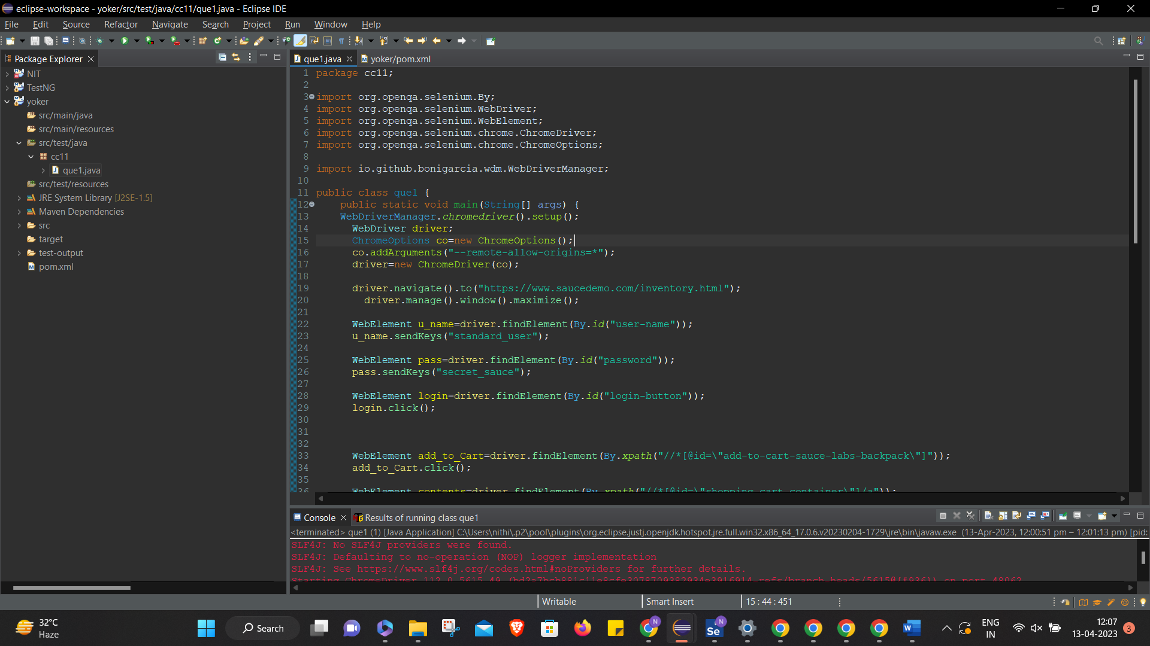

POM.XML:

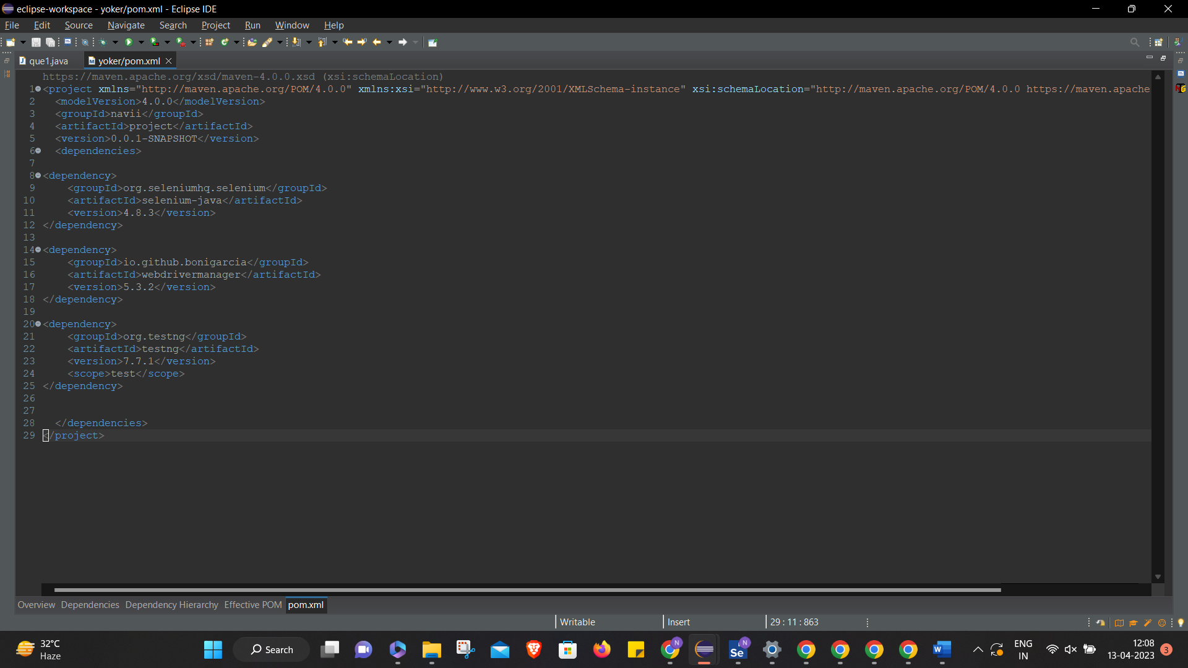

OUTPUT:

