Task 5

Install Maven

sudo apt install maven

Fork the repo on github

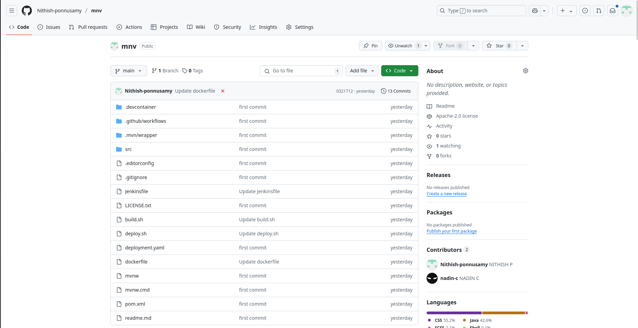

## Configure Jenkins
- In Jenkins go to `configure jenkins > tools
- Locate JDK section
- Uncheck `Install Automatically
- Name `Java 17
- Go to terminal and enter the command and get the java 17 path:

update-java-alternatives --list

- paste the java path in `JAVA_HOME`

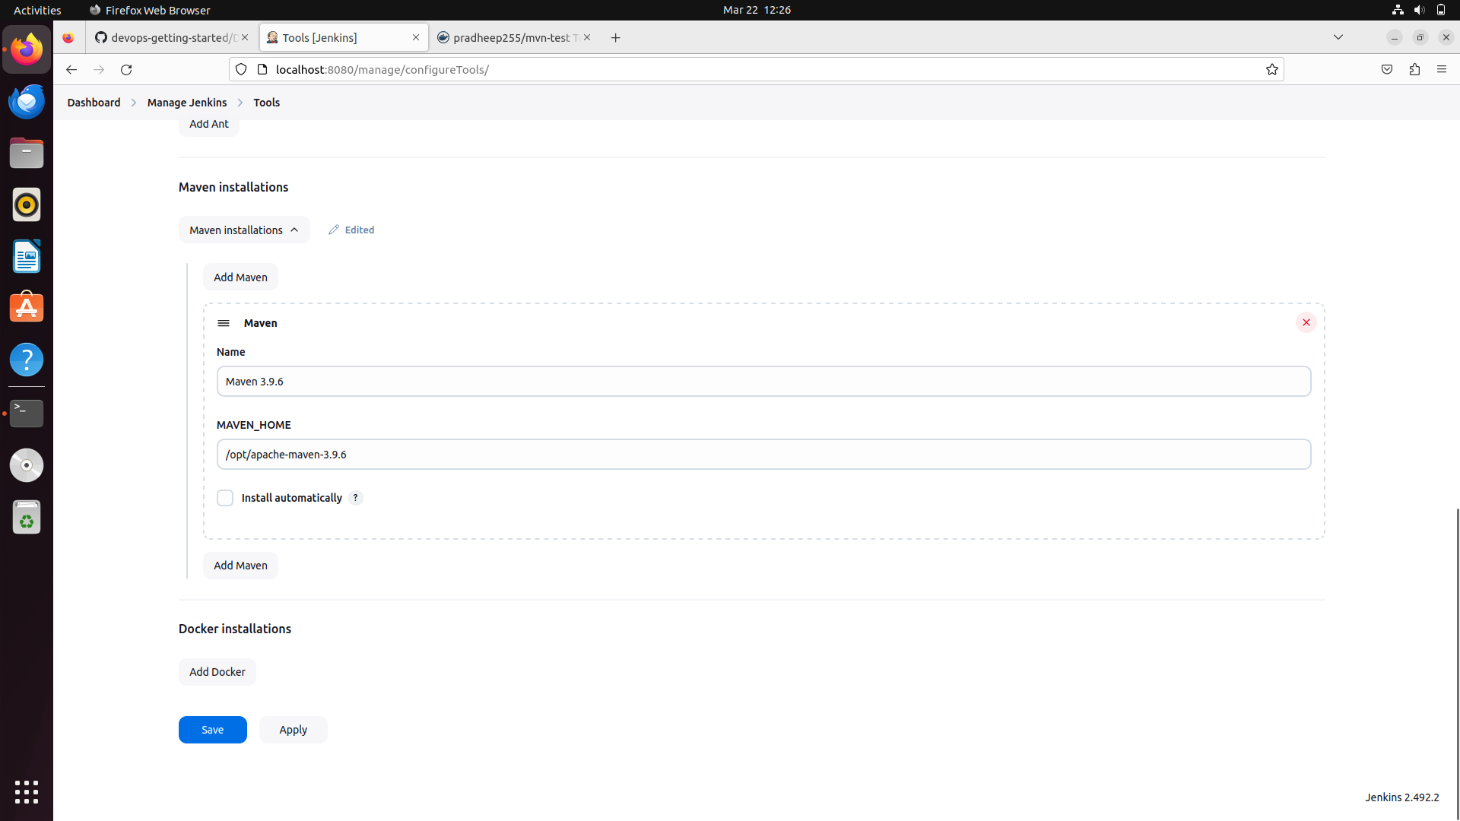

## Add the pipeline script and build the pipeline

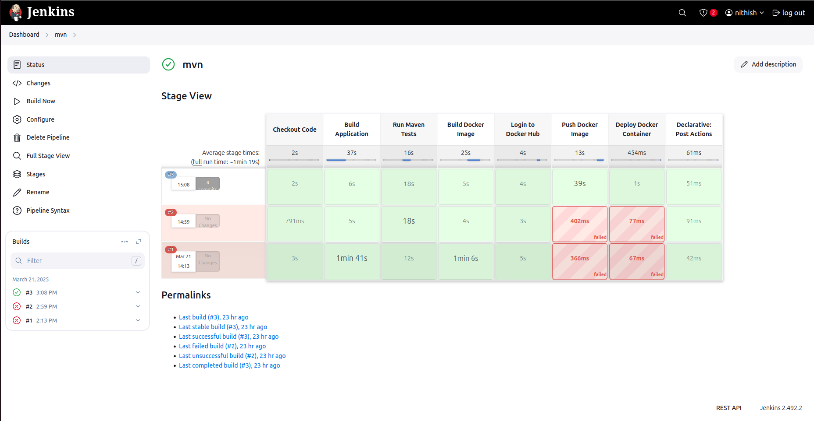

Pipeline

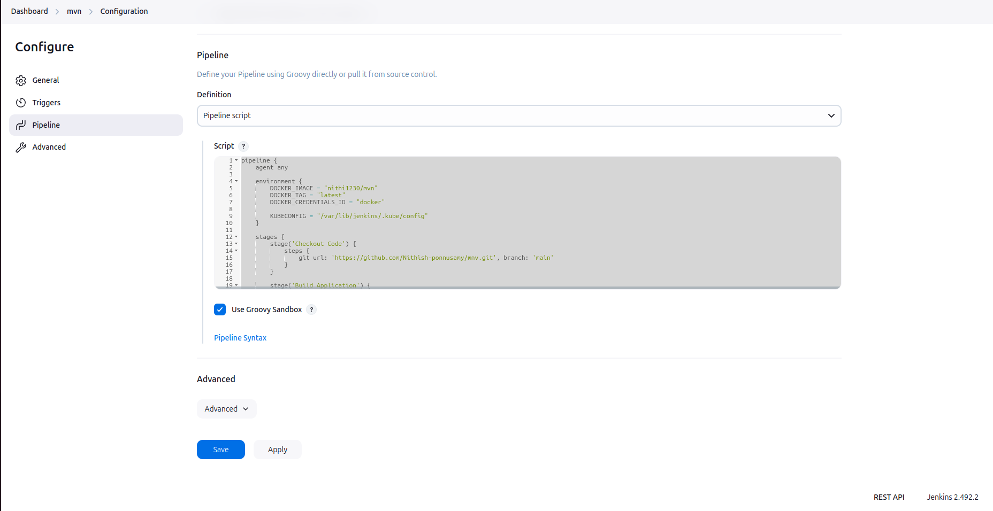
d

Pipeline code

pipeline {
agent any

environment {
DOCKER_IMAGE = "nithi1230/mvn"
DOCKER_TAG = "latest"
DOCKER_CREDENTIALS_ID = "docker"

KUBECONFIG = "/var/lib/jenkins/.kube/config"
}

stages {
stage('Checkout Code') {
steps {
git url: 'https://github.com/Nithish-ponnusamy/mnv.git', branch: 'main'
}
}

stage('Build Application') {
steps {
script {try {
sh '${MAVEN_HOME}/bin/mvn clean package -DskipTests'
} catch (Exception e) {
sh 'mvn test -Dmaven.test.failure.ignore=true'
echo "Tests failed, but proceeding..."
}

}
}
}

stage('Run Maven Tests') {
steps {
script {
try {
sh 'mvn test'
} catch (Exception e) {
sh 'mvn test -Dmaven.test.failure.ignore=true'
echo "Tests failed, but proceeding..."
}
}
}
}

stage('Build Docker Image') {
steps {
echo "Building Docker image..."
sh 'chmod +x build.sh'
sh './build.sh'
}
}
stage('Login to Docker Hub') {
steps {
echo "Logging into Docker Hub..."
withCredentials([usernamePassword(credentialsId: 'docker', usernameVariable: 'DOCKER_USER', passwordVariable: 'DOCKER_PASS')]) {
sh 'docker login -u $DOCKER_USER -p $DOCKER_PASS'
}
}
}

stage('Push Docker Image') {
steps {
echo "Pushing Docker image to Docker Hub..."
sh "docker tag $DOCKER_IMAGE:$DOCKER_TAG $DOCKER_IMAGE:$DOCKER_TAG"
sh "docker push $DOCKER_IMAGE:$DOCKER_TAG"
}
}

stage('Deploy Docker Container') {
steps {
echo "Deploying Docker container..."
sh 'chmod +x deploy.sh'
sh './deploy.sh'
}
}

}

post {
success {
echo "Deployment Successful!"
}
failure {
echo "Deployment Failed!"
}
}
}

Deployment.yaml

apiVersion: apps/v1
kind: Deployment
metadata:
name: mvn-app
spec:
replicas: 2
selector:
matchLabels:
app: mvn-app
template:
metadata:
labels:
app: mvn-app
spec:
containers:
- name: mvn-app
image: nithi1230/mvn:latest
ports:
- containerPort: 8081

service.yaml

apiVersion: v1
kind: Service
metadata:
name: mvn-app-service
spec:
selector:
app: mvn-app
ports:
- protocol: TCP
port: 80
targetPort: 8081
nodePort: 30002
type: NodePort

## Verify the console to see the actions

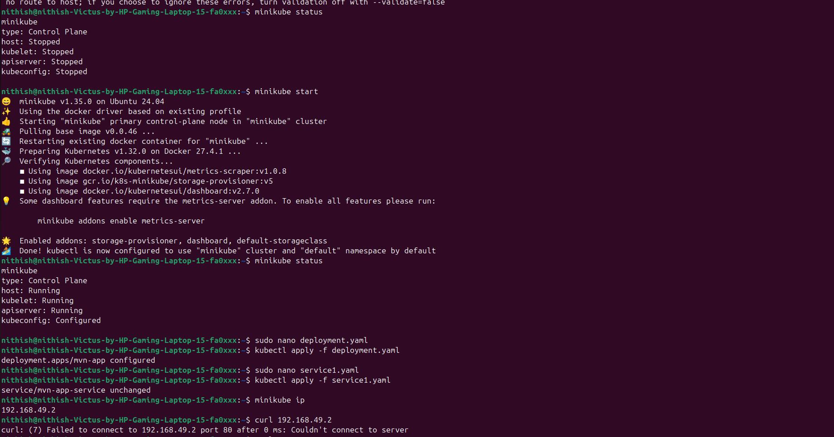

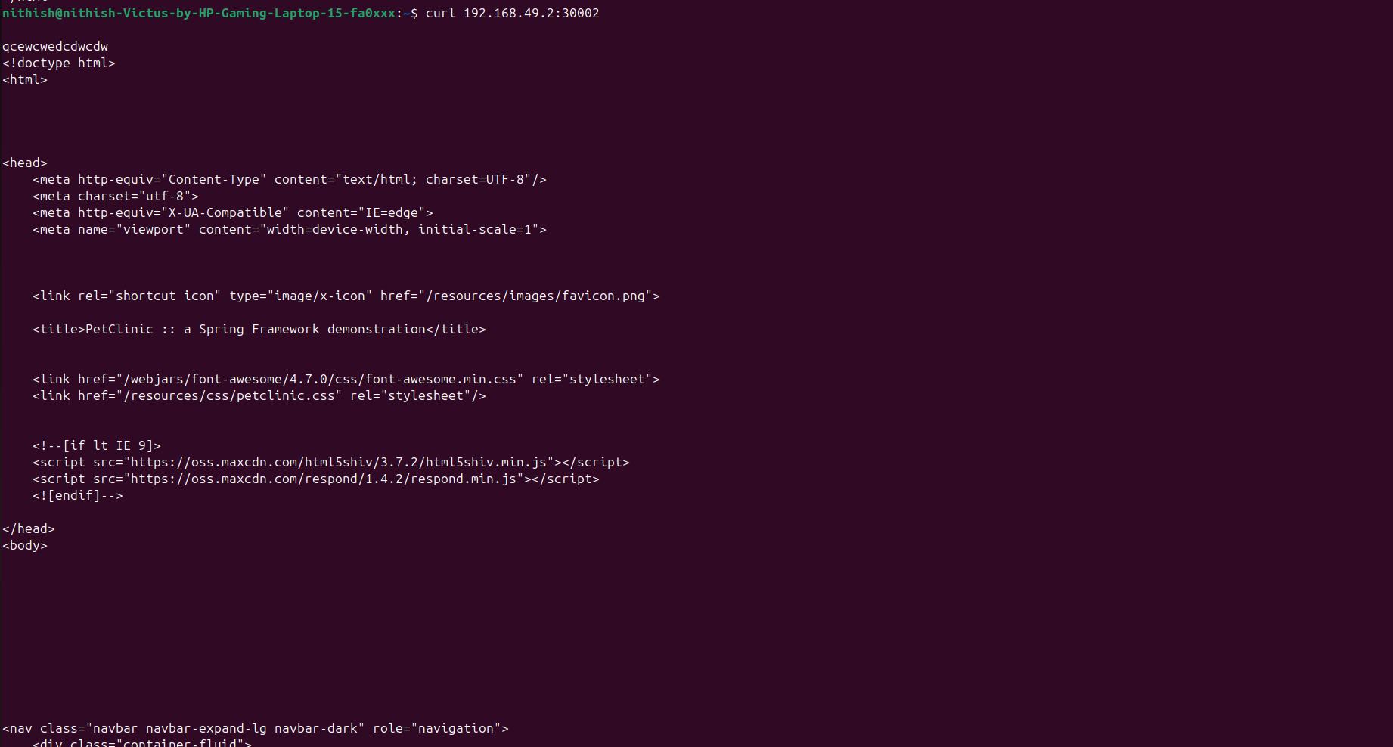

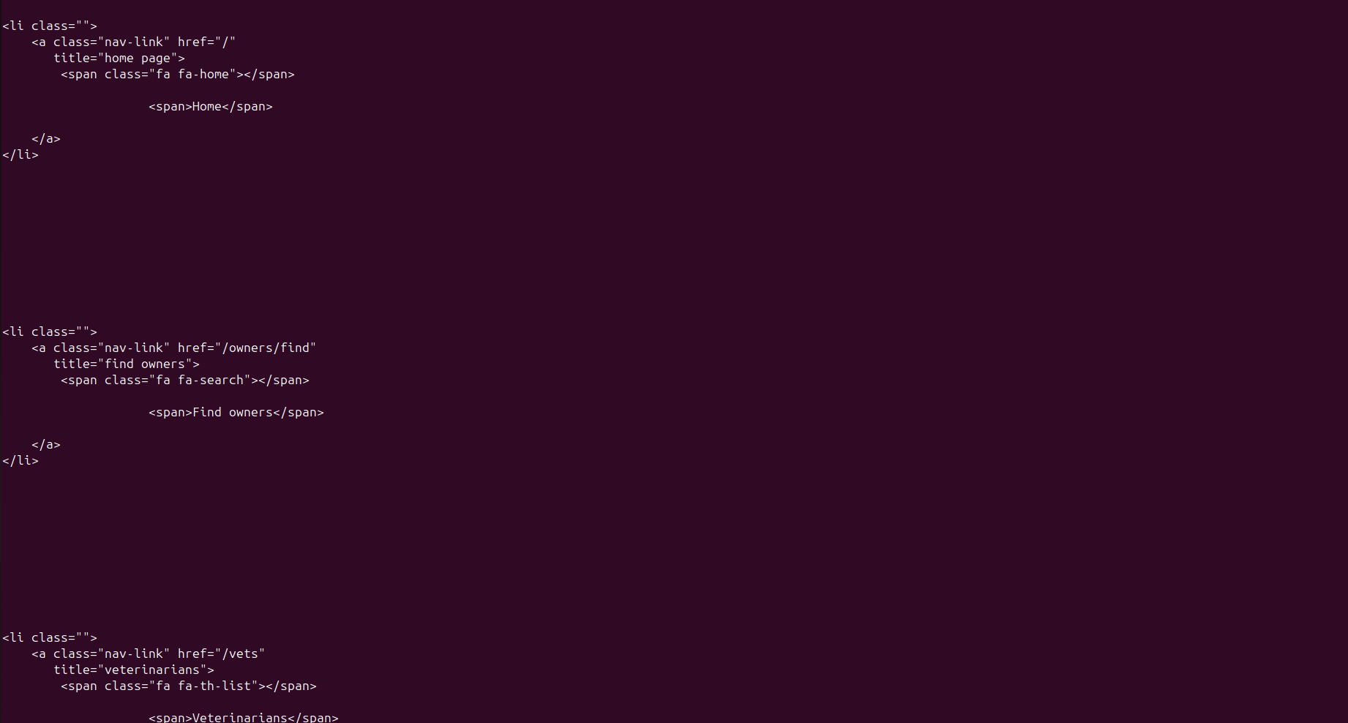

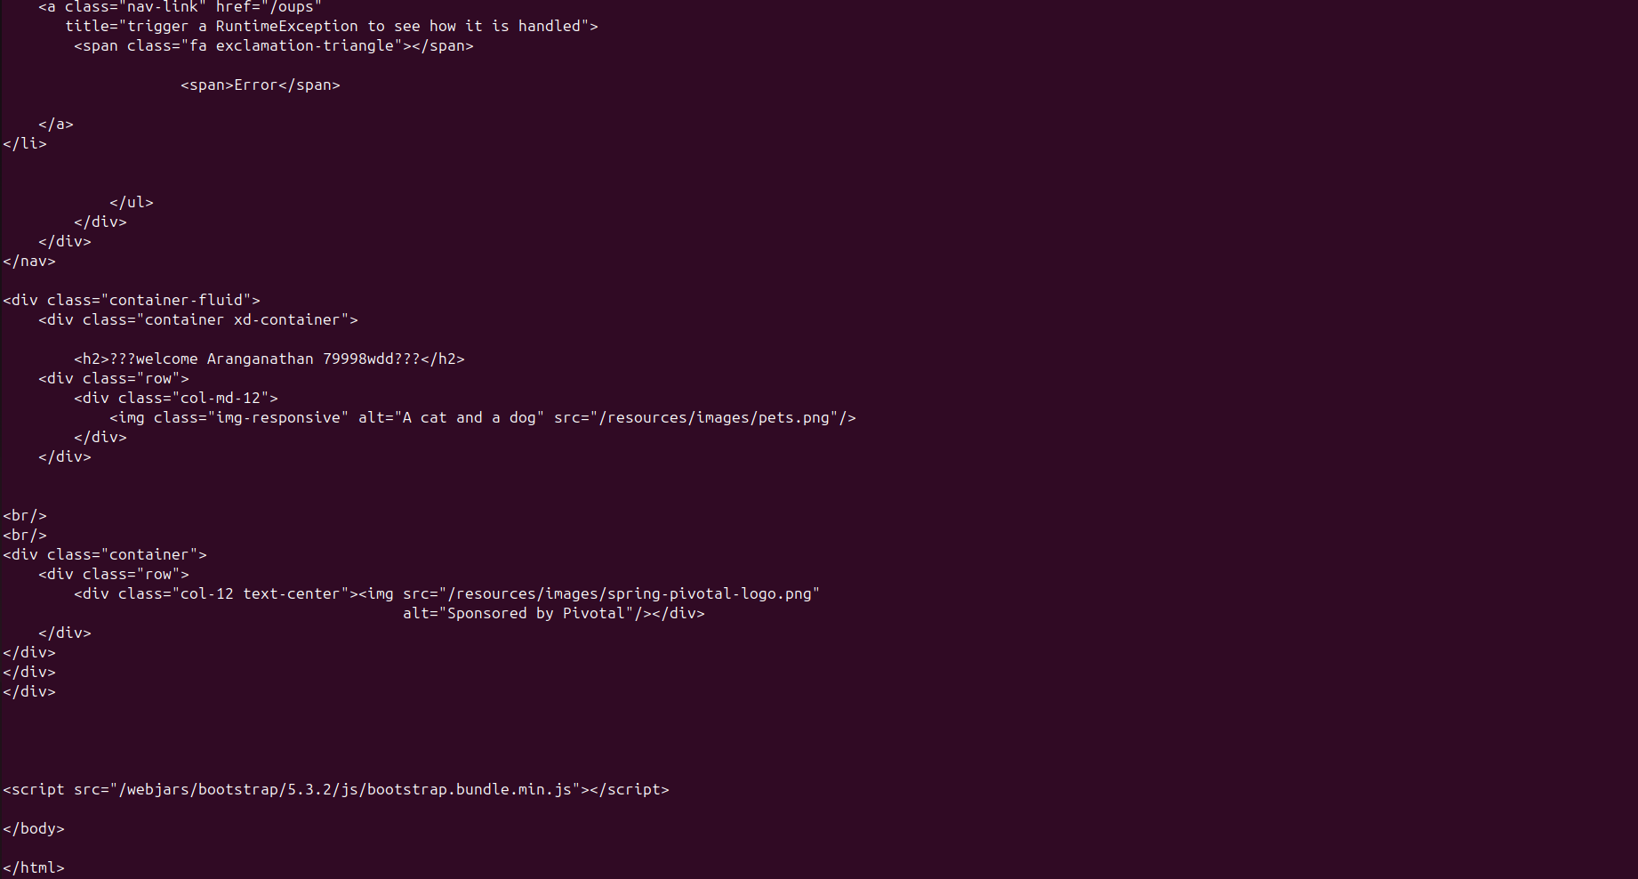

output:

