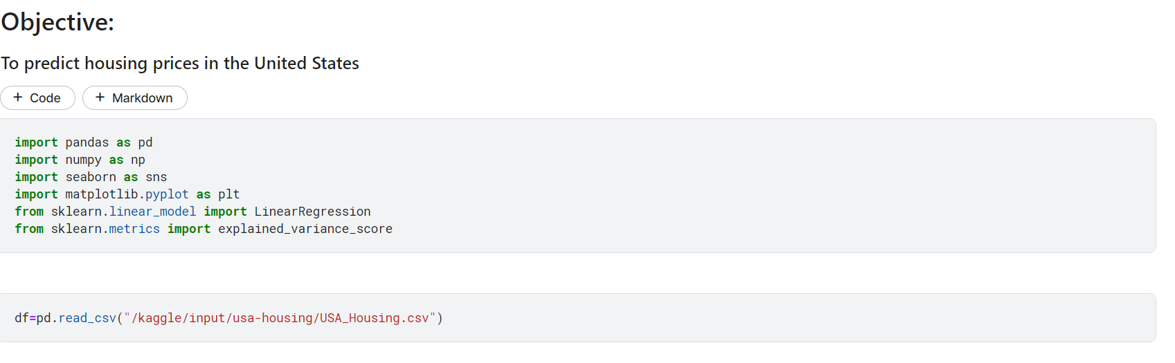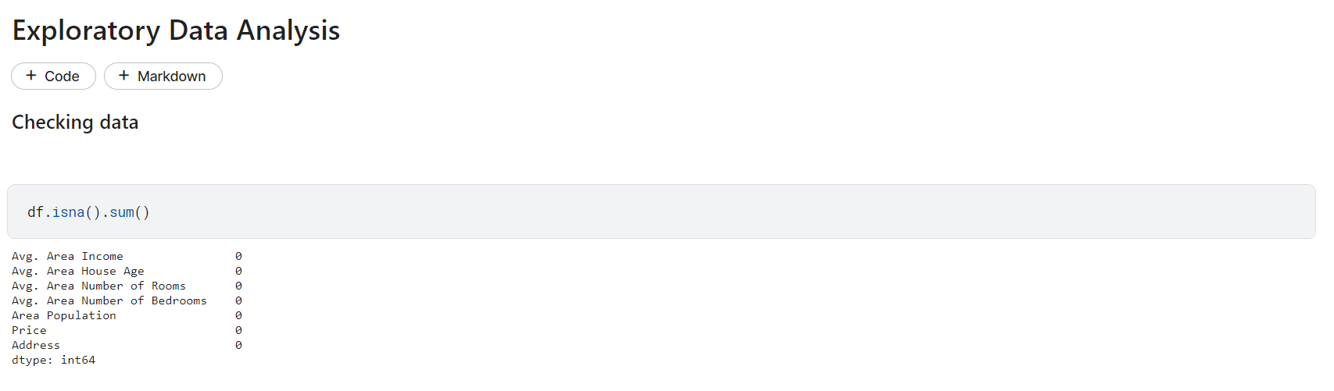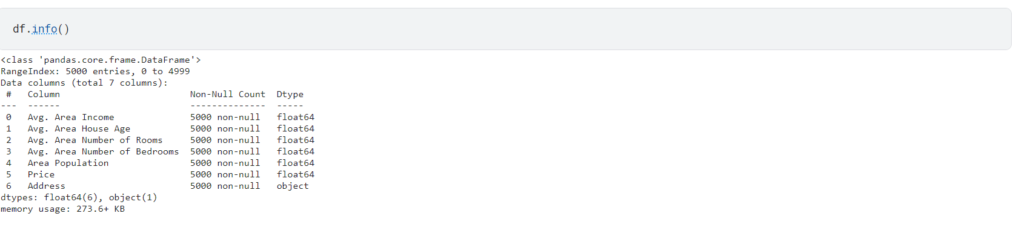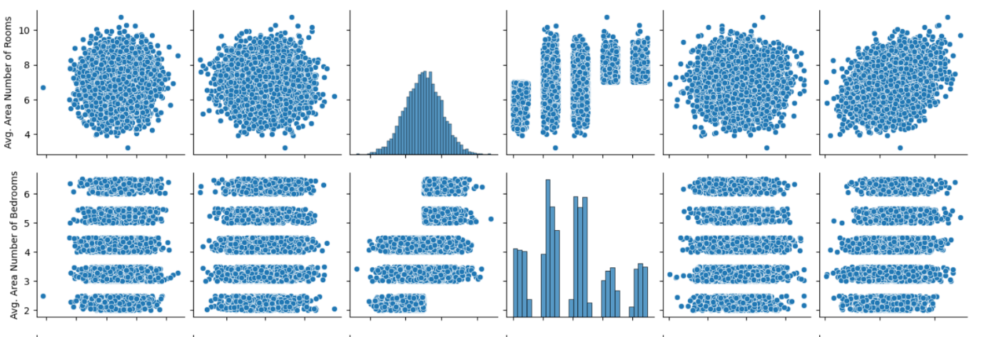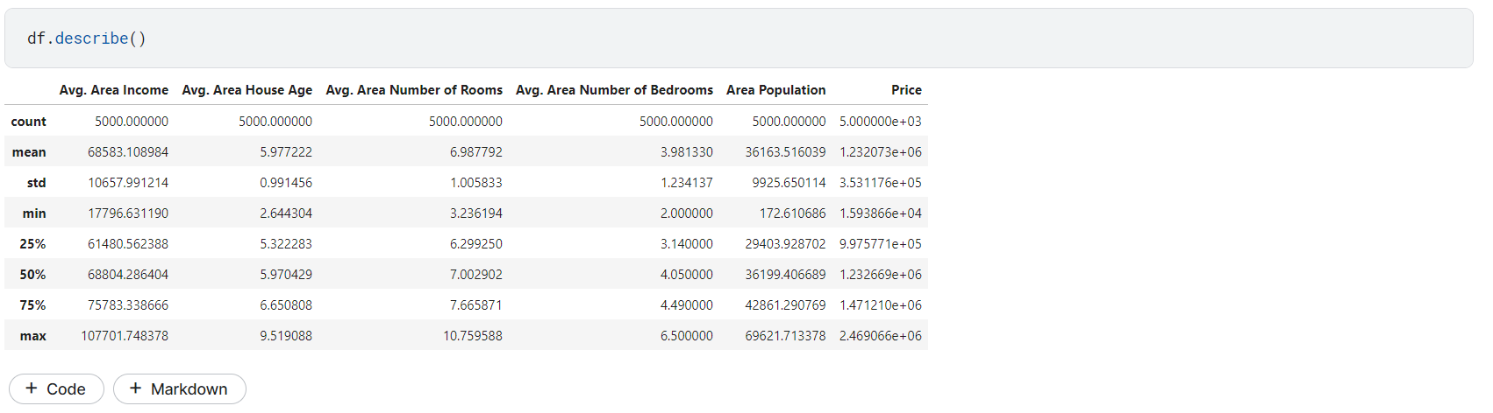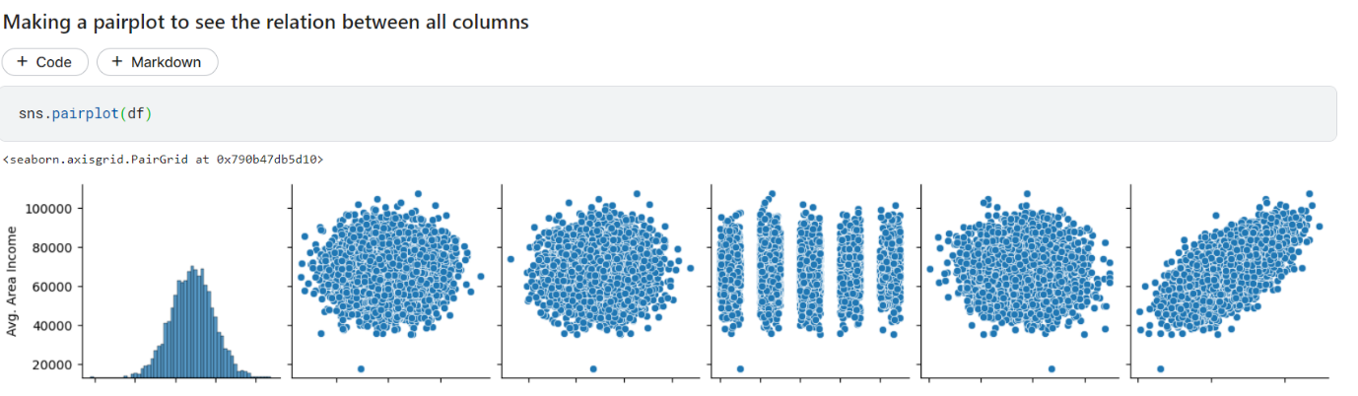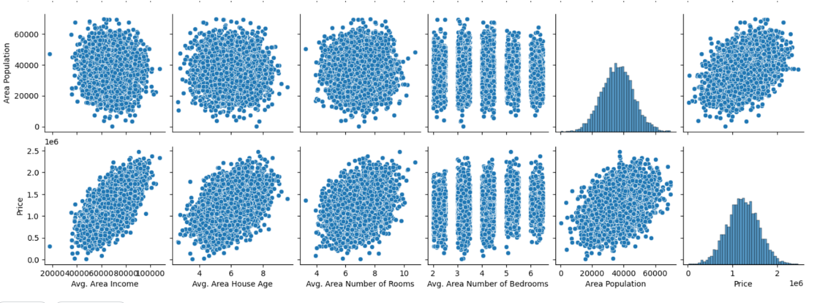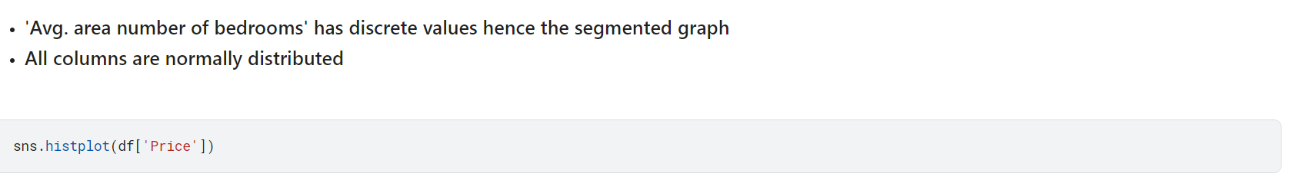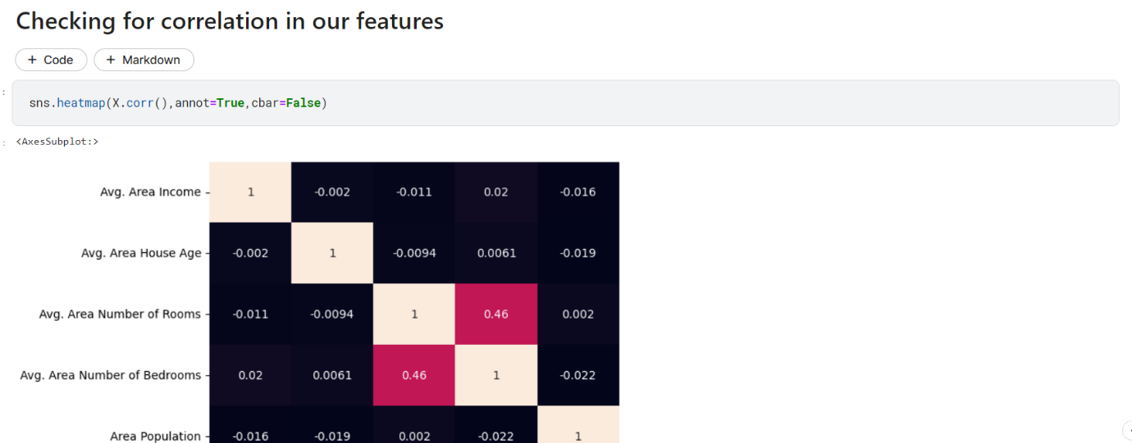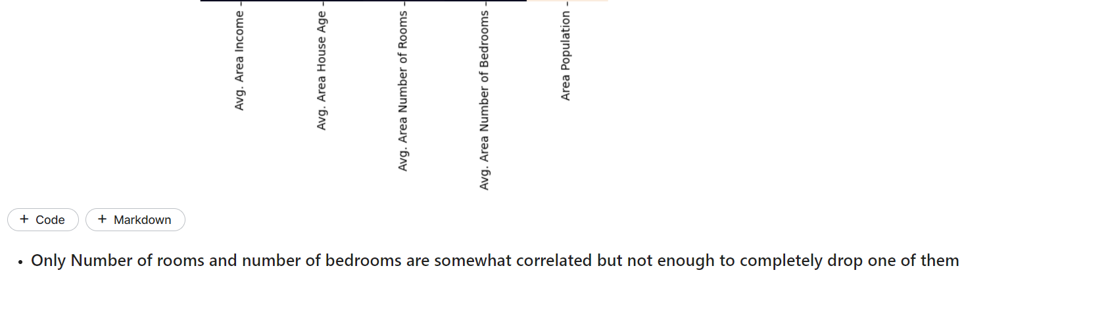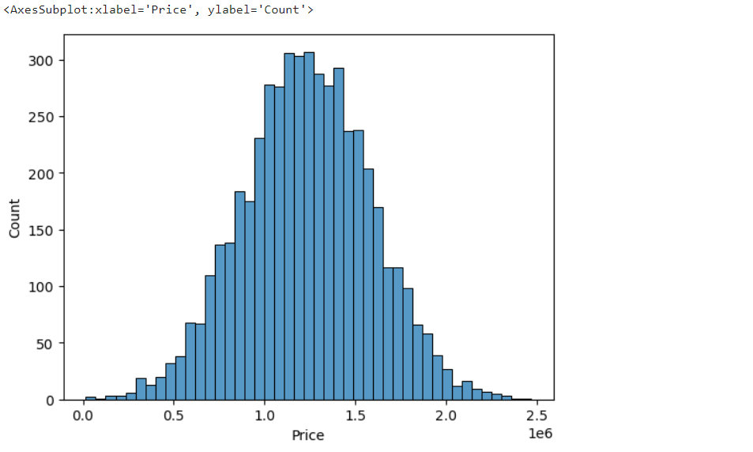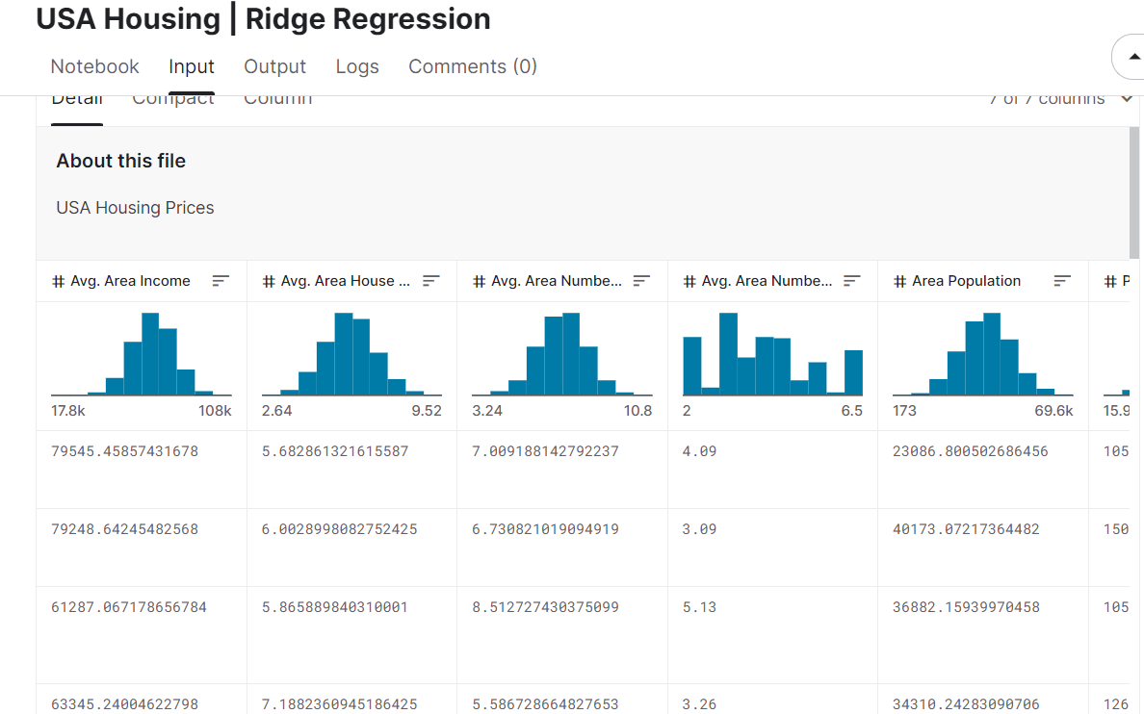

**PREDICTING HOUSE PRICE USING MACHINE LEARNING**

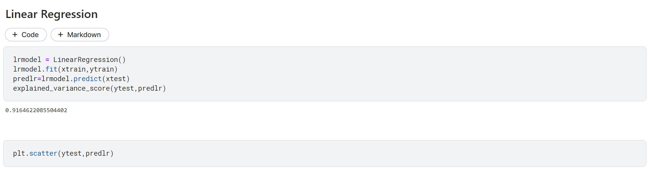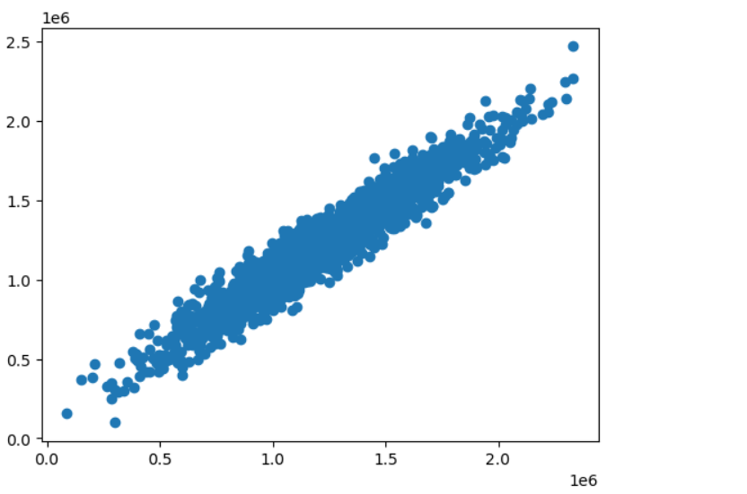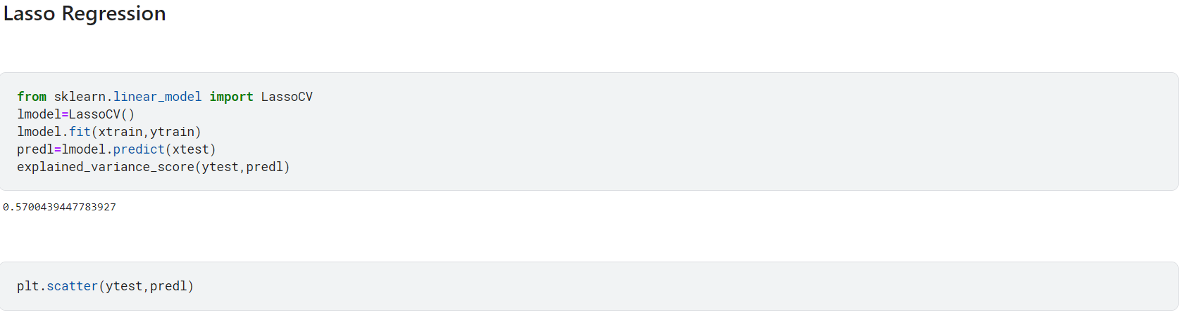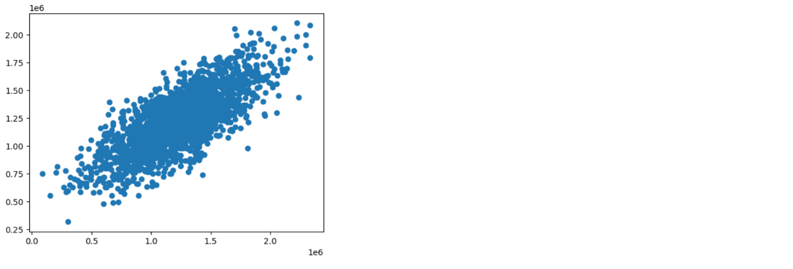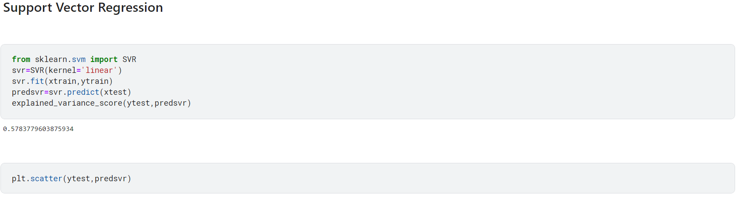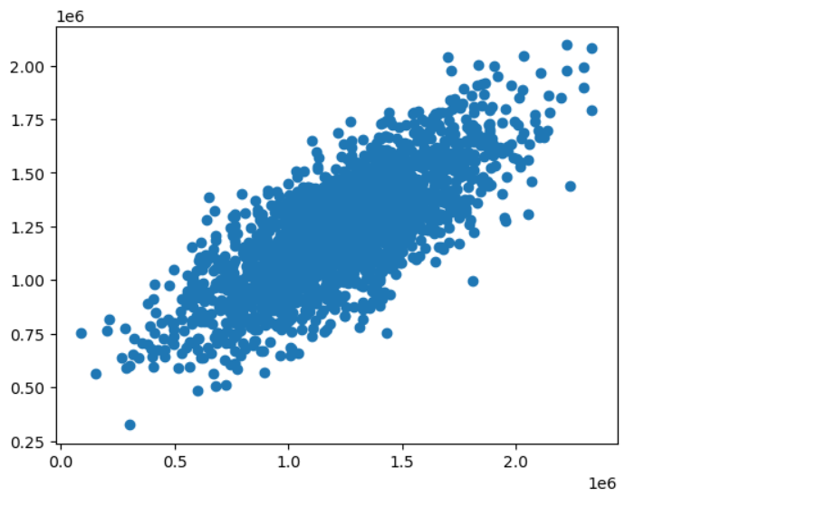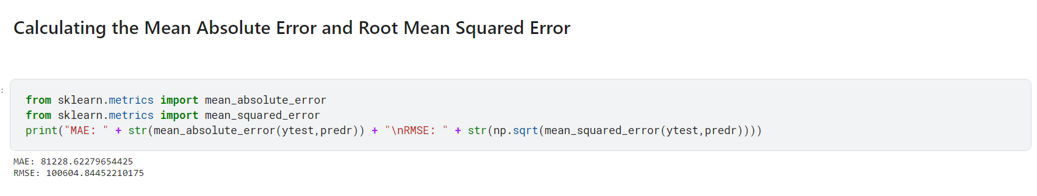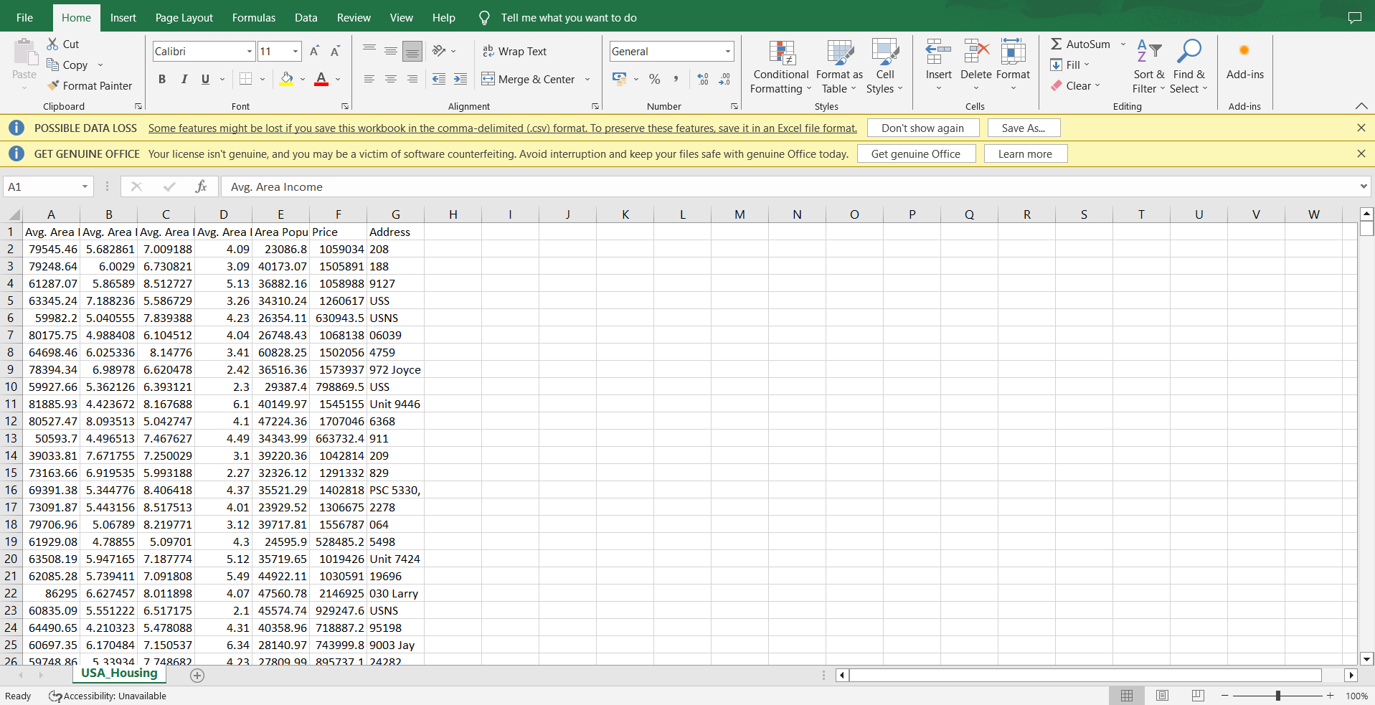

**EVALUATIONS:**

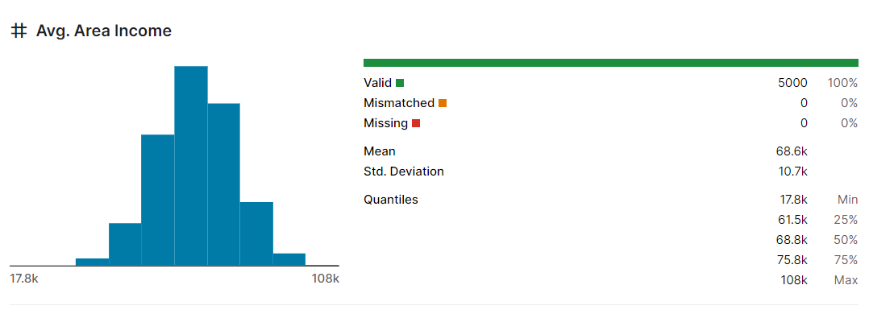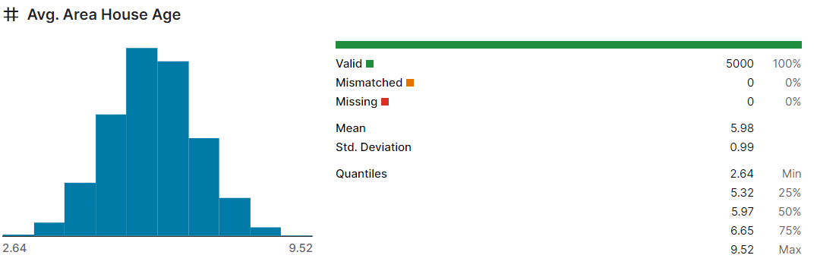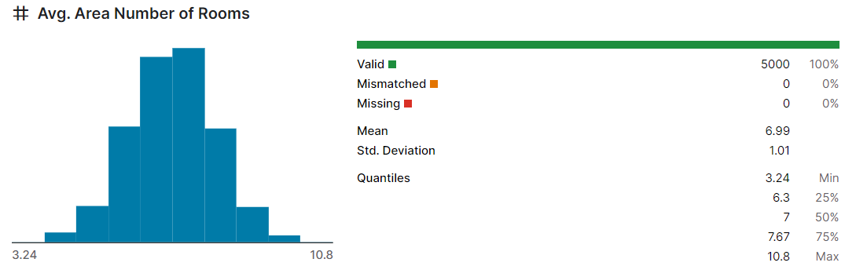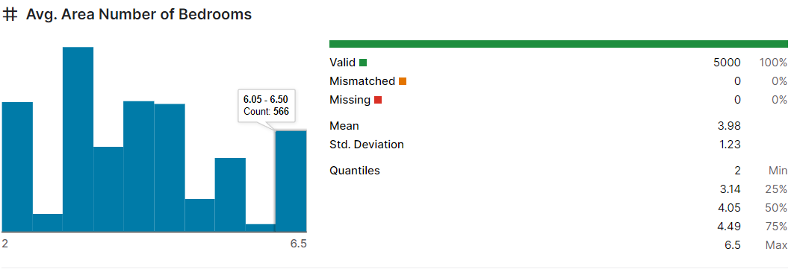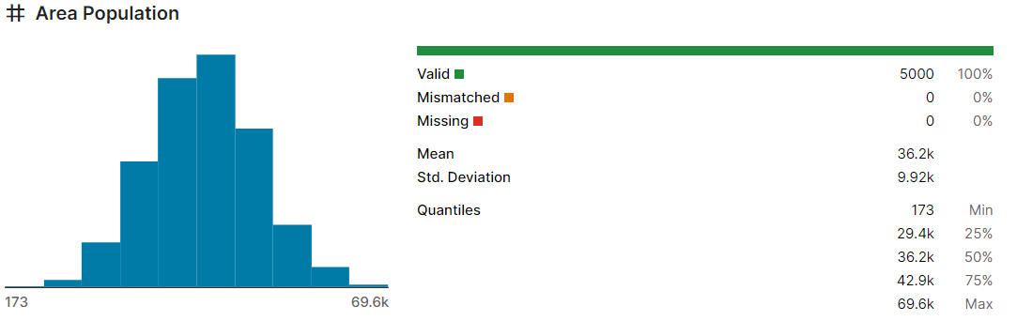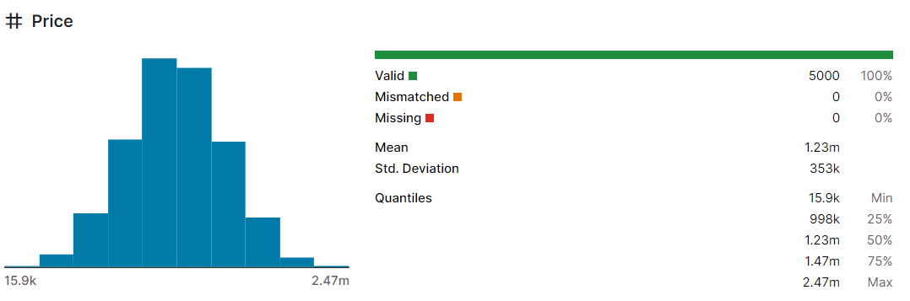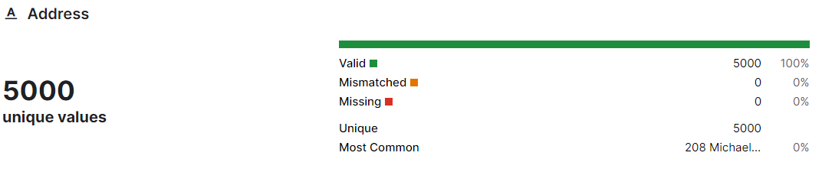

**MODEL AND ACCURACY:**

As we have train the model to determine the continuous values, so we will be using these regression models.

* svm – support vector machine
* random forest regression
* catboost classifier

**SVM - SUPPORT VECTOR MACHINE:**

It can used for both regression and classification problems or models.It finds hyperplane in the n-dimensional plane

**RANDOM FROEST REGRESSION:**

It is an ensemble technique that uses multiple of decisions trees and can be used for both regression and classification tasks.

**CATBOOST CLASSIFIER:**

It is a machine learning algorithm implemented by Yandex and is open-source. It is simple to interface with deep learning frameworks such as Apple’s Core ML and Google’s TenserFlow.

**CONCLUSIONS:**

Clearly ,**svm** **model** is giving better accuracy as the mean absolute error is least among all other regression models i.e, 0.18 approx.To get much better results ensemble learning techniques like **Bagging** and **Boosting** can used.