**JavaScript Functions and Strings:**

1.Maximum number

<!DOCTYPE html>

<html lang="en">

<head>

    <meta charset="UTF-8">

    <meta name="viewport" content="width=device-width, initial-scale=1.0">

    <title>Document</title>

</head>

<body>

    <h3>Maximum number:</h3>

    <script>

        function max(a,b){

            return a>b?a:b;

        }

        document.write(max(5,6));

        document.write("<br>");

        document.write(max(20,17));

    </script>

</body>

</html>

Output:



2.Landscape

<!DOCTYPE html>

<html lang="en">

<head>

    <meta charset="UTF-8">

    <meta name="viewport" content="width=device-width, initial-scale=1.0">

    <title>Document</title>

</head>

<body>

    <h3>Landscape:</h3>

    <script>

        function Landscape(height,width){

            return height<width;

        }

        document.write(Landscape(300,100));

        document.write("<br>");

        document.write(Landscape(500,600));

    </script>

</body>

</html>

Output:



3.Even or odd

<!DOCTYPE html>

<html lang="en">

<head>

    <meta charset="UTF-8">

    <meta name="viewport" content="width=device-width, initial-scale=1.0">

    <title>Document</title>

</head>

<body>

    <h3>Even or Odd numbers</h3>

    <script>

        function Even_Odd(x){

            if(x%2==0){

                document.write(x+" is even number<br>");

            }

            else{

                document.write(x+" is odd number<br>");

            }

        }

        Even_Odd(299);

        Even_Odd(144);

        Even_Odd(71);

        Even_Odd(572);

    </script>

</body>

</html>

Output:

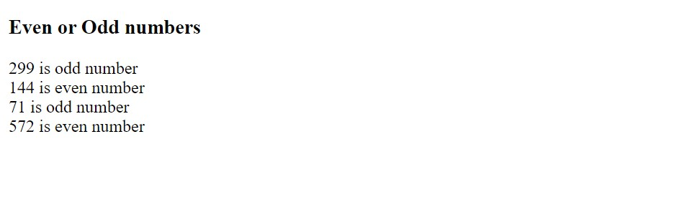

4.Speed limits

<!DOCTYPE html>

<html lang="en">

<head>

    <meta charset="UTF-8">

    <meta name="viewport" content="width=device-width, initial-scale=1.0">

    <title>Document</title>

</head>

<body>

    <h3>Speed limits</h3>

    <script>

        function CheckSpeed(speed){

            let speed_limit=50;

            let warning=80;

            if(speed<=speed_limit){

                document.write("Safe driving.");

            }

            else if(speed>speed_limit && speed<=warning){

                document.write("Decrese speed to 50.");

            }

            else{

                document.write("Your licese suspended!");

            }

            document.write("<br>");

        }

        CheckSpeed(49);

        CheckSpeed(79);

        CheckSpeed(100);

    </script>

</body>

</html>

Output:



5.Sorting array

<!DOCTYPE html>

<html lang="en">

<head>

    <meta charset="UTF-8">

    <meta name="viewport" content="width=device-width, initial-scale=1.0">

    <title>Sort array</title>

</head>

<body>

    <h1>Sorting array in ascending order</h1>

    <script>

        let numbers=[2,5,7,6,4,3];

        document.write("Original array is: "+numbers+"<br>");

        numbers.sort();

        document.write("Sorting of given array in Ascending order is: "+numbers);

    </script>

</body>

</html>

Output:



6.Prime

<!DOCTYPE html>

<html lang="en">

<head>

    <meta charset="UTF-8">

    <meta name="viewport" content="width=device-width, initial-scale=1.0">

    <title>Prime Number</title>

</head>

<body>

    <h3>Check if given number is prime</h3>

    <script>

        function Prime(n){

        let a;

        let prime=true;

        for(a=2;a<n;a++){

            if(n%a==0){

                prime=false;

                break;

            }

        }

        if(prime==false){

            document.write(n+" is not a prime number.");

        }

        else{

            document.write(n+" is a prime number.");

        }

        document.write("<br>");

    }

    Prime(2);

    Prime(4);

    Prime(7);

    Prime(9);

    Prime(10);

    </script>

</body>

</html>

Output:

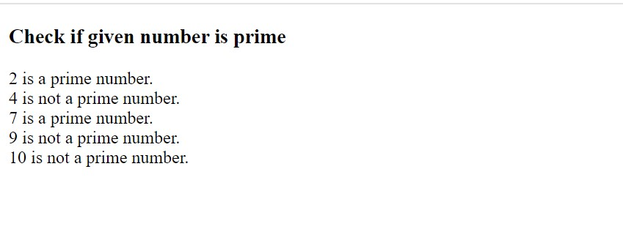

7.Reverse String

<!DOCTYPE html>

<html lang="en">

<head>

    <meta charset="UTF-8">

    <meta name="viewport" content="width=device-width, initial-scale=1.0">

    <title>Reverse String</title>

</head>

<body>

    <h3>Reverse of a String</h3>

    <script>

        let s="'Nithish'";

        let Revstr="";

        for(let i=s.length-1;i>=0;i--){

            Revstr=Revstr+s[i];

        }

        document.write("Reverse of "+s+" is "+Revstr);

    </script>

</body>

</html>

Output:

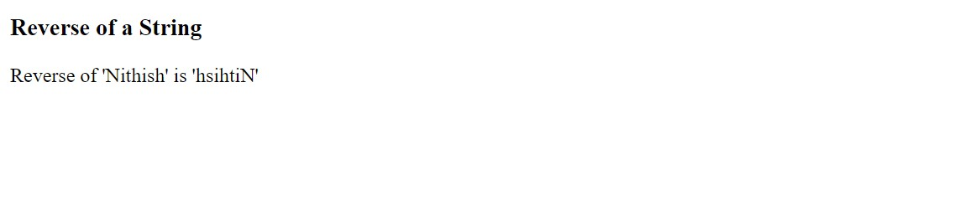

8.Sum of array

<!DOCTYPE html>

<html lang="en">

<head>

    <meta charset="UTF-8">

    <meta name="viewport" content="width=device-width, initial-scale=1.0">

    <title>Sum of Array</title>

</head>

<body>

    <h3>Sum of all elements in array</h3>

    <script>

        let n=[1,3,4,6,10];

        let sum=0;

        for(let i=0;i<n.length;i++){

            sum=sum+n[i];

        }

        document.write("Given array is: "+n+"<br>");

        document.write("Sum of all elements of array is "+sum);

    </script>

</body>

</html>

Output:

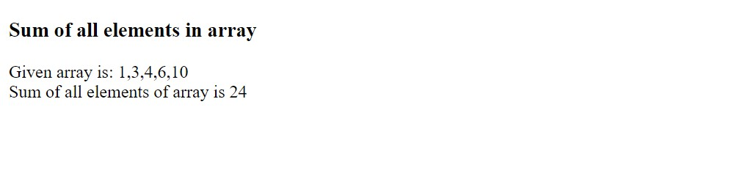

9.Concatenation of Array

<!DOCTYPE html>

<html lang="en">

<head>

    <meta charset="UTF-8">

    <meta name="viewport" content="width=device-width, initial-scale=1.0">

    <title>Document</title>

</head>

<body>

    <h3>Concatenation of array</h3>

    <script>

        let arr1=[1,2,3,4,5];

        let arr2=[6,7,8,9,10];

        document.write("Given arrays are: <br>"+arr1+"<br>"+arr2+"<br>");

        let concat=arr1.concat(arr2);

        document.write("Concat of arrays is: "+concat);

    </script>

</body>

</html>

Output:

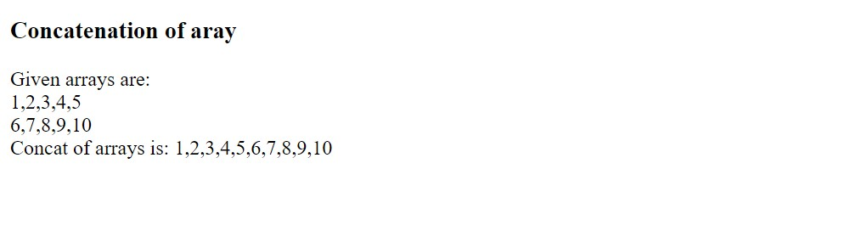

10.Add and delete elements in array

<!DOCTYPE html>

<html lang="en">

<head>

    <meta charset="UTF-8">

    <meta name="viewport" content="width=device-width, initial-scale=1.0">

    <title>Document</title>

</head>

<body>

    <h3>Add or Delete element in array</h3>

    <script>

        let array1=[2,4,6,8,10,12,14];

        document.write("Given array is :"+array1+"<br>");

        array1.push(15,16);

        document.write("After adding elemets: "+array1+"<br><br>");

        let array2=[1,2,3,4,5,6];

        document.write("Given array is :"+array2+"<br>");

        array2.pop();

        document.write("After deleting elemet: "+array2);

    </script>

</body>

</html>

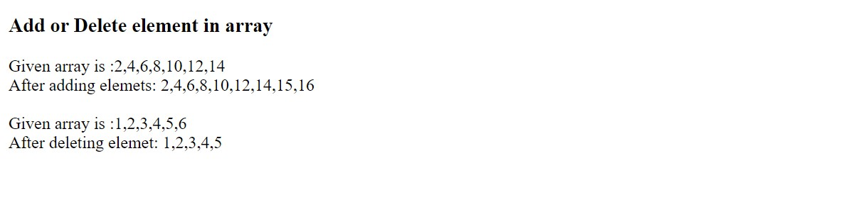

11.Loop in array

<!DOCTYPE html>

<html lang="en">

<head>

    <meta charset="UTF-8">

    <meta name="viewport" content="width=device-width, initial-scale=1.0">

    <title>Document</title>

</head>

<body>

    <h3>Loop in aray</h3>

    <script>

        let array=["A","B","C","D","E"];

        document.write("Elements of given array are:<br>");

        for(let i=0;i<array.length;i++){

            document.write(array[i]+" ");

        }

    </script>

</body>

</html>

Output:

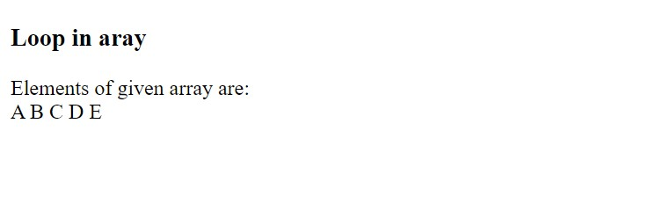

12. Largest of 3 numbers

<!DOCTYPE html>

<html lang="en">

<head>

    <meta charset="UTF-8">

    <meta name="viewport" content="width=device-width, initial-scale=1.0">

    <title>Largest Number</title>

</head>

<body>

    <h3>Largest of 3 numbers</h3>

    <script>

        function Largest(a,b,c){

            if(a>b && a>c){

                document.write(a+" is largest number.");

            }

            else if(b>a && b>c){

                document.write(b+" is largest number.");

            }

            else{

                document.write(c+" is largest number.");

            }

            document.write("<br>");

        }

        Largest(10,20,30);

        Largest(111,201,56);

    </script>

</body>

</html>

Output:

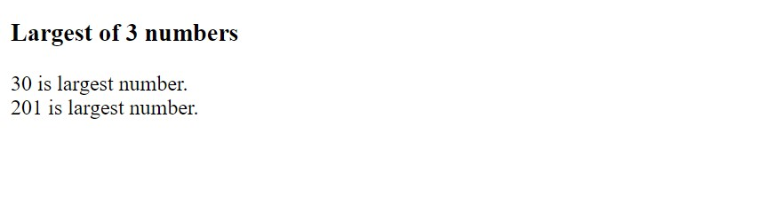

13.Voter age checking

<!DOCTYPE html>

<html lang="en">

<head>

    <meta charset="UTF-8">

    <meta name="viewport" content="width=device-width, initial-scale=1.0">

    <title>Document</title>

</head>

<body>

    <h3>Voter eligibility checking</h3>

    <script>

        function CheckVoter(age){

            if(age<18){

                document.write("Your age is "+age+", so not eligible to apply vote");

            }

            else{

                document.write("Your age is "+age+", so eligible to apply vote");

            }

            document.write("<br>");

        }

        CheckVoter(17);

        CheckVoter(21);

    </script>

</body>

</html>

Outpt:

