1. Write a JavaScript program that prints all even numbers from 1 to 20.

<!DOCTYPE html>

<html lang="en">

<head>

    <meta charset="UTF-8">

    <meta name="viewport" content="width=device-width, initial-scale=1.0">

    <title>Even Numbers</title>

</head>

<body>

    <h2>Even numbers from 1 to 20:</h2>

    <script>

        let x;

        for(x=1;x<=20;x++){

            if(x%2==0){

                document.write(x+"<br>");

            }

        }

    </script>

</body>

</html>

Output:

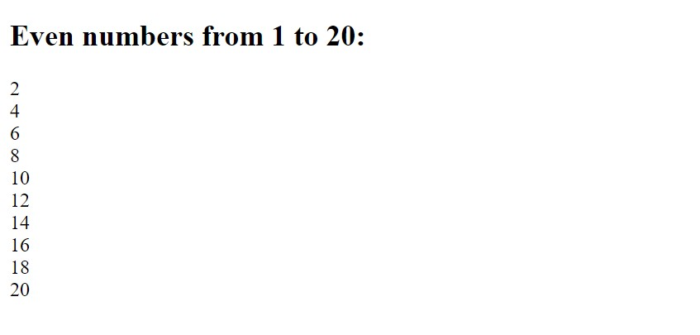

1. Create a JavaScript function that checks if a given number is prime.

<!DOCTYPE html>

<html lang="en">

<head>

    <meta charset="UTF-8">

    <meta name="viewport" content="width=device-width, initial-scale=1.0">

    <title>Prime Number</title>

</head>

<body>

    <h3>Check if given number is prime</h3>

    <script>

        function Prime(n){

        let a;

        let prime=true;

        for(a=2;a<n;a++){

            if(n%a==0){

                prime=false;

                break;

            }

        }

        if(prime==false){

            document.write(n+" is not a prime number.");

        }

        else{

            document.write(n+" is a prime number.");

        }

        document.write("<br>");

    }

    Prime(2);

    Prime(4);

    Prime(7);

    Prime(9);

    Prime(10);

    </script>

</body>

</html>

Output:

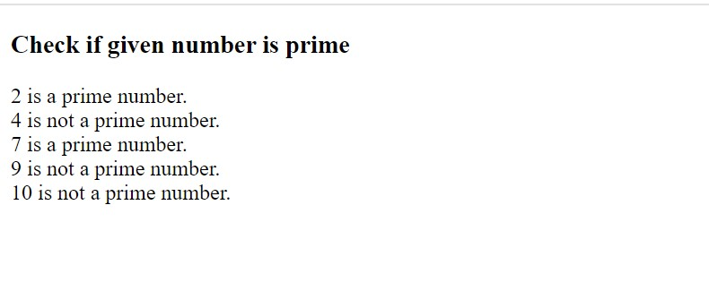

1. Write a JavaScript program to find the largest of three numbers.

<!DOCTYPE html>

<html lang="en">

<head>

    <meta charset="UTF-8">

    <meta name="viewport" content="width=device-width, initial-scale=1.0">

    <title>Largest Number</title>

</head>

<body>

    <h3>Largest of 3 numbers</h3>

    <script>

        let a,b,c;

        a=10;

        b=8;

        c=13;

        if(a>b && a>c){

            document.write(a+" is largest number.");

        }

        else if(b>a && b>c){

            document.write(b+" is largest number.");

        }

        else{

            document.write(c+" is largest number.");

        }

    </script>

</body>

</html>

Output:

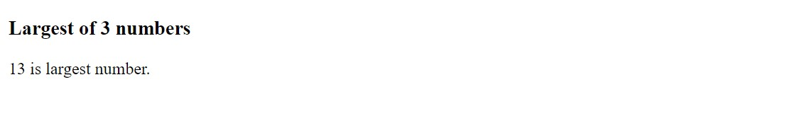

1. Develop a JavaScript function to calculate the factorial of a number using a for loop.

<!DOCTYPE html>

<html lang="en">

<head>

    <meta charset="UTF-8">

    <meta name="viewport" content="width=device-width, initial-scale=1.0">

    <title>Factorial</title>

</head>

<body>

    <h3>Factorial of number</h3>

    <script>

        function Factorial(n){

            let x;

            let fact=1;

            if(n==0){

                document.write("Factorial of "+n+" is 1");

            }

            for(x=2;x<=n;x++){

                fact=fact\*x;

            }

            document.write("Factorial of "+n+" is "+fact);

            document.write("<br>");

        }

        Factorial(4);

        Factorial(5);

    </script>

</body>

</html>

Output:

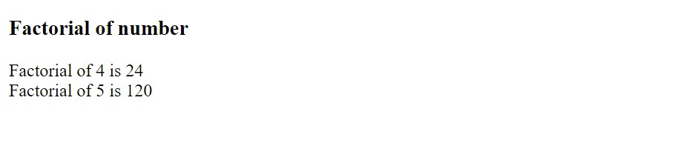

1. Create a JavaScript program that reverses a given string.

<!DOCTYPE html>

<html lang="en">

<head>

    <meta charset="UTF-8">

    <meta name="viewport" content="width=device-width, initial-scale=1.0">

    <title>Reverse String</title>

</head>

<body>

    <h3>Reverse of a String</h3>

    <script>

        let s="'Nithish'";

        let Revstr="";

        for(let i=s.length-1;i>=0;i--){

            Revstr=Revstr+s[i];

        }

        document.write("Reverse of "+s+" is "+Revstr);

    </script>

</body>

</html>

Output:

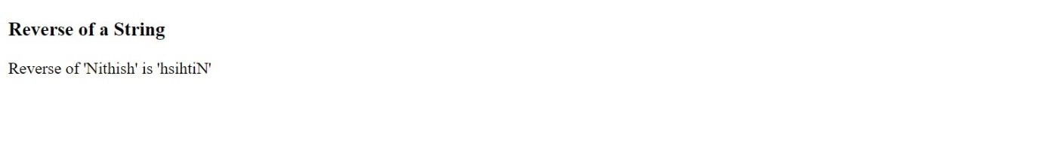

1. Write a JavaScript function that checks if a given string is a palindrome.

<!DOCTYPE html>

<html lang="en">

<head>

    <meta charset="UTF-8">

    <meta name="viewport" content="width=device-width, initial-scale=1.0">

    <title>Palindrome</title>

</head>

<body>

    <h3>Palindrome string</h3>

    <script>

        let s="noton";

        let Revstr="";

        for(let i=s.length-1;i>=0;i--){

            Revstr=Revstr+s[i];

        }

        if(Revstr==s){

            document.write(s+" is a palindrome");

        }

        else{

            document.write(s+" is not a palindrome");

        }

    </script>

</body>

</html>

Output:

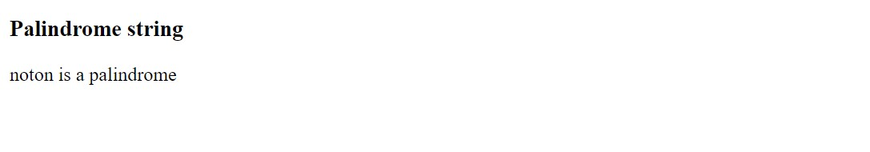

1. Implement a JavaScript program to find the sum of all elements in an array.

<!DOCTYPE html>

<html lang="en">

<head>

    <meta charset="UTF-8">

    <meta name="viewport" content="width=device-width, initial-scale=1.0">

    <title>Sum of Array</title>

</head>

<body>

    <h3>Sum of all elements in array</h3>

    <script>

        let n=[1,3,4,6,10];

        let sum=0;

        for(let i=0;i<n.length;i++){

            sum=sum+n[i];

        }

        document.write("Sum of all elements of array is "+sum);

    </script>

</body>

</html>

Output:

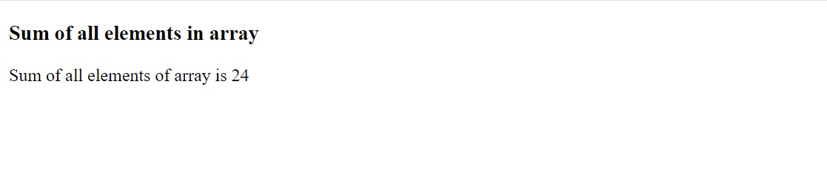

1. Write a JavaScript function to remove duplicates from an array.

<!DOCTYPE html>

<html lang="en">

<head>

    <meta charset="UTF-8">

    <meta name="viewport" content="width=device-width, initial-scale=1.0">

    <title>Remove Duplicates</title>

</head>

<body>

    <h3>Remove duplicates from array</h3>

    <script>

        let num=[2,4,6,5,2,4,2,1];

        function RemoveDuplicates(num) {

           let unique = [];

            num.forEach(element => {

            if (!unique.includes(element)) {

                unique.push(element);

                }

            })

            document.write("Array elements after removing duplicates are:<br>");

            for(let i=0;i<unique.length;i++){

                document.write(unique[i]+"<br>");

            }

        }

        RemoveDuplicates(num);

    </script>

</body>

</html>

Output:

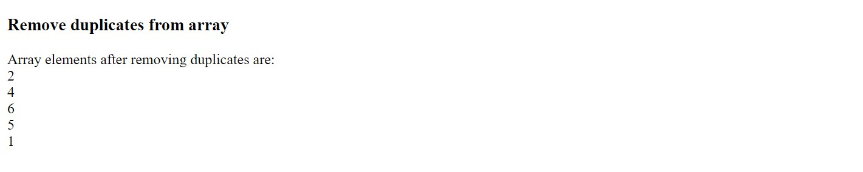

1. Develop a JavaScript program to find the second largest number in an array.

<!DOCTYPE html>

<html lang="en">

<head>

    <meta charset="UTF-8">

    <meta name="viewport" content="width=device-width, initial-scale=1.0">

    <title>Second Largest</title>

</head>

<body>

    <h3>Second largest number in array</h3>

    <script>

        let a=[10,100,60,40,50];

        function SecondLargest(a) {

            let first = -Infinity;

            let second = -Infinity;

            for (let num of a) {

                if (num > first) {

                second = first;

                first = num;

                } else if (num > second && num < first) {

                second = num;

                }

             }

             document.write("Second largest number is "+second);

            }

            SecondLargest(a);

    </script>

</body>

</html>

Output:

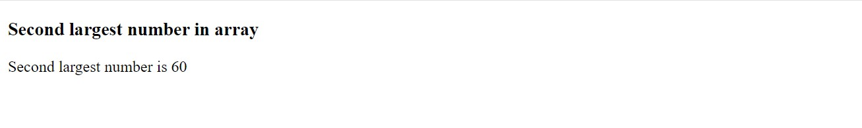

1. Create a JavaScript function that checks if a number is even or odd.

<!DOCTYPE html>

<html lang="en">

<head>

    <meta charset="UTF-8">

    <meta name="viewport" content="width=device-width, initial-scale=1.0">

    <title>Even or odd</title>

</head>

<body>

    <h1>Checking the given number is Even or Odd</h1>

    <script>

        function EvenOrOdd(n){

            if(n%2==0){

                document.write(n+" is even number.");

            }

            else{

                document.write(n+" is odd number.");

            }

            document.write("<br>");

        }

        EvenOrOdd(35);

        EvenOrOdd(40);

    </script>

</body>

</html>

Output:

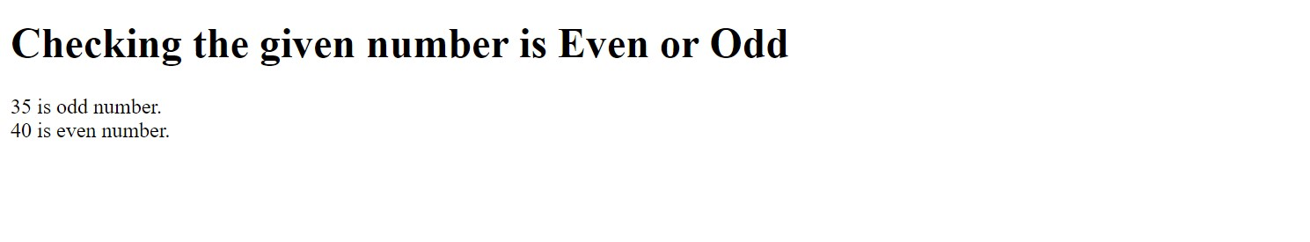

1. Write a JavaScript program to merge two arrays and remove duplicates.

<!DOCTYPE html>

<html lang="en">

<head>

    <meta charset="UTF-8">

    <meta name="viewport" content="width=device-width, initial-scale=1.0">

    <title>Merge Arrays</title>

</head>

<body>

    <h3>Merge 2 arrays and remove duplicates</h3>

    <script>

        let a1 = [0,1,2,1,0,3,4,4];

        let a2 = [6,5,3,6,5];

        let newArray = a1.concat(a2)

        let unique = [];

            newArray.forEach(element => {

            if (!unique.includes(element)) {

                unique.push(element);

                }

            });

            for(let i=0;i<unique.length;i++){

                document.write(unique[i]+"<br>");

            }

 </script>

</body>

</html>

Output:

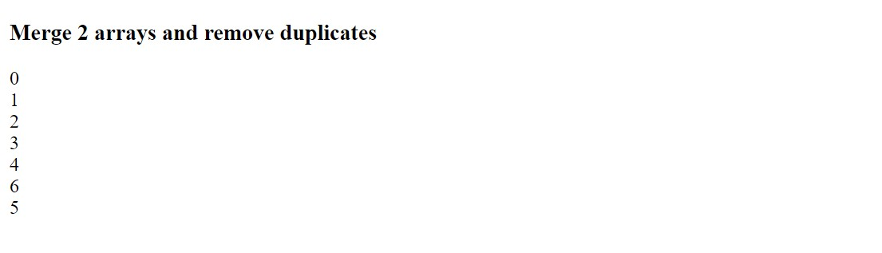

1. Create a JavaScript function to find the GCD of two numbers using a while loop.

<!DOCTYPE html>

<html lang="en">

<head>

    <meta charset="UTF-8">

    <meta name="viewport" content="width=device-width, initial-scale=1.0">

    <title>GCD</title>

</head>

<body>

    <h3>GCD of two numbers</h3>

    <script>

       function GCD(x,y){

        if((typeof x !=='number') || (typeof y !=='number'))

        return false;

        x=Math.abs(x);

        y=Math.abs(y);

        while(y){

            var t=y;

            y=x%y;

            x=t;

        }

        return x;

    }

    document.write(GCD(10,15));

    document.write("<br>");

       document.write(GCD(60,15));

    </script>

</body>

</html>

Output:

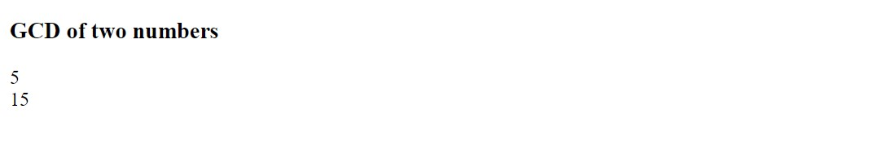

1. Write a JavaScript program to print the Fibonacci series up to a given number.

<!DOCTYPE html>

<html lang="en">

<head>

    <meta charset="UTF-8">

    <meta name="viewport" content="width=device-width, initial-scale=1.0">

    <title>Fibonacci</title>

</head>

<body>

    <h3>Fibonacci series</h3>

    <script>

    var fibonacci=function(n){

        if(n<=1){

            return [0,1];

        }

        else{

            var s=fibonacci(n-1);

            s.push(s[s.length-1]+s[s.length-2]);

            return s.slice(0,n);

        }

    };

        document.write(fibonacci(7));

    Fibonacci(5);

    </script>

</body>

</html>

Output:

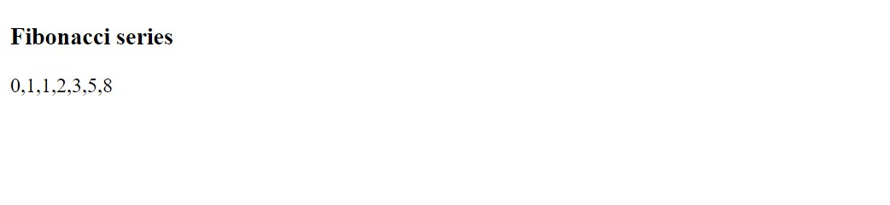

1. Develop a JavaScript function to sort an array of numbers in ascending order.

<!DOCTYPE html>

<html lang="en">

<head>

    <meta charset="UTF-8">

    <meta name="viewport" content="width=device-width, initial-scale=1.0">

    <title>Sort array</title>

</head>

<body>

    <h1>Sorting array in ascending order</h1>

    <script>

        let numbers=[2,5,7,6,4,3];

        function Sorting(numbers){

            let sort=numbers.sort();

            document.write("Sorting of given array in Ascending order is:<br>");

            for(let i=0;i<numbers.length;i++){

                document.write(sort[i]+"<br>");

            }

        }

        Sorting(numbers);

    </script>

</body>

</html>

Output:

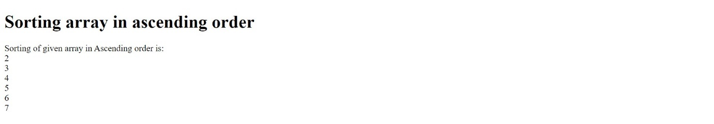

1. Write a JavaScript program to count the number of vowels in a given string

<!DOCTYPE html>

<html lang="en">

<head>

    <meta charset="UTF-8">

    <meta name="viewport" content="width=device-width, initial-scale=1.0">

    <title>Vowels</title>

</head>

<body>

    <h3>Counting number of vowels</h3>

    <script>

            let s='"Nithish Kumar"';

            let vowels="aAeEiIoOuU";

            let count=0;

            for(let i=0;i<s.length;i++){

                if(vowels.indexOf(s[i])!==-1){

                    count+=1;

                }

            }

            document.write("Number of vowels in "+s+" is "+count);

    </script>

</body>

</html>

Output:

