Data-Driven Knowledge-Based AI for Digital Transformation, Innovation, and Entrepreneurship: An Explainable Opportunity-Assessment Framework
Nithish Maley
Short Communication
Affiliation: [Insert institution and postal address]
Corresponding author: [Insert corresponding-author e-mail]
Abstract
Digital transformation decisions combine measurable signals with domain constraints that are rarely represented in a single data table. This Short Communication presents K-AIDE, a data-driven knowledge-based artificial intelligence framework for assessing digital innovation opportunities in entrepreneurial settings. K-AIDE combines a supervised data model with an explicit knowledge layer containing weighted criteria, hard constraints, and interaction rules. The knowledge layer produces an interpretable opportunity score and rule trace, while the data model captures nonlinear patterns in business and market indicators. A controlled benchmark of 15,000 deterministic synthetic records, evaluated across five fixed random seeds, demonstrates the method. The hybrid model achieved mean ROC-AUC 0.7450 (SD 0.0128), mean Brier score 0.2098 (SD 0.0031), and mean accuracy 0.6722 (SD 0.0224). The knowledge rules achieved the strongest ranking performance, with ROC-AUC 0.7539, while the hybrid model provided the best calibration and accuracy. A component ablation and paired error analysis show how each layer contributes to the result. These are reproducibility results rather than evidence of performance in a particular industry. The contribution is a compact, auditable design that connects knowledge engineering, data science, explainable AI, and business decision support.
Keywords: artificial intelligence; data science; knowledge-based systems; decision support; digital transformation; innovation; entrepreneurship
Highlights
- Combines business data with explicit domain knowledge.
- Adds interpretable rules to a supervised AI model.
- Produces opportunity scores and rule-based explanations.
- Demonstrates repeated-seed reproducible evaluation.
- Separates data and knowledge contributions by ablation.
1. Introduction
Digital transformation changes how organizations create value, organize work, and engage with customers [1]. For entrepreneurs and innovation managers, the decision is rarely whether a digital technology exists. The practical decision is which opportunity should be pursued, with which resources, and under which constraints. Market demand, customer need, data readiness, organizational capability, regulatory exposure, and implementation complexity all influence that decision. These signals are heterogeneous and often incomplete. A system that uses only historical data can identify associations, but it may overlook a policy constraint or a condition that business experts regard as non-negotiable.
Digital entrepreneurship is shaped by the interaction between digital technologies and entrepreneurial processes [2]. This interaction creates a knowledge problem as well as a prediction problem. A decision-support system must use available observations while also representing relationships, thresholds, and constraints that are meaningful to the organization. Knowledge-based systems are well suited to this combination because they can encode domain concepts and reasoning procedures alongside computational models. The KBS aims and scope include data science, knowledge representation and engineering, intelligent decision-support systems, prediction systems, and business applications. The framework proposed here addresses these topics through a focused opportunity-assessment task.
Artificial intelligence can support managers by augmenting analysis and expanding the range of alternatives considered [3]. However, AI-supported recommendations are difficult to use when a manager cannot understand why an opportunity was ranked highly or why a recommendation was blocked. Explainability is therefore treated as a design requirement rather than an after-the-fact visualization [4]. The aim of this Short Communication is to present a compact hybrid method that joins a data model with an explicit knowledge layer and produces both a decision score and an explanation.
The contribution is threefold. First, the paper specifies K-AIDE, a knowledge-augmented intelligent decision engine for digital transformation, innovation, and entrepreneurship. Second, it gives an auditable scoring formulation and a short implementation procedure. Third, it provides a repeated-seed benchmark, component ablation, and compact code package. The methodological gap addressed is the lack of a compact evaluation that separates learned patterns from explicit business rules within one opportunity-assessment workflow. The benchmark is deliberately synthetic and controlled. It demonstrates method behavior and reproducibility; it does not make claims about a population of firms.
2. K-AIDE framework
2.1. Design requirements
K-AIDE was designed around four requirements. The first is data integration: the model should accept indicators describing an opportunity and its organizational setting. The second is knowledge integration: domain experts should be able to specify criteria, thresholds, and relationships without retraining the data model. The third is decision transparency: every recommendation should expose the main score components and the rules that affected the result. The fourth is operational simplicity: the method should be implementable with a small software footprint and support a transition from an illustrative benchmark to approved organizational data.
The framework is not intended to replace entrepreneurial judgment. It provides a repeatable screening layer that helps a decision-maker compare opportunities, identify missing capabilities, and see where a recommendation depends on a constraint. This human-in-the-loop orientation is consistent with the view that AI can automate portions of a process while leaving judgment and responsibility with managers [3].
2.2. Data and knowledge layers
The data layer contains ten normalized indicators: market signal, customer need, data readiness, digital maturity, innovation novelty, ecosystem support, resource capacity, implementation complexity, regulatory exposure, and organizational agility. The indicators are examples rather than a universal measurement instrument. In an applied study, each should be operationalized with validated measures and documented data provenance.
The knowledge layer contains three kinds of objects. Weighted criteria represent the relative importance of value, feasibility, innovation, and organizational readiness. Hard constraints represent conditions under which an opportunity should be blocked or strongly penalized. Interaction rules represent useful combinations, such as the joint presence of market demand and innovation novelty. In the executable benchmark, the low-readiness gate is activated when data readiness is below 0.22 and digital maturity is below 0.25; the regulatory gate is activated when regulatory exposure exceeds 0.82 while data readiness is below 0.45; and the market-novelty synergy is activated when market signal exceeds 0.62 and innovation novelty exceeds 0.68. The knowledge layer can be implemented as a rules table, lightweight ontology, or knowledge graph. The important property is that the reasoning structure remains inspectable and can be revised independently from the statistical model.
2.3. Hybrid inference and explanation
Let p_data(x) be the probability returned by the data model for opportunity x, and let s_KB(x) be the normalized score returned by the knowledge layer. The hybrid decision score is:
(1) p_K-AIDE(x) = α p_data(x) + (1 - α) s_KB(x)
where 0 ≤ α ≤ 1. The demonstration uses α = 0.65; the sensitivity curve in Fig. 2 shows how the blend behaves across the full range. In an applied study, α should be selected on validation data. The knowledge score uses the weighted criteria and thresholds in Section 2.2, adds 0.10 for the market-novelty synergy, subtracts 0.32 when either hard gate is active, and maps the resulting score z_KB to the closed interval 0 to 1 with clip((z_KB + 0.20)/1.10, 0, 1). A rule trace records the conditions that contributed to the score. The final output contains (i) a ranked opportunity score, (ii) the data-model probability, (iii) the knowledge score, and (iv) the activated rules.
Figure 1 shows the information flow. Business data and organizational knowledge enter the hybrid AI layer separately, which prevents the knowledge structure from being hidden inside an opaque model. The resulting score can be connected to an innovation portfolio review, a digital-transformation roadmap, or an entrepreneurial opportunity-screening process.
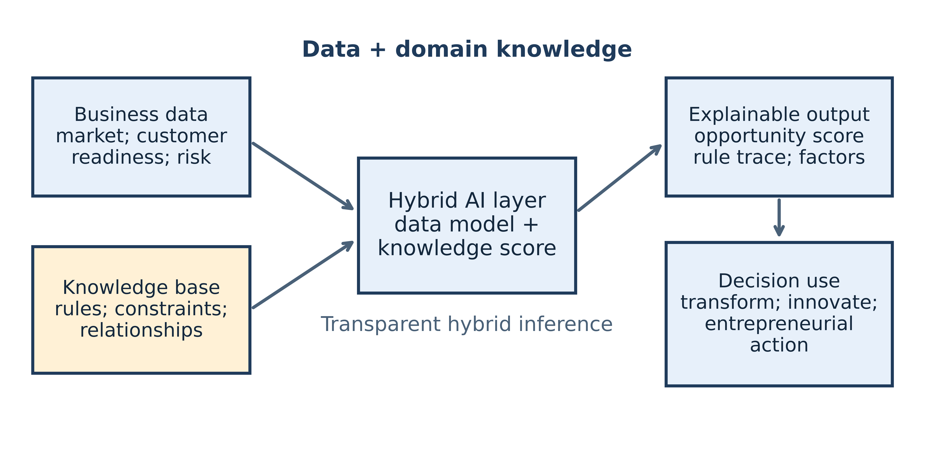
Fig. 1. K-AIDE framework. Business data and explicit knowledge are combined in a hybrid inference layer that returns an opportunity score, rule trace, and decision-support output.
2.4. Assessment procedure
The executable assessment follows five steps. First, it normalizes the opportunity indicators and separates training and test records. Second, it calculates the knowledge score and records every activated rule. Third, it fits a random-forest classifier to the training indicators. Fourth, it blends the data probability and knowledge score using Eq. (1). Fifth, it returns the score, the rule trace, and a ranking that a manager can review. The procedure keeps the symbolic layer visible rather than embedding all reasoning inside the statistical model.
3. Demonstration design
3.1. Controlled benchmark
The demonstration uses 15,000 opportunity records generated across five fixed random seeds, with 3,000 records per seed. Each record contains the ten indicators listed in Section 2.2, sampled from bounded distributions to represent normalized business signals. A latent adoption value is generated from value, feasibility, risk, and interaction terms. Two explicit knowledge constraints are then applied: the low-readiness gate and the regulatory gate defined in Section 2.2. A synergy rule rewards opportunities with both a strong market signal and high innovation novelty. The binary outcome indicates whether an opportunity passes the simulated adoption threshold.
This design makes it possible to test whether a model that exposes the knowledge structure behaves differently from a model that receives only raw indicators. The benchmark does not represent a real industry, and the rules are not claimed to be universal. Its purpose is reproducibility: another researcher can run the supplied script with the same five seeds and regenerate the data, figures, and metrics.
3.2. Baselines, repeated evaluation, and ablation
Three estimators are compared. The data-only AI is a random forest trained on the ten indicators. Random forests are a useful baseline for a short proof of concept because they model nonlinear interactions without requiring a large neural architecture [5]. The implementation uses 350 trees, a minimum leaf size of 8, class-balanced weights, single-threaded execution, and the benchmark seed as the model seed. The knowledge rules estimator uses the normalized knowledge score without training. The hybrid K-AIDE estimator combines the data-model probability and the knowledge score using Eq. (1). Each seed uses a stratified 70% training and 30% test split, yielding 900 held-out records per seed and 4,500 paired held-out records overall. A capability perspective is also relevant because model performance depends on complementary organizational resources, not only on the algorithm [6].
The evaluation reports ROC-AUC, PR-AUC, Brier score, and accuracy. ROC-AUC and PR-AUC evaluate ranking and positive-class retrieval, while the Brier score evaluates probabilistic calibration. These predictive measures are appropriate for a screening system because they separate ranking quality from probability quality [7]. Accuracy is a secondary descriptive measure. Table 1 reports the mean and standard deviation across seeds.
The component ablation in Table 2 evaluates the 2 x 2 presence or absence of the data and knowledge layers: neither layer, data only, knowledge rules only, and the hybrid. Paired two-sided Wilcoxon tests compare record-level squared errors for the hybrid against each single-layer alternative. Because the benchmark is synthetic, these tests describe reproducibility within the generated scenarios and do not support population-level inference.
4. Results and discussion
Table 1 shows that the knowledge rules achieved the highest ranking performance, with mean ROC-AUC 0.7539 and PR-AUC 0.7373. The hybrid model produced the lowest Brier score, 0.2098, and the highest accuracy, 0.6722. Compared with the data-only model, the hybrid improved ROC-AUC from 0.7311 to 0.7450, reduced the Brier score from 0.2104 to 0.2098, and increased accuracy from 0.6709 to 0.6722. The standard deviations are small relative to the mean differences, although they should not be interpreted as confidence intervals for real organizations.
Table 1. Repeated-seed baseline comparison
Estimator | ROC-AUC | PR-AUC | Brier score | Accuracy
Data-only AI | 0.7311 (0.0166) | 0.7119 (0.0164) | 0.2104 (0.0046) | 0.6709 (0.0241)
Knowledge rules | 0.7539 (0.0090) | 0.7373 (0.0155) | 0.2184 (0.0027) | 0.6307 (0.0086)
Hybrid K-AIDE | 0.7450 (0.0128) | 0.7266 (0.0139) | 0.2098 (0.0031) | 0.6722 (0.0224)

Values are mean (standard deviation) across five fixed seeds. Higher is better for ROC-AUC, PR-AUC, and accuracy; lower is better for Brier score.
Figure 2 provides a visual comparison of ranking, calibration, accuracy, and blend sensitivity. The sensitivity panel shows why the blend parameter should be validated rather than treated as a universal constant. The knowledge layer supplies strong ranking structure in this controlled benchmark, while the data model contributes calibration information that improves the combined probability.
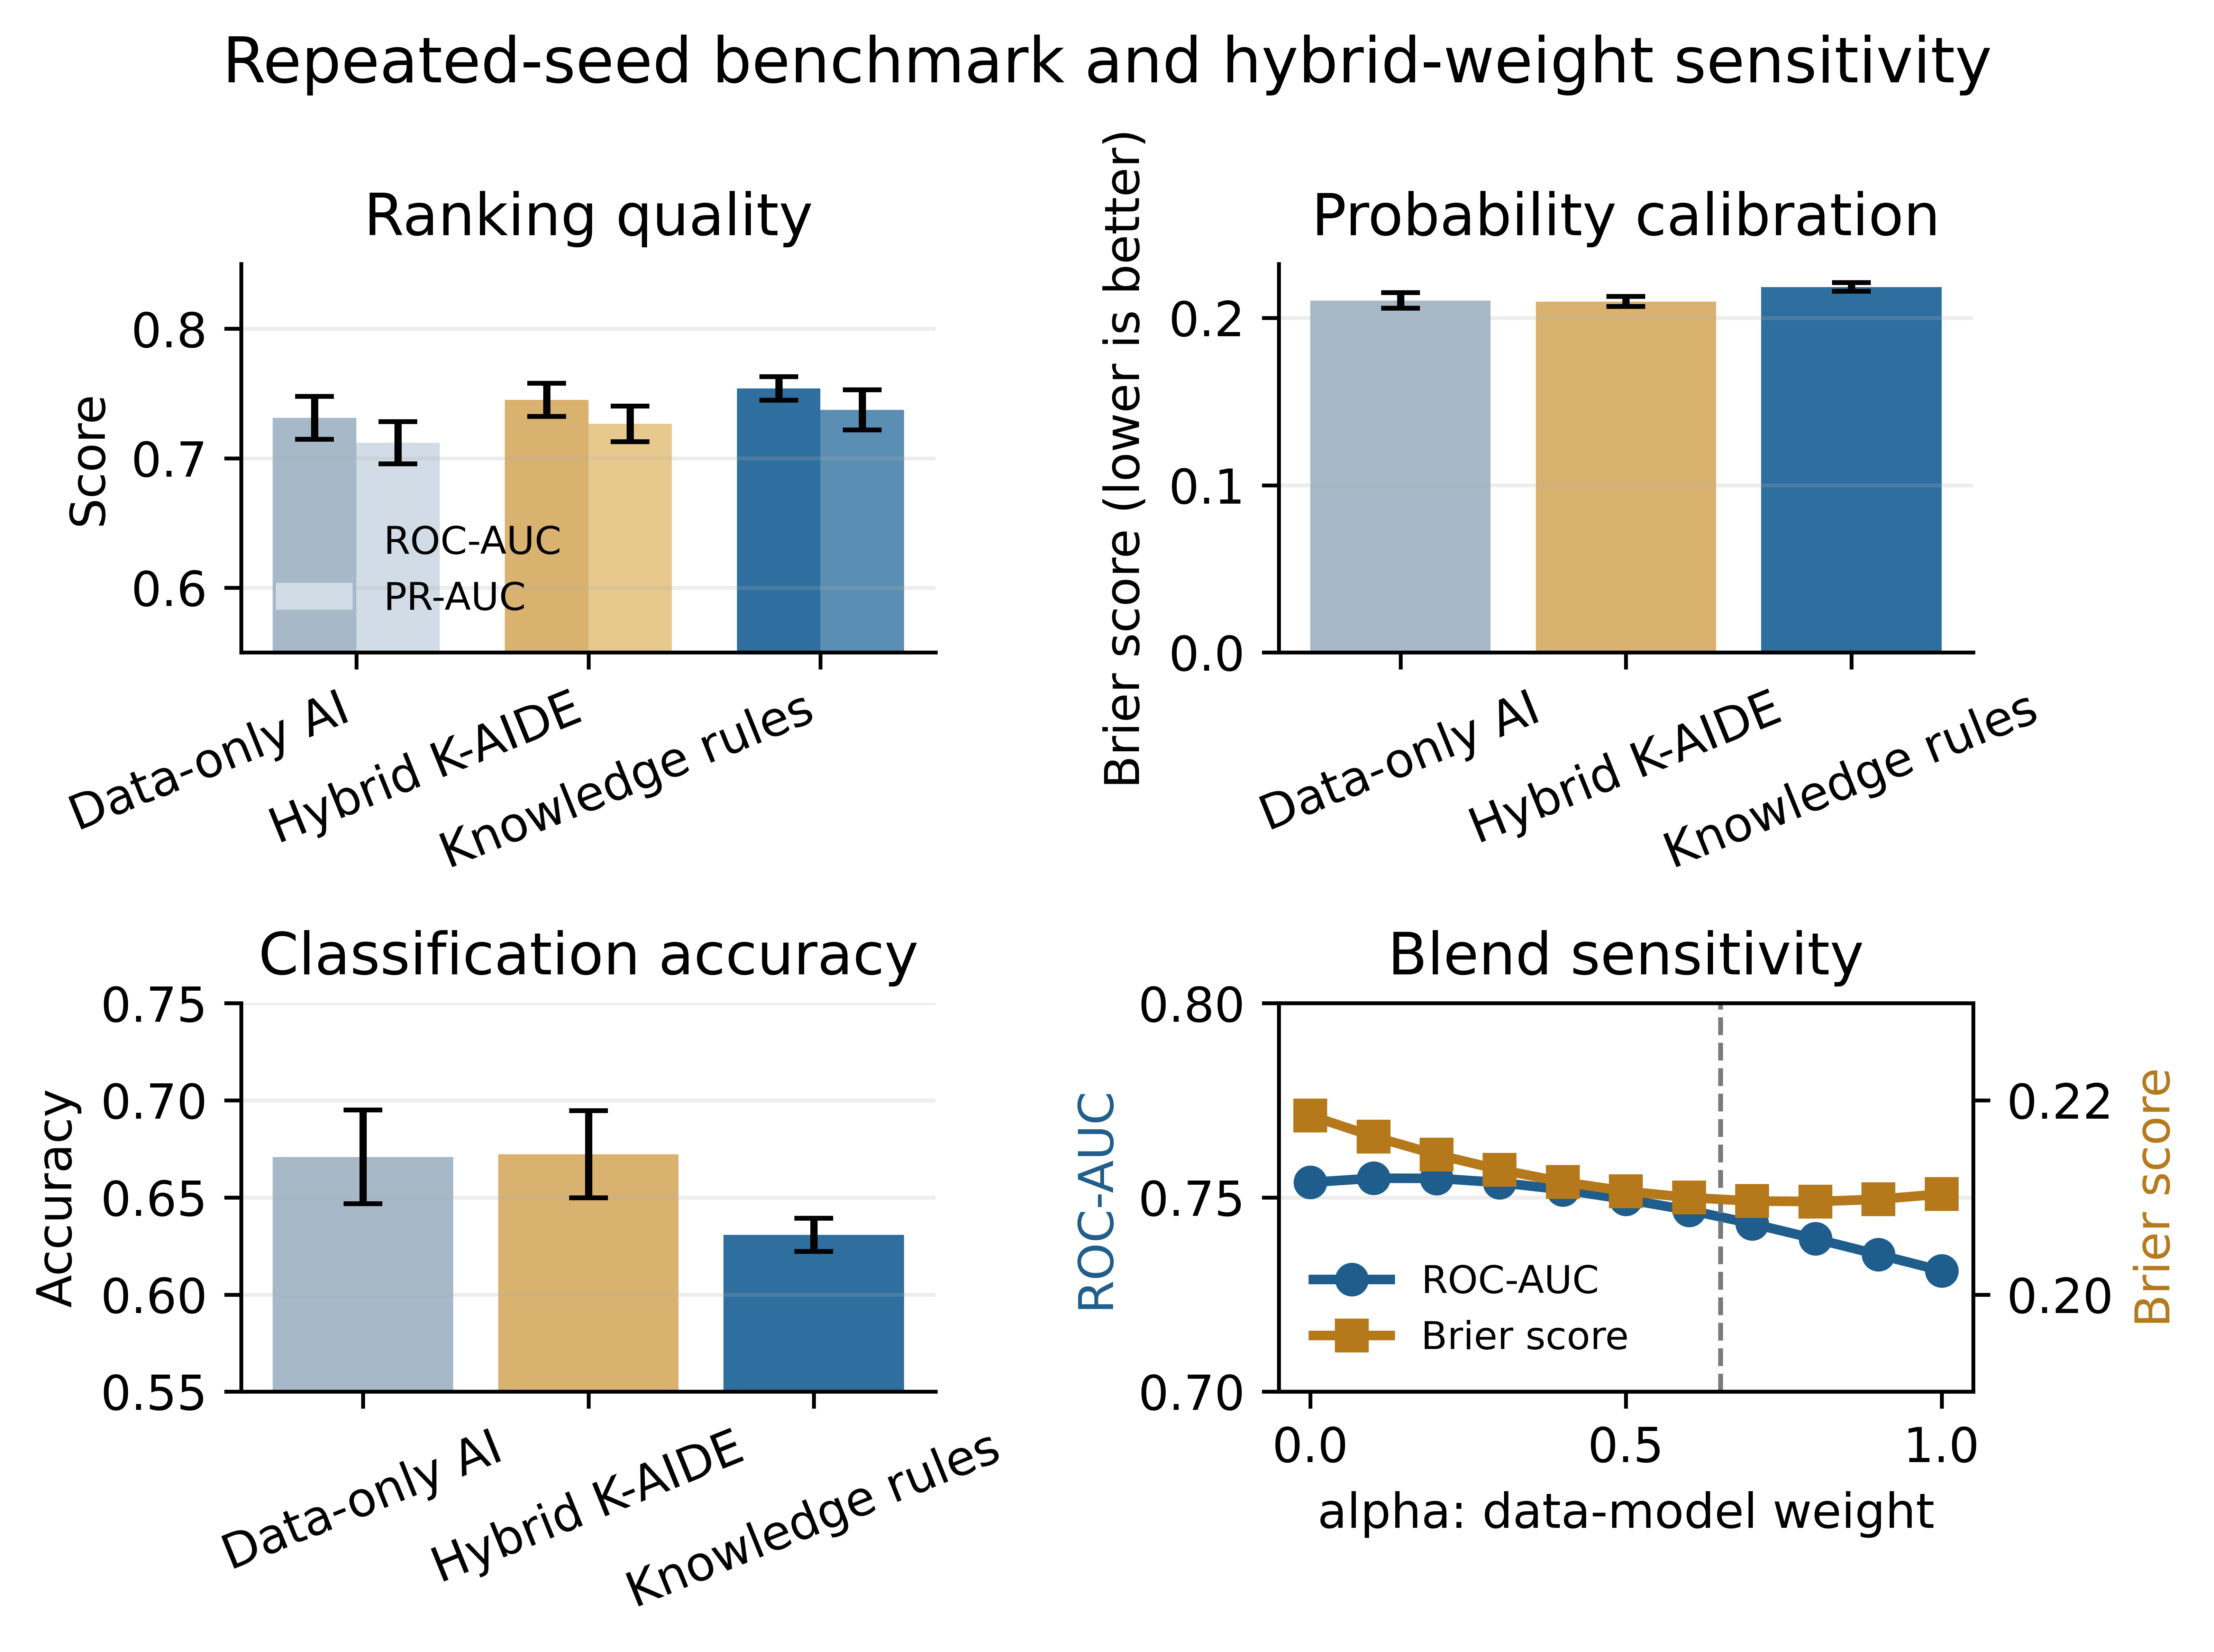
Fig. 2. Repeated-seed performance and blend sensitivity. Bars show mean values with standard-deviation error bars; the lower-right panel varies alpha while holding the held-out records fixed.
Table 2 separates the contributions of the two components. Removing both layers produces a near-chance reference. The data-only and knowledge-only variants recover useful structure, but the hybrid has the lowest Brier score and highest accuracy. The two-sided paired tests on the 4,500 record-level squared-error pairs give p = 3.147e-05 for the hybrid versus data-only comparison and p = 1.995e-20 for the hybrid versus knowledge-rules comparison. These p-values are descriptive within the generated benchmark and should not be presented as field-study significance.
Table 2. 2 x 2 component ablation
Variant | Data model | Knowledge layer | ROC-AUC | Brier score | Accuracy
Neither layer | No | No | 0.5000 | 0.2500 | 0.4804
Data-only AI | Yes | No | 0.7311 | 0.2104 | 0.6709
Knowledge rules | No | Yes | 0.7539 | 0.2184 | 0.6307
Hybrid K-AIDE | Yes | Yes | 0.7450 | 0.2098 | 0.6722

Values are means across five fixed seeds. The paired tests use record-level squared errors from the same held-out records.
The code package also regenerates five supplementary diagnostic figures not reproduced in this Short Communication for length: a feature correlation heatmap, random-forest feature importance, pooled ROC and precision-recall curves, pooled confusion matrices at the 0.5 threshold, and a calibration (reliability) curve for all three estimators. These are available as optional diagnostic supplements and are not part of the two-figure main manuscript.
5. Implications
The main implication is methodological. Digital transformation and entrepreneurial innovation decisions are not purely predictive tasks. They combine measurable signals with organizational knowledge about resources, risk, compliance, and feasibility. A data-only model may learn useful associations, but it cannot guarantee that a decision respects an explicit constraint unless that constraint is represented in the system. K-AIDE makes the two sources visible and allows them to be evaluated separately.
The framework also has a practical implication for innovation governance. A manager can inspect whether an opportunity received a high score because of market and customer signals, because the organization is ready to implement it, or because an interaction rule was activated. This explanation supports a more productive discussion between technical teams, entrepreneurs, and decision-makers. It also creates a record of why a decision-support system recommended or blocked an opportunity. The design follows the principle that interpretable models should be preferred when decision consequences are material [8].
For researchers, the framework creates several testable extensions. A future study could replace the synthetic benchmark with longitudinal venture or innovation-portfolio data, compare different knowledge representations, and estimate how knowledge revisions affect model drift. Another study could compare rule-based explanations with model-agnostic explanations such as local feature attribution [4]. A further extension could use a knowledge graph to represent relationships among technologies, capabilities, markets, and regulatory requirements, then evaluate graph-based retrieval against a flat rules table.
The framework is compatible with digital-transformation research. Digital transformation changes organizational capabilities and business models [1], while entrepreneurship research emphasizes how digital technologies change opportunity creation and discovery [2]. Business-model design is tied to dynamic capabilities and the ability to reconfigure resources [9], while innovation portfolios must balance exploration of new possibilities with exploitation of existing knowledge [10]. K-AIDE translates these ideas into a computational task: ranking opportunities under data and knowledge constraints. This translation connects management research to the technical expectations of a knowledge-based AI journal.
6. Limitations and next steps
The most important limitation is the synthetic benchmark. Because the data-generating process includes the same types of rules used by the knowledge layer, the experiment demonstrates controlled behavior rather than external validity. The reported metrics should not be interpreted as evidence that K-AIDE will outperform a data-only model in a particular industry. A follow-up study should preregister the operational definitions, collect or obtain an approved real dataset, and evaluate the method with a held-out temporal or organizational test set.
The second limitation is that the current knowledge layer is small and manually specified. A production system would require a governance process for approving rules, tracking versions, resolving conflicts, and monitoring whether a rule remains valid as markets and regulations change. The third limitation is that the benchmark contains normalized numeric variables and does not address missing data, concept drift, class imbalance under real conditions, or the social consequences of entrepreneurial recommendations. These limitations define the next empirical steps rather than hidden assumptions of the current demonstration.
7. Conclusion
This Short Communication presented K-AIDE, a compact data-driven knowledge-based AI framework for digital transformation, innovation, and entrepreneurship decisions. The method combines a supervised data model with explicit criteria, constraints, and interaction rules and returns both a score and an explanation. Across five reproducible seeds, the knowledge layer improved ranking while hybrid inference produced the best calibration and accuracy. The ablation makes the source of the improvement visible and the code package permits exact regeneration of the figures and tables. The work provides a technically implementable starting point for a larger empirical study using approved organizational or venture data.
Data availability statement
The benchmark data are synthetic and deterministic. The accompanying code and combined 15,000-record CSV (seeds 42–46) are included for auditability; a public repository identifier is pending and should be added before submission.
Declaration of competing interest
The author declares that there are no known competing financial interests or personal relationships that could have influenced the work reported in this manuscript.
Declaration of generative AI and AI-assisted technologies in the manuscript preparation process
During preparation of this manuscript and the accompanying demonstration code, generative AI tools were used to assist with drafting, language refinement, and code organization. The author reviewed and edited all content, verified the computational outputs, and takes full responsibility for the accuracy, originality, and integrity of the submitted work. No generative AI tool was used to create or alter primary observed data. The figures are generated deterministically from the supplied Python code.
Funding
This research received no specific grant from any funding agency in the public, commercial, or not-for-profit sectors.
CRediT authorship contribution statement
Nithish Maley: Conceptualization, Methodology, Software, Validation, Data curation, Formal analysis, Visualization, Writing - original draft, Writing - review and editing.
Acknowledgements
None.
References
[1] G. Vial, Understanding digital transformation: A review and a research agenda, J. Strateg. Inf. Syst. 28 (2019) 118-144. https://doi.org/10.1016/j.jsis.2019.01.003.
[2] S. Nambisan, Digital entrepreneurship: Toward a digital technology perspective of entrepreneurship, Entrep. Theory Pract. 41 (2017) 1029-1055. https://doi.org/10.1111/etap.12254.
[3] S. Raisch, S. Krakowski, Artificial intelligence and management: The automation-augmentation paradox, Acad. Manag. Rev. 46 (2021) 192-210. https://doi.org/10.5465/amr.2018.0072.
[4] M.T. Ribeiro, S. Singh, C. Guestrin, Why should I trust you? Explaining the predictions of any classifier, in: Proceedings of the 22nd ACM SIGKDD International Conference on Knowledge Discovery and Data Mining, ACM, 2016, pp. 1135-1144. https://doi.org/10.1145/2939672.2939778.
[5] L. Breiman, Random forests, Mach. Learn. 45 (2001) 5-32. https://doi.org/10.1023/A:1010933404324.
[6] P. Mikalef, M. Gupta, Artificial intelligence capability: Conceptualization, measurement calibration, and empirical study on its impact on organizational creativity and firm performance, Inf. Manag. 58 (2021) 103434. https://doi.org/10.1016/j.im.2021.103434.
[7] G. Shmueli, O.R. Koppius, Predictive analytics in information systems research, MIS Q. 35 (2011) 553-572. https://doi.org/10.2307/23042796.
[8] C. Rudin, Stop explaining black box machine learning models for high stakes decisions and use interpretable models instead, Nat. Mach. Intell. 1 (2019) 206-215. https://doi.org/10.1038/s42256-019-0048-x.
[9] D.J. Teece, Business models and dynamic capabilities, Long Range Plann. 51 (2018) 40-49. https://doi.org/10.1016/j.lrp.2017.06.007.
[10] J.G. March, Exploration and exploitation in organizational learning, Organ. Sci. 2 (1991) 71-87. https://doi.org/10.1287/orsc.2.1.71.

