Infotainment Warranty Events – Stakeholder Report
HanuAi ML Assessment · Task 2: Advanced EDA & Text Mining · 1,000 service events, MY2020 vehicles

1. Executive summary
The dataset contains 1,000 warranty/service events for infotainment complaints on model-year-2020 vehicles (4 makes, 23 models, 8 build plants). Every vehicle was built in a single five-week window (Aug–Sep 2019), so differences between events reflect time in service and failure mode, not build date. We cleaned the data, converted three free-text fields into structured tags, grouped events into issue types and clustered them into failure modes.
What the data says
- One part dominates the repair story. The radio / head unit was replaced in 84% of events and some part was replaced in 85%; 68% also needed (re)programming and 30% were escalated to the manufacturer's technical assistance centre (TAC/FSE).
- Top symptoms: radio inoperative / dead (316 events), black or blank screen (212), intermittent operation (199), loss of communication on the vehicle network (134) and no sound (132).
- Early-life failures: median time to claim is 228 days; 21% of claims occur within 90 days and 43% within 180 days of delivery (excluding 76 events whose dates are inconsistent).
- It is not a plant problem. The mix of issue types is statistically indistinguishable across build plants (χ² p = 0.71), pointing to a common design or supplier cause rather than local assembly.
- A third of replacements lack a documented fault. Of 704 component-failure events, only 340 record an explicit internal fault; 232 give no cause and 132 were swapped on TAC advice – a diagnostic-quality and cost opportunity.
- Software/firmware is the fastest-growing issue type (share of events 3.8% → 10.6% from the first to the last full quarter) and its failures appear later in vehicle life (median 310 days).

2. Understanding the data
Aspect | Finding
Volume / schema | 1,000 rows × 20 columns; Event id is unique. 3 free-text columns (customer, causal, correction), structured codes, plant/make/model, 3 dates.
Missing values | CAUSAL_CD_DESC 3, IN_USE_DATE 1, CAUSAL_VERBATIM 1. The six tag columns (Trigger … Fix Condition) are filled for only 5 rows – they are worked examples, used here as a validation set.
Duplicates | No exact duplicates, no duplicate IDs.
Inconsistencies | 76 events opened before the in-service date (flagged and excluded from time-in-service statistics); stray whitespace in category labels; 64 near-empty causal texts (e.g. "#", "RADIO"); 16 events written in Spanish/French; MODLYR constant; PLANT duplicates BUILD_PLANT_DESC.
Treatment | Strip/normalise labels; impute the single missing in-service date with build date + median lag (91 days); label missing causal codes "Unknown"; keep, flag and exclude impossible dates rather than guess.

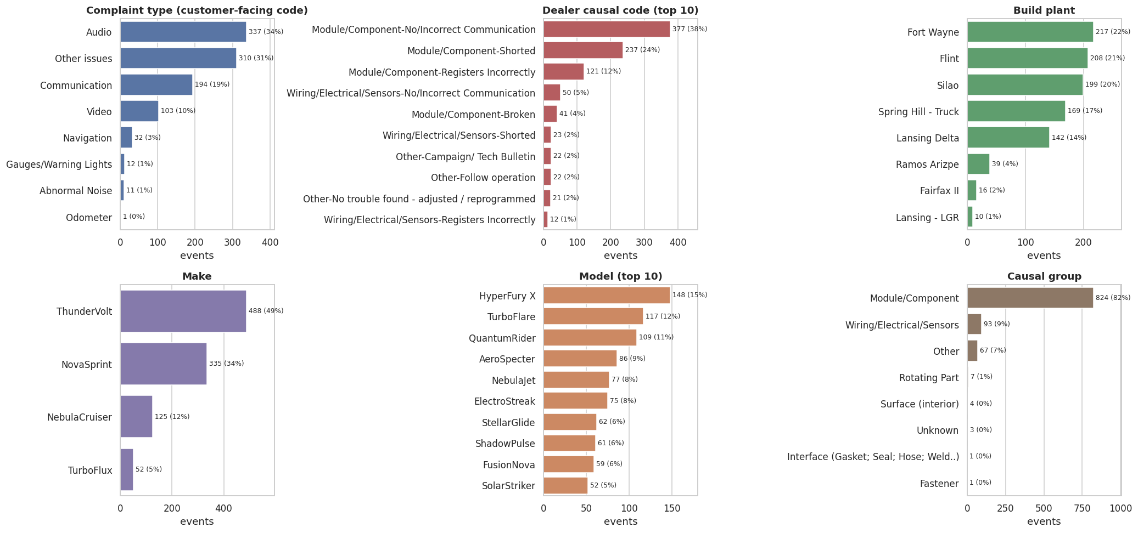
Figure 1 – Frequency of key categorical columns. 94% of complaints are in the Audio/Entertainment/Navigation system.
Numeric summary. Days in service at claim: mean 241.7, median 228, std 161, range 0–615 (n=924). Build-to-in-service lag: mean 121.1, median 91, std 99.5 days.
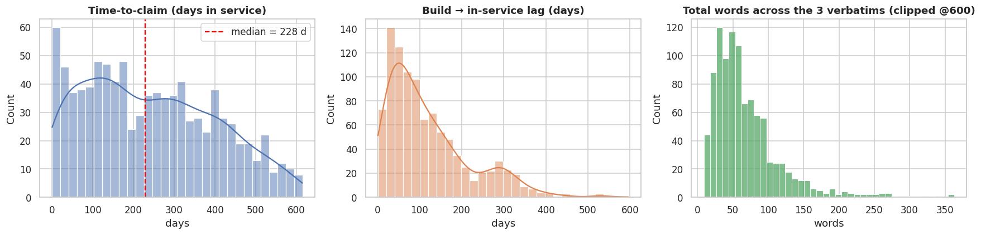
Figure 2 – Time-to-claim and build-to-delivery lag are right-skewed; text length is highly variable.

3. From free text to structured tags
Three free-text columns were mined with a multilingual (EN/ES/FR) dictionary-and-rule approach: normalisation and accent folding, curated entity lists, negation handling ("did not replace radio", "no updates found") and scope rules (customer text → symptoms, technician text → fixes). Dictionary NER was chosen because the vocabulary is closed and technical, results are auditable, and no external model/API is needed.
Tag family | Source column | Examples extracted
Failure Component | Customer + causal | Radio / Head Unit, Display / Screen, Rear Camera, Satellite Radio, Telematics/OnStar, Antenna/Coax
Failure Condition | Customer + causal | Inoperative, Black/Blank Screen, Intermittent, Communication Loss, No Sound, Reboot, Freeze
Trigger / Context | Customer + causal | At start-up, When reversing, After software update, While driving, Repeat visit
Fix Component | Correction | Radio, SPS, USB, OTA, Display, Wiring/Connector, Antenna
Fix Condition | Correction | Replaced, Programmed/Reflashed, Repaired/Cleaned, Reset, No fault found

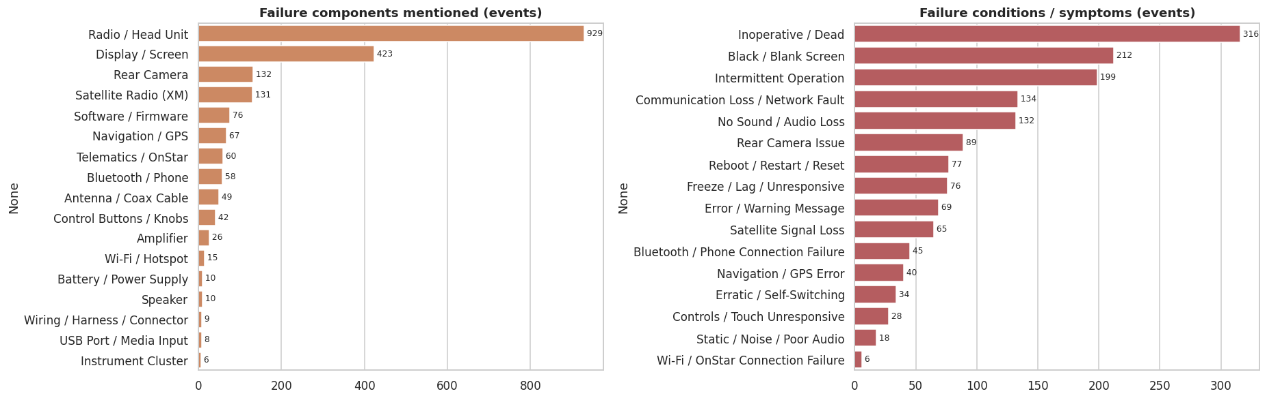
Figure 3 – Most frequent mined failure components and conditions.
Validation. On the 5 hand-labelled example rows the extractor recovered 68% of reference tags (23/34): 100% of failure components, 75% of fix conditions, but only 43% of failure conditions – analysts infer symptoms (e.g. "black screen") from the technician narrative that never appears in the customer text. This is a smoke test on n=5, not a performance estimate.

4. Issue types
Events were scored on technician wording and the dealer causal code and assigned to one of eight issue types (a runner-up category is also stored – 63% of events carry two layers, e.g. lost communication → internal fault → radio replaced).
Issue category | Events | Share | Part replaced | Reprogrammed | Median days
Component Failure | 704 | 70.4% | 95% | 67% | 209
Communication / Network Fault | 120 | 12.0% | 63% | 72% | 230
Electrical / Wiring Issue | 84 | 8.4% | 79% | 67% | 262
Software / Firmware Glitch | 59 | 5.9% | 27% | 90% | 310
Antenna / Reception Issue | 11 | 1.1% | 100% | 64% | 255
Assembly / Installation Quality | 8 | 0.8% | 88% | 50% | 260.5
Other / Unclassified | 8 | 0.8% | 0% | 0% | 281.5
No Fault Found / Unverified | 6 | 0.6% | 67% | 33% | 386

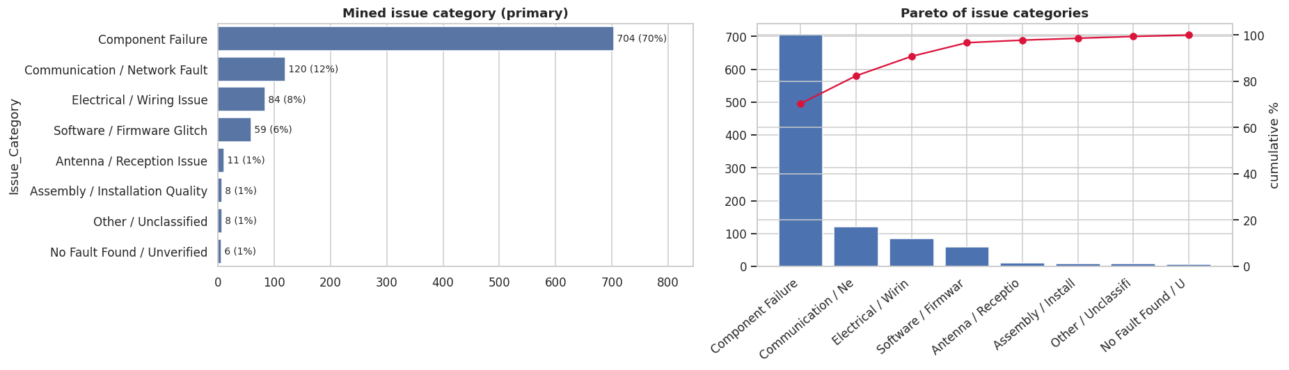
Figure 4 – Issue-category distribution and Pareto.
The mined categories agree with the dealer codes: 75% of "Electrical / Wiring" events (63 of 84) carry a Wiring/Electrical causal code, and 5 of 6 "No Fault Found" events carry an Other/No-trouble-found code – evidence that text and code tell a consistent story.

5. Patterns and trends
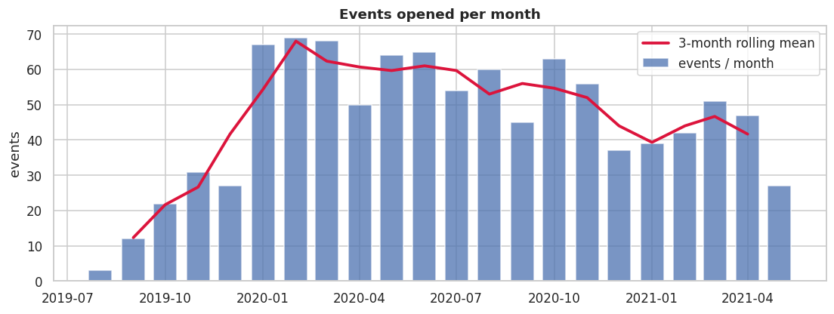
Figure 5 – Events opened per month. Counts ramp up as vehicles enter service, run at ~45–70 per month through 2020, dip in Dec 2020–Feb 2021 (37–42) and partly recover (47–51); May 2021 is a partial month.
- Monthly counts are not failure rates – no production or fleet-size data was provided. The early ramp mainly reflects vehicles entering service; the Dec-2020 dip, the partial May-2021 month and the extract cut-off should be checked against fleet exposure before concluding the problem is fading.
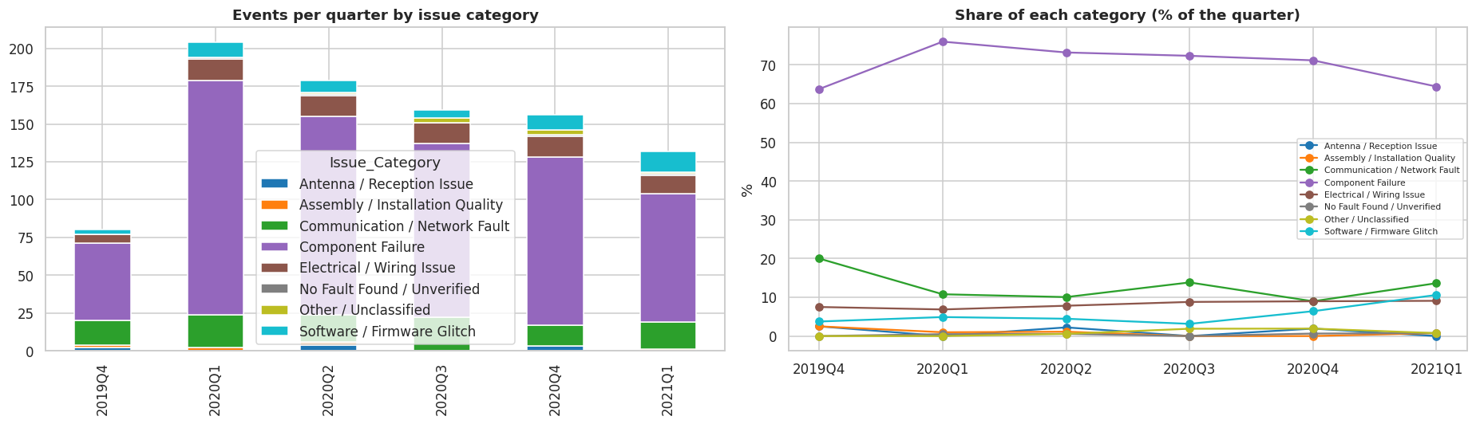
Figure 6 – Quarterly volume and share by issue type.
- Software / firmware share rose from 3.8% to 10.6% (Spearman ρ = 0.60, p = 0.21 – directionally strong, not statistically conclusive with 7 quarters). Electrical / wiring share rose 7.5% → 9.1% with a monotonic trend (ρ = 0.94, p = 0.005) but a small absolute change. Communication faults fell 20% → 13.6%.
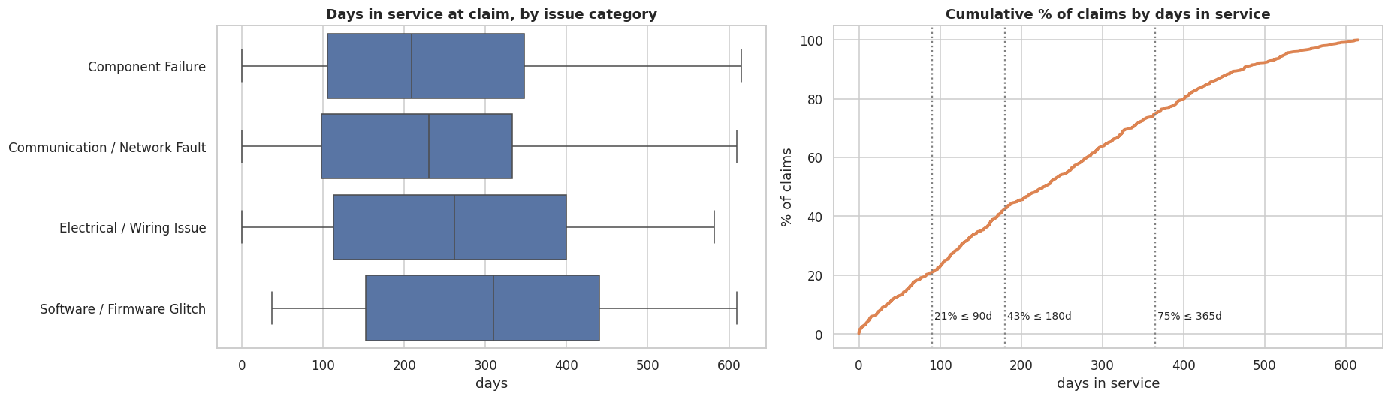
Figure 7 – Time to claim by issue type and cumulative distribution.
- Time-to-claim differs by issue type (Kruskal-Wallis p = 0.013): software issues appear later (median 310 days) than hardware failures (209 days), which may indicate software problems triggered by updates or feature use rather than manufacturing defects (a hypothesis, not proven here).
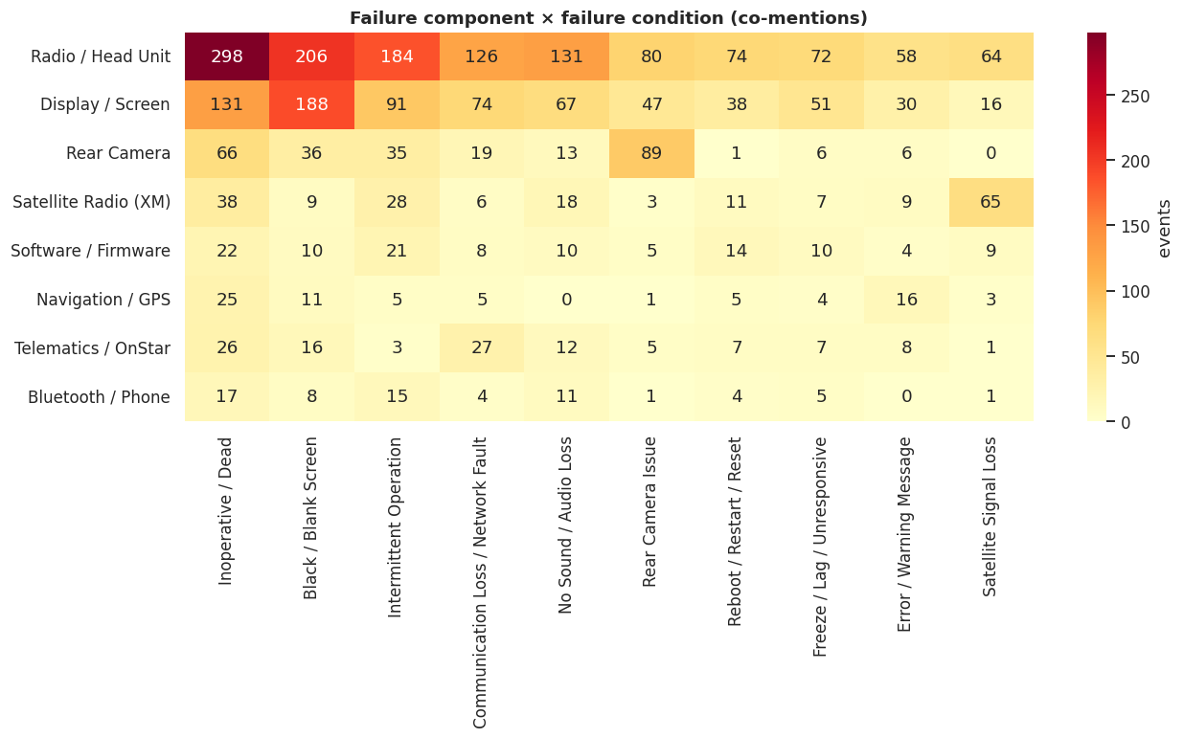
Figure 8 – Component × symptom co-mentions. Radio/head-unit "inoperative" (298) and "black/blank screen" (206) are the two largest failure signatures.

6. Clustering and root causes
Note: clusters A4 (32.6%) and B5 (35.8%) are catch-all groups with generic vocabulary; they are reported but should not be read as specific failure modes.
Two unsupervised views were built (TF-IDF → LSA → K-Means, k chosen by silhouette in 6–10) and cross-checked with an LDA topic model: complaint clusters (what the customer sees) and technician clusters (what was found and done). Silhouette scores are low (0.11 and 0.08), so clusters are soft, thematic groups with overlapping vocabulary rather than sharply separated classes – a normal outcome for short, noisy service notes. Labels were assigned by reading top terms and verbatims.
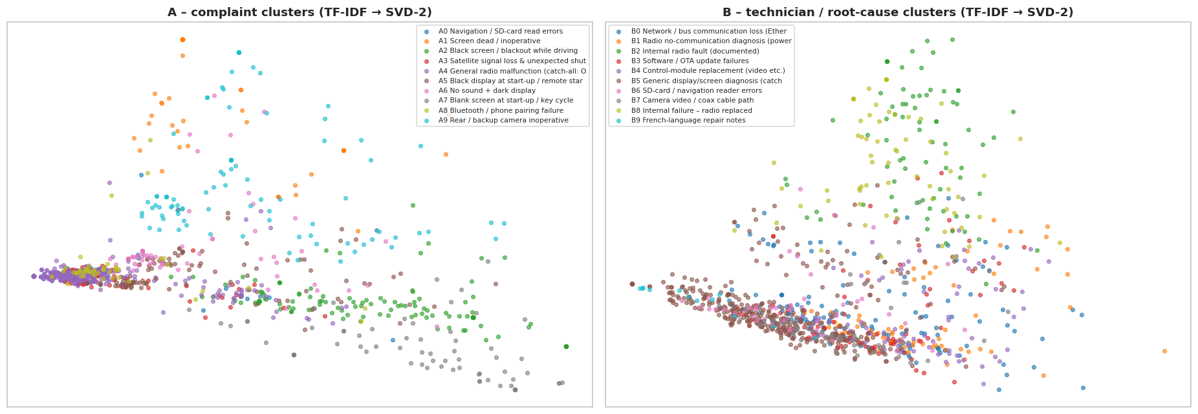
Figure 9 – Cluster maps (SVD-2 projection).

Complaint clusters (failure modes)
Cluster | Events | Share | TAC esc. | Median days
A4 General radio malfunction (catch-all: OnStar/XM/update messages) | 326 | 32.6% | 29% | 240
A2 Black screen / blackout while driving | 119 | 11.9% | 27% | 276.5
A5 Black display at start-up / remote start | 102 | 10.2% | 35% | 171.5
A9 Rear / backup camera inoperative | 89 | 8.9% | 21% | 237
A3 Satellite signal loss & unexpected shut-off | 82 | 8.2% | 37% | 222
A7 Blank screen at start-up / key cycle | 71 | 7.1% | 17% | 224.5
A6 No sound + dark display | 60 | 6% | 28% | 172
A1 Screen dead / inoperative | 53 | 5.3% | 38% | 183
A0 Navigation / SD-card read errors | 49 | 4.9% | 47% | 265
A8 Bluetooth / phone pairing failure | 49 | 4.9% | 33% | 209

Technician clusters (root-cause themes)
Cluster | Events | Part repl. | Reprog. only | TAC esc. | Median days
B5 Generic display/screen diagnosis (catch-all, no specific cause) | 358 | 85% | 9% | 34% | 188
B0 Network / bus communication loss (Ethernet DTCs) | 136 | 87% | 6% | 27% | 259
B3 Software / OTA update failures | 87 | 74% | 25% | 40% | 290
B4 Control-module replacement (video etc.) | 82 | 90% | 6% | 34% | 256
B1 Radio no-communication diagnosis (power/ground checked OK) | 79 | 89% | 10% | 16% | 242
B2 Internal radio fault (documented) | 75 | 92% | 3% | 15% | 176.5
B8 Internal failure – radio replaced | 65 | 86% | 8% | 17% | 224.5
B7 Camera video / coax cable path | 59 | 85% | 10% | 32% | 218
B6 SD-card / navigation reader errors | 47 | 81% | 9% | 51% | 277
B9 French-language repair notes | 12 | 75% | 17% | 17% | 244

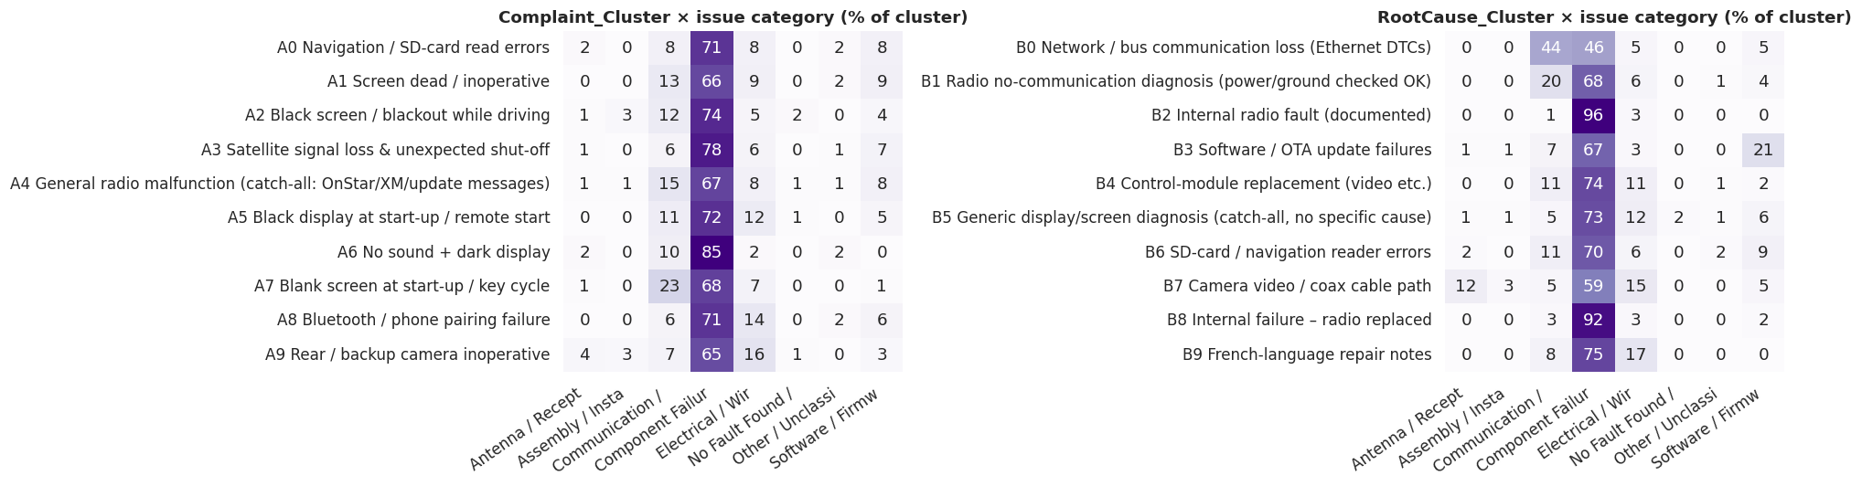
Figure 10 – Cluster × issue-category mix.

Potential root causes for recurring failures
- Radio / head-unit hardware failure (replaced in 84% of events; internal fault explicitly documented in 34%). Black screen, dead unit, intermittent operation and no sound all converge on the same repair (radio replaced). Clusters B2/B8 (14% of events) document an explicit internal fault and fail early (median 177–225 days). The data cannot say *why* the units fail – the next step is failure analysis of returned units (supplier lot, thermal/solder, power stage) to confirm a component-level defect.
- Vehicle network communication loss (B0, 13.6%). Technicians record lost communication with the radio on the Ethernet/CAN bus; only 46% of these are ultimately classed as hardware failure while 44% remain communication faults. Indicates either a radio network interface fault or a marginal bus/power condition that is being fixed by blind replacement.
- Software / update failures (B3, 8.7%). Update failures, "software update resolved" and reprogramming-only repairs (25% of this cluster), with the latest median claim age (290 days). USB flashing (285 events) and SPS (175) dominate; OTA appears in only 19 events. Points to fragile flashing procedures and update-triggered regressions.
- Radio no-communication diagnosis (B1, 7.9%). Technicians scan the vehicle, find the radio not communicating (e.g. with the diagnostic tool or on the Ethernet bus) and verify power/ground wake-up signals – which mostly check out – before replacing the radio (89% part replaced). This points away from power/ground as the cause and toward the radio itself; only 2 of 79 notes mention low voltage or loose fasteners, so harness-level causes are not supported by this extract.
- Camera video / coax path (B7, 5.9%; A9 8.9% of complaints). In 42% of these notes the technician cites the video coax cable or video path; some complaints are a black radio display while the camera still works, which suggests the display/video path rather than the camera itself. Treat as a hypothesis – the notes are short.
- SD-card / navigation reader (B6 4.7%, A0 4.9%). Card read errors, missing cards and reader replacement; this cluster has the highest TAC escalation (47–51%), i.e. the hardest to diagnose.
Associations with plant or make are weak: root-cause cluster × plant p = 0.56 (not significant); cluster × make p = 0.008 with Cramér's V = 0.122 (statistically significant but small effect), and complaint cluster × plant p = 0.05, V = 0.11. We therefore do not recommend plant-specific containment on this evidence.

7. Recommendations and business impact
# | Action | Evidence | Expected impact
1 | Supplier quality investigation of the radio / head unit: failure analysis on returned units, lot/traceability check, end-of-line stress test | Radio replaced in 84% of events; internal fault documented in 34%; 21% of claims within 90 days | Largest lever on warranty cost and customer dissatisfaction; early-life escapes avoided
2 | Guided diagnostics to stop blind swaps: mandatory fault documentation, decision tree for network-communication DTCs before replacement | 364 of 704 component-failure events (52%) have no documented fault; B0 cluster 13.6% | Every 10% of undocumented swaps avoided ≈ 36 radios per 1,000 events; shorter TAC load
3 | Harden the software chain: robust USB/SPS flashing, better OTA coverage, regression test of updates | Software share 3.8% → 10.6%; B3 failures late-life; 68% of events reprogrammed, mostly via USB/SPS | Fewer repeat visits and long programming times; cheaper than hardware
4 | Review the camera/video coax path and the display-video link in design and plant audit | B7 cluster (5.9%): 42% of notes cite coax/video; A9 8.9% of complaints | Addresses a secondary failure mode; validate with a sample teardown first
5 | Targeted fix for SD-card/navigation reader and Bluetooth pairing | A0 4.9%, A8 4.9%; A0 has 47% TAC escalation | Lower TAC escalation and faster resolution
6 | Capture better data: structured tags at claim entry, keep DTC codes (numbers are stripped in this extract), add production/fleet volumes and repair cost | Triggers identified in only 13% of events; 0 DTC codes retrievable | Enables true failure rates, survival analysis and cost-weighted prioritisation

Repeat visits (recurring-issue language) appear in 6.7% of events – each is a customer-satisfaction risk that a first-time-fix programme should track.

8. Key learnings and further improvements

Learnings
- Text carries information the structured codes miss: the causal code says "No/Incorrect Communication" for 427 events, but the narrative separates network faults, internal radio faults and software problems.
- Regex/dictionary tagging is fast and transparent but brittle: recall on the 5 example rows is 68%; symptoms are under-recovered when the customer text is brief, and Spanish conditional repair instructions ("reemplace el cable…") can be mis-read as actions taken.
- K-Means on short technical notes yields soft clusters (silhouette ≤ 0.11); domain stop-word removal (procedure words such as replace/program/USB) was essential to expose cause-related terms.
- Without volumes, counts cannot be turned into rates; trends and plant comparisons are descriptive only.

Next steps
- Use an open-source LLM (e.g. Llama / Qwen) with a JSON-schema prompt, seeded with the dictionary tags as few-shot examples/weak labels, to raise recall on symptoms, triggers and multilingual text; evaluate on a larger hand-labelled sample.
- Try BERTopic / sentence-embedding clustering and fine-tune a small NER model on the weak labels.
- Add fleet volumes and cost to move from counts to failure rates per 1,000 vehicles, Weibull/survival analysis and cost-weighted Pareto.
- Build a monthly monitoring dashboard on the enriched dataset for early detection of rising issue types (e.g. software share).

Deliverables: Task2_EDA_TextMining.ipynb (annotated code), Task2_enriched_dataset.csv / .xlsx (original columns + cleaned fields + mined tags + issue category + cluster labels), this report.

