PHASE 5

PRODUCT SALES ANALYSIS

**Project Definition:**

The project involves using IBM Cognos to analyse sales data and extract insights about top selling products, peak sales periods, and customer preferences. The objective is to help businesses improve inventory management and marketing strategies by understanding sales trends and customer behaviour. This project includes defining analysis objectives, collecting sales data, designing relevant visualizations in IBM Cognos, and deriving actionable insights.

**Design Thinking:**

1. Analysis Objectives: Define the specific insights you want to extract from the sale data, such as identifying top-selling products, analysing sales trends, and understanding customer preferences.
2. Data Collection: Determine the sources and methods for collecting sales data, including transaction records, product information, and customer demographics.
3. Visualization Strategy: Plan how to visualize the insights using IBM Cognos to create interactive dashboards and reports.
4. Actionable Insights: Identify how the derived insights can guide inventory management and marketing strategies.

**Analysis Objectives:**

* Defining specific objectives for analysing sales data will depend on your business's goals and challenges. Prioritize the insights that align with your strategic priorities and use data analysis tools and techniques to extract meaningful information from your sales data.
* It's important to prioritize these objectives based on your business goals and the available data. Defining clear objectives will guide your analysis and help you extract actionable insights from your sales data.

**Data Collection:**

* When collecting sales data, it's essential to ensure data accuracy, security, and compliance with relevant data protection regulations (e.g., GDPR, CCPA).
* Additionally, consider the frequency of data collection and the methods for data storage and backup to maintain data integrity and availability for analysis.
* When collecting sales data, it's essential to ensure compliance with data privacy regulations and protect customer information.
* Data should be stored, managed, and secured following best practices and legal requirements.

**Visualization  Strategy:**

* Start by revisiting your analysis objectives to determine the key metrics and insights you want to visualize. What are the critical KPIs and trends you want to highlight.
* Ensure that your sales data is clean, well-organized, and properly formatted. You may need to preprocess and transform the data before importing it into IBM Cognos.
* Plan the layout and structure of your interactive dashboard. Consider the following elements: Key performance indicators (KPIs) Charts (e.g., bar charts, line charts, pie charts).
* Implement role-based access control to restrict data access based on user roles and permissions. Ensure sensitive data is protected.
* Train end-users on how to navigate and interact with the dashboards effectively. Consider providing training sessions or documentation.
* Gather feedback from users and stakeholders to make improvements. Iterate on the dashboard design based on user suggestions and changing business needs.

**Actionable Insights:**

* Customer feedback and reviews can provide valuable insights. Address customer concerns and suggestions in your marketing strategy to improve product perception.
* By applying these insights to your inventory management and marketing strategies, you can make data-driven decisions that optimize inventory turnover, reduce carrying costs, improve customer satisfaction, and drive sales growth.Regularly monitor and adjust your strategies based on evolving market dynamics and customer behaviour to stay competitive and profitable.

1. **Concseptualize the Campaign:**
   * Conceptualizing the public health awareness campaign is a critical initial step in the journey from design to innovation.
   * This phase involves crafting the overarching vision and strategy for the campaign.
   * To begin, we define the scope and objectives of the campaign, outlining the specific public health issue we aim to address.
   * By identifying the key messages, target audience, and desired outcomes, we lay the foundation for an impactful campaign.
   * We delve into the heart of the matter, seeking to understand the root causes of the health issue and the behavioral changes we hope to inspire.
2. **Data Collection and Preparation**

## Data Sources:

* + Identify the sources of data we will use for our data analysis. This may include public health datasets, surveys, social media data, etc.

## Data Cleaning and Preprocessing:

* + Document the steps taken to clean and preprocess the data, including handling missing values and outliers.

## Data Collection Plan:

* + Documenting our plan for collecting, storing, and managing the data.

Ensure compliance with data privacy and ethical considerations

1. **Data Analysis and Insights**

## Data Analysis Plan:

* + Defining our data analysis approach and methodology, including statistical techniques and data visualization tools.
  + Documenting the research questions or hypotheses we want to address.

## Exploratory Data Analysis (EDA):

* + Documenting the EDA process, including summary statistics, data visualizations, and initial insights gained from the data.

## Statistical Analysis:

* + Documenting the statistical tests or models used to analyze the data, along with the rationale for choosing them.
  + Record the results of the analysis, including any significant findings related to the public health issue.

**4.Challenges during health campaign**

## Message Clarity:

* + Ensuring that campaign messages are clear, concise, and easily understood by the target audience can be challenging. Complex medical or scientific terms may confuse or alienate some individuals.

## Audience Segmentation:

* + Tailoring messages to different demographic groups within the target audience is crucial. Failing to segment the audience properly can result in messages that are not relevant or relatable to specific groups.

## Limited Resources:

* + Budget constraints, staff limitations, and resource scarcity can limit the scope and effectiveness of a campaign. This can affect the ability to reach a wider audience or employ various media channels.

## Message Fatigue:

* + Overexposure to health messages can lead to message fatigue, where the target audience becomes desensitized or disinterested in the campaign's messages.

## Data Collection and Privacy:

* + Gathering data to assess the impact of a campaign while respecting privacy laws and ethical considerations can be complex. Balancing the need for data with individual privacy is important.

## Cultural Sensitivity:

* + Campaigns must be culturally sensitive and consider cultural norms, beliefs, and practices. Failure to can

messages that are perceived as insensitive or offensive.

## Behavioral Change Resistance:

* + Encouraging people to change their behavior or adopt healthier habits can be challenging. Resistance to change is a common problem in health awareness campaign

## Skepticism and Misinformation:

* + Addressing skepticism and countering misinformation, especially in the age of the internet and social media, is a

significant challenge. False or misleading health information can spread rapidly.

## Measuring Impact:

* + Determining the success and impact of a campaign can be challenging. It may take time to see meaningful changes in behavior or health outcomes, and attribution to a specific campaign can be difficult.

## Resource Allocation:

* + Deciding how to allocate resources effectively across different health issues and campaigns can be a dilemma. Some issues may receive more attention and resources than others.

## Public Engagement and Participation:

* + Ensuring active participation and engagement from the target audience can be difficult. Passive reception of

## messages may not lead to behavioral change.

## Coordination and Collaboration:

* + Collaboration with various stakeholders, such as healthcare providers, community organizations, and government agencies, can be challenging due to differing agendas and priorities.

## Emergency Response:

* + During public health emergencies, such as pandemics, the need for rapid and accurate communication becomes critical. Ensuring that messages are timely and trustworthy is essential.

# Innovation and Future Plans

## Innovation and Next Steps:

* + Identifying innovative aspects of our public health campaign and data analysis that can be applied to future projects.
  + Discussing the potential areas for expanding or evolving the campaign.

## Sustainability:

* + Outline plans for the sustainability of our public health awareness efforts, including ongoing data collection and analysis.

## Dissemination:

* + Sharing our findings and insights with the public health community, policymakers, and other relevant stakeholders.

# Solving the challenges:

## Real-time Analysis:

* + Employ real-time data analysis tools and techniques to process incoming data promptly. This allows for immediate detection of problems as they arise

## Post-Campaign Analysis:

* + After the campaign concludes, conduct a comprehensive post- campaign analysis to evaluate overall success and identify areas for improvement in future initiatives.

## Identify Key Metrics:

* + Define key performance indicators (KPIs) that are relevant to your campaign's objectives. These might include website traffic, engagement rates, user demographics, and mental health resource utilization.

## User Feedback Analysis:

* + Analyzing user feedback and comments on social media and other channels to understand user concerns and issues they may encounter. Extract actionable insights from this qualitative data.

# Machine learning algorithm for predictive analysis

## Logistic Regression:

* + We are going to use Logistic Regression to predict the successful campaigns (Public health awareness campaign)
  + Logistic regression can be used for binary classification tasks, including predicting successful campaigns.
  + so we can set the successful class as the positive class and optimize for precision, recall, or F1-score to prioritize the accuracy of successful campaign predictions.

**Visualization by IBM COGNOS:**

**LINECHART:**

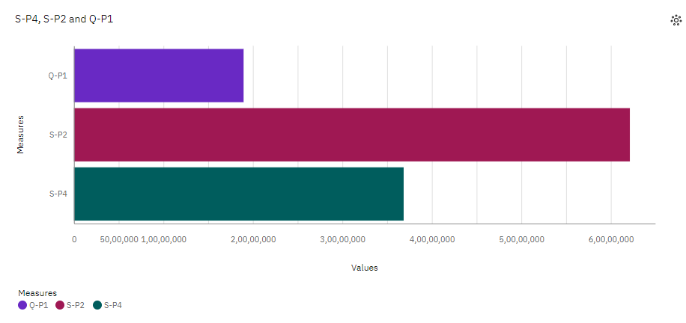

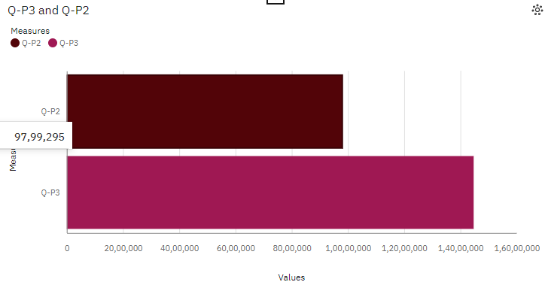

**BARCHART:**

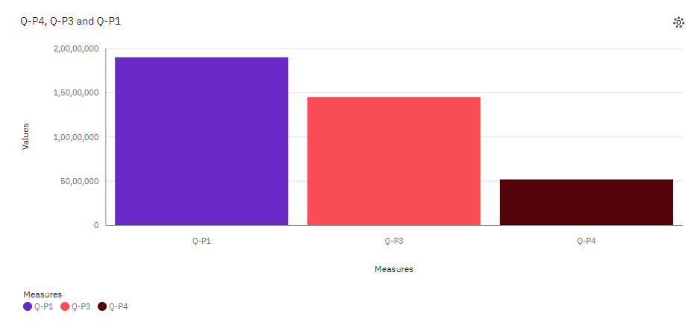

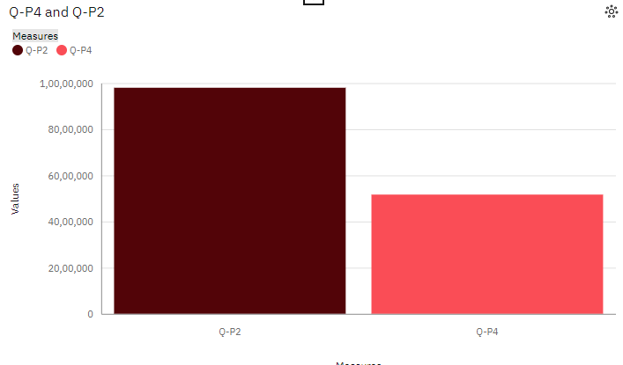

**Preprocessing steps for product sale analysis**:

**1. Data Cleaning**: Handle missing values, outliers, and remove duplicates.

**2. Data Transformation**: Scale or normalize variables, encode categorical variables, and perform feature engineering.

**3. Data Integration**: Merge or join relevant datasets and format the data appropriately.

**4. Data Reduction:** Apply dimensionality reduction techniques if necessary.

**5. Data Splitting**: Split the dataset into training and testing sets.

* **Accuracy and Reliability also done in this process**

**Preprocessing Code(Data Cleaning):**

import pandas as pd

# Read the dataset

df = pd.read_csv('dataset.csv')

# Check for missing values

print(df.isnull().sum())

# Drop rows with missing values

df = df.dropna()

# Remove duplicate rows

df = df.drop_duplicates()

# Save the cleaned dataset

df.to_csv('Tiger.csv', index=False)

**Explanation:**

**1**. First, the code imports the pandas library, which provides powerful data manipulation and analysis tools.

**2**. The dataset is then read into a DataFrame object using `pd.read_csv()`. Adjust the file path and format based on your dataset.

**3**. The `df.isnull().sum()` line checks for missing values in each column and prints the total count of missing values for each column.

**4**. The `df.dropna()` line drops any rows that contain missing values.

**5**. The `df.drop_duplicates()` line removes any duplicate rows from the dataset.

**6**. If needed, you can rename columns using the `rename()` method and passing a dictionary with the old and new column names.

**7**. Unnecessary columns can be removed using the `drop()` function and specifying the column names and axis.

**8**. Additional data cleaning tasks can be performed as needed.

**9.** Finally, the cleaned dataset is saved to a new CSV file using `df.to_csv()`. Adjust the file path and name as desired.

**Analysis objectives of product sales analysis :**

**1. Sales Performance Evaluation:** Assess the overall sales performance of products by analyzing sales data. This includes measuring sales revenue, quantity sold, profit margins, and identifying top-selling products or underperforming products.

**2. Market Segmentation:** Identify different market segments based on customer demographics, geographic locations, or purchasing behaviors. By analyzing product sales data, businesses can understand which products are popular among different customer segments and tailor marketing strategies accordingly.

**3. Trend Analysis:** Identify sales trends over time to understand patterns and seasonal fluctuations. This helps businesses make informed decisions about inventory management, pricing strategies, and promotional activities.

**4. Sales Forecasting:** Use historical sales data to forecast future sales and predict demand for products. This helps businesses optimize production, manage inventory levels, and plan marketing campaigns effectively.

**5. Customer Behavior Analysis:** Analyze product sales data to gain insights into customer behavior, such as repeat purchases, cross-selling opportunities, and customer loyalty. This information can be used to develop targeted marketing campaigns and personalized customer experiences.

**6. Competitor Analysis**: Compare product sales performance with competitors to identify areas of competitive advantage or areas for improvement. This analysis can help businesses identify market gaps, adjust pricing strategies, or differentiate their products.

**7. Channel Analysis:** Analyze sales data across different sales channels (e.g., online, retail, wholesale) to understand channel performance and identify opportunities for optimization. This can involve evaluating sales volume, revenue, and profitability across different channels.

**8. ROI Analysis:** Calculate the return on investment (ROI) for marketing campaigns or promotional activities by analyzing product sales data. This helps businesses evaluate the effectiveness of their marketing efforts and allocate resources more efficiently.

By setting clear analysis objectives, businesses can derive meaningful insights from product sales data and make data-driven decisions to drive growth and improve overall sales performance.

**STEP 1**: To create a dashboard.

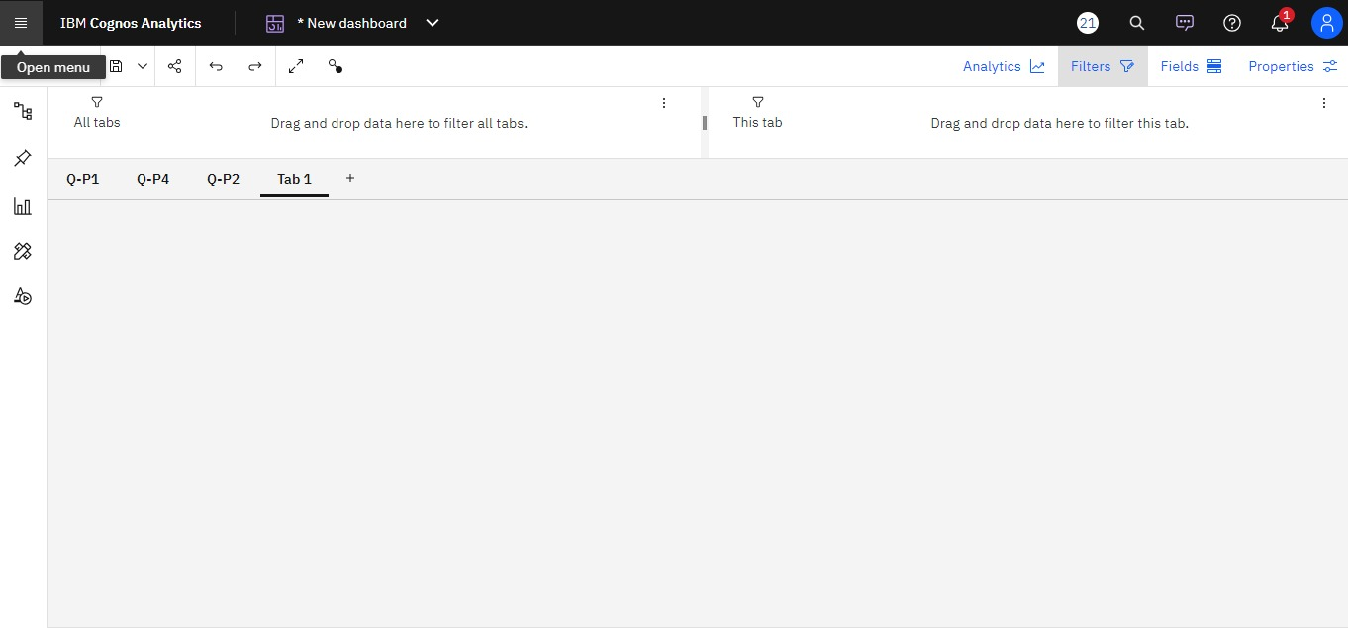**STEP 2:** By comparing the Total revenue from product 1(S-P1) by Total unit sales of product 1(Q-P1).

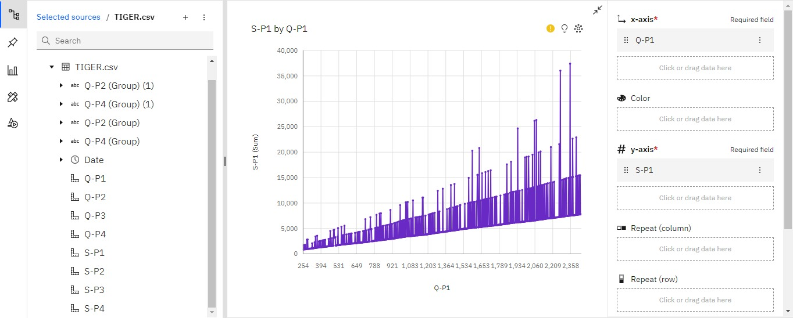**STEP 3:** By comparing the Total revenue from product 2(S-P2) by Total unit sales of product 2(Q-P2).

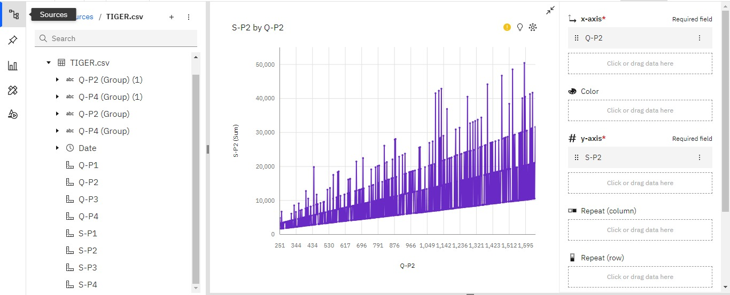

**STEP 4:** By comparing the Total revenue from product 3(S-P3) by Total unit sales of product 3(Q-P3).

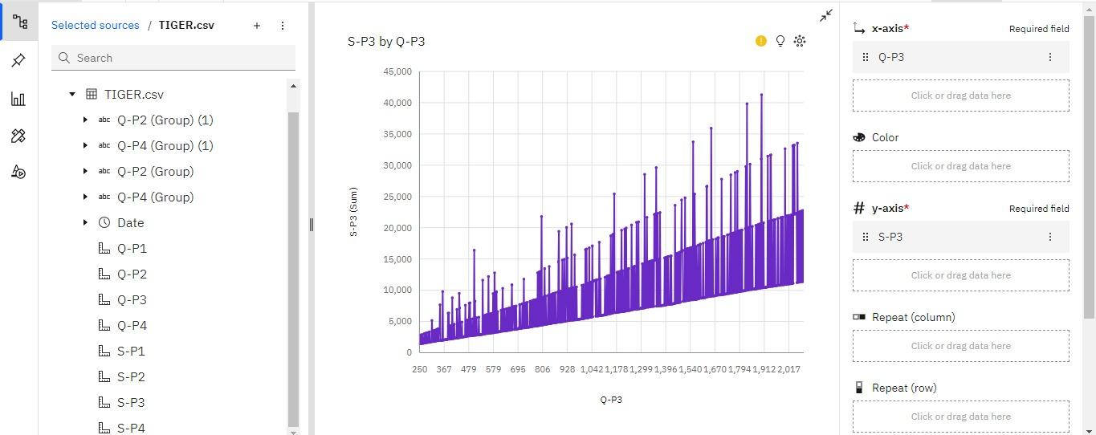**STEP 5:** By comparing the Total revenue from product 4(S-P4) by Total unit sales of product 4(Q-P4).

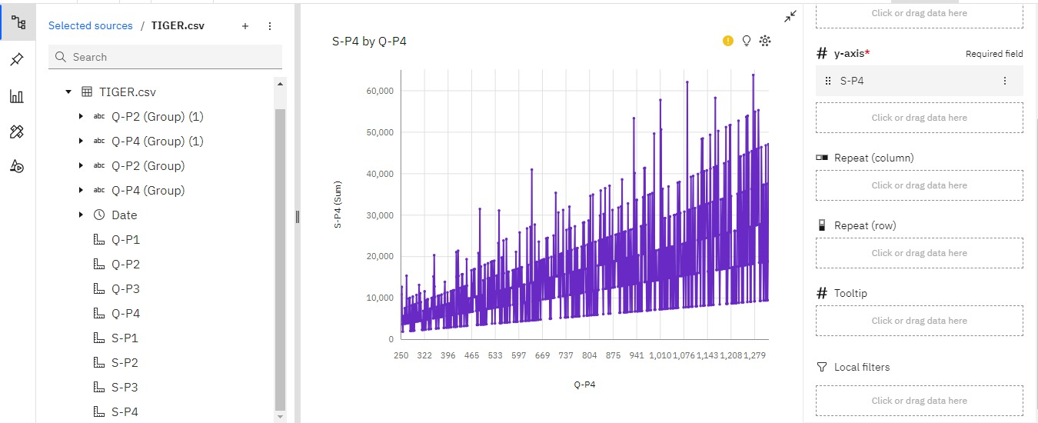

**STEP 6:** The report for the Total unit sales of the product by Total revenue from the products.

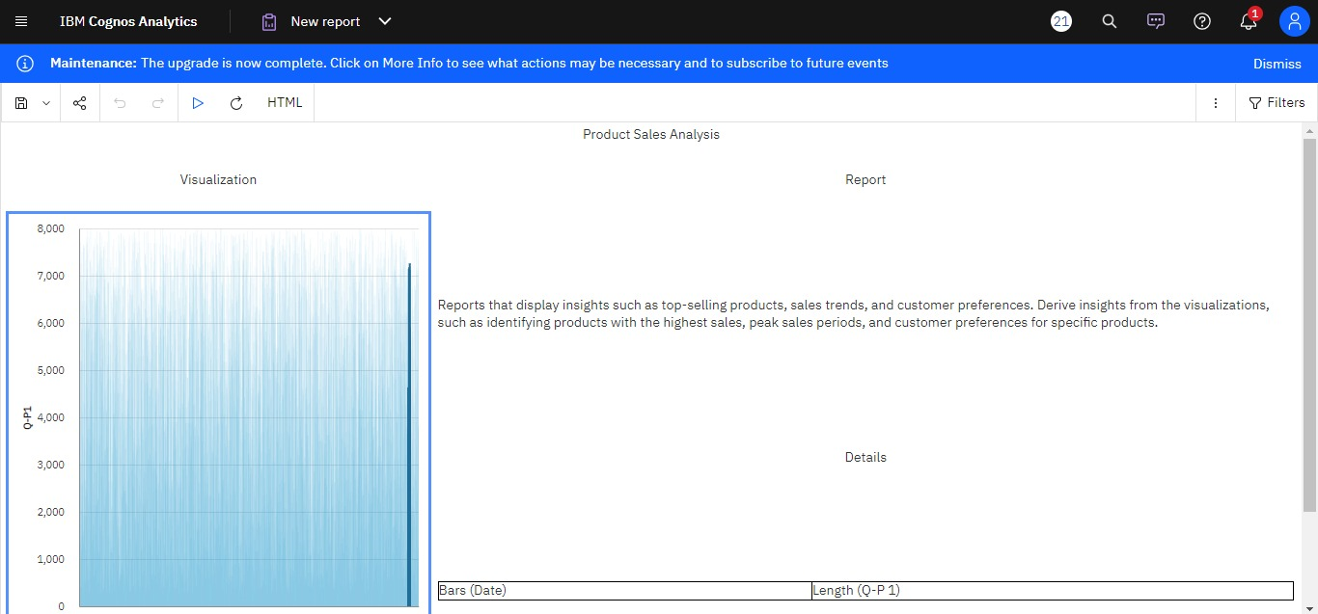**STEP 7: Top selling product , Sales trends , Customer preference**

**Top selling product**

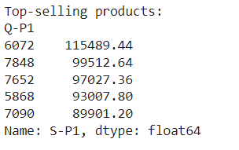

**Sales trends**

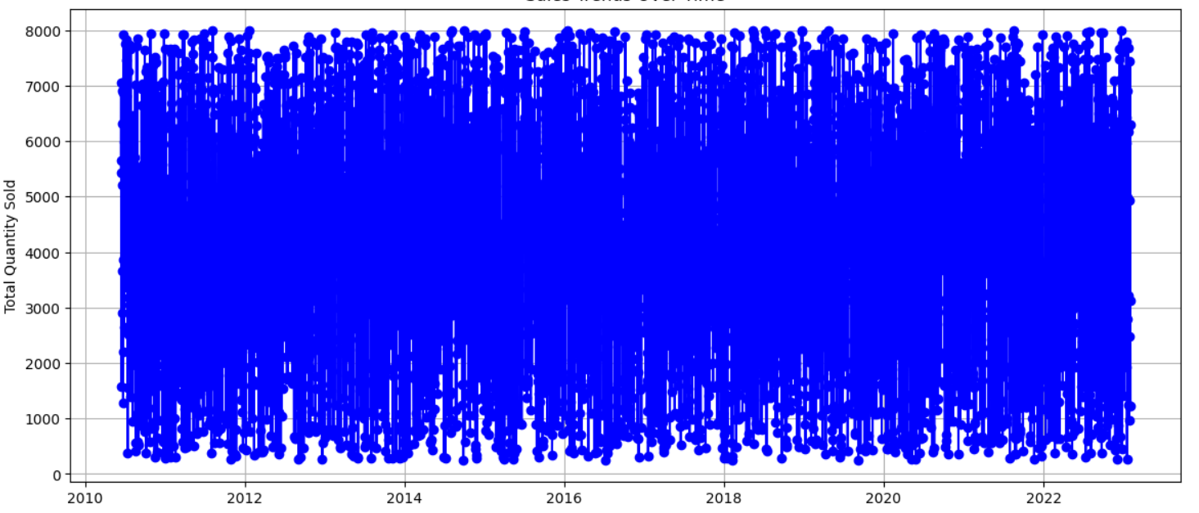

**Customer preference**

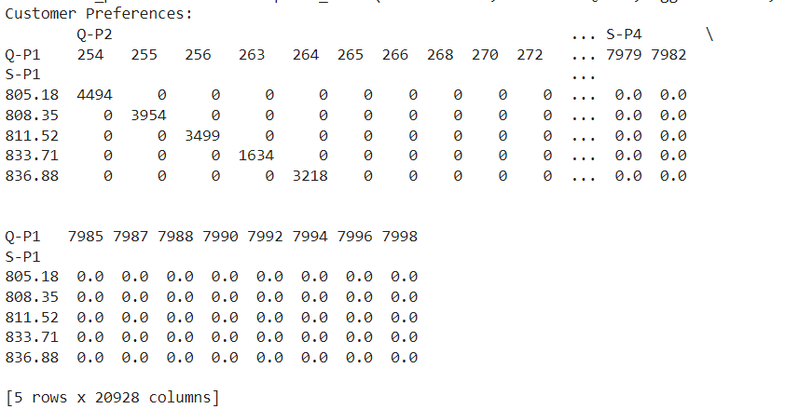

The matrix you've displayed represents customer preferences over time for various products. Each row corresponds to a date, and each column represents a specific product (identified by the product code in 'Q-P1').

The values in the matrix show how many times each product was purchased on a particular date.

If there is a value greater than zero in a cell, it indicates that on that date, a purchase was made for the corresponding product. If the cell contains zero, it means no purchase occurred for that product on that date.

This matrix is a valuable resource for analyzing customer preferences, tracking which products are popular on specific dates, and identifying trends in product choices over time.

You can use this matrix to perform further analysis, such as identifying which products are frequently purchased together or how customer preferences change with time.

**Explain how the insights from the analysis can guide inventory management and marketing strategies.**

* The insights from analysis can play a crucial role in guiding inventory management and marketing strategies. Here's how:

**1. Demand forecasting**: By analyzing historical sales data and market trends, businesses can gain insights into demand patterns for different products. This information can be used to optimize inventory levels, ensuring that enough stock is available to meet customer demand without excess inventory or stockouts.

**2. Seasonal trends**: Analysis can reveal seasonal variations in customer preferences and buying behavior. This information can guide inventory management by helping businesses adjust stock levels accordingly. It can also inform marketing strategies, enabling businesses to create targeted campaigns and promotions during peak seasons.

**3. Product performance**: Analysis can provide information on which products are performing well and which ones are underperforming. By identifying popular products, businesses can prioritize their inventory management efforts to ensure they always have sufficient stock of high-demand items. Additionally, this insight can guide marketing strategies by highlighting products that may require additional promotion or marketing efforts.

**4. Customer segmentation**: Analysis can help identify different customer segments based on their preferences, purchasing behavior, and demographics. This segmentation can guide inventory management by tailoring stock levels and product assortments to meet the specific needs and preferences of different customer groups. It can also inform marketing strategies by enabling businesses to create targeted campaigns and personalized communication for each segment.

**5. Pricing optimization**: Analysis can provide insights into price elasticity and customer sensitivity to price changes. This information can guide pricing strategies, helping businesses determine optimal price points for different products. By understanding how price changes impact demand, businesses can adjust prices to maximize profitability and sales.

**6. Promotional effectiveness**: Analysis can evaluate the effectiveness of different marketing promotions and campaigns. By measuring the impact of promotions on sales and customer behavior, businesses can optimize their marketing strategies and allocate resources to the most effective promotional activities.

In summary, the insights gained from analysis can guide inventory management by

optimizing stock levels, adjusting assortments, and meeting customer demand. They can also inform marketing strategies by identifying trends, targeting specific customer segments, optimizing pricing, and evaluating promotional effectiveness. By leveraging these insights, businesses can make data-driven decisions to improve their inventory management and marketing efforts.

**Provide instructions on how to replicate the analysis and generate visualizations using IBM Cognos:**

To replicate the analysis and generate visualizations using IBM Cognos, follow these steps:

**1. Prepare your data:** Ensure that your data is in a format that can be imported into IBM Cognos. This may involve cleaning and organizing your data in a spreadsheet or database.

**2. Import your data:** Open IBM Cognos Analytics and navigate to the Data module. Click on the "Add data" button and select the appropriate data source (e.g., Excel, CSV, database). Follow the prompts to import your data into Cognos.

**3. Create a new report**: Once your data is imported, navigate to the Reporting module in Cognos. Click on "Create" and select "New Report" to start a new report.

**4. Add data items:** In the report editor, you can add data items to your report by dragging and dropping them from the data pane onto the report canvas. Select the relevant fields from your imported data to include in your analysis.

**5. Apply filters and calculations:** Use the filtering and calculation options in Cognos to refine your analysis. You can apply filters to focus on specific subsets of data and create calculations to derive additional insights.

**6. Generate visualizations:** To create visualizations, select the data items you want to visualize and click on the "Visualization" tab in the report editor. Choose the appropriate chart or graph type (e.g., bar chart, line chart, pie chart) and customize the visual properties as needed.

**7. Customize the report layout:** Use the report editor to customize the layout of your report. You can add titles, headers, footers, and other elements to enhance the visual appeal and clarity of your analysis.

**8. Interact with the report**: Cognos allows you to interact with your report by applying filters, drill-downs, and other interactive features. Use these options to explore your data and gain deeper insights.

**9. Save and share the report:** Once you're satisfied with your analysis and visualizations, save the report in Cognos. You can also share the report with others by exporting it in various formats (e.g., PDF, Excel) or by granting access to specific users within Cognos.

By following these steps, you can replicate the analysis and generate visualizations using IBM Cognos. Remember to explore the various features and options available in Cognos to maximize the insights you can derive from your data.

**GitHub repository link containing the project's code and files**

|  |
| --- |
| https://github.com/Nithish5026/DAC_Phase1.git |