Long-case survival guide — video notes
From the Cochin Ophthalmic Club live mock long-case examination · for the M.S. Ophthalmology practical, 16 October 2026
Seven long cases with the examiners’ corrections, their way of thinking, the viva questions with expected answers, and every clinical image with its points. Times are hh:mm:ss in the video.
Video case · Guide

Contents
No. | Card | Type | Time in video
V0 | The session at a glance — what happened, when, and where it is in these cards | Guide | 0:00:00–4:05:34
V2 | Case 1 — Bilateral primary angle-closure glaucoma with cataract in a diabetic, hypertensive woman | Video case | 0:04:24–0:37:14
V3 | Case 2 — Left ischaemic CRVO with iris neovascularisation, neovascular glaucoma and macular oedema | Video case | 0:37:33–1:16:31
V4 | Case 3 — Right axial proptosis with compressive optic neuropathy: intraconal mass rather than thyroid eye disease | Video case | 1:16:46–1:41:38
V5 | Case 4 — Left isolated, pupil-sparing, partial third nerve palsy (microvascular) in an elderly diabetic smoker | Video case | 1:48:14–2:17:27
V6 | Case 5 — Right perforated corneal ulcer: fungal keratitis versus peripheral ulcerative keratitis with secondary infection | Video case | 2:17:27–2:48:15
V7 | Case 6 — Recurrent anterior uveitis in bilateral high axial myopia: order the diagnosis | Video case | 2:48:30–3:10:36
V8 | Case 7 — Left pseudophakic rhegmatogenous retinal detachment in a vitrectomised eye (after IOFB removal) | Video case | 3:10:53–3:38:37
V10 | Talk — Medical management of glaucoma: IOP, newer drugs and practical points | Guide | 3:50:42–4:03:58
VV | Viva bank — every question asked in the session, by topic, with the expected answer | Guide | —
VS | Slide atlas — every slide in time order, and what was said while it was up | Guide | 0:04:10–4:03:54
VQ | Topic finder — “what did they say about …?” | Guide | —

V0 The session at a glance — what happened, when, and where it is in these cards
Guide · 0:00:00–4:05:34 · Cochin Ophthalmic Club “Super Sunday”, recorded March 2021

What this session is
A live mock long-case examination held on Zoom during the pandemic, when practical exams were moving to virtual case presentations.
- Seven postgraduates presented a long case each. Each presentation was meant to be about 5 minutes; one took 8.
- Each presentation was followed by about 20 minutes of viva and a few minutes of feedback on technique.
- The organisers said plainly that the aim was to test the technique of answering, not knowledge.
- Examiners:
  - Prof M. Vanathi — professor of cornea and refractive surgery, Dr R.P. Centre, AIIMS New Delhi; co-author of a postgraduate ophthalmology textbook with Dr Zia Chaudhuri.
  - Prof Nagaraju — senior professor, Regional Institute of Ophthalmology (Minto), Bangalore; more than 30 years of teaching.
  - Dr Gopal (retina, the organiser) joined for the retina cases.
- Host: Dr Sai Kumar.
- Closing talk: medical management of glaucoma, by Dr Thomas Arun Varghese, at the start of World Glaucoma Week.
- Names are as heard in the recording.

How to read these cards
- One card per case (V2–V8):
  - the case as presented;
  - a table of examiner corrections — what the candidate said and what the examiner wanted;
  - think like this — the reasoning the examiner walked the candidate through;
  - the viva questions with the answers that were accepted or given, each with its time;
  - a corrected say-it summary;
  - the images shown, each with its points.
- “(added)” marks an answer or fact the session did not state in full; it was completed from standard texts so that you have a model answer.
- V10 is the glaucoma talk. VV collects every viva question by topic. VS lists every slide in time order. VQ is a topic finder: “what did they say about …?”.
- Patient names on the slides have been left out and patient photographs are cropped to the eyes.

Time map
Time | What happens | Card
0:00:00–0:04:05 | Welcome, introduction of the examiners and the format (presentation, viva, feedback) | —
0:04:24–0:37:14 | Case 1: bilateral primary angle-closure glaucoma with cataract, diabetes and hypertension (woman, 60) | V2
0:37:33–1:16:31 | Case 2: left ischaemic CRVO with iris new vessels, neovascular glaucoma and macular oedema (man, 67) | V3
1:16:46–1:41:38 | Case 3: right axial proptosis with compressive optic neuropathy — intraconal mass (man, 34) | V4
1:41:38–1:48:14 | Examiners’ general feedback on the first three candidates; YouTube viewer count | —
1:48:14–2:17:27 | Case 4: left isolated pupil-sparing partial third nerve palsy, microvascular (man, 73) | V5
2:17:27–2:48:15 | Case 5: right perforated corneal ulcer — fungal versus PUK (woman, 55) | V6
2:48:30–3:10:36 | Case 6: recurrent anterior uveitis in bilateral high axial myopia (man, 49) | V7
3:10:53–3:38:37 | Case 7: left pseudophakic rhegmatogenous RD in a vitrectomised eye (man, 44) | V8
3:38:37–3:50:42 | Examiners’ advice on preparing during residency | —
3:50:42–4:03:58 | Talk: medical management of glaucoma | V10
4:03:58–4:05:34 | Close | —

Summary of the whole session
Across seven cases the examiners kept asking the same thing: show how you reached the diagnosis.
- History: they wanted it in the patient’s own words, told prospectively (not rearranged to fit the final diagnosis), with optical history under its own heading. Every negative point had to name the differential it excludes.
- Examination: they wanted it described in a fixed order — adnexa before the cornea; disc → macula → vessels → background in the fundus — with exact measurements, not “two-thirds of the cornea”.
- Diagnosis: ordered as primary, then secondary, then tertiary, using precise terms (“senile cataract”, “complicated cataract”, “neurogenic ptosis”, “secondary angle-closure glaucoma”).
- Management:
  - start with your patient, not hypothetical scenarios;
  - drugs by generic name with the correct dose;
  - recent investigations relevant to the case (OCT, anterior segment OCT, angiography) are fair game.
- Mistakes the examiners went for first:
  - an ignored BP of 220/110;
  - ptosis listed separately in a third nerve palsy;
  - “pseudoproptosis” with equal axial lengths;
  - a 49-year-old’s cataract called senile;
  - digital tonometry on a perforated eye.

Summary by hour
First hour (0:00–1:00).
- Case 1, PACG with cataract:
  - building differentials from the history;
  - why each negative history is asked;
  - Van Herick grading;
  - planning surgery for PACG with cataract (medical control first, then cataract surgery alone or sequential surgery);
  - target pressure in the low-to-mid teens;
  - the need for a field report.
- Case 2, CRVO with neovascular glaucoma:
  - categorising risk factors;
  - signs of ischaemia;
  - why NVI rather than NVD;
  - indentation gonioscopy for synechial closure.
Second hour (1:00–2:00).
- Case 2, continued:
  - collaterals versus new vessels;
  - haemorrhage types;
  - IOP control without prostaglandins or miotics;
  - anti-VEGF with the correct dose;
  - OCT thickness;
  - steroids;
  - timing of PRP.
- Case 3, proptosis:
  - signs of TED;
  - when to abandon TED;
  - CT versus MRI;
  - exophthalmometers;
  - red desaturation;
  - pseudoproptosis.
- Feedback break.
- Case 4, third nerve palsy (start): the presentation.
Third hour (2:00–3:00).
- Case 4, viva:
  - the BP and ptosis mistakes;
  - localising the lesion from the orbit to the nucleus;
  - the midbrain syndromes;
  - pupil sparing;
  - when a palsy is an emergency.
- Case 5, perforated corneal ulcer:
  - bacterial versus fungal;
  - corneal diagrams;
  - scraping;
  - Mooren’s versus PUK;
  - glue versus therapeutic keratoplasty;
  - anterior segment OCT.
- Case 6 begins.
Fourth hour (3:00–4:05).
- Case 6, high myopia with uveitis:
  - ordering the diagnosis;
  - proving pseudoproptosis and earlier LASIK.
- Case 7, retinal detachment:
  - trauma history and scars;
  - Shafer’s sign;
  - Lincoff’s rules;
  - degenerations that need treatment;
  - buckle versus vitrectomy;
  - pathological myopia;
  - refractive lens exchange;
  - Gonin.
- Residency-preparation advice.
- Glaucoma talk: newer drugs and their delivery.
Read more: Video: youtube.com/watch?v=e3X1W9wrC_A (“Ophthalmology PG Long case Live – Survival tips explained”, Cochin Ophthalmic Club) · Every time in these cards is hh:mm:ss from the start of that video; add “?t=” and the number of seconds to the link to jump there.

V2 Case 1 — Bilateral primary angle-closure glaucoma with cataract in a diabetic, hypertensive woman
Video case · 0:04:24–0:37:14 · Presenter: 2nd-year MS postgraduate · Examiners: Prof Nagaraju, Prof Vanathi

Case as presented
Mrs X, 60, a tailor. Presentation took 8 minutes (the examiner timed it).
- Complaints: decreased vision in both eyes for 3 years; intermittent left-sided eye pain with headache for 2 years.
- History of presenting illness: gradual, painless, progressive blurring in both eyes, worse for near work (newspaper, stitching) with her present glasses. Left-sided headache and eye pain after long hours of work and while watching television at night, with coloured haloes, relieved by rest. Distance tasks (bus boards, recognising people) were still easy.
- Negative history given: no redness, diplopia, nausea, vomiting, photophobia, seizures or trauma.
- Past and family history: type 2 diabetes mellitus (DM) for 7 years on oral hypoglycaemic agents, well controlled; systemic hypertension (HTN) for 3 years, not on regular treatment. Sister had glaucoma treated surgically.
Finding | Right eye (RE) | Left eye (LE)
Unaided / pinhole | 6/12 → 6/6p | 6/24 → 6/12
Subjective refraction | +2.00 DS / +0.50 DC × 180 → 6/6p | +2.75 DS / +0.75 DC × 180 → 6/12
Near (+2.75 DS add) | N6p | N8
Cornea | Clear | Pigment on the corneal endothelium
Anterior chamber (AC) | Shallow, Van Herick grade 1, quiet | Shallow, Van Herick grade 1, faint flare
Iris and pupil | Normal; 3 mm, brisk, no relative afferent pupillary defect (RAPD) | Loss of pupillary ruff 5–6 o’clock; 4 mm, sluggish direct reflex, RAPD grade 1
Lens | Cortical + posterior subcapsular cataract | Cortical + posterior subcapsular cataract
Intraocular pressure (Goldmann, 2:30 pm) | 26 mm Hg | 33 mm Hg
Gonioscopy | Closed superiorly; multiple focal peripheral anterior synechiae (PAS) on indentation | Closed in most quadrants; diffuse PAS superiorly, hyperpigmented trabecular meshwork
Optic disc (90 D, undilated) | CDR 0.6 × 0.6, superior notch at 11 o’clock, splinter haemorrhage, wedge RNFL defect | CDR 0.8 × 0.8, superotemporal and inferior rim loss, bared circumlinear vessels, superior and inferior RNFL defects
Diagnosis given: both eyes primary angle-closure glaucoma (PACG); both eyes compound hypermetropic astigmatism against the rule; both eyes immature senile cataract; type 2 DM; systemic HTN. The pupils were not dilated because the angles were closed, so diabetic retinopathy was not assessed.

Examiner corrections
What the candidate did or said | What the examiner wanted | Time
History of the main complaint was short and “fragmented” | Describe the decrease of vision in much more detail — onset, course, distance versus near, effect on daily work | 0:12:53
Wrote “coloured haloes” in the history | Write it as the patient says it: “she saw coloured rings around lights”. Signs language in the history shows you put words in her mouth | 0:13:41
No optical history | Give optical history its own heading (glasses: since when, last change, used constantly or not). It is essential in a long case | 0:14:14
Said “cataract” | Be specific — “senile cataract”; and name chronic simple glaucoma (primary open-angle glaucoma) in the list | 0:15:15
Offered migraine for new headache at 58 | Migraine starting at this age is very unlikely — drop it | 0:17:27
Offered ischaemic optic neuropathy as a cause of pain | Anterior ischaemic optic neuropathy is painless — wrong reason | 0:18:36
Said open-angle glaucoma never causes pain | Long-standing chronic glaucoma can reach absolute glaucoma and present with pain | 0:19:41
Asked about seizures and neurological deficits | Not relevant here — every negative question must have a reason you can defend | 0:23:10
History arranged backwards to fit PACG | Present it prospectively, as you took it, and let it lead to the diagnosis; avoid negatives that do not belong to the case | 0:26:19
Answered management with “morgagnian / lens-induced” scenarios | “We are not talking about assumptions” — answer for your patient | 0:32:01
No field or OCT report | Bring the Humphrey field (and OCT) report — a glaucoma diagnosis needs a documented field defect, and field interpretation is asked by most examiners | 0:34:25

Think like this
The examiner rebuilt the case the way he wanted it presented: form the differential diagnosis from the history before you examine, then let each step confirm or exclude.
- Chronic, gradual, painless loss of vision in both eyes at 60: senile cataract → chronic simple glaucoma → diabetic retinopathy or maculopathy (she is diabetic) → age-related macular degeneration.
- Intermittent one-sided eye pain and headache that began at 58: uncorrected or under-corrected hypermetropia (check whether the glasses are worn all the time — she is a tailor doing long near work) → systemic hypertension → intermittent angle closure → lens-induced glaucoma → end-stage chronic glaucoma (absolute glaucoma) → corneal causes in this age group (the examiner prompted for the common corneal degeneration). Migraine is unlikely at this age.
- Why each negative history:
  - Redness → uveitis, acute congestive angle closure.
  - Diplopia → intracranial space-occupying lesion (she has headache).
  - Nausea, vomiting, photophobia → migraine (unlikely) and an acute attack.
  - Trauma → traumatic cataract, angle-recession glaucoma, traumatic subluxation of the lens.
  - Bronchial asthma or heart disease → steroid use (cataract, raised pressure) and contraindication to topical beta-blockers.
- Management in this order: control the pressure medically first → judge how much the lens adds to the shallow chamber (lens thickness) → decide cataract surgery alone, combined surgery, or sequential surgery from the pressure response.

Viva: questions and expected answers
Q From the history alone, what is your differential diagnosis? (0:14:41)
For the visual loss — senile cataract, chronic simple glaucoma, diabetic retinopathy, age-related macular degeneration. For the pain and headache — uncorrected hypermetropia, systemic hypertension, angle closure, lens-induced glaucoma, absolute glaucoma, corneal disease.
Q Why did you ask about redness? (0:21:40)
To exclude uveitis and an acute congestive attack of angle closure.
Q Why did you ask about diplopia? (0:22:23)
She has one-sided headache: diplopia would point to an intracranial space-occupying lesion.
Q Why did you ask about trauma? (0:23:31)
Traumatic cataract, angle recession with secondary glaucoma, and traumatic lens subluxation can all cause this picture.
Q Why does a history of bronchial asthma matter in a patient with decreasing vision? (0:24:05)
Steroids for asthma cause cataract (and raise pressure); and topical beta-blockers are contraindicated in asthma and some heart disease, which changes your glaucoma treatment.
Q How do you assess a shallow anterior chamber clinically? (0:28:48)
Torch test: light from the temporal side; in a shallow chamber the convex iris throws a shadow on the nasal iris. Van Herick test at the slit lamp: a thin optical section at the temporal (or nasal) limbus; compare the peripheral chamber depth with corneal thickness — grade 4 ≥ 1 corneal thickness, grade 3 = ¼–½, grade 2 = ¼, grade 1 < ¼. Grades 2 and 1 need gonioscopy; grade 1 is likely to close. (Accepted.) (added) Grade 0 = iridocorneal contact; grades 0–2 are suspicious of angle closure.
Q She has bilateral PACG and a significant cataract. How will you plan treatment and justify it? (0:31:14)
Control the pressure medically first. Assess whether the lens is adding to the angle crowding (lens thickness). If the pressure is controlled, do cataract surgery alone and watch how much the pressure falls; add drugs if needed; do glaucoma surgery later as a sequential procedure. Consider combined surgery when the pressure is not controlled and synechial closure is extensive (here more than 270°). Know the success rates of combined versus sequential surgery. The examiner’s final advice for this patient: plain cataract extraction first, then follow-up.
Q What is your target pressure? (0:35:40)
Moderate damage (CDR 0.8 with field loss) — aim for the low to mid teens so that cupping and field loss do not progress.
Q What precautions will you take during surgery? (0:36:09)
The examiner wanted you to name the risk of losing the remaining central field in advanced disease (“wipe-out”). (added) Bring the pressure down before surgery (with intravenous mannitol if needed), decompress the eye slowly, avoid a long hypotony, and watch for aqueous misdirection after surgery in angle-closure eyes.
Say it
Mrs X, a 60-year-old tailor with type 2 diabetes for 7 years and hypertension for 3 years, whose sister had glaucoma surgery, has had gradual, painless blurring of vision in both eyes for 3 years, worse for near work. For 2 years she has had left-sided eye pain and headache after long near work and in the evening, with coloured rings around lights, relieved by rest. Best-corrected vision is 6/6 partial in the right eye and 6/12 in the left. Both anterior chambers are shallow (Van Herick grade 1); the left eye shows pigment on the endothelium, loss of the pupillary ruff and a grade 1 relative afferent pupillary defect. Pressures are 26 and 33 mm Hg. Gonioscopy shows synechial angle closure in both eyes, worse on the left. The discs show glaucomatous cupping, 0.6 in the right eye and 0.8 in the left. My diagnosis is both eyes primary angle-closure glaucoma, left more advanced, with both eyes immature senile cataract and hypermetropic astigmatism, in a patient with type 2 diabetes and hypertension. I would like to confirm the field loss with a Humphrey 24-2 field and an OCT of the nerve fibre layer.

Images and their points

Right eye gonioscopy (0:08:40)
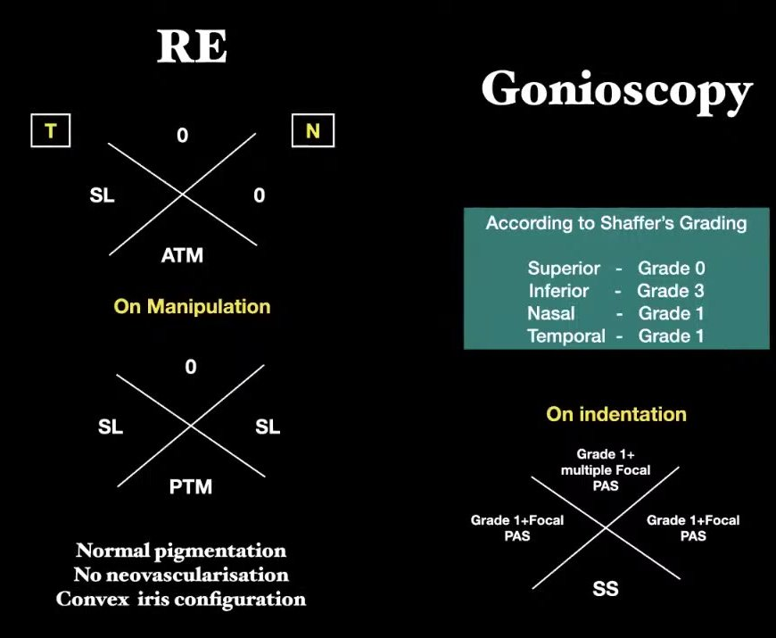
Right eye — gonioscopy crosses without and with manipulation, Shaffer grades and findings on indentation (0:08:40)
- What it shows:
  - The diagram is drawn as the examiner sees it (T on the left, N on the right).
  - Without manipulation: superior closed (0); temporal Schwalbe’s line (SL); nasal closed; inferior anterior trabecular meshwork (ATM).
  - On manipulation: superior still closed; SL temporally and nasally; posterior trabecular meshwork (PTM) inferiorly.
  - On indentation: multiple focal PAS superiorly, focal PAS nasally and temporally, scleral spur (SS) inferiorly.
  - Normal pigmentation, no new vessels, convex iris.
- What the candidate said: the angle is closed superiorly and narrow elsewhere, with PAS on indentation.
- Point (added):
  - The Shaffer table says “inferior grade 3”, but the cross shows PTM on manipulation (about grade 2). The scleral spur was seen only on indentation.
  - Keep the diagram and the grading consistent, and say which method (dynamic or indentation) each grade comes from — an examiner will notice.

Left eye gonioscopy (0:09:10)
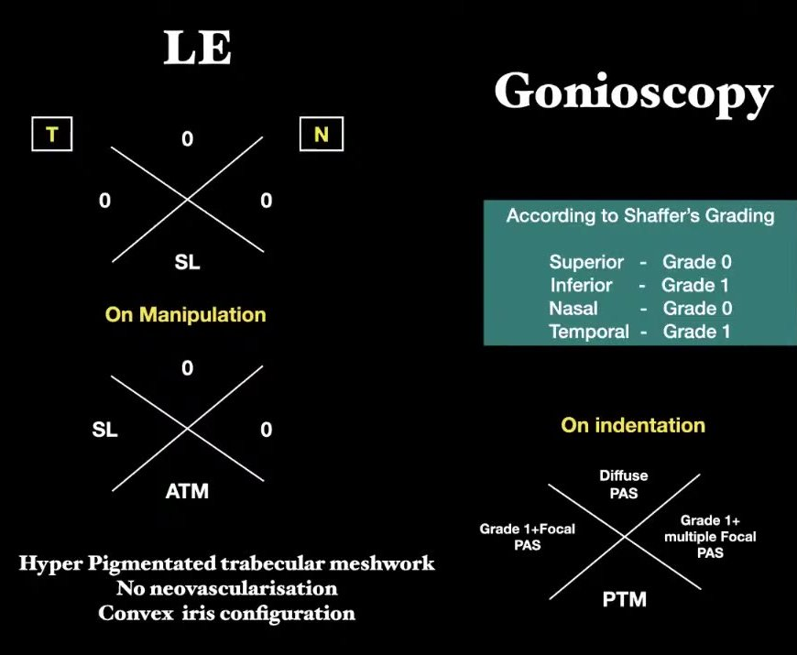
Left eye — gonioscopy crosses, Shaffer grades and findings on indentation (0:09:10)
- What it shows:
  - Without manipulation: closed in three quadrants; only SL visible inferiorly.
  - On manipulation: SL temporally, ATM inferiorly; superior and nasal still closed.
  - On indentation: diffuse PAS superiorly, multiple focal PAS nasally, focal PAS temporally, PTM inferiorly.
  - Hyperpigmented trabecular meshwork, no new vessels, convex iris.
- What the candidate said: closed angles with more than 180° (later “more than 270°”) of iridotrabecular contact. She used this to justify combined trabeculectomy and cataract surgery.
- Examiner’s point: synechial extent is one input; the decision rests on pressure control and the lens (0:33:03). Indentation is what separates synechial from appositional closure — the point the examiner pressed in Case 2.

Optic discs — photographs (0:09:40 and 0:10:10)
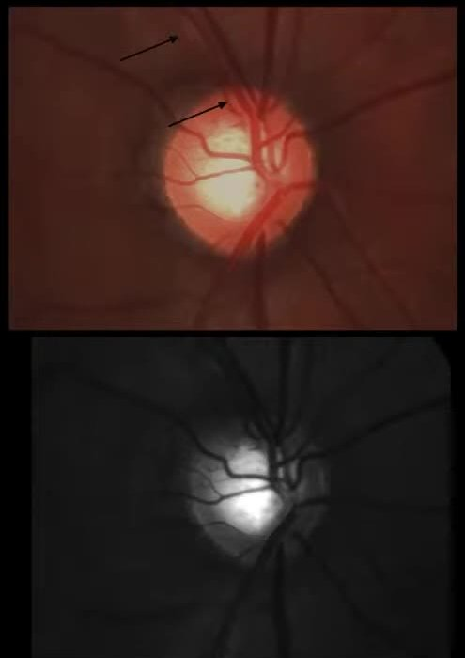
Right optic disc — colour and red-free photographs; arrows mark the superior nerve fibre layer defect (0:09:40)
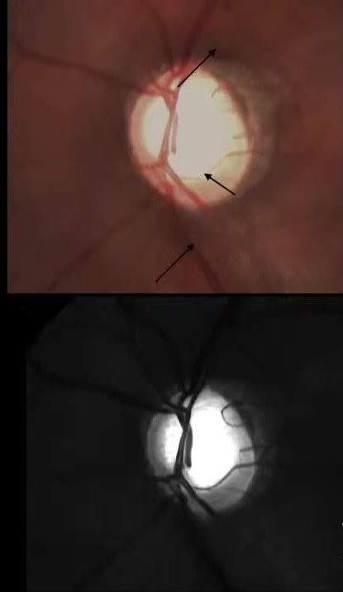
Left optic disc — colour and red-free photographs; arrows mark rim loss and nerve fibre layer defects (0:10:10)
- What they show:
  - Right eye: a normal-sized, vertically oval disc with a moderately enlarged cup. The arrows point to a superotemporal wedge-shaped nerve fibre layer defect running to the rim near 11 o’clock. The red-free view shows the defect as a dark wedge against the striated nerve fibre layer.
  - Left eye: a much larger, pale, deep cup (about 0.8), with rim thinning superotemporally and inferiorly and a vessel bared on the cup. The red-free view shows both the superior and inferior defects.
- What the candidate said:
  - Right eye: CDR 0.6 × 0.6, laminar dot sign, superior notch at 11 o’clock, wedge defect, splinter haemorrhage at the superotemporal margin.
  - Left eye: CDR 0.8 × 0.8, superotemporal rim loss 12–2 o’clock, inferior notch at 6 o’clock with baring of circumlinear vessels, superior and inferior wedge defects.
- Examiner’s point: structure needs function — attach the Humphrey field (and OCT) report to prove glaucoma (0:34:25). Every postgraduate must be able to interpret a field printout.

Optic disc diagrams (0:10:50)
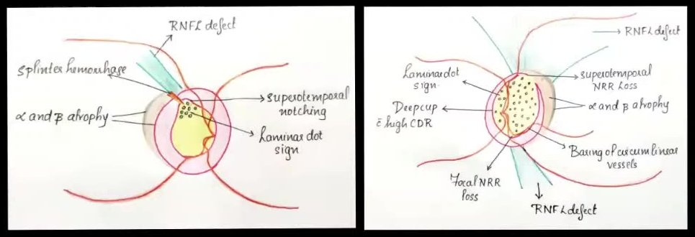
Hand-drawn disc diagrams, right and left, labelled with every glaucomatous sign (0:10:50)
- What they show:
  - Labelled colour drawings.
  - Right: alpha and beta peripapillary atrophy, splinter haemorrhage, superotemporal notch, laminar dot sign, wedge defect.
  - Left: deep cup with a high CDR, laminar dot sign, superotemporal rim loss, focal inferior rim loss, baring of circumlinear vessels, wedge defects.
- Point: a clear, labelled drawing like this is the standard examiners expect for a fundus case. Label every sign you name in the description, and keep the eye orientation correct.
- Differentials come from the history — before the examination.
- Pain in a 58–60-year-old: hypermetropia, hypertension, angle closure, lens-induced, absolute glaucoma — not migraine.
- Every negative history = the differential it rules out.
- Bring the field report. Target IOP for moderate damage: low to mid teens.
- PACG + cataract: medical control → cataract surgery alone → sequential glaucoma surgery if needed.
Read more: Watch: youtu.be/e3X1W9wrC_A?t=264 (presentation) · t=761 (viva) · Linked cards: G4 angle closure · G9 gonioscopy · G10 Humphrey field

V3 Case 2 — Left ischaemic CRVO with iris neovascularisation, neovascular glaucoma and macular oedema
Video case · 0:37:33–1:16:31 · Presenter: postgraduate · Examiners: Prof Vanathi, Prof Nagaraju, Dr Gopal (retina)

Case as presented
Mr X, 67, a farmer.
- Complaint: defective vision in the left eye; worse for the past 1 week.
- History of presenting illness: sudden loss of vision in the left eye 8 months ago. A local clinic referred him to a higher centre but he did not go. The vision has worsened over the last week.
- Negative history given: no redness, pain, discharge, watering, photophobia, headache, glare, haloes, diplopia, distortion, flashes, floaters, trauma or frequent change of glasses.
- Past history: diabetes and hypertension for 10–12 years, on oral hypoglycaemic agents, insulin and antihypertensives. No dyslipidaemia, coronary disease, stroke or asthma.
- General examination: pulse 74/min, regular; both carotids palpable and equal; BP 130/90 mm Hg.
Finding | Right eye | Left eye
Vision | 6/18 unaided → 6/6 with +1.00 DS; N6 with +3.00 add | Counting fingers 2 m → CF 3 m with −1.00 DS; N18
Retinoscopy glow | Red, +2.50 DS both meridians | Dull glow
Anterior chamber | Van Herick grade 3, quiet | Van Herick grade 2, quiet
Iris | Normal | Pattern lost; tuft of branching vessels at the pupillary margin = neovascularisation of the iris (NVI)
Pupil | 3 mm, direct present | 3 mm, grade 1 relative afferent pupillary defect (RAPD)
Lens | Nuclear sclerosis grade 1–2 | Nuclear sclerosis grade 2
Gonioscopy | Open — scleral spur visible in all quadrants | Grade 0 all round, 360° peripheral anterior synechiae (PAS); no new vessels seen in the angle
IOP (Goldmann, 10 am) | 12 mm Hg | 34 mm Hg
Disc | Vertically oval, CDR 0.5, healthy rim (ISNT rule kept) | Hyperaemic, CDR 0.6; small tortuous vessels on the disc — collaterals
Macula and retina | Normal; AV ratio 2:3 | Retinal thickening at the macula, dull foveal reflex; dot, blot and flame-shaped haemorrhages in all four quadrants; AV ratio 2:4
Investigations on the slides:
- fasting blood sugar 114 mg/dL, HbA1c 6.7%;
- haemoglobin 12 g/dL, total count 6,500/mm³;
- total cholesterol 219 mg/dL;
- creatinine 0.96 mg/dL, urea 24 mg/dL;
- OCT: central retinal thickness 272 µm.
FFA was listed but never shown.
Diagnosis given: both eyes senile immature cataract; left eye ischaemic central retinal vein occlusion (CRVO) with macular oedema and neovascular glaucoma (NVG).

Examiner corrections
What the candidate did or said | What the examiner wanted | Time
Listed risk factors in a jumble | Categorise them: systemic vascular, blood (hyperviscosity, thrombophilia), inflammatory, local ocular — then say which one applies to your patient | 0:48:19
Gave a refraction without naming it | Name the refractive error: right eye simple hypermetropia with presbyopia. You must be able to name every refraction you present | 0:50:03
Went straight to the pupil | Start with lids and globe: xanthelasma (lipid disorder), proptosis (orbital cause of vein compression); conjunctiva (subconjunctival haemorrhage in hypertension); AC cells and flare (vasculitis — sarcoidosis, HIV) | 0:51:30
“Sudden 8 months ago … progressive … worse for some days” | Chronology confused. Say it exactly: “sudden loss 8 months ago; a further sudden drop in the last 7 days” | 0:56:56
Blamed the recent drop on macular oedema alone | Think of raised IOP: epithelial (bullous) corneal oedema from an acute pressure rise — look for it | 0:58:32
“360° PAS” on gonioscopy | Say “on indentation gonioscopy the closure was synechial, not appositional”; know how to tell PAS from iris processes | 0:59:17
Called it ischaemic but there were few cotton-wool spots | Reconsider: probably a non-ischaemic CRVO that has become ischaemic (Dr Gopal agreed) | 1:05:56, 1:16:08
Described the vessels loosely | Show which vessel is the artery and which the vein; look for hypertensive crossing changes; describe the fundus in order disc → macula → vessels → background | 1:04:41
(added) Showed an OCT printout labelled OD (right eye) for a left-eye disease | Check the eye label on every investigation you bring; a wrong-eye report is a gift to the examiner | 0:47:00
“Ranibizumab 0.5 ml” | Use the pharmacological name with the correct dose — never brand names. (added) Ranibizumab 0.5 mg in 0.05 mL | 1:11:57

Think like this
- Risk factors for CRVO, in categories:
  - Systemic vascular: age, hypertension, diabetes, dyslipidaemia.
  - Blood: hyperviscosity (polycythaemia, multiple myeloma), thrombophilia (antiphospholipid antibody syndrome, protein C or S deficiency; hyperhomocysteinaemia in the young).
  - Inflammatory: sarcoidosis, tuberculosis, other vasculitis.
  - Local: raised IOP or glaucoma, orbital compression.
Then: “in my patient the likely cause is the vasculopathy of diabetes and hypertension; I would investigate to exclude the rest”.
- Ischaemic or non-ischaemic?
  - Vision worse than 6/60, an RAPD, NVI or NVG, and many cotton-wool spots favour ischaemic.
  - Few cotton-wool spots after 8 months suggest a non-ischaemic occlusion that has converted.
- Why the iris and not the disc? The ischaemic retina releases vascular endothelial growth factor (VEGF). In a CRVO the retina is so widely damaged that it cannot grow new vessels itself, so the VEGF acts forward on the iris and angle. With less ischaemia you see new vessels on the disc (NVD) or elsewhere (NVE).
- Why look at the disc in any vein occlusion? Glaucoma is a risk factor; the disc shows collaterals or new vessels; hypertensive changes show on the vessels.
- Management in three parts, after the physician controls the systemic disease:
  - lower the IOP;
  - treat the macular oedema;
  - make the new vessels regress.

Viva: questions and expected answers
Q What risk factors did you rule out for CRVO? (0:47:55)
Age; hypertension, diabetes, dyslipidaemia; hyperviscosity (polycythaemia, multiple myeloma); thrombophilia (antiphospholipid syndrome, protein C or S deficiency, hyperhomocysteinaemia in young patients); inflammation (sarcoidosis, tuberculosis); raised IOP or glaucoma.
Q What do you look for on examination in a CRVO? (0:50:42)
Vision (worse than 6/60 suggests ischaemia); RAPD; NVI at the pupillary margin; gonioscopy for angle new vessels (NVA). Also lids (xanthelasma), proptosis, conjunctiva and AC cells or flare for a systemic or inflammatory cause.
Q Why does NVI occur in vein occlusion, and why not NVD or NVE here? (0:53:45)
Ischaemic retina releases VEGF. In a CRVO the damage is so extensive that the retina cannot respond, so new vessels form on the iris and in the angle. Lesser ischaemia produces NVD or NVE.
Q Why did the vision drop suddenly in the last week? (0:57:58)
An acute rise of IOP from angle closure can cause epithelial corneal oedema; the macular oedema may also have increased.
Q Gonioscopy shows 360° closure — synechial or appositional? (0:59:30)
On indentation gonioscopy the angle did not open, so it is synechial closure from contraction of the fibrovascular membrane. Know how to differentiate PAS from iris processes.
Q How do you classify retinal vein occlusions? (1:00:44)
Central, hemi-central and branch; each ischaemic or non-ischaemic.
Q Where is the block in a CRVO? (1:01:05)
At or just behind the lamina cribrosa. The candidate said ischaemic occlusions are at the lamina and non-ischaemic ones further back, where collaterals are possible.
Q Which quadrant has the most branch vein occlusions, and why? (1:01:33)
Superotemporal, because it has the most arteriovenous crossings. (added) Temporal occlusions involve the macula and are noticed; nasal ones are often asymptomatic and go undetected.
Q Is this CRVO ischaemic or non-ischaemic, and why? (1:02:24)
Ischaemic — vision counting fingers, RAPD, NVI and NVG. The examiner noted the lack of cotton-wool spots, suggesting a non-ischaemic CRVO that has become ischaemic.
Q How do you tell collaterals from new vessels on the disc? (1:04:24)
Collaterals are looped vessels that do not branch and do not leak on FFA; new vessels branch and leak.
Q What arteriovenous crossing changes do you see in hypertensive retinopathy? (1:05:10)
(added) Gunn’s sign (tapering of the vein on either side of the crossing), Salus’ sign (deflection of the vein), Bonnet’s sign (banking of the vein distal to the crossing), plus arteriolar narrowing and copper or silver wiring.
Q How do you describe flame, dot and blot haemorrhages, and a microaneurysm? (1:06:13)
Flame-shaped haemorrhages lie in the nerve fibre layer and follow its fibres; dot and blot haemorrhages lie deeper, in the inner nuclear and outer plexiform layers. (added) A microaneurysm is a sharp-edged red dot that shows as a pinpoint hyperfluorescent dot on FFA (some leak); a dot haemorrhage blocks fluorescence. Be ready to list all the red lesions of the fundus.
Q How will you lower the IOP? (1:08:13)
Acetazolamide by mouth; topical timolol 0.5%, brimonidine and dorzolamide. Avoid prostaglandin analogues (they worsen macular oedema and inflammation) and miotics (more inflammation, more synechiae).
Q What other topical drugs will you give? (1:09:24)
Topical steroids and atropine. Atropine is right even though the angle is closed: this is secondary angle closure from neovascularisation, not pupil block, and it reduces inflammation and pain.
Q What type of glaucoma is this, and how do you classify secondary glaucomas? (1:09:53)
Secondary angle-closure glaucoma due to neovascularisation. Secondary glaucomas are classified as open-angle or closed-angle.
Q How do you treat the macular oedema? (1:11:40)
Intravitreal anti-VEGF, named with the dose: (added) ranibizumab 0.5 mg/0.05 mL, bevacizumab 1.25 mg/0.05 mL or aflibercept 2 mg/0.05 mL. Review the IOP, the NVI and the OCT at follow-up.
Q What does the OCT show in macular oedema, and what is normal? (1:13:05)
Altered foveal contour, increased central retinal thickness and cystic spaces in the inner layers. Normal central thickness is about 250 µm; above 270–280 µm suggests oedema. (added) The exact normal values depend on the OCT machine — compare with that machine’s normative data.
Q Which other intravitreal drugs can you use? (1:14:11)
Steroids — dexamethasone implant 0.7 mg, or triamcinolone (added) 4 mg/0.1 mL. Monitor the IOP closely with steroids.
Q If you had found new vessels in the angle, what would you add, and when? (1:15:02)
Pan-retinal photocoagulation (PRP), sparing the macula. (added) The Central Vein Occlusion Study advises PRP promptly once there are 2 clock hours of NVI or any NVA, not as prophylaxis.
Say it
Mr X, a 67-year-old farmer with diabetes and hypertension for 10–12 years, had a sudden loss of vision in the left eye 8 months ago and a further sudden drop in the last week. Left vision is counting fingers at 3 metres, with a grade 1 relative afferent pupillary defect, new vessels at the pupillary margin, 360° synechial angle closure on indentation gonioscopy and a pressure of 34 mm Hg. The left fundus shows a hyperaemic disc with collaterals, haemorrhages in all four quadrants and macular thickening. The right eye has early nuclear sclerosis and is otherwise normal. My diagnosis is left eye central retinal vein occlusion, now ischaemic, with macular oedema and neovascular glaucoma (secondary angle-closure glaucoma), and both eyes immature senile cataract, in a patient with diabetes and hypertension.

Images and their points

Fundus photographs — right eye (normal) and left eye (CRVO) (0:42:52 and 0:44:55)
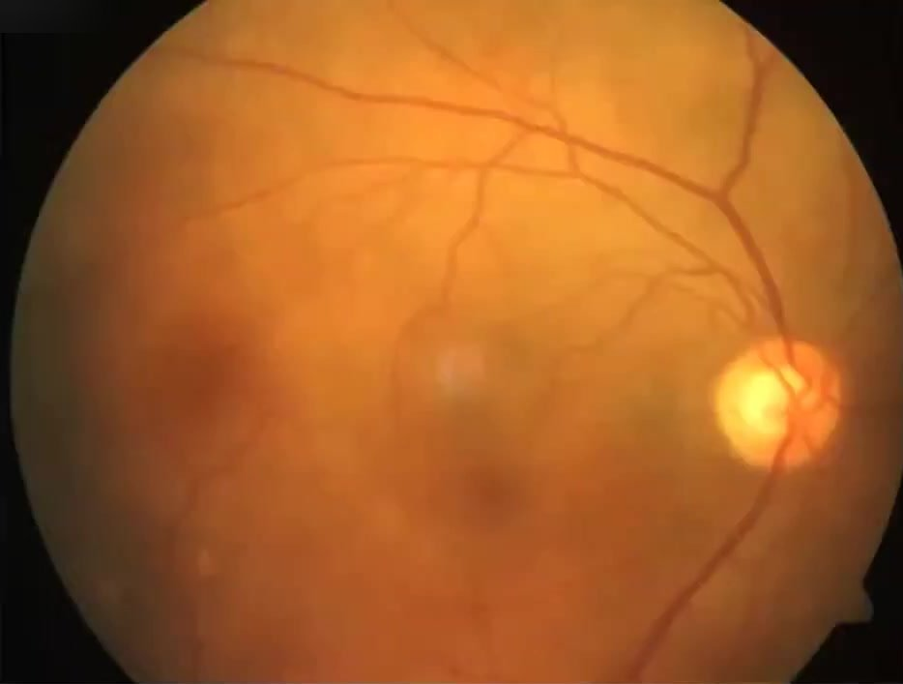
Right eye — normal posterior pole; vertically oval disc, CDR about 0.5, normal vessels (0:42:52)
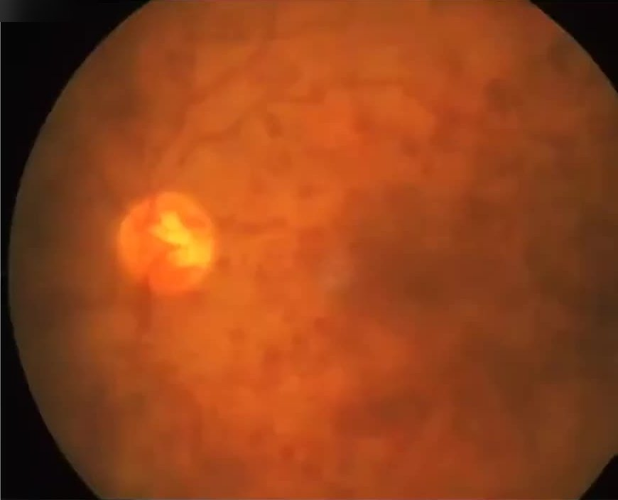
Left eye — central retinal vein occlusion: hyperaemic disc, dilated tortuous veins, haemorrhages in all quadrants (0:44:55)
- What they show:
  - Right eye: a well-defined pink disc with a healthy rim and a cup of about 0.5; normal arteries and veins; no haemorrhages.
  - Left eye: a hazy picture with a hyperaemic, swollen-looking disc, dilated, tortuous veins and many blotchy dark-red (dot and blot) haemorrhages throughout the posterior pole in all quadrants. The macula is obscured, and the fine collaterals on the disc cannot be resolved on this photograph.
- What the candidate said: left disc hyperaemic, CDR 0.6, small tortuous vessels on the disc (collaterals), retinal thickening at the macula, deep and superficial haemorrhages in all four quadrants.
- Examiner’s points:
  - Show which vessel is the artery and which the vein — the vein is darker and wider, and the artery has the brighter light reflex.
  - Look for hypertensive crossing changes.
  - Be ready to defend “collaterals” against “new vessels on the disc” — collaterals are looped, do not branch and do not leak (1:04:24).
  - The examiner also noted that cotton-wool spots were not obvious, which questions the label “ischaemic” (1:05:56).

Fundus charts (0:44:55)
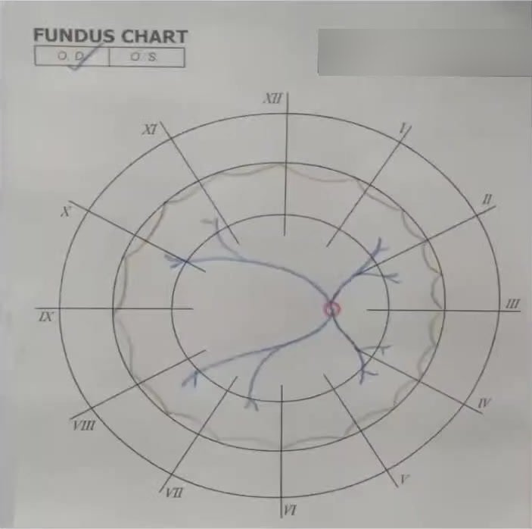
Right eye fundus chart — normal disc and vessels (0:44:55)
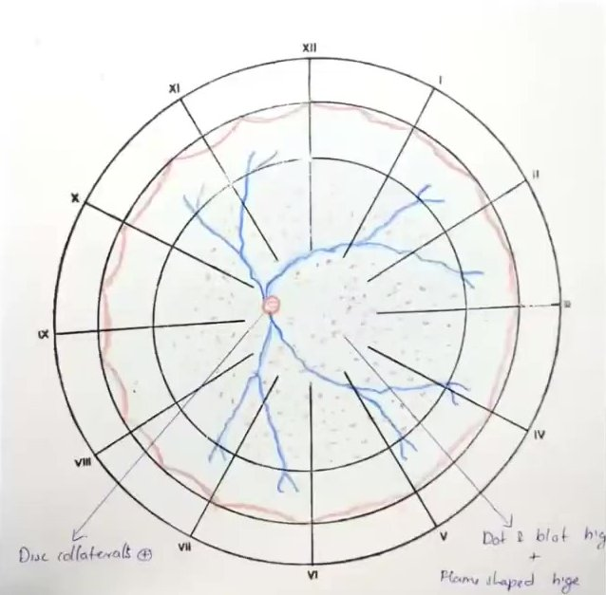
Left eye fundus chart — disc collaterals, dilated tortuous veins, dot-blot and flame-shaped haemorrhages in all quadrants (0:44:57)
- What they show:
  - Right chart: normal, with the disc drawn just nasal of centre and four arcades.
  - Left chart: dilated tortuous veins in all four quadrants, haemorrhages as small red dots throughout the posterior pole and mid-periphery, and the labels “disc collaterals” and “dot and blot + flame-shaped haemorrhages”.
- Point: this is the drawing the examiners expect for a vein occlusion. Draw every lesion you name, in the quadrants where it lies, and mark the disc as the starting point. Describe it in the order disc → macula → vessels → background (1:05:37).

Iris new vessels — hand-drawn (0:42:30)
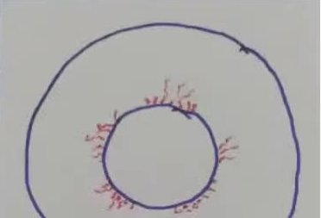
Left iris — new vessels (red tufts) at the pupillary margin (0:42:30)
- What it shows: fine red tufts of new vessels all round the pupillary margin of the left iris. No vessels are drawn in the angle; the gonioscopy slide said “no new vessels in the angle”, with 360° synechial closure.
- What the candidate said: normal iris pattern lost, with a tuft of branching vessels at the pupillary margin — NVI.
- Examiner’s point: NVI with an angle closed all round means secondary angle-closure (neovascular) glaucoma. Say that you confirmed synechial closure by indentation gonioscopy (0:59:17). If new vessels are found in the angle, do PRP (1:15:02).

OCT macula (0:47:00)
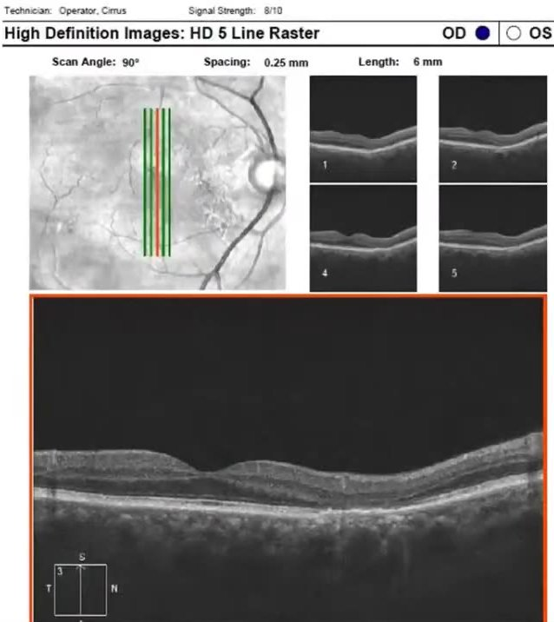
Macular OCT printout (5-line raster) shown with the case — note it is labelled OD (right eye) (0:47:00)
- What it shows:
  - A 5-line raster through the fovea.
  - The enlarged scan has a shallow, slightly irregular foveal contour with mild inner-retinal thickening.
  - No large cysts or subretinal fluid at this resolution.
  - Central retinal thickness 272 µm.
  - The printout is marked OD, and its fundus image is a right eye.
- What the candidate said: OCT shows macular oedema — altered foveal contour, increased thickness, cystic spaces in the inner layers.
- Examiner’s point: normal central thickness is about 250 µm; above 270–280 µm suggests oedema (1:13:05). 272 µm is only borderline. (added) The eye label does not match the left-eye disease — always check it before you show a report.
- Risk factors in categories, then name your patient’s.
- Ischaemic CRVO: VA < 6/60, RAPD, NVI/NVA, cotton-wool spots.
- Indentation gonioscopy = synechial vs appositional.
- NVG drugs: acetazolamide, timolol, brimonidine, dorzolamide + steroid + atropine; no prostaglandins, no miotics.
- Generic drug name + correct dose (ranibizumab 0.5 mg/0.05 mL).
- Fundus order: disc → macula → vessels → background.
Read more: Watch: youtu.be/e3X1W9wrC_A?t=2253 (presentation) · t=2850 (viva) · Linked cards: G5 neovascular glaucoma · G7 CRVO with POAG · B master fundus format

V4 Case 3 — Right axial proptosis with compressive optic neuropathy: intraconal mass rather than thyroid eye disease
Video case · 1:16:46–1:41:38 · Presenter: postgraduate · Examiners: Prof Nagaraju, Prof Vanathi

Case as presented
Mr X, 34. Before the presentation the examiner asked for a brief history: “say ‘nothing contributory on systemic examination’ rather than listing every normal”.
- Complaint: prominence of the right eye for 1 year, slowly increasing; mild aching pain behind the eye for 3 months.
- Negative history: no blurring, double vision, postural or diurnal variation, redness, discharge, difficulty moving the eye, weight loss, night sweats, heat or cold intolerance, tremor, or lumps elsewhere.
Examination | Findings
Vision | 6/6, N6 both eyes (small cylinder, 0.5 DC); colour vision 21/21 Ishihara both eyes
Pupils | Right grade 1 relative afferent pupillary defect (RAPD)
Alignment and movements | Orthotropic (Hirschberg, cover–uncover); ocular movements full in all gazes (nine-gaze photograph)
Inspection | Right axial proptosis — Naffziger method, confirmed on worm’s-eye view; lids normal, no inflammation, no lagophthalmos, good Bell’s phenomenon
Palpation | Resistance on retropulsion; no thrill, pulsation, palpable mass, tenderness or nodes; orbital margins intact; finger passes between margin and globe; no infraorbital or supraorbital anaesthesia
Hertel exophthalmometry (base 105 mm) | Right 23 mm, left 19 mm
Anterior segment and IOP | Normal; Van Herick grade 4; IOP 10 mm Hg both eyes
Fundus | Right disc oedema: elevated, hyperaemic disc with blurred margins; blurred, tortuous vessels on the disc. Left normal, CDR 0.2
Diagnosis given: right axial proptosis with compressive optic neuropathy. Differentials: thyroid eye disease (TED) first; then intraconal masses — cavernous haemangioma, optic nerve sheath meningioma, optic nerve glioma, circumscribed lymphangioma, orbital lymphoma. Plan: investigate.

Examiner corrections
What the candidate did or said | What the examiner wanted | Time
Kept TED as the first diagnosis although no TED sign was present | “I don’t agree with your diagnosis of thyroid eye disease.” Use the absent signs to move on to an intraconal mass | 1:33:06
“Retropulsion positive” | Positive is ambiguous — say what you felt: resistance on retropulsion (not reducible) | 1:26:15
Chose MRI for a proptosis | A CT scan is good enough to make the diagnosis here; MRI is not needed first. (The image shared later in the viva was in fact an MRI.) | 1:29:22
Did not ask about pets | Ask — parasitic orbital disease (for example cysticercosis or hydatid cyst) is a cause of proptosis | 1:36:25
Tested colour only with Ishihara | In a suspected optic nerve lesion compare red desaturation between the eyes — more important than the plate score | 1:39:56
Did not know the Luedde exophthalmometer | Know the instruments: Hertel; Luedde (simple, cheap, useful in TED); the one that rests on the superior and inferior rims for use after lateral orbitotomy | 1:32:17
Thought lymphoma was a main differential | Unlikely as the primary cause in this age group | 1:38:00

Think like this
- The commonest cause of proptosis in an adult — unilateral or bilateral, man or woman, 30 or 50 — is TED. So it is the right first thought.
- Then test it against the case:
  - Signs of inflammation? None.
  - Lid retraction, lid lag? None.
  - Restricted movements? None.
  - Thyroid profile? Normal.
  - Axial proptosis with resistance on retropulsion? Yes.
So drop TED and say “intraconal mass”.
- What else can push the eye forward?
  - Vascular: a carotid–cavernous fistula gives pulsation and congestion; orbital varix gives postural variation.
  - Inflammatory: myositis, idiopathic orbital inflammation.
  - Parasitic.
  - Trauma.
Ask and examine for each.
- Optic nerve function in every proptosis: vision, RAPD, colour (red desaturation), fields. Disc oedema with an RAPD and normal acuity = early compressive optic neuropathy.
- The examiner’s summary of this case: a young man, symptom-free, vision normal, cosmetic proptosis growing slowly over a year, axial, no postural change, resistance on retropulsion → intraconal mass. The candidate reported a well-defined, homogeneous globular intraconal mass with normal muscles. The scan shared was an MRI (axial T1 and T2), although it was discussed as a CT.

Viva: questions and expected answers
Q How do you examine for proptosis? (1:23:21)
Naffziger method: stand behind the seated patient, tilt the head back and look along the brow — the affected globe shows beyond the orbital margin. Worm’s-eye view: look up from below with the head tilted back. Ruler test for minimal proptosis. Measure with an exophthalmometer.
Q Name the signs of thyroid eye disease. (1:24:10)

- Dalrymple — lid retraction.
- von Graefe — lid lag on downgaze.
- Stellwag — infrequent blinking.
- Kocher — staring look.
- Ballet — restricted muscle movement.
- Braley — IOP rises on upgaze.
- Möbius — weak convergence (the examiner called it one of the earliest signs; (added) the textbooks give lid retraction as the commonest and earliest sign of TED).
The examiner keeps a list of about 28 signs.
Q What is the commonest cause of unilateral and of bilateral proptosis in adults? (1:26:55)
Thyroid eye disease, for both.
Q Which features of your case are against TED? (1:25:36)
No inflammation (no redness, chemosis or lid oedema), no lid retraction or lid lag, full movements, axial proptosis, normal thyroid tests.
Q How do you make a definitive diagnosis in proptosis? (1:28:28)
Blood tests and thyroid profile with antibodies, then imaging — a CT is enough here. An orbital B-scan shows the mass’s reflectivity, how well defined it is, and its relation to the optic nerve and muscles.
Q Which vascular causes did you exclude, and how? (1:30:15)
Carotid–cavernous fistula — no pulsation, bruit or congestion. Orbital varix — no change in proptosis with posture or Valsalva.
Q What is absolute and relative exophthalmometry? (1:31:49)
Absolute — compared with the normal for age and race. Relative — the difference between the two eyes. (added) A difference of more than 2 mm is significant; here it is 4 mm.
Q Which exophthalmometer can you use after an orbitotomy? (1:32:47)
One that rests on the superior and inferior orbital rims instead of the lateral rim — (added) the Naugle exophthalmometer — because the lateral rim may have been removed.
Q What CT changes would TED show? (1:35:18)
Spindle-shaped (fusiform) enlargement of the muscle bellies with sparing of the tendons, more orbital fat, crowding at the apex.
Q If the tendons were also thickened? (1:36:51)
Think of orbital myositis, an inflammatory condition.
Q How do you assess the optic nerve in this patient? (1:39:01)
Vision, pupils (RAPD), colour vision (Ishihara plates and red desaturation compared between the eyes), visual fields.
Q What is pseudoproptosis? (1:40:27)
The eye looks prominent without true forward displacement. Causes: axial myopia (most common), lid retraction, enophthalmos of the other eye.
Q What is the pseudo-Graefe sign? (1:41:06)
Lid elevation on attempted downgaze or adduction from aberrant regeneration of the third nerve.
Say it
Mr X, a 34-year-old man, has noticed slowly increasing prominence of his right eye for one year, with an ache behind the eye for three months and no double vision, redness or postural change. He has right axial proptosis, 23 mm against 19 mm on Hertel exophthalmometry at a base of 105, with resistance on retropulsion and full ocular movements. There are no signs of thyroid eye disease. Vision is 6/6 in each eye, but the right eye has a grade 1 relative afferent pupillary defect and disc oedema. My diagnosis is right axial proptosis due to an intraconal mass lesion, most likely a cavernous haemangioma, with early compressive optic neuropathy. Optic nerve sheath meningioma is the main differential. I would confirm with imaging of the orbits — a CT is enough, and the MRI done shows a well-defined intraconal mass.

Images and their points

Fundus photographs (1:17:00)
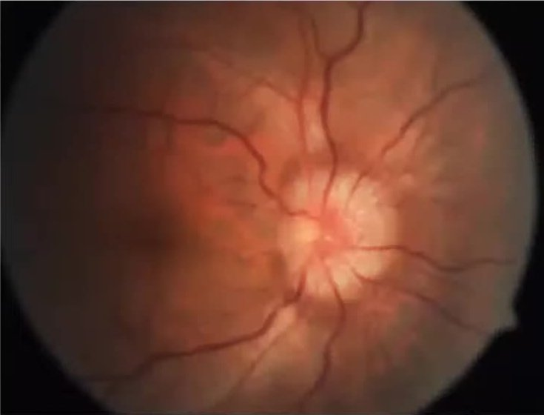
Right eye — disc oedema: elevated, hyperaemic disc with blurred margins all round (1:17:00)
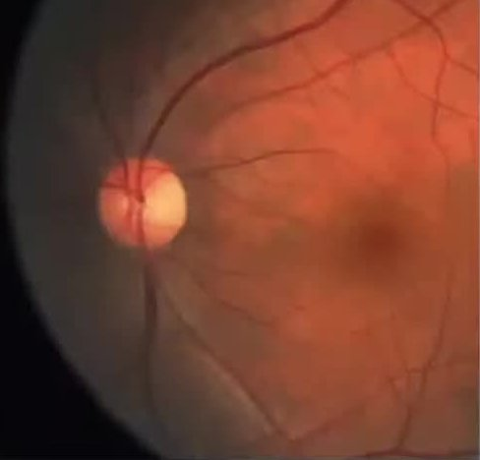
Left eye — normal disc (CDR about 0.2) and macula (1:17:00)
- What they show:
  - Right disc: swollen — elevated, hyperaemic, margins blurred through 360°, the cup filled in, and vessels partly hidden as they cross the margin. No haemorrhages or macular star.
  - Left disc: normal, with a small cup.
- What the candidate said: right disc elevated and hyperaemic with blurred margins and blurred, tortuous vessels — disc oedema; left normal.
- Examiner’s point: unilateral disc oedema with a grade 1 RAPD and normal acuity is early compressive optic neuropathy — so test colour (red desaturation) and fields (1:39:01). (added) Look for optociliary shunt vessels and choroidal folds, which also point to a mass behind the globe.

Fundus diagrams (1:21:30)
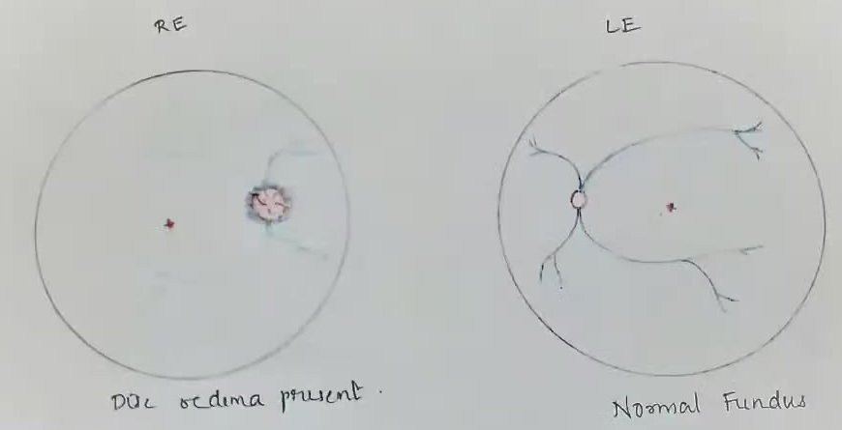
Hand-drawn fundus diagrams — right eye “disc oedema present”, left eye “normal fundus” (1:21:30)
- What they show: the right disc drawn with a fuzzy, feathered margin and obscured vessels; the left disc and arcades normal; both foveae marked.
- Point: a simple, labelled diagram of each eye is enough — show the disc margin and vessel obscuration clearly.

Ocular movements — gaze photographs (1:21:40)
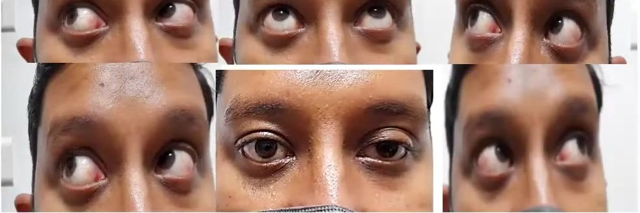
Gaze photographs — elevation and horizontal gazes with the primary position (centre, bottom row); full movements (1:21:40)
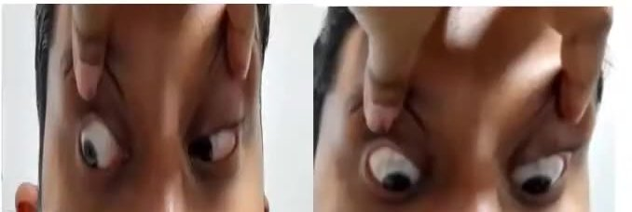
Down-gazes with the upper lids held up (1:21:40)
- What they show:
  - Full excursions in every gaze, with no restriction or overaction.
  - In the primary position: no lid retraction, no scleral show above the cornea, no lid swelling or redness.
  - The proptosis is not obvious from the front.
- What the candidate said: ocular motility full and free in all directions; no lid retraction or lid lag.
- Examiner’s point: these normal movements and lids are the evidence against thyroid eye disease — use them (1:25:36). Restriction, lid retraction or lid lag would have supported TED.

Worm’s-eye view (1:21:45)
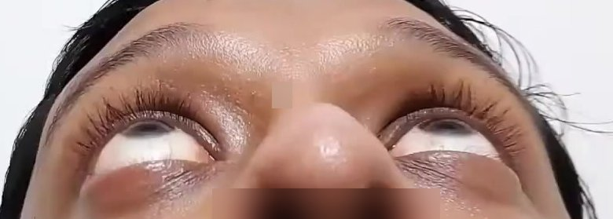
Worm’s-eye view (head tilted back, viewed from below) — the right globe projects slightly further (1:21:45)
- What it shows: both globes seen from below the chin, with the patient’s right on the viewer’s left. The right globe projects a little beyond the left. The difference is subtle on one frame, as expected for a 4 mm difference.
- What the candidate said: right axial proptosis on worm’s-eye view, confirmed by Hertel exophthalmometry (23 against 19 mm).
- Examiner’s point: know the clinical methods — Naffziger’s (from behind and above), worm’s-eye view, and the ruler test for minimal proptosis — before quoting exophthalmometry (1:23:21, 1:33:46).

MRI of the orbits (1:34:40)
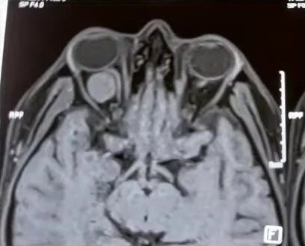
Axial T1-weighted MRI (fat-suppressed) — round, well-defined right intraconal mass behind the globe (1:34:40)
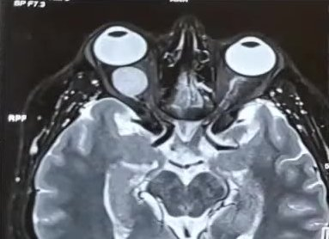
Axial T2-weighted MRI — the mass is homogeneously bright; right axial proptosis (1:34:40)
- What they show:
  - Radiological convention — the patient’s right is on the image left.
  - A well-circumscribed, round, homogeneous mass inside the muscle cone of the right orbit, directly behind the globe and between the recti.
  - Bright on T2 with a smooth margin; no bone erosion; the right globe pushed forward.
  - The left orbit is normal.
- What the candidate said: no thickening of the extraocular muscles; an intraconal, globular, homogeneous mass.
- Examiner’s points:
  - First, ask what TED would show — spindle-shaped muscle bellies with the tendons spared. Tendons involved → myositis (1:35:18).
  - The examiner agreed with “intraconal mass” and did not agree with TED.
  - (added) A well-defined, round, T2-bright intraconal mass in an adult is most typical of a cavernous haemangioma (cavernous venous malformation). An optic nerve sheath meningioma would cause tubular thickening along the nerve, with “tram-track” enhancement of the sheath around a non-enhancing nerve, and calcification in some.
- TED = commonest cause; then test it against the signs and drop it if they are absent.
- Describe retropulsion (“resistance felt”), do not just say “positive”.
- CT is enough. TED on CT: fusiform muscle bellies, tendons spared. Tendon involved → myositis.
- Optic nerve: VA, RAPD, red desaturation, fields.
- Pseudoproptosis: axial myopia. Pseudo-Graefe: aberrant third nerve regeneration.
Read more: Watch: youtu.be/e3X1W9wrC_A?t=4606 (presentation) · t=5021 (viva)

V5 Case 4 — Left isolated, pupil-sparing, partial third nerve palsy (microvascular) in an elderly diabetic smoker
Video case · 1:48:14–2:17:27 · Presenter: postgraduate · Examiners: Prof Nagaraju, Prof Vanathi

Case as presented
Mr X, 73, a businessman.
- Complaints: double vision for 7 days; drooping of the left upper lid for 3 days.
- The diplopia: sudden and painless; images side by side with one slightly higher; present for distance and near; worse on looking to the right; relieved by closing one eye. Once the lid dropped completely, the diplopia went.
- Negative history was long, each item aimed at something:
  - redness, pain, discharge;
  - fatigability or evening worsening (myasthenia);
  - scalp tenderness or jaw claudication (giant cell arteritis);
  - headache, vomiting, loss of consciousness (raised intracranial pressure);
  - hearing, smell, taste, swallowing or speech problems, numbness, weakness, involuntary movements, gait change (other cranial nerves or brainstem).
- Past history:
  - a similar episode in the right eye 5 years ago (complete ptosis with diplopia, “a nerve problem”) that recovered within a year;
  - diabetes for 20 years, tablets stopped a year ago, current control unknown;
  - coronary bypass 4 years ago, on anticoagulants;
  - smoker, 1 pack a day for 10 years.
- Vitals: BP 220/110 mm Hg. Other cranial nerves, motor, sensory and cerebellar examination normal.
Examination (left eye unless stated) | Findings
Ptosis | Palpebral fissure height 5 mm; margin reflex distance 1 (MRD1) −1 mm; MRD2 6 mm; levator function 4 mm (poor); ice test negative; no synkinesis
Primary position (lid lifted) | Left exotropia about 30° with hypotropia (Hirschberg); confirmed by cover tests
Movements | All movements limited except abduction and intorsion (lateral rectus and superior oblique working); slow, “floating” saccades on adduction
Prism bar cover test | Right eye fixing: 50 prism dioptres base-in + 10 base-down; left eye fixing: 60 base-in — secondary deviation > primary (paralytic)
Forced duction | Negative (no restriction)
Diplopia charting (red–green glasses) | Separation maximal to the right and up; crossed diplopia
Vision | 6/12, N24 unaided → 6/9, N6 with glasses both eyes (compound hypermetropic astigmatism)
Pupils | 2 mm, round, equal; direct and consensual normal — pupil spared
Lens, IOP, fundus | Nuclear sclerosis grade 2 + cortical cataract both eyes; IOP 17 and 18 mm Hg (Goldmann, 1 pm); colour vision and confrontation fields normal (lid held up); fundus normal, CDR 0.5
Diagnosis given:
- left isolated, pupil-sparing, partial oculomotor nerve palsy, probably microvascular ischaemia from uncontrolled diabetes and hypertension;
- left severe ptosis with poor levator function;
- both eyes immature cataract;
- both eyes compound hypermetropic astigmatism.

Examiner corrections
What the candidate did or said | What the examiner wanted | Time
Recorded BP 220/110 and moved on | The first thing is near-malignant hypertension: look at the fundus for hypertensive retinopathy (and papilloedema) and act on it | 2:00:03
Listed “severe ptosis with poor LPS function” as a separate diagnosis | The ptosis is part of the third nerve palsy. If you name it, classify it — neurogenic ptosis | 2:01:29
Wrote “severe” without a method | Grade ptosis properly: (added) mild ≤ 2 mm, moderate 3 mm, severe ≥ 4 mm of droop. Here MRD1 is −1 mm against a normal 4–5 mm, so about 5–6 mm of droop — severe | 2:00:37
Had a “musculoskeletal system” slide | Write instead “neurological evaluation: no sensory or motor deficit” — that is what the examiner needs | 2:02:56
Asked to look at the fundus “for anything” | Use your findings: in this patient look first for hypertensive changes, then for papilloedema (space-occupying lesion) | 1:59:13

Think like this
- Read your own summary slide before the examiner does — he went straight to the diagnosis slide and the vitals to find mistakes.
- Localise a third nerve lesion from the orbit back to the nucleus (the examiner asked for this order because it is easier to follow):
  - Orbit: the nerve has split. The superior division supplies levator and superior rectus; the inferior division supplies medial rectus, inferior rectus, inferior oblique and the pupil. So you see a palsy of one division, often with proptosis or a mass.
  - Superior orbital fissure and cavernous sinus: several cranial nerves together — III, IV, V1 and VI pass through the fissure; the cavernous sinus also holds V2. Tolosa–Hunt syndrome is painful. Cavernous sinus thrombosis brings fever and proptosis. At the orbital apex the optic nerve joins in.
  - Subarachnoid space: posterior communicating artery aneurysm (painful, pupil involved); basal meningitis (fever, meningeal signs); granulomas (sarcoidosis, tuberculosis).
  - Fascicle (midbrain):
  - Nothnagel — with cerebellar ataxia;
  - Claude — with contralateral ataxia;
  - Benedikt — with contralateral tremor or involuntary movements;
  - Weber — with contralateral hemiparesis.
  - Nucleus: bilateral ptosis (one central nucleus for both levators) and weakness of the opposite superior rectus.
- Rule to remember (examiner’s dictum): an isolated medial rectus palsy or an isolated dilated pupil is almost never a partial third nerve palsy.
- Why the pupil is spared or involved: the pupillary fibres run on the surface of the nerve, fed by pial vessels. Microvascular (vasa nervorum) ischaemia damages the core and spares the pupil. Compression from outside (an aneurysm) hits the surface first and involves the pupil.
- A palsy only one week old may still be evolving: a pupil-sparing palsy can become pupil-involving if an aneurysm enlarges, so recheck the pupil.

Viva: questions and expected answers
Q What type of ptosis is this, and how do you grade ptosis? (2:00:24)
Neurogenic ptosis, part of the third nerve palsy. (added) Grade by the amount of droop: mild ≤ 2 mm, moderate 3 mm, severe ≥ 4 mm. This is severe (MRD1 −1 mm, fissure 5 mm), with poor levator function.
Q Why do you call it isolated, partial and pupil-sparing? (2:02:34)
Isolated — no other cranial nerve or neurological sign. Partial — movements limited, not abolished. Pupil-sparing — pupils equal and reacting.
Q If it were not isolated, which syndromes would you think of? (2:03:21)
The midbrain (fascicular) syndromes: Nothnagel, Claude, Benedikt and Weber. Also nuclear palsy (bilateral ptosis, opposite superior rectus weak), cavernous sinus and orbital apex lesions.
Q How do you localise a third nerve lesion, from the orbit to the nucleus? (2:05:19)
Orbit — single-division palsy. Fissure (III, IV, V1, VI) or cavernous sinus (also V2) — several cranial nerves. Subarachnoid space — aneurysm (painful, pupil involved) or meningitis. Fascicle — midbrain syndromes. Nucleus — bilateral ptosis and opposite superior rectus weakness.
Q Where do you think the lesion is in your patient? (2:08:42)
Not the orbit or fissure (no proptosis, other nerves normal, vision normal), not the nucleus. Most likely microvascular ischaemia of the nerve in its subarachnoid or cavernous course.
Q Which nerves lie next to the third nerve in the cavernous sinus? (2:10:33)
In the lateral wall, from above down: III, IV, V1, V2. The VI nerve lies inside the sinus beside the internal carotid artery.
Q How do you test the fourth nerve when the third is paralysed? (2:11:05)
Ask the patient to look down. If the superior oblique works, the eye intorts — watch a conjunctival vessel or iris landmark at the slit lamp. The examiner noted this is hard to judge in a partial palsy.
Q Why does a microvascular palsy spare the pupil? (2:14:02)
Pupillary fibres are superficial and supplied by pial vessels. Ischaemia of the vasa nervorum affects the centre of the nerve. Compression affects the surface first.
Q What is the pupil like when it is involved? (2:13:37)
Fixed and dilated — an efferent defect.
Q What is the likely cause here? (2:14:43)
Microvascular ischaemia — elderly, long-standing uncontrolled diabetes, uncontrolled hypertension, smoker, and a similar recovered palsy of the other eye 5 years ago.
Q Why does pupil sparing matter for management? (2:15:12)
Pupil-sparing — conservative care with the physician controlling diabetes, BP and smoking, and close follow-up of the pupil. Pupil-involving — an aneurysm until proved otherwise: urgent angiography (CT angiography, MR angiography or digital subtraction angiography) and a neurosurgeon for clipping or coiling. It can be life-threatening.
Q When is a third nerve palsy an emergency? (2:16:00)
A “third nerve plus” picture — pupil involvement, sudden severe headache, meningeal signs, other neurological deficits such as hemiparesis. Refer to a neurosurgeon at once.
Say it
Mr X, a 73-year-old man with 20 years of diabetes (treatment stopped a year ago), coronary bypass surgery and a heavy smoking history, presents with sudden painless double vision for 7 days and drooping of the left upper lid for 3 days. Five years ago he had a similar episode in the right eye that recovered. His blood pressure today is 220/110 mm Hg, which needs urgent attention, and I would examine the fundus for hypertensive retinopathy. He has severe left neurogenic ptosis with poor levator function. On lifting the lid the left eye is exotropic and hypotropic, with limitation of all movements except abduction and intorsion; the secondary deviation exceeds the primary. The pupils are equal and reacting, and all other cranial nerves are normal. My diagnosis is a left isolated, pupil-sparing, partial oculomotor nerve palsy, probably microvascular, in a patient with uncontrolled diabetes and hypertension, with both eyes immature cataract.

Images and their points

The patient in primary gaze (1:50:30)
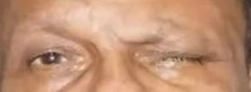
Primary gaze, cropped to the eyes — severe left ptosis covering the pupil (1:50:30)
- What it shows: the left upper lid covers the pupil, leaving a narrow slit; the right lid is at a normal height. The left brow is not obviously raised, so there is little frontalis compensation. He was closing the eye on purpose before the ptosis to stop the diplopia.
- What the candidate said: severe left ptosis; palpebral fissure height 5 mm, MRD1 −1 mm, levator function 4 mm.
- Examiner’s point: name and grade it correctly — neurogenic ptosis, part of the third nerve palsy, not a separate diagnosis (2:01:29).

Versions — nine-gaze photographs and H-charts (1:53:50)
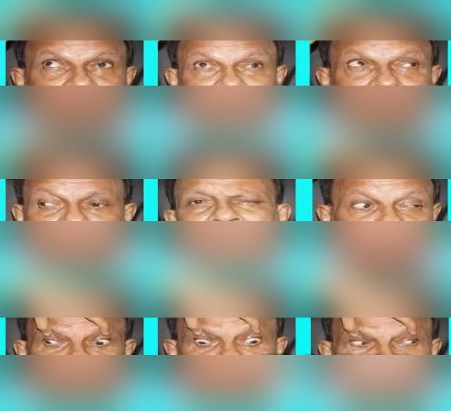
Nine-gaze photographs with the lids lifted (eye bands only; the rest of the face blurred) (1:53:50)
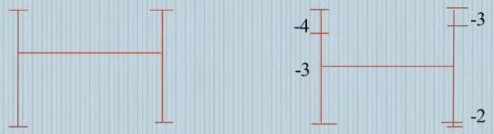
Version H-charts — right eye full; left eye −4 elevation in adduction, −3 adduction, −3 elevation in abduction, −2 depression in abduction (1:53:50)
- What they show:
  - Primary position: left ptosis.
  - Looking right: the left eye does not adduct past the midline.
  - Upgaze: the left eye lags below the right.
  - Downgaze: the left eye depresses less and stays out. Lateral rectus and superior oblique are spared.
  - The H-chart grades: left elevation in adduction −4, adduction −3, elevation in abduction −3, depression in abduction −2; abduction and depression in adduction full.
- What the candidate said: all movements of the left eye limited except abduction and intorsion; the inferior oblique, inferior rectus, superior rectus and medial rectus are involved.
- Point (added):
  - This is the textbook third nerve pattern with IV and VI spared.
  - Keep the grades consistent across slides. The duction chart (next figure) gives −3 where the version chart gives −4 for elevation in adduction, and an examiner may ask which is right.

Ductions (1:54:37 and 1:54:40)
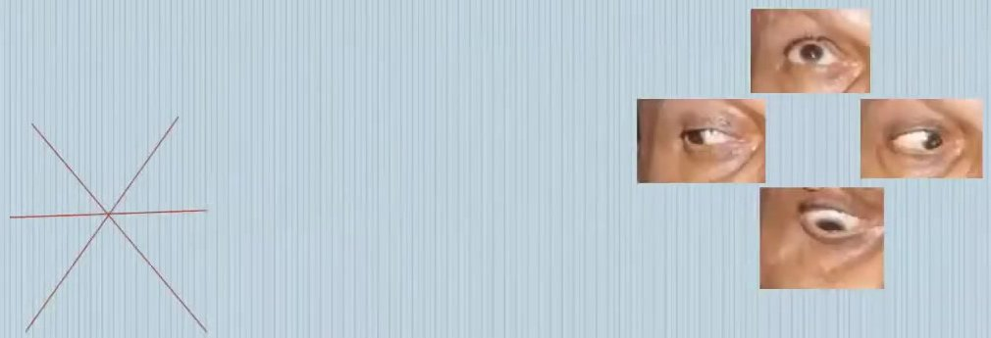
Right eye ductions — full in all directions (1:54:37)
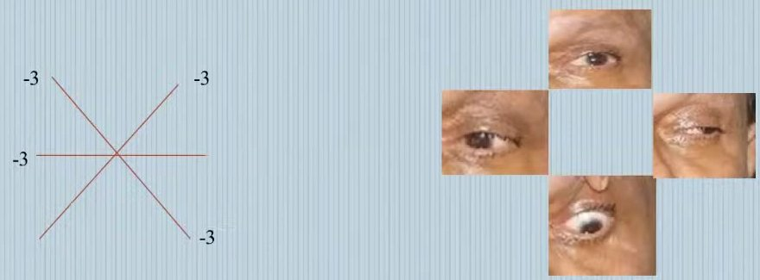
Left eye ductions — −3 elevation (in abduction and adduction), −3 adduction, −3 depression in abduction; abduction and depression in adduction spared (1:54:40)
- What they show: single-eye photographs and star charts. The right eye moves fully. The left eye is limited up, in, and down-and-out with the lid held up; it abducts fully and depresses in adduction.
- Examiner’s point: to prove the fourth nerve is working when the third is paralysed, look for intorsion on attempted downgaze — watch a conjunctival vessel at the slit lamp (2:11:05).

Diplopia charting and Worth four-dot (1:57:30)
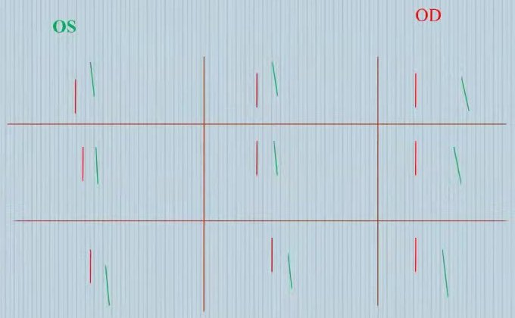
Diplopia charting — red = right eye image, green = left eye image (tilted); crossed images, widest separation to the right (1:57:30)
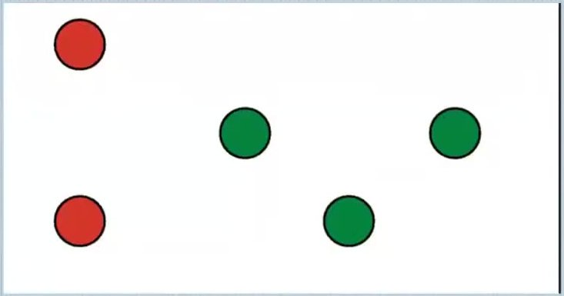
Worth four-dot result — five lights (two red, three green) = diplopia; crossed (1:57:40)
- What they show:
  - The green (left eye) image lies to the right of the red in every field — crossed diplopia, as expected with an exotropia.
  - The separation is widest on looking right (left medial rectus palsy).
  - The left image is higher in upgaze and lower in downgaze, and it is tilted.
  - Worth four-dot shows five lights (diplopia), again crossed.
- What the candidate said: images separated more to the right and in upgaze; crossed diplopia.
- Point (added):
  - Know the rule: crossed diplopia = exodeviation, uncrossed = esodeviation.
  - The separation is greatest in the field of action of the weak muscle.
  - The image displaced further out belongs to the paretic eye.
- Read the vitals and your diagnosis slide first — BP 220/110 cannot be ignored.
- Ptosis in a third nerve palsy = neurogenic, part of the palsy.
- Localise orbit → fissure/cavernous sinus → subarachnoid → fascicle (Nothnagel, Claude, Benedikt, Weber) → nucleus.
- Isolated medial rectus palsy or isolated mydriasis ≠ partial third nerve palsy.
- Pupil involved or “plus” signs = emergency → neurosurgeon.
Read more: Watch: youtu.be/e3X1W9wrC_A?t=6494 (presentation) · t=7110 (viva)

V6 Case 5 — Right perforated corneal ulcer: fungal keratitis versus peripheral ulcerative keratitis with secondary infection
Video case · 2:17:27–2:48:15 · Presenter: postgraduate · Examiners: Prof Vanathi (cornea), Prof Nagaraju

Case as presented
Mrs X, 55, a housewife, with hypertension for 4 years.
- Complaint: sudden decrease of vision in the right eye with severe pain since this morning. For two weeks before that she had redness, watering, foreign-body sensation and photophobia, slowly getting worse.
- The sudden drop followed poking the eye with her own finger.
- Already treated:
  - an ophthalmologist diagnosed a corneal ulcer 2 weeks ago;
  - scraping was sent: Gram and KOH smears negative, no growth on culture at 7 days;
  - she was started on natamycin, moxifloxacin, atropine and oral ketoconazole.
- Negative history: foreign body, dry eye, contact lens, lagophthalmos, recent surgery, earlier eye drops, diabetes or autoimmune disease; the other eye is normal.
Examination (right eye) | Findings
Vision | Perception of light present, projection accurate (left eye 6/6)
IOP | “Low on digital tonometry” (left eye 16 mm Hg by non-contact tonometry)
Lids and adnexa | Upper lid covering 4 mm of cornea; oedematous lid margin; meibomian orifices open but no expressible secretion; matted lashes; regurgitation on pressure over the lacrimal sac (ROPLAS) negative
Conjunctiva | Moderate circumcorneal congestion
Cornea | Irregular surface; central greyish-white, full-thickness, irregular infiltrate covering about two-thirds of the cornea (about 8 × 6 mm) with stromal oedema, worse inferiorly. Overhanging edges with necrosis at the periphery. Peripheral perforation about 5 × 2 mm from 1 to 5:30 o’clock with iris incarcerated. Superficial vascularisation 12–7 o’clock. Seidel test positive
Anterior chamber, pupil, lens | AC flat; iris plugging the perforation; pupil irregular; lens not seen
Posterior segment | No view; B-scan normal
Diagnosis given: right corneal ulcer with perforation; systemic hypertension. Two hand-drawn corneal diagrams were shown (frontal and slit views).

Examiner corrections
What the candidate did or said | What the examiner wanted | Time
Brought a perforated acute ulcer as a long case | Such cases are rarely kept as long cases — expect a healing fungal keratitis or a corneal opacity | 2:24:45
One frontal diagram and one vague slit view | Draw the frontal view plus slit sections at three places: the involved stroma, apparently normal cornea, and the perforation. Draw lids with lashes and the tear meniscus in profile; stromal oedema in blue; learn the colour codes and hatching | 2:29:08
“Infiltrate covering two-thirds of the cornea” | Measure and describe: describe the cornea first, then the lesion within it — size, shape, depth, margins, surrounding cornea | 2:29:40
Went straight to the cornea | Adnexa first: lid margin, meibomian glands, lash position, tear film and meniscus. Many corneal ulcers start there. In a suspected PUK, record dry-eye signs | 2:30:04, 2:32:44
Recorded IOP by digital tonometry in a perforated eye | Do not press on a perforated globe — you add to the damage | 2:32:21
Proposed starting natamycin straight away | Investigate first: scrape the ulcer and look at a simple smear (KOH) under the microscope for hyphae, then start empirical treatment | 2:34:22
Relied on ROPLAS | Syringe the lacrimal passages in every infectious keratitis; treat any block — the ulcer responds better | 2:40:00
“Glue with a bandage contact lens” for this perforation | Glue is not advisable for a large perforation with iris in it; control infection and plan an early therapeutic keratoplasty | 2:45:32

Think like this
- Give two diagnoses, aetiological and morphological.
  - The pictures show a large peripheral ulcer running around the circumference with central involvement, iris plugging a perforation, and unhealthy lid margins.
  - So consider a peripheral ulcerative keratitis (PUK) that has perforated, with secondary infection, against an infective keratitis (keratomycosis) with secondary bacterial infection.
  - Keep the other possibilities open: Mooren’s ulcer, systemic vasculitis, viral keratitis.
- The goal in infectious keratitis is to eliminate infection and prevent complications — restoring vision comes later. Every step should serve those two aims.
- The order of management:
  - control the infection;
  - look for signs that it is controlled;
  - then treat the underlying cause (immune therapy for PUK or Mooren’s);
  - then repair the tissue.
- A Mooren’s ulcer is deceptive: the overhanging edge hides a larger ulcer — lift the edge to see its true extent.

Viva: questions and expected answers
Q What is your aetiological and morphological diagnosis? (2:25:39)
Infective (or inflammatory/autoimmune with secondary infection), confirmed by repeat scraping and an immunological work-up. Morphologically: a large ulcer with peripheral, circumferential involvement and perforation. The examiner favoured perforated PUK with secondary infection, or keratomycosis.
Q How do you differentiate bacterial from fungal keratitis? (2:27:56)
Bacterial: rapid onset, symptoms out of proportion, marked congestion, sharply demarcated ulcer, dense stromal infiltrate, sterile mobile hypopyon. Fungal: slower course over 1–2 weeks, history of vegetable-matter injury, dry raised ulcer with feathery margins, satellite lesions, thick immobile hypopyon with a convex top that may contain fungus.
Q What investigations will you do? (2:34:33)
Corneal scraping for Gram stain, KOH mount and cultures for bacteria and fungi. Start empirical cover for gram-positive and gram-negative bacteria and fungi while waiting, then narrow it to the organism. Look at the KOH smear under the microscope yourself to see hyphae.
Q Where do you scrape from? (2:35:27)
The leading edge (margins) and the base of the ulcer, after removing necrotic debris. Avoid thinned areas, where you could cause a perforation.
Q What other investigation would you do when the fundus is not visible? (2:36:13)
B-scan ultrasound, to rule out posterior spread or endophthalmitis — essential before you take a perforated eye to surgery.
Q What antibacterial therapy is used in infectious keratitis? Is monotherapy acceptable? (2:37:00)
Fortified cefazolin 5% (for gram-positive organisms) with a fortified aminoglycoside, or a fluoroquinolone (moxifloxacin, gatifloxacin). Fluoroquinolone monotherapy is acceptable when fortified drops are not available and the ulcer is small, off the visual axis and responding (the examiner’s criteria). (added) The textbook limits: under 3 mm, less than half the stromal depth, mid-peripheral or peripheral.
Q How do you differentiate Mooren’s ulcer from other PUK? (2:38:04)
Diagnostic features of Mooren’s ulcer (the criteria discussed in the session): crescent-shaped peripheral ulcer with an undermined edge, no scleritis, no detectable systemic disease (a diagnosis of exclusion). (added) Watson’s classification has three types: type 1 unilateral, in the elderly, very painful; type 2 bilateral and aggressive, in the young; type 3 bilateral and indolent, in the elderly. Pain is out of proportion. PUK from systemic autoimmune disease often has adjacent scleritis — always examine the neighbouring sclera — and the immunological work-up is positive. Also look for blepharitis or meibomian disease (marginal keratitis) at the lid margin.
Q What signs show that the infection is coming under control? (2:41:40)
Smaller, less dense infiltrate; less AC reaction; hypopyon resolving; vessels growing in; re-epithelialisation.
Q If it were a Mooren’s ulcer, what local procedure would you do? (2:42:06)
Conjunctival resection (peritomy) next to the ulcer, extending beyond it on either side. The candidate said two clock hours; the examiner said three. (added) The textbook value is 2 clock hours beyond each end of the ulcer and about 4 mm back from the limbus. Then steroids once infection is controlled, and systemic immunosuppression.
Q What is the goal of treating infectious keratitis? (2:43:30)
Eliminate the infection and prevent complications. Restoring vision is not the immediate aim.
Q How will you manage this large perforation? (2:44:52)
Glue only suits perforations smaller than 2 mm with no uveal tissue in them — here it is contraindicated. Control the infection with topical and systemic drugs, then do an early therapeutic penetrating keratoplasty under general anaesthesia (not an optical keratoplasty).
Q If it were only thinning with impending perforation, which investigation would you use to follow it? (2:47:00)
Serial anterior segment OCT to measure thinning, so that you can operate before it perforates. Examiners do ask about recent investigations relevant to your case.
Say it
Mrs X, a 55-year-old housewife with hypertension, has had redness, pain, watering and photophobia in the right eye for two weeks, treated as a culture-negative corneal ulcer with natamycin, moxifloxacin, atropine and oral ketoconazole. This morning she had a sudden painful loss of vision after rubbing the eye. Vision is perception of light with accurate projection. The lid margins are oedematous with inspissated meibomian glands. There is moderate circumcorneal congestion and a large, full-thickness, greyish-white infiltrate of about 8 by 6 mm with overhanging edges, a 5 by 2 mm peripheral perforation from 1 to 5:30 o’clock plugged by iris, a flat anterior chamber and a positive Seidel test. The B-scan is normal. My diagnosis is right perforated corneal ulcer, either peripheral ulcerative keratitis with secondary infection or fungal keratitis, with iris prolapse, in a hypertensive patient. I would plan a therapeutic keratoplasty once the infection is controlled.

Images and their points

The right cornea on diffuse illumination (2:22:20)
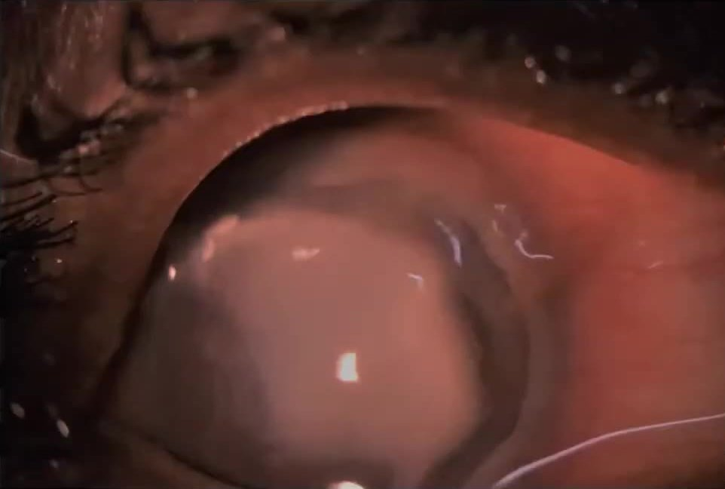
Right eye, diffuse illumination — dense grey-white infiltrate filling most of the cornea, with iris incarcerated along a peripheral perforation (2:22:20)
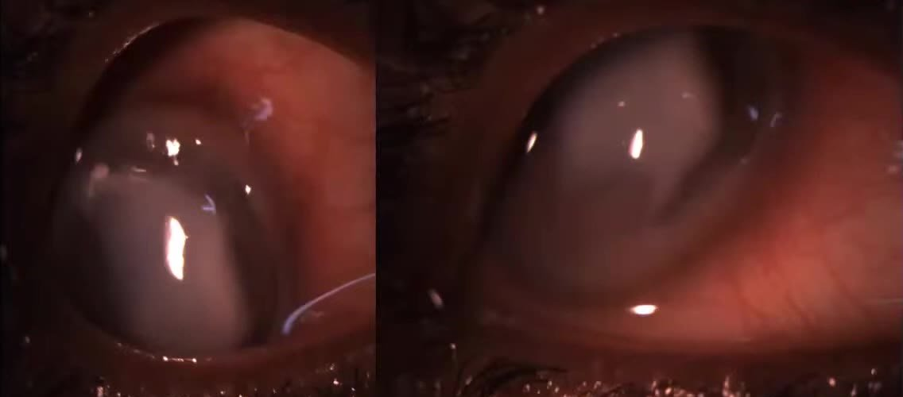
Two further views of the right eye — the dark-brown arc of iris along the edge of the opacity marks the perforation (2:22:50)
- What they show:
  - The cornea is almost entirely replaced by a dense, greyish-white, dull infiltrate with an irregular surface.
  - A curved dark-brown band of iris is plugged into a crescentic peripheral perforation at about 1 to 5:30 o’clock.
  - There is intense circumcorneal and conjunctival congestion, and the anterior chamber cannot be seen.
- What the candidate said: central, irregular, greyish-white, full-thickness infiltrate covering about two-thirds of the cornea, with stromal oedema; overhanging edges with necrosis; perforation of about 5 × 2 mm from 1 to 5:30 o’clock with incarcerated iris; superficial vessels from 12 to 7 o’clock.
- Examiner’s points:
  - From the pictures, the examiner saw a large peripheral, circumferential ulcer with central involvement and an iris plug, plus unhealthy lids. That suggests a perforated PUK with secondary infection — or keratomycosis — and not a clear-cut picture (2:25:39, 2:32:55).
  - Measure the lesion instead of “two-thirds of the cornea”.

Corneal diagram (2:22:30)
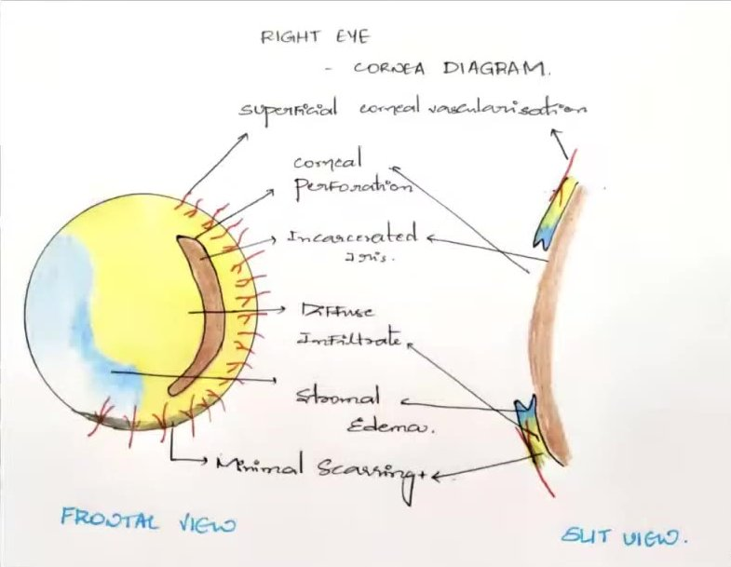
Hand-drawn right cornea diagram, frontal and slit views — yellow infiltrate, blue oedema, brown incarcerated iris, red superficial vessels, grey scarring (2:22:30)
- What it shows:
  - Frontal view: yellow diffuse infiltrate over most of the cornea; blue stromal oedema to the left and below; a brown crescent of incarcerated iris along the 1–5 o’clock margin; red radial superficial vessels from 12 to 7 o’clock; grey minimal scarring below.
  - Slit view: one corneal section with the infiltrate, oedema and vessels at its ends and a notch for the perforation.
- What the candidate said: this is the corneal diagram — frontal view and slit view.
- Examiner’s points:
  - The colours are right, but one slit section is not enough. Draw three — through the involved stroma, through apparently normal cornea, and through the perforation.
  - Add the lids with lashes and the tear meniscus in profile: a normal triangular meniscus, or a thin, concave one with debris in dry eye.
  - Depict stromal oedema in blue and learn the hatching conventions (2:29:08–2:31:56).

Slit-lamp photograph (2:23:00)
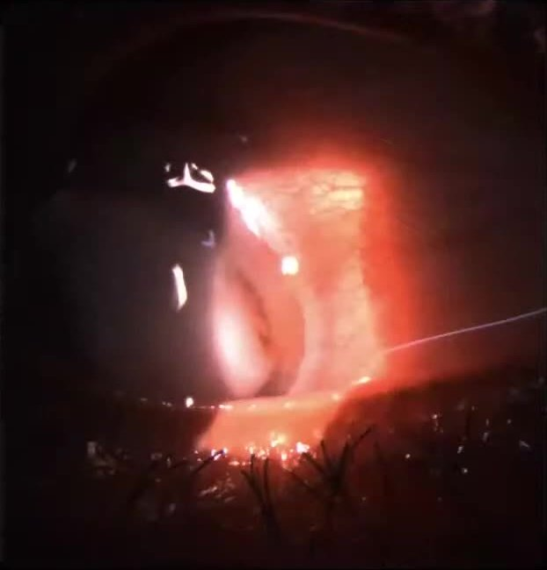
Right eye with a broad oblique slit beam — thick, opaque cornea with an irregular surface (2:23:00)
- What it shows: a thick, opaque cornea under a broad beam, with a darker curved band inside it (probably the iris plug). The photograph is dim and red, so depth cannot be judged.
- Point: for an ulcer, the slit photograph should show depth — a narrow optical section through the infiltrate and the thinnest area. That is also where you would follow thinning with anterior segment OCT (2:47:00).
- Adnexa first: lid margin, meibomian glands, tear film. Syringe every infectious keratitis.
- No digital tonometry on a perforated eye.
- Diagram: frontal view + three slit sections; lids, lashes, tear meniscus; colour code.
- Scrape the leading edge and base; look at the KOH smear yourself.
- Glue only for perforations < 2 mm with no iris in them → otherwise therapeutic PK.
- Goal: eliminate infection, prevent complications.
Read more: Watch: youtu.be/e3X1W9wrC_A?t=8271 (presentation) · t=8680 (viva)

V7 Case 6 — Recurrent anterior uveitis in bilateral high axial myopia: order the diagnosis
Video case · 2:48:30–3:10:36 · Presenter: postgraduate · Examiners: Prof Nagaraju, Prof Vanathi

Case as presented
Mr X, 49. Examiners said this is usually a short case.
- Complaints: redness, pain and blurring of the right eye for 1 week. The redness was sudden and constant, with watering and photophobia.
- Past episodes: similar episodes in the right eye about every 6 months for 5 years, each settling with treatment. Periorbital swelling of the right eye last year, which settled on antibiotics.
- Ocular history: glasses since age 12; “LASIK in the right eye 25 years ago”.
- Medical history: diabetes and hypertension for 18 years; ischaemic heart disease for 2 years.
Finding | Right eye | Left eye
Vision | 1/60 → 6/36 with −12.00 DS / −1.00 DC × 130; N36 | 1/60 → 6/12 with −21.00 DS; N10
Axial length | 30.99 mm | 31 mm
Hertel (base 108) | 21 mm | 20 mm
Alignment and movements | Right hypotropia; movements limited — elevation −3, abduction −2, adduction −1, depression full | Exotropia 15° (Hirschberg); movements full
Lids | Superior periorbital fullness | Normal
Conjunctiva | Circumcorneal congestion | Quiet
Cornea | Clear; fine keratic precipitates (KPs), iris pigment on the endothelium | Clear
Anterior chamber | Normal depth; cells 2+, flare 1+ | Quiet
Pupil | 2 mm, sluggish | 3 mm, brisk
Lens | Nuclear sclerosis grade 1 + posterior subcapsular cataract | Posterior subcapsular cataract
IOP (Goldmann) | 12 mm Hg | 16 mm Hg
Fundus | Large disc, extensive peripapillary atrophy, chorioretinal atrophy around the disc, tessellated fundus, dull foveal reflex | Same
Diagnosis given:
- both eyes immature cataract;
- both eyes high myopia;
- right eye status post LASIK;
- right eye acute recurrent non-granulomatous anterior uveitis;
- “pseudoproptosis” of the right eye.

Examiner corrections
What the candidate did or said | What the examiner wanted | Time
Called the right eye “pseudoproptosis” | Prove it: pseudoproptosis needs a larger globe or a shallower orbit. The axial lengths are equal (≈31 mm each), so the difference is not explained by globe size | 2:57:52
Accepted “LASIK 25 years ago” without checking | Look for the flap edge: press gently on the cornea with a blunt instrument or cotton-tipped applicator to show the scar. A PRK leaves no mark | 2:59:13
Periorbital “swelling that settled on antibiotics”, never examined further | Examine the lacrimal gland: lift and pull the upper lid laterally while the patient looks down and in; look for an inflamed palpebral lobe, local injection, tenderness | 3:01:23
Put cataract first in the diagnosis | Order the diagnosis: the primary pathology is bilateral high axial (possibly pathological) myopia; the uveitis is secondary; the rest is tertiary. A hint like “this is a cataract case” does not mean cataract leads | 3:02:05
“Senile” cataract at 49 | 45 is the cut-off for presenile in India. With high myopia and uveitis, call it a complicated cataract | 3:04:26
Described the fundus as “tessellated” only | When findings are few, describe them fully: disc size and colour, CDR, tilt, peripapillary atrophy, chorioretinal degeneration at the disc and macula, posterior staphyloma (the examiner saw one) | 3:08:22
(added) Summary slide gave left best-corrected vision 6/36; the vision table said 6/12 | Make the summary match the tables — examiners compare them | 2:55:00
Called the redness “congestion” | Name its pattern: circumcorneal (ciliary) congestion | 3:07:24

Think like this
- Which pathology explains the most? Here it is bilateral axial high myopia, with lengths of 31 mm and corrections of −12 and −21 D. Then come the right recurrent anterior uveitis, the complicated cataracts and the claimed refractive surgery.
- Corroborate every history with an examination finding. Records are often missing, so:
  - claimed LASIK → flap edge, keratometry, topography, and ask whether he was ever spectacle-free afterwards;
  - claimed periorbital inflammation → lacrimal gland, orbit.
- If he still needs −12 D after “LASIK”, think of regression, partial correction or no surgery at all. Keratometry settles it: an ablated cornea is flat, while 44–45 D suggests no ablation.
- In a uveitis case, show you can read the anterior segment:
  - KP type and age;
  - signs of previous attacks (pigment on the lens, posterior synechiae, iris atrophy);
  - granulomatous or non-granulomatous.

Viva: questions and expected answers
Q How do you make a definite diagnosis of pseudoproptosis? (2:58:06)
Proptosis is forward displacement of a normal globe. Pseudoproptosis is apparent prominence from a large globe (axial myopia), a shallow orbit, lid retraction or enophthalmos of the other eye. Compare the axial lengths and the facial and orbital symmetry.
Q He says he had LASIK. What will you look for? (2:59:56)
The flap edge at the slit lamp, which becomes visible when you press gently near it. Keratometry: a flat cornea after an ablation; with 44–45 D, refractive surgery is unlikely. Topography if available. History of seeing without glasses after the surgery.
Q You have no topography in a peripheral centre. Which simple test tells you the cornea was operated on? (3:05:32)
Keratometry.
Q What is your primary diagnosis? (3:03:10)
Bilateral high axial (possibly pathological) myopia. Secondary: right recurrent acute non-granulomatous anterior uveitis. Tertiary: complicated cataract in both eyes, claimed refractive surgery in the right eye.
Q What type of cataract is it at 49 with high myopia and uveitis? (3:04:52)
Complicated cataract, not senile.
Q How do you describe the hyperaemia in anterior uveitis? (3:07:24)
Circumcorneal (ciliary) congestion.
Q What would you describe in this high-myopic fundus? (3:08:22)
Disc size, colour and CDR; tilted disc; peripapillary atrophy or temporal crescent; chorioretinal degeneration around the disc and at the macula; posterior staphyloma; vessel course; tessellation; (added) lacquer cracks and Foster–Fuchs spot.
Q How do you tell fresh KPs from old ones? (3:09:34)
(added) Fresh KPs are white, round and fluffy. Old KPs are shrunken, pigmented and crenated (glassy). Mutton-fat KPs mean granulomatous inflammation; fine KPs mean non-granulomatous.
Say it
Mr X, a 49-year-old man with diabetes, hypertension and ischaemic heart disease, has had redness, pain, photophobia and blurring of the right eye for one week. He has had similar episodes about every six months for five years. He has worn glasses since childhood and reports refractive surgery in the right eye 25 years ago, but he still needs −12 D in that eye and −21 D in the left; axial lengths are about 31 mm in both. The right eye shows circumcorneal congestion, fine keratic precipitates and 2+ cells with 1+ flare. Both eyes have posterior subcapsular cataract and myopic fundi with large discs, extensive peripapillary atrophy and chorioretinal degeneration. My diagnosis is bilateral high axial (probably pathological) myopia, with right recurrent acute non-granulomatous anterior uveitis and complicated cataract in both eyes. I would confirm any earlier refractive surgery with keratometry.

Images and their points

The patient in primary gaze and the movements (2:51:00–2:51:44)
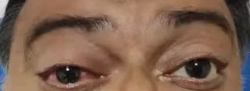
Primary gaze, cropped to the eyes (patient masked) — red right eye with a full upper lid (2:51:00)
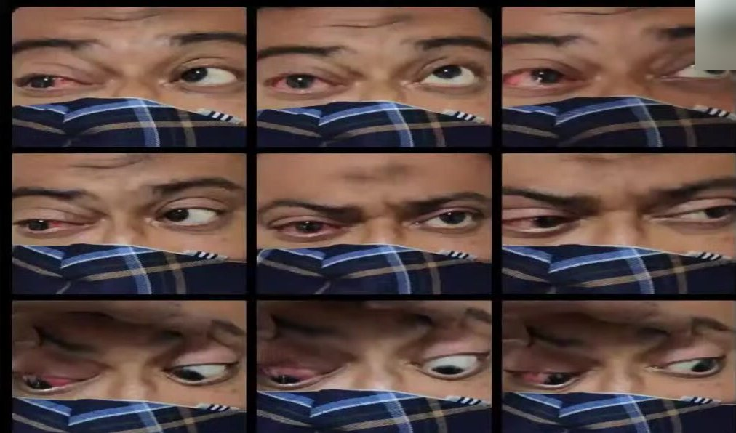
Nine-gaze photographs (masked, periocular) — the right eye is injected and lags in upgaze (2:51:42)
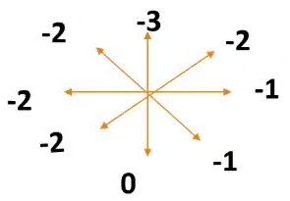
Right eye movement chart — elevation −3, abduction −2, oblique gazes −1 to −2, depression full (2:51:30)
- What they show:
  - The right eye is red and its upper lid full and puffy (the “superior periorbital fullness”). It sits a little lower than the left (right hypotropia), with a small left exotropia.
  - In the gaze photographs the right eye lags in upgaze and abducts less; depression is full.
  - The chart grades elevation −3, abduction −2, adduction −1 and the oblique gazes −1 to −2.
- What the candidate said: restricted abduction, elevation and mild adduction in the right eye; left full; called the prominence pseudoproptosis.
- Examiner’s points:
  - Prove pseudoproptosis with the axial lengths — they are equal (2:57:52).
  - With periorbital fullness that “settled on antibiotics”, examine the lacrimal gland (3:01:23).
  - (added) Restricted elevation and abduction in a very long eye also suggest myopic strabismus (the “heavy eye”), which an orbit scan would show.

Anterior segment photographs — right and left (2:53:16–2:53:30)
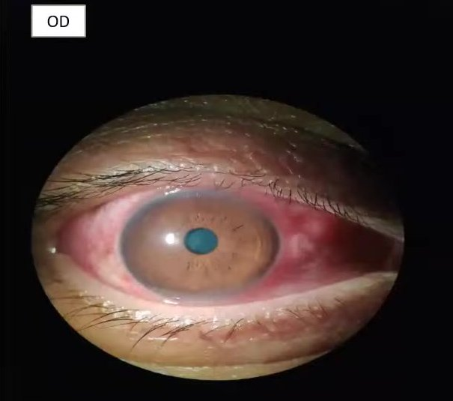
Right eye, diffuse light — marked circumcorneal (ciliary) flush and a small pupil (2:53:16)
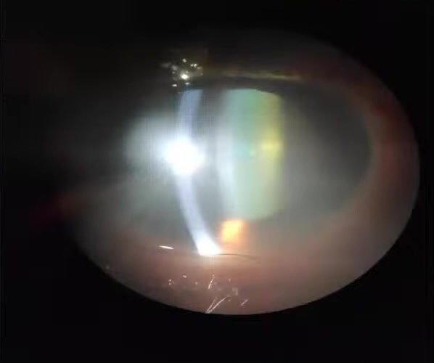
Right eye, broad oblique beam — nuclear opalescence of the lens (2:53:16)
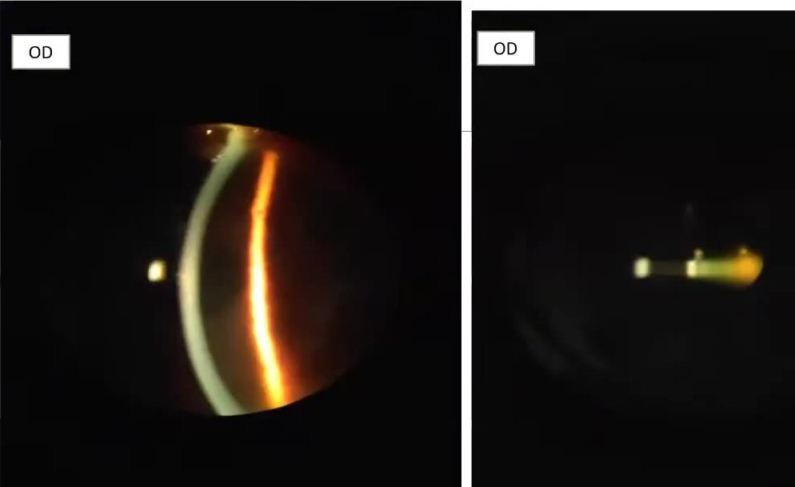
Right eye — optical section of the cornea (left) and a short conical beam in the anterior chamber for cells and flare (right) (2:53:22)
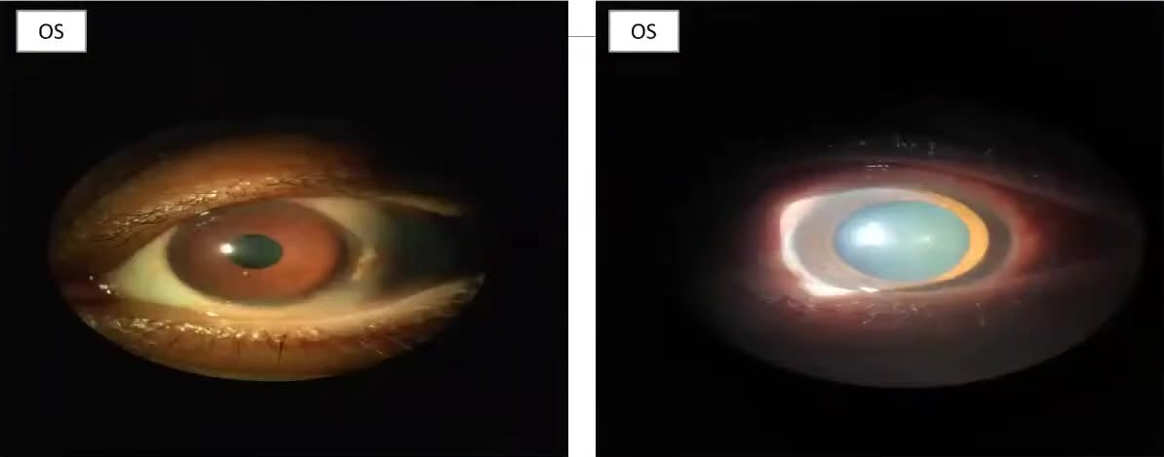
Left eye — quiet, white eye (left) and the lens opacity glowing on retro-illumination (right) (2:53:28)
- What they show:
  - Right eye:
  - a deep red-violet circumcorneal flush round the limbus with diffuse conjunctival injection;
  - a clear cornea and a small (miotic) pupil — acute anterior uveitis;
  - on the slit-lamp views, nuclear opalescence and an orange glow through a posterior subcapsular opacity;
  - a narrow optical section of the cornea;
  - a short conical beam in the anterior chamber — the technique for grading cells and flare.
  - Left eye: quiet, but its lens opacity shows on retro-illumination.
  - The KPs and cells themselves are too fine to see at video resolution.
- What the candidate said: circumcorneal congestion, fine KPs with iris pigment on the endothelium, cells 2+ and flare 1+, pupil 2 mm and sluggish; posterior subcapsular cataract in both eyes.
- Examiner’s points:
  - Describe the congestion as circumcorneal (ciliary) (3:07:24).
  - The lens change at 49 in a high myope with uveitis is a complicated cataract, not senile (3:04:26).
  - (added) The conical-beam photograph is the right way to document AC cells and flare. Mention the grading scale you used (SUN grading).

Fundus photographs (2:53:50)
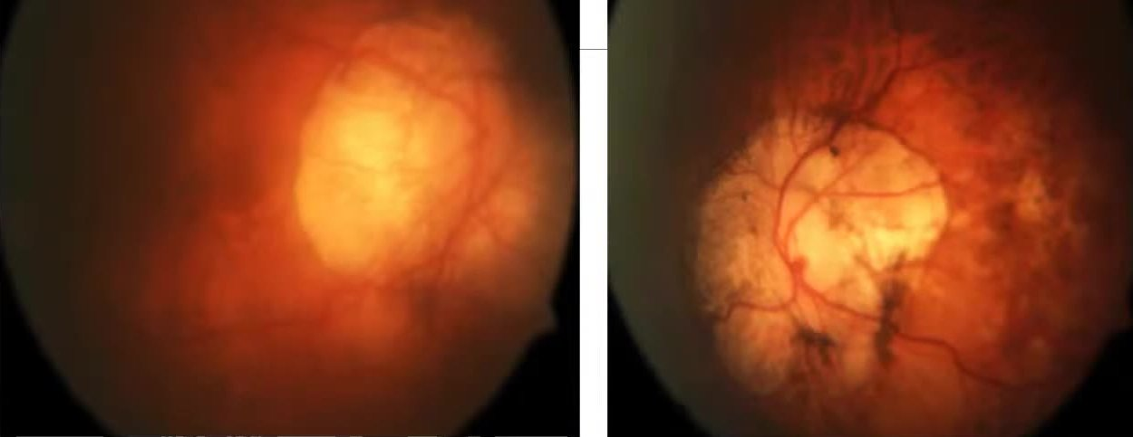
Fundus photographs — right eye (left image) hazy; left eye (right image) with a large zone of peripapillary chorioretinal atrophy, pigment clumps and a tessellated fundus (2:53:50)
- What they show:
  - Right eye: hazy (media) — a large pale zone where the disc merges into peripapillary atrophy.
  - Left eye: clearer — a large, irregular area of peripapillary chorioretinal atrophy with bare sclera and large choroidal vessels, pigment clumps at its edges, a pale, hard-to-outline disc, and a tessellated (tigroid) fundus.
  - Vessels bend at the edge of the atrophy, suggesting a posterior staphyloma.
- What the candidate said: large discs, extensive peripapillary atrophy with chorioretinal atrophic patches around the disc, tessellated fundus, dull foveal reflex.
- Examiner’s point: with so few findings, describe each fully — disc size and colour, CDR, tilt, peripapillary atrophy, chorioretinal degeneration at the disc and macula, and the posterior staphyloma the examiner thought she saw. The primary diagnosis is pathological high myopia (3:02:05, 3:08:22).

Anterior segment diagram (2:55:03)
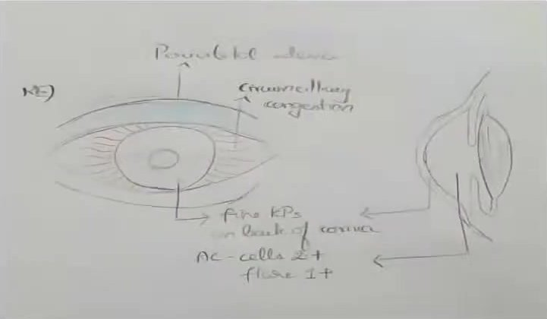
Hand-drawn right anterior segment, frontal and slit views — periorbital oedema, circumciliary congestion, fine KPs, cells 2+ and flare 1+ (2:55:03)
- What it shows: a faint pencil drawing with labels for periorbital oedema, circumciliary congestion, fine KPs on the back of the cornea, and AC cells 2+ and flare 1+.
- Point (added): it was on screen for half a second and drawn too faintly to read. Use firm lines and the standard colours — a diagram the examiner cannot read earns nothing.
- Primary → secondary → tertiary diagnosis. Here: high axial myopia → recurrent anterior uveitis → complicated cataract.
- Pseudoproptosis needs proof: axial length, orbit symmetry.
- Claimed LASIK → flap edge, keratometry, topography.
- Not “senile” below 45 in India; myopia + uveitis = complicated cataract.
- Few findings → describe each one fully (myopic fundus, staphyloma).
Read more: Watch: youtu.be/e3X1W9wrC_A?t=10110 (presentation) · t=10630 (viva)

V8 Case 7 — Left pseudophakic rhegmatogenous retinal detachment in a vitrectomised eye (after IOFB removal)
Video case · 3:10:53–3:38:37 · Presenter: postgraduate · Examiners: Prof Nagaraju, Prof Vanathi, Dr Gopal (retina)

Case as presented
Mr X, 44, an automobile workshop mechanic.
- Complaint: diminished vision in the left eye for 1 week — sudden, not progressing. No flashes, floaters, pain, redness or photophobia.
- Past ocular history:
  - left eye injury 15 years ago → surgery to remove an intraocular foreign body (IOFB);
  - left cataract surgery in 2016;
  - Nd:YAG capsulotomy for posterior capsule opacification the same year.
- No diabetes or hypertension.
Finding | Right eye | Left eye
Vision | 6/6; N6 with +1.00 DS (presbyopia) | 1/60, no improvement; near worse than N36
Retinoscopy | +1.50 / +1.75 | +5.50 both meridians, pale (dull) reflex
IOP (Goldmann, 10:30 am) | 16 mm Hg | 10 mm Hg
Gonioscopy | Scleral spur visible in all quadrants (open) | Scleral spur visible in all quadrants (open)
Anterior segment | Normal; Van Herick grade 3; lens clear | Cornea clear; Van Herick grade 3, quiet AC; posterior chamber IOL with residual PCO and an open YAG capsulotomy
Disc | CDR 0.5, healthy rim | CDR 0.6 with temporal pallor
Retina | Normal | Peripheral laser marks superotemporally and inferiorly; shallow temporal detachment, 2 to 5 o’clock (the slide said “superotemporal”), with superficial folds involving the macula; no break found; foveal reflex absent
Diagnosis given:
- right eye presbyopia;
- left eye pseudophakic retinal detachment involving the macula;
- status post vitreoretinal surgery (IOFB removal);
- status post YAG capsulotomy.
Fundus photographs and a colour-coded fundus drawing were shown.

Examiner corrections
What the candidate did or said | What the examiner wanted | Time
Said little about the injury | Elaborate the trauma: what he was doing (hammering a vehicle part — metal on metal, a high-velocity metallic foreign body). Try to get the old records | 3:20:00
Did not say where the foreign body entered | Vision stayed good for 10 years after the injury, so the entry was probably scleral (posterior), not corneal. Look for scars — limbus, sclerotomy ports, conjunctiva, dark pigment under the conjunctiva | 3:20:49, 3:37:21
Did not say what cataract surgery he had | Phaco or small-incision? Look for the scar (clear corneal or scleral tunnel) and be definite. State where the IOL is (in the bag; rhexis margin visible) | 3:21:27
Found no break and stopped | Search again with indentation. The likely site is near the dark pigment or laser scar where the foreign body struck, between 2 and 5 o’clock | 3:23:28, 3:38:01
Called pigment in the vitreous “Shafer sign” in an operated eye | Shafer’s sign is pathognomonic only in an eye that has not been operated on — surgery itself releases pigment and cells | 3:26:43
Said paving-stone degeneration needs treatment | Wrong — revise which degenerations need prophylaxis and which do not | 3:29:07
(added) Slides disagreed: vision “1/60” in the table but “counting fingers ½ m” in the summary; peripheral lesions “laser marks” in the table but “chorioretinal atrophy patches” in the summary | Make every slide say the same thing — examiners read the summary against the tables. The examiner’s own reading: the pigmented scar is probably where the foreign body struck | 3:17:50
Mentioned angioid streaks among myopic fundus signs | (added) Angioid streaks are not a myopic sign. The myopic signs are lacquer cracks, Foster–Fuchs spot, staphyloma and chorioretinal atrophy | 3:33:06

Think like this
- Count the risk factors for detachment in this eye:
  - a vitrectomised eye (after IOFB removal);
  - pseudophakia;
  - YAG capsulotomy;
  - (here) old trauma with an atrophic scar near the laser marks.
- Classify every RD: rhegmatogenous, tractional, exudative, or combined. This one is rhegmatogenous, so there must be a break — keep looking.
- Use Lincoff’s rules to predict where the break lies from the shape of the detachment, then indent that area.
- Remember the principle of surgery:
  - “Find the break and seal it” (Gonin).
  - The examiner’s analogy: either bring the mountain to Muhammad (external procedures — the scleral buckle pushes the wall in to the retina) or Muhammad to the mountain (internal procedures — gas or silicone oil push the retina out to the wall).
- A vitrectomised eye behaves differently: a buckle alone may suit a fresh detachment, but the choice depends on the surgeon (Dr Gopal).

Viva: questions and expected answers
Q How do you classify retinal detachment? (3:23:48)
Rhegmatogenous, tractional, exudative (serous) and combined. This is rhegmatogenous.
Q What slit-lamp signs suggest a rhegmatogenous RD? (3:24:57)
Pigment in the anterior vitreous (Shafer’s sign, “tobacco dust”), and a lower IOP than the other eye — (added) usually about 4–5 mm Hg lower. Shafer’s sign is pathognomonic only in an unoperated eye.
Q Which risk factors does this eye have? (3:25:40)
Previous trauma, vitrectomy, cataract surgery and YAG capsulotomy. In general also high myopia and predisposing peripheral degenerations.
Q What are Lincoff’s rules? (3:27:13)
They predict the primary break from the shape of the RD. (added) The main ones:
- A shallow inferior RD that is slightly higher on one side has its break on that side.
- An inferior RD with equal fluid on both sides has its break near 6 o’clock.
- A superior RD that stays on one side has its break within 1–1.5 clock hours of its highest border.
- A superior RD crossing the 12 o’clock meridian has its break near 12 o’clock, on the side of the lower border.
- A bullous inferior RD usually comes from a break above the horizontal meridian.
Q Which peripheral degenerations predispose to RD, and which do not? (3:28:19)
Predispose: lattice degeneration (especially with holes or tears), snail-track degeneration, cystic retinal tufts, retinal tears, (added) degenerative retinoschisis with outer-layer holes. Do not (no treatment): paving-stone (cobblestone) degeneration, microcystoid degeneration, (added) honeycomb (reticular) degeneration and peripheral drusen. White without pressure is usually only observed.
Q A high myope has lattice with holes. What do you do? (3:29:42)
Prophylactic barrage laser around the lesion (in suitable cases — fellow eye of an RD, symptomatic tears).
Q What are the principles of managing this RD? (3:30:20)

- Identify the type and find every break.
- For a rhegmatogenous RD the options are a scleral buckle or pars plana vitrectomy with tamponade (SF6 or C3F8 gas, or silicone oil).
- In this already vitrectomised eye: check for residual vitreous (stain with triamcinolone), complete the vitrectomy, drain the subretinal fluid, treat the breaks with laser or cryotherapy, then tamponade.
Q When is an encircling band indicated? (3:31:46)
Breaks in several quadrants, extensive detachment or degeneration over more than two quadrants, large breaks; (added) also to support the vitreous base when proliferative vitreoretinopathy is present.
Q What is pathological myopia? (3:32:19)
(added) High myopia (more than −6 D, axial length more than 26 mm) with degenerative changes: peripapillary atrophy and temporal crescent, tilted disc, lacquer cracks, Foster–Fuchs spot, choroidal neovascularisation, posterior staphyloma, chorioretinal atrophy.
Q What refractive surgery would you offer a 45-year-old high myope with early posterior subcapsular cataract who wants to stop wearing glasses? (3:33:16)
Refractive lens exchange, usually done only after about 45 years of age because the risk of RD is high in younger high myopes. Other options for high myopia: phakic IOL (ICL) and bioptics.
Q Who is the father of modern retinal surgery? (3:35:44)
Jules Gonin — “find the break and seal it”.
Say it
Mr X, a 44-year-old automobile mechanic, noticed a sudden painless drop in vision in his left eye one week ago. Fifteen years ago, while hammering, the eye was injured and he had an intraocular foreign body removed by vitrectomy. He had cataract surgery in 2016 and a YAG capsulotomy the same year. Left vision is 1/60. The IOP is 10 mm Hg against 16 in the right eye. There is a posterior chamber IOL in the bag with an open capsulotomy. The fundus shows peripheral laser marks and a shallow temporal retinal detachment from 2 to 5 o’clock with folds involving the macula; I have not yet found the break and would search with indentation, starting near the scarred area. My diagnosis is left pseudophakic rhegmatogenous retinal detachment involving the macula in a previously vitrectomised eye after intraocular foreign body removal and YAG capsulotomy, with presbyopia in the right eye.

Images and their points

Left fundus photograph (3:17:30)
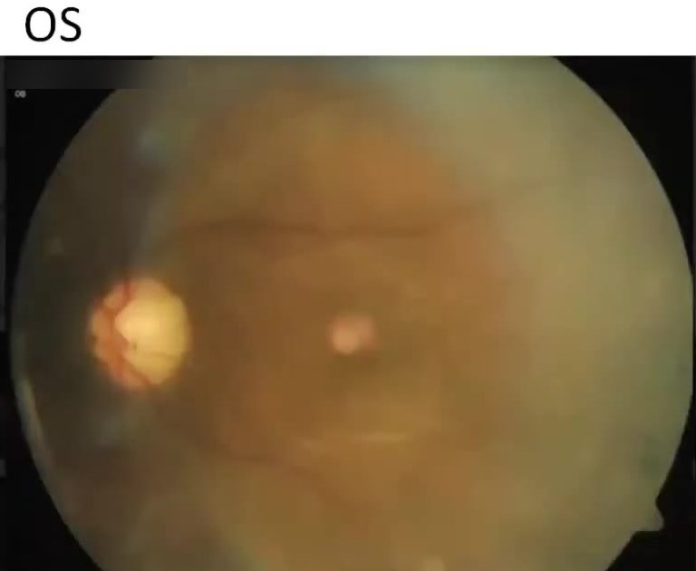
Left eye (OS) colour fundus photograph of the posterior pole (3:17:30); the camera label is blurred
- What it shows:
  - A hazy photograph centred on the macula.
  - The disc is sharply defined and pale, most marked temporally.
  - A wavy fold runs above the fovea along the superior arcade and a second fold below it, outlining a shallowly elevated area that includes the macula.
  - The temporal fundus looks paler and greyish, with loss of choroidal detail — detached retina.
  - No foveal reflex; the bright spot at the centre is probably a reflection.
  - No break is visible in this field.
- What the candidate said: shallow elevation of the retina temporally, 2 to 5 o’clock, with superficial folds involving the macula; no break seen.
- Examiner’s point: a rhegmatogenous RD means a break exists — keep searching with indentation, starting at the pigmented or laser-scarred area (3:23:28). The temporal pallor of the disc deserves a mention too.

Fundus drawing, both eyes (3:18:00)
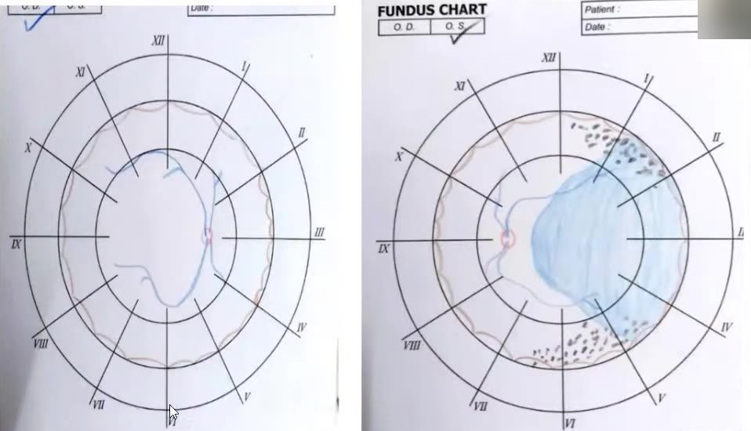
Colour-pencil fundus charts — right eye normal; left eye blue-shaded detached retina temporally with black peripheral laser/pigment marks (3:18:00)
- What it shows:
  - Right chart: normal, with the ora drawn as a brown scalloped line.
  - Left chart: a blue-shaded detachment over the temporal fundus from about 1 to 5 o’clock, running from the ora to just temporal of the disc. The chart centre (macula) lies inside it — macula off.
  - Black marks between the equator and the ora, superotemporally (about 12–2 o’clock) and inferiorly (about 5–7 o’clock) — laser or pigmented scars.
  - No break drawn.
- What the candidate said: this is the detachment, shown in blue, with the laser marks in black.
- Examiner’s point: the dark, confluent pigment cluster is the likely site where the foreign body struck — atrophic retina or laser scars there can form a hole. Look for the break there and draw it (red outlined in blue) once found (3:23:28).
- Point (added): the drawing shows about 1 to 5 o’clock while the text says 2 to 5. Make the two match. Use the standard colour code: red = attached retina, blue = detached retina, red outlined in blue = break, black = pigment or laser.

Left anterior segment, enlarged during the viva (3:19:50)
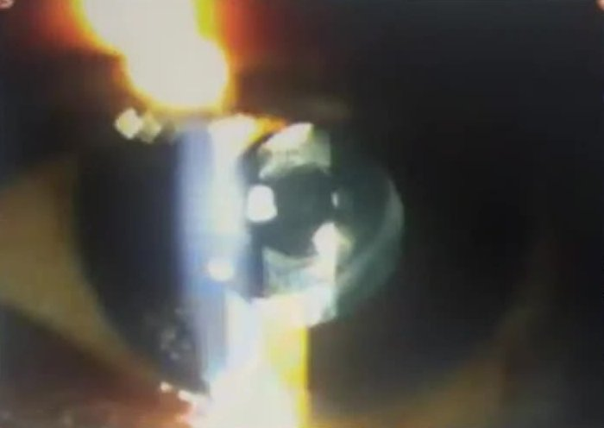
Left eye slit-lamp photograph — IOL optic edge, residual posterior capsule opacification and a central Nd:YAG capsulotomy opening (3:19:50)
- What it shows:
  - The circular edge of the posterior chamber IOL optic.
  - A central dark opening in the posterior capsule — the Nd:YAG capsulotomy — ringed by grey-white residual capsule opacification with pearls at its margin.
  - The photograph is out of focus.
- What the candidate said: posterior chamber IOL with posterior capsule opacification and a YAG capsulotomy opening; the IOL in the bag (rhexis margin visible).
- Examiner’s point:
  - The examiner asked for this picture to be shown.
  - He wanted the type of cataract surgery stated definitely, from the wound scar (clear corneal or scleral tunnel).
  - He wanted the eye searched for the old injury and vitrectomy scars (limbus, sclerotomies, conjunctiva).
  - Three risk factors for RD are in this one picture: pseudophakia, YAG capsulotomy and a vitrectomised eye (3:20:00–3:22:40).
- Trauma history: what, how, where it entered — then look for the scars.
- Shafer’s sign counts only in an unoperated eye; low IOP (about 4–5 mm Hg less) is a clue.
- Lincoff’s rules → where to indent.
- Lattice/holes → barrage laser; paving stone → no treatment.
- Gonin: find the break, seal it. Buckle (outside-in) vs vitrectomy + tamponade (inside-out).
- RLE in high myopes only after about 45 (RD risk).
Read more: Watch: youtu.be/e3X1W9wrC_A?t=11453 (presentation) · t=11950 (viva) · Linked card: B master fundus format

V10 Talk — Medical management of glaucoma: IOP, newer drugs and practical points
Guide · 3:50:42–4:03:58 · Dr Thomas Arun Varghese, glaucoma consultant · World Glaucoma Week

What the talk covered
A short, practical talk for postgraduates, not a textbook lecture. Its points are listed below.

Intraocular pressure — why it rules management
- IOP is the main modifiable risk factor; most management decisions rest on it.
- What the landmark trials showed (as listed on the slides, 3:54:20):
Trial | Finding
EMGT (Early Manifest Glaucoma Trial) | Every mm Hg counts
OHTS (Ocular Hypertension Treatment Study) | Lowering IOP reduces conversion of ocular hypertension to glaucoma; central corneal thickness (CCT) matters when you judge IOP, and is an independent risk factor
EGPS (European Glaucoma Prevention Study) | The slide said “confirmed the OHTS findings”. (added) Precisely: dorzolamide was no better than placebo, but the study confirmed the OHTS risk factors (corneal thickness, cup–disc ratio, pattern standard deviation) and validated the risk-prediction model
CNTGS (Collaborative Normal-Tension Glaucoma Study) | A 30% reduction slowed disease in some patients; some normal-tension glaucoma is IOP-independent
AGIS (Advanced Glaucoma Intervention Study) | IOP in the low teens benefits advanced glaucoma
CIGTS (Collaborative Initial Glaucoma Treatment Study) | The slide’s point: IOP fluctuation is a risk factor for progression (a secondary analysis). (added) The main result: initial trabeculectomy and initial medication gave similar field outcomes; surgery gave a lower IOP but more cataract
- Central corneal thickness: once thought very important. Now simply remember whether a patient has a thick or thin cornea when you read their pressures.
- IOP fluctuation is hard to detect when you see the patient for a few minutes a day. Diurnal variation testing helps.

Measuring IOP well
- All decisions rest on the reading, so: patient comfortably seated, correct technique, calibrate the tonometer once a month, careful disinfection.
- Home (self) tonometry: rebound tonometers on the cornea; transpalpebral devices (a phosphene-based pen and an indentation pen applied over the upper lid). Patients may soon send you their readings.
- Continuous 24-hour monitoring devices — an implantable sensor ring placed with an IOL, and a contact-lens sensor — may show how much fluctuation matters in an individual patient, like an ambulatory BP monitor.

The drugs — classes and points made
- Drugs either reduce aqueous production or increase outflow.
  - Until recently, outflow drugs acted mainly on the uveoscleral pathway (prostaglandin analogues).
  - The new Rho kinase (ROCK) inhibitors act on the conventional trabecular pathway.
- Beta-blockers: very effective, limited by systemic side effects.
- Brimonidine: works well, but many patients develop topical allergy.
- Carbonic anhydrase inhibitors (topical): work, but less effective than prostaglandin analogues or beta-blockers.
- Pilocarpine: still used in selected cases.
- Timeline: pilocarpine and timolol alone for a long time → topical carbonic anhydrase inhibitors (dorzolamide) → latanoprost (which changed practice) → newer prostaglandin analogues → fixed combinations, including brimonidine + brinzolamide.

Newer drugs (“the new kids on the block”)
Drug | Points from the talk
Ripasudil (ROCK inhibitor) | Approved in Japan in 2014; Indian preparations available (about ₹200–250); used twice daily
Netarsudil (ROCK inhibitor) | Approved in the USA in 2017; once daily at night; about ₹400–450 in India. Three actions: relaxes the trabecular meshwork (more outflow), reduces aqueous production (norepinephrine-transporter inhibition) and lowers episcleral venous pressure — a new mechanism
ROCK inhibitors in general | Still lower IOP by a few mm Hg in patients already on two or three drugs — useful as add-on therapy; may become first line with time and experience
Latanoprostene bunod | Approved by the US FDA in 2017; a nitric oxide-donating prostaglandin F2α analogue — acts on both outflow pathways
Netarsudil + latanoprost | Fixed combination targeting both the trabecular and uveoscleral pathways; approved abroad, not yet in India (at the time of the talk)
Bimatoprost implant | A biodegradable rod injected into the anterior chamber with a pre-loaded applicator; it rests in the inferior angle. Concern about endothelial cell loss: the higher dose caused more loss, so the lower dose (10 µg) was approved, in March 2020
Travoprost punctal plug | A plug with a drug-eluting core placed in the lower punctum and canaliculus; studied mainly in Singapore; response over time awaited
Preservative-free drops | Benzalkonium chloride damages the ocular surface. Companies moved to reduced and then zero-preservative formulations

A case from the talk — topical allergy
- A patient on several drops (a prostaglandin–timolol combination plus a carbonic anhydrase inhibitor) developed a severe skin allergy around the eyes, with few conjunctival follicles.
- The patient blamed the prostaglandin combination; brimonidine is the usual culprit, but it could have been the preservative.
- What was done: stop all topical drops, keep the IOP controlled on oral acetazolamide for a few weeks until the skin clears, then reintroduce the drops one at a time to find the culprit.

A logical order for choosing drugs
- Prostaglandin analogue first if affordable — once a day and now cheaper.
- Beta-blocker if cost is the problem (and there is no contraindication).
- Carbonic anhydrase inhibitor for mild to moderate reduction.
- Good response but target not reached → add a second drug. Poor first response → switch to a different drug rather than add.
- Patients respond differently — one may fail on one prostaglandin and respond to another. Find out by trial and error.

Beyond drugs
- Ask about the daily routine, compliance and activities that change IOP.
- Glaucoma is a chronic disease: unlike a cataract patient you will see them for years, so build a rapport.
- The closing message: aim for a safe IOP without disturbing the patient’s life. Treat the person, not just the disease.

Images and their points

Calibrating the Goldmann tonometer (3:55:20)
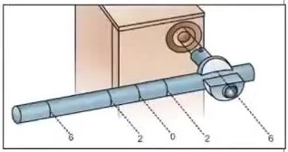
Goldmann tonometer check-weight bar clamped on the tonometer for calibration (3:55:20)
- What it shows: the calibration bar with its graduations (0, 2 and 6) fixed to the tonometer. The bar is used to check the reading at 0, 20 and 60 mm Hg.
- Point: the slide says calibrate once a month. An uncalibrated tonometer makes every decision about target pressure unreliable.

Where the drugs act (3:56:20)
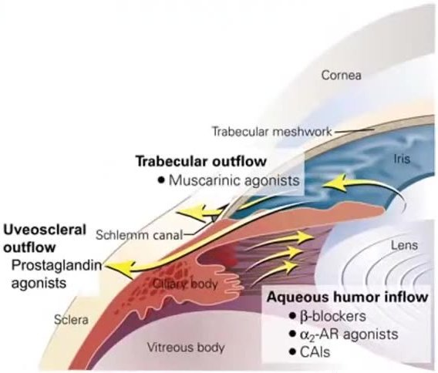
Anterior segment diagram — aqueous inflow at the ciliary body, trabecular outflow and uveoscleral outflow, with the drug classes acting at each (3:56:20)
- What it shows:
  - Inflow (ciliary body): beta-blockers, alpha-2 agonists, carbonic anhydrase inhibitors reduce production.
  - Trabecular (conventional) outflow: muscarinic agonists (pilocarpine). ROCK inhibitors act here too; nitric oxide also acts on this pathway.
  - Uveoscleral outflow: prostaglandin analogues.
- Point: classify every glaucoma drug by “reduces production” or “increases drainage” and name the pathway. Latanoprostene bunod and the netarsudil–latanoprost combination act on both outflow pathways.

Timeline of glaucoma drugs (3:57:10)
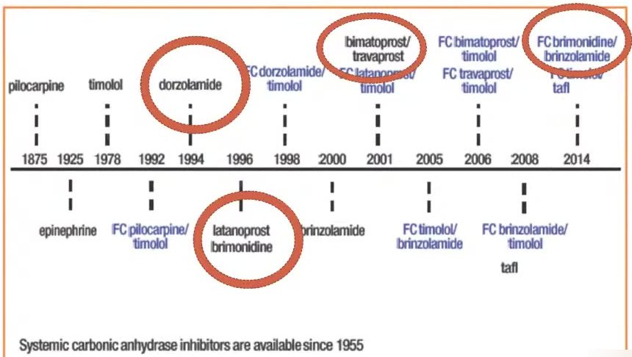
Timeline of antiglaucoma medications 1875–2014; the speaker’s red circles mark the new classes (3:57:10)
- What it shows:
  - Pilocarpine (1875), epinephrine (1925), timolol (1978);
  - dorzolamide (1994);
  - latanoprost and brimonidine (1996);
  - brinzolamide (2000);
  - bimatoprost and travoprost (2001);
  - tafluprost (2008);
  - fixed combinations from 1992 onwards, ending with the beta-blocker-free brimonidine–brinzolamide combination (2014).
A footnote says systemic carbonic anhydrase inhibitors have been available since 1955.
- Point: for a long time there were only pilocarpine and timolol. Topical carbonic anhydrase inhibitors, then prostaglandin analogues, then combinations followed; the ROCK inhibitors are the newest class.

Bimatoprost implant on gonioscopy (3:59:10)
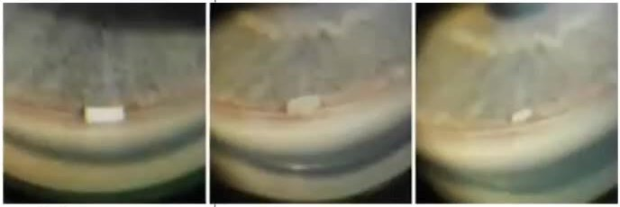
Gonioscopy photographs of the intracameral bimatoprost implant — a small white rod lying in the inferior angle (3:59:10)
- What it shows: a small white rod resting in the inferior angle against the trabecular meshwork in three gonioscopy views. It looks smaller in the later views, possibly as it biodegrades; the slide does not say.
- Point: this is a sustained-release delivery that removes the compliance problem. The concern is the corneal endothelium, because the implant sits in the angle near the endothelium.

Topical allergy to glaucoma drops (4:00:20)
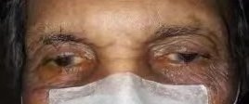
Periocular allergic contact dermatitis in a patient on several glaucoma drops (cropped to the eyes) (4:00:20)
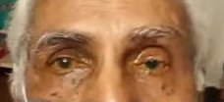
A milder periocular reaction with watering and conjunctival injection (cropped to the eyes) (4:00:20)
- What they show:
  - First photograph: both upper and lower lids red, dry, scaly and pigmented (eczematous) with congested eyes.
  - Second photograph: milder lid redness and pigmentation with watering and conjunctival injection.
- Point: the allergy may be to the drug or to the preservative. Brimonidine is the usual culprit, but with several drops you cannot tell. Stop everything, cover the IOP with oral acetazolamide, let the skin settle, then reintroduce one drop at a time.
- IOP = the main modifiable risk factor; every mm Hg counts; low teens in advanced disease.
- ROCK inhibitors: ripasudil (Japan 2014, twice daily), netarsudil (USA 2017, once daily, also lowers episcleral venous pressure) — work as add-ons.
- Latanoprostene bunod = NO-donating PGF2α analogue (2017). Bimatoprost implant (2020) — endothelial loss concern.
- Allergy on many drops → stop all, oral acetazolamide, reintroduce one by one.
- Order: prostaglandin → beta-blocker → CAI; switch if the first response is poor, add if it is good but insufficient.
Read more: Watch: youtu.be/e3X1W9wrC_A?t=13842 · Linked cards: G1 POAG · G8 applanation tonometry

VV Viva bank — every question asked in the session, by topic, with the expected answer
Guide · questions from all seven cases and the talk

History — the examiner’s reasoning questions
Q In a 60-year-old with gradual loss of vision in both eyes, what is the differential before you examine? (V2)
Senile cataract, chronic simple glaucoma, diabetic retinopathy or maculopathy, age-related macular degeneration.
Q Intermittent one-sided eye pain and headache that began at 58 — causes? (V2)
Uncorrected hypermetropia, systemic hypertension, intermittent angle closure, lens-induced glaucoma, absolute glaucoma, corneal disease. Migraine is unlikely at this age.
Q Why ask about redness, diplopia, nausea and vomiting, trauma, and asthma in a glaucoma suspect? (V2)

- Redness → uveitis, acute congestive attack.
- Diplopia → intracranial space-occupying lesion.
- Nausea and vomiting → migraine or an acute attack.
- Trauma → traumatic cataract, angle recession, subluxated lens.
- Asthma → steroid use; beta-blockers contraindicated.
Q How should a symptom like haloes be written in the history? (V2)
In the patient’s words — “coloured rings around lights” — not in the language of signs.
Q A patient says he had LASIK 25 years ago and still needs −12 D. How do you check? (V7)
Look for the flap edge (press gently with a blunt instrument); keratometry (flat after ablation); topography; ask whether he was ever spectacle-free.

Glaucoma
Q How do you assess a shallow anterior chamber clinically? (V2)
Torch test (iris shadow on the nasal side) and the Van Herick slit-lamp grading:
- grade 4: chamber ≥ 1 corneal thickness;
- grade 3: ¼–½;
- grade 2: ¼;
- grade 1: < ¼;
- grade 0: iris touching the cornea.
Grades 2, 1 and 0 need gonioscopy.
Q PACG with a significant cataract — what plan? (V2)
Control the IOP medically first; judge the lens contribution (lens thickness). If controlled → cataract surgery alone and watch the IOP; sequential glaucoma surgery if needed. Combined surgery when uncontrolled with extensive synechial closure.
Q Target IOP for moderate glaucomatous damage? (V2)
Low to mid teens.
Q How do you tell synechial from appositional angle closure? (V3)
Indentation (dynamic) gonioscopy — an appositional angle opens, a synechial one does not.
Q Which antiglaucoma drugs do you avoid in neovascular glaucoma, and why? (V3)
Prostaglandin analogues (macular oedema, inflammation) and miotics (inflammation, synechiae). Use acetazolamide, timolol, brimonidine, dorzolamide, plus topical steroid and atropine.
Q How are secondary glaucomas classified? (V3)
Secondary open-angle and secondary angle-closure. NVG with 360° PAS is secondary angle-closure glaucoma.
Q What is the newest class of glaucoma drug, and how does it work? (V10)
Rho kinase inhibitors (ripasudil, netarsudil). They increase outflow through the trabecular meshwork; netarsudil also lowers episcleral venous pressure.

Retina and vascular
Q Risk factors for CRVO, in categories? (V3)

- Systemic vascular: age, hypertension, diabetes, dyslipidaemia.
- Blood: hyperviscosity (polycythaemia, myeloma), thrombophilia (antiphospholipid syndrome, protein C or S deficiency, hyperhomocysteinaemia).
- Inflammatory: sarcoidosis, tuberculosis.
- Local: glaucoma.
Q Signs of an ischaemic CRVO? (V3)
Vision worse than 6/60, RAPD, NVI or NVA, many cotton-wool spots (and non-perfusion on FFA).
Q Why NVI rather than NVD in a CRVO? (V3)
VEGF from widely ischaemic retina that cannot itself support new vessels acts on the anterior segment; lesser ischaemia gives NVD or NVE.
Q Collaterals versus NVD? (V3)
Collaterals are looped, do not branch and do not leak on FFA.
Q Why is superotemporal BRVO the commonest? (V3)
Most arteriovenous crossings are in that quadrant. (added) Temporal occlusions affect the macula and are noticed; nasal ones often go undetected.
Q Normal central macular thickness on OCT, and the oedema threshold? (V3)
About 250 µm; more than 270–280 µm suggests oedema — (added) the exact values depend on the OCT machine.
Q Dose of intravitreal ranibizumab? (V3)
(added) 0.5 mg in 0.05 mL. Dexamethasone implant 0.7 mg; triamcinolone 4 mg/0.1 mL.
Q When do you do PRP in a CRVO? (V3)
(added) Promptly when 2 clock hours of NVI or any NVA appear (Central Vein Occlusion Study), not as prophylaxis.
Q In what order do you describe a fundus? (V3)
Disc → macula → vessels → background.

Retinal detachment and myopia
Q Classify retinal detachment. (V8)
Rhegmatogenous, tractional, exudative, combined.
Q Slit-lamp clues to a rhegmatogenous RD? (V8)
Shafer’s sign (pigment in the anterior vitreous — only in unoperated eyes) and a lower IOP than the other eye (about 4–5 mm Hg).
Q Lincoff’s rules — the gist? (V8)
The shape of the detachment points to the break. An inferior RD with equal sides → break near 6 o’clock; one side higher → break on that side; superior RD on one side → break near its highest border; crossing 12 o’clock → break near 12.
Q Degenerations that need prophylaxis versus those that do not? (V8)
Treat lattice with holes (barrage laser) in at-risk eyes. Paving-stone (cobblestone), microcystoid and honeycomb degeneration and peripheral drusen need no treatment.
Q Indications for an encircling band? (V8)
Breaks in several quadrants, extensive detachment or degeneration, (added) proliferative vitreoretinopathy.
Q Definition and signs of pathological myopia? (V7, V8)
More than −6 D or axial length more than 26 mm, with degenerative changes: peripapillary atrophy, tilted disc, lacquer cracks, Foster–Fuchs spot, choroidal neovascularisation, posterior staphyloma, chorioretinal atrophy.
Q Refractive options for high myopia; when is refractive lens exchange done? (V8)
Phakic IOL (ICL), refractive lens exchange, bioptics. RLE usually after about 45, because of the risk of RD in younger myopes.
Q Father of modern retinal surgery? (V8)
Jules Gonin — find the break and seal it.

Orbit and neuro-ophthalmology
Q Commonest cause of unilateral and bilateral proptosis in adults? (V4)
Thyroid eye disease, for both.
Q Name the TED signs. (V4)
Dalrymple (lid retraction), von Graefe (lid lag on downgaze), Stellwag (infrequent blinking), Kocher (staring look), Möbius (weak convergence), Ballet (muscle restriction), Braley (IOP rises on upgaze). (added) The commonest and earliest sign is lid retraction.
Q CT in TED? If the tendon is involved? (V4)
Fusiform enlargement of the muscle belly sparing the tendon. Tendon involved → orbital myositis.
Q Which exophthalmometer after a lateral orbitotomy? (V4)
One resting on the superior and inferior rims — (added) Naugle. Also know Hertel and Luedde.
Q How do you test optic nerve function in proptosis? (V4)
Vision, RAPD, colour vision with red desaturation, fields.
Q Pseudoproptosis — causes? Pseudo-Graefe sign? (V4, V7)
Axial myopia (commonest), lid retraction, enophthalmos of the other eye, shallow orbit. Pseudo-Graefe sign = aberrant regeneration of the third nerve.
Q Localise a third nerve lesion from the orbit to the nucleus. (V5)

- Orbit — one division.
- Fissure — III, IV, V1, VI; cavernous sinus — also V2.
- Subarachnoid space — PCOM aneurysm (pupil, pain), meningitis.
- Fascicle — Nothnagel, Claude, Benedikt, Weber.
- Nucleus — bilateral ptosis and opposite superior rectus weakness.
Q Why is the pupil spared in a microvascular third nerve palsy? (V5)
Pupillary fibres are superficial and pial-fed. Ischaemia affects the core; compression affects the surface.
Q When is a third nerve palsy an emergency? (V5)
Pupil involvement, sudden severe headache, meningeal signs, other neurological deficits (“third nerve plus”) → neurosurgeon at once.
Q Grade ptosis. (V5)
(added) Mild ≤ 2 mm, moderate 3 mm, severe ≥ 4 mm of droop. In a third nerve palsy it is neurogenic ptosis.

Cornea
Q Bacterial versus fungal keratitis? (V6)
Bacterial: fast, sharp margins, dense infiltrate, sterile mobile hypopyon. Fungal: slow, vegetable trauma, dry raised ulcer, feathery margins, satellite lesions, immobile convex-topped hypopyon.
Q Where do you take a corneal scraping from? (V6)
The leading edge and base, after removing debris; avoid thin areas.
Q Mooren’s ulcer — diagnostic features, and Watson’s classification? (V6)
Diagnosis: crescentic peripheral ulcer with an undermined edge, no scleritis, no detectable systemic disease. (added) Watson’s types: 1 unilateral elderly painful; 2 bilateral aggressive young; 3 bilateral indolent elderly.
Q Goal of treating infectious keratitis? (V6)
Eliminate the infection and prevent complications.
Q When is glue suitable for a corneal perforation? (V6)
Small perforations (under 2 mm) without uveal prolapse. Otherwise use a therapeutic keratoplasty.
Q How do you follow impending corneal perforation? (V6)
Serial anterior segment OCT.
Q Why syringe in infectious keratitis even when ROPLAS is negative? (V6)
A hidden lacrimal block keeps reinfecting the ulcer; treating it improves the prognosis.

Uveitis and lens
Q How do you describe the congestion of anterior uveitis? (V7)
Circumcorneal (ciliary) congestion.
Q Cataract at 49 with high myopia and uveitis — what type? (V7)
Complicated cataract (not senile; 45 is the presenile cut-off).
Q Fresh versus old keratic precipitates? (V7)
(added) Fresh: white, round, fluffy. Old: shrunken, pigmented, crenated. Mutton-fat = granulomatous.
Read more: Each answer is short; the full discussion, with times, is on the case card named in brackets. “(added)” = completed from standard texts.

VS Slide atlas — every slide in time order, and what was said while it was up
Guide · 0:04:10–4:03:54 · screenshots every 10 s plus scene changes

How this atlas was made
- A screenshot was taken every 10 seconds through the whole recording, plus extra frames at every scene change, so that slides shown for only a second or two were not missed.
- Identical screenshots were merged into one slide; webcam views were set aside.
- Each slide is listed with a short summary of its content and of what was said while it was on screen.
- During the vivas no slides were shared except the MRI in Case 3 and the enlarged anterior-segment photo in Case 7; the rest of each viva is webcam only.

Case 1 — bilateral PACG with cataract (card V2)
Time | Slide | What was said
0:04:10 | Title — clinical case presentation (2nd-year MS postgraduate) | Greeting to the examiners
0:04:30 | Patient data: woman, 60, tailor | Introduces the patient
0:04:40 | Presenting complaints | Decreased vision in both eyes for 3 years; left eye pain and headache for 2 years
0:04:50 | History of presenting illness | Gradual painless loss, worse for near; evening headache with haloes, relieved by rest
0:05:20 | Negative history list | No redness, diplopia, nausea or vomiting, photophobia, seizures, trauma
0:05:30 | Past ocular and medical history | Diabetes 7 years; hypertension 3 years, irregular treatment
0:05:40 | Drug, personal and family history | Sister had glaucoma surgery
0:05:50 | General and systemic examination | Normal; vitals normal
0:06:10 | Ocular examination — posture, alignment | Orthotropic on Hirschberg test; no facial asymmetry
0:06:20 | Vision table | RE 6/12 → 6/6p, LE 6/24 → 6/12; colour vision and confrontation fields normal
0:06:40 | Refraction table (retinoscopy cross, subjective, near) | Compound hypermetropic astigmatism; +2.75 D add
0:07:00 | Anterior segment tables | Shallow AC (Van Herick 1) both; left endothelial pigment, flare, loss of pupillary ruff, RAPD; cortical and posterior subcapsular cataract
0:08:20 | IOP table | Goldmann at 2:30 pm: 26 and 33 mm Hg (after a brief connection drop)
0:08:40 | Right eye gonioscopy diagram | Shaffer grades; PAS on indentation
0:09:10 | Left eye gonioscopy diagram | Diffuse PAS superiorly; hyperpigmented meshwork
0:09:30 | Fundus examination heading | 90 D lens; not dilated because the angles were closed
0:09:40 | Right optic disc photographs | CDR 0.6, notch at 11 o’clock, splinter haemorrhage
0:10:10 | Left optic disc photographs | CDR 0.8, superior and inferior rim loss, bared vessels
0:10:50 | Disc diagrams | “This is the disc diagram”
0:11:00 | Fundus table | Media, disc and macula summarised
0:11:10 | Summary | Read aloud
0:12:00 | Probable diagnosis | Bilateral PACG, hypermetropic astigmatism, immature senile cataract, diabetes, hypertension. The examiner noted 8 minutes taken

Case 2 — left ischaemic CRVO with NVG (card V3)
Time | Slide | What was said
0:37:40 | Title and demographics (shown in edit view while the share restarted) | Help given to start full-screen
0:38:50 | Demographics: man, 67, farmer | Introduces the patient
0:39:20 | Presenting complaint | Defective vision, left eye, 1 week
0:39:30 | History of presenting illness | Sudden loss 8 months ago, referred but did not go; worse for a week; long negative list
0:40:10 | Past medical and drug history | Diabetes and hypertension on tablets and insulin
0:40:30 | Personal and family history | Nothing relevant
0:40:50 | General examination and vitals | Pulse 74 regular, carotids equal, BP 130/90
0:41:10 | Systemic and ocular examination | Normal; orthophoric, full movements
0:41:30 | Refraction table | RE +1.00 → 6/6; LE counting fingers, dull glow
0:42:00 | Anterior segment tables | RE normal; LE Van Herick 2, iris pattern lost, RAPD grade 1
0:42:30 | Iris table with hand-drawn NVI diagram | “Tuft of branching vessels at the pupillary margin”
0:42:40 | IOP and gonioscopy crosses | 12 and 34 mm Hg; RE open; LE grade 0 all round with 360° PAS; no new vessels in the angle
0:42:52 | Right fundus photograph (2 s) and right-eye findings | Normal disc, CDR 0.5
0:43:30 | Presenter scrolls back and forth through earlier slides | No new content
0:44:52 | Right fundus chart, left fundus photograph, left fundus chart (each 1–2 s) | —
0:45:00 | Left-eye findings | Hyperaemic disc, collaterals, macular thickening, haemorrhages in four quadrants
0:45:50 | Summary | Read aloud
0:46:40 | Provisional diagnosis | Senile immature cataract both eyes; left ischaemic CRVO with macular oedema and NVG
0:46:50 | Investigations | Sugar, HbA1c 6.7%, lipids, renal function; OCT and FFA listed
0:47:00 | OCT printout (labelled OD) | “CRT 272 µm”; the examiner asked to stop sharing and start the discussion

Case 3 — right axial proptosis (card V4)
Time | Slide | What was said
1:16:50 | Title (edit view); the slideshow opens briefly on the last slides | The examiner asks for a brief history
1:17:00 | Fundus photographs, both eyes (flashed at the start) | —
1:17:10 | Title — case presentation (DNB resident) | Greeting
1:17:30 | Demographics and complaint | Man, 34; prominence of the right eye for 1 year
1:17:40 | History of present illness | Gradual outward protrusion; ache behind the eye for 3 months; long negative list
1:18:10 | Past, drug and personal history | No thyroid symptoms; no lumps elsewhere
1:18:40 | General and ocular examination | Orthotropic; right RAPD grade 1; 6/6 both; colour 21/21
1:19:20 | Orbital examination — inspection | Right axial proptosis (Naffziger, worm’s-eye view); motility full
1:19:50 | Palpation | Resistance on retropulsion; no thrill, mass or tenderness
1:20:10 | Exophthalmometry | Hertel 23 and 19 mm, base 105
1:20:20 | Anterior segment tables | Normal; IOP 10 both
1:21:00 | Fundus table | Right disc oedema; left normal
1:21:30 | Fundus diagrams | “Disc oedema present” / “normal fundus”
1:21:40 | Gaze photographs and worm’s-eye view (2 s) | No restriction; right proptosis visible from below
1:21:50 | Fundus photographs again | Right disc oedema
1:22:00 | Summary | Axial proptosis with compressive optic neuropathy
1:22:30 | Differentials | TED first; intraconal masses; needs investigation
1:34:40 | MRI orbits, axial T1 and T2 (edit view, about 15 s, during the viva) | Discussed as “the CT”: no muscle thickening; intraconal globular homogeneous mass

Case 4 — left pupil-sparing partial third nerve palsy (card V5)
Time | Slide | What was said
1:48:30 | Title — case sheet | Apology that one picture was missing; thanks to the examiners
1:48:40 | Demographics and complaints: man, 73, businessman | Double vision 7 days; left lid drooping 3 days
1:49:10 | History of presenting illness | Sudden painless diplopia, horizontal with a vertical element, worse looking right; relieved when the lid dropped
1:50:00 | Negative history | Myasthenia, giant cell arteritis, raised pressure and brainstem symptoms all asked about
1:50:30 | Patient photograph, primary gaze | “Closing the left eye on purpose to relieve the diplopia”
1:50:40 | Past history | Similar right-sided palsy 5 years ago, recovered in a year
1:51:00 | Medical and personal history | Diabetes 20 years, treatment stopped; bypass surgery; smoker
1:51:30 | General examination; vitals (BP 220/110) (9 s) | Read out without comment — the examiner’s first criticism
1:51:50 | Central nervous system and cranial nerve tables | All other cranial nerves, motor, sensory and cerebellar normal
1:53:20 | Ocular examination | Lid lifted: left eye exotropic and hypotropic
1:53:30 | Ptosis evaluation | Fissure 5 mm, MRD1 −1, MRD2 6, levator 4 mm; ice test negative
1:53:50 | Versions — nine-gaze photographs and H-charts | Left eye limited in all gazes except abduction
1:54:37 | Ductions, right eye (3 s) and left eye | Right full; left −3 up, in and down-and-out; intorsion present
1:54:50 | Hirschberg and cover tests | Left exotropia 30° with hypotropia
1:55:20 | Prism bar cover test | Secondary deviation larger than primary
1:55:50 | Forced duction and saccades | Forced duction negative; floating saccades
1:56:00 | Vision, refraction, IOP, colour, fields | 6/9 both with glasses; IOP 17 and 18
1:56:30 | Lids, cornea, AC, pupil, lens tables | Pupils 2 mm, equal and reacting; cataract both eyes
1:57:20 | Fundus | Normal, CDR 0.5
1:57:30 | Diplopia charting and Worth four-dot | Separation greater to the right and up; crossed diplopia
1:57:50 | Summary | Read aloud
1:58:10 | Provisional diagnosis | Isolated pupil-sparing partial left oculomotor palsy, microvascular; severe ptosis; cataract; hypermetropic astigmatism

Case 5 — right perforated corneal ulcer (card V6)
Time | Slide | What was said
2:17:50 | Title — case presentation | Introduces herself
2:18:05 | Demographics: woman, 55, housewife | —
2:18:10 | Chief complaints | Sudden painful loss of vision since morning, after 2 weeks of redness, watering and photophobia
2:18:20 | History of present illness | Diagnosed elsewhere with a corneal ulcer; poked the eye with her finger this morning
2:19:00 | Negative history | No foreign body, contact lens, dry eye, diabetes or autoimmune disease
2:19:20 | Ocular history | Scraping: smears and culture negative; on natamycin, moxifloxacin, atropine, oral ketoconazole
2:19:50 | Past medical history | Hypertension 4 years
2:20:05 | General and systemic examination | Normal; BP 130/80
2:20:20 | Vision and IOP | Right perception of light, projection accurate; IOP “low” by digital tonometry (later criticised)
2:20:40 | Eye movements | Full
2:20:50 | Adnexa table | Oedematous lid margin, blocked meibomian glands, matted lashes; ROPLAS negative
2:21:30 | Cornea on diffuse illumination (text) | Large infiltrate, overhanging edges, perforation 1 to 5:30 o’clock with iris, vessels 12 to 7 o’clock, Seidel positive
2:22:20 | Right cornea photographs | —
2:22:30 | Corneal diagram, frontal and slit views | “This is my corneal diagram”
2:23:00 | Slit-lamp findings with slit photograph | Perforation and incarcerated iris; infiltrate about 8 × 6 mm
2:23:20 | AC, iris, pupil, lens table | AC flat; pupil irregular; lens not seen
2:24:00 | Fundus | No view; B-scan normal
2:24:10 | Summary | Read aloud
2:24:20 | Probable diagnosis | Right corneal ulcer with perforation; hypertension. The examiner noted perforated ulcers are rarely long cases

Case 6 — anterior uveitis in high axial myopia (card V7)
Time | Slide | What was said
2:48:25 | Title (edit view) and demographics: man, 49 | Introduces the patient
2:48:50 | History of presenting complaints | Redness, pain, photophobia and blurring of the right eye for a week; episodes every 6 months for 5 years
2:49:20 | Negative history | —
2:49:30 | Past ocular history | Swelling last year treated with antibiotics; glasses since 12; LASIK in the right eye 25 years ago
2:50:00 | Past medical and family history | Diabetes and hypertension 18 years; ischaemic heart disease
2:50:30 | General, CNS and systemic examination | Normal
2:51:00 | Ocular examination with primary-gaze photograph | Head posture; Hertel 21 and 20 mm; left exotropia, right hypotropia
2:51:30 | Movement chart and nine-gaze photographs (3 s) | Right eye limited in elevation, abduction and slightly adduction
2:51:40 | Vision and refraction | −12 D and −21 D
2:52:30 | Anterior segment tables | Circumcorneal congestion; fine KPs; cells 2+, flare 1+; posterior subcapsular cataract both
2:53:16 | Right and left anterior segment photographs | —
2:53:30 | Fundus table | Large discs, extensive peripapillary atrophy, tessellated fundus
2:53:50 | Fundus photographs | —
2:55:03 | Anterior segment and fundus diagrams (under 1 s each) | —
2:55:00 | Summary | Read aloud
2:56:30 | Provisional diagnosis | Immature cataract both eyes, high myopia, right post-LASIK, right acute non-granulomatous anterior uveitis, “pseudoproptosis”

Case 7 — left pseudophakic RD in a vitrectomised eye (card V8)
Time | Slide | What was said
3:11:00 | Title — case presentation | Greeting
3:11:20 | Demographics: man, 44, automobile workshop mechanic | Introduces the patient
3:11:30 | History of presenting illness | Sudden non-progressive loss in the left eye for a week; no flashes, floaters or pain
3:12:50 | Past history | IOFB removed 15 years ago; cataract surgery and YAG capsulotomy in 2016
3:13:20 | Family, personal and general examination | Nothing relevant; BP 130/80
3:13:50 | Ocular examination | Orthophoric; full movements
3:14:00 | Vision, refraction and IOP table | RE 6/6; LE 1/60 with pale reflex; IOP 16 and 10 mm Hg
3:14:50 | Gonioscopy crosses | Scleral spur visible all round, both eyes
3:15:00 | Anterior segment tables with two small photographs | Van Herick 3; left IOL with an open capsulotomy
3:16:10 | Fundus table | Left CDR 0.6 with temporal pallor; peripheral laser marks
3:16:30 | Macula table | Shallow detachment 2–5 o’clock (called superotemporal; in a left eye this is temporal) with folds, macula involved, no break seen
3:17:30 | Left fundus photograph | “Pale elevated retina superotemporally, involving the macula”
3:17:50 | Case summary | Read aloud
3:18:00 | Fundus drawing, both eyes | The examiner asked for it to be explained: blue = detached retina, black = laser marks
3:19:00 | Provisional diagnosis | Right presbyopia; left pseudophakic RD involving the macula, after VR surgery and YAG capsulotomy
3:19:50 | Left slit-lamp photograph, enlarged (on screen until 3:22:40) | The examiner asked for it: what injury, entry site, type of cataract surgery, scars

Glaucoma talk (card V10)
Time | Slide | What was said
3:50:50 | (Host) YouTube viewer statistics | About 930 playbacks; a few audience questions answered later
3:53:50 | Title — medical management of glaucoma | Not a textbook talk; practical points
3:54:00 | Outline — IOP check, new drugs, non-medical aspects | —
3:54:20 | Landmark studies (1): EMGT, OHTS, EGPS | Every mm Hg counts; lowering IOP reduces conversion; CCT
3:54:50 | Landmark studies (2): CNTGS, AGIS, CIGTS | 30% reduction; low teens in advanced disease; fluctuation
3:55:20 | IOP measurement — calibration | Seat the patient, technique, calibrate monthly, disinfect
3:55:40 | Home tonometry devices | Patients may send their own readings
3:56:00 | Continuous IOP monitoring devices | Like a 24-hour BP monitor
3:56:20 | Where the drugs act | Reduce production or increase drainage
3:56:30 | Drug classes table, ROCK circled | The new class
3:57:10 | Timeline of glaucoma drugs | Pilocarpine and timolol only for years; then CAIs, prostaglandins, combinations
3:57:30 | Two drainage pathways | Uveoscleral (prostaglandins), trabecular (ROCK inhibitors, pilocarpine)
3:57:50 | ROCK inhibitors — ripasudil, netarsudil | Approval, dosing, cost; work as add-ons; lower episcleral venous pressure
3:58:50 | Latanoprostene bunod | Nitric oxide-donating prostaglandin, FDA 2017
3:59:00 | Netarsudil–latanoprost combination | Both pathways; not yet in India
3:59:10 | Bimatoprost implant on gonioscopy | Intracameral; endothelial cell loss concern; March 2020
3:59:40 | Travoprost punctal plug | Studied in Singapore
3:59:50 | Role of preservatives | Move to preservative-free formulations
4:00:20 | Topical allergy photographs | Stop all drops, oral acetazolamide, reintroduce one at a time
4:01:30 | A logical approach | Prostaglandin first; beta-blocker if cost matters; switch or add
4:02:30 | Non-medical aspects | Routine, compliance, difficulty with drops
4:03:00 | Conclusion | Safe IOP without disturbing life; treat the person
Read more: Times are the moment the slide appears (±5 s). Patient names, hospital numbers and places shown on some slides are left out. Clinical images are reproduced, with their points, on the case cards (V2–V8, V10).

VQ Topic finder — “what did they say about …?”
Guide · topic → time in the video → card

How to use
Find the topic, jump to the time, and read the card named in the last column. Times are where the discussion starts.

Presenting a case — history and technique
Topic | Time | Card
Format of the exam: presentation, viva, feedback | 0:02:08 | V0
Presenting a glaucoma long case (full presentation) | 0:04:24 | V2
History too short; symptoms in the patient’s own words | 0:12:53 | V2 corrections
Optical history as a separate heading | 0:14:14 | V2 corrections
Building differentials from the history | 0:14:41 | V2 think like this
Why each negative history (redness, diplopia, trauma, asthma) | 0:21:40 | V2 viva
Prospective, not retrospective, history; defend what you write | 0:25:12 | V2 corrections
Brief history for normal findings | 1:17:11 | V4
Name the refractive error you present | 0:50:03 | V3 corrections
Diagnosis order — primary, secondary, tertiary | 3:02:05 | V7
Corroborate the history with the examination (LASIK, trauma) | 2:59:13, 3:20:00 | V7, V8
Use generic drug names with doses | 1:11:57 | V3
Recent investigations relevant to your case | 2:47:00 | V6

Glaucoma
Topic | Time | Card
Assessing a shallow anterior chamber; Van Herick | 0:28:48 | V2 viva
PACG with cataract — surgical plan | 0:31:14 | V2 viva
Field and OCT reports; reading a field printout | 0:34:25 | V2
Target IOP | 0:35:40 | V2 viva
Precautions during surgery in advanced glaucoma | 0:36:09 | V2 viva
Neovascular glaucoma — drugs to use and avoid | 1:08:13 | V3 viva
Secondary glaucoma classification | 1:09:53 | V3 viva
Glaucoma talk — landmark studies, every mm Hg counts | 3:52:00 | V10
IOP measurement technique, home tonometry, fluctuation | 3:55:26 | V10
Rho kinase inhibitors (ripasudil, netarsudil) | 3:57:46 | V10
Latanoprostene bunod; netarsudil–latanoprost combination | 3:58:46 | V10
Bimatoprost implant, travoprost punctal plug | 3:59:15 | V10
Preservative-free drops; a topical allergy case | 3:59:54 | V10
Logical order of choosing glaucoma drugs | 4:01:32 | V10

Retina and vascular
Topic | Time | Card
Presenting a CRVO with NVG | 0:39:02 | V3
CRVO risk factors by category | 0:47:55 | V3 viva
Examination points in CRVO (lids, AC, pupils, gonioscopy) | 0:50:42 | V3 viva
Why NVI and not NVD or NVE | 0:53:45 | V3 viva
Sudden worsening — corneal oedema from raised IOP | 0:57:58 | V3
Indentation gonioscopy; PAS versus iris processes | 0:59:17 | V3
Classification of vein occlusions; site of block | 1:00:44 | V3 viva
Why superotemporal BRVO is commonest | 1:01:33 | V3 viva
Ischaemic versus non-ischaemic | 1:02:24 | V3 viva
Collaterals versus new vessels; artery versus vein; crossing changes | 1:04:24 | V3 viva
Fundus description order; types of haemorrhage | 1:05:37 | V3
Anti-VEGF, OCT thickness, steroids, PRP timing | 1:11:40 | V3 viva
Presenting a retinal detachment | 3:12:15 | V8
Trauma history, scars, type of cataract surgery | 3:20:00 | V8
Shafer’s sign, low IOP | 3:24:57 | V8 viva
Lincoff’s rules | 3:27:13 | V8 viva
Degenerations that need laser, and those that do not | 3:28:19 | V8 viva
RD surgery — buckle, vitrectomy, encircling band | 3:30:20 | V8 viva
Pathological myopia; refractive lens exchange; ICL | 3:32:19 | V8 viva
Gonin; Dr Gopal’s retina comments | 3:35:44 | V8

Orbit and neuro-ophthalmology
Topic | Time | Card
Presenting a proptosis case | 1:17:28 | V4
Examining for proptosis; TED signs | 1:23:21 | V4 viva
Points against TED; commonest cause of proptosis | 1:25:36 | V4 viva
CT versus MRI; orbital B-scan; vascular causes | 1:28:28 | V4 viva
Exophthalmometers (Hertel, Luedde, after orbitotomy) | 1:31:49 | V4 viva
CT in TED; myositis; parasitic causes | 1:35:18 | V4 viva
Optic nerve function; red desaturation | 1:39:01 | V4 viva
Pseudoproptosis; pseudo-Graefe sign | 1:40:27 | V4 viva
Presenting a third nerve palsy | 1:48:58 | V5
BP 220/110 and ptosis-in-the-diagnosis mistakes | 1:58:44 | V5 corrections
Ptosis grading and type | 2:00:24 | V5 viva
Midbrain syndromes (Nothnagel, Claude, Benedikt, Weber) | 2:03:21 | V5 viva
Localising a third nerve lesion, orbit → nucleus | 2:05:19 | V5 viva
Cavernous sinus anatomy; testing the fourth nerve | 2:10:33 | V5 viva
Pupil sparing — why, and why it matters | 2:13:37 | V5 viva
Third nerve palsy as an emergency | 2:16:00 | V5 viva

Cornea, uveitis and lens
Topic | Time | Card
Presenting a corneal ulcer | 2:17:51 | V6
Aetiological and morphological diagnosis | 2:25:39 | V6 viva
Bacterial versus fungal keratitis | 2:27:56 | V6 viva
Corneal diagrams — three slit sections, tear meniscus, colours | 2:29:08 | V6 corrections
Adnexa first; no digital tonometry after perforation | 2:30:04 | V6 corrections
Scraping site, KOH smear, B-scan | 2:34:22 | V6 viva
Antibiotic choice; monotherapy | 2:37:00 | V6 viva
Mooren’s ulcer versus PUK; diagnostic features and Watson’s types | 2:38:04 | V6 viva
Syringing in infectious keratitis | 2:40:00 | V6
Peritomy; goal of treatment; glue versus therapeutic PK | 2:42:06 | V6 viva
Anterior segment OCT for thinning | 2:47:00 | V6 viva
Presenting uveitis with high myopia | 2:48:47 | V7
Pseudoproptosis and axial length | 2:57:52 | V7
Checking for previous LASIK; keratometry | 2:59:13 | V7
Lacrimal gland examination | 3:01:23 | V7
Complicated versus senile cataract | 3:04:26 | V7
Describing a high-myopic fundus | 3:08:22 | V7
Read more: Open youtube.com/watch?v=e3X1W9wrC_A and add “&t=” plus the time in seconds (hh × 3600 + mm × 60 + ss), or drag the slider to the time shown.

