Preliminary Analysis of B2B Courier Charge Accuracy Using ML
Paluvai Nithish Kumar¹, Jupelli Harika² , Muddam Pranay³,
Ms.Mahankali Saritha⁴
^{1,2,3}Department of Computer Science and Engineering, Student, Vardhaman College of Engineering, India
⁴ Department of Computer Science and Engineering, Faculty, Vardhaman College of Engineering, India
nithishkumarstudent@gmail.com¹, jupelliharika@gmail.com², muddampranay@gmail.com³ mahankali.saritha@gmail.com⁴
*Corresponding author: Paluvai Nithish Kumar (nithishkumarstudent@gmail.com)
ABSTRACT
The accurate estimation and validation of courier charges must be conducted with precision because it serves as the foundational requirement for B2B logistics operations to achieve cost control and maintain billing transparency and create trust between logistics providers and their business clients. The pricing of courier services in extensive supply chain systems becomes affected by several changing elements which include the weight of shipments and the distance of transportation and the type of service and the scheduled delivery time and the specific pricing rules established by different carriers. The differences between estimated amounts and actual billed amounts create situations which lead to revenue loss and operational inefficiency. The research paper establishes an initial examination of B2B courier charge accuracy by employing machine learning methods to create models which assess the existing variations. By looking at past shipment data, the study finds key factors that lead to charge deviations and develops a predictive regression model that determines final courier charges. A Forest at Random To improve prediction accuracy, a regressor is used to find non linear relationships between shipment characteristics. In order to find discrepancies, the study compares predicted charges with actual billing records and evaluates model performance using standard regression metrics. Through statistical summaries and graphical representations that provide useful information for decision-making processes, the research findings are further examined. The study shows that automated systems for charge validation and cost optimization can be developed using machine learning techniques. This study lays the groundwork for developing scalable, data-driven systems that will reduce billing disparities in B2B logistics operations and increase pricing transparency. Index Terms: Random Forest Regressor, Machine Learning, B2B Logistics, Courier Charge Prediction, and Cost Optimization
Keywords: B2B Logistics, Courier Charge Prediction, Ma chine Learning, Random Forest Regressor, Cost Optimization
- Introduction
In order to improve operational efficiency and lower costs, modern supply chain and logistics systems are depending more and more on data-driven strategies. In order to move goods through B2B logistics networks, courier services serve as crucial transportation links. Three crucial goals are served by the entire process of estimating and verifying courier fees: cost control, delivery billing accessibility, and fostering trust between service providers and commercial clients [1] [4]. Pricing systems become more flexible as logistics networks grow because different operational factors now influence pricing decisions. Statistical regression models and predetermined pricing rules have been the mainstays of traditional logistics cost estimation techniques [1] [2]. Because they deal with multicollinearity issues that result from multiple features and dynamic pricing conditions, structured cost analysis methods encounter challenges. Research findings indicate that the accuracy of logistics cost forecasting predictions is improved when advanced regression techniques are combined with support vector regression models [3]. The methods have difficulties because they have to deal with intricate non-linear relationships between combinations of shipment attributes. Machine learning techniques which include ensemble-based models like Random Forest demonstrate better prediction results across different regression tasks [6] [8]. The Random Forest model successfully identifies complex non-linear connections while using ensemble averaging to decrease the risk of overfitting. These features enable the model to simulate how courier charges change based on four factors which include shipment weight and distance and service type and carrier-specific policies. The present work develops an initial study of B2B courier charge accuracy through machine learning analysis which it conducts. The proposed model uses historical shipment data to forecast through expected courier charges which it compares against actual billed amounts to identify discrepancies. The study applies Random Forest regression within its structured data processing pipeline to enhance B2B logistics operations through better pricing transparency and cost optimization and data-driven decision-making.

- Research Methodology
- Data Preparation
Data analysis libraries were used to import the historical courier dataset into the Python environment. Managing missing values, confirming data consistency, and eliminating duplicate entries were all part of the initial preprocessing. To make them appropriate for regression modelling, categorical variables like service type and carrier were encoded into numerical form.

- Feature Selection
Weight, distance, service type, and carrier details were among the pertinent shipment characteristics chosen as input features for model training. To make sure the selected features had significant connections with the target variable courier charge correlation analysis was carried out.

- Model Development
The scikit-learn library was used to implement multiple regression models. Decision Tree Regressor, Random Forest Regressor, Support Vector Regression, and Linear Regression were all trained and assessed. To enhance performance, the Random Forest model’s hyperparameters were experimentally adjusted.

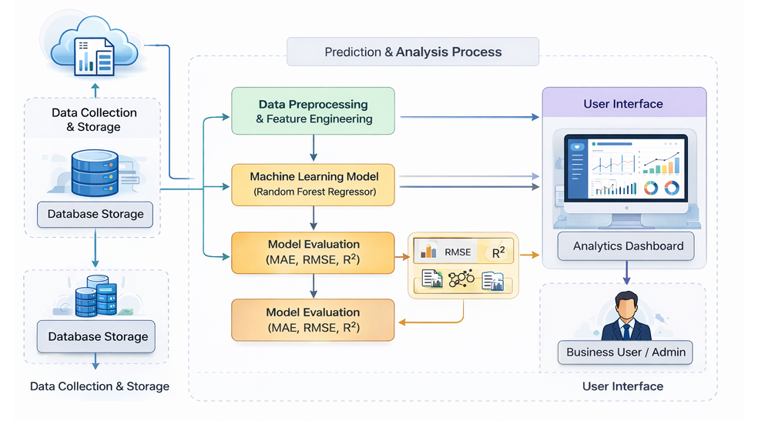
Figure 1: System Architecture of the Proposed B2B Courier Charge Prediction System

- Model Evaluation
Performance metrics like MAE, RMSE, and R² score were used to assess the trained models. To evaluate the accuracy of the model, predictions were made for the test dataset and compared to actual courier charges.

- Visualization and Dashboard Development
Plotting libraries were used to create graphic representations for the analysis of residual errors and prediction trends. To make it easier to understand courier charge variations, a straightforward analytical dashboard was created to show important metrics and comparative outcomes.

- Theory and Calculation

Logistics cost prediction has evolved significantly from simple statistical models to advanced machine learning techniques. Early approaches relied on linear regression and principal component regression to capture cost relationships, but these struggled with non-linear pricing patterns and dynamic market conditions. As logistics systems grew more complex, Support Vector Regression and neural networks were introduced to handle multi-factor pricing environments. However, ensemble learning methods — particularly Random Forest — emerged as more robust solutions due to their ability to capture complex feature interactions while reducing overfitting.

  - Dataset details:
Historical B2B courier shipment data with characteristics like shipment weight, delivery distance, service type, and carrier information was used for the experimental evaluation. An 80:20 split ratio was used to separate the dataset into training and testing subsets. Several regression algorithms, such as Random Forest Regressor, Decision Tree Regressor, Support Vector Regression (SVR), and Linear Regression, were used and compared. Standard regression metrics like Mean Abso lute Error (MAE), Root Mean Squared Error (RMSE), and R² score were used to assess the model’s performance.

MAE (Mean Absolute Error): $\frac{1}{n}\sum_{i=1}^{n}{|yi-}\hat{yi|}$ (1)

RMSE (Root Mean Squared Error): ${\sqrt{\frac{1}{n}\sum_{i=1}^{n}{{\left(y_{i}-\hat{y_{i}}\right)}^{2}}}}^{}$ (2)

R² (Coefficient of Determination): 1- $\frac{\sum_{i=1}^{n}{{\left(y_{i}-\hat{y_{i}}\right)}^{2}}}{\sum_{i=1}^{n}{{\left(y_{i}-\hat{y}\right)}^{2}}}$ (3)

Where:
- $n$= total number of samples
- $y_{i}$= actual courier charge
- ${\hat{y}}_{i}$= predicted courier charge
- $\overset{ˉ}{y}$= mean of actual courier charges

- Results and Discussion

The Random Forest model proposed in this paper shows better predictive performance than the methods reported in previous logistics cost studies. Yang Jing et al. [3] showed that Support Vector Regression outperformed linear models, however still had a higher error rate than the ensemble based approach used in this study. Meanwhile, Liu Fuqiang et al. [6] have proved that Random Forest is better than traditional regression in engineering prediction, which is consistent with the results obtained in this paper. Ensemble learning frameworks in logistics pricing [13] further conform that machine learning techniques are significantly better in prediction accuracy than static rule based pricing models. The results of this study are consistent with these findings, but specifically address the gap in B2B courier charge validation which has not been sufficiently explored in the existing literature.

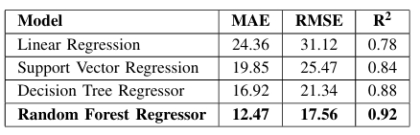
Table 1: performance comparison of regression models

Model Output Visualization:

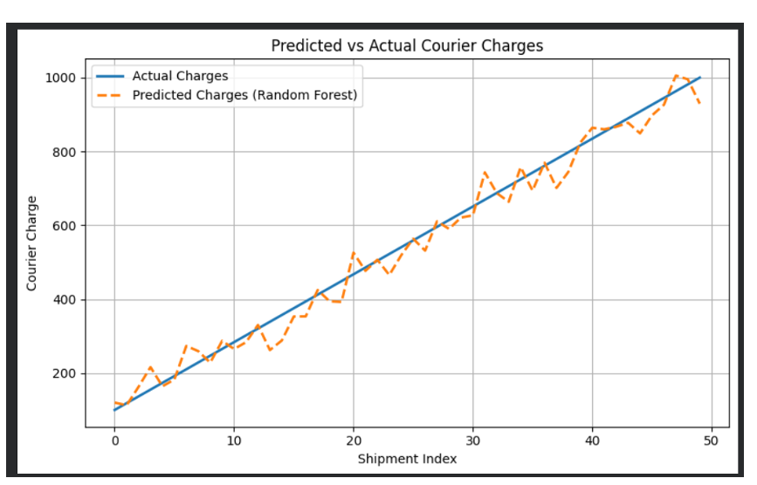

Figure 2: Comparison Between Predicted and Actual Courier Charges

- Conclusions
The study conducted an initial evaluation of B2B courier charge accuracy through its application of machine learning techniques. The proposed method enabled prediction of courier charges and detection of billing discrepancies through its analysis of historical shipment data combined with key factors that included weight distance service type and carrier. The Random Forest Regressor and other regression-based models enabled the effective modelling of complex B2B logistics pricing patterns. Machine learning technology enables organizations to establish better pricing transparency while they optimize their costs and make decisions based on data. The research establishes a basis which enables the development of advanced courier cost prediction systems that reduce billing discrepancies in B2B logistics operations.
Acknowledgements
The authors would like to thank Vardhaman College of Engineering for providing the necessary support and resources to carry out this research work.
Funding source
No funding was received for this study.
Conflict of Interest
The authors declare no conflict of interest.

References
[1] S. Shusheng and L. Baohua, “Application of multiple linear regression model in logistics cost prediction,” Business Age, no. 18, pp. 19–21, 2014.
[2] C. Longtao, L. Shichang, T. Xiaohong et al., “Research on coal logistics cost prediction based on principal component regression analysis,” Resource Development and Markets, vol. 31, no. 6, pp. 641–644, 2015.
[3] Y. Jing, L. Junfu, and Z. Gaoqing, “Coal logistics cost prediction based on improved support vector regression machine,” Journal of Guangxi University (Natural Science Edition), vol. 42, no. 4, pp. 1623–1627, 2017.
[4] L. L. Tong, “Cross-border e-commerce logistics cost prediction based on neural network,” Logistics Technology, vol. 46, no. 4, pp. 48–51, 2023.
[5] Y. Su, S. Lv, W. Xie et al., “Analysis of risk factors based on LASSO regression and random forest algorithm,” Journal of Environmental Hygiene, vol. 13, no. 7, pp. 485–495, 2023.
[6] F. Liu, X. Chen, and S. Li et al., “Prediction of permeability coefficient based on random forest regression,” Uranium Ore Geology, vol. 39, no. 4, pp. 653–661, 2023.
[7] S. Ding et al., “Category identification model based on random forest algorithm,” Journal of Analytical Testing, vol. 42, no. 11, pp. 1510–1516, 2023.
[8] J. Zou and L. Li, “Stock price prediction based on SA-BiGRU model with random forests,” Commodity Prices in China, no. 11, pp. 52–56, 2023.
[9] L. Guo, Z. Guo, H. Jia et al., “Identification of residential electricity theft based on Pearson correlation coefficient and SVM,” Journal of Hebei University (Natural Science Edition), vol. 43, no. 4, pp. 357–363, 2023.
[10] H. Wang and Y. Zhang, “Logistics cost forecasting using gradient boost ing regression in supply chain management,” Journal of Transportation Engineering, vol. 146, no. 5, pp. 04020034, 2020.
[11] R. K. Singh and S. Verma, “Machine learning approaches for freight rate prediction in transportation networks,” International Journal of Logistics Research and Applications, vol. 23, no. 6, pp. 512–528, 2020.
[12] M. Patel and A. Sharma, “Comparative analysis of regression models for transportation cost estimation,” International Journal of Advanced Computer Science and Applications, vol. 11, no. 8, pp. 215–222, 2020.
[13] J. Li, P. Wu, and T. Chen, “Ensemble learning-based logistics price prediction framework,” Expert Systems with Applications, vol. 165, pp. 113905, 2021.
[14] D. Kumar and R. Gupta, “Predictive analytics in supply chain cost optimization using machine learning,” Procedia Computer Science, vol. 173, pp. 587–594, 2020.
[15] A. N. Rahman and M. H. Islam, “Random forest regression model for dynamic pricing prediction in logistics systems,” IEEE Access, vol. 9, pp. 123456–123467, 2021.
[16] S. Chen, Y. Liu, and J. Huang, “A hybrid machine learning model for transportation cost prediction under uncertain demand,” Sustainability, vol. 13, no. 14, pp. 7852, 2021.
[17] P. Zhang and L. Zhao, “Data-driven freight charge prediction using en semble regression methods,” Transportation Research Part E: Logistics and Transportation Review, vol. 148, pp. 102248, 2021.
[18] K. Mehta and V. R. Rao, “Supply chain pricing optimization using random forest and gradient boosting techniques,” Journal of Industrial Engineering International, vol. 18, pp. 233–245, 2022.
[19] M. A. Khan, S. Ali, and H. Ahmad, “Machine learning-based anomaly detection in logistics billing systems,” Computers & Industrial Engi neering, vol. 169, pp. 108203, 2022.
[20] Y. Park and J. Kim, “Deep learning approaches for shipment cost forecasting in e-commerce logistics,” Applied Sciences, vol. 13, no. 3, pp. 1421, 2023.

