A Mini Project Report

On

QUIZ GAME
Submitted in partial fulfillment of the requirements for the award of degree of

Bachelor of Engineering
In
Computer Science and Engineering
Submitted by

K. Shanti 1608-16-733-105
Nithish Nadham.D 1608-16-733-093
Theertha Prasad. G 1608-16-733-103

Under the Guidance of
Mrs. M. Priyanka
Assistant Professor
Department of CSE

Department of Computer Science and Engineering
Matrusri Engineering College
(Affiliated to Osmania University, Approved by AICTE)
Saidabad, Hyderabad – 500059
(2017-2018)
Department of Computer Science and Engineering
Matrusri Engineering College
(Affiliated to Osmania University, Approved by AICTE)
Saidabad, Hyderabad - 500059

CERTIFICATE
This is to certify that A Mini Project report entitled “QUIZ GAME” is being submitted by K.Shanti (1608-16-733-105) in partial fulfilment of the requirement of the award for the degree of Bachelor of Engineering in “Computer Science and Engineering” O.U., Hyderabad during the year 2017-2018 is a record of bonafide work carried out by her under my guidance. The results presented in this mini project report have been verified and are found to be satisfactory.

Project Coordinator Project Guide HOD

Mrs. K. Shalini Mrs. M.Priyanka Dr. P. Vijayapal Reddy
Assistant Professor Assistant Professor Professor & Head
Dept. of CSE Dept. of CSE Dept. of CSE

External Examiner(s)

CONTENTS

Acknowledgement V
Abstract VI
List of Images VII

S.No Chapter Page No
1. INTRODUCTION 1-4
1.1Objective 1
1.2 Existing System 1
1.2.1 Advantages of existing system 1
1.2.2 Disadvantages of existing system 1
1.3 Present System 2
1.3.1 Advantages of the Present System 2
1.4 Scope and Importance 2
1.5 System Requirements 3
1.5.1 Software Requirements 3
1.5.1.2 Operating System 3
1.5.1.3 Compiler 3
1.5.2 Hardware Requirements 4

2. ARCHITECTURE & IMPLEMENTATION 5
2.1 Implementation 6
2.1.1 Program Analysis 6
2.1.1.1 Header Files 6
2.1.1.2 Namespaces 6
2.1.1.3 Class HEAD 6
2.1.1.4 Functions 6
2.1.1.5 Compilation Details 7
2.2 Modules 8
2.2.1 Administrative Modules 8
2.2.2 User Modules 9-11
3. OUTPUT SCREENS 12- 18
4. CONCLUSION 19
5. FUTURE ENHANCEMENTS 20
6. REFERENCES 21

ACKNOWLEDGEMENT

It is our privilege and pleasure to express our profound sense of respect, gratitude and indebtedness to our guide Mrs. M. Priyanka, Assistant professor, Department of Computer Science and Engineering, Matrusri Engineering College, for his/her indefatigable inspiration, guidance, cogent discussion, constructive criticisms and encouragement throughout this dissertation work.

We express our sincere thanks to mini project coordinator Mrs. K. Shalini, Assistant professor, Department of Computer Science and Engineering, Matrusri Engineering College, for her valuable suggestions and constant help in completing the work.

We express our sincere gratitude to Dr. P. Vijayapal Reddy, Professor & Head, Department of Computer Science and Engineering, Matrusri Engineering College, for his precious suggestions, motivation and co-operation.

We extend our sincere thanks to Dr. D. Hanumantha Rao, Principal, Matrusri Engineering College, Saidabad, Hyderabad, for his encouragement and constant help.

We extend our sincere thanks to all the teaching and non-teaching staff of CSE Department for their support and encouragement.

Last but not least, we wish to acknowledge our friends and family members for giving moral strength and helping us to complete this dissertation.

ABSTRACT

A Quiz is a mind game to test the knowledge of an individual on a particular subject. Our project is aimed at assessing the general awareness of the player on topics like Arts, Sports, Music, History and Science & Technology, with each domain comprising of 20 questions each. The game has a multiple choice question format. The players are evaluated as per the category chosen. The program code involves C++ language, adopting the concepts of Object Oriented Programming. It further comprises of File Handling operations to store and retrieve the details of the participants and the questionnaires. The objective of our project is to provide the player an engaging experience and a scope for overall enlightenment.

LIST OF IMAGES

S.No | Fig No. | Name of the Figure | Page No
1 | 3.1 | Welcome screen | 12
2 | 3.2 | Player’s Name | 13
3 | 3.2.1 | Entering Player’s name | 13
4 | 3.3 | Categories | 14
5 | 3.4 | Quiz Game | 14
6 | 3.5 | Game Progress | 15
7 | 3.6 | Game Ending | 16
8 | 3.6.1 | Lost all lives | 16
9 | 3.6.2 | High score | 16
10 | 3.7 | Instructions | 17
11 | 3.8 | Top Scorer’s File | 18

Chapter - 1
INTRODUCTION

This document describes the features and categories of an Offline Quiz game.

This document specifies the project objective, the hardware, software requirements, implementation, scope and future enhancements of the project.

This offline Quiz game provides an interesting enrichment of knowledge on various fields for the players. It tests the skills of the participants and improves the diversity of the knowledge of the player.

It is programmed in the C++ language, for the purpose of putting its Object Oriented Programming concepts to their best use. C++ provides rich library functions that are easier to handle and produce the aimed output.

This project covers interesting questions in technical areas like various Sciences that include questions in branches of Biology- Anatomy, Ichthyology, Physics; questions on modern-day Computers and technology. Apart from these fields, it has added non-technical fields of importance like Arts, Music and Sports. Another category of History has been specially included to enhance the players’ knowledge on the varied Cultures and the olden days.

The maximum score that can be secured is 50 per game. Each player is given 3 lives to go through the game. The attempt of the player is recorded and is evaluated accordingly. The lives are reduced by one per every wrong attempt. The player is given information on the number of lives left. At the end of each game, the total score of the player is displayed. Also, the player’s score is stored in the Top Players’ file given that it is more than 30. Players are also allowed to try other categories within the same game.

Thus, this program is designed to provide an easier access to enhance knowledge on multiple branches. An effective approach to this game is beneficial to the players in learning along with fun.

1.1 OBJECTIVE

- To create a simple offline program that helps in obtaining worldly knowledge in an easier and an efficient way.
- To provide various topics to choose from, for an overall enlightening experience, thus creating an enjoyable way of learning.
- Allowing the participant to choose his own field of interest, thus supporting personal interests and passions.
- Providing the players an opportunity to try other categories to build an interest in it.

  - EXISTING SYSTEM

The quizzes already in existence are those which follow traditional techniques of implementation. There are certain challenges faced by the manual quizzing techniques.

1.2.1 Advantages of the Existing System:

- Testing provides feedback to instructors and lets them know what is learned or what is not.
- Frequent testing encourages students to study. Having frequent quizzes and tests motivates study and reduces procrastination.
- It causes students to learn more from the next study episode. Essentially it reduces forgetting which makes the next related study area more productive.
- It produces better organization of knowledge by helping the brain organize material in clusters to allow better retrieval.

1.2.2 Disadvantages of the Existing System:

- Quizzes conducted on paper do not capture the leaner’s attention.
- Evaluating the answers given by the students becomes a tremendous task for the teachers.
- Students do not get an immediate response from the concerned teacher and lose the opportunity of learning faster.
- It doesn’t have re usability.
- Requires paperwork, hence wastes paper and resources

  - PRESENT SYSTEM

The current system developed is an offline game, which is designed to overcome the problems faced with the manual system.

    - Advantages of the Present System

- It allows the teacher to quickly evaluate the performance of the group
- This mode of quizzing takes up less time and effort.
- All data can be stored on a single server.
- Teachers can mix and match the question styles on exams, including graphics and make them more interactive than paper exams.
- Eliminates human error in grading

1.4 SCOPE & IMPORTANCE

- The offline Quiz Game project is targeted at providing enriching knowledge for Educational Institutions (students of colleges, schools, other educational centers).
- Quizzing methods improve the learning of the students by creating a more motivating atmosphere for the students.
- This enables a better performance in an overall basis for the students.
- Our project is aimed at providing such student- friendly environment by implementing the quizzing techniques.
- The Quiz Game handles the operations of providing questions to the players, accepting the answers and evaluating them. It warns the players of the numbers of lives available at each wrong attempt.
- Total score of the player is displayed at the end of the entire game.
- Thus, the students can evaluate their performance of their test.
- The questions are displayed in a multiple choice question format with 4 options per question, to aid the player with further hints.

1.5 SYSTEM REQUIREMENTS

1.5.1 Software Requirements

The minimal requirements for the program can be taken as follows:

1.5.1.2 Operating System

IDE: Ubuntu 16.04 LTS

Ubuntu 16.04 is the operating system used for the program. The program is also compatible with Windows, Mac OS and other Integrated Development Environments, with apt changes made to the Header files.

1.5.1.3 Compiler

The compilation process is currently done under the GCC compiler. The program can also be compiled in other compilers available, like Dev C++, Visual Studio, Turbo C++, etc. However, minor changes are to be made to the program to achieve this.

1.5.2 Hardware Requirements

The minimal hardware requirements can be recorded as follows:

- 2 MB RAM to run the program
- Hard disk to store the required files
- 32-bit or a 64-bit Operating system

Chapter - 2
ARCHITECTURE

This application is brought in C++ language. It provides Object Oriented Programming System (OOPS), which enables the programmer to add characteristics like data security, data encapsulation, etc.

2.1 IMPLEMENTATION

// SAMPLE OF CODE IMPLEMENTED

#include<iostream>
#include<cstdlib>
#include<cstring>
#include<fstream>
#include<string>
using namespace std;
class HEAD
{public:
char Player[100];
void Screen_1();
void Screen_2();
void Instructions();
void Screen_3();
void Arts();
void Sports();
void Music();
void History();
void Science_Technology();
void Score(char[],int,string);
void Shuffle(int *, size_t);
}; // END OF CODE
2.1.1 Program Analysis

2.1.1.1 Header Files

The header files used in the program can be listed as:

- #include<iostream>
This header file includes the required streams for Input and Output operations on the console.

- #include<fstream>
It allows the reading and writing of files to the console and vice versa.

- #include<cstdlib>
The rand ( ) function used for a crucial role in the program is contained in this header.

- #include<ctime>
The access to the system time is provided by the ctime header file.

- #include<string>
This header is imported to the program to allow string type variables to be accessed.

2.1.1.2 Namespaces

A namespace is a declarative region that provides a scope to the identifiers (names of the types, function, variables etc.) inside it.

This program code implements the namespace “std”, for added convenience while accessing member objects of iostream like cin, cout, etc.

2.1.1.3 Class HEAD

This is the head of the program. It consists of all the functions present in the program.
The access specifier is taken as “public”, to ensure that all the member functions have an access outside the class.

2.1.1.4 Functions

The functions Screen_1(), Screen_2(), Screen_3() and Instructions() show an output of what their name suggests.
The function Shuffle(), creates an array of random integers from 1 to 10 and sends them to the functions which contain the categories.

Each of the functions Arts(), Sports(), Music(), History() and Science_Technology() have 10 questions each. These functions accept the shuffled list sent by the Shuffle() function and display the questions to the console.

These functions each use “switch” cases. Each of these cases contain an integer from the integer array sent by the Shuffle() function. Switch cases ensure that no two questions are repeated to the console. It is easier to program and its simplicity is aimed for making the program more readable.

The function Score() takes three parameters – name of the player who secured a high score, the points scored by him/her and the category in which he scored the points. These are sent then sent to the file, “Player_list.txt”.

2.1.1.5 Compilation Details

2.2 MODULES

2.2.1 Administrative Modules

2.2.1.1 Source code is in C++

C++ is a highly portable language and is often the language of choice for multi-device, multi-platform app development. It is an object oriented programming language with the concepts of classes, inheritance and polymorphism. The language has a greater flexibility as compared to C.

2.2.1.2 Usage of Object Oriented Programming Concepts

OOPs concepts of C++ are very helpful in making our code understandable. The functions of the code are clearly understood due to the usage of the scope resolution operator in defining the functions outside the classes.

      - Files to store and retrieve the user data

File streams are used in the program to store the details of the players who scored above 30(out of 50 points). After each game, the counter of the points checks the points secured by the player. If the score is above 30, control is sent to the function which takes the player’s name, his score and category in which the player played as parameters and streams these details into the specified file, “Player_list.txt”. This list containing the top players’ details can be viewed as per the player’s choice.

2.2.2 User Module

2.2.2.1 Welcome screen
This screen contains the following options:
- Play
- Instructions
- Leader board
- Exit

Play –
This option has to be chosen by pressing “1” and <ENTER>. It then leads to Screen_2.
Instructions –
Instructions are to be chosen by sending “2” as an input and pressing <ENTER>. This displays the instructions on the console. These instructions are to be followed by the player through the game. The player can exit this screen by pressing any key and <ENTER>.
Leader Board –
On selecting the “Leader boards” option, the player can view the players who scored above 30 previously. The names are displayed category-wise, so that the player can have a proper knowledge of the top scorers. This is intended to pique the player’s interest into accepting the challenge of the game and playing with a sportive spirit.
Exit –
This option allows the player to return back to the console. It exits the game.

Any other options other than these would also cause the player to exit his game.

2.2.2.2 Screen 2:
This screen accepts the player’s name. The name can have up to 100 characters including spaces, bold letters and tabs. Duplication of the names is also allowed. After entering the name, <ENTER> has to be pressed which then leads to the next screen.

2.2.2.3 Categories
This screen contains the following categories for the player to choose from:
- Arts
- Music
- Sports
- History
- Science & Technology
The player has to choose one amongst these options. The game thus begins.

2.2.2.4 Quiz Game
Each of the above listed sections has 10 questions. 4 options are provided for each question displayed. The player has to choose one amongst the available options as his/her answer and press <ENTER>. The answer is evaluated internally and a response is generated. For a correct answer, the score increases by 5, while for every wrong answer, one life is deducted.
The options are to be entered only in the specified format. This is intended in keeping the player alert and propels him to judiciously go with the flow. Answers of any other type are awarded a 0 and a life is lost by the player.
The player initially has 3 lives. For every life lost by the player, a warning is generated, which displays the number of lives left for the player. If all the lives are lost before the completion of the game, a message is displayed saying that the player lost all his lives.
However, if the player is able to score above 30 points by the end of the game, his name is sent to the list of the top scorers.
In case of the player falling in neither of these categories, the game automatically exits after the completion of the ten questions. In both the latter cases, a “Thank you” message is displayed.
On pressing any key and <ENTER>, the control automatically returns to the Categories screen. The same player can have access to the other categories within the same game.
The player is allowed to have number of attempts at the game to ensure a never- ending fun filled experience. At any stage, “0” allows the player to go to the previous screens, and then finally exit.

Chapter - 3
OUTPUT SCREENS

3.1 Welcome Screen

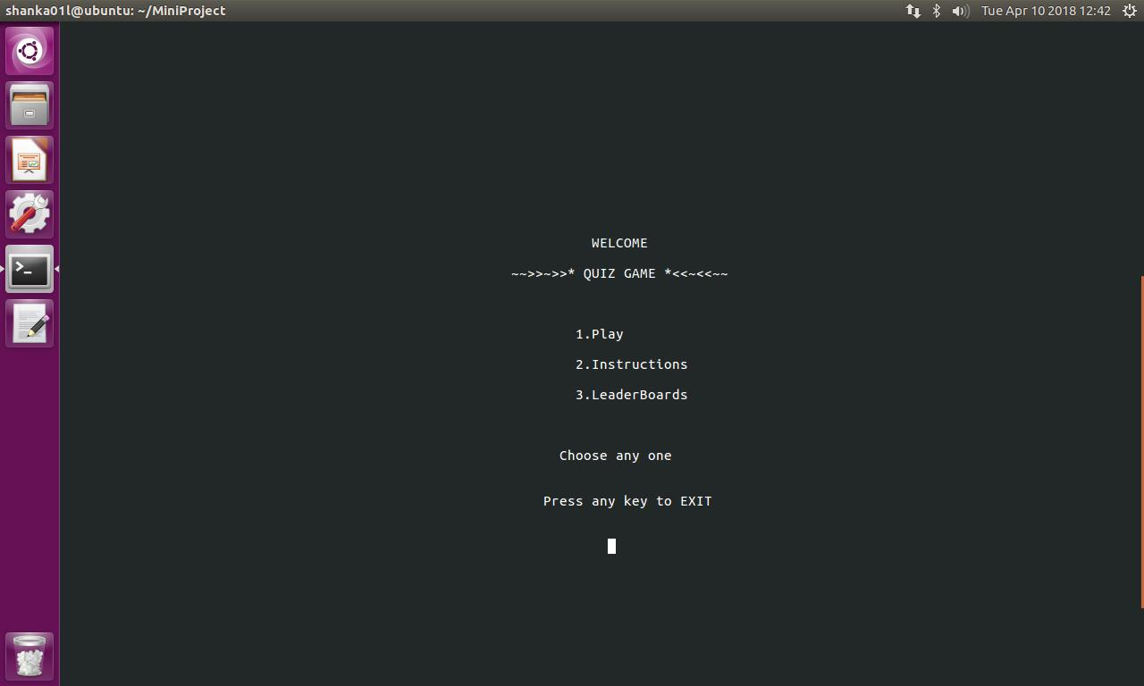
Image shows the welcome screen, with its various options.

3.2 Player’s Name

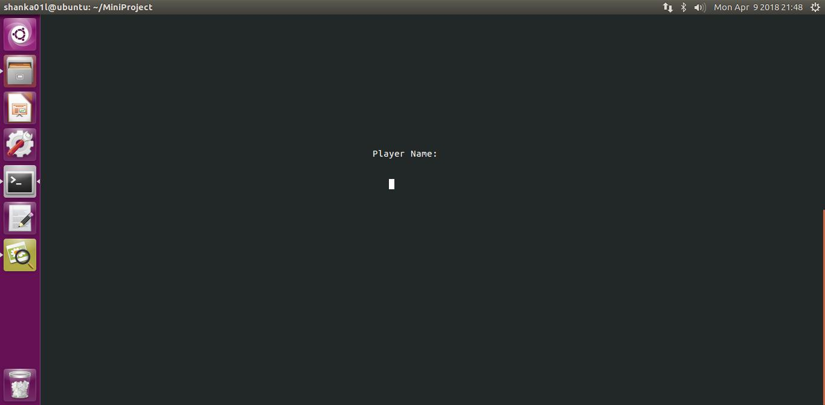
The server asks the player to enter his/her name.

3.2.1 Entering Player’s Name

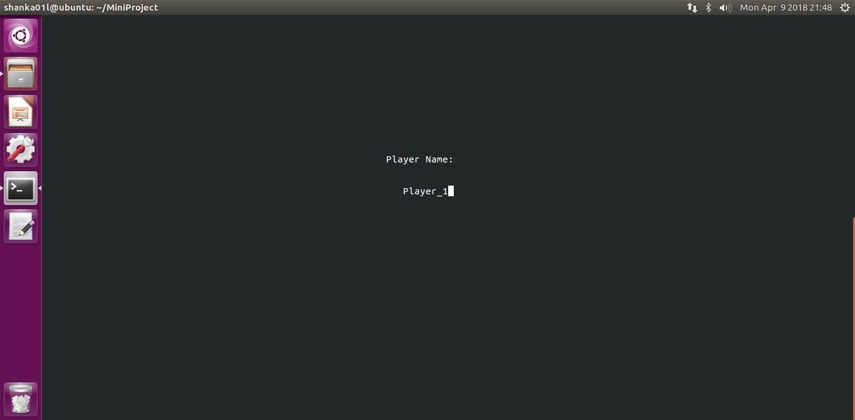
Input to the player’s name. Image shows a player “Player_1” entering his name.
3.3 Categories

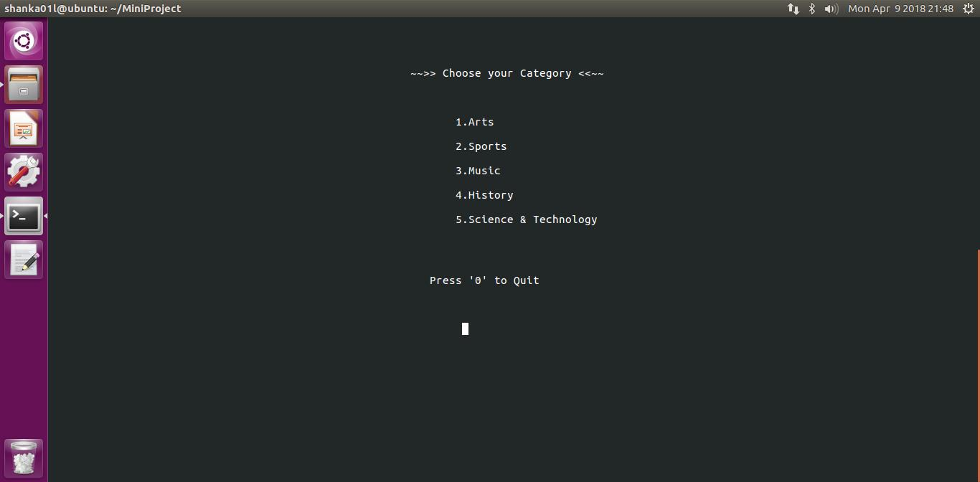
Image shows various categories available to the player.
3.4 Quiz Game:
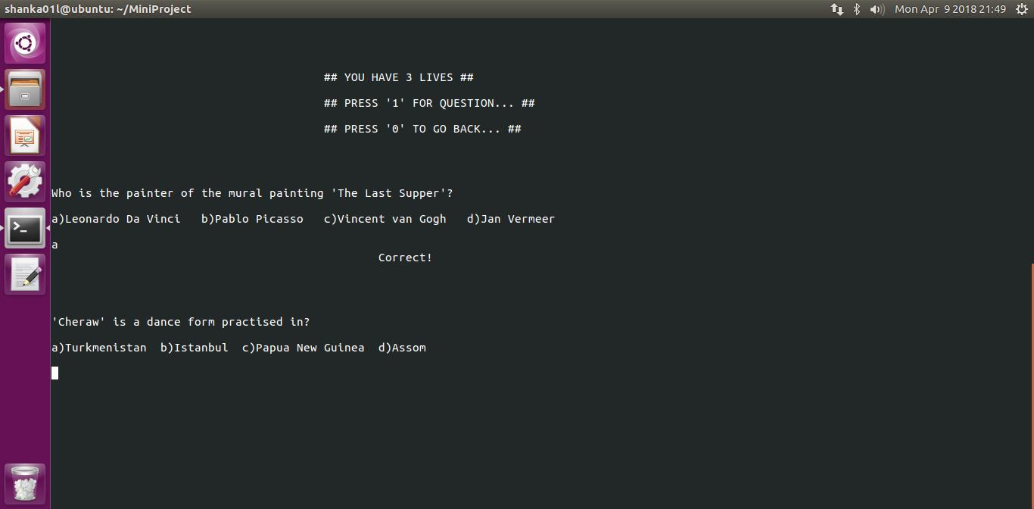
The game has begun at this stage. Image shows the primary instructions to the player again at this stage. Questions are displayed with multiple options.
3.5 Game Progress

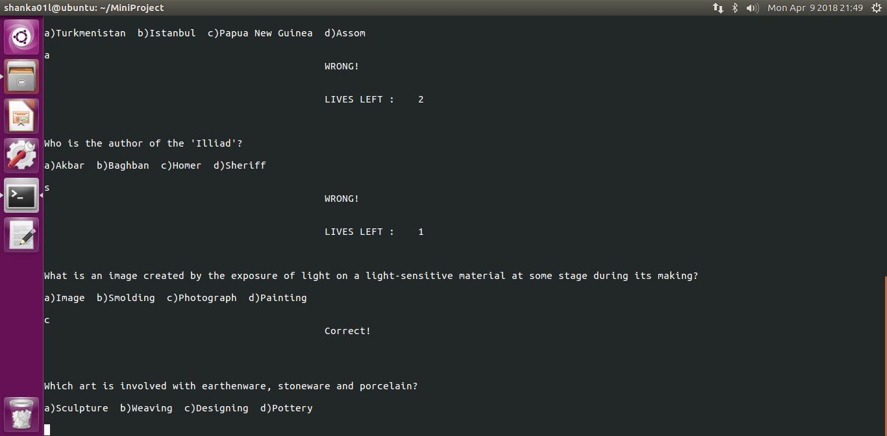
The game is being played by a player. The figure displays the messages showing “Correct” and “Wrong” as in response to the answers given by the player.

3.6 Ending
3.6.1 Lost all Lives
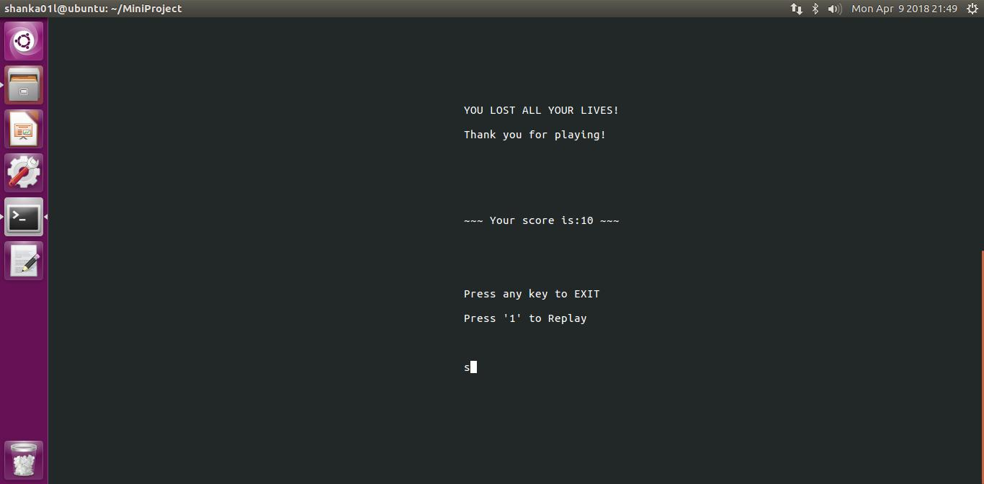 Here, the player lost all his lives.
3.6.2 High Score
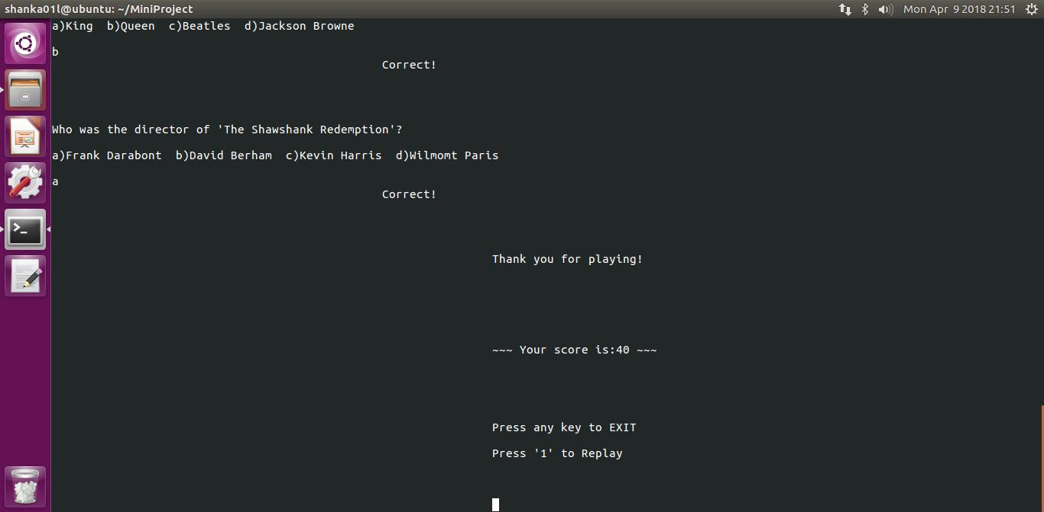 The player obtained a high score.
3.7 Instructions

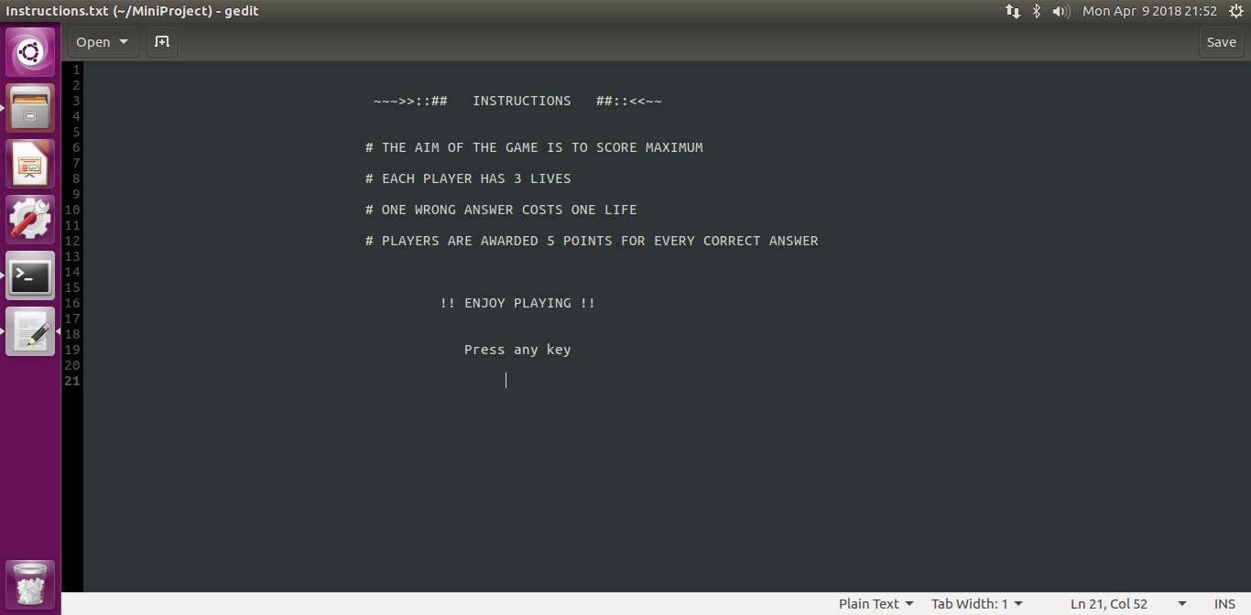
The guidelines for the players are stored in “Instructions.txt”.

3.8 Top Scorers’ File

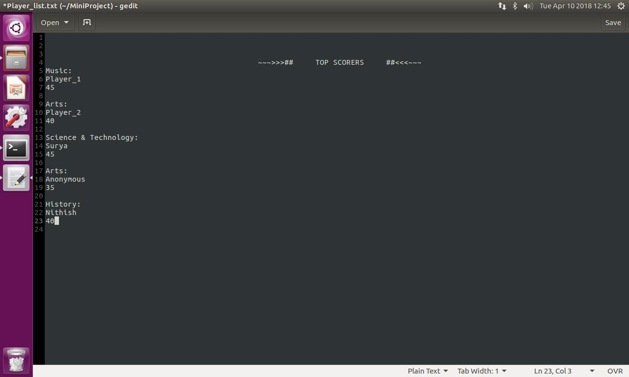
The details of the top scorers are stored in the file, “Player_list.txt”.

Chapter-4
CONCLUSION

Cognitive psychology strongly suggests that the act of retrieving information directly helps students learn. Frequent quizzes give the teacher an idea of how well the class as a whole grasps the concepts. It lets the teachers rethink the way of explaining something, provide additional instruction in the classroom, or create an engaging activity for the class to do together to make sure the content is clear. Quizzes help students identify what they know and what they don’t know. For the modern- day, classroom teaching techniques are greatly improvised by the concept of quizzing. It redefines the old school methods of classroom teaching and helps in motivating students to learn with better motivation.

Chapter-5
DESIGN ISSUES & FUTURE ENHANCEMENTS

The current program contains various design issues. They can be listed as:
1) How many categories are possible overall?
2) How can the questions be changed?
3) How much more efficient can the program be made?
4) What all could be done to extend the functionality?

The program can be improvised further and be made online. This increases the accessibility to many more students. More number of categories can be added as a part of development. This game can be designed as an application and be made available to smartphones. In the contemporary day, high accessibility can be achieved by creating applications on Android and Apple OS.

Chapter-6
REFERENCES

