Question 42: Dormant Account Identification

1. Aim
To develop a COBOL program to identify dormant accounts by comparing the number of days since the last customer-initiated activity with a specified inactivity threshold and display the flagged account IDs and their total count.

2. Problem Statement
A bank needs to identify accounts that have remained inactive for a specified period. The program reads the number of accounts, each account's ID and inactivity days, and a threshold value. It flags accounts whose inactivity days are strictly greater than the given threshold and displays the flagged account IDs along with the total number of flagged accounts. Accounts with inactivity days equal to the threshold must not be flagged.

3. Algorithm
- Start.
- Read the number of account records, N.
- Repeat N times: read an account ID and its inactivity days, and store the pair in a list.
- Read the threshold T.
- Initialize the flagged account count to zero.
- Compare the inactivity days of each account with the threshold.
- If the inactivity days are greater than the threshold then Display the account ID and Increment the flagged account count by one.
- Repeat the comparison for all accounts.
- Display the total number of flagged accounts.
- Stop.

4. Program (COBOL)

IDENTIFICATION DIVISION.
PROGRAM-ID. DORMANT-ACCOUNT.

DATA DIVISION.
WORKING-STORAGE SECTION.

01 N PIC 9(6).
01 I PIC 9(6).
01 THRESHOLD-DAYS PIC 9(9).
01 FLAGGED-COUNT PIC 9(6) VALUE 0.

01 ACCOUNT-TABLE.
05 ACCOUNT-RECORD OCCURS 100000 TIMES.
10 ACCOUNT-ID PIC X(20).
10 INACTIVE-DAYS PIC 9(9).

PROCEDURE DIVISION.

ACCEPT N

PERFORM VARYING I FROM 1 BY 1 UNTIL I > N
ACCEPT ACCOUNT-ID(I)
ACCEPT INACTIVE-DAYS(I)
END-PERFORM

ACCEPT THRESHOLD-DAYS

PERFORM VARYING I FROM 1 BY 1 UNTIL I > N
IF INACTIVE-DAYS(I) > THRESHOLD-DAYS
DISPLAY FUNCTION TRIM(ACCOUNT-ID(I))
ADD 1 TO FLAGGED-COUNT
END-IF
END-PERFORM

DISPLAY "Flagged count: "
FLAGGED-COUNT

STOP RUN.

5. Sample Input and Dry Run
Sample input: 3 accounts (A1 30, A2 91, A3 90) with threshold 90.
Account ID | Inactivity days | Threshold | Days > Threshold? | Flagged
A1 | 30 | 90 | 30 > 90 → No | No
A2 | 91 | 90 | 91 > 90 → Yes | Yes
A3 | 90 | 90 | 90 > 90 → No (equal) | No
Only A2 exceeds the threshold. A3 equals the threshold, so it is not flagged.

6. Output Screenshot
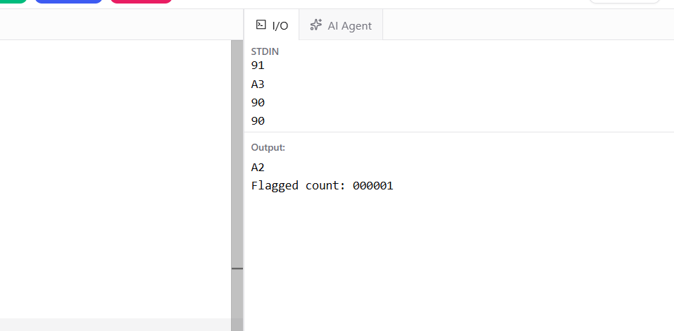
Figure 1: Program run on the sample input

7. Result
Thus, the COBOL program was developed and executed successfully to identify accounts whose inactivity exceeds the specified threshold. It displays the flagged account IDs and the total number of flagged accounts, excluding accounts whose inactivity days are equal to the threshold.

