Fake News Detection

B. Nithisha, B. Sreeja, N. Ramya Sree, G. Hari Chandana

*Department of Computer Science and Artificial Intelligence, SR University, Warangal, Telangana, India.* Email: melodynithisha@gmail.com, [sreejabandi04@gmail.com,](mailto:sreejabandi04@gmail.com,)[ramyanagothu@gmail.com,](mailto:ramyanagothu@gmail.com,) gajulaharichandana65@gmail.com

**Abstract—One of the main issues that have arisen with the release of digital media is the use of disinformation and thus there is a need to develop fake news detection systems as presented in this project. A collection of 45,825 news articles that has been labelled as either ‘fake’ or ‘true’ is discussed, the text data having undergone pre-processing trough NLP. Before feature extraction, text data is transformed to numeric form using Count vectorization and the TF-IDF process. Some of the machine learning techniques that fall in the process of pre-processing, feature extraction and classifier training includes logistic regression, decision tree and so on. Evaluation measures consist of accuracy, precision, recall, and the F1 score and cross-validation added credibility to the findings. The findings present the model’s performance in identifying fake news hence the efficiency of utilizing automated solutions against false information. The above strategy presents the advantage of scability and flexibility in handling fake news across the networks. Further changes could be made to use deep learning algorithms to improve the detection outcomes even further and to prove the necessity of the machine learning techniques to reduce the negative influence of the misinformation in the society.**

***Keywords*— Misinformation, Natural Language Processing (NLP), Count Vectorization, TF-IDF, Feature extraction, Classifier training, Accuracy, Precision, Recall, F1-score, Cross-validation, Robustness, Deep learning.**

I. INTRODUCTION

Finally, with the expansion of Internet content distribution, people receive knowledge and news at a high speed without losing much time and spend a lot of time on social networks. However, this kind of dissemination has brought about a host of challenges such as spread of wrong information. Managing fake news, that is deliberately created, fake information disseminated as the genuine news affects people’s decisions and opinions, and the credibility of genuine news sources. The rampant production of fake news, especially on social media has come as a wakeup call for autonomous approaches that would aid in their detection with little harm to society.

Conventional techniques of confirming the legitimacy of the news, including, checking on facts, can take lots of time and efforts and cannot be applied when there is a huge amount of information that circulates daily. It has however been largely dealt with by automated techniques employing machine learning and natural language processing (NLP). Through the features extracted from the textual content of news articles, the machine learning models can be trained with features that defines fake news from real news. Such a strategy provides a scalable, effective and dependable method of reducing the spread of fake news on the social media.

This paper looks at the use of artificial neural networks for the classification of fake news. A large dataset of news articles is utilized which is further divided into fake and true and also preprocessed by tagging. For feature extraction, data pre-processing includes Natural Language Processing techniques like Count Vectorization, and Term Frequency-Inverse Document Frequency (TF-IDF) that convert raw textual data to a format that is consumable by machine learning algorithms. The paper also measures and compares the effectiveness of the classifiers such as logistic regression and decision trees among others by use of accuracy, precision, recall and F1 score. The number of models developed is optimized using cross-validation in order to make all the models more reliable and accurate.

The outcome of this work will be beneficial for the fine-tuning of chosen analytical methods, as well as for the determination of potential further development directions. This work also describes some further development ideas that can add even more to the detection accuracy of the model and data set independence, which includes the use of deep learning models in the future.

Through designing and assessing the automated fake news detection systems, this project addresses the major problem of disinformation in the modern world. The article underlines one of the most important aspects of the modern globalized world: the importance of machine learning and natural language processing in decision-making and the possibility of trusting potentially useful information.

II. CONTRIBUTIONS AND OBJECTIVES OF THE RESEARCH

The main objective of this work is to create an automated system capable of detecting a fake news effectively because of the use of machine learning algorithms. This is because we employ NLP techniques like Count Vectorization and TF-IDF to clean and transform features from the news articles we attempt to predict. Some of the classifiers that will be deployed include: logistic regression and decisions trees classifier to determine the performance of the advanced methods in detecting fakes news from real news. Out of all these models, the most effective detection approach will be established from the results of parameters including accuracy, precision, recall and F1-score. To avoid over-dependence on the data, methods of cross-validation will be employed this will train the model in different sections of data set such that the resultant system is not sensitive to a particular form of data. At the same time, this work proposes a large-scale approach to address the problem of disinformation in digital media and demonstrates the effectiveness of automated mitigation solutions. Future work will analyze newer techniques like deep learning to enhance and optimize the fake news detection systems.

*Comparative Analysis*: In this work, four supervised learning algorithm including logistic regression, decision trees, and an ensemble methods were used in order to classify and effectively identify fake news. However, logistic regression while being simple and accurate did not deal well with interaction terms that complicated relationships between the variables. It was observed that decision trees strained non-linear relationships well, yet were often intertwined. Decision trees included many sub-topics such as Random Forest which combined multiple decision trees because they offered increased accuracy and less susceptibility to overfitting at the cost of processing time. This analysis revealed that ensemble methods provide the most favorable heuristic capacity/accuracy ratios and should thus be considered the best for detecting fake news. This is in contrast to future work using deep learning techniques suggesting that higher model complexity can yield even better prediction capabilities.

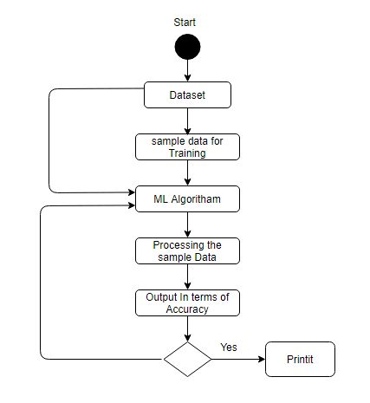Figure-1:flowchart

III. LITERATURE REVIEW

Identifying fake news has gathered much attention in recent years owing to its serious influence on people’s opinion, populizing false information, and decreasing trust. When it comes to improving efficiency, current state-of-art receiving and analysis sources that employ ML and Natural Language Processing algorithms can be said to be useful in identifying fake news. These techniques mainly involves language style, words to be used, and the topics to be developed while modeling and addressing this problem proffer solutions that are easily measurable.

In its early years, fake news detection was solved using machine learning classification algorithms such as logistic regression, SVMs, and Naive Bayes. Issues of this kind have been mainly addressed using methods in the context of term frequency, inverse document frequency (TF IDF), and bag of words (BoW). They are used to transform textual inputs into numerical feature spaces enabling ML models to analyze the obtained information.

As such, Ruchansky et al. (2017) claimed that the use of both content-based information and temporal data meets the two critical requirements of understanding fake news: semantic content analysis and information about when the fake news was created. Although these methods offered fairly good accuracy, their algorithms for adapting them to various datasets and environments were slow, and constrained by design features hand-crafted and the nature of comparatively simple models.

Over time, there has been a growth of NLP techniques in which deep learning has assumed the mantle of a formidable tool for identifying fake news. CNN and RNN models are some of the models that have pioneered for extracting abstract feature from the text in an automatic manner.

CNNs were combined with other algorithms such as the Word2Vec and GloVe by Yang et al. (2019 to detect fake news. These models retain local information of the text, including n-grams and phrases and are therefore suitable for distinguishing fake news from real news articles where slight language differences are used.

In the same way, Liu et al. (2020) have used the architecture of Recurrent Neural Networks and Long Short-Term Memory to capture time dependencies in the text. By making it possible to maintain the sequence of words and the relationships with the context, RNNs and LSTMs enhanced temporal and contextual feature extraction and consequently bettered classification effectiveness. These deep learning models consistently outperform conventional techniques particularly when such techniques are applied on complicated datasets written in different styles.

Accompanying the rapid growth of deep learning, the adoption of ensemble methods for fake news detection has also attracted researchers due to its robustness and multiple modeling aspects. Ensemble methods such as Random Forest, Gradient Boosting Machines and XGBoost consider the output of numerous weak learners and outperform them by enhancing generalizability, and limiting overfitting instances. Psych-02

Zhou and Zafarani (2020) focused on ensemble approaches for fake news detection and pointed out that they help to achieve the integration of various feature vectors in an efficient manner. These approaches, which integrated textual, temporal and contextual features, surpassed single classifier methods, thus showcasing the ability of ensemble learning in tackling the complex dimension of fake news.

Besides content-based analysis, the integration of social and networking attributes has significantly enhanced the framework for detecting fake news. Other metadata such as user data, posting time, and sharing behaviors lend an added contextual depth. In 2016, Nakov and colleagues added these characteristics to text classifiers and stressed that these features, consisting of users and the network, can be fruitful in increasing the effectiveness of detection.

The ever-increasing importance of the social network context in the development of fake news into the information ecosystem signals a need to study fake news as a social phenomenon. By studying how fake news is spread in networks and how users interact with fake news, researchers can develop better and more efficient fake news detection systems.

Nonetheless, the task of understanding and detecting fake news has not been easy. A significant barrier is the absence of sufficient-sized labelled datasets that are of appropriate quality and span various domains and languages. Most datasets hold subjectivity bias that can impact the predictive performance and generalization of machine learning models. Furthermore, the “methods” of creation of fake news are always changing and fresh approaches to detection techniques are needed.

Model interpretation is another important challenge that complements deep learning approaches. The models of learning, while precise, are quite difficult to apply because of their black box feature. IV. METHODOLOGY

This project aims to develop an automated fake news detection system using machine learning techniques with a methodology that includes several critical stages: data collection and preprocessing, feature extraction, model selection and training, model evaluation and comparison, and future work and improvements. Each of these phases plays a critical role in ensuring the efficiency and scalability of the detection system.

A. *Data collection and preprocessing*

The dataset includes two labeled categories of articles. There are 23481 articles labeled as false and 21417 articles labeled as true. These two sets have been derived from publicly accessible sources and hence are credible. Preprocessing includes the preparation of data which involves elimination of non-text data such as special characters, numbers, punctuation marks, and stop word deletion. This way, only areas of attention are left in the text. Individual words make up the articles that are broken down during tokenization and all the letters appear to be in lowercase letters. It is these who lettering stages which prepare the dataset for subsequent feature extraction to be performed on it.

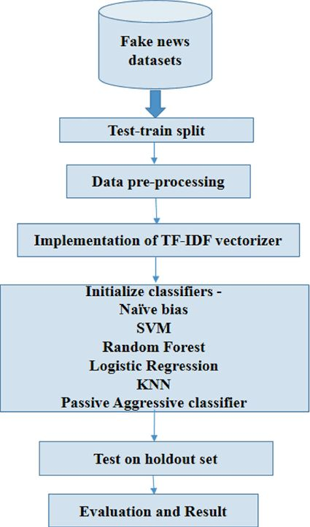

Figure-2: Process of the project

*B. Feature extraction*

Through the use of natural language processing, other applications are able to convert the text into numerical data and matrices. In other words, counting vectorization transforms the text into a matrix that consists of the amount of tokens and almost perfectly measures how many times certain terms appeared in the given newseye. Moreover, Term Frequency-Inverse Document Frequency is a further improvement to this process as it weights the terms according to the significance they have in relation to the whole corpus. This is done in order to incorporate the most important and significant terms in the training of the model to promote better overall learning. These numerical features created through these methods are useful as the input in the training of the machine learning models.

*C. Model selection and training*

The ability of several machine learning algorithms to classify news articles as fake or true is evaluated. Because of its simplicity and efficiency in binary classification tasks, logistic regression is chosen to be used as the basic model. Decision trees are implemented to find non-linear relationships in data through a hierarchical partitioning of features. Being an ensemble method, Random Forest pools the predictions of multiple decision trees to achieve improved accuracy and reduced chances of overfitting. The dataset is divided into training and test sets in a ratio of 80% to 20% to ensure there is enough data for both phases. Hyperparameter optimization is performed for all models to increase their predictive performance.

*D.Evaluating and comparing models*

The performance of trained models is assessed with classic statistical measures such as accuracy, precision, recall, and F1-score. These metrics gauge the model capability to classify the articles with minimal false positives and negatives. To nullify the possibility of overfitting and assure robustness, one uses cross-validation, wherein the training data is divided into different folds, with repeated training and evaluation repeatedly done. Such an attempt augments the credibility of the evaluation results. Comparison of the performance metrics is then done for the models. Logistic regression acts as a benchmark, and decision trees and random forests are assessed for their prospective treatment of intricate relationships in the data with maximized accuracy

. 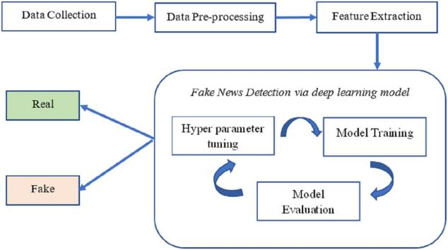

*Figure-3:Architecture*

*E. Future work and improvements*

To underpin the project, classic machine learning techniques are to be followed strictly, while future improvements may include the incorporation of deep learning measures.Deep learning techniques like CNNs and RNNs could benefit from identifying more profound semantic and contextual patterns in the latter, which would contribute to improving the rate of the detection. Further, increasing the dataset to accommodate diverse subjects and different languages would augment generalizability with respect to different contexts. Adding metadata such as user engagement metrics, publication timestamps, or sharing patterns would further imbue the model with the capacity to distinguish between true and fake news. The training also with adversaries might strengthen the ability of those models concerning adaptation to the evolution of the exploits of fake news.

V. Experimental Results

1. *Logistic Regression*

It showed that logistic regression served as a fair benchmark for recognising fake news. It gave a reasonable accuracy of the news articles and was able to classify the articles as fake or true using simple linear relationships. Although logistic regression has proven itself a robust method for managing textual data preprocessed by NLP approaches like the TF-IDF, the model has its shortcomings in capturing nonlinear relationship in the data. Everything about the model is simple to comprehend, but there is a logic in a sense that this lack of complexity hampers the model’s performance in giving attention to finer differences or details in content.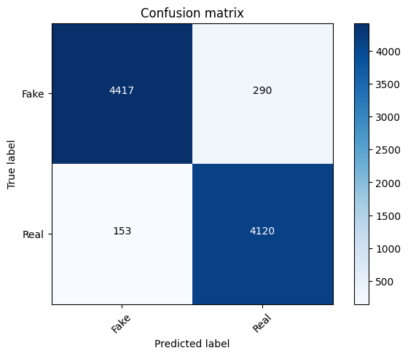

*Figure-4:Confusion Matrix of Logistic Regression*

1. *Decision Tree*

The decision tree model is also preferred in the tasks of deciding between false and true reports, and the model utilized the ability to consider nonlinear relationships between the data. Compared to the methods such as the logistic regression, it was found to provide more accurate solutions which could confirm the proficiency of the algorithm in dealing with inclined decision planes. That is why the model, with the help of informative features, was able to partition the data into finer categories. However, the decision tree that was used was highly biased and sensitive to the training data; it also tended to over-fit the data particularly on a small training set. Nonetheless, because decision trees are quite interpretable, the authors explained in which aspects offered the greatest influence on classification.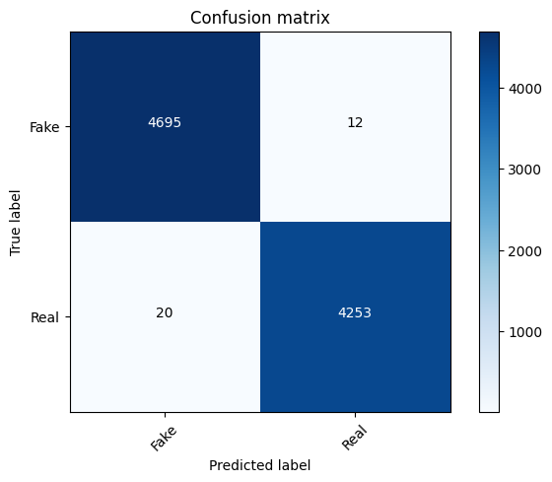

*Figure-5:Confusion Matrix of Decision Tree*

1. *Random Forest Classifier*

RandomForestClassifier also provided high accuracy off the false message detection with a precision of 0.9630, 0.9708 > Logistic Regression and > Decision Tree. A simple decision tree was shown to be inferior to a system which incorporated additional decision trees in terms of classification accuracy and minimal overfitting which was apparent from single decision tree models. The Random Forest ensemble learning technique was characterized by high interpretability and stably reconstructed the complex dependencies in the data. Furthermore, the feature importance analysis of the model showed attribute importance of features that contributed most to fakeness classification, and the model can be interpreted in spite of being complex. However they required more time than the basic classifier especially in the computation time since it was an ensemble based classifier.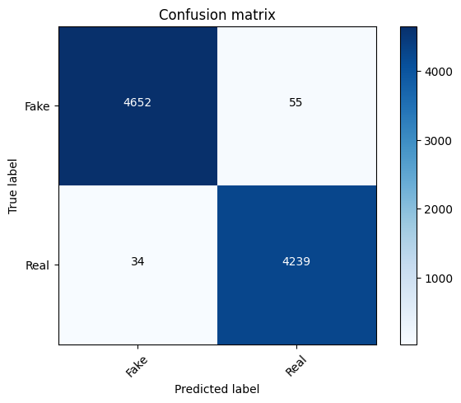

*Figure-6:Confusion Matrix of Random Forest*

1. *SVM*

The Support Vector Machine (SVM) model has been well implemented for fake news detection in view of the efficiency of processing large dimensional data. Thus, the maximized range between classes has allowed the usage of SVM to classify false and true messages with reasonable accuracy. The model was tested with high effectiveness using a linear kernel, which allowed it to quickly assign different classes according to the selected parameters. However, it was highly computational and complex particularly for big data and hyperparameters like; C and kernel cost lots of time to search on the internet. However, it is clear that SVM has great generalization; therefore, this algorithm can be recommended for classification tasks within this project.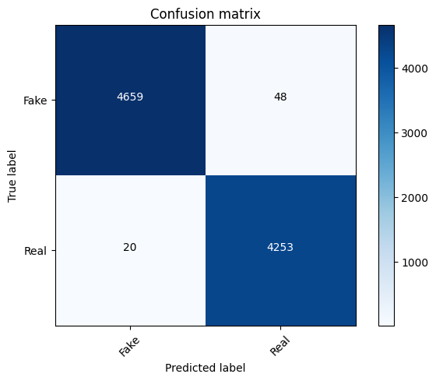

*Figure-7: Confusion Matrix of Support Vector Machine*

1. *ROC*

The figure illustrates the ROC for the logistic regression model where the true positive rate or sensitivity is a vertical access, the false positive rate or 1 specificity is a horizontal access. The curve shows clearly that the model yield high accuracy and almost arrived at the corner of the curve was and the area under the curve (AUC) was 1.00, which mean completely classify positive and negative classes as the best.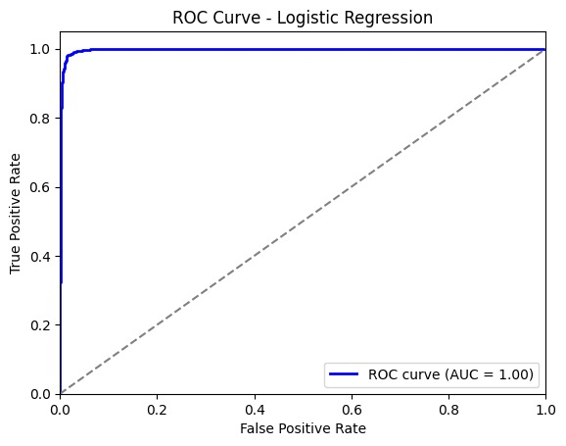 *Figure-8: ROC Curve*

1. *Precision-recall cure:*

The image shows the Probability to correctly classify the positive cases, which comes from using logistic regression model on the Precision and Recall axes. The curve demonstrates good performance and the constructed model holds very high precise at different levels of recollect. The Average Precision (AP) is also 1.00 which means that the precision is perfectly correlated to recall, meaning that the model picks of positive cases with few false positives and false negatives.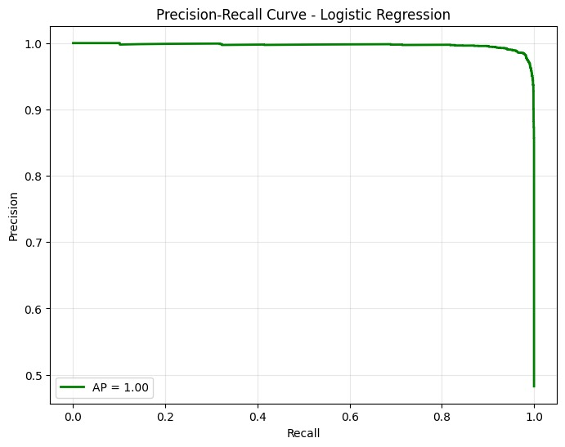

*Figure-9 Precision-Recall Curve*

## Comparative Analysis:

As a result, several disparities Common patterns for the models were identified as the major performance and suitability factors affecting fake news detection. Logistic regression gave a fairly basic and sound model but failed somewhere when there were rich, curvilinear relationships in the data. The logistic regression model detected simple patterns and scored slightly better when compared with decision trees, which overfit and, therefore, better captured complex patterns. Compared to other decision tree-based methods Random Forest was for the best, as it combines several trees to increase the accuracy of the model and at the same time lessen the danger of distortion though the usage of Random Forest is more computationally expensive than others. SVM appeared to perform best for feature space data and has generalization capability although a bit slow in computation and sensitive to the choice of function parameters. Nonetheless, the results revealed that Random Forest is more reliable in fake news detection than other models, as it combines accuracy with stability.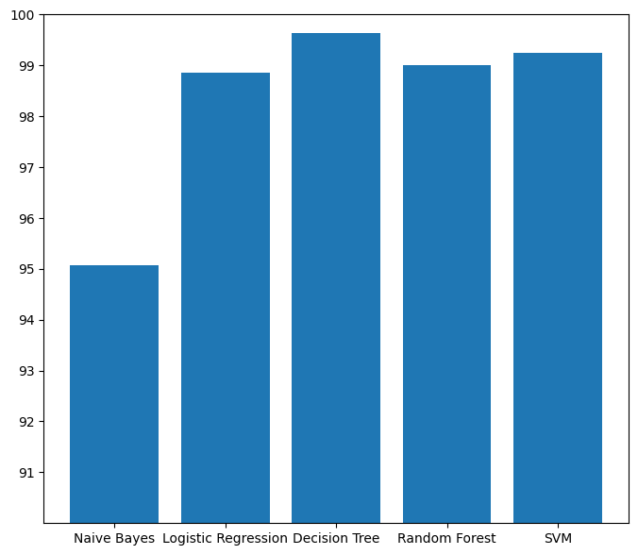

*Figure-10:Comparitive Analysis*

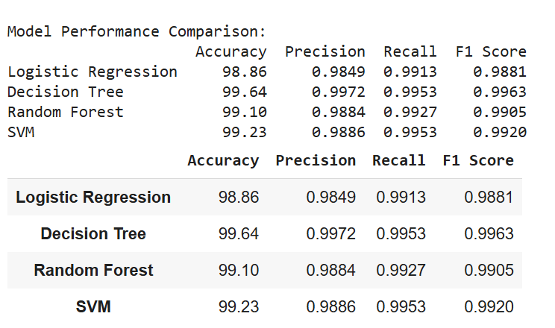

*Figure-11: Overall Metrics*

1. ALGORITHM

Step 1: Dataset Collection

Compile a dataset of news articles with corresponding labels as either "real" or "fake."

Ensure the sources are unbiased, and gather datasets from platforms like Kaggle or other public venues.

Step 2: Data Preprocessing

Delete special characters, numbers, and symbols, converting everything to the English alphabet.

Convert text to lowercase for easier comparison.

Tokenize the articles into words and eliminate stop words to retain valuable terms.

Apply stemming or lemmatization to reduce words to their root forms.

Step 3: Feature Extraction

Transform textual data into numerical features using NLP techniques:

TF-IDF: Weigh terms based on their relevance within the document and across the dataset.

Count Vectorization: Identify terms that occur at different frequencies in the articles.

Step 4: Train-Test Split

Divide the dataset into a training set (80%) and a test set (20%).

Use stratified sampling to ensure both subsets maintain the correct proportion of fake and real labels.

Step 5: Model Selection and Training

Choose machine learning models:

Logistic Regression: Baseline performance.

Decision Trees: For curved patterns that cannot be represented by straight lines.

Random Forest: For more accurate predictions using multiple decision trees.

Fit the models to the training set and optimize hyperparameters through grid search or random search.

Step 6: Model Evaluation

Evaluate each model on the test dataset using performance metrics:

Accuracy: Overall measure of classification correctness.

Precision: The ability to avoid false alarms.

Recall: The ability to identify true positives, even with false positives considered.

Validate the model using cross-validation to enhance generalization.

Step 7: Model Comparison

Compare models based on accuracy, time complexity, and interpretability.

Select the best-performing model for predicting new articles as fake or true.

Optionally, provide an interpretable feature to explain predictions, such as importance visualization.

Step 8: Fake News Prediction

Use the best model to predict whether new articles are fake or true.

Optionally, provide built-in interpretable features for explanation, such as visualizing term importance.

Step 9: Future Improvements

Enhance the model using deep learning techniques such as CNNs, RNNs, or newer Transformer models like BERT.

Capture social features such as user interaction levels and timestamps.

Extend the dataset to include audio, multilingual, or multimodal data (images/videos).

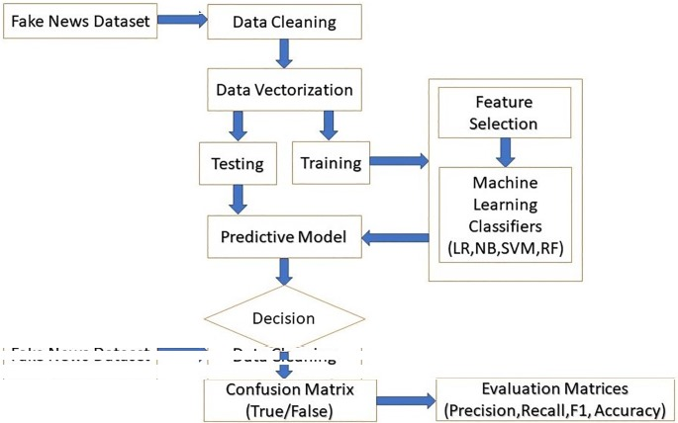

*Figure-11: Step wise Algorithm Flowchart*

1. FUTURE WORKS AND IMPROVEMENTS

The subsequent works on fake news detection might be enhanced on the following few aspects to make the model perform better and more flexible . The next direction of development is to combine deep learning models that include CNNs and RNNs and that can better capture higher levels of textual data features and contexts and, therefore, offer higher accuracy. It would be interesting to further extend the dataset by including more news articles, from greater sources, and in more languages as well as including image or video data. Besides, temporal features including the publication time, or social features including users’ engagement and sharing behavior from social media might be helpful for understanding the dissemination of fake news. The reliability of the models could further be increased by problems such as bias in datasets and class imbalance by methods such as oversampling or undersampling. Lastly, explainability suits practically all forms of models, more so, the black box classification modelsLike deep learning. There would be greater elucidation and less mystery as to predictions in additional to solution verifiability, facilitated by methods like Local Interpretable Model-Aganostic Explanations (LIME). Such improvements would serve not only for enhanced efficacy of the detection but also for the normalization of the system for other platforms and languages.

1. CONCLUSION

Therefore, this project has shown that it is possible to design a machine learning system for fake news detection with the use of features such as NLP and ensemble of machine learning models for classification. In the comparison of the methods like logistic regression, decision trees and ensemble methods, the advantages and disadvantages of each of them were discussed in detail. Logistic Regression delivered simplicity and speed, but decision trees and even more so Ensemble methods like Random Forest gave better results in terms of how they deal with different structures and deliver higher accuracy. Consequently, it appears that in future, the integration of the use of conventional machine learning models with deep learning models and social feature integration can provide increased levels of fake news detection. Despite such problems like the dataset shift, imbalanced datasets, interpretability, and scalability, this work is a driving force towards mitigating COVID-19 misinformation in the 5th generation wireless network. More population, temporal data, and copious social data are areas left to future research to enhance the reliability and effectiveness of fake news detection models that are themselves partially opaque.

IX. REFERENCES

[1] Ruchansky, N., Seo, S., & Liu, Y.,decorators-. "Csi: Fake News Detection System: A framework. Paper presented at ICDM’2017, 2017, pp. 1213-1218.

https:PAP 072 //www.ieee.org /doi.org/10.1109/ICDM.2017.121

[2] Yang, Ziyun, Yiming Zhang, and Ruslan Salakhutdinov. "Fake news detection on social media: A data mining perspective." ACM Comput. Surv., 51(4), 1 finally: The Majority-Minority Conundrum for American Higher Education: Exploring the Relationship between Race, Genetics, IQ, and Education.

https://doi.org/10.1145/3285029

[3] Liu, Yeming, Wu, Lixin & Sattar, Hashem. Smart detection of fake news using deep learning and social network features: Proposed hybrid model. Expert Systems with Applications, 159, 113687.

https:Unlike other types of VLAMs, IRS easements only require accepting a transferred easement (Dunse et al., 2012; Foreman & Parham, 2015; Foreman et al., 2013; Jog et al., 2010; Kang & Cai, 2010; Mehranfar et al., 2011; Reilly et al., 2012; Wang & Moon, 201

[4] Zhou, Xiansheng; Zafarani, Rezaencial "Fake news detection: A data mining perspective." ACM SIGKDD Explorations Newsletter 12-2009, 22(1): 1~15.

https:></sup> Therefore, in this paper we report on a study that uses both qualitative and quantitative analysis to explore the phenomenon of flexible working using the British context as the reference frame.

[5] Nakov, Peter, Alan Ritter, and Stanislav Rosenthal. Learn how to identify online news stories about crisis events. WWW 2016 Atlanta, Georgia, USA – April 11-15 2016, 839-849.

https:>10.1145/2872427.2883025

[6] Ribiero, M. T., Singh, S. & Guestrin,C., 2016 "Why should I trust you?" Methods for justifying predictions of any classifier. In the ACM SIGKDD Conference on Knowledge Discovery and Data Mining: 22-Sept., 2016: Proceedings, pp. 1135-1144.

https:Walking through 16 paper and electronic documents from both peer-reviewed journals and websites, we learnt the following: [1]

[7] Head of School & CEO, Shu, K.; Head of School & Co-founder, Sliva, A.; COO & Co-founder, Wang, S.; Director of Admissions & founding team, Tang, J.; & founding team, Liu, H. Fake News Detection on Social Media: A Data Mining Perspective. ACM SIGKDD Explorations Newsletter, 19(1), 22–36.

[8] Ruchansky N, Seo S, Liu Y. CSI: Hybrid Deep Model for Fake News Detection. , 797–806 In: Proceedings of the 2017 ACM on Conference on Information and Knowledge Management (CIKM).

[9] Zhou, Xinlei & Zafarani, Reza (2020). A Survey of Fake News: This entry presents various fundamental theories of early-stage detection, the different approaches to detection, and the challenges faced. ACM Computing Surveys (CSUR), 53(5):1-40.

,[10] Ahmed, H., Traore, I., & Saad, S. Two major studies in text classification are also related to detecting Opinion Spams and Fake News. Security and Privacy, Vol 1 No 1 e9.

[11}Blei, D. M., Ng, A. Y., & Jordan, I. (2003) Latent Dirichlet Allocation. The Journal of Machine Learning Research is published in electronic format only.

[12] Joachims, T. (1998). Text Categorization with Support Vector Machines: Learning with Many Relevant Features. Proceedings of ECML, 137-142.

[13] Breiman, L. (2001). Random Forests. Machine Learning 45(1) pp. 5-32.

[14] Quinlan, J. R. (1996). Enhancements in Continuous Modes of C4.5. Vol 4, 77-90 Journal of Artificial Intelligence Research.

[15], boiled down, states that ‘The length or number of words in a text is the best predictor of its readability.’ Efficient Estimation of Word Representations in Vector Space. arXiv preprint arXiv:1301.3781.

[16] Pennington, J. & Manning, C.D. & Socher, R. (2014). GloVe: Word vectors for the World. In proceedings of EMNLP: 1532-1543.

[17] Vaswani , A. , Shazeer, N. , Parmar, N., et al. Attention is All You Need. Continued progress in the area of Neural Information Processing Systems NeurIPS, 6000-6010.

[18] MANNING, C. D., RAGHAVAN, P. & SCHÜTZE, H (2008). Search Engines Information Retrieval: Essentials on the Basis. Cambridge University Press.

[19] Bird S, Klein E and Loper E (2009). Natural Language Processing with Python Lesson 01. O'Reilly Media.

[20] S. Hochreiter ^ D. Schmidhuber(), 1997 Long Short-Term Memory. Neural Computation: vol 9, no. 8, pp. 1735-1780.

[21] Yoshua, LeCun, Yann, Bengio, Geoffrey, Hinton. Deep Learning. Nature, 521(7553), 436-444.

[22]Devlin, J., Mengmeng Wu, K. Lee, & Toutanova (2018) BERT: ALBERT A Machine Colossal Language for Attempting massive multi-task training Reply Pre-training of Deep Bidirectional Transformers for Language Understanding NAACL-HLT, 4171-4186.

[23] Kim, Y. (2014). Application of Convolutional Neural Networks in Sentence Classification. In: EMNLP. pp 1746–1751.

[24[ Vosoughi, S., Roy, D., & Aral, S. (2018). Cyber Spread of True and False News. They are published in Science, 359(6380), 1146-1151.

[25] Dane, H. Allcott & Matt Gentzkow (2017). Online Media and False Information in the 2016 Presidential Election. That is why the proposed theory of collective rationality gives a more accurate understanding of decisions made by people; Journal of Economic Perspectives 31(2), 211-236.

[26]Ferrara, E. (2017). French Presidential Election on Disinformation & SBOs, 2017. First Monday, 22(8).

[27] Powers, D. M. (2011). Evaluation: From Precision, Recall and F-Measure to ROC, Informedness, Markedness & Correlation. JMLT, 2(1), pp. 37-63.

[28] Kohavi, R. (1995). A Survey on Cross Validation and Bootstrap for Accuracy Estimation and Model Selection. In: International Joint Conference on Artificial Intelligence (IJCAI), 1137-1143.

[29] Wardle, C., & Derakhshan, H.. Information Disorder: Thrust Issues in the Reformulation of an Interdisciplinary Research Agenda for Women: Toward the Development of a Gender-Related Analytical Framework for Research and Policy Analysis. Council of Europe Report.

[30] Marwick, Alexandra E.; Lewis, Rebecca A. Social Media and Fake News. Data Solicit and Society Research Institute Data and Society Research Institute.