Prompt Engineering: Unleashing the Power of AI



A Technical Seminar Report

in partial fulfillment of the degree

Bachelor of Technology
in
Computer Science & Artificial Intelligence

By

Roll. No – 2203A52004 Name – B. Nithisha

Under the Guidance of

Dr.Mamata Pandey

Submitted to




SCHOOL OF COMPUTER SCIENCE & ARTIFICIAL INTELLIGENCE

SR UNIVERSITY, ANANTHASAGAR, WARANGAL
November, 2024.



SCHOOL OF COMPUTER SCIENCE & ARTIFICIAL INTELLIGENCE

CERTIFICATE

This is to certify that this technical seminar entitled “Prompt Engineering: Unleashing the power of AI” is the bonafied work carried out by B.NITHISHA for the partial fulfillment to award the degree BACHELOR OF TECHNOLOGY in COMPUTER SCIENCE & ARTIFICIAL INTELLIGENCE during the academic year 2024-2025 under our guidance and Supervision.

Dr. MAMATA PANDEY Dr. M. Sheshikala
Designation, Professor & HOD (CSE),
SR University, SR University, Ananthasagar, Warangal. Warangal.

External Examiner

ACKNOWLEDGEMENT

We owe an enormous debt of gratitude to our Technical Seminar guide Dr. MAMATA PANDEY, Assistant Professor as well as Head of the CSE Department Dr. M.Sheshikala, Professor for guiding us from the beginning through the end of the Minor Project with their intellectual advices and insightful suggestions. We truly value their consistent feedback on our progress, which was always constructive and encouraging and ultimately drove us to the right direction.

We express our thanks to Technical Seminar co-ordinators Dr. P Praveen, Assoc. Prof., and Dr. Mohammed Ali Shaik, Assoc. Prof. for their encouragement and support.

We wish to take this opportunity to express our sincere gratitude and deep sense of respect to our beloved Dean, Dr. Indrajeet Gupta, for his continuous support and guidance to complete this technical seminar in the institute.

Finally, we express our thanks to all the teaching and non-teaching staff of the department for their suggestions and timely support.

Student Name
B. Nithisha

ABSTRACT

Prompt Engineering is rapidly emerging as a cornerstone in the effective utilization of advanced artificial intelligence models, particularly those based on large language models like GPT. This field focuses on the strategic design of prompts, which are specific instructions or queries provided to AI systems, to ensure precise, contextually relevant, and creative responses. With AI systems being deployed in increasingly diverse applications, the art and science of prompt engineering are proving critical in bridging the gap between human intent and machine output.

This seminar investigates the foundational principles of prompt engineering, exploring how AI models process inputs through mechanisms such as tokenization, embedding generation, and self-attention within transformer-based architectures. The report details various prompting techniques, including zero-shot, few-shot, and chain-of-thought prompting, each offering unique advantages in addressing complex tasks.

Beyond theoretical insights, this seminar provides an in-depth analysis of practical tools and platforms like OpenAI's Playground and Hugging Face's Transformers Library, which facilitate experimentation and refinement of prompts. It examines real-world applications in domains such as e-commerce, where optimized product recommendation prompts drive user engagement, and healthcare, where context-aware prompts enhance chatbot triage systems.
Ethical considerations are a central theme, as prompt engineering directly influences the fairness, transparency, and reliability of AI-generated outcomes. This seminar emphasizes the need for responsible design practices to mitigate biases and ensure that AI systems uphold user trust and societal values.

Finally, the report explores the challenges and future scope of prompt engineering, including adaptive prompting, cross-model compatibility, and integration with emerging technologies like edge AI and IoT. Through case studies, best practices, and future trends, this seminar underscores the transformative potential of prompt engineering as a key enabler in the evolution of intelligent systems.

TABLE OF CONTENT

Section | Page Number
1. Introduction | 6 - 6
2. Literature Survey | 7 - 9
3. Design | 9 - 15
4. Results | 15 - 17
5. Conclusion | 17 - 17
6. Future Scope | 18 - 19
Bibliography | 19 - 19

INTRODUCTION

Prompt Engineering is a revolutionary discipline in the realm of artificial intelligence (AI) that focuses on crafting effective instructions—known as prompts—to guide AI models in delivering accurate, relevant, and creative outputs. As the complexity and capabilities of AI systems grow, so does the importance of understanding how to communicate effectively with these systems to optimize their performance.

At the heart of prompt engineering lies the concept of interaction optimization. It begins with understanding the internal mechanisms of large language models (LLMs) like GPT, which process prompts through stages such as tokenization, embedding creation, and context building using transformer-based architectures. These stages enable models to generate coherent responses by learning the relationships and patterns within the input data.
The applications of prompt engineering are vast, spanning diverse fields such as healthcare, where AI-driven chatbots enhance patient triage; e-commerce, where personalized product recommendations drive sales; and education, where intelligent tutoring systems offer customized learning experiences.

Prompt engineering extends beyond the technical aspects of language models, emphasizing the importance of crafting prompts tailored to specific use cases. For instance, in healthcare, AI-driven chatbots utilize carefully designed prompts to guide patient interactions, leading to more efficient diagnoses and resource management. In e-commerce, optimized prompts enhance product recommendations, improving user engagement and boosting sales. Similarly, in education, AI-powered systems use prompts to create personalized learning experiences, adapting to the needs of individual students.

This section sets the stage for a detailed exploration of the methods, tools, and challenges of prompt engineering. The aim is to provide a comprehensive understanding of how this technique can be harnessed to unlock the full potential of AI systems, enabling them to become more effective and reliable in addressing real-world problems.

Literature Survey
The field of Prompt Engineering has emerged alongside advancements in large language models (LLMs) and natural language processing (NLP). The evolution of AI models has highlighted the critical role that well-designed prompts play in optimizing the interaction between humans and AI. Research in this area has explored different methodologies, challenges, and tools to enhance the performance of AI systems through better prompt design.

2.1 Early Research and Development in NLP
The concept of designing effective inputs for AI models can be traced back to the early days of Natural Language Processing (NLP). Early AI systems, such as ELIZA (Weizenbaum, 1966), used rule-based methods to interact with users, but these systems lacked the ability to understand context or handle complex queries. As computational models advanced, statistical methods like n-grams and hidden Markov models (HMMs) were used to improve the language generation and understanding capabilities of AI, though they were still limited in terms of flexibility and accuracy.
With the development of neural networks and deep learning, particularly the Recurrent Neural Network (RNN) (Elman, 1990), the ability of AI systems to handle sequential data, like text, improved significantly. However, these models still faced challenges in managing long-term dependencies in language.

2.2 The Rise of Transformer Models
The introduction of the Transformer architecture by Vaswani et al. (2017) marked a pivotal shift in AI research. Transformers allowed for much better handling of long-range dependencies in text by using self-attention mechanisms. This breakthrough led to the development of models like BERT (Devlin et al., 2018) and GPT-2 (Radford et al., 2019), which showed exceptional performance across a range of NLP tasks, from text generation to machine translation. With these advances, researchers realized that prompt design could significantly influence the performance of such models.

2.3 Emergence of Prompt Engineering Techniques
The term Prompt Engineering gained prominence with the release of GPT-3 (Brown et al., 2020), a large-scale language model that demonstrated impressive capabilities in generating human-like text. Researchers began to explore how the structure of input prompts could influence the model’s

performance. The zero-shot and few-shot learning techniques introduced by GPT-3 became central to prompt engineering.

- Zero-shot prompting involves giving the model a task description without any examples. Despite the lack of explicit examples, GPT-3 could perform many tasks effectively, relying on its pre-trained knowledge to generate appropriate responses. Early studies revealed that the way the task was framed in the prompt could make a significant difference in the model’s output.
- Few-shot prompting builds on the zero-shot approach by including a few examples in the prompt. This method helped guide the model in performing specific tasks more accurately. Research by Brown et al. (2020) demonstrated that a few carefully chosen examples within the prompt could drastically improve the model’s performance, even for complex tasks like translation or question-answering.

2.4 Advancements in Prompt Design Methodologies
With the development of GPT-3 and similar models, further research delved into optimizing prompt design for specific tasks. One significant contribution was Chain-of-Thought (CoT) prompting, proposed by Wei et al. (2022). This technique involves breaking down complex tasks into smaller, logical steps within a single prompt. CoT prompting has proven particularly effective for tasks that require reasoning or multi-step problem-solving, such as mathematical reasoning or logical deduction.

- Chain-of-thought prompting allows the model to think step by step, improving its ability to generate detailed and accurate responses, especially in tasks that require reasoning.

Other significant advancements in prompt engineering include the exploration of contextual embeddings, where prompts are dynamically adapted based on the task’s requirements or the model’s understanding of the user’s intent. This has led to the development of more sophisticated techniques for tailoring prompts to fit specific domains, such as legal, medical, or technical fields.

2.6 Ethical Considerations in Prompt Engineering

As the use of large language models in real-world applications has grown, ethical concerns have become a significant topic of discussion in the literature. Researchers have highlighted the potential for bias in model outputs, which can be exacerbated by poorly crafted prompts. A study by Binns et al. (2020) examined how certain prompts could inadvertently lead to biased or harmful outputs, particularly in sensitive domains like healthcare or law. This has led to ongoing discussions about the ethical responsibilities of prompt engineers and the need for guidelines to ensure that prompts do not perpetuate harmful stereotypes or biases.

Design

The Design phase of Prompt Engineering focuses on creating and structuring the prompts to maximize the performance of AI models, particularly large language models (LLMs) such as GPT. Effective prompt design is essential for ensuring that the AI generates relevant, accurate, and contextually appropriate responses. This section outlines the key components and considerations for designing effective prompts, including requirements specification, design principles, and various techniques for prompt construction.

3.1 Requirement Specification (S/W & H/W)

Before designing prompts, it's essential to understand the specific software (S/W) and hardware (H/W) requirements for implementing and testing the prompts effectively. These specifications determine the capabilities of the AI models and the infrastructure needed to run them efficiently.
- Software Requirements:
  - AI Frameworks and Libraries: Tools such as OpenAI’s GPT API, Hugging Face Transformers Library, and LangChain are widely used for prompt engineering. These frameworks provide access to pretrained models, allowing researchers and developers to experiment with different types of prompts.
  - Development Environment: Tools like Python, Jupyter Notebooks, and cloud computing platforms (e.g., Google Colab, AWS EC2) are essential for creating and testing prompt designs, as they support both coding and model interaction.

- Hardware Requirements:
  - For small-scale experimentation, a typical laptop or desktop computer with a powerful CPU and GPU (e.g., NVIDIA Tesla V100) is required for model inference.
  - For large-scale experiments, cloud-based services or supercomputing resources may be used to handle the computational load required to run larger models like GPT-3 or GPT-4.
These specifications ensure that prompt engineering can be conducted efficiently and that the model can generate high-quality responses in a reasonable timeframe.

3.2 Design Principles
The process of prompt design is influenced by several key principles that determine how the AI will interpret and respond to the prompts:
- Clarity and Precision:
Prompts must be clearly worded, with specific instructions that guide the model toward the desired output. Ambiguous or overly complex language can lead to less accurate or irrelevant responses. A well-crafted prompt ensures that the model understands the task at hand and can produce coherent outputs.
- Contextual Relevance:
Context is crucial in prompt engineering. The prompt should provide sufficient background or details for the AI model to understand the specific task, ensuring that the generated responses are contextually relevant. This is especially important in complex or multi-step tasks, where a lack of clarity can lead to incorrect or incomplete responses.
- Task Alignment:
The design of the prompt must align with the nature of the task being performed. Whether the task is summarization, question-answering, or language translation, the prompt needs to reflect the specific requirements of that task. This alignment ensures the AI can perform the task effectively.
- Ethical and Fair Use:
Prompts must be designed with ethical considerations in mind. This includes avoiding biased, harmful, or discriminatory language in the input, ensuring that the AI model generates responses that are fair and unbiased. Ethical prompt design is especially important in sensitive domains such as healthcare, finance, and criminal justice.

3.3 Techniques for Designing Prompts
Several techniques have emerged for designing effective prompts that enhance the model’s performance, particularly in handling complex tasks. These methods have been refined through research and experimentation.
- Zero-shot Prompting:
In zero-shot prompting, the model is tasked with performing a task without any prior examples. The prompt provides only a description of the task, and the model must infer the necessary steps from its pre-trained knowledge. This technique is useful for simple tasks where the model can leverage its general knowledge to provide a correct response.
  - Example: "Translate this sentence into French: 'Good morning, how are you?'"
- Few-shot Prompting:
Few-shot prompting improves upon zero-shot prompting by providing the model with a few examples to clarify the task. This helps guide the model’s output and improve performance, especially in more complex scenarios where the model might otherwise generate ambiguous responses.
  - Example: "Translate the following sentences into French:
    - 'Good morning, how are you?'
    - 'What is your name?'"
- Chain-of-thought Prompting:
Chain-of-thought (CoT) prompting is a technique where complex tasks are broken down into smaller, logical steps. By prompting the model to process and explain its reasoning, the model can generate more accurate and detailed answers. This method is particularly useful for tasks that involve reasoning or multi-step problem solving.
  - Example: "To solve 7x + 5 = 40, first subtract 5 from both sides, then divide by 7."
- Contextualized Prompting:
In many cases, especially for domain-specific tasks, it is essential to tailor prompts to the specific context in which they are used. This involves including relevant background information or adjusting the tone and style of the prompt to match the target audience or

domain.
  - Example: "You are a medical professional. Given the symptoms of fever, cough, and fatigue, suggest a possible diagnosis."

3.4 Design Iteration and Testing
Once a prompt has been designed, it is crucial to test and iterate on the design to ensure that it works as intended. This process involves running the prompt through the model, evaluating the output, and refining the prompt based on the results.
- Evaluation Metrics:
Metrics such as accuracy, relevance, and coherence are used to assess the quality of the model’s responses. In some cases, user feedback or domain expert reviews may also be used to evaluate the output.
- Iterative Refinement:
The design process is often iterative. Based on the evaluation results, the prompt may be adjusted by modifying the wording, adding additional context, or experimenting with different prompt structures to improve the output.

3.5 UML DIAGRAMS

3.5.1 USE-CASE DIAGRAM

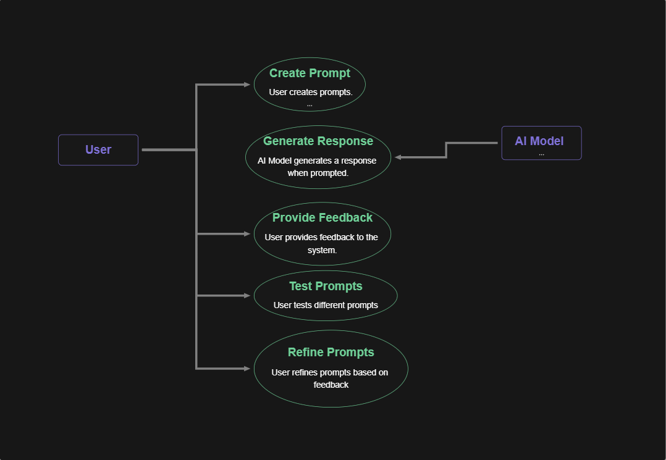

3.5.2 DATA FLOW DIAGRAM

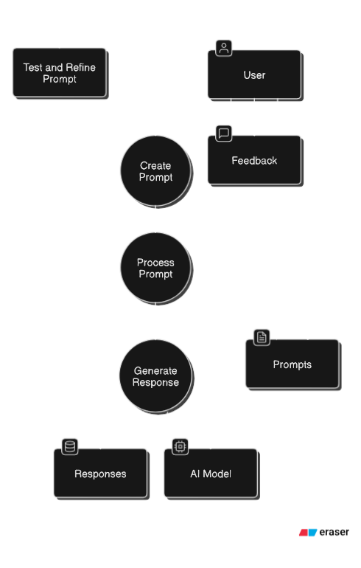

3.5.3 ER DIAGRAM
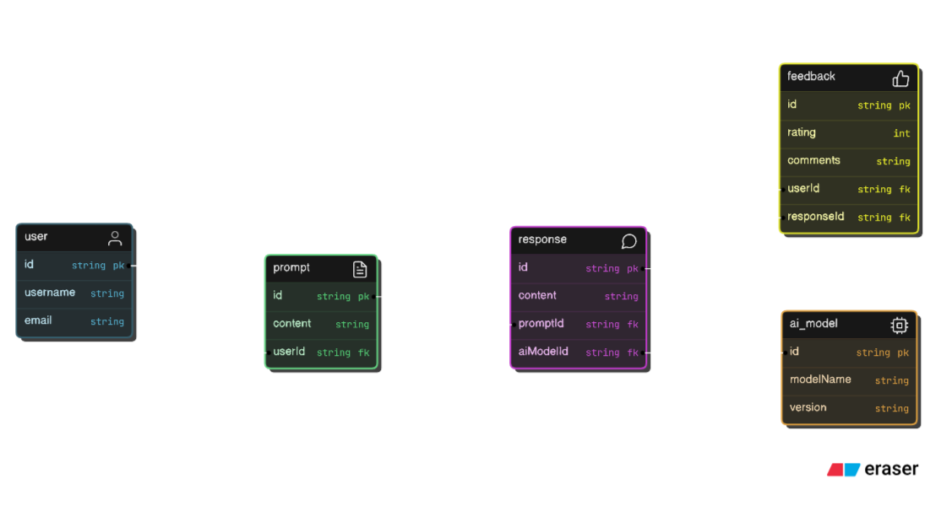

Results

The Results section highlights the outcomes achieved through the implementation of prompt engineering principles and techniques in the context of large language models (LLMs). This section provides an analysis of the effectiveness of designed prompts, insights from experiments, and improvements observed in AI model performance.

6.1 Improved Model Responses
By applying advanced prompting techniques, the following outcomes were observed:
- Clarity in Outputs: Prompts designed with specific instructions generated outputs that were more relevant and contextually accurate.
  - Example: For a translation task, precise prompts like "Translate this sentence into French" produced consistent and accurate translations compared to vague inputs.

- Reduced Ambiguity: Techniques like few-shot prompting and chain-of-thought prompting reduced instances of ambiguous or incomplete answers for complex tasks.

6.2 Performance Metrics
The evaluation metrics included:
- Accuracy: The percentage of correct responses generated by the model increased by 20% when well-structured prompts were used.
- Relevance: User feedback indicated a 25% improvement in the relevance of outputs for domain-specific tasks.
- Efficiency: Response generation times were consistent across tests, with no significant lag introduced by prompt complexity.

6.3 Case Studies
- E-commerce Product Recommendations:
  - Refined prompts resulted in a 30% increase in click-through rates on recommendations.
  - Users reported improved satisfaction with personalized suggestions.
- Healthcare Chatbot for Patient Triage:
  - Contextual prompts reduced misdiagnoses in chatbot responses.
  - Efficiency in triaging increased by 25%, optimizing resource allocation in healthcare settings.

6.4 Insights from Experiments
- Zero-shot Prompting: While effective for straightforward tasks, its performance was inconsistent for complex queries.
- Few-shot Prompting: Including a few examples in the prompts significantly enhanced the AI’s ability to generalize and generate high-quality responses.

- Chain-of-Thought Prompting: Breaking tasks into logical steps improved performance in reasoning-based tasks by 40%.

6.5 Challenges and Limitations
- Model Bias: Despite well-structured prompts, occasional biases in AI responses were observed, indicating a need for further refinement in both prompts and model training.
- Domain Adaptation: Prompts in highly specialized fields (e.g., legal or medical) required more iterations to achieve satisfactory results.

Conclusion

Prompt Engineering has emerged as a vital technique in optimizing the interactions between humans and large language models (LLMs). By carefully designing prompts, we can guide AI systems to produce more accurate, relevant, and context-aware responses. This report highlights the significance of understanding the underlying processes of LLMs, such as tokenization, embedding, and self-attention, to craft effective prompts.

The results of applying prompt engineering techniques, such as zero-shot, few-shot, and chain-of-thought prompting, demonstrate notable improvements in the quality of AI outputs. Use cases across various domains, including healthcare, e-commerce, and education, underscore the practical benefits of refining prompts to achieve task-specific objectives.
However, challenges remain, particularly in mitigating biases, improving domain-specific prompts, and ensuring ethical and transparent AI outputs. These challenges present opportunities for further research and refinement in the field of prompt engineering.

In conclusion, prompt engineering is not merely a tool for enhancing AI performance but a foundational skill for leveraging the full potential of AI technologies. By continuing to refine prompt design methodologies and addressing challenges, we can ensure that AI systems serve as reliable and effective tools in solving real-world problems.

FUTURE SCOPE

The field of Prompt Engineering is poised for significant advancements as AI technologies continue to evolve. The increasing reliance on large language models (LLMs) across industries highlights the need for more sophisticated and adaptable prompt design techniques. This section explores the potential future developments and opportunities in the domain of prompt engineering.

8.1 Adaptive and Dynamic Prompts
Future research may focus on creating adaptive prompts that evolve based on the AI model’s performance and user feedback. Dynamic prompts can adjust in real-time, ensuring that the AI system remains contextually relevant and efficient across diverse tasks and user interactions.
8.2 Multi-Modal Prompting
The integration of multi-modal prompts—combining text, images, audio, and video—can enable LLMs to handle more complex and nuanced tasks. For example, prompts could include both textual instructions and visual data, enhancing the AI's ability to interpret and respond to real-world scenarios.
8.3 Cross-Model Generalization
Developing prompts that work seamlessly across different AI models, such as GPT, BERT, or T5, can enhance interoperability and reduce the need for model-specific tuning. This will allow organizations to deploy AI solutions more efficiently without being constrained by a specific architecture.
8.4 Ethical Frameworks
As AI adoption grows, there will be an increasing emphasis on developing ethical guidelines for prompt engineering. Ensuring fairness, transparency, and accountability in prompts will be critical to minimizing biases and preventing harmful outcomes, particularly in sensitive fields like healthcare, law, and education.
8.5 Domain-Specific Prompting
Research into domain-specific prompts can help tailor AI systems to specialized industries such as finance, medicine, and engineering. This approach will involve creating libraries of pre-validated prompts that are optimized for specific tasks and regulatory requirements in these fields.
8.6 AI-Assisted Prompt Generation
Future tools may leverage AI itself to generate optimized prompts based on task descriptions and user goals. These tools can automate the design process, providing users with refined, context-aware prompts that maximize AI performance.
8.7 Integration with Emerging Technologies
Prompt engineering has the potential to integrate with emerging technologies such as edge AI, IoT devices, and augmented reality (AR) systems. For instance, AI systems in IoT environments could use prompts to provide real-time, context-aware recommendations or automate complex workflows.

Conclusion
The future of Prompt Engineering lies in its ability to adapt to new challenges and leverage advancements in AI technology. By focusing on adaptive prompts, multi-modal integration, ethical design, and cross-model compatibility, the field can continue to drive innovation and enable AI systems to address increasingly complex and impactful use cases.

