**Simulator for Human Error Prediction**

**Nithisha Boyapati**

**Abstract**

This paper describes the hybrid agent-based and system dynamics architecture of a simulation model that estimates human error probability for humans performing certain tasks in a given scenario. The Simulator for Human Error Probability (SHEP) provides a tool for estimating or predicting the probability of an error for a given scenario in an industrial system. Human reliability is estimated as a function of the tasks performed and the performance shaping factors (PSF). At the early stages in the initial state, using hierarchical task analysis technique the permit to work (PTW) was analyzed through studying the procedure and interviewing the personnel in the industry. Here, the initial sate is assumed to be done. HEP is considered as a goal and the detailed tasks in achieving the goal are analyzed. In this work, the SPAR-H reliability analysis method was applied for estimating the probability of human error.

**Keywords:** Simulation; Modeling; System Dynamics; Performance shaping factor.

1. **Introduction**

Human error is one of the many contributing causes of risk events and has been cited as the main contributing factor in accidents and disasters in industries as diverse as nuclear power. Preventing human error is usually seen as a major contribution to safety and reliability of systems. The performance of humans can be affected by many factors such as state of mind, attitude, age, emotions, physical health, errors etc. In the field of Human Reliability Analysis (HRA), the importance of modeling and simulation has been stated in various studies. The combination of human reliability analysis with modeling and simulation can address the progression and dynamic nature of human behavior in a better way than other HRA models. This model is a fusion of HRA with modeling and simulation for providing a way to estimate human error probabilities. Estimating or predicting the HEP can help in determining policies to avoid errors or reduce the likelihood of errors especially if a task is critical. Policies may include but are not limited to adding more operators to perform certain tasks, training the operator to improve his/her skills for this task, change shift or take break before a certain task.

From past years, there has been an exponential growth of interest to analyze the human operator behavior and activities for designing a better system. SHEPRA (Simulator for Human Error Probability Analysis) assesses the human reliability and uses some information in order to predict the obtained results from the work break distribution and different configurations by offering the possibility and determining the breaks for optimal configuration in terms of distribution and duration of shifts [1]. One of the first HRA method, THERP (Technique for Human Error Rate Prediction) that was developed is still valid in which the human reliability analysis is to evaluate the contribution of the operator to system reliability [2]. Over the time human reliability methods have been developed in three phases. The first phase (1970-1990) focused on operational human error and human error probability. The first phase includes 35-40 human reliability methods out of which many are single method variations [3]. Many methods like ASEP (Accident sequence Evaluation Program), THERP and HCR (Human Cognition Reliability) has the assumption that human natural deficiencies cause these methods to fail logically while performing the tasks. These methods determine HEP using expert judgement or human reliability models, established tables. The second phase (1990 – 2005) focuses on cognitive processes and human performance factors. Human performance factors influence human performance like stress, sociological issues, illness, workload, psychological issues etc. [3]. The focus of second phase has been shifted to humans’ cognitive aspects, interdependencies of PSFs [5]. CREAM (Cognitive Reliability and Error Analysis Method) contains an operator model that is less simplistic and more significant than in the first phase method [6-14]. The third phase (started in 2005) is still in progress and is represented by methods which focuses on dependencies and the relations of human performance factors. The current HRA tools of third phase are Bayesian networks and NARA (Nuclear Action Reliability Assessment).

This research focuses on the simulation of operators performing tasks in any scenario while incorporating human error estimation. A simulation model, named Simulator for Human error prediction (SHEP), has been developed for estimating the human error probability. This is hybrid a model developed in AnylogicTM and is a combination of agent-based (AB) and system dynamics (SD) models. This model reads inputs from a database and estimates the probability of the errors to occur based on the type of the task (action vs diagnosis task), human operator variability (experience) and other performance shaping factors.

1. **Background**

Human Reliability Analysis includes basis functions like identifying human errors, predicting their likelihood and reducing them if needed. The SPAR-H (Standardized plant analysis Risk-Human Reliability Analysis) method is explicitly built on the information processing model of human performance that is derived from the literature of behavioral sciences [3,9,15-21]. The main difference between two phases is due to the consideration of the impact of PSFs on the operators. For the first phase the PSFs are derived by focusing on the operator’s environmental impacts, whereas for the second phase the PSFs are derived by focusing on the operator’s cognitive impacts. In SPAR-H it is evident that its eight operational factors are associated directly with the performance of human model and display the human information processing with which they are associated. SPAR-H method assigns human activity to action or diagnosis which are one of the two general task categories. The two task types base error rates that are associated with SPAR-H method are calibrated against other methods of HRA. This calibration reveals that the SPAR-H error rates of human falls in the predicted range of the other HRA methods.

**Simulators for simulating human behavior in the field of HRA:**

* Man Machine Integration Design and Analysis System (MIDAS), is a suite of software components that are developed to aid analysts and designers for applying human performance models and human factor principles for designing complex human machine systems in the field of aviation. It also simulates the pilot’s behavior for air traffic controller or civic aviation. Here, the operator’s model is based on Rasmussen’s model [22-24].
* Cognitive Environment Simulation (CES), simulated the control room operator’s behavior in the emergency situations in a nuclear power plant. The purpose of this is to emulate the way the operators decided to respond and use the responses that are generated as a basis of quantification [25]. It is developed using programming of artificial intelligence.
* Probabilistic Cognitive Simulator (PROCOS), supports the analysis of human reliability in the context of complex operation. By means of semi static approach the standard hazard analysis has been integrated with cognitive human error analysis. By reproducing the industry operator behavior this model comprises two cognitive flow charts. This simulator allows the analysis of error recovery and error prevention [22,23].

**Problem Statement**

Based on investigations made on industrial accidents, human errors account for greater than 90% in nuclear industries, greater than 80% in chemical industries [26]. Human error is also one of the direct causes for the most shocking industrial accidents that occurred around the world such as Texaco refinery in wales (1994), Chernobyl in Ukraine (1986), Piper Alpha in United Kingdom (1988) and Bhopal in India (1984) [4]. To reduce the human errors a model has been proposed in this paper for predicting the human error probabilities using combination of system dynamics and agent-based simulation models.

1. **Objective**

Based on the above discussed challenges and issues, the following objectives are presented:

* To review the literature and determine the necessity for the Simulator for Human Error Prediction
* To develop the simulation model by considering the type of the task (action vs diagnosis task), human operator variability (experience) and other performance shaping factors.
* To investigate a scenario and provide suggestions to reduce the likelihood of errors

1. **Establishment of a simulator for human error prediction**

The main objective of this research is to develop a simulation model of individuals performing tasks in a certain scenario while accounting for error prediction. The resulting simulation model is called the simulator for human error prediction and is a model that can perform simulation tasks of an individual or operator in any context. This model is being implemented in Anylogic simulation model that has a deployment of System Dynamics (SD) and agent-based (AB). The agent-based model captures the behavior of operator whereas system dynamics estimate the errors. Combination of more than one method is expected for providing the specific characteristics of a structure and more accurate system representation.

1. **Proposed Methodology**

This model combines basic concepts of SPAR-H method, agent-based and system dynamics simulation for analyzing the human error in tasks under a certain scenario. More specially, this model incorporates the tasks that have already been decomposed using TA methods. The decomposed tasks are used as an input to the SPAR-H method for human error assessment. The steps involved in simulator development are:

* Defining the PSFs.
* Creating data base which contains the tasks and its values.
* Designing the system dynamic model
* Verify and validate the model
* Interpret the results.

|  |  |  |
| --- | --- | --- |
| **Properties** | **Definition** | **Model Variable** |
| ID | Unique identifier | *id (integer)* |
| Available Time | The time for which an operator will be available for performing the task. | *available_time (double)* |
| Stress | Stress levels of an operator during the task performance. | *stress (double)* |
| Complexity | States the complexity of a task to be performed. | *complexity (double)* |
| Experience | Experience level each operator is having while performing the task. | *experience (double)* |
| Procedure | Describes the knowledge of an operator on a specific task. | *procedure (double)* |
| Ergonomics | States the efficiency of an operator while performing the task. | *ergonomics (double)* |
| Fitness for Duty | Fitness level of an operator during the task performance. | *fitnessforduty (double)* |
| Work processes | States the process of work of an operator | *workprocesses (double)* |
| NHEP | Nominal Human Error Probability whose values are 0.01 and 0.001 | *nhep (double)* |

Table 1: Describing the eight available PSF’s for performing the task

In the initial stages, by studying various task procedures, the process of PTW was analyzed by HTA (Hierarchical task analysis) technique. With this PTW was considered as a goal and the tasks for achieving the goal are analyzed. In the later step, the SPARH analysis method was developed, applied for HEP estimation [26]. The above is a structural HRA technique used for identifying and calculating the human error probability in the described tasks. It is based on a set of performance shaping factors (PSF’s), basic nominal error rate and the dependency of error between the tasks. According to Whaley et al [4], the steps included in SPARH analysis model are

* Categorization of HFE as diagnosis or/and action.
* Rating and evaluating the PSF’s. Here all the HFE’s are calculated based on the available eight PSF’s. The corresponding PSF’s levels are chosen from the Fig 1, based on the procedure. If there is no required information available in order to provide a judgement, the PSF was assumed to be nominal.
* Calculating the HEP of modified PSF’s.

Once the levels of PSF are assigned, then the final HEP was the product of basic HEP and PSF multipliers.

$$HEP=NHEP ×PSFc$$

$$PSFc= π PSFs$$

When the action and diagnosis were combined into a single HFE, the two HEPs are separately calculated and then summed for producing the composite HEP. With at least three negative PSFs for task based on the levels of PSF, HEP is calculated using:

$$HEP=\frac{NHEP ×PSFc}{NHEP \left(PSFc-1\right)+1}$$

Where PSFc is Composite PSF, NHEP is Nominal HEP. NHEP’s for diagnostic and action are considered are 0.01 and 0.001 respectively. These nominal values are based on the rates of error for implementation of action and cognitive processing in the diagnosis activities.

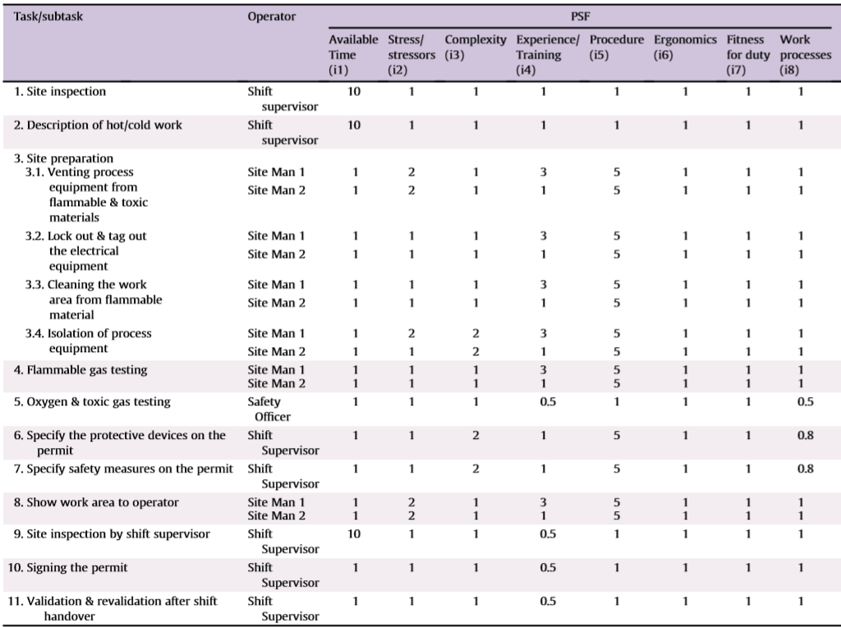

Fig 1: Related performance shaping factors in the PTW task [27]

**Flow Chart**

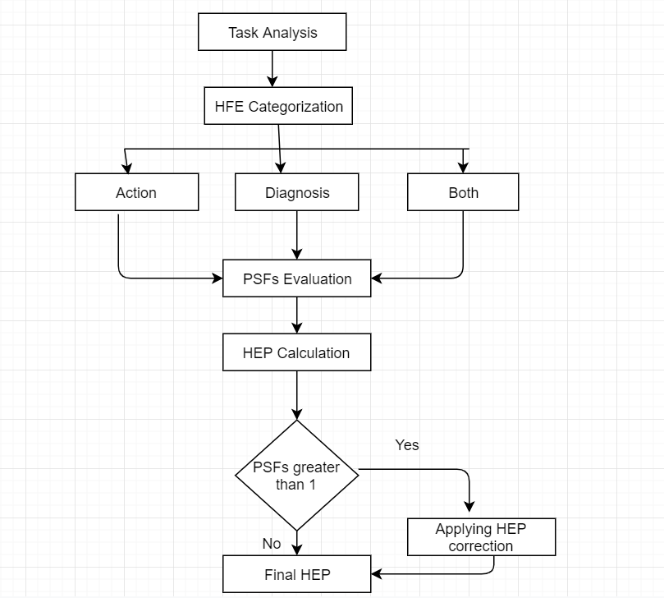

**Agent-based Simulation**

The relatively new modelling approach is Agent-based (AB) simulation which focuses on the agent’s interaction and analysis of actions over time. Agents are intelligent and autonomous constructs who have their own behavior with a set of rules and may also interact with other agents available in the environment. AB simulation allows individual modeling and for agent heterogeneity of each agent. Diversity existing between agents can be observed by individually modeling agents.

The initial step involved in the development of AB simulation is defining the behavior of an agent which is generally done by specifying a simple set of rules which agent should follow. These set of rules may represent the goals an agent should accomplish as they are very general.

AB simulation applications cover over a wide range of domains which includes understanding the behavior of consumer purchasing, modeling an agent behavior supply chains, understanding ancient civilizations fall, predicting the spread of epidemics, modeling the engagement of forces at sea or on the battlefield and many more.

**System Dynamics**

System Dynamics (SD), an approach to understand the non-linear behavior of complex systems over the time using internal feedback loops, flows, stocks, time delays and table functions. It is a mathematical modeling technique and a methodology to understand, frame and discuss complex problems and issues developed originally in 1950s for helping the corporate managers to improve their understanding of industrial process. At present it is widely used throughout private and public sectors for design and policy analysis and design. This simulation mainly involves three components:

* Stocks – represents items moving in the system.
* Casual loop diagram – specifies relationship between system variables.
* Flows – input and output stocks that refers to the change in rate of the stocks.

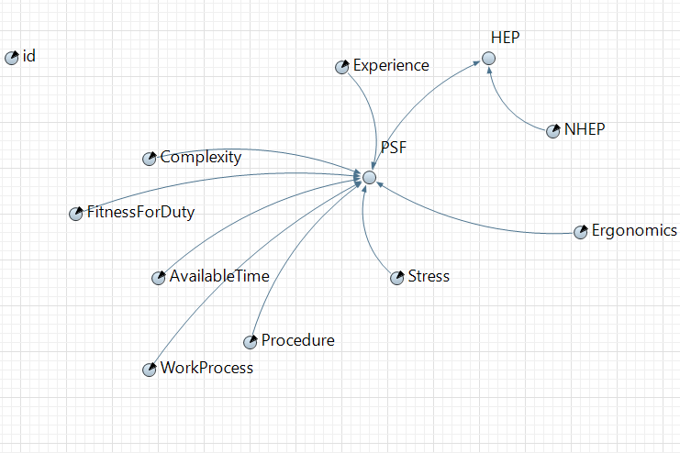

**Output**

The mean and the probability of human error in the PTW process is estimated. This model extracts the required measures for decreasing the error probabilities in PTW system by quantifying the potential human errors. Some suggestions are provided to decrease the likelihood of errors mainly in the field of modifying the performance shaping factor.

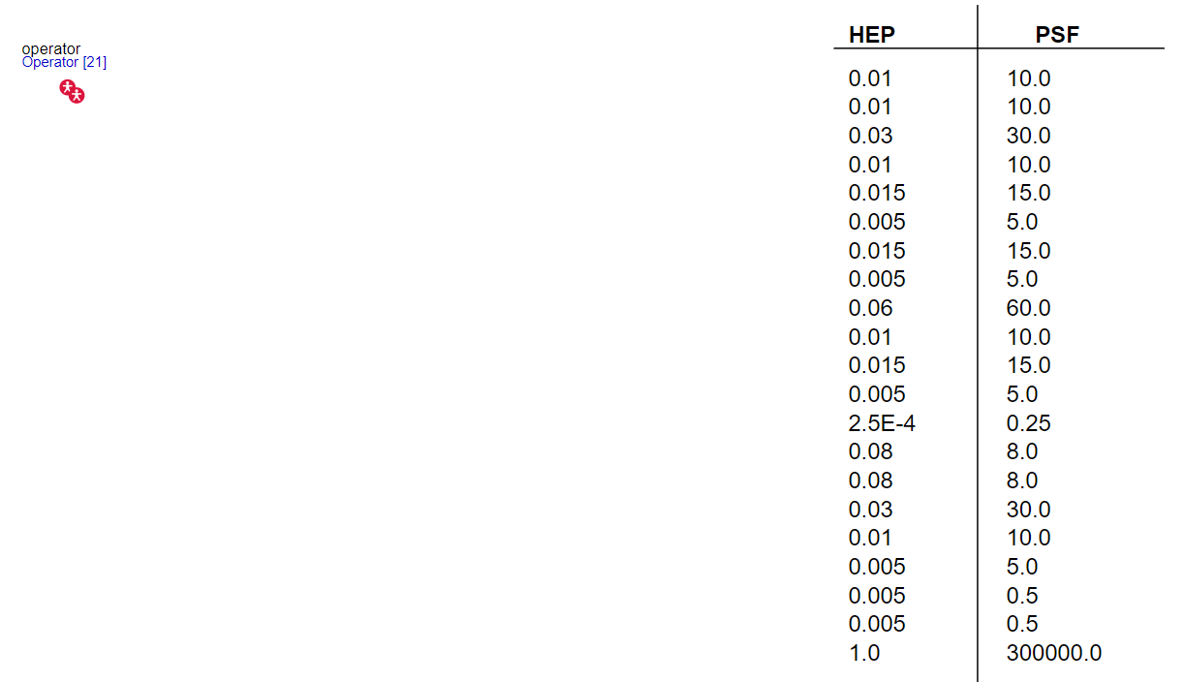

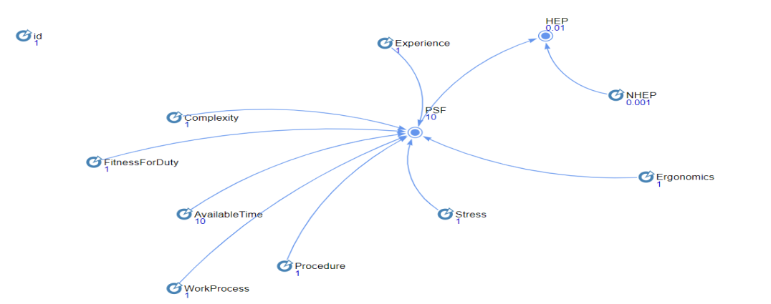

**Future Work:**

Creating an interface for the proposed model. Combine the model with the task analysis simulator. Compare the proposed model with other HRA models.

**References:**

[1] Valentina Di Pasquale*, Salvatore Mirands, Raffaele Iannone, Stefano Riemma. A Simulator for Human Error Probability Analysis (SHERPA).

[2] Kirwan B. A guide to practical human reliability assessment. London: Taylor & Francis; 1994.

[3] Calixto E, Comparing SLIM, SPAR-H and Bayesian network methologies. Open J Saf Sci Technol 2013;3:31-41.

[4] Johnson C. Why human error modeling has failed to help systems development. Interact Comput; 1999.

[5] Jannone R., Riemma S., Mirinfa S. Proposta di un modello simulative per la determinazione automatica delle pause di lavaro in attivita manifatturiere a prevalente contenuto manual. In: Atti del XXXI Convegno Nazionale Animp, Treviso; October 14-15, 2004, p. 46-60.

[6] Mandonna M, Martella G, Pichini Maini E, Monica I, Tomassini I, II fattore umano nella valutazoine dei rischi: confront metodologico fra le tecniche per l’analisi dell’affidabilita umana. Prev Oggi 2009;5:67-83.

[7] De Felice F, Romano U, Carlomusto A, Petrillo A. A review of human reliability analysis: management prectices and techniques. Glob J Manag Sci Technol 2012;1(4):131-47.

[8] Hollnagel E. Cognitive reliability and error analysis method (CREAM). Amsterdam: Elsevier; 1998.

[9] Holroyd J, Bell J. Review of human reliability assessment methods. London, UK: Health and safety Executive Research report RR679; 2009.

[10] Seong PH, Hollnagel E, Kim MC. A probabilistic approach for determining the control mode in CREAM. Reliab Eng Syst Saf 2006; 91(2):191-9.

[11] Markatos N, Kiranoudis C, Nivolianitou Z, Konstandinidou M. A fuzzy modeling application of CREAM methodology for Human Reliability Analysis. Relian Eng Syst Saf 2006;91(6):706-16.

[12] Caux C, Duriex S, Nguyen C, Schemeleva K. Human error probability computation for manufacturing system simulation using CREAM. In: Proceedings of the 9th international conference of modeling, optimization and simulation, Bordeaux, France; June 6-8, 2012.

[13] Belkacem O, Yang Z, Rochdi M, Wang J. Bayesian modelling for human error probability analysis in CREAM. In: Proceedings for the international conference on quality, reliability, risk, maintenance, and safety engineering. Xi’an, China; June 17-19, 2011.

[14] Liangfa S, Le Y, Qiang S. A novel method of analyzing quality defects due to human errors in engine assembly line. In: proceedings of the international conference on information management, innovation management and industrial engineering; October 2012. P. 154-7.

[15] Mahadevan S, Griffith CD. Inclusion of fatigue effects in Human Reliability Analysis. Reliab Eng Syst Saf 2011;96(11):1437-47.

[16] Smith C, Gertman D, Byers J, Blackman H, Marble J. The SPAR-H Human Reliability Analysis method. Washington, DC: US: Nuclear Regulatory Commission; 2005 [NUREG/CR-6883].

[17] Boring RL, Galyean WJ, Kelly DL, Whaley AM. SPARH-H step-by-step guidance. Idaho National Laboratory (United States). Funding Organization: US Department of Energy (United States); 2011.

[18] Boring RL. How many performance shaping factors are necessary for Human Reliability Analysis. In: Proceedings of the 10th international probabilistic safety assessment and management conference (PSAM10), Seattle, US; 2010.

[19] Boring RL, Blackman HS, Gertman DI. Human error quantification using performance shaping factors in SPAR-H method. In: Proceedings of the human factors and ergonomics society annual meeting. SAGE Publications; 2008: 52(21).

[20] Van de Merwe K, Gould KS, Ringstad AJ. Human Reliability Analysis in major accident risk analyses in the Norwegian petroleum industry. In: Proceedings of the human factors and ergonomics society annual meeting; 2012.

[21] Blackman HS, Boring RL. The origins of the SPAR-H method’s performance shaping factor multipliers. In :13th annual meeting on human factors and power plants and HPRCT., Sage Publications; August 2007. P. 177-84.

[22] Lava MC, Trucco P. A probabilistic cognitive simulator for HRA studies (PROCOS). Reliab Eng Syst Saf 2007;92(8):1117-1130.

[23] Grippa D, De Ambroggi M, De Garis R, Leva MC, Trucco P, et al. Quantitative analysis of ATM safety issues using retrospective accident data: The Dynamic Risk Modelling Project. Saf Sci 2009; 47:250-264.

[24] Jarvis PA, Gore BF. New integrated modelling capabilities: MIDAS’ recent Behavioral Enhancements. SAE Technical Paper; 2005.

[25] Hollnagel E. Reliability analysis and operator modelling. Reliab Eng Syst Saf 1996; 52(3):327-337.

[26] Ramondo A, De Felice F, Carlomusto A, Petrillo A. Human reliability analysis: a review of the state of the art. IRACST – Int J Res Manage Technol (IJRMT) 2012;2:35-41.

[27] Mehdi Jahangir, Naser Hoboubi, Akbar Rostamabadi, Sareh Keshavarzi, Ali Akbar Hosseini. Human Error Analysis in a Permit to Work System: A Case Study in a Chemical Plant.