**Mymovieplan**

**Table of Contents**

|  |  |
| --- | --- |
| **Topic** | **Page Number** |
| **1.0 Introduction** |  |
| * 1. **Purpose of this Document** | **3** |
| * 1. **Project Overview** | **3** |
| * 1. **Project Development Flow** | **3** |
| **2.0 FrontEnd Concepts** |  |
| [**2.1**](#_26in1rg)  **JSP** | **4** |
| [**2**](#_lnxbz9)**.2** **HTML** | **5** |
| **2.3 CSS** | **5** |
| **2.4 Bootstrap** | **5-6** |
| **2.5 JavaScript** | **6-7** |
| **2.6 Angular** | **7** |
| **3.0 BackEnd Concepts** |  |
| **3.1 Spring Boot** | **8** |
| **3.2 Hibernate** | **8-9** |
| **3.3 Servlets** | **9** |
| **4.0 Database Management** |  |
| **4.1 MySQL Server** | **9-10** |
| **5.0 Testing Concepts** |  |
| **5.1 Postman** | **10** |
| **5.2 Aws** | **10-11** |
| **5.3 Jenkins** | **11-12** |
| **4.4 Docker** | **12-13** |

# **1.Introduction**

## **Purpose of this document**

This document's objective is to describe the project's general structure, component information, methods employed, and project functioning. It is comprehensive project that aims to deliver end-to-end functionality of business application.

* 1. **Project Overview**

The Project is designed to span a number of stages, including testing, agile planning, database administration, the backend, and the frontend. The main objective of this project is to develop and construct MyMoviePlan, an online movie ticket booking platform that allows users to choose movies and afterwards reserve tickets for the desired day, time, and language. Application with two portals: an admin portal with the ability to perform CRUD Operations and disable or enable movie shows from the application, and a user portal with the ability to search for and choose their preferred movies, purchase tickets for those films, and then proceed to the payment gateway.

* 1. **Project Development Flow**

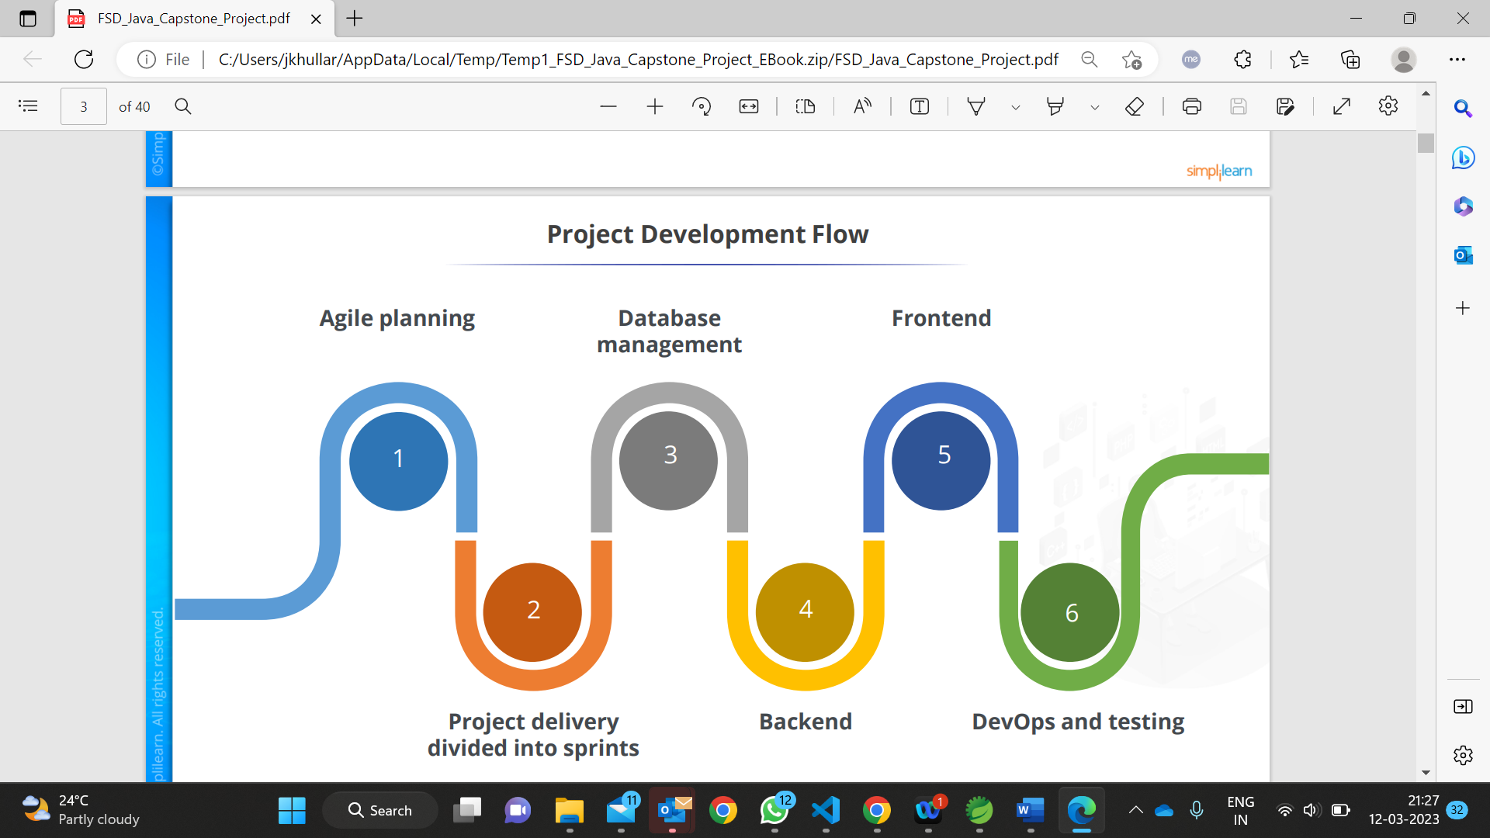

**2. FrontEnd Concepts**

# **2.1 JSP**

Java Server Pages (JSP) is a server-side programming technology that enables the creation of dynamic, platform-independent method for building Web-based applications. JSP have access to the entire family of Java APIs, including the JDBC API to access enterprise databases. A JavaServer Pages component is a type of Java servlet that is designed to fulfill the role of a user interface for a Java web application. Web developers write JSPs as text files that combine HTML or XHTML code, XML elements, and embedded JSP actions and commands.

Using JSP, you can collect input from users through Webpage forms, present records from a database or another source, and create Webpages dynamically.

JSP tags can be used for a variety of purposes, such as retrieving information from a database or registering user preferences, accessing JavaBeans components, passing control between pages, and sharing information between requests, pages etc.

**Process of Execution**

Steps for Execution of JSP are following:-

* Create html page from where request will be sent to server eg try.html.
* To handle to request of user next is to create .jsp file Eg. new.jsp
* Create project folder structure.
* Create XML file eg my.xml.
* Create WAR file.
* Start Tomcat
* Run Application

# **2.2 HTML**

**HTML** stands for**HyperText Markup Language**. It is used to design web pages using the **markup language**. HTML is the combination of **Hypertext** and **Markup language**. Hypertext defines the link between the web pages and markup language defines the text document within the tag that define the structure of web pages.

"Hypertext" refers to links that connect web pages to one another, either within a single website or between websites. Links are a fundamental aspect of the Web. By uploading content to the Internet and linking it to pages created by other people, you become an active participant in the World Wide Web.

This language is used to annotate (make notes for the computer) text so that a machine can understand it and manipulate text accordingly. Most markup languages (e.g., HTML) are human-readable. The language uses tags to define what manipulation must be done on the text.

**2.3. CSS**

**Cascading Style Sheets** (**CSS**) is a [style sheet language](https://en.wikipedia.org/wiki/Style_sheet_language) used for describing the [presentation](https://en.wikipedia.org/wiki/Presentation_semantics) of a document written in a [markup language](https://en.wikipedia.org/wiki/Markup_language) such as [HTML](https://en.wikipedia.org/wiki/HTML) or [XML](https://en.wikipedia.org/wiki/XML). CSS is designed to enable the [separation of content and presentation](https://en.wikipedia.org/wiki/Separation_of_content_and_presentation), including [layout](https://en.wikipedia.org/wiki/Page_layout), [colors](https://en.wikipedia.org/wiki/Color" \o "Color), and [fonts](https://en.wikipedia.org/wiki/Typeface).

This separation can improve content [accessibility](https://en.wikipedia.org/wiki/Accessibility); provide more flexibility and control in the specification of presentation characteristics; enable multiple [web pages](https://en.wikipedia.org/wiki/Web_page) to share formatting by specifying the relevant CSS in a separate .css file, which reduces complexity and repetition in the structural content; and enable the .css file to be [cached](https://en.wikipedia.org/wiki/Cache_(computing)) to improve the page load speed between the pages that share the file and its formatting. CSS3 is the latest version of the CSS specification.

CSS3 adds several new styling features and improvements to enhance the web presentation capabilities. A significant change in CSS3 in comparison to CSS2 is the introduction of modules. The benefit of this functionality is that it allows the specification to be finalized and accept faster, as segments are finalized and accepted in portions. Also, this allows the browser to support segments of the specification.

**2.4. BootStrap**

Bootstrap is a free and open-source tool collection for creating responsive websites and web applications. It is the most popular [HTML](https://www.geeksforgeeks.org/html/), [CSS](https://www.geeksforgeeks.org/css/), and [JavaScript](https://www.geeksforgeeks.org/javascript/) framework for developing responsive, mobile-first websites. Nowadays, the websites are perfect for all browsers (IE, Firefox, and Chrome) and for all sizes of screens (Desktop, Tablets, Phablets, and Phones).

By using this framework, we can easily manipulate the styling of any web page, like font style, text color, background color, flex, grid system, etc. Bootstrap [Vesrion 4](https://www.geeksforgeeks.org/bootstrap-4-introduction/" \t "_blank) & [Vesrion 5](https://www.geeksforgeeks.org/bootstrap-5-introduction/" \t "_blank) are the most popular versions. This framework is the most popular because of below mentioned features:

* It is Faster and Easier way for Web-Development.
* It creates Platform-independent webpages.
* It creates Responsive Webpages.
* It designs responsive web pages for mobile devices too.
* It is a free and open-source framework available on [www.getbootstrap.com](http://www.getbootstrap.com)

**2.5 JavaScript**

JavaScript is a lightweight, interpreted programming language. It is designed for creating network-centric applications. It is complimentary to and integrated with Java. JavaScript is very easy to implement because it is integrated with HTML. It is open and cross-platform.

• Javascript is the most popular programming language in the world and that makes it a programmer’s great choice. Once you learnt Javascript, it helps you developing great front-end as well as backend software’s using different Javascript based frameworks like jQuery, Node.JS etc.

• Javascript is everywhere, it comes installed on every modern web browser and so to learn Javascript you really do not need any special environment setup. For example Chrome, Mozilla Firefox , Safari and every browser you know as of today, supports Javascript.

• Javascript helps you create really beautiful and crazy fast websites. You can develop your website with a console like look and feel and give your users the best Graphical User Experience.

• JavaScript usage has now extended to mobile app development, desktop app development, and game development. This opens many opportunities for you as Javascript Programmer.

• Due to high demand, there is tons of job growth and high pay for those who know JavaScript. You can navigate over to different job sites to see what having JavaScript skills looks like in the job market.

• Great thing about Javascript is that you will find tons of frameworks and Libraries already developed which can be used directly in your software development to reduce your time to market.

**Applications of Javascript Programming**

As mentioned before, Javascript is one of the most widely used programming languages (Front-end as well as Back-end). It has its presence in almost every area of software development. I'm going to list few of them here:

**• Manipulating HTML Pages -** Javascript helps in manipulating HTML page on the fly. This helps in adding and deleting any HTML tag very easily using javascript and modify your HTML to change its look and feel based on different devices and requirements.

**• User Notifications -** You can use Javascript to raise dynamic popups on the webpages to give different types of notifications to your website visitors.

**• Back-end Data Loading -** Javascript provides Ajax library which helps in loading back-end data while you are doing some other processing. This really gives an amazing experience to your website visitors.

**• Presentations -** JavaScript also provides the facility of creating presentations which gives website look and feel. JavaScript provides RevealJS and BespokeJS libraries to build a web-based slide presentation.

**• Server Applications -** Node JS is built on Chrome's Javascript runtime for building fast and scalable network applications. This is an event-based library which helps in developing very sophisticated server applications including Web Servers.

**2.6 Angular**

Angular is an open-source, JavaScript framework written in TypeScript. Google maintains it, and its primary purpose is to develop single-page applications. As a framework, Angular has clear advantages while also providing a standard structure for developers to work with. It enables users to create large applications in a maintainable manner. JavaScript is the most commonly used client-side scripting language.

It is written into HTML documents to enable interactions with web pages in many unique ways. As a relatively easy-to-learn language with pervasive support, it is well-suited to develop modern applications. But is JavaScript ideal for developing single-page applications that require modularity, testability, and developer productivity? Perhaps not.

These days, we have a variety of frameworks and libraries designed to provide alternative solutions. With respect to front-end web development, Angular addresses many, if not all, of the issues developers face when using JavaScript on its own.

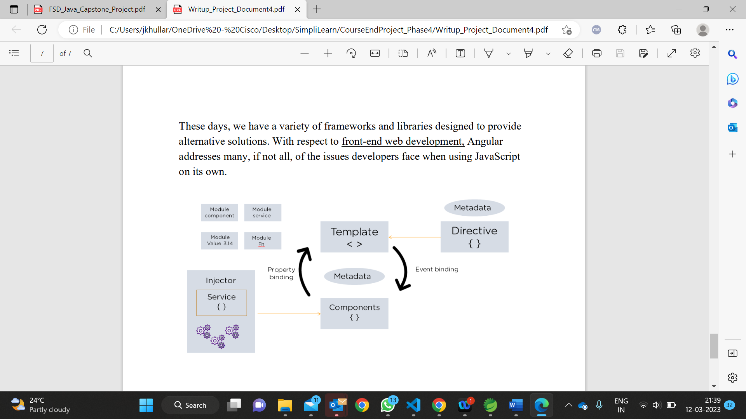

**3. BackEnd Concepts**

**3.1. Spring Boot**

Spring Boot is a project that is built on the top of the Spring Framework. It provides an easier and faster way to set up, configure, and run both simple and web-based applications. It is a Spring module that provides the **RAD (Rapid Application Development)** feature to the Spring Framework. It is used to create a stand-alone Spring-based application that you can just run because it needs minimal Spring configuration.

In Spring Boot, there is no requirement for XML configuration (deployment descriptor). It uses convention over configuration software design paradigm that means it decreases the effort of the developer. Spring Boot provides a good platform for Java developers to develop a stand-alone and production-grade spring application that you can **just run**. You can get started with minimum configurations without the need for an entire Spring configuration setup.

Spring Framework offers a dependency injection feature that lets objects define their own dependencies that the Spring container later injects into them. This enables developers to create modular applications consisting of loosely coupled components that are ideal for [microservices](https://www.ibm.com/topics/microservices) and distributed network applications.

Spring Framework also offers built-in support for typical tasks that an application needs to perform, such as data binding, type conversion, validation, exception handling, resource and event management, internationalization, and more.

**3.2 Hibernate**

Hibernate is an open source object relational mapping ([ORM](https://theserverside.techtarget.com/definition/object-relational-mapping)) tool that provides a framework to map object-oriented domain models to relational databases for web applications. Object relational mapping is based on the containerization of objects and the abstraction that provides that capacity. Abstraction makes it possible to address, access and manipulate objects without having to consider how they are related to their data sources. Hibernate maps Java classes to database tables and from Java data types to SQL data types and relieves the developer from 95% of common data persistence related programming tasks.

Hibernate sits between traditional Java objects and database server to handle all the works in persisting those objects based on the appropriate O/R mechanisms and patterns.

## **Hibernate Advantages**

* Hibernate takes care of mapping Java classes to database tables using XML files and without writing any line of code.
* Provides simple APIs for storing and retrieving Java objects directly to and from the database.
* If there is change in the database or in any table, then you need to change the XML file properties only.
* Abstracts away the unfamiliar SQL types and provides a way to work around familiar Java Objects.
* Hibernate does not require an application server to operate.
* Manipulates Complex associations of objects of your database.
* Minimizes database access with smart fetching strategies.
* Provides simple querying of data.

**3.3 Servlets**

Servlets are the Java programs that run on the Java-enabled web server or application server. They are used to handle the request obtained from the webserver, process the request, produce the response, then send a response back to the webserver.

Properties of Servlets are as follows:

* Servlets work on the server-side.
* Servlets are capable of handling complex requests obtained from the webserver.

**Execution of Servlets basically involves six basic steps:**

1. The clients send the request to the webserver.
2. The web server receives the request.
3. The web server passes the request to the corresponding servlet.
4. The servlet processes the request and generates the response in the form of output.
5. The servlet sends the response back to the webserver.
6. The web server sends the response back to the client and the client browser displays it on the screen.

**4. Database Management**

**4.1. MySql Server**

The MySQL server provides a database management system with querying and connectivity capabilities, as well as the ability to have excellent data structure and integration with many different platforms. It can handle large databases reliably and quickly in high-demanding production environments. The MySQL server also provides rich function such as its connectivity, speed, and security that make it suitable for accessing databases. MySQL is a relational database management system based on the Structured Query Language, which is the popular language for accessing and managing the records in the database.

MySQL follows the working of Client-Server Architecture. This model is designed for the end-users called clients to access the resources from a central computer known as a server using network services. Here, the clients make requests through a graphical user interface (GUI), and the server will give the desired output as soon as the instructions are matched. The process of MySQL environment is the same as the client-server model.

The core of the MySQL database is the MySQL Server. This server is available as a separate program and responsible for handling all the database instructions, statements, or commands. The working of MySQL database with MySQL Server are as follows:

1. MySQL creates a database that allows you to build many tables to store and manipulate data and defining the relationship between each table.
2. Clients make requests through the GUI screen or command prompt by using specific SQL expressions on MySQL.
3. Finally, the server application will respond with the requested expressions and produce the desired result on the client-side.

**4. Testing API**

**4.1. Postman**

Postman is an API(application programming interface) development tool which helps to build, test and modify APIs. Almost any functionality that could be needed by any developer is encapsulated in this tool. Postman is a standalone software testing API (Application Programming Interface) platform to build, test, design, modify, and document APIs. It is a simple Graphic User Interface for sending and viewing HTTP requests and responses. While using Postman, for testing purposes, one doesn't need to write any HTTP client network code. Instead, we build test suites called collections and let Postman interact with the API.

In this tool, nearly any functionality that any developer may need is embedded. This tool can make various types of HTTP requests like GET, POST, PUT, PATCH, and convert the API to code for languages like JavaScript and Python.

Postman **enables you to create and send API requests**. Send a request to an endpoint, retrieve data from a data source, or test an API's functionality. You don't need to enter commands in a terminal or write any code. Create a new request and select Send, and the API response appears right inside Postman.

**4.2 AWS**

AWS stands for Amazon Web Services. It is a cloud computing platform that provides a wide range of cloud-based services, including computing power, storage, and databases, as well as tools for analytics, machine learning, and application development.

AWS is a collection of over 200 cloud-based services that are available on-demand and can be accessed from anywhere in the world. These services include infrastructure as a service (IaaS), platform as a service (PaaS), and software as a service (SaaS)offering, providing users with a flexible, scalable, and cost-effective way to build and manage their applications and data.

AWS offers a variety of services, including compute, storage, database, networking, security, machine learning, and more. Some of the popular services include Amazon EC2 (Elastic Compute Cloud) for scalable computing capacity, Amazon S3 (Simple Storage Service) for object storage, Amazon RDS (Relational Database Service) for managed relational databases, and Amazon Lambda for serverless computing.

AWS also provides various tools and services to help manage and automate infrastructure, such as Amazon CloudFormation for infrastructure as code, AWS Elastic Beanstalk for deploying and scaling web applications, and AWS CloudTrail for logging and auditing AWS account activity. AWS is used by millions of customers around the world, including startups, enterprises, government agencies, and non-profit organizations, to build and deploy applications in the cloud, analyze data, run machine learning models, and more.

**4.3. Jenkins**

Jenkins is an open-source automation server that is used to automate the software development process. It provides a platform for Continuous Integration (CI) and Continuous Delivery (CD), which means it can automatically build, test, and deploy software changes.

Jenkins is highly extensible and offers a vast range of plugins to support the integration of different tools and technologies in the software development process. It supports a variety of programming languages and tools, including Java, C#, Ruby, Python, and more.

Jenkins works by monitoring the source code repository for changes and then triggering a build process when new changes are detected. It then builds the code, runs tests, and generates reports. If the build process is successful, Jenkins can automatically deploy the changes to production.

### **How Jenkins works**

Jenkins runs as a server on a variety of platforms including Windows, MacOS, Unix variants and especially, [Linux](https://www.techtarget.com/searchdatacenter/definition/Linux-operating-system). It requires a Java 8 VM and above and can be run on the Oracle JRE or [OpenJDK](https://www.theserverside.com/definition/OpenJDK). Usually, Jenkins runs as a Java servlet within a Jetty application server. It can be run on other Java application servers such as Apache Tomcat. More recently, Jenkins has been adapted to run in a [Docker container](https://www.techtarget.com/searchitoperations/definition/Docker). There are read-only Jenkins images available in the Docker Hub online repository.

To operate Jenkins, pipelines are created. A pipeline is a series of steps the Jenkins server will take to perform the required tasks of the CI/CD process. These are stored in a plain text Jenkinsfile. The Jenkinsfile uses a curly bracket syntax that looks similar to [JSON](https://theserverside.techtarget.com/definition/JSON-Javascript-Object-Notation). Steps in the pipeline are declared as commands with parameters and encapsulated in curly brackets. The Jenkins server then reads the Jenkinsfile and executes its commands, pushing the code down the pipeline from committed source code to production runtime. A Jenkinsfile can be created through a GUI or by writing code directly.

**4.4. Docker**

Docker is an open-source platform that allows developers to easily create, deploy, and run applications in a containerized environment. Containers are lightweight, standalone executable packages that contain everything needed to run an application, including the code, runtime, libraries, and system tools. With Docker, developers can create a container image of their application and its dependencies, which can be easily distributed and run on any system that supports Docker. This makes it much easier to move applications between different environments, such as development, testing, and production. Docker also provides a range of tools and features that make it easy to manage containers, such as Docker Compose, which allows developers to define and run multi-container applications, and Docker Swarm, which allows developers to orchestrate and scale containers across multiple hosts.

**Docker is a containerization platform that allows you to package and run applications in isolated containers. Here's how it works:**

1. **Docker architecture:** Docker is built on a client-server architecture. The Docker client communicates with the Docker daemon, which is responsible for managing the containers, images, networks, and volumes.
2. **Docker images:** Docker images are the basis of containers. An image is a read-only template with instructions on how to create a container. You can think of it as a snapshot of a container's filesystem.
3. **Docker containers:** A Docker container is a lightweight, standalone, and executable package that includes everything needed to run an application. It is created from a Docker image and can be started, stopped, moved, and deleted.
4. **Docker registries:** Docker registries are repositories for storing and distributing Docker images. Docker Hub is the most popular public registry, but you can also set up your own private registry.
5. **Dockerfile:** A Dockerfile is a text file that contains instructions on how to build a Docker image. It includes instructions for installing dependencies, configuring the environment, and running the application.
6. **Docker networking:** Docker provides a networking model that allows containers to communicate with each other and with the outside world. You can create custom networks for your containers and control how they connect to each other.
7. **Docker volumes:** Docker volumes are a way to persist data generated by containers. They are separate from the container's filesystem and can be shared between containers.