EX-9

# PROGRAM:

using System;

using System.Collections.Generic; using System.Linq;

using System.Web; using System.Web.UI;

using System.Web.UI.WebControls; using System.Data.SqlClient;

namespace ex_9_ASP

{

public partial class WebForm1 : System.Web.UI.Page

{

protected void Page_Load(object sender, EventArgs e)

{

string connetionString; SqlConnection cnn;

connetionString = @"Data Source=(localdb)\mssqllocaldb;Initial Catalog=sarvash;Integrated Security=True";

cnn = new SqlConnection(connetionString); cnn.Open();

}

protected void Button1_Click(object sender, EventArgs e)

{

insert();

}

protected void Button2_Click(object sender, EventArgs e)

{

update();

}

protected void Button3_Click(object sender, EventArgs e)

{

delete();

}

protected void Button4_Click(object sender, EventArgs e)

{

select();

}

protected void TextBox1_TextChanged(object sender, EventArgs e)

{

}

protected void TextBox2_TextChanged(object sender, EventArgs e)

{

}

public void insert()

{

string connetionString; SqlConnection cnn;

connetionString = @"Data Source=(localdb)\mssqllocaldb;Initial Catalog=sarvash;Integrated Security=True";

cnn = new SqlConnection(connetionString);

cnn.Open(); SqlCommand command; String sql;

sql = "insert into Department(Id,Dept_name) values('" + Convert.ToInt32(TextBox1.Text) + "','" + TextBox2.Text + "')";

command = new SqlCommand(sql, cnn); command.ExecuteNonQuery();

Response.Write("Record inserted successfully!!!"); cnn.Close();

}

public void select()

{

string connetionString; SqlConnection cnn;

connetionString = @"Data Source=(localdb)\mssqllocaldb;Initial Catalog=sarvash;Integrated Security=True";

cnn = new SqlConnection(connetionString); cnn.Open();

SqlCommand command; SqlDataReader dataReader; String sql, Output = " ";

sql = "Select Id,Dept_name from Department"; command = new SqlCommand(sql, cnn); dataReader = command.ExecuteReader();

while (dataReader.Read())

{

Output = Output + dataReader.GetValue(0) + "-" + dataReader.GetValue(1) + "</br>";

}

Response.Write(Output); dataReader.Close(); cnn.Close();

}

public void update()

{

string connetionString; SqlConnection cnn;

connetionString = @"Data Source=(localdb)\mssqllocaldb;Initial Catalog=sarvash;Integrated Security=True";

cnn = new SqlConnection(connetionString); cnn.Open();

SqlCommand command; String sql;

sql = "update Department set Dept_name='"+TextBox2.Text+"'where Id='"+ Convert.ToInt32(TextBox1.Text)+"'";

command = new SqlCommand(sql, cnn); command.ExecuteNonQuery();

Response.Write("Record Updated successfully!!!"); cnn.Close();

}

public void delete()

{

string connetionString; SqlConnection cnn;

connetionString = @"Data Source=(localdb)\mssqllocaldb;Initial Catalog=sarvash;Integrated Security=True";

cnn = new SqlConnection(connetionString); cnn.Open();

SqlCommand command; String sql;

sql = "delete from Department where Id='"+Convert.ToInt32(TextBox1.Text)+ "'";

command = new SqlCommand(sql, cnn);

command.ExecuteNonQuery();

Response.Write("Record Deleted successfully!!!"); cnn.Close();

}

}

}

# OUTPUT:

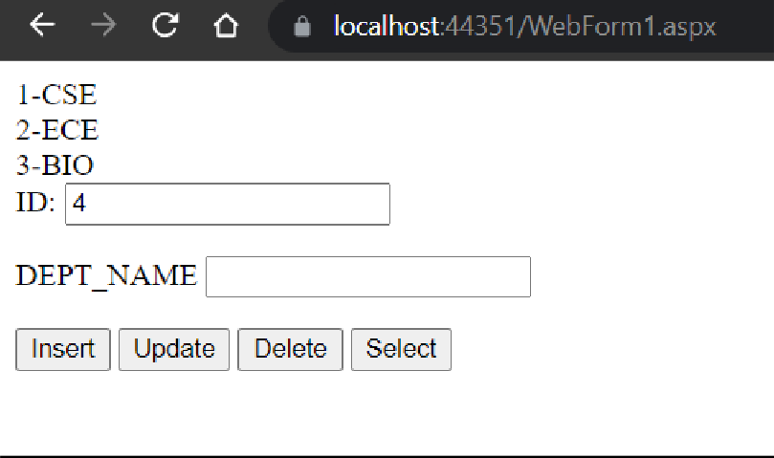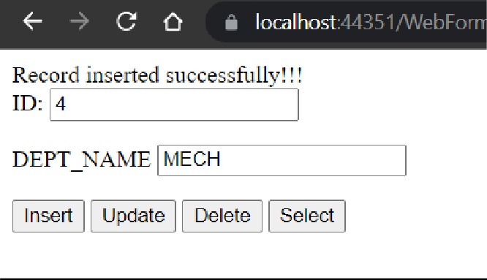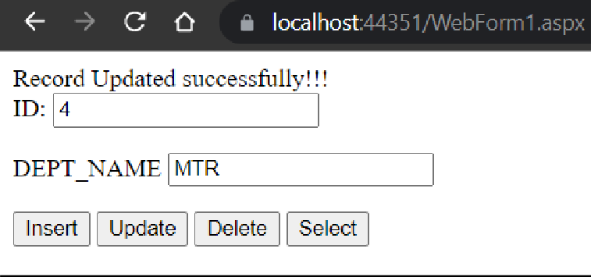



Reoord Deleted successfully!!! ID: 2

DEPT AME

' '

[ IInsert ] [ Update ] [ Delete ] [ Select ]

**dbo.Department [Data] ;:i X** WebForm1

U I **Ta**I V f Max Rows: 1000

►

|  |  |  |  |
| --- | --- | --- | --- |
|  | Id | I | Dept_narne |
| I> | 1 | CSE | |
|  | 3 | BIO | |
|  | 4 | **MTR** | |
| 0 | *NULL* | *NULL* | |