**Ex-1**

**Roll No:20ucs013 PROGRAM:**

using System; class JaggedArray {

public static void Main(string[] args) {

int[][]jagged=new int[3][]; jagged[0]=new int[2]; jagged[1]=new int[6]; jagged[2]=new int[2];

for(int i=0;i<jagged.Length;i++)

{

for(int j=0;j<jagged[i].Length;j++)

{

Console.Write("Enter the elements of row{0}, column{1} : ",i+1,j+1); jagged[i][j]=Convert.ToInt32(Console.ReadLine());

}

}

for(int i=0;i<jagged.Length;i++)

{

int sum=0;

for(int j=0;j<jagged[i].Length;j++)

{

sum+=jagged[i][j];

}

Console.WriteLine("Sum of row{0} : {1}",i+1,sum);

}

}

}

# OUTPUT:

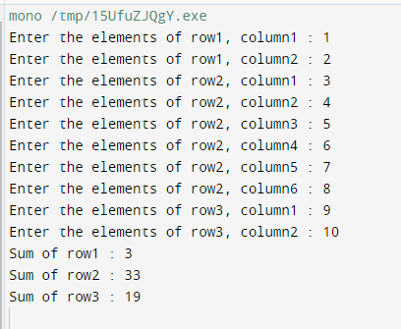

EX-2(a)

**PROGRAM:**

using System;

class swappingNumbers {

public static void Main(string[] args) { int x;

int y;

Console.Write("Enter First Number:"); x=Convert.ToInt32(Console.ReadLine()); Console.Write("Enter Second Number:"); y=Convert.ToInt32(Console.ReadLine()); Console.Write("Before Swapping:\n");

Console.WriteLine("First Number={0}\nSecond Number={1}",x,y); swap(ref x,ref y);

Console.Write("After Swapping:\n");

Console.Write("First Number={0}\nSecond Number={1}",x,y);

}

static void swap(ref int x,ref int y){ int temp;

temp=x; x=y; y=temp;

}

}

**OUTPUT:**

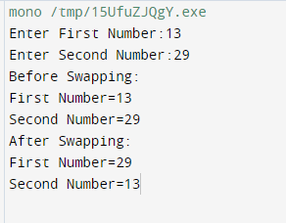

EX-2(b)

# PROGRAM:

using System;

class AreaOfTriangle {

public static void Main(string[] args) { int x;

int y; int z;

Console.Write("Enter Base Value:"); x=Convert.ToInt32(Console.ReadLine()); Console.Write("Enter Height Value:"); y=Convert.ToInt32(Console.ReadLine());

area(in x,in y,out z);

Console.Write("Area Of The Triangle is {0}",z);

}

static void area(in int x,in int y,out int z){ z=(x*y)/2;

}

}

# OUTPUT:

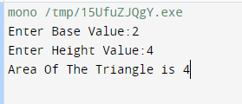

**PROGRAM:** Ex-3(A)

using System; public class Circle

{

public int radius;

public void areaOfCircle(int r)

{

radius=r;

Console.WriteLine("Area of the Circle is {0}",(3.14*r*r));

}

public void PerimeterOfCircle(int r)

{

radius=r;

Console.WriteLine("Perimeter of the Circle is {0}",(2*3.14*r));

}

}

class TestCircle

{

public static void Main(string[] args)

{

Circle c=new Circle();

Console.WriteLine("Enter the radius of the circle: "); int r=Convert.ToInt32(Console.ReadLine()); c.areaOfCircle(r);

c.PerimeterOfCircle(r);

}

}

# OUTPUT:

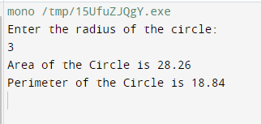

**Ex-3b RollNo:20ucs013 Program:**

using System;

public class student

{

public int roll; public string name; public int[] m;

student(int rm, string n, int[] mar)

{

roll = rm; name = n; m = mar;

}

public void showmark()

{

Console.WriteLine("Roll Number: " + roll + "\nName: " + name); Array.Sort(m);

Array.Reverse(m);

Console.WriteLine("Best Two Marks:" + m[0] + ',' + m[1]); for (int i = 0; i < m.Length; i++)

{

Console.WriteLine(m[i]);

}

double avg = (m[0] + m[1]) / 2.0; Console.WriteLine("Average of Best two marks:" + avg);

}

public static void Main(string[] args)

{

int[] arr = { 98, 95, 99 };

student cod = new student(13, "Uma Dharshini", arr); cod.showmark();

}

}

**Output:**

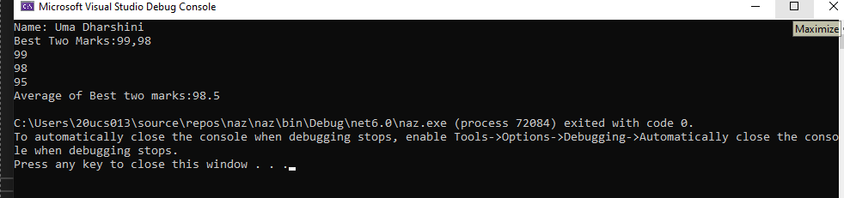

**Ex-4**

**ROllNo: 20ucs013 Program:**

using System; namespace name

{

interface Gross

{

public void Gross_sal(); double TA

{

get; set;

}

double DA

{

get; set;

}

}

class Employee

{

public string name; public int basic; public double ta, da;

public Employee(string name, int sal)

{

this.name = name; this.basic = sal;

}

public double DA

{

set

{

}

get

{

}

}

da = value;

return da;

public double TA

{

set

{

}

get

{

}

}

ta = value;

return ta;

public void basic_sal()

{

}

}

class salary : Employee, Gross

{

public int HRA;

public double gross_sal;

public salary(string name, int HRA, int salary) : base(name, salary)

{

this.HRA = HRA;

}

public void Gross_sal()

{

gross_sal = basic + HRA + TA + DA;

}

public void Disp_sal()

{

Console.WriteLine("Name: " + name); Console.WriteLine("Employees gross salary is " + gross_sal);

}

}

class main_class

{

static void Main(string[] args)

{

Console.Write("Enter the Employee name:"); string name = Console.ReadLine(); Console.Write("Enter the Basic pay:");

int sal = Convert.ToInt32(Console.ReadLine()); Console.Write("Enter the HRA:");

int hra = Convert.ToInt32(Console.ReadLine()); salary emp = new salary(name, hra, sal); emp.DA = sal * 0.1;

emp.TA = 3600 + (3600 * 17) / 100;

emp.Gross_sal(); emp.Disp_sal();

}

}

}

**Output:**

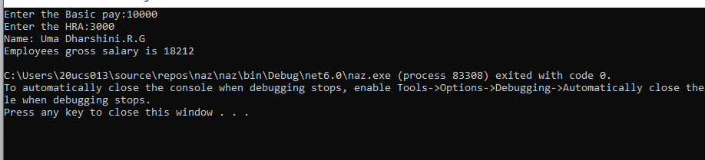

**EX-5a**

**RollNo:20ucs013 Program:**

class Program

{

static void Main()

{

Console.WriteLine("INT Number:");

int n = Convert.ToInt32(Console.ReadLine()); int[] arr = new int[n];

List<int> list = new List<int>(); for (int i = 0; i < n; i++)

{

Console.Write("{0}: ", i + 1);

arr[i] = Convert.ToInt32(Console.ReadLine()); list.Add(arr[i]);

}

ProcessItems<int>(arr); Console.WriteLine("Float Number:");

int Fn = Convert.ToInt32(Console.ReadLine()); double[] arrFloat = new double[Fn]; List<double> listFloat = new List<double>(); for (int i = 0; i < Fn; i++)

{

Console.Write("{0}: ", i + 1);

arrFloat[i] = Convert.ToDouble(Console.ReadLine()); listFloat.Add(arrFloat[i]);

}

ProcessItems<double>(arrFloat);

}

static void ProcessItems<T>(IList<T> coll)

{

dynamic sum = 0;

foreach (T item in coll)

{

sum += item;

}

System.Console.WriteLine(sum);

}

}

**Output:**

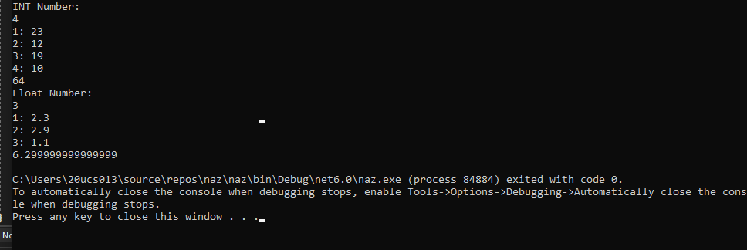

**Ex-5b RollNo:20ucs013 Program:**

using System;

public class InvalidTimeException : Exception

{

public InvalidTimeException(String message)

: base(message)

{

}

}

public class TestUserDefinedException

{

static void validate(int hrs, int mins, int secnds)

{

secnds)

}

if (hrs > 12 || mins > 60 || secnds > 60 || 0 > hrs || 0 > mins || 0 >

{

throw new InvalidTimeException("Enter a valid Time");

}

public static void Main(string[] args)

{

try

{

}

Console.Write("Hours:");

int hrs = Convert.ToInt32(Console.ReadLine()); Console.Write("Minutes:");

int mins = Convert.ToInt32(Console.ReadLine()); Console.Write("Seconds:");

int secnds = Convert.ToInt32(Console.ReadLine()); Console.WriteLine("\nTIME {0}:{1}:{2}", hrs, mins, secnds); validate(hrs, mins, secnds);

catch (InvalidTimeException e)

{

Console.WriteLine(e);

}

Console.WriteLine("Rest of the code");

}

}

**Output:**

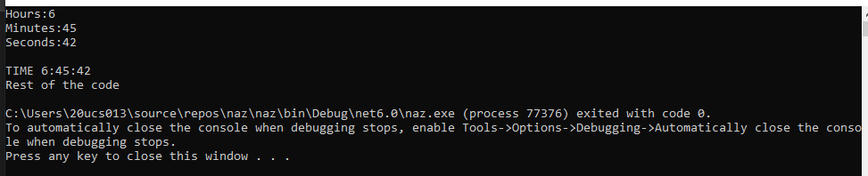

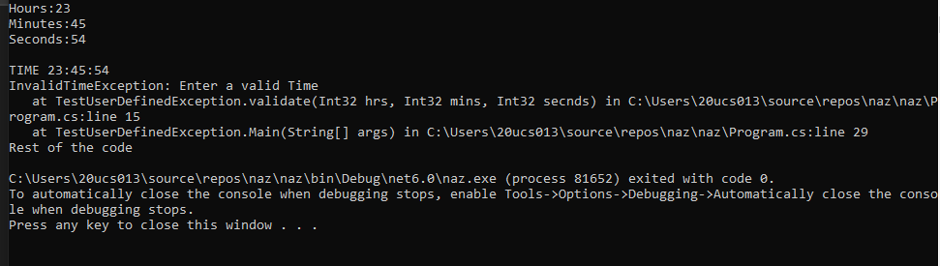

**Ex-6a RollNo:20ucs013 Program:**

using System;

class TrafficSignal

{

public static void yellow()

{

Console.WriteLine("Yellow Light Signal To Get Ready");

}

public static void Green()

{

Console.WriteLine("Green Light signal To Go");

}

public static void Red()

{

Console.WriteLine("Red Light Signal To Stop");

}

delegate void TrafficDel(); TrafficDel[] x = new TrafficDel[3]; public void IdentifySignal()

{

x[0] = new TrafficDel(yellow); x[1] = new TrafficDel(Green); x[2] = new TrafficDel(Red);

}

public void Show()

{

x[0]();

x[1]();

x[2]();

}

}

class Myclass

{

public static void Main(String[] args)

{

TrafficSignal m = new TrafficSignal(); m.IdentifySignal();

m.Show();

}

}

**Output:**

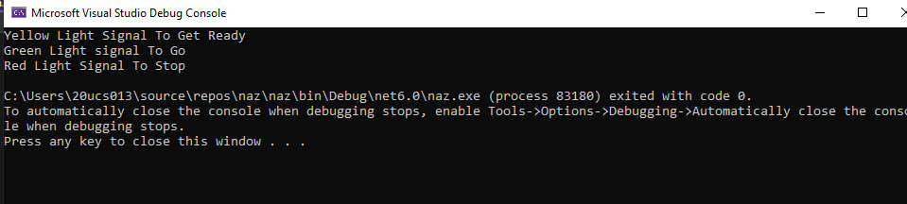

**Ex-6b RollNo:20ucs013 Program:**

public class TwoNum

{

public delegate void DelegateAdd(); public static event DelegateAdd Eadd; public static void Addprg()

{

Console.WriteLine("The Number is ODD");

}

public static void Main(string[] args)

{

Console.Write("Enter Number 1 : ");

int no1 = Convert.ToInt32(Console.ReadLine()); Console.Write("Enter Number 2 : ");

int no2 = Convert.ToInt32(Console.ReadLine()); int sum = no1 + no2;

if (sum % 2 != 0)

{

Eadd += new DelegateAdd(Addprg); Eadd.Invoke();

}

else

{

Console.WriteLine("Sum of the the numbers is " + sum);

}

}

}

**Output:**

