**Ex-4 Logistic Regression**

**Python program:**

import numpy as num

import matplotlib.pyplot as plt

import pandas as pd

from sklearn import metrics

data=pd.read_csv('logistics.csv')

x=data.iloc[:,:-1].values

y=data.iloc[:,1].values

**#model creation using liblinear**

from sklearn.linear_model import LogisticRegression

model=LogisticRegression(solver='liblinear',random_state=0)

model.fit(x,y)

**#confusion matrix**

from sklearn.metrics import classification_report,confusion_matrix

cm=confusion_matrix(y,model.predict(x))

**#classification report**

print(classification_report(y,model.predict(x)))

**#visulaization of heatmap**

fig,ax=plt.subplots(figsize=(8,8))

ax.imshow(cm)

ax.xaxis.set(ticks=(0,1),ticklabels=('Predicted 0s','Predicted 1s'))

ax.yaxis.set(ticks=(0,1),ticklabels=('Actual 0s','Actual 1s'))

for i in range(2):

for j in range(2):

ax.text(j,i,cm[i,j],ha='center',va='center',color='red')

plt.show()

**Output Figure:**

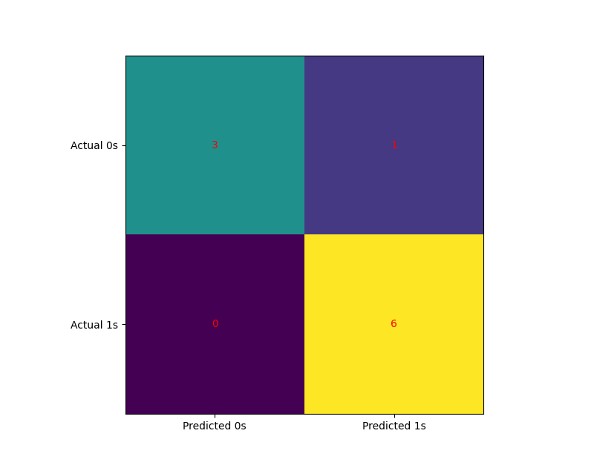

**Output:**

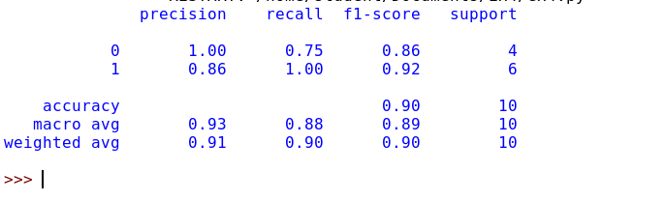

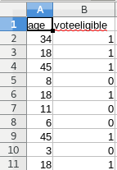**Ex: 4**

**Ex: 5**

