**Ex-5 Decision Trees Classification**

**Python program:**

import numpy as num

import matplotlib.pyplot as plt

import pandas as pd

from sklearn.tree import DecisionTreeClassifier

from sklearn.model_selection import train_test_split

from sklearn import metrics

data=pd.read_csv('decision.csv')

colnames=['RID','age','income','student','credit','buy_computer']

features=['age','income','credit']

x=data[features].values

y=data.buy_computer

xtr,xte,ytr,yte=train_test_split(x,y,test_size=0.3,random_state=0)

clf=DecisionTreeClassifier(criterion="entropy",max_depth=3)

clf=clf.fit(xtr,ytr)

ypre=clf.predict(xte)

**#confusion matrix**

from sklearn.metrics import classification_report,confusion_matrix

cm=confusion_matrix(y,clf.predict(x))

print("Confusion Matrix")

print(cm)

print("Classification Report")

print(classification_report(y,clf.predict(x)))

from sklearn import tree

plt.figure(figsize=(7,7),facecolor='w')

a=tree.plot_tree(clf,rounded=True,feature_names=features,class_names=y,filled=True,fontsize=12)

plt.show()

**Output:**

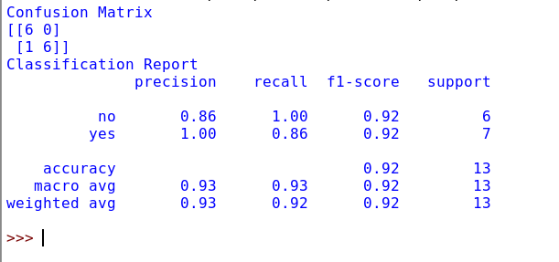

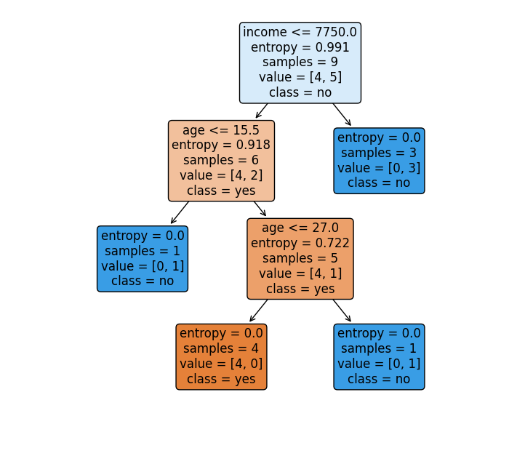**Output figure:**