**Ex-7 Naive Bayes Classification**

**Python program:**

import numpy as np

import matplotlib.pyplot as plt

import pandas as pd

from sklearn.naive_bayes import GaussianNB

from sklearn.preprocessing import LabelEncoder

from sklearn.model_selection import train_test_split

from sklearn.metrics import accuracy_score

from sklearn import metrics

data=pd.read_csv('naive.csv')

print("Before Transformation")

print(data)

**#data preprocessing convert the string into integer**

number = LabelEncoder()

data['age']=number.fit_transform(data['age'])

data['income']=number.fit_transform(data['income'])

data['student']=number.fit_transform(data['student'])

data['credit']=number.fit_transform(data['credit'])

data['buy']=number.fit_transform(data['buy'])

print("After Transformation")

print(data)

**#selected the important features**

feature=['age','income','student','credit']

x=data[feature]

y=data.buy

xtr,xte,ytr,yte=train_test_split(x,y,test_size=0.3,random_state=0)

model=GaussianNB()

model.fit(xtr,ytr)

ypre=model.predict(xte)

acc=accuracy_score(yte,ypre)

**#confusion matrix**

from sklearn.metrics import classification_report,confusion_matrix

cm=confusion_matrix(y,model.predict(x))

**#classification report**

print(classification_report(y,model.predict(x)))

**#visulaization of heatmap**

fig,ax=plt.subplots(figsize=(8,8))

ax.imshow(cm)

ax.xaxis.set(ticks=(0,1),ticklabels=('Predicted 0s','Predicted 1s'))

ax.yaxis.set(ticks=(0,1),ticklabels=('Actual 0s','Actual 1s'))

for i in range(2):

for j in range(2):

ax.text(j,i,cm[i,j],ha='center',va='center',color='red')

plt.show()

**Output figure:**

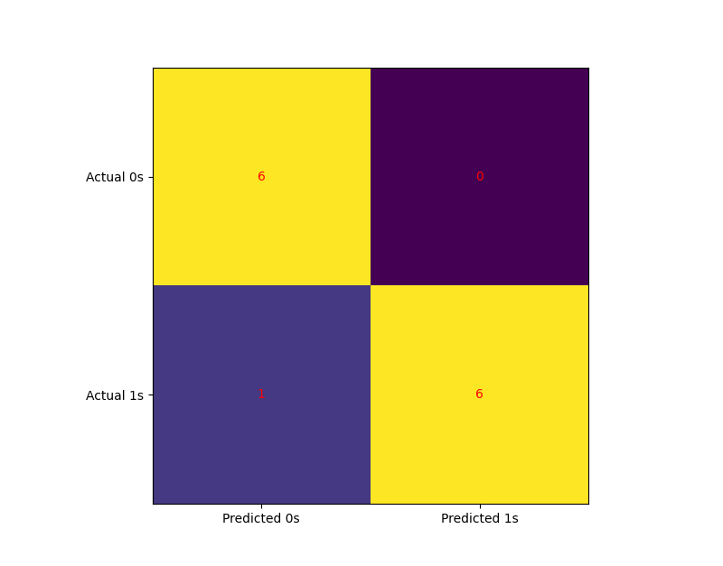

**Output:**

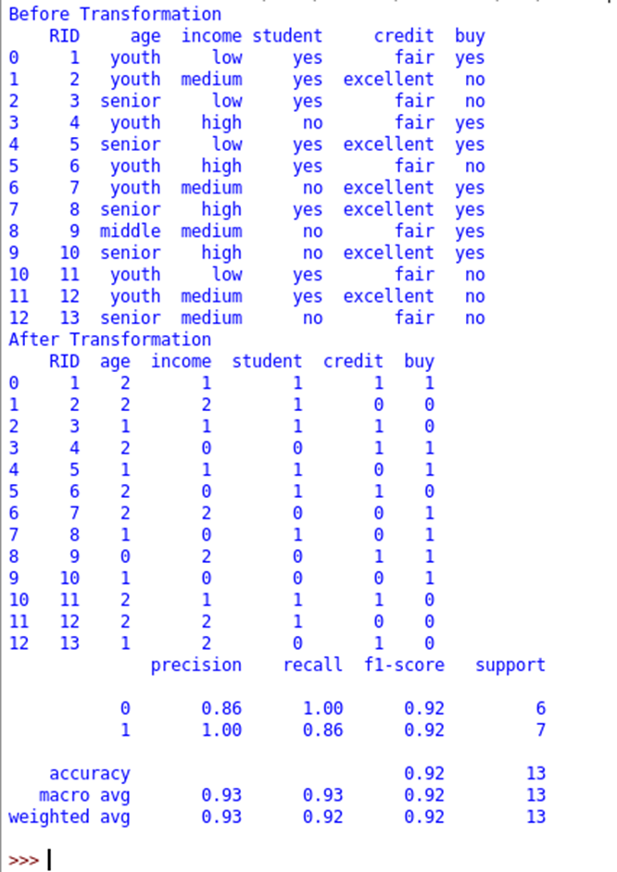

**Ex: 5**

