Name: G.R.Nithishkumar
Roll no.: 20ucs088
Ex no.: 9
Program: HTTP Web Client Program to download a web page using TCP sockets

SERVER PROGRAM:

import socket
import codecs
s = socket.socket()
port = 12044
s.bind(('localhost', port))
s.listen(5)
print('Waiting for connection..')
c, addr = s.accept()
print ('Got connection from', addr)
c.send('Thank you for connecting'.encode())
rmsg=c.recv(1024)
u=rmsg.decode()
import urllib.request,urllib.error,urllib.parse
response = urllib.request.urlopen(u)
webContent= response.read().decode('utf-8')
f = open('yahoo.html','w')
f.write(webContent)
f. close
import webbrowser
webbrowser.open("yahoo.html")
c.send(u.encode())
c.close()

CLIENT PROGRAM:

import socket
s = socket.socket()
host = socket.gethostname()
port = 12044
s.connect(('localhost', port))
print (s.recv(1024).decode())
msg=input('me:>')
s.send(msg.encode())
rmsg=s.recv(1024)
print(rmsg.decode())

SERVER OUTPUT:

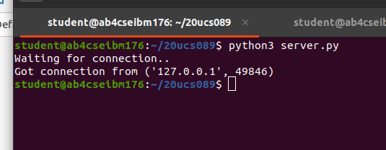

CLIENT OUTPUT:

