Name: G.R.Nithishkumar (20ucs088)
Ex12: Performance evaluation of TCP/UDP using NS2

TCP:

set ns [new Simulator]
set tracefile1 [open sk.tr w]
$ns trace-all $tracefile1
set namfile1 [open out.nam w]
$ns namtrace-all $namfile1
set n0 [$ns node]
set n1 [$ns node]
set n2 [$ns node]
set n3 [$ns node]
set n4 [$ns node]
set n5 [$ns node]
$ns duplex-link $n0 $n1 0.25Mb 50ms DropTail
$ns duplex-link $n1 $n2 0.25Mb 50ms DropTail
$ns duplex-link $n2 $n3 0.25Mb 50ms DropTail
$ns duplex-link $n3 $n4 0.25Mb 50ms DropTail
$ns duplex-link $n4 $n5 0.25Mb 50ms DropTail
$ns queue-limit $n2 $n3 20
set tcp [new Agent/TCP]
$ns attach-agent $n0 $tcp

set sink [new Agent/TCPSink]
$ns attach-agent $n5 $sink
$ns connect $tcp $sink

$tcp set packetSize 552

set ftp [new Application/FTP]
$ftp attach-agent $tcp

$ns at 0.1 "$ftp start"
$ns at 10.0 "finish"

proc finish {} {
global ns tracefile1 namfile1
$ns flush-trace
close $tracefile1
close $namfile1
exec nam out.nam &
exit 0
}
$ns run
AWK FILE:

BEGIN {
PacketRcvd=0; ftime=0; latency=0; Throughput=0.0; packet_size=0;
}

{
if(($1=="r") && ($5=="tcp"))
{
packet_size+=$6;
PacketRcvd++;
}
ftime=$2;
}
END {
Throughput=(packet_size/ftime)*(8/1000000); printf("packet received:%f\n", PacketRcvd); printf("packet size:%f\n", packet_size);
printf( "the Throughput is:%f\n",Throughput);
}

OUTPUT:

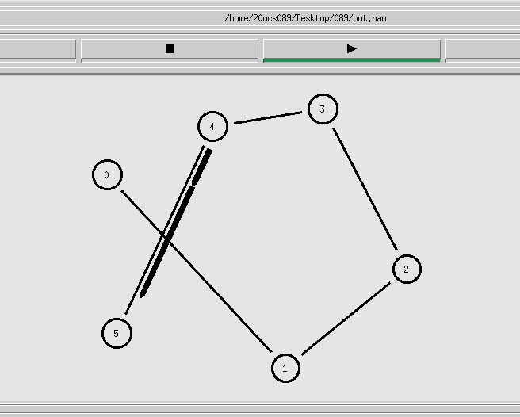

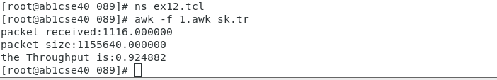

UDP:

set ns [new Simulator]
set tr [open s1.tr w]
$ns trace-all $tr
set ftr [open out1.nam w]
$ns namtrace-all $ftr
set n0 [$ns node]
set n1 [$ns node]
set n2 [$ns node]
set n3 [$ns node]
set n4 [$ns node]
$ns duplex-link $n0 $n1 2Mb 4ms DropTail
$ns duplex-link $n0 $n2 2Mb 4ms DropTail
$ns duplex-link $n0 $n3 2Mb 4ms DropTail
$ns duplex-link $n0 $n4 2Mb 4ms DropTail
set udp0 [new Agent/UDP]
set null0 [new Agent/Null]
$ns attach-agent $n0 $udp0
$ns attach-agent $n1 $null0
set cbr [new Application/Traffic/CBR]
$cbr attach-agent $udp0
$ns connect $udp0 $null0
$ns at 0.1 "$cbr start"
$ns at 2.0 "$cbr stop"
$ns at 2.3 "finish"
proc finish {} {
global ns tr ftr
$ns flush-trace
close $tr
close $ftr
exec nam out1.nam &
exit
}
$ns run

AWK FILE:

BEGIN{
PacketRcvd=0; ftime=0; Throughput=0.0; packet_size=0;
}
{
if (($1=="r") &&($5=="cbr"))
{
packet_size+=$6;
PacketRcvd++;
}
ftime=$2;
}

END{
Throughput=(packet_size/ftime)*(8/1000000);
printf("packet received:%f\n", PacketRcvd);
printf("packet size:%f\n", packet_size);
printf("the Throughput is:%f\n", Throughput);
}

OUTPUT:

