Name: G.R.Nithishkumar (20ucs088)
Ex4: Simulation of Routing Protocol using NS2

DISTANCE VECTOR ROUTING:

set ns [new Simulator]
set nf [open out.nam w]
$ns namtrace-all $nf
set tr [open out.tr w]
$ns trace-all $tr
proc finish { } {
global nf ns tr
$ns flush-trace
close $tr
exec nam out.nam &
exit 0
}

set n0 [$ns node]
set n1 [$ns node]
set n2 [$ns node]
set n3 [$ns node]
set n4 [$ns node]
set n5 [$ns node]

$ns duplex-link $n0 $n1 10Mb 10ms DropTail
$ns duplex-link $n1 $n3 10Mb 10ms DropTail
$ns duplex-link $n2 $n1 10Mb 10ms DropTail
$ns duplex-link $n2 $n4 10Mb 10ms DropTail
$ns duplex-link $n4 $n5 10Mb 10ms DropTail
$ns duplex-link $n5 $n3 10Mb 10ms DropTail

$ns duplex-link-op $n0 $n1 orient right-down
$ns duplex-link-op $n1 $n3 orient right

$ns duplex-link-op $n2 $n1 orient right-up
set tcp [new Agent/TCP]
$ns attach-agent $n0 $tcp

set ftp [new Application/FTP]

$ftp attach-agent $tcp

set sink [new Agent/TCPSink]
$ns attach-agent $n3 $sink
set udp [new Agent/UDP]
$ns attach-agent $n2 $udp

set cbr [new Application/Traffic/CBR]

$cbr attach-agent $udp
set null [new Agent/Null]
$ns attach-agent $n3 $null

$ns connect $tcp $sink

$ns connect $udp $null

$ns rtmodel-at 1.0 down $n1 $n3

$ns rtmodel-at 2.0 up $n1 $n3

$ns rtmodel-at 4.0 down $n1 $n3

$tcp set fid_ 1
$udp set fid_ 2
$ns color 1 Red
$ns color 2 Green
$ns rtproto DV
$ns at 0.5 "$ftp start"
$ns at 0.0 "$cbr start"
$ns at 5.0 "finish"
$ns run

OUTPUT:

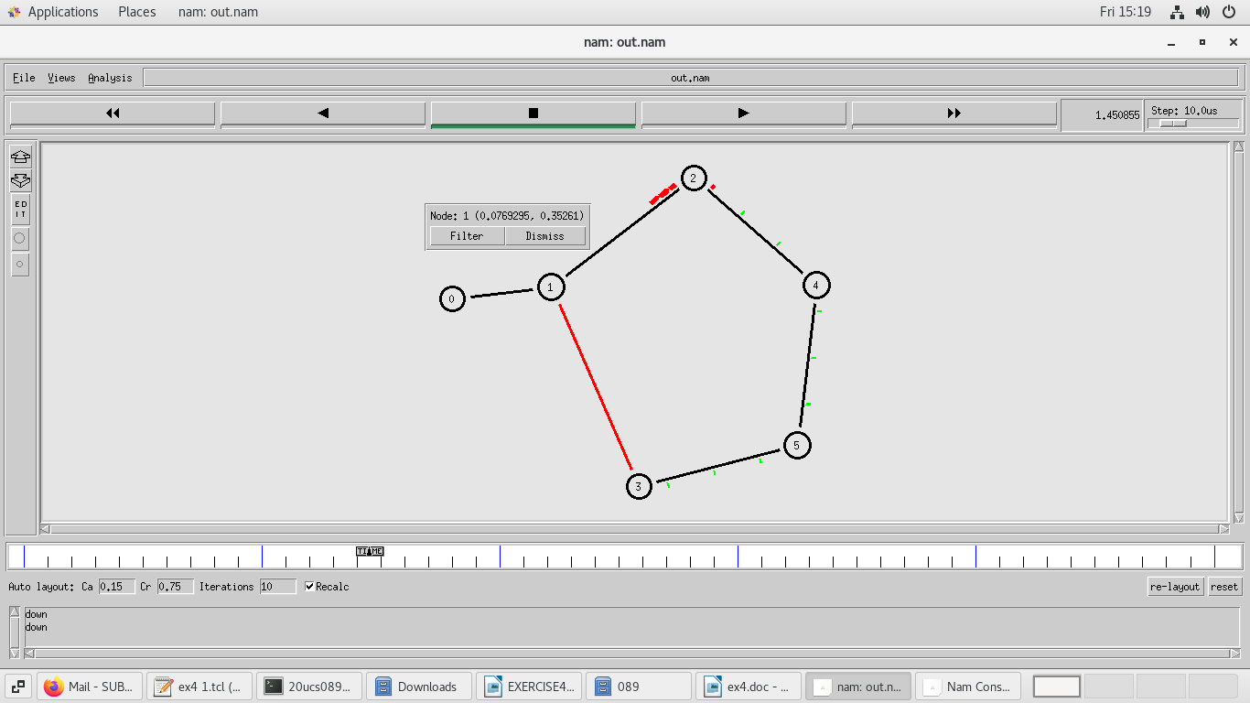

LINK STATE ROUTING:

set ns [new Simulator]
set nr [open thro.tr w]
$ns trace-all $nr
set nf [open thro.nam w]
$ns namtrace-all $nf
proc finish { } {
global ns nr nf
$ns flush-trace
close $nf
close $nr
exec nam thro.nam &
exit 0
}

for { set i 0 } { $i < 8} { incr i 1 } {
set n($i) [$ns node]}

for {set i 0} {$i < 4} {incr i} {
$ns duplex-link $n($i) $n([expr $i+1]) 1Mb 10ms DropTail }

$ns duplex-link $n(0) $n(4) 1Mb 10ms DropTail
$ns duplex-link $n(4) $n(5) 1Mb 10ms DropTail
$ns duplex-link $n(5) $n(7) 1Mb 10ms DropTail
$ns duplex-link $n(3) $n(6) 1Mb 10ms DropTail
$ns duplex-link $n(7) $n(6) 1Mb 10ms DropTail

set tcp0 [new Agent/TCP]
$ns attach-agent $n(0) $tcp0
set ftp0 [new Application/FTP]
$ftp0 set packetSize_ 500
$ftp0 set interval_ 0.005
$ftp0 attach-agent $tcp0
set sink0 [new Agent/TCPSink]
$ns attach-agent $n(4) $sink0
$ns connect $tcp0 $sink0
set udp1 [new Agent/UDP]
$ns attach-agent $n(1) $udp1
set cbr1 [new Application/Traffic/CBR]
$cbr1 set packetSize_ 500
$cbr1 set interval_ 0.005
$cbr1 attach-agent $udp1
set null0 [new Agent/Null]
$ns attach-agent $n(4) $null0
$ns connect $udp1 $null0
$ns rtproto LS
$ns rtmodel-at 10.0 down $n(3) $n(2)
$ns rtmodel-at 15.0 down $n(7) $n(6)
$ns rtmodel-at 30.0 up $n(3) $n(2)
$ns rtmodel-at 20.0 up $n(7) $n(6)
$tcp0 set fid_ 1
$udp1 set fid_ 2
$ns color 1 Red
$ns color 2 Green
$ns at 1.0 "$ftp0 start"
$ns at 2.0 "$cbr1 start"
$ns at 45 "finish"
$ns run

OUTPUT:

