**EX-3**

# Parity Server:

import socket s=socket.socket(socket.AF_INET,socket.SOCK_DGRAM) s.bind(("localhost",5000))

print("----------Server is listening ")

while True: data1,address=s.recvfrom(1024) data2,address=s.recvfrom(1024) print("client--> "+data1.decode()) msg=data1.decode() num=data2.decode()

if data1.decode()=="bye": s.sendto(msg.encode(),address) break;

elif(num=='1'):

n=msg.count('1') if n%2==0:

res="Reject" s.sendto(res.encode(),address)

else:

res="Accept" s.sendto(res.encode(),address)

elif(num=='2'):

n=msg.count('1') if n%2==0:

res="Accept" s.sendto(res.encode(),address)

else:

res="Reject" s.sendto(res.encode(),address)

s.close()

# Parity Client:

import socket import random

s=socket.socket(socket.AF_INET,socket.SOCK_DGRAM) while True:

randomnumber=random.randint(0,1) rnumber=str(randomnumber)

n=int(input("1.Odd parity\n2.Even parity\n3.Exit\nEnter your choice : ")) if(n==1):

msg=input("client--> "); num="1" msg+=rnumber print(msg)

s.sendto(msg.encode(),('localhost',5000)) s.sendto(num.encode(),('localhost',5000)) data,addr=s.recvfrom(1024) print("Answer: --> "+data.decode())

if msg=="bye": break

elif(n==2): msg=input("client--> "); num="2" msg+=rnumber print(msg)

s.sendto(msg.encode(),('localhost',5000)) s.sendto(num.encode(),('localhost',5000)) data,addr=s.recvfrom(1024) print("Answer: --> "+data.decode())

if msg=="bye": break

elif(n==3): break

print("\n\n")

s.close()

Output : Server :

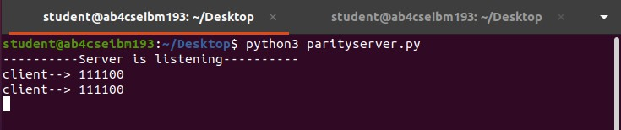

Client :

