Name: G.R.Nithishkumar

Roll no.: 20ucs088

Ex no.: 10

Program: Simulation of ARP and RARP using TCP and UDP

**TCP**

**ARP:**

**Client:**

import socket

client=socket.socket()

client.connect(('localhost',7777))

choice="Y"

while choice=="Y":

ipaddr=input("Enter the ip address: ")

client.send(ipaddr.encode())

macaddr=client.recv(1024).decode()

print("The mac address for the ip address given is",macaddr)

choice=input("Enter(Y/N): ")

if(choice=='N'):

client.send(choice.encode())

client.close()

**Output:**

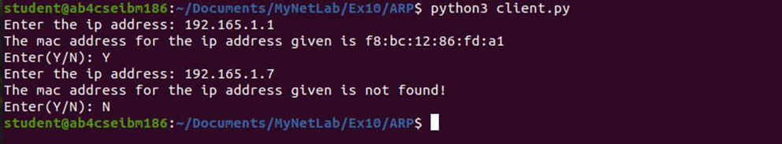

**Server:**

import socket

server=socket.socket()

server.bind(('localhost',7777))

server.listen(3)

arp_table={'192.165.1.1':'f8:bc:12:86:fd:a1','192.165.1.2':'f8:bc:12:86:fd:a2',

'192.165.1.3':'f8:bc:12:86:fd:a3','192.165.1.4':'f8:bc:12:86:fd:a4'}

print('Waiting for connection...')

conn, addr = server.accept()

print('Got connection from',addr[0])

while True:

ipaddr = conn.recv(1024).decode()

if(ipaddr=='N'):

break

macaddr=arp_table.get(ipaddr,"not found!").encode()

conn.send(macaddr)

print("the ip address is resolved and mac address is sent to client",addr[0])

conn.close()

server.close()

**Output:**



**RARP:**

**Client:**

import socket

client=socket.socket()

client.connect(('localhost',7777))

choice="Y"

while choice=="Y":

macaddr=input("Enter the mac address: ")

client.send(macaddr.encode())

ipaddr=client.recv(1024).decode()

print("The ip address for the mac address given is",ipaddr)

choice=input("Enter(Y/N): ")

if(choice=='N'):

client.send(choice.encode())

client.close()

**Output:**

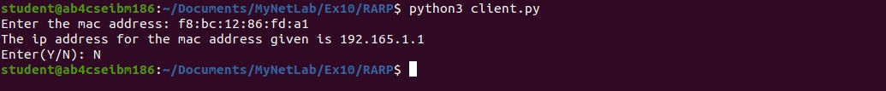

**Server:**

import socket

server=socket.socket()

server.bind(('localhost',7777))

server.listen(3)

arp_table={'f8:bc:12:86:fd:a1':'192.165.1.1','f8:bc:12:86:fd:a2':'192.165.1.2',

'f8:bc:12:86:fd: a3':'192.165.1.3','f8:bc:12:86:fd:a4':'192.165.1.4'}

conn, addr = server.accept()

print('Got connection from',addr[0])

while True:

macaddr = conn.recv(1024).decode()

if(macaddr=='N'):

break

ipaddr=arp_table.get(macaddr,"not found!").encode()

conn.send(ipaddr)

print("the mac address is resolved and ip address is sent to client",addr[0])

conn.close()

server.close()

**Output:**



**UDP**

**ARP:**

**Client:**

import socket

c=socket.socket(socket.AF_INET,socket.SOCK_DGRAM)

choice="Y"

while choice=="Y":

ip=input("Enter the ip address: ")

c.sendto(ip.encode(),("localhost",7777))

data,addr=c.recvfrom(1024)

macinfo=data.decode()

print("The mac address for the ip address given is",macinfo)

choice=input("Enter(Y/N): ")

if(choice=="N"):

c.sendto(choice.encode(),("localhost",7777)

**Output:**



**Server:**

import socket

s=socket.socket(socket.AF_INET,socket.SOCK_DGRAM)

arp_table={'192.165.1.1':'f8:bc:12:86:fd:a1','192.165.1.2':'f8:bc:12:86:fd:a2',

'192.165.1.3':'f8:bc:12:86:fd:a3','192.165.1.4':'f8:bc:12:86:fd:a4'}

s.bind(("localhost",7777))

while True:

data,addr=s.recvfrom(1024)

data=data.decode()

if(data=="N"):

break

macinfo=arp_table.get(data,"not found!").encode()

send=s.sendto(macinfo,addr)

print("the ip address is resolved and mac address is sent to client",addr[0])

s.close()

**Output:**



**RARP:**

**Client:**

import socket

c=socket.socket(socket.AF_INET,socket.SOCK_DGRAM)

choice="Y"

while choice=="Y":

mac=input("Enter the mac address: ")

c.sendto(mac.encode(),("localhost",7777))

data,addr=c.recvfrom(1024)

ipinfo=data.decode()

print("The ip address for the mac address given is",ipinfo)

choice=input("Enter(Y/N): ")

if(choice=="N"):

c.sendto(choice.encode(),("localhost",7777))

**Output:**

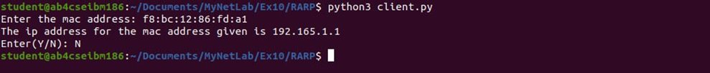

**Server:**

import socket

s=socket.socket(socket.AF_INET,socket.SOCK_DGRAM)

arp_table={'f8:bc:12:86:fd:a1':'192.165.1.1','f8:bc:12:86:fd:a2':'192.165.1.2',

'f8:bc:12:86:fd: a3':'192.165.1.3','f8:bc:12:86:fd:a4':'192.165.1.4'}

s.bind(("localhost",7777))

while True:

data,addr=s.recvfrom(1024)

data=data.decode()

if(data=="N"):

break

ipinfo=arp_table.get(data,"not found!").encode()

send=s.sendto(ipinfo,addr)

print("the mac address is resolved and ip address is sent to client",addr[0])

s.close()

**Output:**

