Name: G.R.Nithishkumar (20ucs088)

Ex11: Simulation of Congestion Control Algorithms using NS

**RING Topology**

**Program:**

set ns [new Simulator]

# To Create The Trace Files We Write

set tf [open new.tr w]

$ns trace-all $tf

# To Create the nam files we write

set nf [open new.nam w]

$ns namtrace-all $nf

# Defining the 'finish' procedure

proc finish {} {

global ns nf tf

$ns flush-trace

close $nf

close $tf

exec nam new.nam &

exit 0

}

# Create Node

set n0 [$ns node]

set n1 [$ns node]

set n2 [$ns node]

set n3 [$ns node]

set n4 [$ns node]

# Create Link between two nodes

$ns duplex-link $n0 $n1 2Mb 10ms DropTail

$ns duplex-link $n1 $n2 2Mb 10ms DropTail

$ns duplex-link $n2 $n3 2Mb 10ms DropTail

$ns duplex-link $n3 $n4 2Mb 10ms DropTail

$ns duplex-link $n4 $n1 2Mb 10ms DropTail

$ns duplex-link $n1 $n0 2Mb 10ms DropTail

# Set queue-size of the link (n1-n2) to 10

$ns queue-limit $n0 $n1 10

# Give position to the nodes in NAM

$ns duplex-link-op $n0 $n1 orient down

$ns duplex-link-op $n1 $n2 orient down

$ns duplex-link-op $n2 $n3 orient right

$ns duplex-link-op $n3 $n4 orient up

$ns duplex-link-op $n4 $n1 orient left

$ns duplex-link-op $n1 $n0 orient down

# setting a tcp connection

set tcp [new Agent/TCP]

$ns attach-agent $n0 $tcp

set sink [new Agent/TCPSink]

$ns attach-agent $n4 $sink

$ns connect $tcp $sink

$tcp set fid_ 1

$tcp set packet_Size 552

# Initiating FTP over TCP

set ftp [new Application/FTP]

$ftp attach-agent $tcp

# Setting up a UDP connection

set udp0 [new Agent/UDP]

$ns attach-agent $n0 $udp0

set null [new Agent/Null]

$ns attach-agent $n4 $null

$ns connect $udp0 $null

$udp0 set fid_ 2

# Setup cbr over udp

set cbr0 [new Application/Traffic/CBR]

$cbr0 attach-agent $udp0

$cbr0 set packet_size 1000

$cbr0 set rate 0.01Mb

$cbr0 set random false

set null0 [new Agent/Null]

$ns attach-agent $n3 $null0

$ns connect $udp0 $null0

# Scheduling the Events

$ns at 0.1 "$cbr0 start"

#$ns at 1.0 "$ftp start"

#$ns at 124.0 "$ftp stop start"

$ns at 124.5 "$cbr0 stop"

# Making the flows

$ns color 1 Blue

$ns color 2 Red

$ns color 3 Green

$ns at 0.1 "$cbr0 start"

#$ns at 0.1 "$ftp start"

$ns at 1.0 "finish"

$ns run

**Output of Ring topology:**

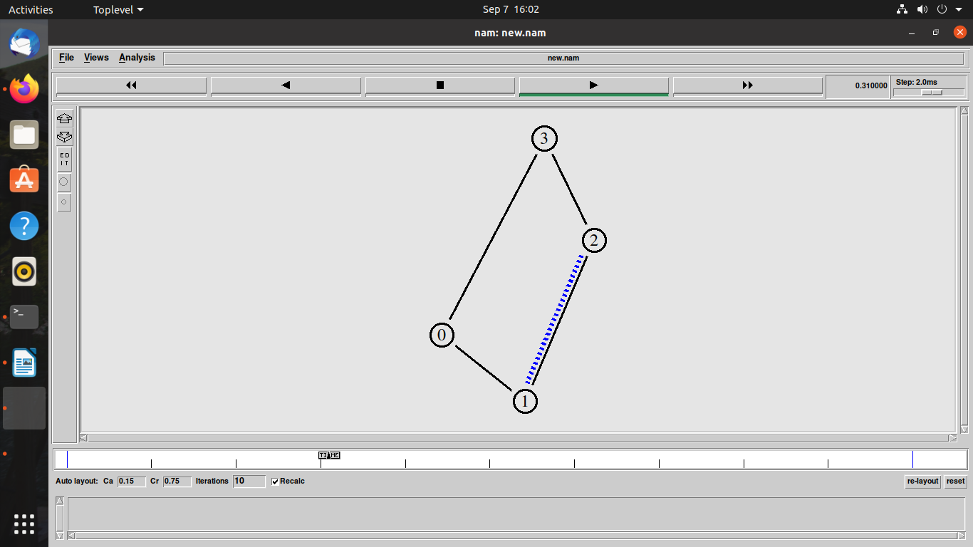

**MESH Topology**

**Program:**

set ns [new Simulator]

# To Create The Trace Files We Write

set tf [open new.tr w]

$ns trace-all $tf

# To Create the nam files we write

set nf [open new.nam w]

$ns namtrace-all $nf

# Defining the 'finish' procedure

proc finish {} {

global ns nf tf

$ns flush-trace

close $nf

close $tf

exec nam new.nam &

exit 0

}

# Create Node

set n0 [$ns node]

set n1 [$ns node]

set n2 [$ns node]

set n3 [$ns node]

set n4 [$ns node]

# Create Link between two nodes

$ns duplex-link $n0 $n1 100Mb 10ms DropTail

$ns duplex-link $n0 $n2 10Mb 10ms DropTail

$ns duplex-link $n0 $n3 10Mb 10ms DropTail

$ns duplex-link $n0 $n4 10Mb 10ms DropTail

#$ns duplex-link $n1 $n1 100Mb 10ms DropTail

$ns duplex-link $n1 $n2 10Mb 10ms DropTail

$ns duplex-link $n1 $n3 10Mb 10ms DropTail

$ns duplex-link $n1 $n4 10Mb 10ms DropTail

#$ns duplex-link $n2 $n1 100Mb 10ms DropTail

#$ns duplex-link $n2 $n2 10Mb 10ms DropTail

$ns duplex-link $n2 $n3 10Mb 10ms DropTail

$ns duplex-link $n2 $n4 10Mb 10ms DropTail

#$ns duplex-link $n3 $n1 100Mb 10ms DropTail

#$ns duplex-link $n3 $n2 10Mb 10ms DropTail

#$ns duplex-link $n3 $n3 10Mb 10ms DropTail

$ns duplex-link $n3 $n4 10Mb 10ms DropTail

#$ns duplex-link $n4 $n0 10Mb 10ms DropTail

# Set queue-size of the link (n1-n2) to 10

$ns queue-limit $n0 $n1 10

# Give position to the nodes in NAM

$ns duplex-link-op $n0 $n1 orient down

$ns duplex-link-op $n1 $n2 orient down

$ns duplex-link-op $n2 $n3 orient right

$ns duplex-link-op $n3 $n4 orient up

$ns duplex-link-op $n4 $n1 orient left

$ns duplex-link-op $n1 $n0 orient down

# setting a tcp connection

set tcp [new Agent/TCP]

$ns attach-agent $n0 $tcp

set sink [new Agent/TCPSink]

$ns attach-agent $n4 $sink

$ns connect $tcp $sink

$tcp set fid_ 1

$tcp set packet_Size 552

# Initiating FTP over TCP

set ftp [new Application/FTP]

$ftp attach-agent $tcp

# Setting up a UDP connection

set udp0 [new Agent/UDP]

$ns attach-agent $n0 $udp0

set null [new Agent/Null]

$ns attach-agent $n4 $null

$ns connect $udp0 $null

$udp0 set fid_ 2

# Setup cbr over udp

set cbr0 [new Application/Traffic/CBR]

$cbr0 attach-agent $udp0

$cbr0 set packet_size 1000

$cbr0 set rate 0.01Mb

$cbr0 set random false

set null0 [new Agent/Null]

$ns attach-agent $n3 $null0

$ns connect $udp0 $null0

# Scheduling the Events

#$ns at 0.1 "$cbr0 start"

$ns at 1.0 "$ftp start"

$ns at 124.0 "$ftp stop start"

#$ns at 124.5 "$cbr0 stop"

# Making the flows

$ns color 1 Blue

$ns color 2 Red

$ns color 3 Green

#$ns at 0.1 "$cbr0 start"

$ns at 0.1 "$ftp start"

$ns at 1.0 "finish"

$ns run

**Output Mesh topology:**

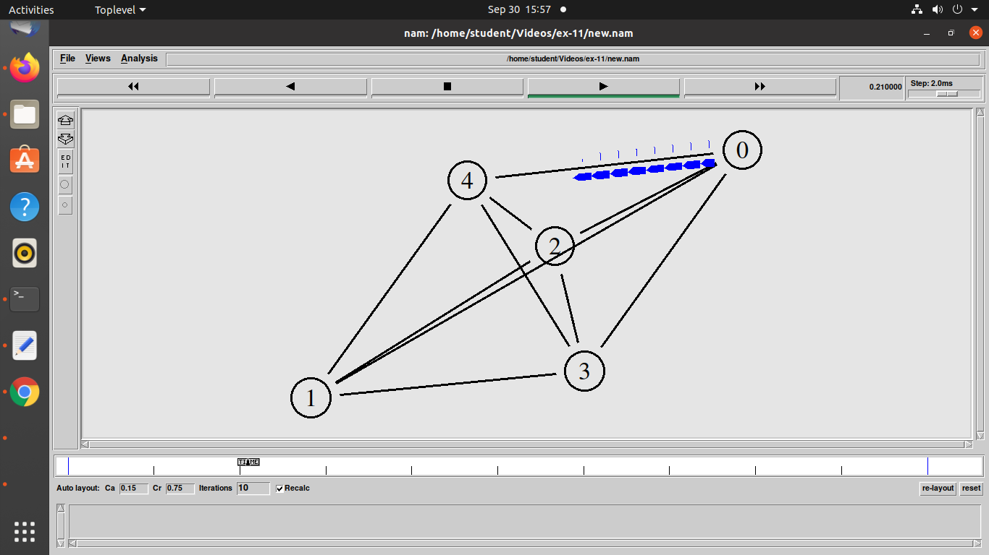

**BUS Topology**

**Program:**

set ns [new Simulator]

# To Create The Trace Files We Write

set tf [open new.tr w]

$ns trace-all $tf

# To Create the nam files we write

set nf [open new.nam w]

$ns namtrace-all $nf

# Defining the 'finish' procedure

proc finish {} {

global ns nf tf

$ns flush-trace

close $nf

close $tf

exec nam new.nam &

exit 0

}

# Create Node

set n0 [$ns node]

set n1 [$ns node]

set n2 [$ns node]

set n3 [$ns node]

set n4 [$ns node]

# Create Link between two nodes

$ns duplex-link $n0 $n1 2Mb 10ms DropTail

$ns duplex-link $n1 $n2 2Mb 10ms DropTail

$ns duplex-link $n2 $n3 2Mb 10ms DropTail

$ns duplex-link $n3 $n4 2Mb 10ms DropTail

# Set queue-size of the link (n1-n2) to 10

$ns queue-limit $n0 $n1 10

# Give position to the nodes in NAM

$ns duplex-link-op $n0 $n1 orient down

$ns duplex-link-op $n1 $n2 orient down

$ns duplex-link-op $n2 $n3 orient down

$ns duplex-link-op $n3 $n4 orient down

# setting a tcp connection

set tcp [new Agent/TCP]

$ns attach-agent $n0 $tcp

set sink [new Agent/TCPSink]

$ns attach-agent $n4 $sink

$ns connect $tcp $sink

$tcp set fid_ 1

$tcp set packet_Size 55

# Initiating FTP over TCP

set ftp [new Application/FTP]

$ftp attach-agent $tcp

# Setting up a UDP connection

set udp0 [new Agent/UDP]

$ns attach-agent $n0 $udp0

set null [new Agent/Null]

$ns attach-agent $n4 $null

$ns connect $udp0 $null

$udp0 set fid_ 2

# Setup cbr over udp

set cbr0 [new Application/Traffic/CBR]

$cbr0 attach-agent $udp0

$cbr0 set packet_size 1000

$cbr0 set rate 0.01Mb

$cbr0 set random false

set null0 [new Agent/Null]

$ns attach-agent $n3 $null0

$ns connect $udp0 $null0

# Scheduling the Events

#$ns at 0.1 "$cbr0 start"

$ns at 1.0 "$ftp start"

$ns at 124.0 "$ftp stop start"

#$ns at 124.5 "$cbr0 stop"

# Making the flows

$ns color 1 Blue

$ns color 2 Red

$ns color 3 Green

#$ns at 0.1 "$cbr0 start"

$ns at 0.1 "$ftp start"

$ns at 1.0 "finish"

$ns run

**Output of Bus topology:**

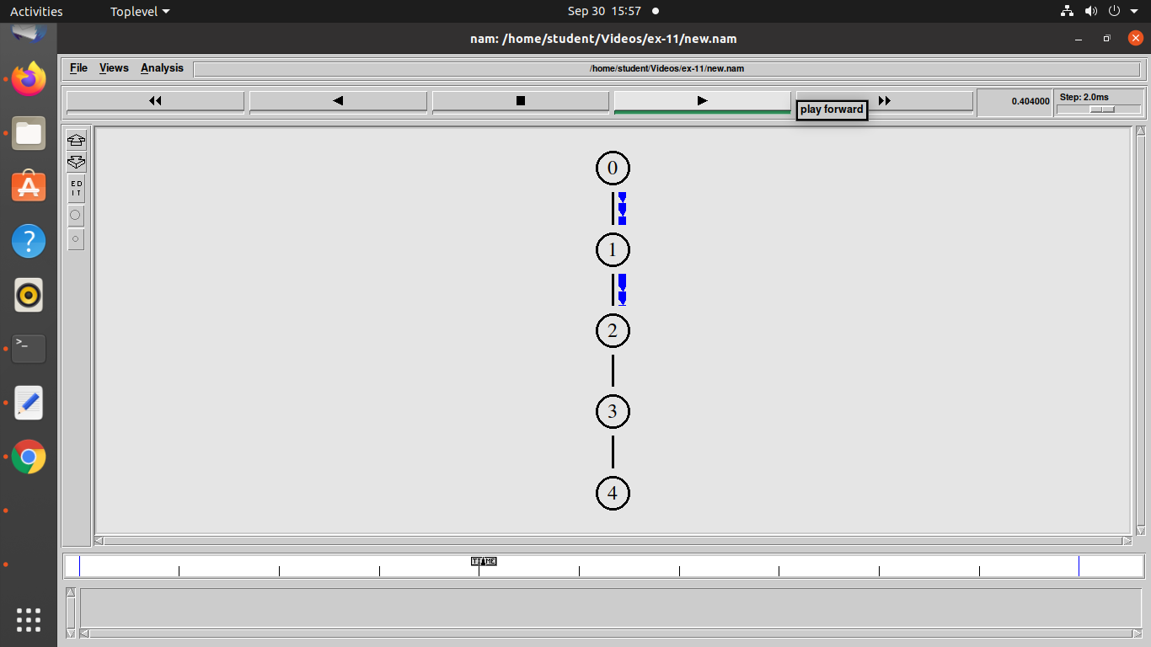

**STAR Topology**

**Program:**

set ns [new Simulator]

# To Create The Trace Files We Write

set tf [open new.tr w]

$ns trace-all $tf

# To Create the nam files we write

set nf [open new.nam w]

$ns namtrace-all $nf

# Defining the 'finish' procedure

proc finish {} {

global ns nf tf

$ns flush-trace

close $nf

close $tf

exec nam new.nam &

exit 0

}

# Create Node

set n0 [$ns node]

set n1 [$ns node]

set n2 [$ns node]

set n3 [$ns node]

set n4 [$ns node]

# Create Link between two nodes

$ns duplex-link $n0 $n1 2Mb 10ms DropTail

$ns duplex-link $n0 $n2 2Mb 10ms DropTail

$ns duplex-link $n0 $n3 2Mb 10ms DropTail

$ns duplex-link $n0 $n4 2Mb 10ms DropTail

# Set queue-size of the link (n1-n2) to 10

$ns queue-limit $n0 $n1 10

# Give position to the nodes in NAM

$ns duplex-link-op $n0 $n1 orient down

$ns duplex-link-op $n0 $n2 orient down

$ns duplex-link-op $n0 $n3 orient right

$ns duplex-link-op $n0 $n4 orient up

# setting a tcp connection

set tcp [new Agent/TCP]

$ns attach-agent $n0 $tcp

set sink [new Agent/TCPSink]

$ns attach-agent $n4 $sink

$ns connect $tcp $sink

$tcp set fid_ 1

$tcp set packet_Size 552

# Initiating FTP over TCP

set ftp [new Application/FTP]

$ftp attach-agent $tcp

# Setting up a UDP connection

set udp0 [new Agent/UDP]

$ns attach-agent $n0 $udp0

set null [new Agent/Null]

$ns attach-agent $n4 $null

$ns connect $udp0 $null

$udp0 set fid_ 2

# Setup cbr over udp

set cbr0 [new Application/Traffic/CBR]

$cbr0 attach-agent $udp0

$cbr0 set packet_size 1000

$cbr0 set rate 0.01Mb

$cbr0 set random false

set null0 [new Agent/Null]

$ns attach-agent $n3 $null0

$ns connect $udp0 $null0

# Scheduling the Events

$ns at 0.1 "$cbr0 start"

#$ns at 1.0 "$ftp start"

#$ns at 124.0 "$ftp stop start"

$ns at 124.5 "$cbr0 stop"

# Making the flows

$ns color 1 Blue

$ns color 2 Red

$ns color 3 Green

$ns at 0.1 "$cbr0 start"

#$ns at 0.1 "$ftp start"

$ns at 1.0 "finish"

$ns run

**Output of Star topology:**

