# Name: G.R.Nithishkumar (20ucs088)

# Ex13: Working with RMI using Java

# Program:

**Adder.java:**

import java.rmi.*;

public interface Adder extends Remote{

public int add(int x,int y)throws RemoteException;

}

# AdderRemote.java :

import java.rmi.*; import java.rmi.server.*;

public class AdderRemote extends UnicastRemoteObject implements Adder{ AdderRemote()throws RemoteException{

super();

}

public int add(int x,int y){return x+y;}

}

# MyServer.java :

import java.rmi.*;

import java.rmi.registry.*; public class MyServer{

public static void main(String args[]){ try{

Adder stub=new AdderRemote(); Naming.rebind("rmi://localhost:5000/sonoo",stub);

}catch(Exception e){System.out.println(e);}

}

}

# Myclient.java :

import java.rmi.*; import java.util.*; public class MyClient{

public static void main(String args[]){ try{

Adder stub=(Adder)Naming.lookup("rmi://localhost:5000/sonoo"); Scanner ta=new Scanner(System.in);

System.out.println("Enter two numbers:"); int a=ta.nextInt();

int b=ta.nextInt(); System.out.println(stub.add(a,b));

}catch(Exception e){}

}

}

# Output :

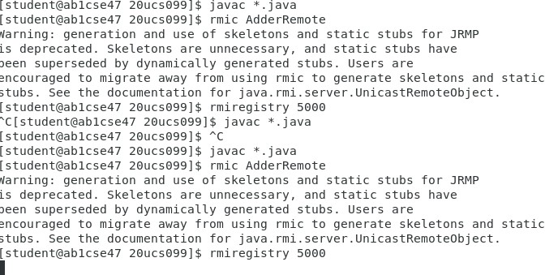

**rver :**

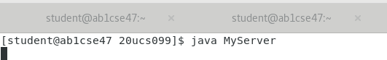

# Client :