# Name: G.R.Nithishkumar (20ucs088)

# Ex5: Performance evaluation of various protocol using simulator tool (Wire Shark)

# Distance Vector:

set ns [new Simulator] set nf [open out.nam w]

$ns namtrace-all $nf set tr [open out.tr w]

$ns trace-all $tr proc finish {} {

global nf ns tr

$ns flush-trace close $tr

exec nam out.nam & exit 0

}

set n0 [$ns node] set n1 [$ns node] set n2 [$ns node] set n3 [$ns node] set n4 [$ns node] set n5 [$ns node]

$ns duplex-link $n0 $n1 1Mb 100ms DropTail

$ns duplex-link $n1 $n3 1Mb 10ms DropTail

$ns duplex-link $n2 $n1 1Mb 10ms DropTail

$ns duplex-link $n2 $n4 1Mb 10ms DropTail

$ns duplex-link $n4 $n5 1Mb 10ms DropTail

$ns duplex-link $n5 $n3 1Mb 10ms DropTail

$ns duplex-link-op $n0 $n1 orient right-down

$ns duplex-link-op $n1 $n3 orient right

$ns duplex-link-op $n2 $n1 orient right-up set tcp [new Agent/TCP]

$ns attach-agent $n0 $tcp

set ftp [new Application/FTP]

$ftp attach-agent $tcp

set sink [new Agent/TCPSink]

$ns attach-agent $n3 $sink set udp [new Agent/UDP]

$ns attach-agent $n2 $udp

set cbr [new Application/Traffic/CBR]

$cbr attach-agent $udp set null [new Agent/Null]

$ns attach-agent $n3 $null

$ns connect $tcp $sink

$ns connect $udp $null

$ns rtmodel-at 1.0 down $n1 $n3

$ns rtmodel-at 2.0 up $n1 $n3

$ns rtmodel-at 4.0 down $n1 $n3

$ns rtproto DV

$ns at 0.5 "$ftp start"

$ns at 0.0 "$cbr start"

$ns at 5.0 "finish"

$ns run

# AWK File:

BEGIN {

PacketRcvd=0; ftime=0; latency=0; Throughput=0.0; packet_size=0;

}

{

if(($1=="r") && ($5=="tcp" || $5=="cbr"))

{

packet_size+=$6;

PacketRcvd++;

}

ftime=$2;

}

END {

Throughput=(packet_size/ftime)*(8/1000000); printf("packet received:%f\n", PacketRcvd); printf("packet size:%f\n", packet_size);

printf( "the Throughput is:%f\n",Throughput);

}

# OUTPUT:

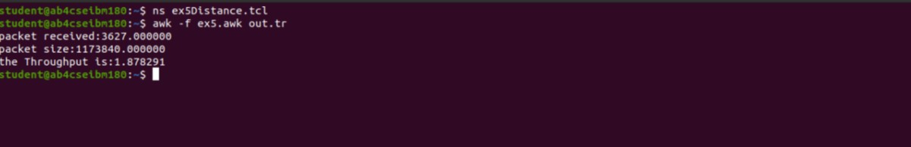

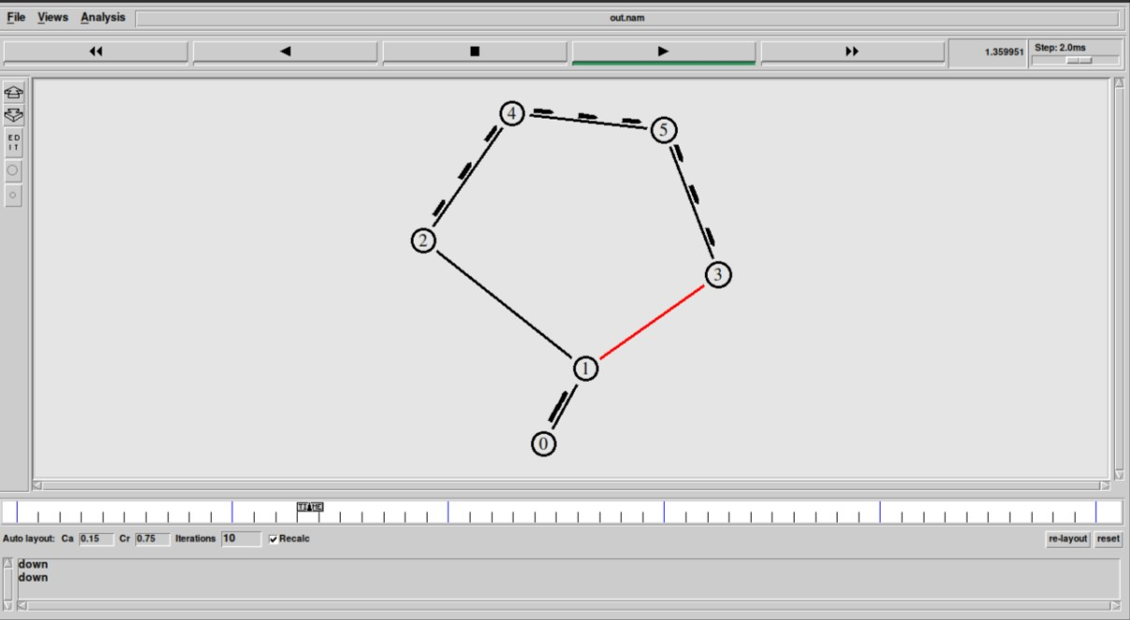

**Link State Routing:**

set ns [new Simulator] set nr [open thro.tr w]

$ns trace-all $nr

set nf [open thro.nam w]

$ns namtrace-all $nf proc finish { } {

global ns nr nf

$ns flush-trace close $nf close $nr

exec nam thro.nam & exit 0

}

for { set i 0 } { $i < 8} { incr i 1 } { set n($i) [$ns node]}

for {set i 0} {$i < 4} {incr i} {

$ns duplex-link $n($i) $n([expr $i+1]) 1Mb 10ms DropTail }

$ns duplex-link $n(0) $n(4) 1Mb 10ms DropTail

$ns duplex-link $n(4) $n(5) 1Mb 10ms DropTail

$ns duplex-link $n(5) $n(7) 1Mb 10ms DropTail

$ns duplex-link $n(3) $n(6) 1Mb 10ms DropTail

$ns duplex-link $n(7) $n(6) 1Mb 10ms DropTail set tcp0 [new Agent/TCP]

$ns attach-agent $n(0) $tcp0 set ftp0 [new Application/FTP]

$ftp0 set packetSize_ 500

$ftp0 set interval_ 0.005

$ftp0 attach-agent $tcp0

set sink0 [new Agent/TCPSink]

$ns attach-agent $n(4) $sink0

$ns connect $tcp0 $sink0 set udp1 [new Agent/UDP]

$ns attach-agent $n(1) $udp1

set cbr1 [new Application/Traffic/CBR]

$cbr1 set packetSize_ 500

$cbr1 set interval_ 0.005

$cbr1 attach-agent $udp1 set null0 [new Agent/Null]

$ns attach-agent $n(4) $null0

$ns connect $udp1 $null0

$ns rtproto LS

$ns rtmodel-at 10.0 down $n(3) $n(2)

$ns rtmodel-at 15.0 down $n(7) $n(6)

$ns rtmodel-at 30.0 up $n(3) $n(2)

$ns rtmodel-at 20.0 up $n(7) $n(6)

$tcp0 set fid_ 1

$udp1 set fid_ 2

$ns color 1 Red

$ns color 2 Green

$ns at 1.0 "$ftp0 start"

$ns at 2.0 "$cbr1 start"

$ns at 45 "finish"

$ns run

# AWK File:

BEGIN {

PacketRcvd=0; ftime=0; latency=0; Throughput=0.0; packet_size=0;

}

{

if(($1=="r") && ($5=="tcp"))

{

packet_size+=$6;

PacketRcvd++;

}

ftime=$2;

}

END {

Throughput=(packet_size/ftime)*(8/1000000); printf("packet received:%f\n", PacketRcvd); printf("packet size:%f\n", packet_size);

printf( "the Throughput is:%f\n",Throughput);

}

# OUTPUT:

