Name: G.R.Nithishkumar

Roll no.: 20ucs088

Ex no.: 8

Program: Socket programming using TCP

**Program for chat**

**Client:**

import socket

s=socket.socket()

#host=socket.gethostname()

port=1200

s.connect(('localhost',port))

print(s.recv(1024).decode())

while True:

msg=input('client: ')

s.send(msg.encode())

rmsg=s.recv(1024).decode()

print('server: ',rmsg)

if msg=='bye':

break;

s.close()

**Output:**

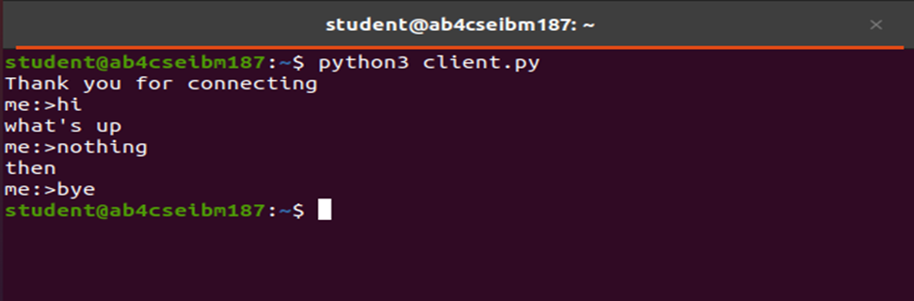

**Server:**

import socket

s=socket.socket()

#host=socket.gethostname()

port=1200

s.bind(('localhost',port))

s.listen(5)

print('Waiting for Connections...')

c,addr=s.accept()

print ('Got Connection from',addr)

c.send('Thank you for connecting...'.encode())

while True:

rmsg=c.recv(1024)

print('client: ',rmsg.decode())

msg=rmsg.decode()

c.send(msg.encode())

if msg=='bye':

break;

s.close()

**Output:**

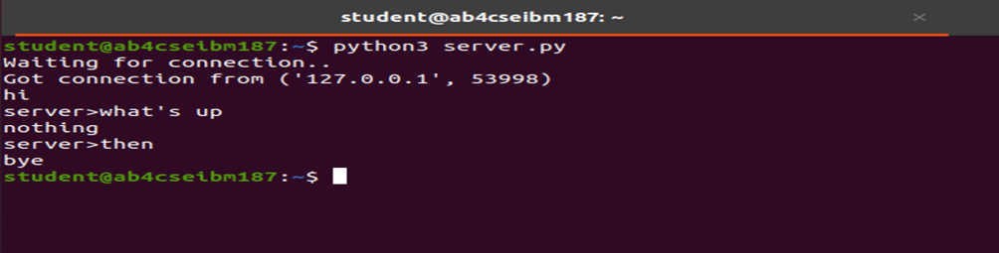

**Program for echo**

**Client:**

import socket

s=socket.socket()

#host=socket.gethostname()

port=1200

s.connect(('localhost',port))

print(s.recv(1024).decode())

while True:

msg=input('client: ')

s.send(msg.encode())

rmsg=s.recv(1024).decode()

print('server: ',rmsg)

if msg=='bye':

break;

s.close()

**Output:**



**Server:**

import socket

s=socket.socket()

#host=socket.gethostname()

port=1200

s.bind(('localhost',port))

s.listen(5)

print('Waiting for Connections...')

c,addr=s.accept()

print ('Got Connection from',addr)

c.send('Thank you for connecting...'.encode())

while True:

rmsg=c.recv(1024)

print('client: ',rmsg.decode())

msg=rmsg.decode()

c.send(msg.encode())

if msg=='bye':

break;

s.close()

**Program for file transfer**

**Client:**

import socket

s=socket.socket()

s.connect(('localhost',9000))

print(s.recv(1024).decode())

file="op.txt"

f=open(file,'wb')

data=s.recv(1024)

while data:

print(data)

l=f.write(data)

data=s.recv(1024)

print("Received successfully")

f.close()

s.close()

**Output:**

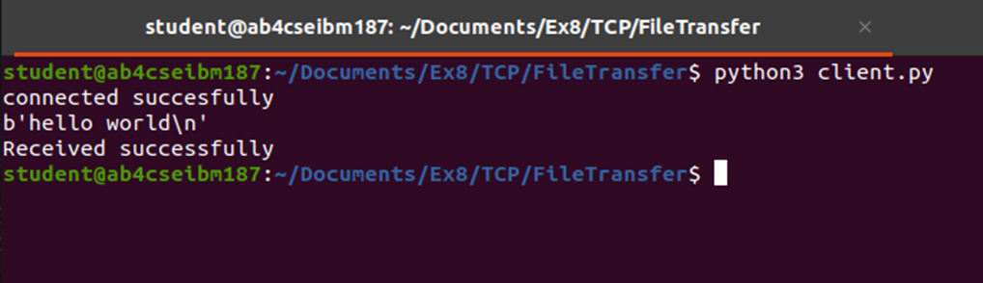

**Server:**

import socket

s=socket.socket()

s.bind(('localhost',9000))

s.listen(3)

print("waiting for the client connection")

c,addr=s.accept()

c.send("connected succesfully".encode())

print("connected with",addr)

file="test.txt"

f=open(file,'rb')

l=f.read(1024)

print(l)

while l:

c.send(l)

l=f.read(1024)

print("sent successfully")

f.close()

c.close()

s.close()

**Output:**

