Name: G.R.Nithishkumar

Roll no.: 20ucs088

Ex No.: 9

Program: Simulation of DNS using UDP sockets

**Program for CHAT**

**UDP server:**

import socket

s=socket.socket(socket.AF_INET,socket.SOCK_DGRAM)

hostname=socket.gethostname()

ip=socket.gethostbyname(hostname)

port=2000

server_address=(ip,port)

s.bind(server_address)

while True:

     print("###### server is listening ######")

     data, address=s.recvfrom(1024)

     print("client: "+data.decode())

     msg=input("server:")

     s.sendto(msg.encode(), address)

     if data.decode()=="bye":

         break;

s.close()

**Output:**

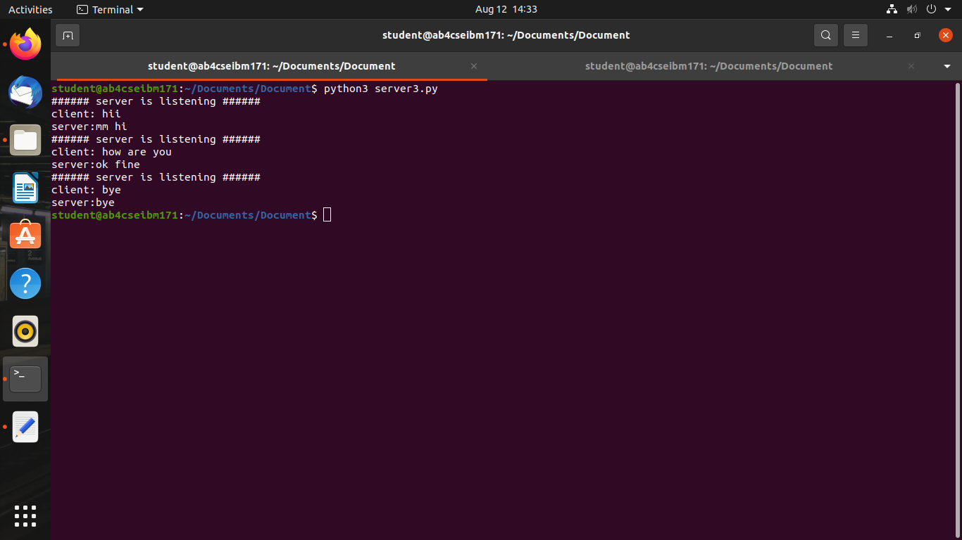

**UDP client:**

import socket

s=socket.socket(socket.AF_INET,socket.SOCK_DGRAM);

hostname=socket.gethostname()

ip=socket.gethostbyname(hostname)

port=2000

while True:

    msg=input("Client:");

    s.sendto(msg.encode(),(ip,port))

    data,address=s.recvfrom(4096)

    print("server: "+data.encode())

    if msg=="bye":

        break

s.close()

**Output:**

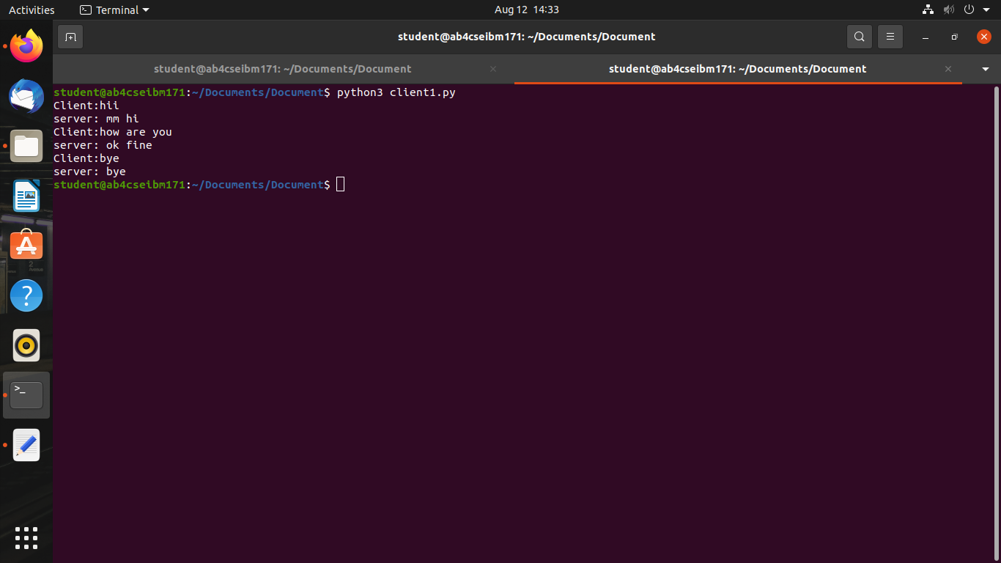

**Program for ECHO**

**UDP server:**

import socket

s=socket.socket(socket.AF_INET,socket.SOCK_DGRAM)

hostname=socket.gethostname()

ip=socket.gethostbyname(hostname)

port=2000

server_address=(ip,port)

s.bind(server_address)

while True:

print("###### server is listening ######")

data, address=s.recvfrom(1024)

print("client: "+data.decode())

msg=data.decode()

s.sendto(msg.encode(), address)

if data.decode()=="bye":

break;

s.close()

**UDP client:**

import socket

s=socket.socket(socket.AF_INET,socket.SOCK_DGRAM);

hostname=socket.gethostname()

ip=socket.gethostbyname(hostname)

port=2000

while True:

    msg=input("Client:");

    s.sendto(msg.encode(),(ip,port))

    data,address=s.recvfrom(4096)

    print("server: "+data.encode())

    if msg=="bye":

        break

s.close()

**Output:**

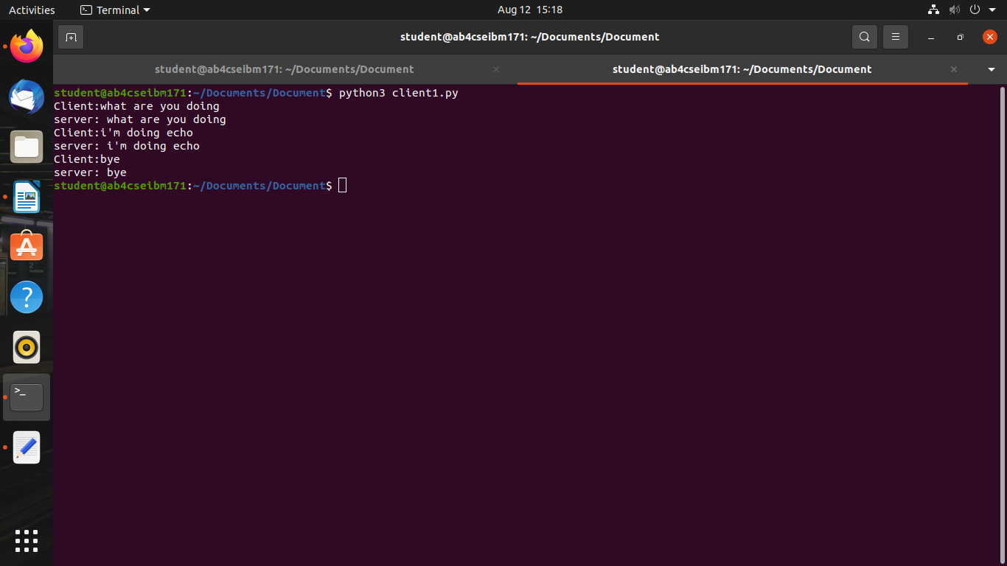

**Program for FILE SHARING**

**Server.py**

import socket

s=socket.socket(socket.AF_INET,socket.SOCK_DGRAM)

s.bind(("127.0.0.1",5016))

print("waiting for the client file upload..")

file_name,addr=s.recvfrom(1024)

name="ft_"+file_name.decode()

f=open(name,'wb')

data,addr=s.recvfrom(1024)

while data:

data,addr=s.recvfrom(1024)

f.write(data)

if(data):

break

print("Received successfully..")

f.close()

s.close()

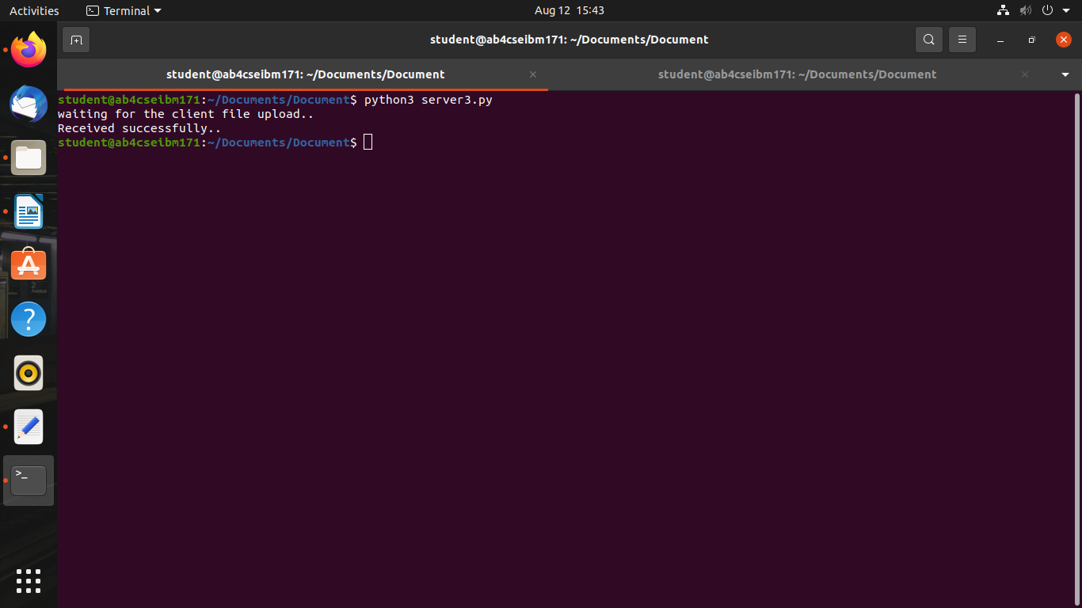**Output:**

**Client.py**

import socket

UDP_IP="127.0.0.1"

UDP_PORT=5016

buf=1024

file_name="rav.txt"

name=file_name.encode()

s=socket.socket(socket.AF_INET,socket.SOCK_DGRAM)

s.sendto(name,(UDP_IP,UDP_PORT))

f=open(file_name,"rb")

data=f.read(buf)

s.sendto(data,(UDP_IP,UDP_PORT))

while data:

s.sendto(data,(UDP_IP,UDP_PORT))

data=f.read(buf)

print("Sent successfully..")

f.close()

s.close()

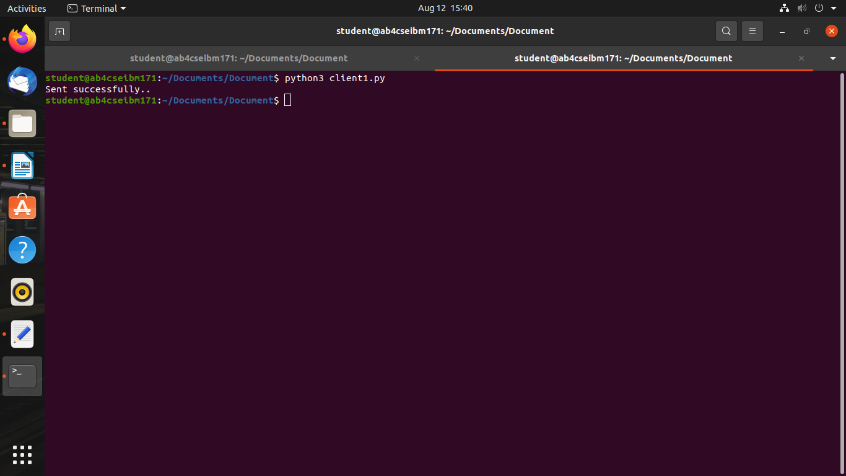**Output:**

**DNS USING UDP**

**Server.py**

import socket

s=socket.socket(socket.AF_INET,socket.SOCK_DGRAM)

print("Socket created")

dns_table={'www.google.com' : '192.165.1.1',

'www.youtube.com' : '192.165.1.3',

'www.amazon.com' : '192.165.1.2',

'www.gmail.com' : '192.165.1.4',

'www.kamarajengg.edu.in' : '192.165.1.5'}

s.bind(("localhost",9999))

while True:

data,addr=s.recvfrom(1024)

data=data.decode()

if data=="N":

break;

ipinfo=dns_table.get(data,"Not Found:").encode()

send=s.sendto(ipinfo,addr)

print("The dns is resolved & ip address is send to client:",ipinfo)

s.close()

**Output:**

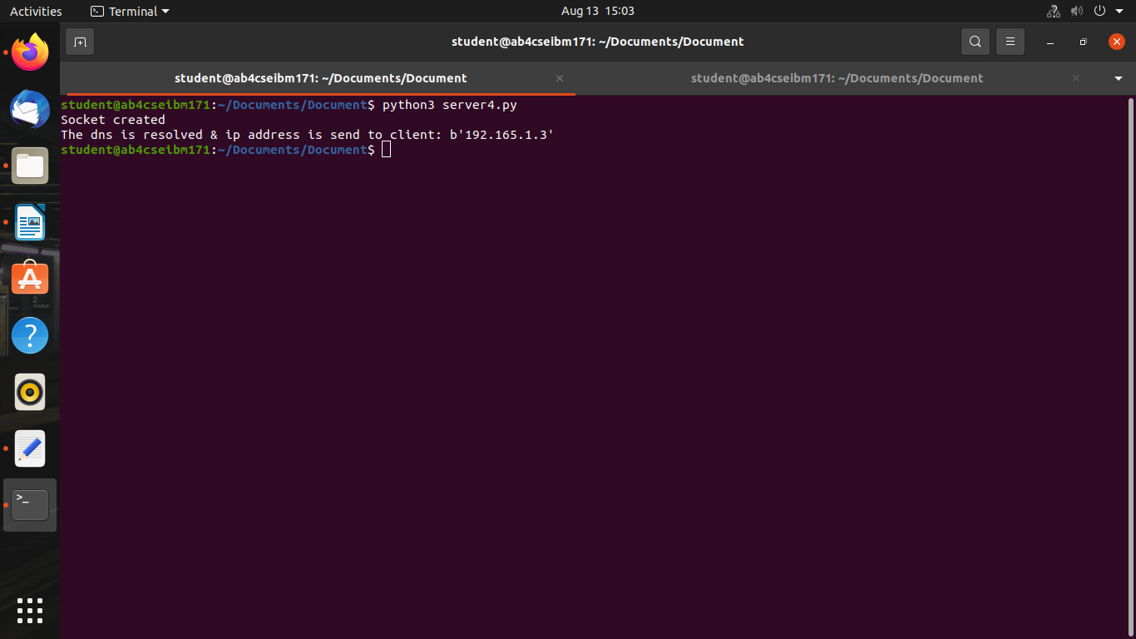

**Client.py**

import socket

c=socket.socket(socket.AF_INET,socket.SOCK_DGRAM)

choice="Y"

while choice=="Y":

domain_name=input("Enter domain name:")

c.sendto(domain_name.encode(),("localhost",9999))

data,addr=c.recvfrom(1024)

ipinfo=data.decode()

print("The ip address for the domain name given is:",ipinfo)

choice=input("Enter Y/N:")

if choice=="N":

c.sendto(choice.encode(),("localhost",9999))

break;

c.close()

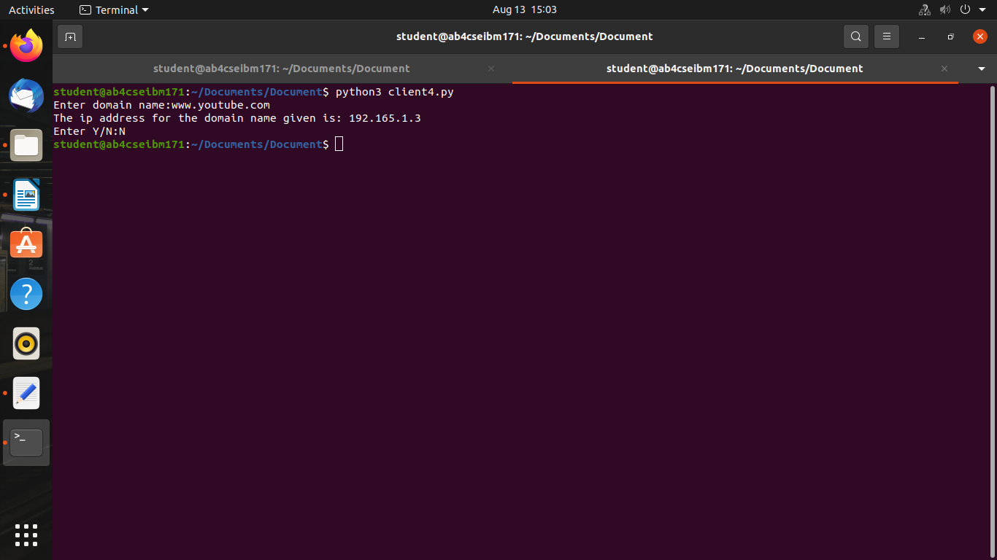**Output:**