SIMATS ENGINEERING
CO3_AT1_Assessment Tool: EXPERIMENT
DSA06 – Data Handling and Visualization | Assessment Tool: Experiment
DSA06 – DATA HANDLING AND VISUALIZATION
ASSESSMENT TOOL I – EXPERIMENTS
Course: Data Handling and  Visualization | Code: DSA0603 | CO: CO3
Duration: 120 min | Total Marks: 100 | Reg No :  Name:

COURSE OUTCOME COVERED
CO3: Analyze time-series data, trends, associations, and uncertainty through appropriate visualization methods. (BL4) Activity Tool : Experiments
Weightage: 20%

Code of Conduct:
I JAANA NITHISH/192324275 (Name / Reg No) certify that this submission is my original work and that I have adhered to the guidelines specified for this assessment. I understand that any violation of academic integrity rules will result in disciplinary action.
Signature of the student: JAANA NITHISH

Criteria | Understanding of Concepts  25% | Experimental  Design  30% | Use of Tools  20% | Analysis of  Results  15% | Documents  10% | Total
Q1
Q2
Q3
Q4
Q5

Question 1 – Distribution Diagnosis using ECDF and Q-Q Plot
Scenario: An engineering department records response time (ms) of an automated fault-detection system under 20 test runs. The team claims the distribution is approximately normal and wants to use mean and standard deviation for monitoring.
Dataset (n=20): 118, 121, 125, 127, 129, 131, 134, 136, 138, 141, 144, 147, 151, 156, 162, 171, 184, 205, 249, 318 Tasks:
1. Construct an ECDF and a normal Q-Q plot.
2. Use both plots to evaluate the normality claim.
3. Identify evidence of skewness and/or extreme observations.
4. Recommend percentile-based limits or mean ± standard-deviation limits, with justification.
Key competency: ECDF, Q-Q plot, skewness, outliers, distribution interpretation
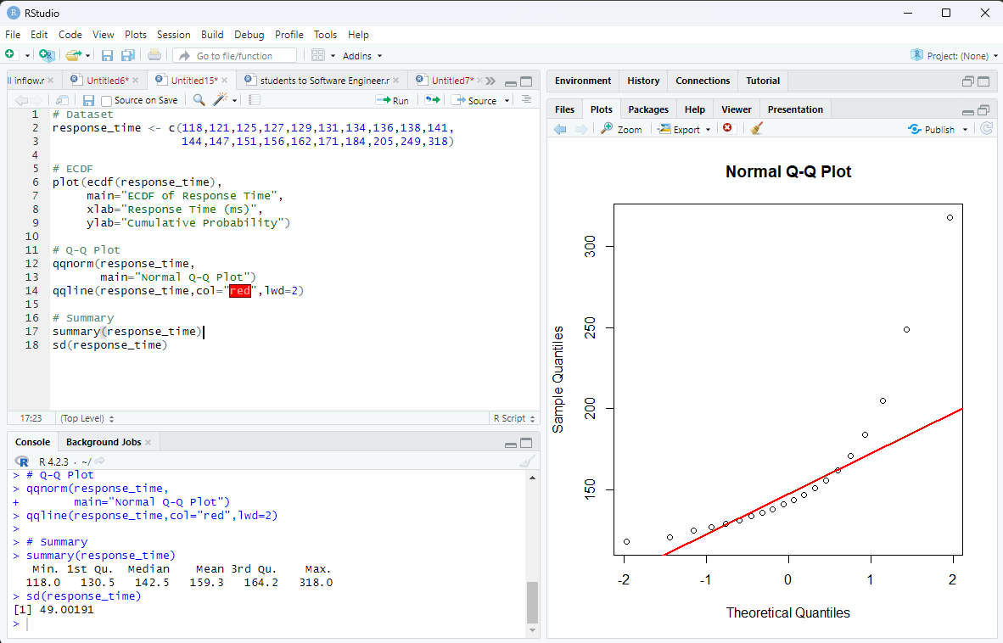
# Question 1
response_time <- c(118,121,125,127,129,131,134,136,138,141,
144,147,151,156,162,171,184,205,249,318)
# ECDF
plot(ecdf(response_time),
main = "ECDF of Response Time",
xlab = "Response Time (ms)",
ylab = "Cumulative Probability")
# Normal Q-Q Plot
qqnorm(response_time,
main = "Normal Q-Q Plot")
qqline(response_time)
# Summary statistics
mean(response_time)
sd(response_time)
quantile(response_time, c(0.05,0.95))

Expected Output
The program produces:
- An ECDF plot showing the cumulative distribution.
- A Normal Q-Q plot with most lower observations near the line but the largest observations deviating upward.
- Mean, standard deviation, and 5th/95th percentiles.

Analysis
- The ECDF increases gradually for most observations but rises slowly at the upper end because of very large values.
- The Q-Q plot shows noticeable upward deviation for 205, 249, and 318 ms.
- This indicates positive (right) skewness and the presence of extreme observations.
- Therefore, the data is not approximately normal.

Recommendation
Percentile-based limits are preferable to mean ± standard deviation limits because the distribution is skewed and contains extreme values. Percentiles are less affected by outliers.

Conclusion
The normality claim is not supported. The response-time data is right-skewed with extreme high values, so percentile-based monitoring limits are recommended.

Question 2 – Comparing Many Distributions and Bean Plots
Scenario: A semiconductor manufacturer measures chip fabrication cycle time (minutes) for four production lines. Management wants to identify differences in variability and distribution shape.
Production Line | Cycle Times (minutes)
L1 | 42, 44, 45, 46, 47, 48, 49, 50, 51, 53
L2 | 38, 41, 44, 47, 50, 53, 56, 59, 62, 65
L3 | 45, 46, 46, 47, 47, 48, 48, 49, 49, 50
L4 | 40, 41, 42, 43, 44, 45, 48, 55, 61, 72

Tasks:
1. Create a visualization comparing all four distributions.
2. Construct bean plots or an equivalent distribution visualization along the vertical axis.
3. Determine which line has greatest variability and which has the most concentrated distribution. 4. Explain why comparing only means is insufficient.
Key competency: Multiple distributions, vertical-axis distributions, bean plots, variability
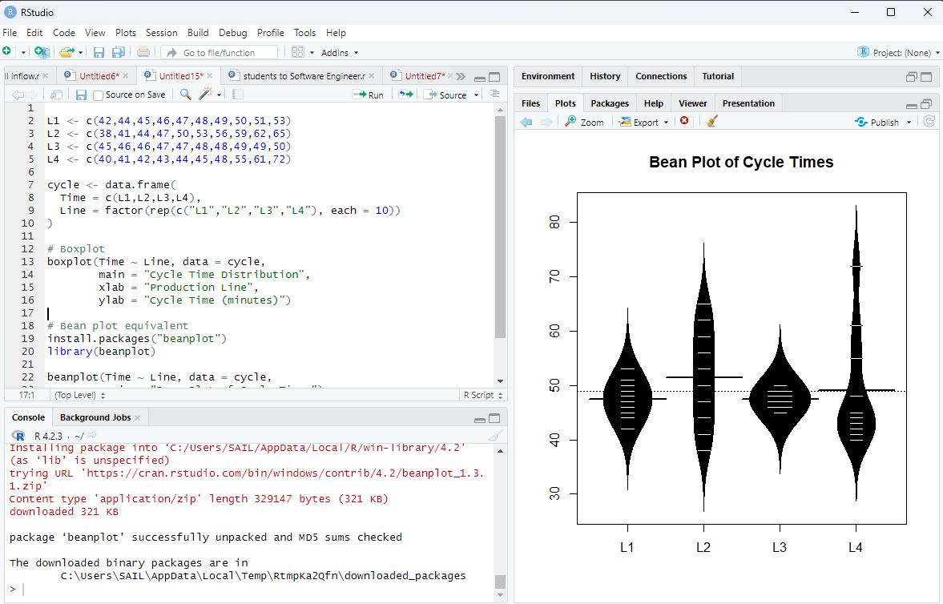
# Question 2
L1 <- c(42,44,45,46,47,48,49,50,51,53)
L2 <- c(38,41,44,47,50,53,56,59,62,65)
L3 <- c(45,46,46,47,47,48,48,49,49,50)
L4 <- c(40,41,42,43,44,45,48,55,61,72)
cycle <- data.frame(
Time = c(L1,L2,L3,L4),
Line = factor(rep(c("L1","L2","L3","L4"), each = 10))
)
# Boxplot
boxplot(Time ~ Line, data = cycle,
main = "Cycle Time Distribution",
xlab = "Production Line",
ylab = "Cycle Time (minutes)")
# Bean plot equivalent
install.packages("beanplot")
library(beanplot)
beanplot(Time ~ Line, data = cycle,
main = "Bean Plot of Cycle Times")
# Standard deviations
tapply(cycle$Time, cycle$Line, sd)

Expected Output
The output contains:
- A boxplot comparing all four lines.
- A bean plot showing distribution shape and density.
- Standard deviations for each production line.

Question 3 – Proportion Visualization and Choice of Chart
Scenario: A university analyzes preferred learning mode of 240 students across three departments. The dean wants comparison without exaggerating small differences.
Department | Online (%) | Blended (%) | Face-to-Face (%)
CSE | 52 | 28 | 20
ECE | 45 | 35 | 20
IT | 30 | 40 | 30

Tasks:
1. Create a side-by-side bar chart and a 100% stacked bar chart.
DSA06 – Data Handling and Visualization | Assessment Tool: Experiment
2. Explain which chart better supports comparison of individual proportions and why.
3. Explain why separate pie charts may be less effective for comparing departments.
4. Identify one design choice that could make small proportional differences appear larger.
Key competency: Proportions, side-by-side bars, stacked bars, pie charts, misleading proportions
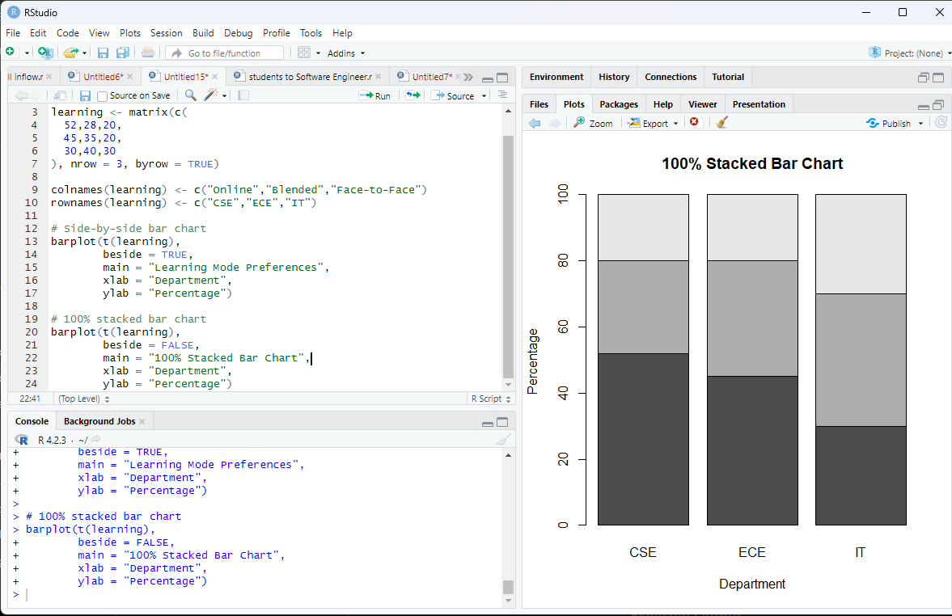

Expected Output
Two charts are generated:
- Side-by-side grouped bar chart.
- 100% stacked bar chart.

Analysis
- The side-by-side bar chart is better for comparing individual proportions because bars for the same learning mode share a common baseline.
- The stacked chart is useful for showing the composition of each department.
- Separate pie charts are less effective because comparing angles across multiple pies is difficult.
- Starting the y-axis above zero or using a truncated axis can exaggerate small differences.

Conclusion
For comparing proportions across departments, the side-by-side bar chart is the clearer and more accurate choice.

Question 4 – Nested Proportions using Treemap and Sunburst
Scenario: An e-commerce company analyzes annual revenue of ₹1.2 crore across product categories and subcategories. The dashboard must show both category contribution and internal composition.
Category | Subcategory | Revenue (₹ lakh)
Electronics | Mobiles | 24
Electronics | Laptops | 18
Electronics | Accessories | 8
Home | Furniture | 14
Home | Appliances | 10
Home | Decor | 6
Fashion | Men | 7
Fashion | Women | 8
Fashion | Kids | 5

Tasks:
1. Construct a treemap showing category and subcategory revenue.
2. Construct a sunburst chart representing the same hierarchy.
3. Determine the largest category and calculate its percentage of total revenue.
4. Compare treemap and sunburst for identifying nested proportions.
5. State one situation in which area encoding could mislead interpretation.
Key competency: Treemaps, sunburst charts, nested proportions, area encoding
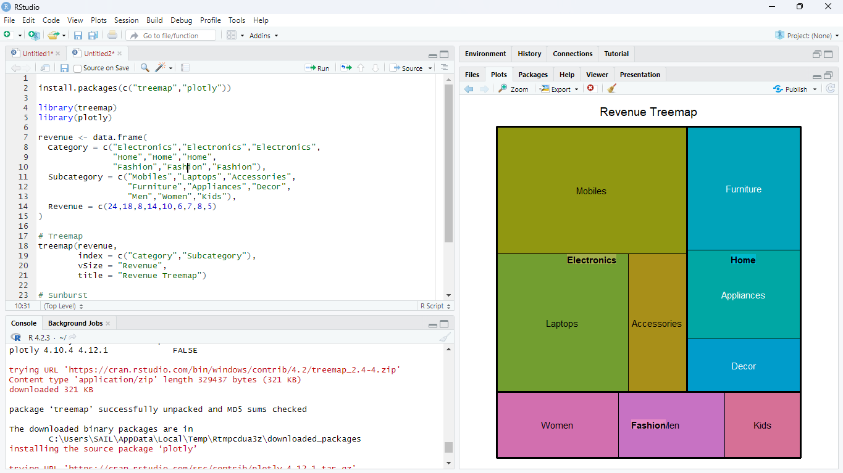

Expected Output
- A treemap where rectangle area represents revenue.
- A sunburst chart showing category and subcategory hierarchy.

Analysis
Category totals:
Category | Revenue (₹ lakh)
Electronics | 50
Home | 30
Fashion | 20

Conclusion
Electronics is the largest category, contributing 50% of the listed total revenue. Treemaps emphasize size, while sunbursts emphasize hierarchical structure.

Question 5 – Flow Proportions using Sankey Diagram / Parallel Sets Scenario: A smart-city mobility study follows 200 commuters from residential zone through primary transport mode to destination zone. The planning team wants dominant flows and possible bottlenecks.
Origin | Mode | Destination | Commuters
Residential | Bus | Central | 35
Residential | Bus | Industrial | 15
Residential | Train | Central | 25
Residential | Train | Industrial | 10
Suburban | Bus | Central | 20
Suburban | Bus | Industrial | 10
Suburban | Train | Central | 30
Suburban | Train | Industrial | 15
Rural | Bus | Central | 12
Rural | Bus | Industrial | 8
Rural | Train | Central | 10
Rural | Train | Industrial | 10

Tasks:
1. Construct a Sankey diagram showing Origin → Mode → Destination.
2. Construct a parallel-sets representation of the same categorical flows.
DSA06 – Data Handling and Visualization | Assessment Tool: Experiment
3. Identify the three largest flows and calculate their percentages of all commuters.
4. Compare Sankey and parallel sets for flow magnitude and category relationships.
5. Explain one way poor link widths or category ordering could mislead the viewer.
Key competency: Sankey diagrams, parallel sets, flow proportions, categorical relationships
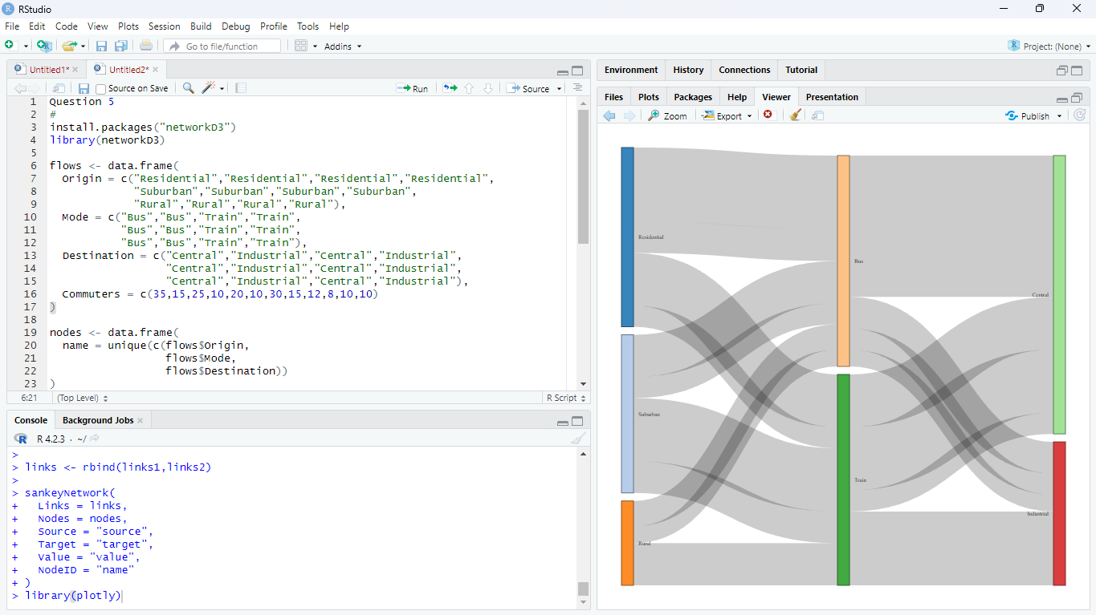

Suggested Evaluation Rubric – Experiment
Criterion | Excellent (4) | Good (3) | Satisfactory (2) | Needs Improvement (1)
Data preparation | Correct and complete | Minor issue | Several issues | Incorrect/incomplete
Visualization choice | Highly appropriate  and justified | Appropriate | Partially appropriate | Poor choice
Technical execution | Accurate and clear | Mostly accurate | Some errors | Major errors
Interpretation | Insightful and  evidence-based | Correct | Basic | Incorrect/unsupported
Misleading-design  analysis | Bias clearly identified and explained | Bias identified | Limited explanation | Not identified

Suggested marks: 20 marks per question; 100 marks total. Level: Competitive / advanced undergraduate.

