EX.No.7 DECOMPOSING TIME SERIES DATA INTO TREND AND SEASONALITY

Date:03.04.25

AIM:

Implement program for decomposing time series data into trend and seasonality.

Procedure and Code:

Step1:

import numpy as np

import pandas as pd

import matplotlib.pyplot as plt

from statsmodels.tsa.seasonal import seasonal_decompose

Step2:

# Load the AirPassengers dataset

df = pd.read_csv('/content/LBMA-SILVER(2).csv', parse_dates=['Month'], index_col='Month')

df.columns = ['Passengers']

Step3:

# Perform decomposition

result = seasonal_decompose(df['Passengers'], model='multiplicative', period=12)

Step4:

# Plot the decomposition

plt.figure(figsize=(10, 8))

Step5: plt.subplot(411)

plt.plot(df['Passengers'], label='Original Time Series')

plt.legend()

Step6:

plt.subplot(412)

plt.plot(result.trend, label='Trend', color='orange')

plt.legend()

Step7:

plt.subplot(413)

plt.plot(result.seasonal, label='Seasonality', color='green')

plt.legend()

Step 8:

plt.tight_layout()

plt.show()

OUTPUTS:

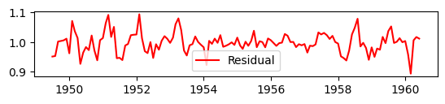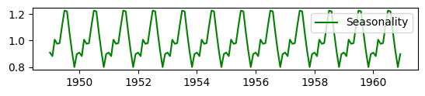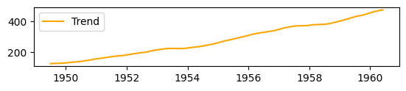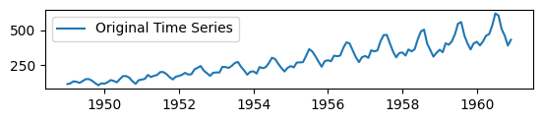

RESULT:

The program to execute trend in time series data and seasonality has been executed successfully.