# 2. Basic Filtering and Sorting

## Objective

To write the queries that filter records and sort the result set.

## Queries

1. ***Select * from employee***
2. ***where department = "sales"***
3. ***Order by lastName;***

* This **Where** statement is used to filter the employee details who are in the **sales** department and **order** it by the employee’s **last name**.

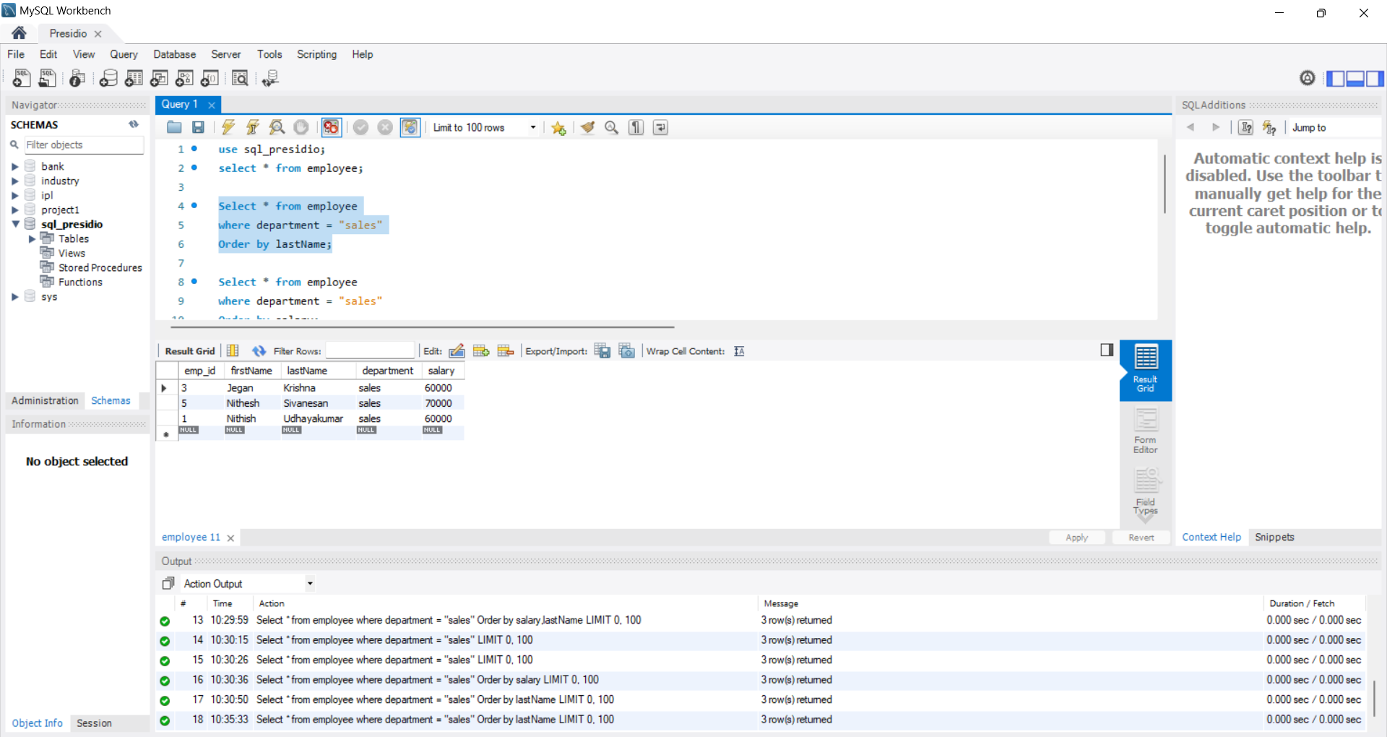

1. ***Select * from employee***
2. ***where department = "sales"***
3. ***Order by salary;***

* This **Where** statement is used to filter the employee details who are in the **sales** department and **order** it by the employee’s **salary**.

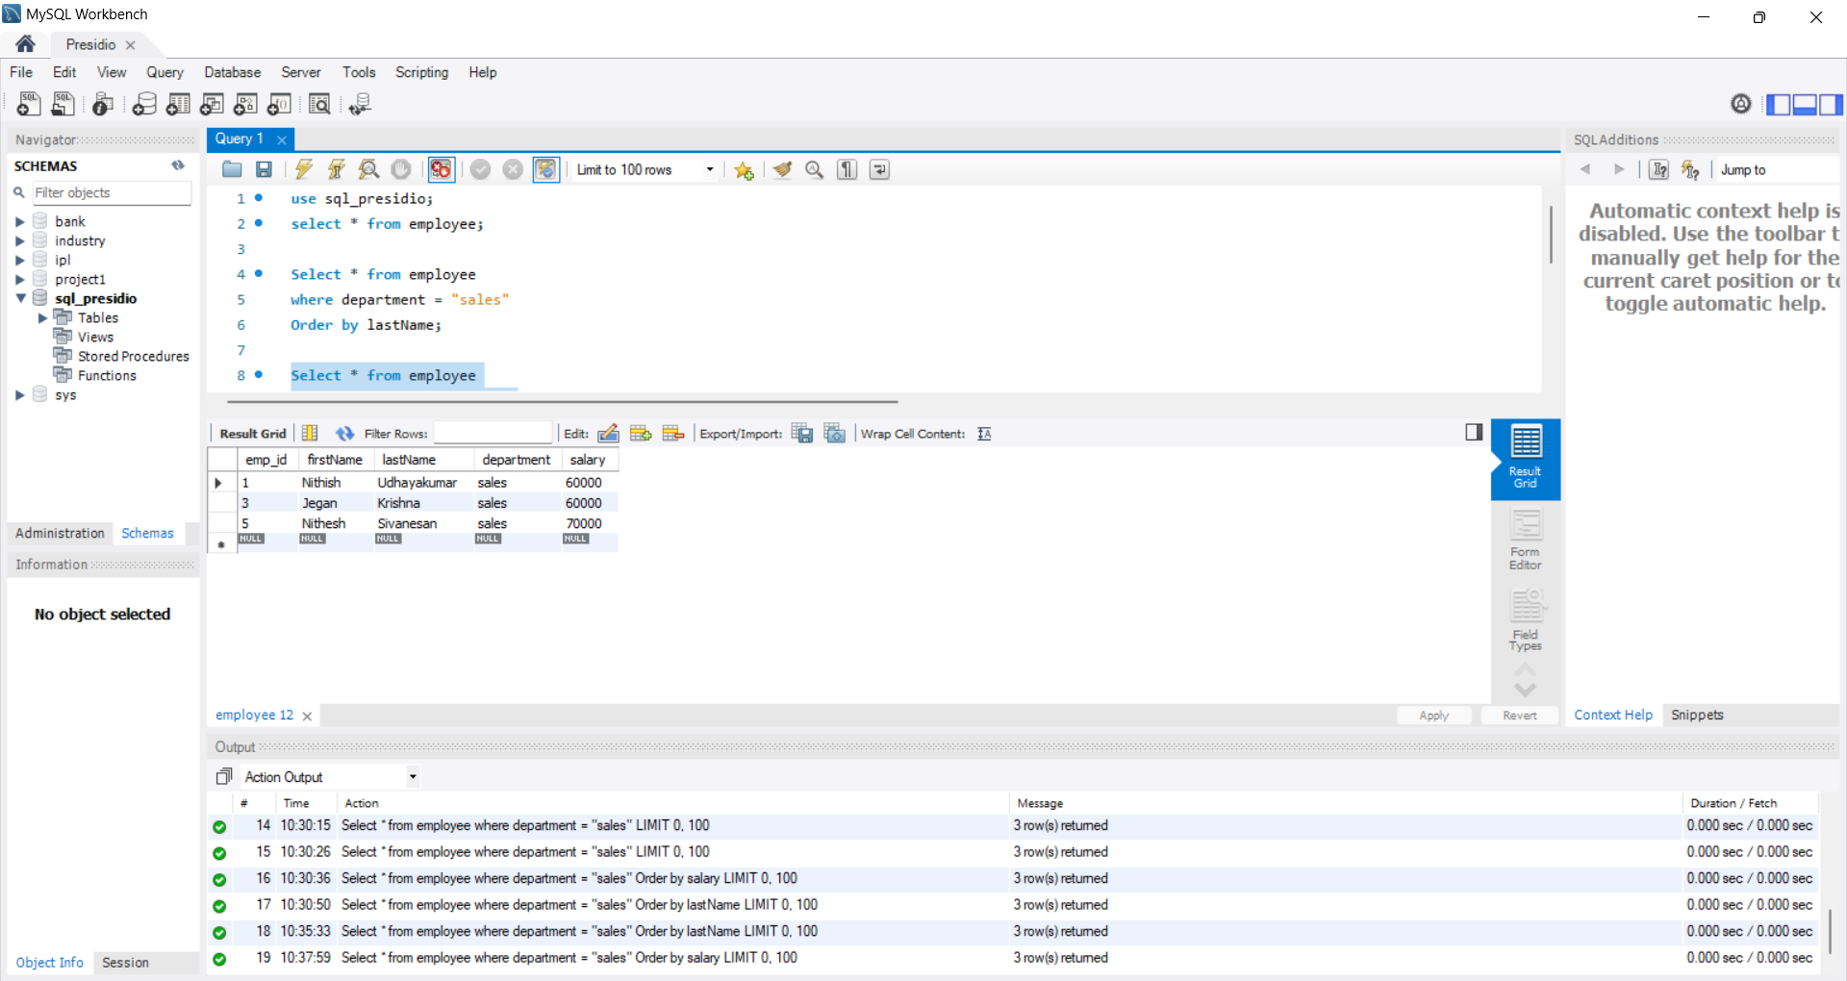

1. ***Select * from employee***
2. ***where department = "sales" AND salary>60000;***

* This statement is using **AND** operator to use multiple conditions in one statement.
* Logic of **AND** operator is both condition should be true.
* Here, it’ll return the rows which satisfy the conditions (department = "sales" & salary>60000).

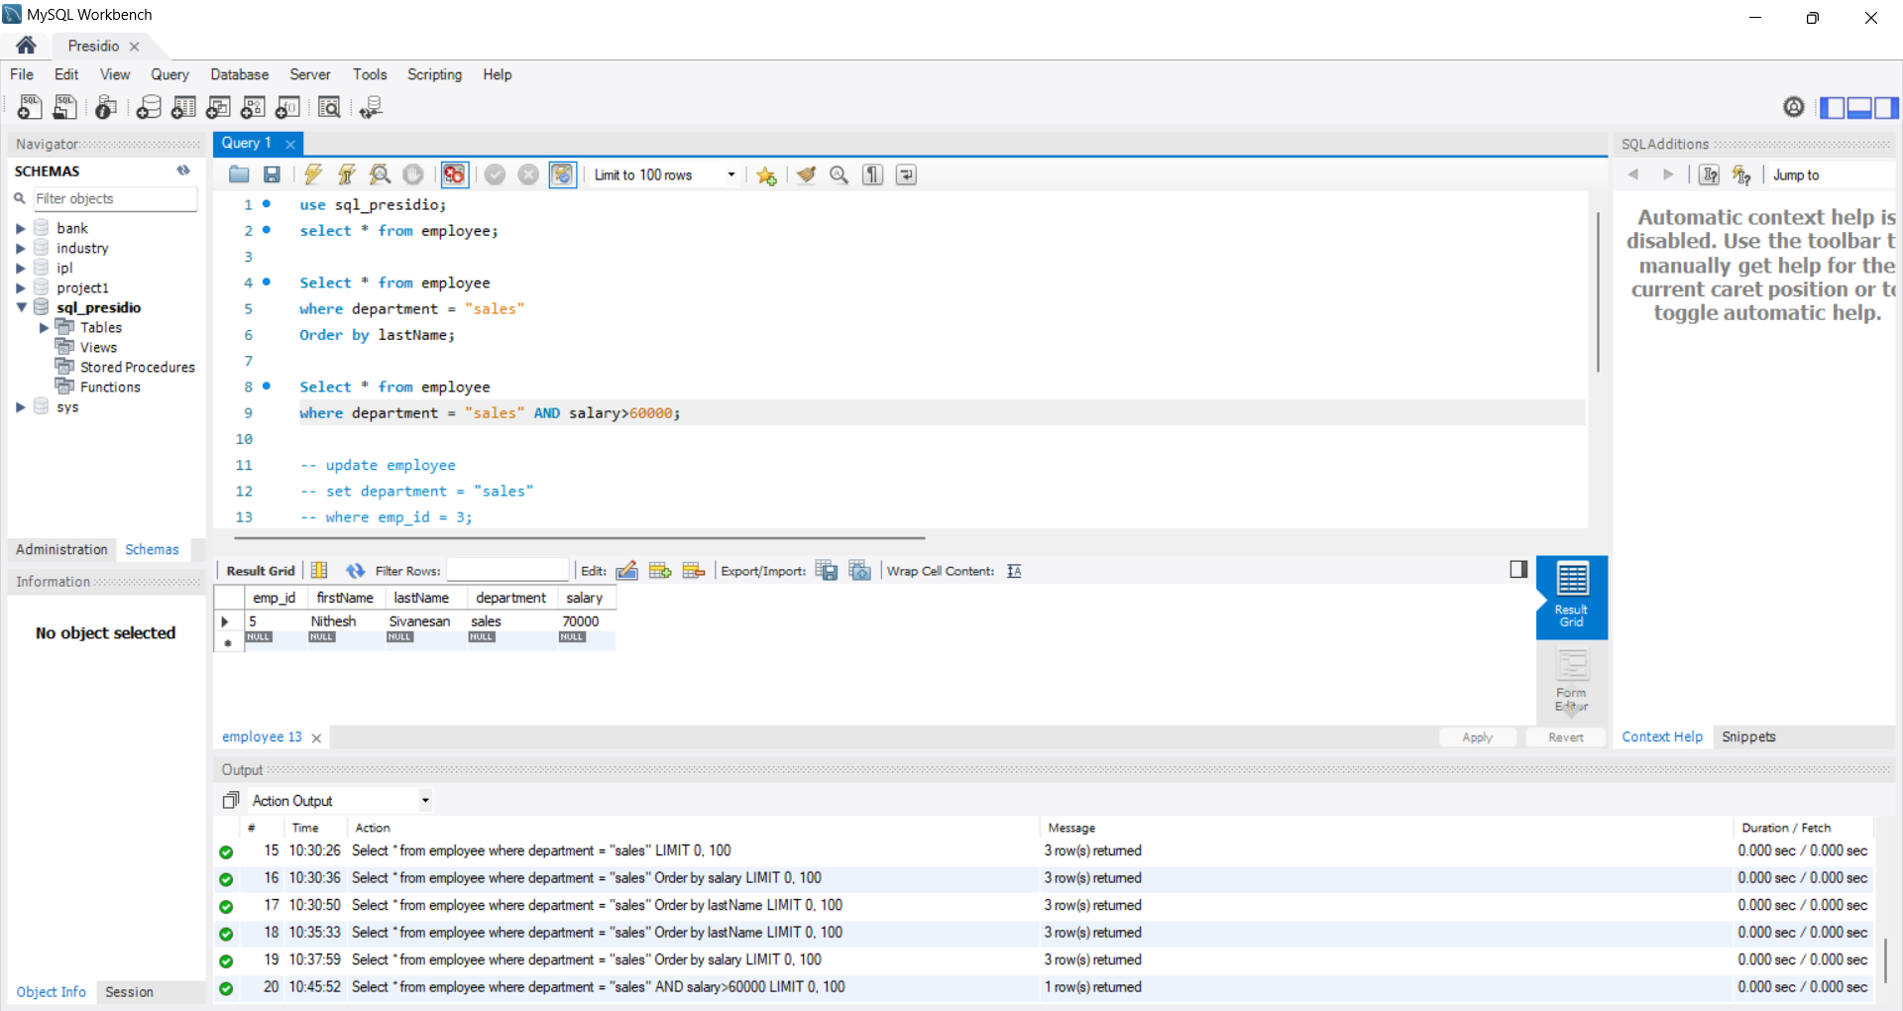

1. ***Select * from employee***
2. ***where department = "sales" OR salary>60000;***

* This statement is using **OR** operator to use multiple conditions in one statement.
* Logic of **OR** operator is either one condition should be true.
* Here, it’ll return the rows which satisfy the conditions (department = "sales" & salary>60000).

