# 3. Simple Aggregation and Grouping

## Objective

To summarize data using aggregate functions and grouping.

## Queries

1. ***select count(*) AS TotalEmp,sum(salary) AS TotalSalary ,***
2. ***avg(salary) AS AverageSalary***
3. ***from employee;***

* Used the Aggregate functions such as **COUNT()**, **SUM()**, or **AVG()** to count the total no of employees(**TotalEmp**), Total salary of the employees(**TotalSalary**) and average salary of employees(**AverageSalary**).

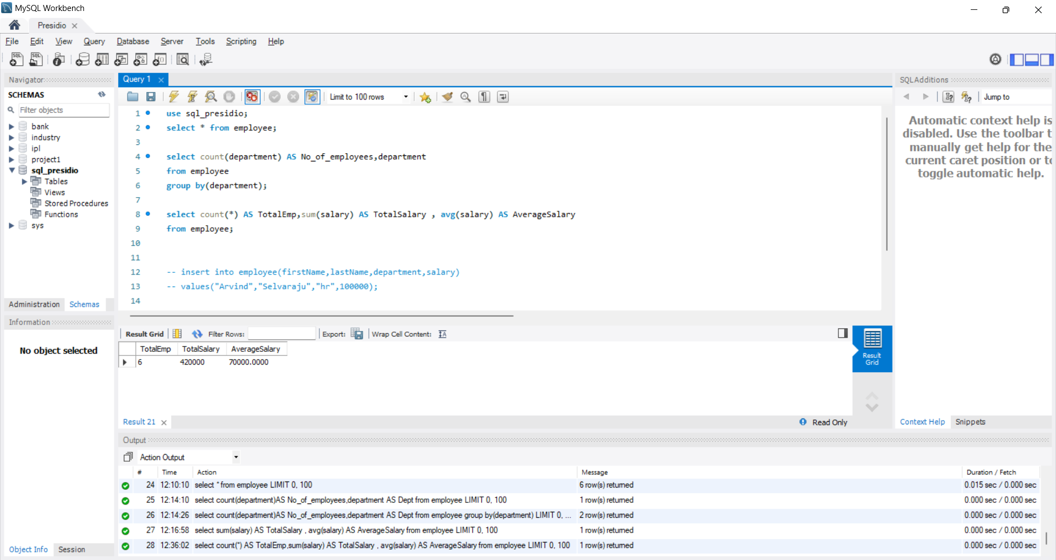

1. ***select avg(salary) AS AvgSalary,department***
2. ***from employee***
3. ***group by(department);***

* **Group by** clause group the rows based on the single specified column and it’s useful with aggregate function.
* Here, I used **Group by** clause to group the rows by **department** and **Avg()**  function returns the value of employee salary(AvgSalary).

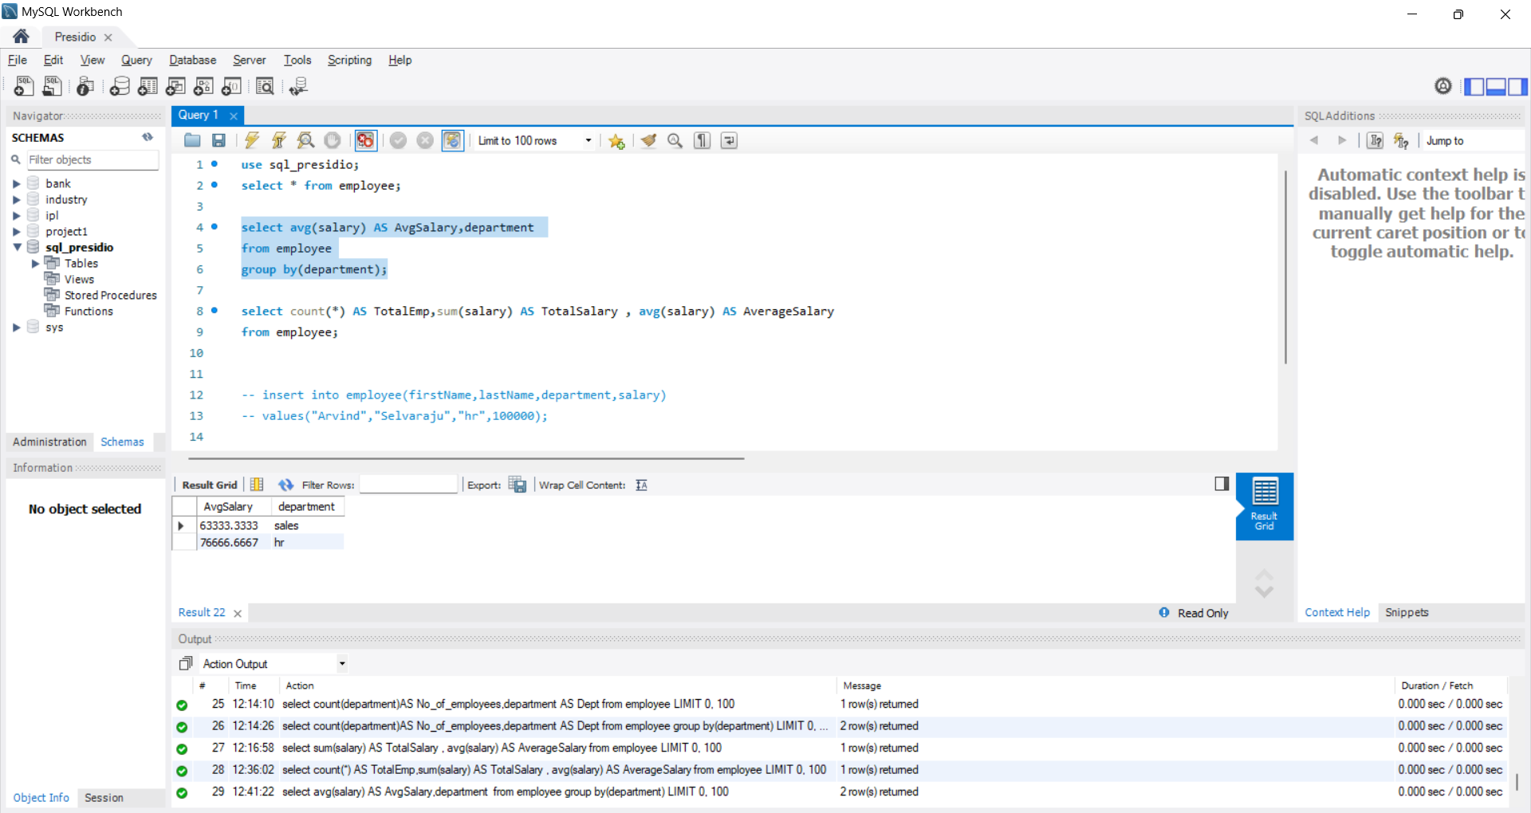

1. ***select avg(salary) AS AvgSalary,department***
2. ***from employee***
3. ***group by(department)***
4. ***Having AvgSalary>65000;***

* This query will return the same row like previous query but here I used **Having**  clause.
* **Having** clause is same as **where**  clause but it can’t be used with aggregate function.
* Here It’ll return the rows which is having Average salary more than 65,000(AvgSalary).

