# 5. Subqueries and Nested Queries

## Objective

To use subqueries to filter or compute values within a main query.

## Queries

1. ***select * from employee e1***
2. ***where salary > (select avg(salary) from employee e2 where e2.department = e1.department);***
3. ***-- Correlated subquery***
4. ***select * from employee***
5. ***where salary > (select avg(salary) from employee);***
6. ***-- Non-correlated subquery***

* My understanding between correlated and non-correlated subqueries,
  + **Correleated** subquery is depends on the outer query to return value because it runs the subquery for every rows (Repeats).
  + **Non-correlated** subquery isn’t depend on it because it only once runs the outer query and use it for the main query.
* In 1st query, it will return the employee details whose salary is higher than **his department’s average salary**.
* In 2nd query, it will return the employee details whose salary is higher than **the company’s average salary**.

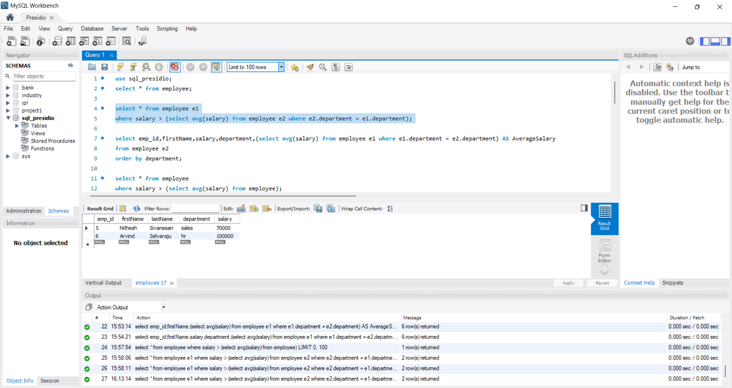 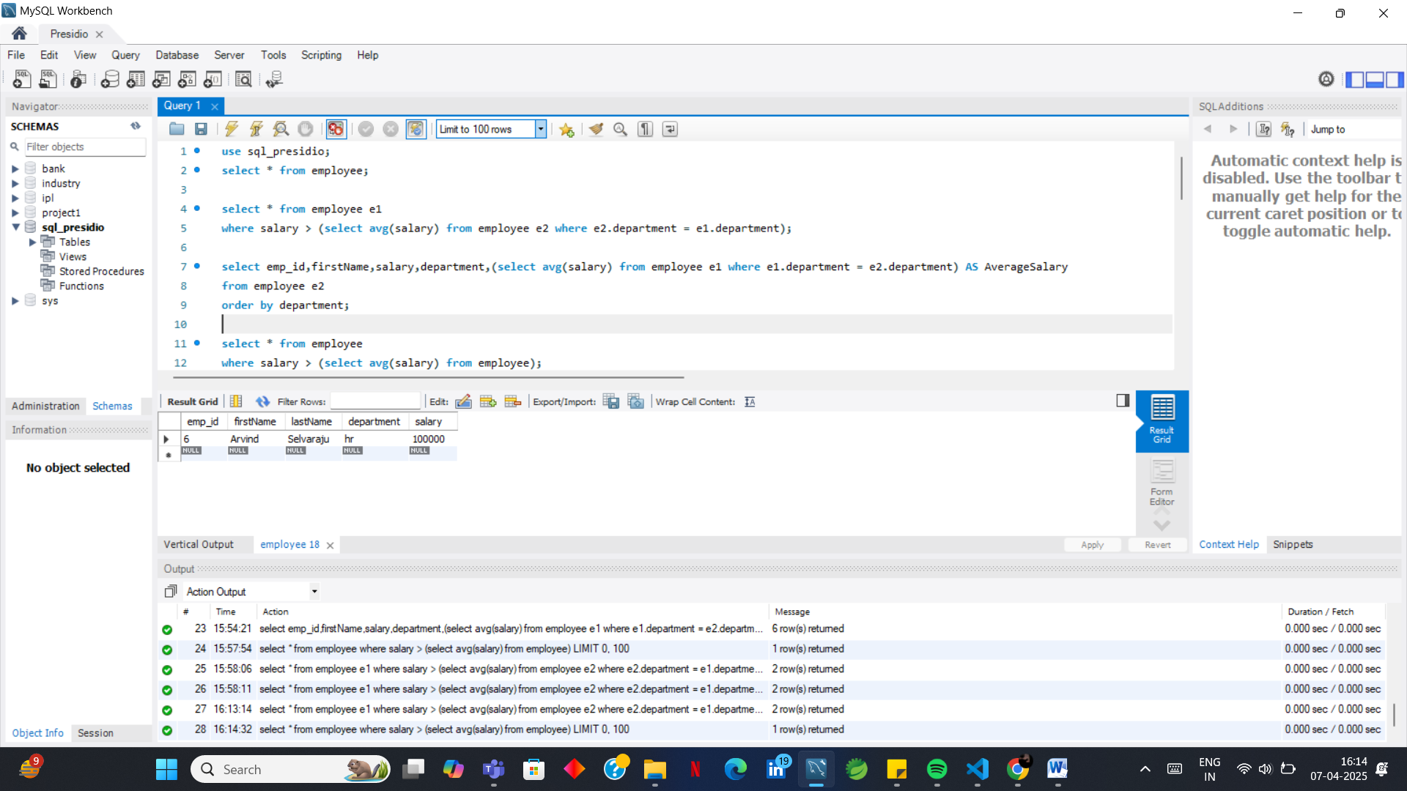

1. ***select emp_id,firstName,salary,department,(select avg(salary) from employee e1 where e1.department = e2.department) AS AverageSalary***
2. ***from employee e2***
3. ***order by department;***

* **“(select avg(salary) from employee e1 where e1.department = e2.department) AS AverageSalary”** This query returns the average salaries of each department in a separate column named **AverageSalary**.

