# 6. Date and Time Functions

## Objective

To manipulate and query data based on date and time values.

## Queries

1. ***select * from orders where datediff(current_date(),order_date)<=30;***

* I have covered some **Date** function. **datediff()** is used to calculate the difference between two dates.
* Here, It is calculating difference between the ordered date and current date. If it is less than or equal to 30, it’ll return the rows.

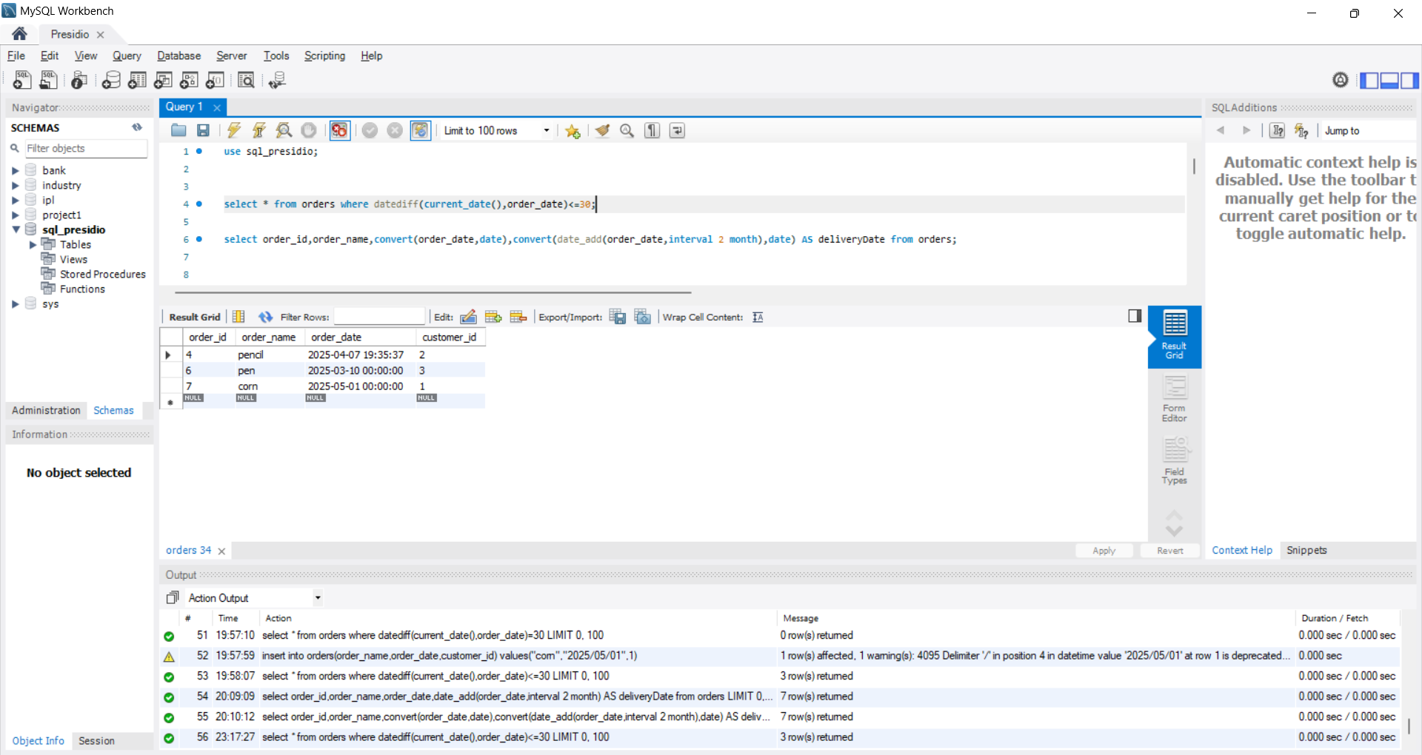

1. ***Select order_id,order_name,***
2. ***convert(order_date,date),***
3. ***convert(date_add(order_date,interval 2 month),date) AS deliveryDate***
4. ***from orders;***

* Here, I used another **date** function **date_add()** to increase/decrease the date values to order_date.
* Here, The **convert()** function will convert the **datetime(yyyy-mm-dd hh:mm:ss)** format into **date(yyyy-mm-dd)**. This function is used to change the data type of the value.

