# 9. Stored Procedures and User-Defined Functions

## Objective

To observe the concepts of Stored Procedures and User-Defined Functions.

## Understanding

* Stored procedures are the saved function and can be reused whenever we want it.
* Stores in database and persistent.
* User-defined functions are categorized by scalar, table valued function.
  + Scalar valued function – It return only one value
  + Table valued function – It return the table as a value (Mysql doesn’t support)
  + So we can use view or procedure to show table.

## Queries

1. ***DELIMITER //***
2. ***CREATE PROCEDURE totalSales(***
3. ***IN range1 DATE,***
4. ***IN range2 DATE,***
5. ***Out Total INT)***
6. ***BEGIN***
7. ***SELECT COUNT(*) INTO Total FROM orders***
8. ***WHERE order_date between range1 and range2;***
9. ***END //***
10. ***DELIMITER ;***
11. ***-- procedure calls***
12. ***call totalSales("2024-12-11","2025-01-07",@total);***
13. ***select @total AS totalSales;***

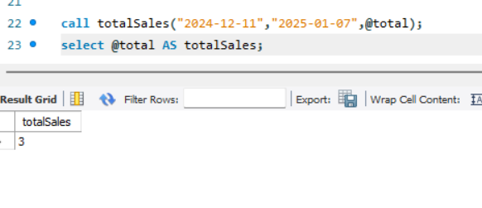

* Stored procedure has three type of parameters mode,
  + In – It’s like a input parameter
  + Out – It’s like a output parameter
  + InOut – It’s combination of both
* In stored procedure (**totalSales**), I have created it with two “in” and one “out” mode parameters to accept date range and return the rows.
  + range1(In), range2(In) and Total(out)
* call totalSales("2024-12-11","2025-01-07",@total);
  + call stored_procedure_name(parameters);

1. ***DELIMITER //***
2. ***create function discount_calculate(order_amount DECIMAL(10,2))***
3. ***returns DECIMAL(10,2)***
4. ***deterministic***
5. ***begin***
6. ***declare discount DECIMAL(10,2);***
7. ***if order_amount >= 100 then***
8. ***set discount = order_amount * 0.2;***
9. ***elseif order_amount >= 50 then***
10. ***set discount = order_amount * 0.1;***
11. ***else***
12. ***set discount = 0;***
13. ***end if;***
14. ***return discount;***
15. ***end //***
16. ***DELIMITER ;***
17. ***select *,discount_calculate(amount_paid) AS discount from orders;***

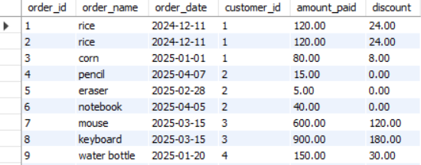

* This is same as function in other programming language like get parameters from user and return the value.
* Have to initialize the return data type and write code in the begin end limiters.
* I called the function in select statement which takes the amount paid by the user as a input and return the discount amount.