FINAL REPORT
Book a Doctor
Full Stack Development using MERN Stack

1. Introduction
Project Title:
“Book a Doctor” – Online Doctor Appointment Booking System
Name | Role
Nithiswaran G | Full Stack Developer (MERN)

Introduction
Book a Doctor is a full-stack web application developed using the MERN Stack (MongoDB, Express.js, React.js, and Node.js). The application enables patients to search for doctors, view their profiles, book appointments online, manage bookings, and securely access healthcare services.
The system reduces manual appointment booking and provides a fast, user-friendly, and secure platform for both patients and doctors.

2. Project Overview
Purpose
The main objective of the project is to simplify doctor appointment booking through an online platform.
The system allows users to:
- Register/Login securely
- Search doctors
- Filter by specialization
- View doctor profiles
- Book appointments
- Manage appointments
- Cancel bookings
- Admin management
Features
- User Registration
- Secure Login
- JWT Authentication
- Doctor Listing
- Doctor Search
- Category Filtering
- Appointment Booking
- Appointment Cancellation
- Doctor Dashboard
- Admin Dashboard
- MongoDB Database
- Responsive UI
- Profile Management

3. Architecture
Frontend
Developed using:
- React.js
- React Router
- Axios
- CSS
- Responsive Components

Responsibilities:
- User Interface
- Form Validation
- API Integration
- State Management
- Navigation

Backend
Developed using:
- Node.js
- Express.js
Responsibilities:
- REST APIs
- Authentication
- Authorization
- Appointment Management
- Database Operations
- Error Handling

Database
MongoDB stores:
Users Collection
- User ID
- Name
- Email
- Password (Encrypted)
- Phone
Doctors Collection
- Doctor Name
- Specialization
- Experience
- Consultation Fee
- Hospital
- Availability
Appointments Collection
- Patient
- Doctor
- Date
- Time
- Status

Relationships:
User
↓
Appointment
↓
Doctor

4. Setup Instructions
Prerequisites
Install:
- Node.js
- MongoDB Compass
- Git
- VS Code
- npm

Installation:

Clone Repository
git clone https://github.com/yourusername/book-a-doctor.git
Backend
cd server
npm install
Frontend
cd client
npm install
Create .env
PORT=5000

MONGO_URI=mongodb://127.0.0.1:27017/book_a_doctor

JWT_SECRET=yourSecretKey

5. Folder Structure
Book-A-Doctor

client/
│
├── src/
│ ├── components/
│ ├── pages/
│ ├── context/
│ ├── services/
│ ├── App.js
│ └── index.js
│

server/
|
├── controllers/
├── models/
├── routes/
├── middleware/
├── config/
├── utils/
├── server.js
├── package.json
└── .env

Folder Description
components → Reusable UI
pages → Application Pages
routes → API Endpoints
controllers → Business Logic
models → MongoDB Models
middleware → Authentication
config → Database Connection

6. Running the Application
Backend
cd server
npm run dev

Frontend
cd client
npm start

Application URLs
Frontend
http://localhost:3000
Backend
http://localhost:5000

7. API Documentation
User APIs
Register
POST
/api/users/register
Request
{
"name":"Jeeva",
"email":"jeeva@gmail.com",
"password":"123456"
}

Response
{
"message":"User Registered Successfully"
}

Login
POST
/api/users/login
Returns
JWT Token

Doctor APIs
GET
/api/doctors
Returns all doctors.
GET
/api/doctors/:id
Returns single doctor details.

Appointment APIs
POST
/api/appointments/book
Book Appointment
GET
/api/appointments/user

User Appointments
DELETE
/api/appointments/:id
Cancel Appointment

Admin APIs
GET
/api/admin/users
GET
/api/admin/doctors
POST
/api/admin/addDoctor
DELETE
/api/admin/deleteDoctor/:id

8. Authentication
Authentication is implemented using JSON Web Token (JWT).
Workflow
- User registers.
- Password encrypted using bcrypt.
- User logs in.
- Server verifies credentials.
- JWT Token generated.
- Token stored in browser.
- Protected APIs require token.
Security Features
- JWT Authentication
- Password Hashing
- Protected Routes
- Role-based Authorization
- Token Verification
- Secure API Access

9. User Interface
The application provides a modern and responsive interface.
Main Pages
- Home
- Login
- Register
- Doctors List
- Doctor Profile
- Appointment Booking
- User Dashboard
- Admin Dashboard
- Contact
- About
Design Features
- Responsive Design
- Clean Layout
- Easy Navigation
- Mobile Friendly
- Professional Color Scheme
- Interactive Cards
- Search Filters

10. Testing
Testing Methods
Functional Testing
- User Registration ✔
- Login ✔
- Logout ✔
- Search ✔
- Appointment ✔
API Testing
Performed using:
- Postman
Database Testing
Checked:
- CRUD Operations
- Data Validation
- Authentication
UI Testing
Verified:
- Buttons
- Navigation
- Forms
- Responsive Layout
Result
All major functionalities worked successfully.

11. Screenshots / Demo

Home Page

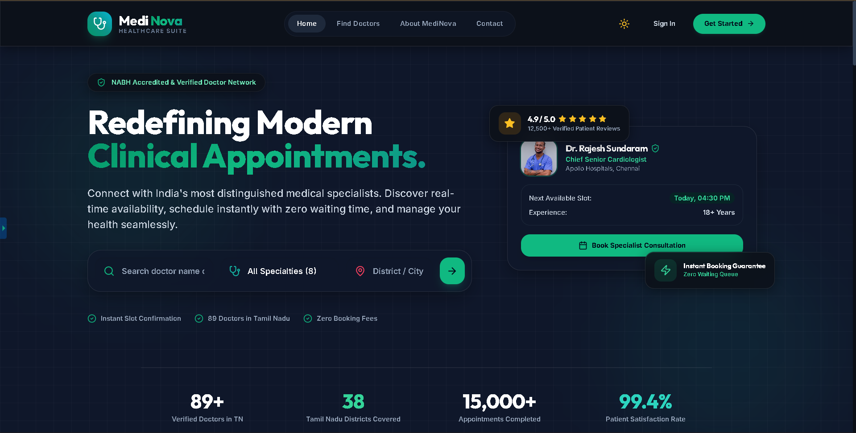

Login Page

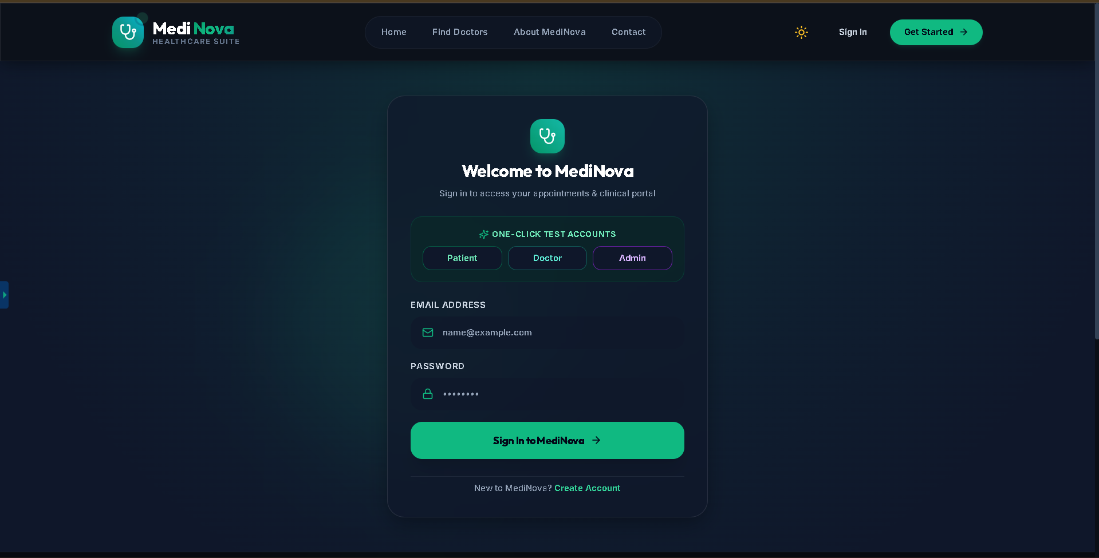

Registration Page

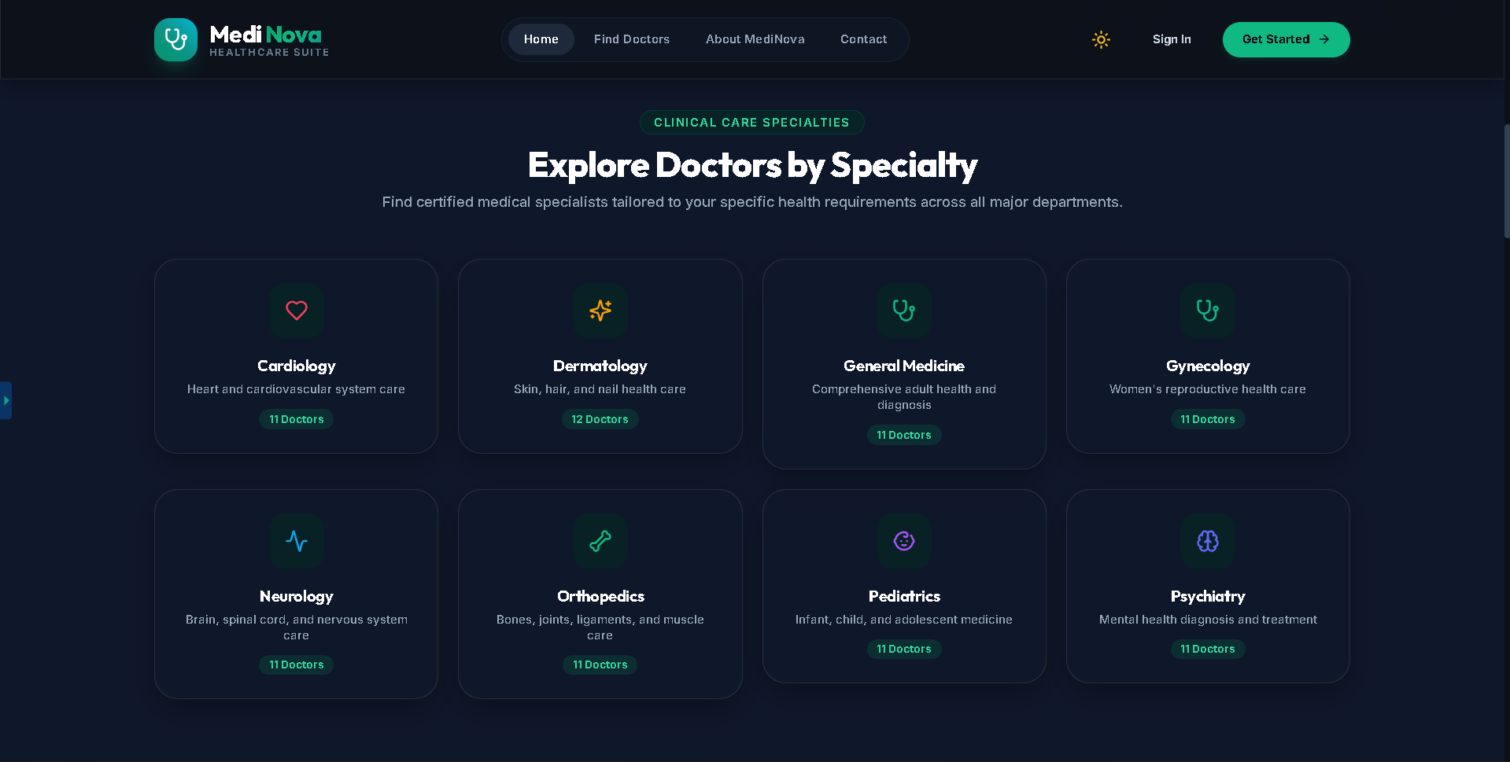

Doctors Page

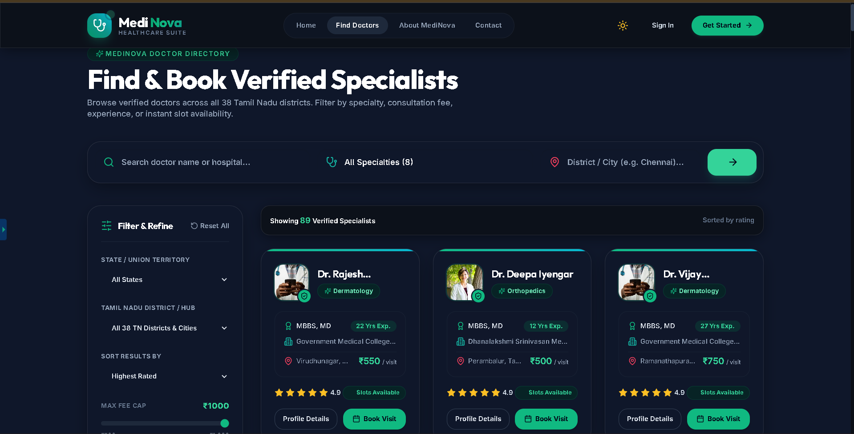

Doctor Details

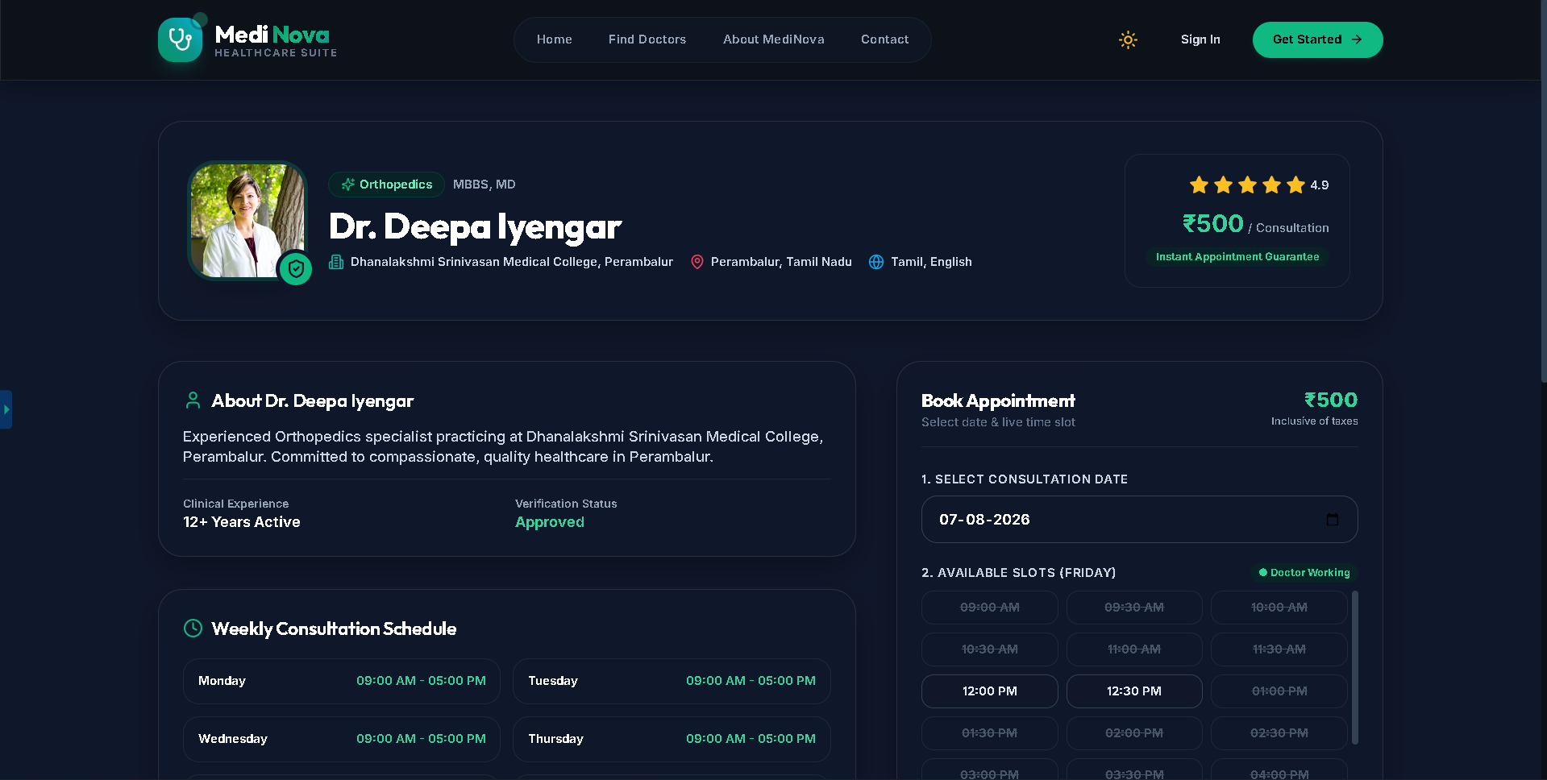

Appointment Booking

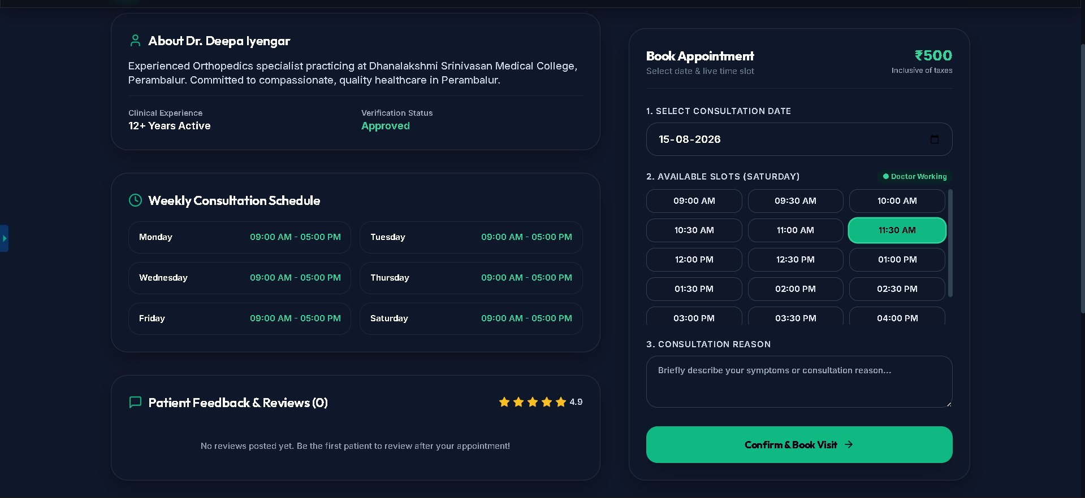

User Dashboard

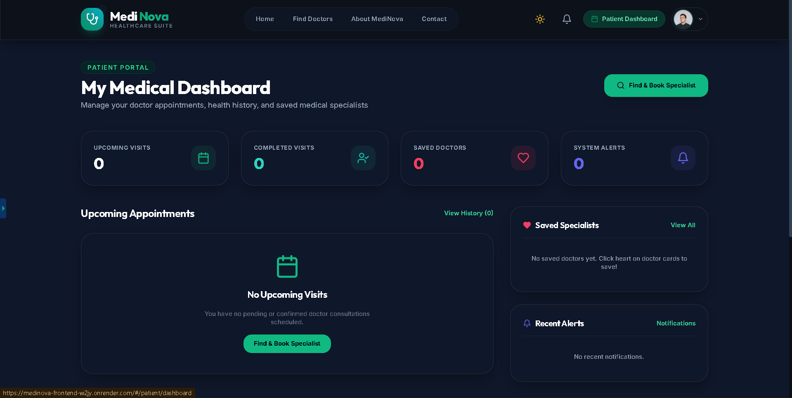

MongoDB Collections

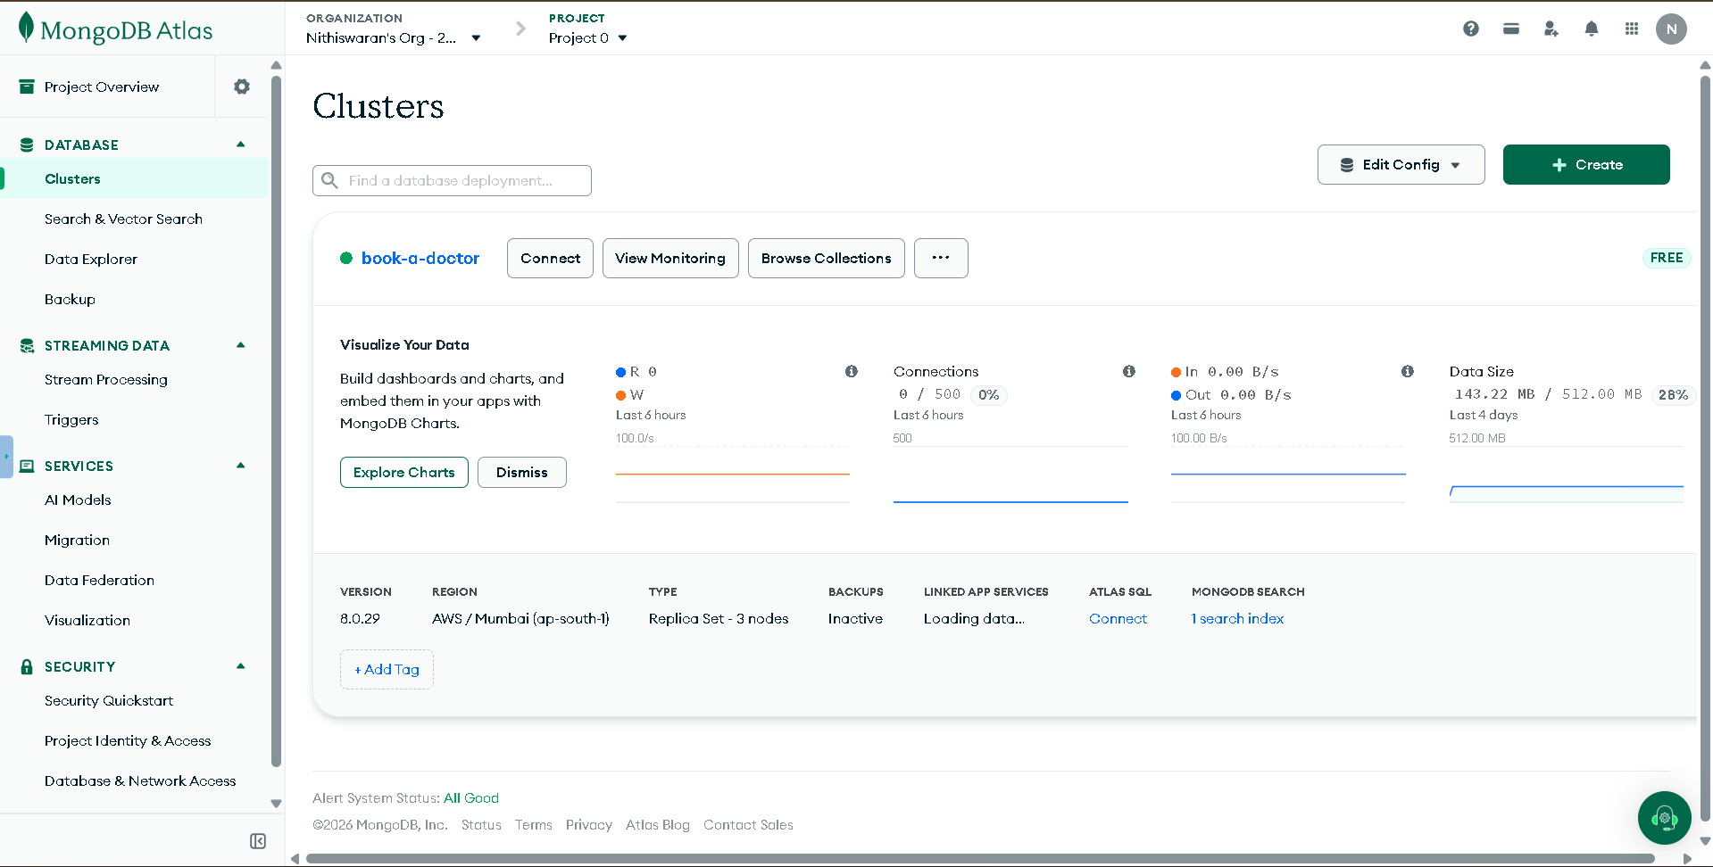

Responsive Mobile View
Home Page
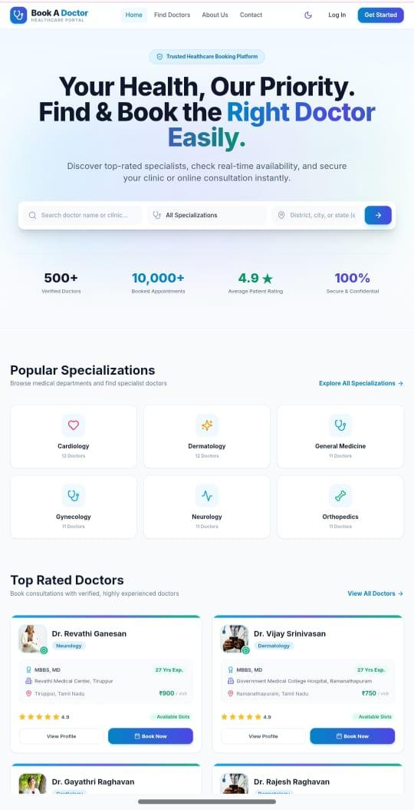

Doctor Finding

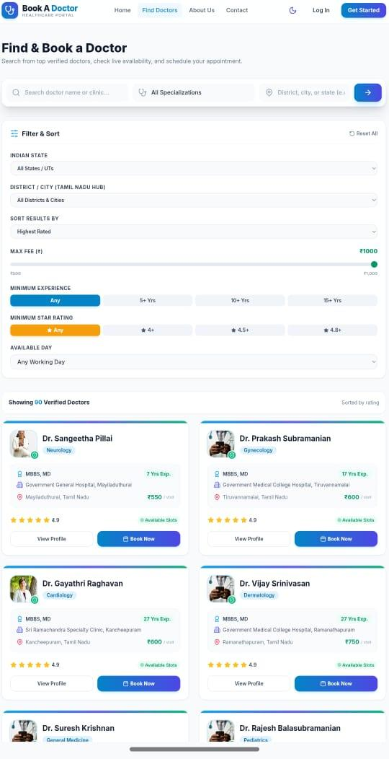

About us Page
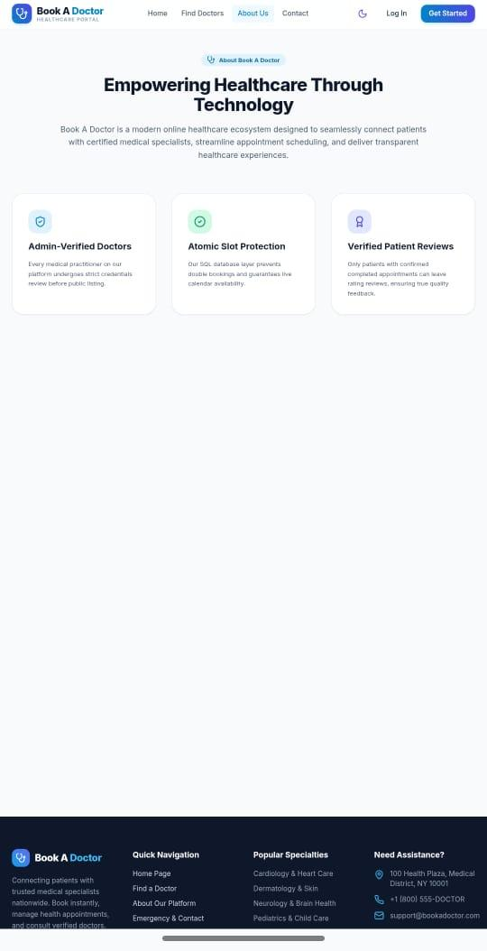

Demo Link
https://medinova-frontend-w2jy.onrender.com
GitHub Repository
https://github.com/Nithiswaran-G/Repository-name-book-a-doctor

12. Known Issues
Current limitations include:
- Online payment gateway not integrated.
- Email notifications are not implemented.
- Video consultation is unavailable.
- Doctors cannot upload medical reports.
- No real-time chat support.
- Appointment reminders are not available.
These limitations can be addressed in future versions.

13. Future Enhancements
The application can be enhanced by adding:
- Online Payment Gateway (Razorpay/Stripe)
- AI-based Doctor Recommendation
- Video Consultation
- Live Chat with Doctors
- Email Notifications
- SMS Appointment Reminders
- Medical Prescription Upload
- Patient Medical History
- Doctor Availability Calendar
- Ratings and Reviews
- Multi-language Support
- Dark Mode
- Progressive Web App (PWA)
- Cloud Image Upload (Cloudinary)
- Analytics Dashboard
- Mobile Application (React Native)

