Jira Integration

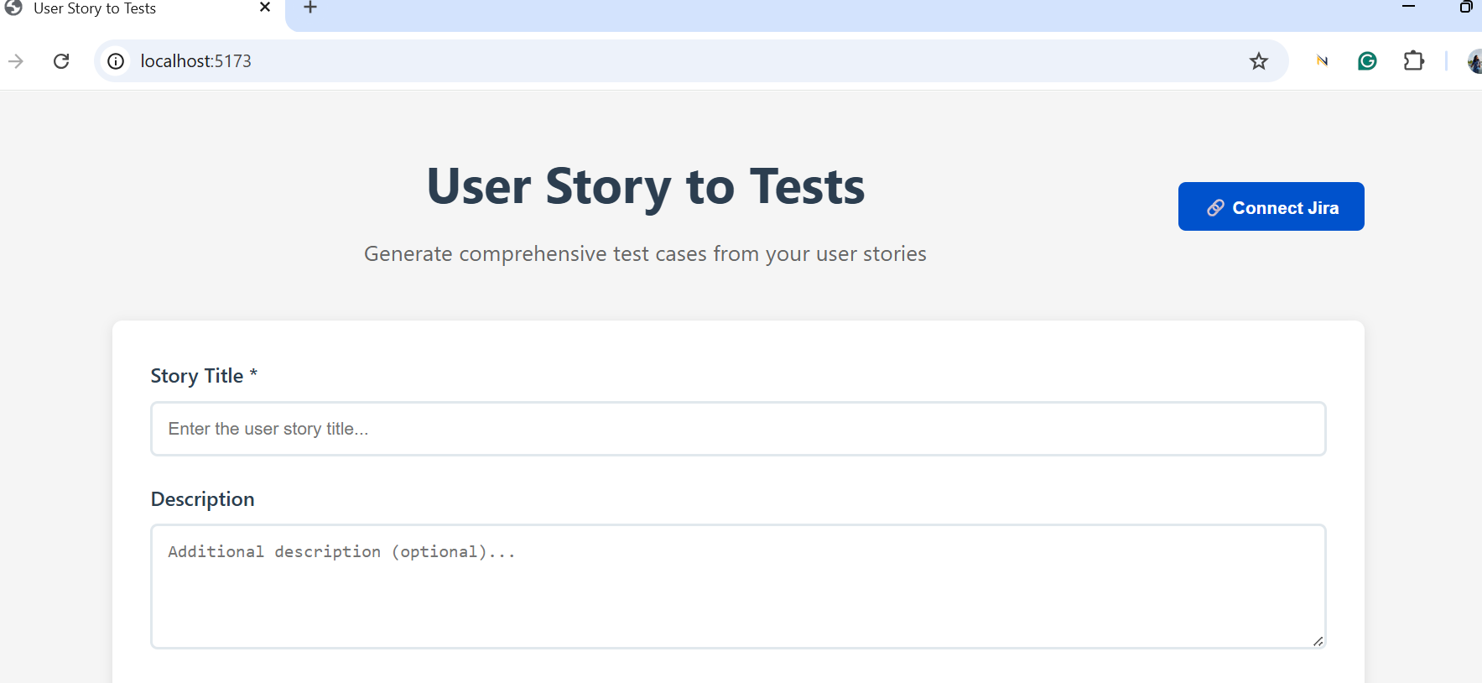
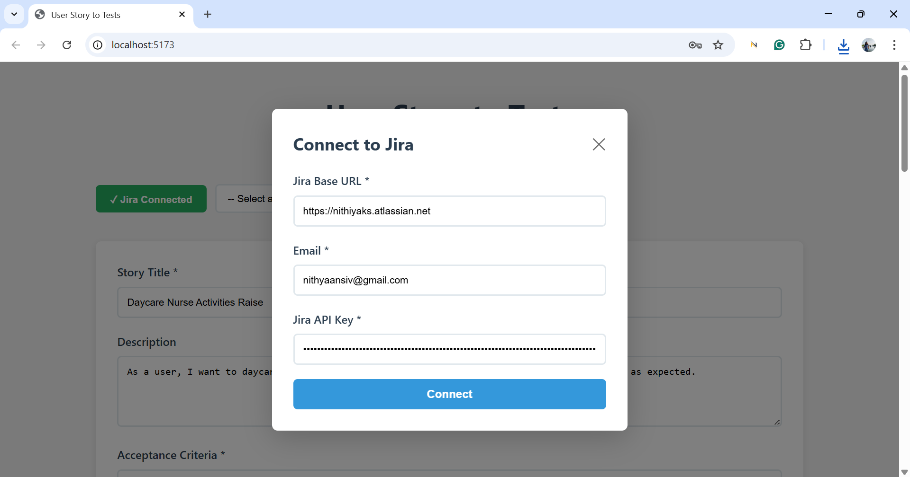

Export Button Prompt:
Instruction:
- Implement 3 Export buttons at the bottom of the page.
- Provide a text as Export the testcases
- Under the text implement 3 buttons for Export as csv, export as excel, export as json
- Implement functionality for these buttons, described as below,
  - Understand that after clicking Generate button, test cases are displayed in a table
  - Export as csv should export the testcases from the table and provide in a downloadable csv format
  - Export as excel should export the testcases from the table and provide in a downloadable excel format
  - Export as json should export the testcases from the table and provide in a downloadable json format
- [STRICTLY] export all columns and rows of the table
- Align export section to the center
Context: As a frontend developer provide options for users to download the testcases in different formats

