- Python - Playwright addition to Ai Extension tool
Prompt:
Instruction:
- Explore the code base to understand the implemenation of the AI Browser Extension tool to create test scripts
- Replicate the same behavior for Python - Playwright selection
- Generate test script for the DOM inspection from web page
- Provide the summary of changes you propose to make and upon my approval make the changes
Context:
As an experienced python playwright automation engineer, generate testscript for the inspected DOM
Persona: As an automation lead engineer review the test script for accuracy and inline to the ai extension code base already available for selenium Java.

Response from copilot in ask mode
Analysis & Implementation Plan for Python-Playwright Support
I've analyzed your codebase thoroughly. Here's my assessment and proposed changes:
Current Implementation Summary
Your extension currently supports:
Groq, OpenAI, Testleaf APIs
Selenium Java with Page Objects & Cucumber features
DOM inspection via content script
Token tracking and cost management
Proposed Changes for Python-Playwright Support
1. Extend Prompts (prompts.js)
Add three new prompt templates:
PLAYWRIGHT_PYTHON_PAGE_ONLY - Page Object pattern for Playwright
PLAYWRIGHT_PYTEST_ONLY - Pytest-based test with fixtures
PYTEST_WITH_PLAYWRIGHT_STEPS - BDD-style with pytest-bdd
2. Update Chat Logic (chat.js)
Extend getPromptKeys() to handle Python/Playwright combinations
Add language/engine validation for Python ecosystem
Support pytest fixtures and async/await patterns
3. Enhance UI (panel.html & CSS)
Add Python-specific generation options (Page Object vs Pytest vs BDD)
Show async/await handling toggle
Add browser context management options
4. API Response Handling
Ensure token counting works for Python responses
Handle Playwright-specific imports and syntax
Summary of Proposed Changes
Component | Change | Impact
prompts.js | Add 3 Python-Playwright prompt templates | Enables Pytest & Playwright code generation
chat.js | Add isPythonPlaywright() & update getPromptKeys() | Routes Python requests to correct prompts
panel.html | Add Python language option & async/await toggle | Users can select Python + Playwright combo
styles | No changes needed | Existing CSS works for new options
API handlers | No changes needed | Token counting already works for Python
Testing Checklist
User selects Python + Playwright + Pytest
DOM inspection returns valid HTML
Groq/OpenAI generates valid Python code
Code blocks render with python syntax highlighting
Page objects use proper async patterns
Test data matches South India format
Token counting accurate for Python responses
Copy functionality works for generated code
Would you like me to proceed with implementing these changes? I can:
✅ Update prompts.js with all three Python-Playwright templates
✅ Modify chat.js logic for language routing
✅ Update panel.html with Python options
✅ Test with sample DOM and verify output
Please confirm approval, and I'll make all the necessary code changes.

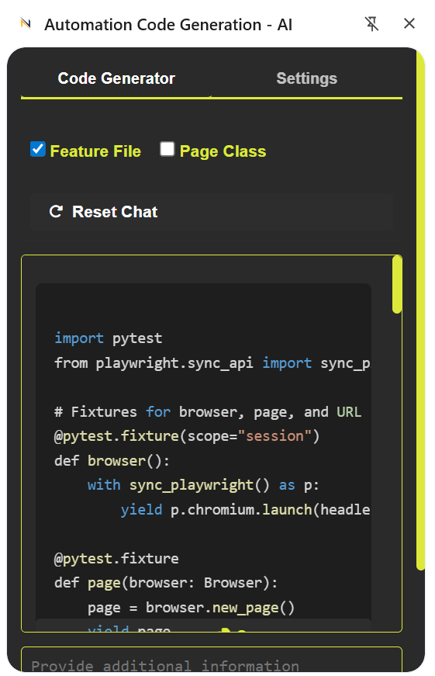
Added disclaimer in settings tab
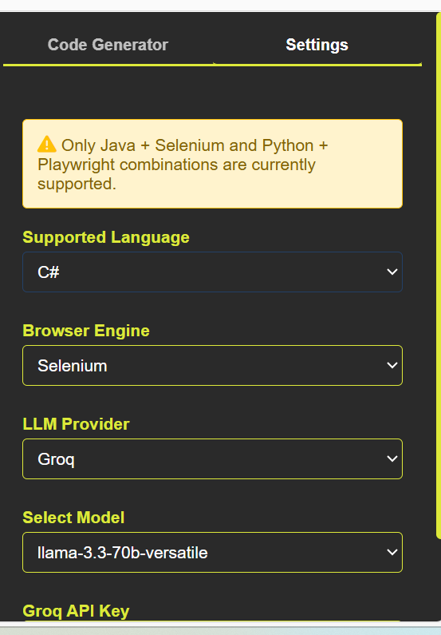
Pushed code to feature/base branch

- Use Bugmagnet extension for form filling
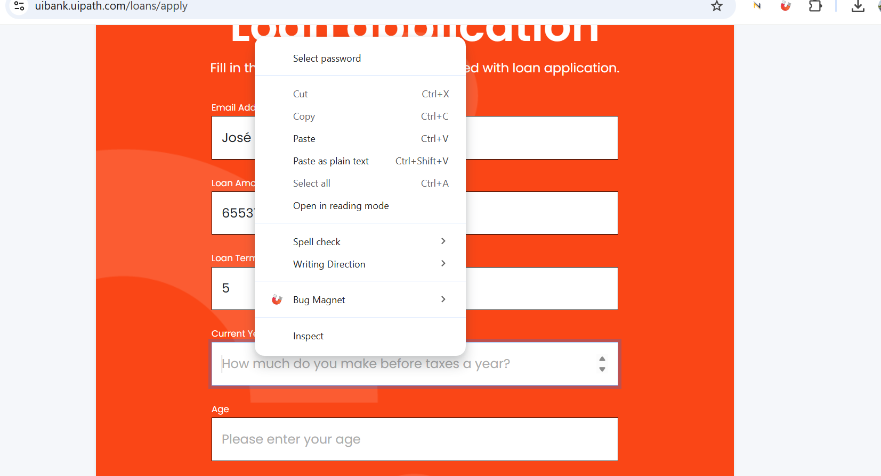
- Use grammarly extension to correct the mistakes in your content
