TITLE: FAKE NEWS DETECTION USING NLP

# PHASE 3 : DEVELOPMENT PART 1 SUBMITTED BY : Nithiya .G

**Mail ID :nya0746@gmail.com**

# Loading and Pre-Processing the Dataset

**ABOUT THIS PHASE :**

**In this phase we need to do loading and pre-processing the datasets. Here I explain about what are the process to do this phase.**

**DATA PREPROCESSING:**

After gathering the data, you must preprocess it to make sure it is clean and suitable for analysis. This entails:

**Handling missing data:** If any of the fields have missing values, you may need to fill them up or delete the entries that correspond to them.

## **Data encoding:** Genre and language categories have to be encoded into a category-specific format. This is achievable.utilizing methods like label encoding or one-hot encoding

**Feature scaling:** If you intend to employ algorithms that are sensitive to feature scales, such as gradient descent- based approaches, you might need to scale numerical features like runtime to have similar ranges.

## **Outlier detection:** Find any unusual trends in the IMDb ratings or runtime that might skew the forecasts and deal with them.

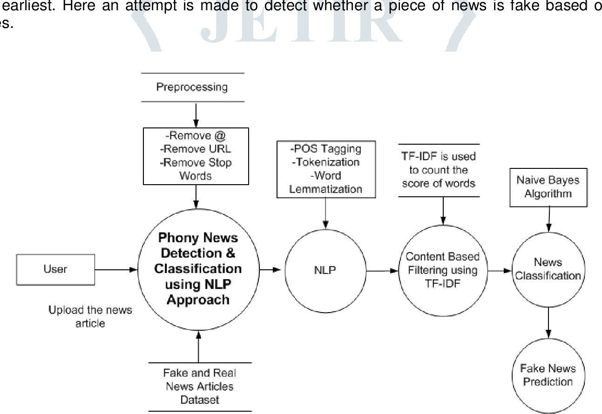

### Importing Dataset

import pandas as pd import numpy as np

import seaborn as sns

import matplotlib.pyplot as plt

from sklearn.model_selection import train_test_split from sklearn.metrics import accuracy_score

from sklearn.metrics import classification_report import re

import string

df_fake = pd.read_csv("/content/Fake.csv.zip") df_true = pd.read_csv("/content/True.csv.zip")

df_fake.head()

#### title text subject date

1. Donald Trump Sends Out Embarrassing New Year’... Donald Trump just couldn t wish all Americans ... News December 31, 2017
2. Drunk Bragging Trump Staffer Started Russian ... House Intelligence Committee Chairman Devin Nu... News December 31, 2017
3. Sheriff David Clarke Becomes An Internet Joke... On Friday, it was revealed that former Milwauk... News December 30, 2017
4. Trump Is So Obsessed He Even Has Obama’s Name... On Christmas day, Donald Trump announced that ... News December 29, 2017
5. Pope Francis Just Called Out Donald Trump Dur... Pope Francis used his annual Christmas Day mes... News December 25, 2017

df_true.head(5)

#### title text subject date

1. As U.S. budget fight looms, Republicans flip t... WASHINGTON (Reuters) - The head of a conservat... politicsNews December 31, 2017
2. U.S. military to accept transgender recruits o... WASHINGTON (Reuters) - Transgender people will... politicsNews December 29, 2017
3. Senior U.S. Republican senator: 'Let Mr. Muell... WASHINGTON (Reuters) - The special counsel inv... politicsNews December 31, 2017
4. FBI Russia probe helped by Australian diplomat... WASHINGTON (Reuters) - Trump campaign adviser ... politicsNews December 30, 2017
5. Trump wants Postal Service to charge 'much mor... SEATTLE/WASHINGTON (Reuters) - President Donal... politicsNews December 29, 2017

### Inserting a column "class" as target feature

df_fake["class"] = 0

df_true["class"] = 1

df_fake.shape, df_true.shape ((23481, 5), (21417, 5))

# Removing last 10 rows for manual testing df_fake_manual_testing = df_fake.tail(10) for i in range(23480,23470,-1):

df_fake.drop([i], axis = 0, inplace = True)

df_true_manual_testing = df_true.tail(10) for i in range(21416,21406,-1):

df_true.drop([i], axis = 0, inplace = True)

df_fake.shape, df_true.shape ((23471, 5), (21407, 5))

df_fake_manual_testing["class"] = 0

df_true_manual_testing["class"] = 1

<ipython-input-10-3aaf8ec2aad1>:1: SettingWithCopyWarning:

A value is trying to be set on a copy of a slice from a DataFrame. Try using .loc[row_indexer,col_indexer] = value instead

See the caveats in the documentation: [https://pandas.pydata.org/pandas-docs/stable/user_guide/indexing.html#returning-a-view-versus](https://pandas.pydata.org/pandas-docs/stable/user_guide/indexing.html#returning-a-view-versus-a-copy) df_fake_manual_testing["class"] = 0

<ipython-input-10-3aaf8ec2aad1>:2: SettingWithCopyWarning:

A value is trying to be set on a copy of a slice from a DataFrame.

Try using .loc[row_indexer,col_indexer] = value instead

See the caveats in the documentation: [https://pandas.pydata.org/pandas-docs/stable/user_guide/indexing.html#returning-a-view-versus](https://pandas.pydata.org/pandas-docs/stable/user_guide/indexing.html#returning-a-view-versus-a-copy) df_true_manual_testing["class"] = 1

df_fake_manual_testing.head(10)

|  |  |  |  |  |  |
| --- | --- | --- | --- | --- | --- |
|  | **title** | **text** | **subject** | **date** | **class** |
| **23471** | Seven Iranians freed in the prisoner swap have... | 21st Century Wire says This week, the historic... | Middle-east | January 20, 2016 | 0 |
| **23472** | #Hashtag Hell & The Fake Left | By Dady Chery and Gilbert MercierAll writers ... | Middle-east | January 19, 2016 | 0 |
| **23473** | Astroturfing: Journalist Reveals Brainwashing ... | Vic Bishop Waking TimesOur reality is carefull... | Middle-east | January 19, 2016 | 0 |
| **23474** | The New American Century: An Era of Fraud | Paul Craig RobertsIn the last years of the 20t... | Middle-east | January 19, 2016 | 0 |
| **23475** | Hillary Clinton: ‘Israel First’ (and no peace ... | Robert Fantina CounterpunchAlthough the United... | Middle-east | January 18, 2016 | 0 |
| **23476** | McPain: John McCain Furious That Iran Treated ... | 21st Century Wire says As 21WIRE reported earl... | Middle-east | January 16, 2016 | 0 |
| **23477** | JUSTICE? Yahoo Settles E-mail Privacy Class-ac... | 21st Century Wire says It s a familiar theme. ... | Middle-east | January 16, 2016 | 0 |
| **23478** | Sunnistan: US and Allied ‘Safe Zone’ Plan to T... | Patrick Henningsen 21st Century WireRemember ... | Middle-east | January 15, 2016 | 0 |
| **23479** | How to Blow $700 Million: Al Jazeera America F... | 21st Century Wire says Al Jazeera America will... | Middle-east | January 14, 2016 | 0 |
| **23480** | 10 U.S. Navy Sailors Held by Iranian Military ... | 21st Century Wire says As 21WIRE predicted in ... | Middle-east | January 12, 2016 | 0 |

df_true_manual_testing.head(10)

|  |  |  |  |  |  |
| --- | --- | --- | --- | --- | --- |
|  | **title** | **text** | **subject** | **date** | **class** |
| **21407** | Mata Pires, owner of embattled Brazil builder ... | SAO PAULO (Reuters) - Cesar Mata Pires, the ow... | worldnews | August 22, 2017 | 1 |
| **21408** | U.S., North Korea clash at U.N. forum over nuc... | GENEVA (Reuters) - North Korea and the United ... | worldnews | August 22, 2017 | 1 |
| **21409** | U.S., North Korea clash at U.N. arms forum on ... | GENEVA (Reuters) - North Korea and the United ... | worldnews | August 22, 2017 | 1 |
| **21410** | Headless torso could belong to submarine journ... | COPENHAGEN (Reuters) - Danish police said on T... | worldnews | August 22, 2017 | 1 |
| **21411** | North Korea shipments to Syria chemical arms a... | UNITED NATIONS (Reuters) - Two North Korean sh... | worldnews | August 21, 2017 | 1 |
| **21412** | 'Fully committed' NATO backs new U.S. approach... | BRUSSELS (Reuters) - NATO allies on Tuesday we... | worldnews | August 22, 2017 | 1 |
| **21413** | LexisNexis withdrew two products from Chinese ... | LONDON (Reuters) - LexisNexis, a provider of l... | worldnews | August 22, 2017 | 1 |
| **21414** | Minsk cultural hub becomes haven from authorities | MINSK (Reuters) - In the shadow of disused Sov... | worldnews | August 22, 2017 | 1 |
| **21415** | Vatican upbeat on possibility of Pope Francis ... | MOSCOW (Reuters) - Vatican Secretary of State ... | worldnews | August 22, 2017 | 1 |
| **21416** | Indonesia to buy $1.14 billion worth of Russia... | JAKARTA (Reuters) - Indonesia will buy 11 Sukh... | worldnews | August 22, 2017 | 1 |

df_manual_testing = pd.concat([df_fake_manual_testing,df_true_manual_testing], axis = 0) df_manual_testing.to_csv("manual_testing.csv")

### Merging True and Fake Dataframes

df_merge = pd.concat([df_fake, df_true], axis =0 ) df_merge.head(10)

|  |  |  |  |  |
| --- | --- | --- | --- | --- |
| **title** | **text** | **subject** | **date** | **class** |
| **0** Donald Trump Sends Out Embarrassing New Year’... | Donald Trump just couldn t wish all Americans ... | News | December 31, 2017 | 0 |
| **1** Drunk Bragging Trump Staffer Started Russian ... | House Intelligence Committee Chairman Devin Nu... | News | December 31, 2017 | 0 |
| **2** Sheriff David Clarke Becomes An Internet Joke... | On Friday, it was revealed that former Milwauk... | News | December 30, 2017 | 0 |
| **3** Trump Is So Obsessed He Even Has Obama’s Name... | On Christmas day, Donald Trump announced that ... | News | December 29, 2017 | 0 |
| **4** Pope Francis Just Called Out Donald Trump Dur... | Pope Francis used his annual Christmas Day mes... | News | December 25, 2017 | 0 |
| **5** Racist Alabama Cops Brutalize Black Boy While... | The number of cases of cops brutalizing and ki... | News | December 25, 2017 | 0 |
| **6** Fresh Off The Golf Course, Trump Lashes Out A... | Donald Trump spent a good portion of his day a... | News | December 23, 2017 | 0 |
| **7** Trump Said Some INSANELY Racist Stuff Inside ... | In the wake of yet another court decision that... | News | December 23, 2017 | 0 |
| **8** Former CIA Director Slams Trump Over UN Bully... | Many people have raised the alarm regarding th... | News | December 22, 2017 | 0 |
| **9** WATCH: Brand-New Pro-Trump Ad Features So Muc... | Just when you might have thought we d get a br... | News | December 21, 2017 | 0 |

df_merge.columns

Index(['title', 'text', 'subject', 'date', 'class'], dtype='object')

### Removing columns which are not required

df = df_merge.drop(["title", "subject","date"], axis = 1)

df.isnull().sum()  text 0

class 0

dtype: int64

### Random Shuffling the dataframe

df = df.sample(frac = 1)

df.head()

|  |  |  |
| --- | --- | --- |
|  | **text** | **class** |
| **7701** | Bobby Jindal abandoned his home state of Louis... | 0 |
| **16528** | Newsflash Hillary WAR is not aesthetically ple... | 0 |
| **9527** | WASHINGTON (Reuters) - The White House confirm... | 1 |
| **18516** | Texas Democrat Rep. Al Green announced on Wedn... | 0 |
| **993** | WASHINGTON (Reuters) - The U.S. State Departme... | 1 |

df.reset_index(inplace = True)

df.drop(["index"], axis = 1, inplace = True)

df.columns

Index(['text', 'class'], dtype='object')

df.head()

#### text class

1. Bobby Jindal abandoned his home state of Louis... 0
2. Newsflash Hillary WAR is not aesthetically ple... 0
3. WASHINGTON (Reuters) - The White House confirm... 1
4. Texas Democrat Rep. Al Green announced on Wedn... 0
5. WASHINGTON (Reuters) - The U.S. State Departme... 1

### Creating a function to process the texts

def wordopt(text):

text = text.lower()

text = re.sub('\[.*?\]', '', text) text = re.sub("\\W"," ",text)

text = re.sub('https?://\S+|www\.\S+', '', text) text = re.sub('<.*?>+', '', text)

text = re.sub('[%s]' % re.escape(string.punctuation), '', text) text = re.sub('\n', '', text)

text = re.sub('\w*\d\w*', '', text) return text

df["text"] = df["text"].apply(wordopt)

### Defining dependent and independent variables

x = df["text"]

y = df["class"]